QUES 2 : Kubernetes service types (ClusterIP, NodePort, LoadBalancer)

SOLN:

In Kubernetes, a Service is an abstraction that exposes a set of Pods as a network service. While Pods in Kubernetes are ephemeral and can change IPs, Services provide a stable endpoint for reliable communication.
Kubernetes supports multiple types of Services to handle different networking needs. These types determine how and where your application can be accessed — internally within the cluster or externally from the internet.
The 3 commonly used service types are:

ClusterIP (Default Service Type)
- Purpose: Makes the service accessible only within the cluster.
- Use Case: Ideal for internal communication (e.g., frontend ↔ backend).
- Example: Backend database or internal microservices.

NodePort
- Purpose: Exposes the service on a static port on each node's IP.
- Use Case: Allows external access by hitting <NodeIP>:<NodePort>.
- Limitations: Port range is limited (30000–32767), less secure for production.

LoadBalancer
- Purpose: Provisions a cloud load balancer and assigns a public IP.
- Use Case: Best for production when deploying on cloud platforms like AKS, EKS, or GKE.
- Benefit: External users can access your service through a single public IP.

My Deployment Using LoadBalancer (As Part of This Task) :
As part of exploring Kubernetes service types, I have already deployed a sample application using the LoadBalancer service type on my Azure Kubernetes Service (AKS) cluster.

REFERENCE TO QUES 1

This setup allowed me to expose the application externally through a public IP address assigned by the cloud provider (Azure). This proves the practical use of the LoadBalancer type in real-world, cloud-based environments.

My Cluster and Pod Setup:

COMMAND USED : kubectl get nodes
kubectl get pods

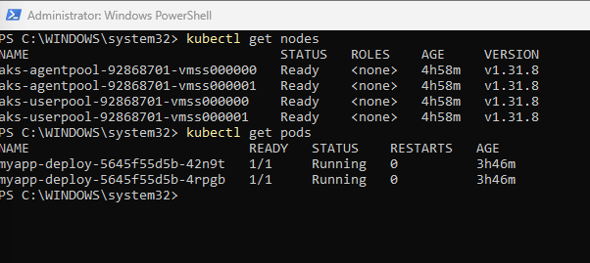

YAML File Used for LoadBalancer Service:

apiVersion: v1
kind: Service
metadata:
name: myapp-service
spec:
selector:
app: myapp
ports:
- protocol: TCP
port: 80
targetPort: 80
type: LoadBalancer

Result:
After applying this YAML, Kubernetes automatically provisioned a public IP through Azure, enabling users to access the application from outside the cluster.
COMMAND USED : kubectl get svc

This demonstrates how LoadBalancer services simplify external access in cloud environments, without needing manual NodePort configuration.

What the Entries Mean:

kubernetes (ClusterIP):
- This is automatically created by Kubernetes.
- It exposes the Kubernetes API server internally to the cluster.
- It's not related to the app.
- Yes, it is a ClusterIP type service, but not your own custom one.

myapp-service (LoadBalancer):
- This is the one created for app.
- It has both:
  - A ClusterIP (10.0.121.175) → for internal access
  - An External IP (4.213.203.76) → for public access via LoadBalancer
- It also auto-assigned a NodePort: 32143 (which is how LoadBalancer works internally).

What is it?
The LoadBalancer type in Kubernetes is used to expose your service to the internet by automatically provisioning an external load balancer (via the cloud provider like Azure, AWS, or GCP).

How It Works (Internally):
When you create a service of type LoadBalancer:
- Kubernetes creates a NodePort service in the background.
- The cloud provider provisions a load balancer with a public IP.
- The load balancer forwards traffic from its public IP → to the NodePort on cluster nodes → which routes to your Pod(s).

Flow of Traffic:
- User accesses the public IP of the LoadBalancer.
- LoadBalancer sends the traffic to one of the NodePorts.
- NodePort forwards the request to the target port on the Pod.

Diagram: LoadBalancer Service Flow

[ Public User ]
|
[Cloud LoadBalancer] (External IP: 4.213.203.76)
|
-------------------------------
| | |
[Node1] [Node2] [Node3]
:32143 :32143 :32143
| | |
[Pod1:80] [Pod2:80] [Pod3:80]

32143 → Auto-assigned NodePort
- 80 → Target port inside each pod
- Traffic from internet → LoadBalancer → NodePort → Pod

Advantages of LoadBalancer:
- Simplifies exposure to the internet.
- Automatic provisioning of public IP and traffic routing.
- Ideal for production deployments on cloud platforms like AKS, EKS, GKE

SO LETS CONTINUE ON THIS AND CREATE A CLUSTER IP SERVICE AND NODEPORT SERVICE FOR THE SAME IMAGE DEPLOYMENT

Step 1: Create and Apply ClusterIP and NodePort Services

A. Create clusterip.yaml

apiVersion: v1
kind: Service
metadata:
name: clusterip-svc
labels:
env: dev
type: internal
spec:
selector:
app: myapp
ports:
- port: 80
targetPort: 80
type: ClusterIP

Apply it:
kubectl apply -f clusterip.yaml

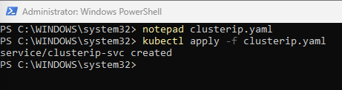

3. Create nodeport.yaml

notepad nodeport.yaml

apiVersion: v1
kind: Service
metadata:
name: nodeport-svc
spec:
selector:
app: myapp
ports:
- port: 80
targetPort: 80
nodePort: 32000
type: NodePort

command used :
kubectl apply -f nodeport.yaml

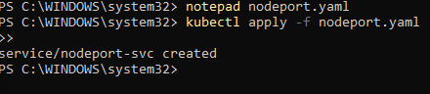

4. Verify Services

kubectl get svc

You should now see 3 services:
- myapp-service (LoadBalancer)
- clusterip-svc (ClusterIP)
- nodeport-svc (NodePort)
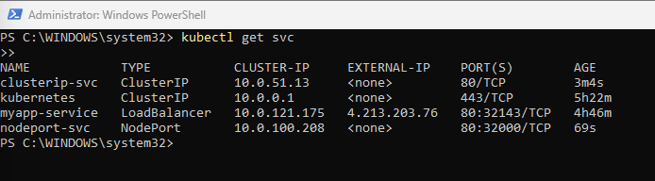

5. Optional: Describe to Check if Pod Is Reached

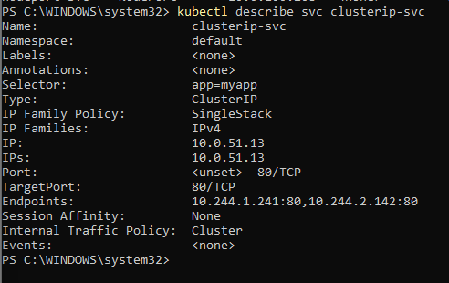
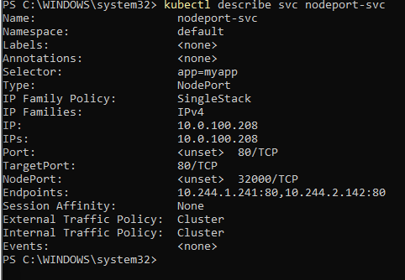

so untill this :

Service | Type | Internal Access | External Access | Status
clusterip-svc | ClusterIP | ✅ Yes (within cluster) | ❌ No | Working
nodeport-svc | NodePort | ✅ Yes (if port-forwarded) | ❌ No (no external node IP) | Working
myapp-service | LoadBalancer | ✅ Yes | ✅ Yes (4.213.203.76) | Working

WE CANNOT ACCESS PUBLICALLY CAUSE :
NodePort mapped the app to a static port (32000) on each node, but due to lack of external node IPs in AKS, it cannot be accessed directly from the internet.

WHAT WE CAN DO TO ACCESS IT PUBLICALLY:

Option 1: Manually Expose a VM Node to the Internet (NOT recommended)

Steps (Advanced & Not Secure for Production):
- Create a public IP address in Azure.
- Assign that IP to a network interface on a VM Scale Set (one of the AKS nodes).
- Open firewall port (e.g., 32000).
- Then you can access:

http://<Public-Node-IP>:<NodePort>

Option 2: Use a LoadBalancer to Simulate NodePort (Cleanest + Practical)
Since Azure doesn't expose nodes directly, you can:
- Keep your service as NodePort
- Manually create a LoadBalancer resource in Azure Portal
- Point it to backend pool → Node IPs → NodePort
- Result: Public IP hits NodePort behind the scenes
But this defeats the purpose because...
Kubernetes LoadBalancer service already does this automatically!
SO ITS DONE FILNALLY:

In this task, I explored all three main types of Kubernetes Services: ClusterIP, NodePort, and LoadBalancer.
I deployed a sample app (myapp-deploy) and connected it to all 3 services:
- ClusterIP was used to enable internal communication inside the cluster.
- NodePort mapped the app to a static port (32000) on each node, but due to lack of external node IPs in AKS, it cannot be accessed directly from the internet.
- LoadBalancer was used to expose the app to the public internet via Azure’s managed load balancer, which provided a working external IP (4.213.203.76).

SO WE CAN UNDER STAND THE USE CASES AS :

Real-World Use Case Comparison of Kubernetes Service Types

🔹 1. ClusterIP – Internal Service Communication Only
Theory:
ClusterIP exposes the service only inside the Kubernetes cluster, typically used for backend-to-backend communication between microservices.
Real-World Example:
In a real e-commerce site, the frontend service (React or Angular) calls the backend service (Node.js or Django) via ClusterIP. The backend in turn calls database or authentication services, all of which are invisible outside the cluster.
Why?
These components don’t need to be public. Using ClusterIP keeps them secure and isolated.

2. NodePort – Debug or Dev-Level External Access
Theory:
NodePort exposes the service on a fixed port (30000–32767) on every node's IP. It’s often used for quick testing or temporary external access, especially in bare metal or local setups.
Real-World Example:
In a private company network, a dev team may use NodePort to expose a service to their office network so team members can test the staging build by visiting http://<node-ip>:32000.
Why?
No need for a full cloud LoadBalancer in non-production or internal settings. But not ideal for public or large-scale access.

3. LoadBalancer – Production-Grade Public Access
Theory:
LoadBalancer provisions a cloud-managed external IP and routes public traffic to the app. It's best for production websites and APIs exposed to the internet.
Real-World Example:
In real production apps like Tabcura, Amazon, or Netflix, frontend services are exposed via LoadBalancer.
For instance:
https://www.netflix.com → hits a cloud LoadBalancer → routes to Kubernetes pods hosting their frontend.
Why?
It provides scalability, public reach, and is managed by the cloud (e.g., Azure Load Balancer in AKS).

