Ques 6 : Configure Taints and Tolerants.

SOLN:

Taint (Definition):
A taint is a property that you apply to a Kubernetes node to prevent pods from being scheduled onto it unless those pods explicitly tolerate the taint.

Toleration (Definition):
A toleration is applied to a pod to allow (or tolerate) the scheduling of the pod onto a node that has a matching taint.

Taints and tolerations work together to ensure that pods are only scheduled onto appropriate nodes. Taints act as a barrier, and tolerations grant exceptions to that barrier.

Layman Explanation:
Imagine a restaurant (your Kubernetes cluster) with many tables (nodes).
- Some tables have “Reserved” signs (taints) saying:
“Only VIPs (special pods) can sit here.”
- A regular customer (normal pod) walks in.
He sees the “Reserved” sign and doesn’t sit there.
- A VIP customer (pod with toleration) walks in.
He has permission (toleration) and can sit at the reserved table.
So:
- Taint = puts a restriction on a node.
- Toleration = allows specific pods to ignore that restriction and get scheduled on that node.

Use Case in Real Life:
Suppose you have:
- GPU Nodes: These are expensive and meant only for ML workloads.
- You taint them to prevent general pods from using them.
- You add toleration to ML pods so they can go to those nodes.

Concept Diagram :

[NODE A - Tainted: key=gpu:NoSchedule]
|
|--> POD 1 [No toleration] ❌ Will not schedule
|
|--> POD 2 [Tolerates gpu:NoSchedule] ✅ Scheduled here

[NODE B - No Taint]
|
|--> POD 1 ✅ Will schedule
|--> POD 2 ✅ Will also schedule

Taint = Node says "Don't schedule pods on me unless you tolerate me."
Toleration = Pod says "I can handle that taint — let me run here."

Step 1: Add a Taint to a Node

kubectl taint nodes aks-userpool-92868701-vmss000000 key1=value1:NoSchedule

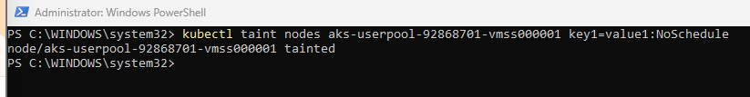

Step 2: Apply a Pod with a Toleration

apiVersion: apps/v1
kind: Deployment
metadata:
name: myapp-deploy
spec:
replicas: 2
selector:
matchLabels:
app: myapp
template:
metadata:
labels:
app: myapp
spec:
tolerations:
- key: "role"
operator: "Equal"
value: "frontend"
effect: "NoSchedule"
containers:
- name: myapp-container
image: prateek2004/my-frontend
ports:
- containerPort: 80
livenessProbe:
httpGet:
path: /
port: 80
initialDelaySeconds: 15
periodSeconds: 10
readinessProbe:
httpGet:
path: /
port: 80
initialDelaySeconds: 5
periodSeconds: 5

VERIFY:

kubectl get pods -o wide

It should land on aks-userpool-92868701-vmss000000

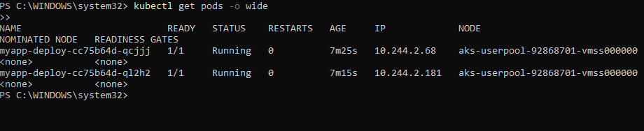

In real production systems, taints are used to segregate workloads. For example, GPU-heavy nodes may be tainted so only pods with GPU requirements (and tolerations) run there. This prevents general workloads from using expensive resources. In my setup, I tainted one node and configured tolerations in the pod to target it — simulating a dedicated node scheduling scenario.

