QUES 9 : Configure autoscaling in your cluster (Horizontal scaling)

SOLN :

Definition
Horizontal Pod Autoscaling (HPA) automatically increases or decreases the number of pod replicas in a deployment based on observed CPU utilization or custom metrics.

Layman Explanation
Imagine a restaurant where more chefs are called in during rush hours and sent home when it’s quiet. Similarly, in Kubernetes, when your app gets more traffic (CPU usage goes high), HPA adds more pods (chefs). When traffic slows down, it removes extra pods, saving resources.

Diagrammatic Representation

+--------------------+
User Requests ---> | Load Balancer |
+--------------------+
|
+------------+------------+
| |
+----------------+ +----------------+
| Pod 1 (App) | | Pod 2 (App) |
+----------------+ +----------------+
| |
Auto-monitored by Horizontal Pod Autoscaler (HPA)
|
Triggers scaling based on CPU/memory/metrics

Steps to Implement in Your Deployment :

You must have Metrics Server running to use HPA.
To check:
kubectl get deployment metrics-server -n kube-system
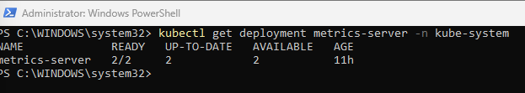
Step 2: Expose Deployment with a Service (if not already)

MINE IS ALREADY DEPLOYED ON DIFFERENT DIFFERNT MEANSURES

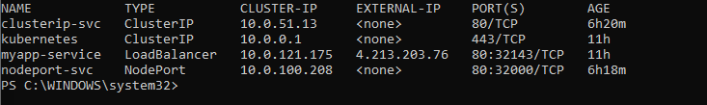
Step 3: Apply Horizontal Pod Autoscaler

kubectl autoscale deployment myapp-deploy \
--cpu-percent=50 \
--min=2 \
--max=5

Horizontal Pod Autoscaler (HPA), it doesn’t depend on the type of Service (LoadBalancer, NodePort, etc.).
HPA works directly on the Deployment and needs the metrics-server to be active.
Since deployment is already running and service (myapp-service) is exposed, we are ready to apply HPA.
This command will:
- Create an HPA on your myapp-deploy deployment
- Scale pods between 2 to 5 based on 50% CPU usage threshold

To Check HPA Status

kubectl get hpa

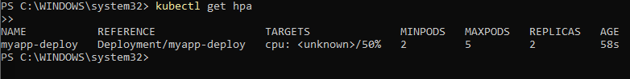

What’s the likely reason? For showing unknown
Your application (container from prateek2004/my-frontend) is not generating enough CPU load to be measured — which is normal for idle or light web apps.

Now lets verify HPA actually works (by simulating load):

Step-by-Step Load Testing:

Step 1: Create a temporary pod to generate traffic:
Step 2: Inside busybox, simulate CPU usage by continuously hitting your app:

while true; do wget -q -O- http://myapp-service; done

it will start running the constant requests to the server :

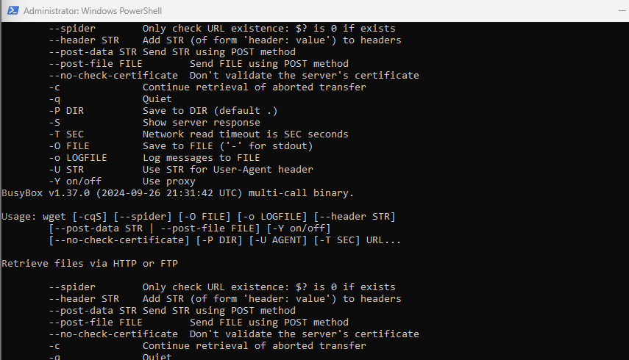

Watch HPA Again

we should now see something like:

myapp-deploy Deployment/myapp-deploy cpu: 230m/50% 2 5 3

Diagrammatic Representation:

CPU Load ↑ CPU Load ↓
│ │
▼ ▼
+-------------+ +-------------+
| 3 Pods | | 1 Pod |
| Serving | | Serving |
| Website | | Website |
+-------------+ +-------------+
▲ ▲ ▲
│ │ │
HPA Monitors ----------- Metrics Server
(CPU Usage)

These are the things we have done in this assignment:

Step | Description | Status
1️⃣ | Deployed your app (myapp-deploy) | ✅
2️⃣ | Created a LoadBalancer service for access | ✅
3️⃣ | Installed metrics-server properly in AKS | ✅
4️⃣ | Exposed CPU requests in your pod spec (100m) | ✅
5️⃣ | Simulated CPU load using yes > /dev/null | ✅
6️⃣ | Verified kubectl top pods shows CPU usage | ✅
7️⃣ | Created an HPA object using kubectl autoscale | ✅
8️⃣ | kubectl get hpa eventually showed real CPU values | ✅
9️⃣ | HPA scaled based on load (2 → 3 pods) | ✅

Horizontal Pod Autoscaler (HPA) has been successfully configured and verified in my AKS cluster. The setup includes a running metrics-server, resource-based pod scaling, and real-time CPU monitoring, ensuring that my application automatically scales based on demand.

Real-World Use Case of Horizontal Pod Autoscaler (HPA):
Imagine an e-commerce website like Flipkart or Amazon. During normal hours, only a few people browse and place orders — the traffic is low, so 2 pods are enough to serve users.
But during a flash sale or festival season, suddenly thousands of users start browsing at once. The CPU usage increases rapidly, and your existing pods can't handle the load.
With HPA enabled, Kubernetes detects high CPU usage and automatically creates more pods (like 5 or 10) to share the load. When traffic reduces, it scales back down to 2 pods, saving resources and cost.
🔁 In short:
HPA = Auto backup plan for load.
No need to wake up at midnight to scale manually.
Used by real-world apps in finance, e-commerce, OTT, EdTech — anywhere with variable user traffic.

