QUES 4 ;

Managing Kubernetes with Azure Kubernetes Service (AKS), Creating and managing AKS clusters, Scaling and upgrading AKS clusters
SOLN:

In the previous QUESTIONS, I had already created different types of Kubernetes Services (ClusterIP, NodePort, LoadBalancer), deployed applications using ReplicaSet, ReplicationController, and Deployments, and managed them manually. In this task, I extended that learning by creating and managing a Kubernetes cluster using Azure Kubernetes Service (AKS), and explored how to scale and upgrade it efficiently in a managed cloud environment.

SO LETS FOCUS ON UPGRADING AND SCALING THE CLUSTERS THROUGH :

Cluster Autoscaler (Node Autoscaling) :

Scales the number of nodes (VMs) in the cluster when more pods need to be scheduled and no space is available.
- Automatically adds/removes nodes based on pod resource demands.
- Enabled in AKS using the --enable-cluster-autoscaler flag

It deals with node-level scaling, which is part of cluster management.

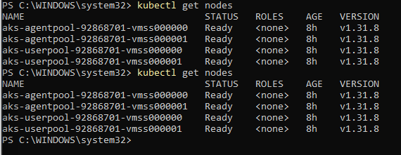
This is what we have deployed it till now

we have two node pools: agentpool and userpool
- Each pool has 2 nodes and is built on VMSS (since the names have vmss, i.e., Virtual Machine Scale Set)
This means we can enable cluster autoscaler on your existing AKS cluster without recreating it.

1. Enable autoscaler on a node pool
Choose one pool to enable (e.g., agentpool):
az aks nodepool update \
--resource-group myResourceGroup \
--cluster-name myAKSCluster \
--name agentpool \
--enable-cluster-autoscaler \
--min-count 2 \
--max-count 5
our autoscaler was enabled before formatting :

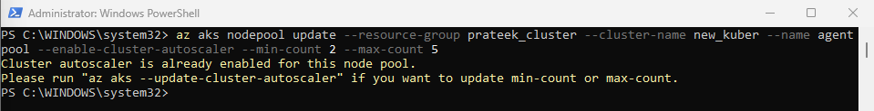
Check if autoscaler is enabled

az aks show --resource-group prateek_cluster --name new_kuber --query "agentPoolProfiles[].{Name:name, AutoScaling:enableAutoScaling, Min:minCount, Max:maxCount}" --output table

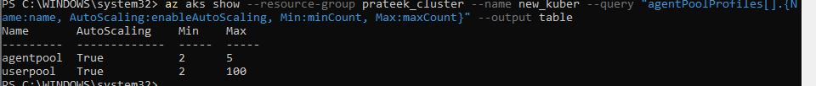

NOW LETS US UPGRADE THE CLUSTER IF NEEDED AND THE VERSIONS ARE AVAILABLE FOR THE SAME :

Step 1: Check Available Upgrade Versions
az aks get-upgrades --resource-group prateek_cluster --name new_kuber --output table

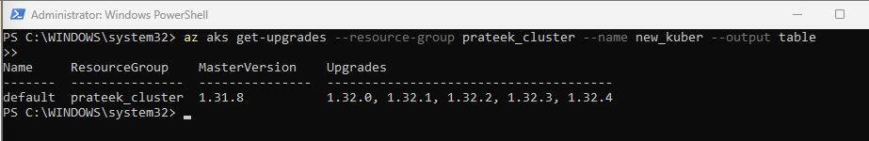
Step 2: Upgrade Your Cluster

az aks upgrade --resource-group prateek_cluster --name new_kuber --kubernetes-version 1.32.4 –yes

During upgrade:
- The control plane is upgraded first.
- Node pools are then cordoned and upgraded one by one.
- No data loss, but short downtime might happen.

In a real-world scenario like an e-commerce website during festive sales or flash deals (e.g., Flipkart Big Billion Days or Amazon Great Indian Festival), user traffic spikes drastically in a short time.
Using Cluster Autoscaler, the AKS cluster can automatically add more nodes to handle the surge in user requests, preventing app crashes or latency. Once traffic reduces, nodes scale down automatically — saving infrastructure cost.
On the other hand, upgrading the AKS cluster ensures that the platform runs on the latest Kubernetes version with enhanced security patches, better performance, and support for new features — which is critical for large-scale production systems where downtime or vulnerabilities could cause massive losses.
“A practical example is e-commerce platforms during flash sales, where autoscaling ensures reliability during peak loads, and cluster upgrades provide long-term security and performance in production ”

