Ques 1 : Deploy Replica Set and Replication Controller, and deployment. Also learn the advantages and disadvantages of each.

SOLN:
FIRST WE WILL DEPLOY THESE USING BASIC KUBERNETES LOCAL CLUSTER AND TRY TO CONFIGURE THE
1> REPLICATION CONTROLLER
2> REPLICA SET
3> DEPLOYMENT

Steps to Deploy ReplicationController, ReplicaSet & Deployment Using kubeadm Kubernetes Cluster :

Prerequisites
Ensure:
- You have 2 Linux VMs (Ubuntu preferred) — 1 master + 1 worker
- kubeadm, kubelet, kubectl, docker/containerd are installed
SO LETS GO WITH THE INSTALLATIONS :
COMMANDS I HAVE WRITTEN DOWN HERE FOR THE FULL INSTALLATIONS WE HAVE DONE IT IN ASSIGNMENT 5 FROM THE SRATCH

Kubernetes & Containerd Setup (All-in-One Script)

sudo apt update && sudo apt install -y apt-transport-https curl ca-certificates gnupg lsb-release && curl -fsSL https://packages.cloud.google.com/apt/doc/apt-key.gpg | sudo gpg --dearmor -o /usr/share/keyrings/kubernetes-archive-keyring.gpg && echo "deb [signed-by=/usr/share/keyrings/kubernetes-archive-keyring.gpg] https://apt.kubernetes.io/ kubernetes-xenial main" | sudo tee /etc/apt/sources.list.d/kubernetes.list && sudo apt update && sudo apt install -y kubelet kubeadm kubectl containerd && sudo apt-mark hold kubelet kubeadm kubectl

🔧 After that, configure containerd (required):
sudo mkdir -p /etc/containerd && containerd config default | sudo tee /etc/containerd/config.toml > /dev/null && sudo systemctl restart containerd && sudo systemctl enable containerd

Local Kubernetes Setup (kubeadm)

1️ Initial Setup on Master Node
sudo kubeadm init –pod-network-cidr=192.168.0.0/16

2️ Configure kubectl for Master

mkdir -p $HOME/.kube
sudo cp /etc/kubernetes/admin.conf $HOME/.kube/config
sudo chown $(id -u):$(id -g) $HOME/.kube/config

3 Install Pod Network (e.g., Calico or Flannel)
kubectlapply-f https://raw.githubusercontent.com/projectcalico/calico/v3.26.1/manifests/calico.yaml

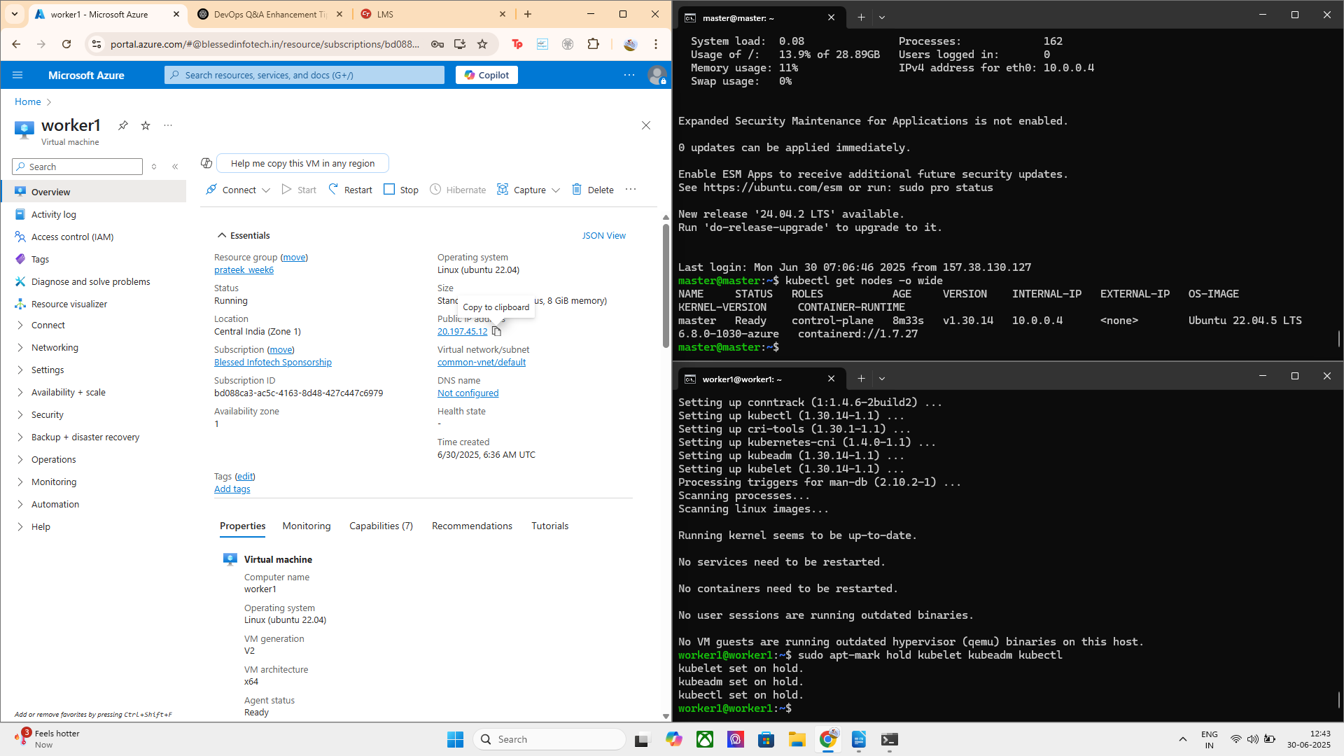

Join Worker Node to Cluster
sudo kubeadm join <master-ip>:6443 --token <token> --discovery-token-ca-cert-hash sha256:<hash>

kubectl get nodes
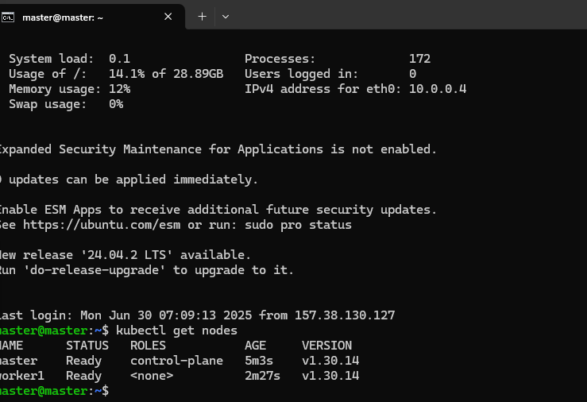
kubectl get pods -A

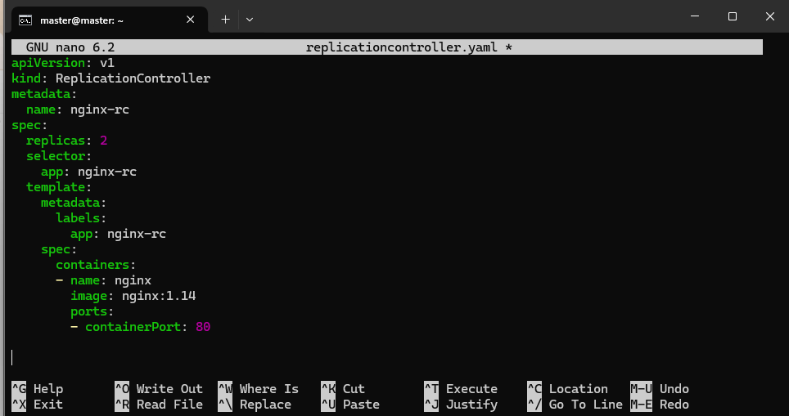

master@master:~$ kubectl apply -f replicationcontroller.yaml --validate=false
replicationcontroller/nginx-rc created

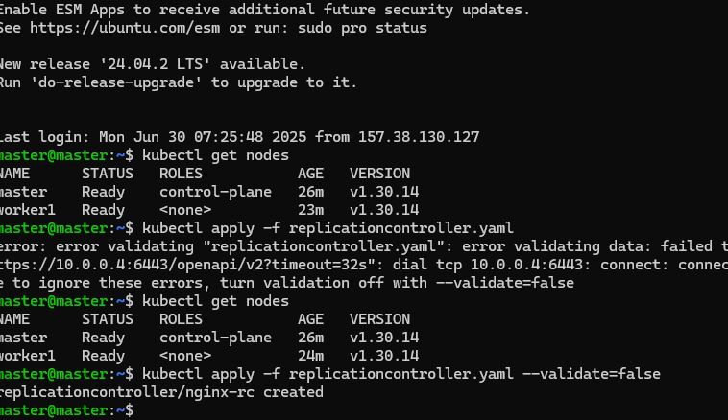

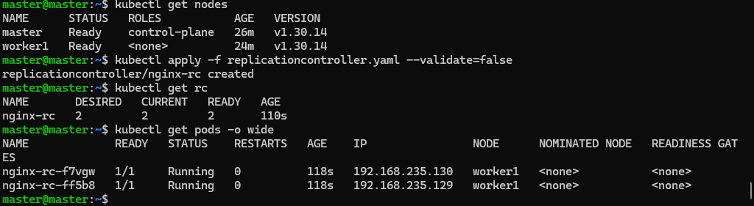

Deploy Your Application

1. ReplicationController

kubectl apply -f replicationcontroller.yaml

2. ReplicaSet

kubectl apply -f replicaset.yaml

3. Deployment

kubectl apply -f deployment.yaml

4. Service

kubectl apply -f service.yaml

Step-by-Step: Create & Deploy ReplicaSet

📝 1. Create a file called replicaset.yaml
In your terminal:

nano replicaset.yaml
Paste the following content:
yaml
CopyEdit
apiVersion: apps/v1
kind: ReplicaSet
metadata:
name: nginx-rs
labels:
app: nginx
spec:
replicas: 2
selector:
matchLabels:
app: nginx
template:
metadata:
labels:
app: nginx
spec:
containers:
- name: nginx
image: nginx:latest
ports:
- containerPort: 80
Save and exit:
- Press Ctrl + O, then Enter to save
- Press Ctrl + X to exit

2. Apply the ReplicaSet

kubectl apply -f replicaset.yaml

3. Confirm it’s Running

kubectl get rs
kubectl get pods -l app=nginx
This should show 2 pods created by the ReplicaSet.

4. Bonus (Optional): Delete one pod an

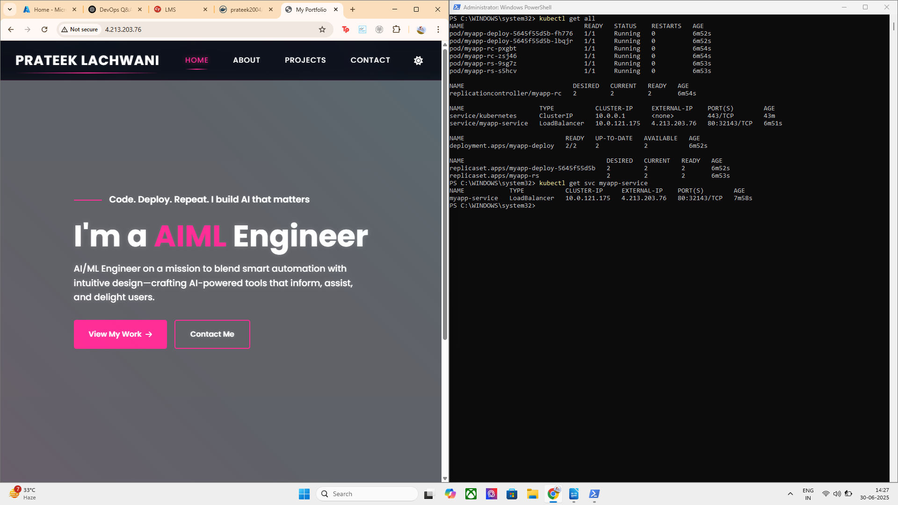

Lets configure the same using cloud native development :

Using AKS ( Azure Kubernetes services ):

FIRST CREATE A AKS CLUSTER USING AZURE PORTAL AND THE CONFIGURATIONS AS GIVEN BELOW :

THEN

1. Connect to AKS Cluster

command used = az aks get-credentials --resource-group <your-resource-group> --name <your-cluster-name>
kubectl get nodes # Confirm connection

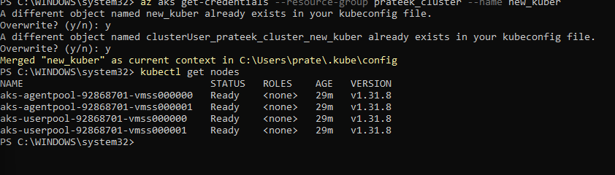

2. Package Your App into a Docker Image

THAT I ALREADY HAD YOU CAN ALSO ACCESS THE IMAGE AT THIS

3. Write 3 Separate YAML Files

a. ReplicationController YAML

@"
apiVersion: v1
kind: ReplicationController
metadata:
name: myapp-rc
spec:
replicas: 2
selector:
app: myapp
template:
metadata:
labels:
app: myapp
spec:
containers:
- name: myapp-container
image: prateek2004/my-frontend
ports:
- containerPort: 80
"@ | Out-File -Encoding UTF8 -FilePath .\replicationcontroller.yaml
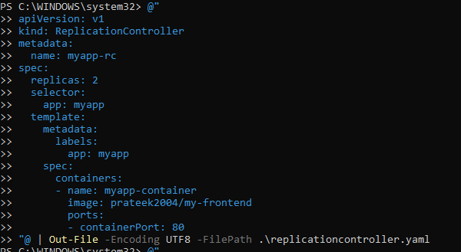

B. ReplicaSet YAML

@"
apiVersion: apps/v1
kind: ReplicaSet
metadata:
name: myapp-rs
spec:
replicas: 2
selector:
matchLabels:
app: myapp
template:
metadata:
labels:
app: myapp
spec:
containers:
- name: myapp-container
image: prateek2004/my-frontend
ports:
- containerPort: 80
"@ | Out-File -Encoding UTF8 -FilePath .\replicaset.yaml

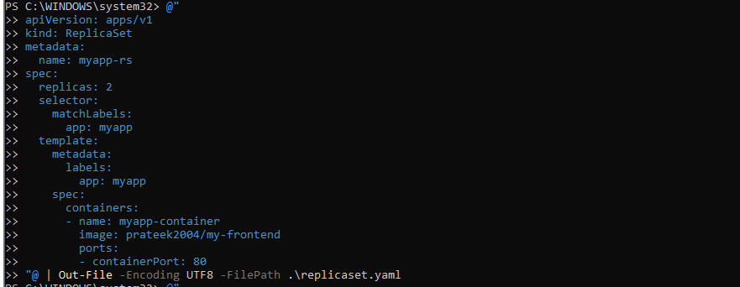

C. Deployment YAML

@"
apiVersion: apps/v1
kind: Deployment
metadata:
name: myapp-deploy
spec:
replicas: 2
selector:
matchLabels:
app: myapp
template:
metadata:
labels:
app: myapp
spec:
containers:
- name: myapp-container
image: prateek2004/my-frontend
ports:
- containerPort: 80
"@ | Out-File -Encoding UTF8 -FilePath .\deployment.yaml

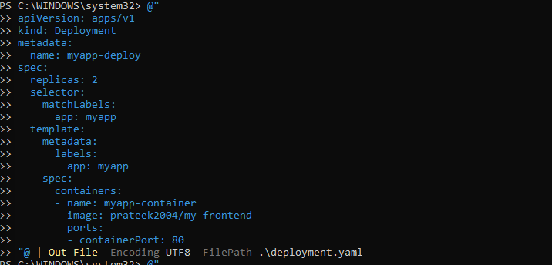

NOW LETS ALSO CREATE A SERVICE CONFIGURATION FOR THE SAME DEPLOYMENT TO VISIBLE A PUBLIC IP :

Service YAML

@"
apiVersion: v1
kind: Service
metadata:
name: myapp-service
spec:
selector:
app: myapp
type: LoadBalancer
ports:
- port: 80
targetPort: 80
"@ | Out-File -Encoding UTF8 -FilePath .\service.yaml

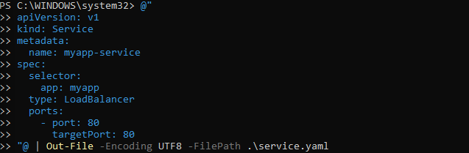
Apply Files to AKS :

command used :
kubectl apply -f .\replicationcontroller.yaml
kubectl apply -f .\replicaset.yaml
kubectl apply -f .\deployment.yaml
kubectl apply -f .\service.yaml

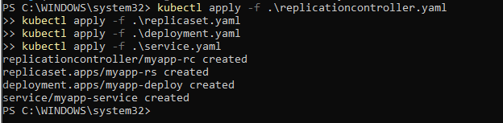

Next Steps: Verify the Setup

1. ✅ Check All Resources
kubectl get all
EVERYTHING UPTO THE POINT :
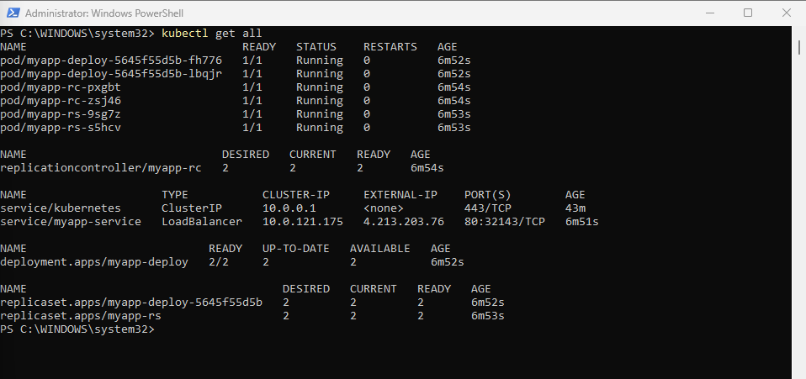

YOU CAN GET THE SERVICE USING :

kubectl get svc myapp-service

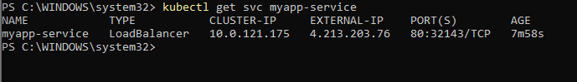
URL: http://4.213.203.76 it can be accessed on the web

Recap of What We’ve Done:
Component | Status | Description
ReplicationController | ✅ Created | Manages legacy pods (less commonly used now)
ReplicaSet | ✅ Created | Modern controller ensuring fixed number of identical pods
Deployment | ✅ Created | Manages rollout, updates, rollback over ReplicaSets
Service | ✅ LoadBalancer | Exposes app to the internet
Docker Image | ✅ prateek2004/my-frontend | custom personal web app

Advantages and Disadvantages

Controller Type | Advantages | Disadvantages
ReplicationController | - Ensures desired pod count- Was Kubernetes' first controller | - Deprecated for most use-cases- No rolling updates or rollback
ReplicaSet | - Ensures desired number of pods- Supports label-based selection | - Doesn’t support rollbacks or declarative updates on its own
Deployment | - Built on top of ReplicaSet- Supports rolling updates, rollback, pause/resume- Most widely used in real-world | - Slightly more complex YAML structure

To check the use case and behavior of each controller — ReplicationController, ReplicaSet, and Deployment (manager) — here’s how you can observe, test, and differentiate them practically

1. Check Which Pod Was Created by Which Controller

kubectl get pods –show-labels
kubectl describe pod <pod-name>
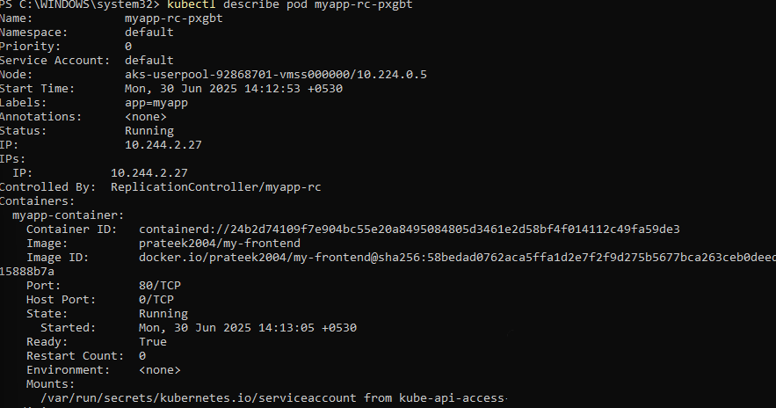
HENCE In the description, check the Controlled By section:
- If it says ReplicationController, the pod was managed by it.
- If it says ReplicaSet, same logic.
- For Deployment, it will show Deployment → ReplicaSet → Pods.
SO HERE ITS BY REPLICATION CONTROLLER

2. LETS Simulate a Pod Failure

Manually delete a pod and observe:

kubectl delete pod <pod-name>
Now check:

kubectl get pods

You’ll see that the controller automatically recreates the deleted pod.
This demonstrates the self-healing use case.

myapp-rc-pdnb9 1/1 Running 0 18s

REGENERATED 18SECS BEFORE SHOWING SELF HEAL PROPERTY

3. Check Ownership and Hierarchy

kubectl get rs
kubectl describe rs <replicaset-name>

You’ll see:
- If a ReplicaSet is created by a Deployment, it says so in "Controlled By".
- If it’s standalone, it has no owner — useful when comparing RS vs Deployment.
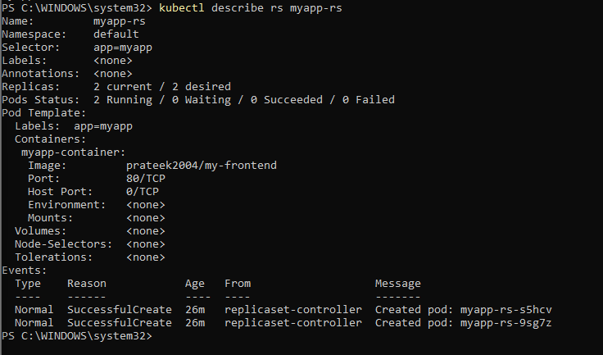

4. Try a Rolling Update (Deployment Only)

kubectl set image deployment/myapp-deploy myapp-container=nginx

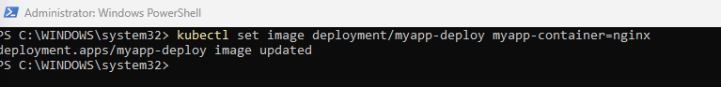
NOW CHECK:
kubectl rollout status deployment/myapp-deploy

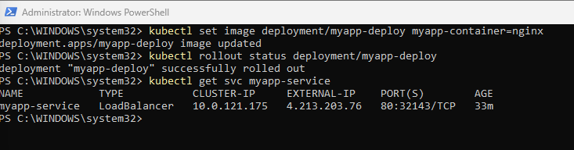

Visit the EXTERNAL-IP — you’ll now see the NGINX welcome page

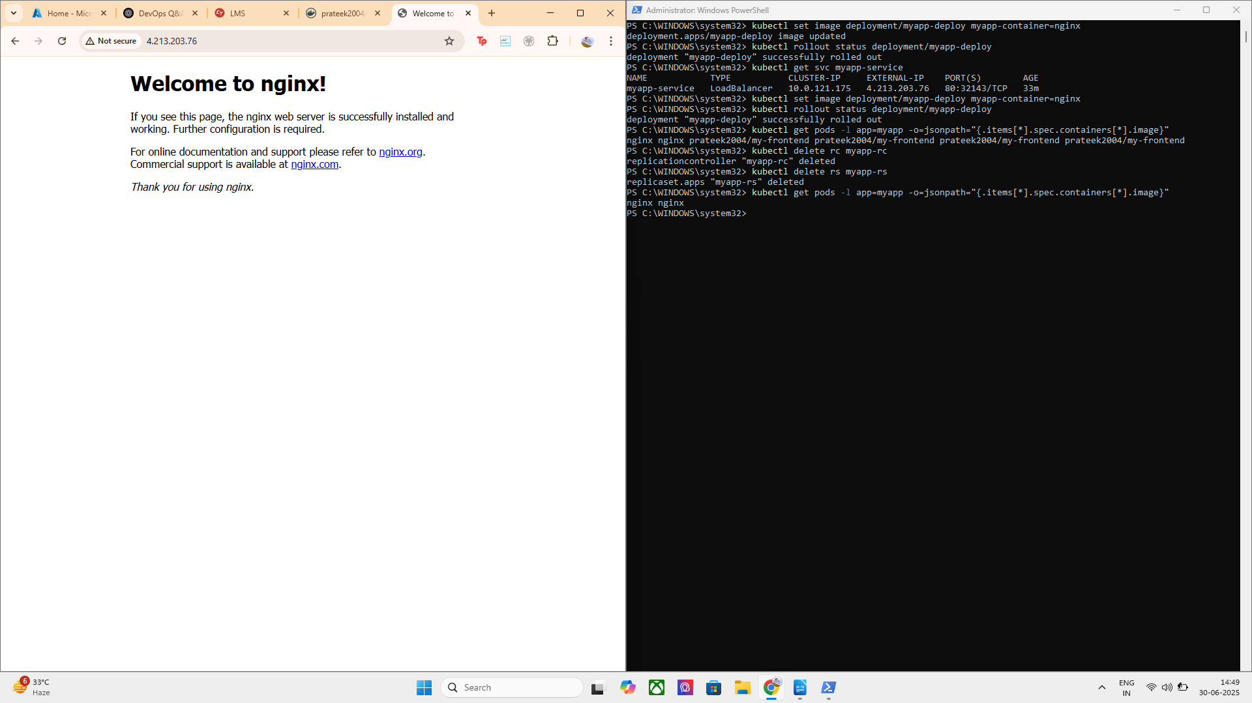

ROLLED AGAIN TO ORIGINAL:

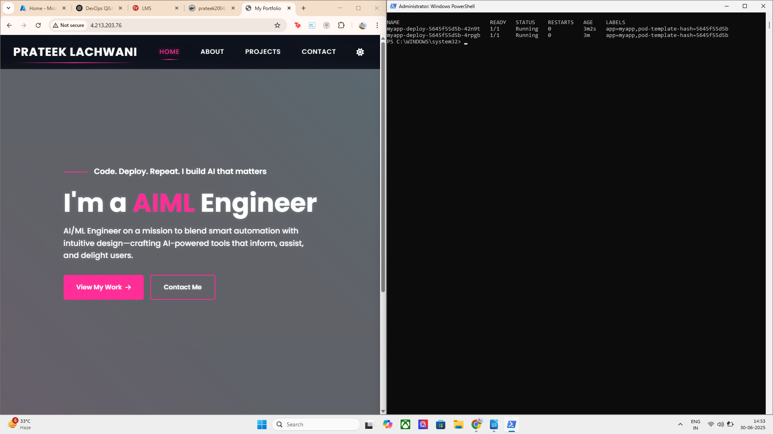

In this task, I deployed a ReplicationController, a ReplicaSet, and a Deployment in Azure Kubernetes Service (AKS) to manage my custom web application hosted on Docker Hub (prateek2004/my-frontend).
Each of these ensures high availability by maintaining multiple replicas (2 pods) of the application.
I used YAML files to define and apply all three controllers, and exposed them via a LoadBalancer Service for external access.
I also performed a rolling update on the Deployment to test seamless version changes (from my image to nginx and back).
To verify, I checked pod health, ReplicaSets, rollout history, and container images using various kubectl commands.
In addition, I learned the ownership difference between RC, RS, and Deployment, and how Deployment provides better lifecycle and update management

ExtraS :
- Switched from self-hosted kubeadm to Azure AKS due to reliability.
- Created Docker image of a personal project and hosted on Docker Hub.
- Understood and compared the behaviors of ReplicaSet vs ReplicationController vs Deployment.
- Used kubectl get, set image, rollout status, and describe for deeper insights.
- Created a LoadBalancer-type service to make the app publicly accessible.

