QUES 3 : PersistentVolume (PV) and PersistentVolumeClaim (PVC)

SOLN:

In Kubernetes, a PersistentVolume (PV) is a piece of storage in the cluster that has been provisioned by an admin or dynamically provisioned using StorageClasses. A PersistentVolumeClaim (PVC) is a request for that storage by a user. This mechanism allows containers to store data persistently, even across pod restarts or rescheduling.

In simple words, PersistentVolume (PV) is like a hard disk that's kept aside for use in your Kubernetes system. And PersistentVolumeClaim (PVC) is like a request your app makes saying, "Hey, I need some space to store my data."
Normally, when a pod stops or restarts, it loses all its data. But when you use PV and PVC, your app gets permanent storage — like saving your files on a pen drive instead of RAM, so they don’t get lost.

In the previous tasks (Q1 & Q2), I successfully deployed a sample application (myapp-deploy) and exposed it via a Kubernetes service. Now, in this task (Q3), I am implementing persistent storage using PersistentVolume (PV) and PersistentVolumeClaim (PVC) to ensure the application can store and retain data even if the pod restarts or gets rescheduled.

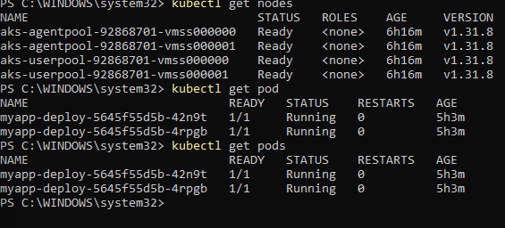
ALL THE DEPLOYMENTS ARE WORKING FINE

LETS CREATE A YAML FILE TO CONFIGURE PV & PVC FOR THE PROJECT:

pv-pvc.yaml

apiVersion: v1
kind: PersistentVolume
metadata:
name: my-pv
spec:
capacity:
storage: 1Gi
accessModes:
- ReadWriteOnce
storageClassName: manual
hostPath:
path: "/mnt/data" # For demo/testing only
---
apiVersion: v1
kind: PersistentVolumeClaim
metadata:
name: my-pvc
spec:
accessModes:
- ReadWriteOnce
storageClassName: manual
resources:
requests:
storage: 1Gi

lets apply it :

kubectl apply -f pv-pvc.yaml
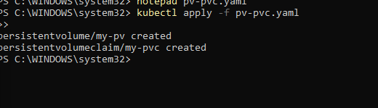
PVC AND PV HAS BEEN SUCCESSFULLY CREATED

LETS TRY TO MOUNT THESE PVC AND PV TO OUR PREVIOUS BUILT DEPLOYMENT

STEP : MODIFY THE DEPLOYMENT.YAML FILE

apiVersion: apps/v1
kind: Deployment
metadata:
name: myapp-deploy
spec:
replicas: 2
selector:
matchLabels:
app: myapp
template:
metadata:
labels:
app: myapp
spec:
containers:
- name: myapp-container
image: prateek2004/my-frontend
ports:
- containerPort: 80
volumeMounts:
- name: app-storage
mountPath: /app/data # ✅ You can change this to wherever your app writes files
volumes:
- name: app-storage
persistentVolumeClaim:
claimName: my-pvc

NOTE:

volumeMounts tells your container to use storage inside the container at /app/data.
- volumes connects the PVC (my-pvc) to the pod.
- You can change /app/data to wherever your frontend app writes data (like user uploads, logs, etc.).

Save and close.
- Then reapply it:

kubectl apply -f deployment.yaml
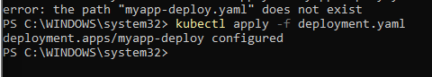

Verify It Worked:

kubectl get pods

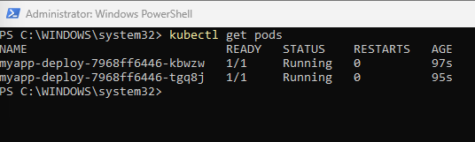
kubectl describe pod <your-pod-name>

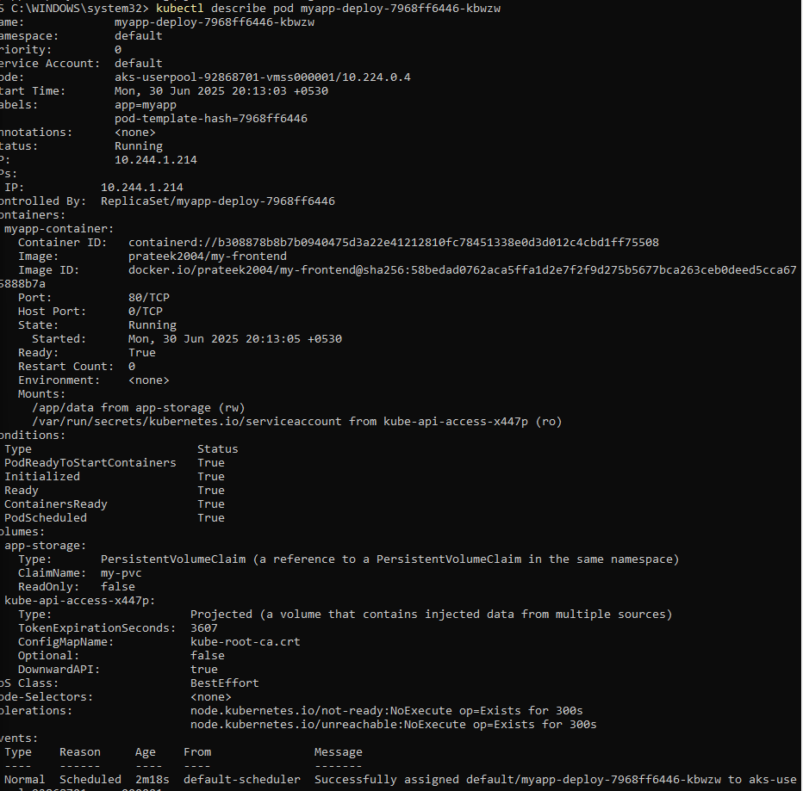
. we can see a successfull mount

kubectl exec -it <your-pod-name> -- sh

ls /app/data
echo "Testing PVC connection" > /app/data/test.txt
cat /app/data/test.txt

HENCE ITS SUCCESSFULLY VERIFIED AND TESTED:

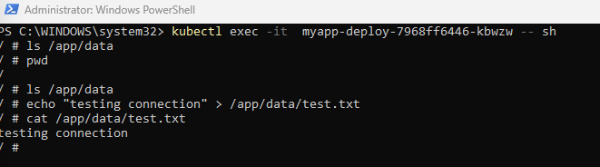

In real-world applications, PersistentVolumes and PersistentVolumeClaims are used wherever long-term storage is required — such as databases (MySQL, MongoDB), file upload systems, media platforms, and content management systems like WordPress. Without persistent storage, all application data would be lost every time a pod is recreated or updated.

