**Fire Alert System**

**INTRODUCTION**

Fire Alert Systems are quite popular in commercial buildings and industries. These devices typically have a cluster of sensors that continuously monitor for any flame, gas, or fire in the structure and activate an alarm if any of these are detected. An IR Flame sensor, which has an IR photodiode that is sensitive to IR light, is one of the easiest ways to detect fire. Now, in the event of a fire, the fire will not only create heat but will also release IR rays; yes, every burning flame will emit some degree of IR light; this light is not visible to the naked eye, but our flame sensor can detect it and signal a microcontroller such as Arduino that a fire has occurred.

**Softwares Used**

* Visual Studio

* SimulIDE

* Aurdino IDE

**Component Description**

* Power Supply:

- External source of power supply that powers all devices, switches and microcontroller

* Microcontroller:

- Performs all operations required by our system. Takes input the signals from the Potentiometer and gives output by turning on the LED and BUZZER

* Flame Sensor

- A flame detector is a sensor designed to detect and respond to the presence of a flame or fire.

* Potentiometer

- A potentiometer is a type of position sensor. They are used to measure displacement in any direction. Linear potentiometers linearly measure displacement and rotary potentiometers measure rotational displacement. In this case Potentiometer is used as Flame sensor

* LED

- Receives signals from the potentiometer used as Flame Sensor and turn on when fire is detected

* Buzzer

- Acts as a device to communicate with the user when fire is detected

## High Level Requirements-

|  |  |  |
| --- | --- | --- |
| **ID** | **Description** | **Status** |
| HL01 | To detect fire | Implemented |
| HL02 | To provide warning in form of sound with help of Buzzer and Indicate using LED | Implemented |
|  |  |  |

## Low Level Requirements

|  |  |  |
| --- | --- | --- |
| **ID** | **DESCRIPTION** | **STATUS** |
| LLR1 | To provide warning in form of sound with help of Buzzer and Indicate using LED | IMPLEMENTED |
| LLR2 | Interface LED With Arduino uno | IMPLEMENTED |
| LLR3 | Interface Buzzer with Arduino Uno | IMPLEMENTED |
|  |  |  |

**System Architecture**

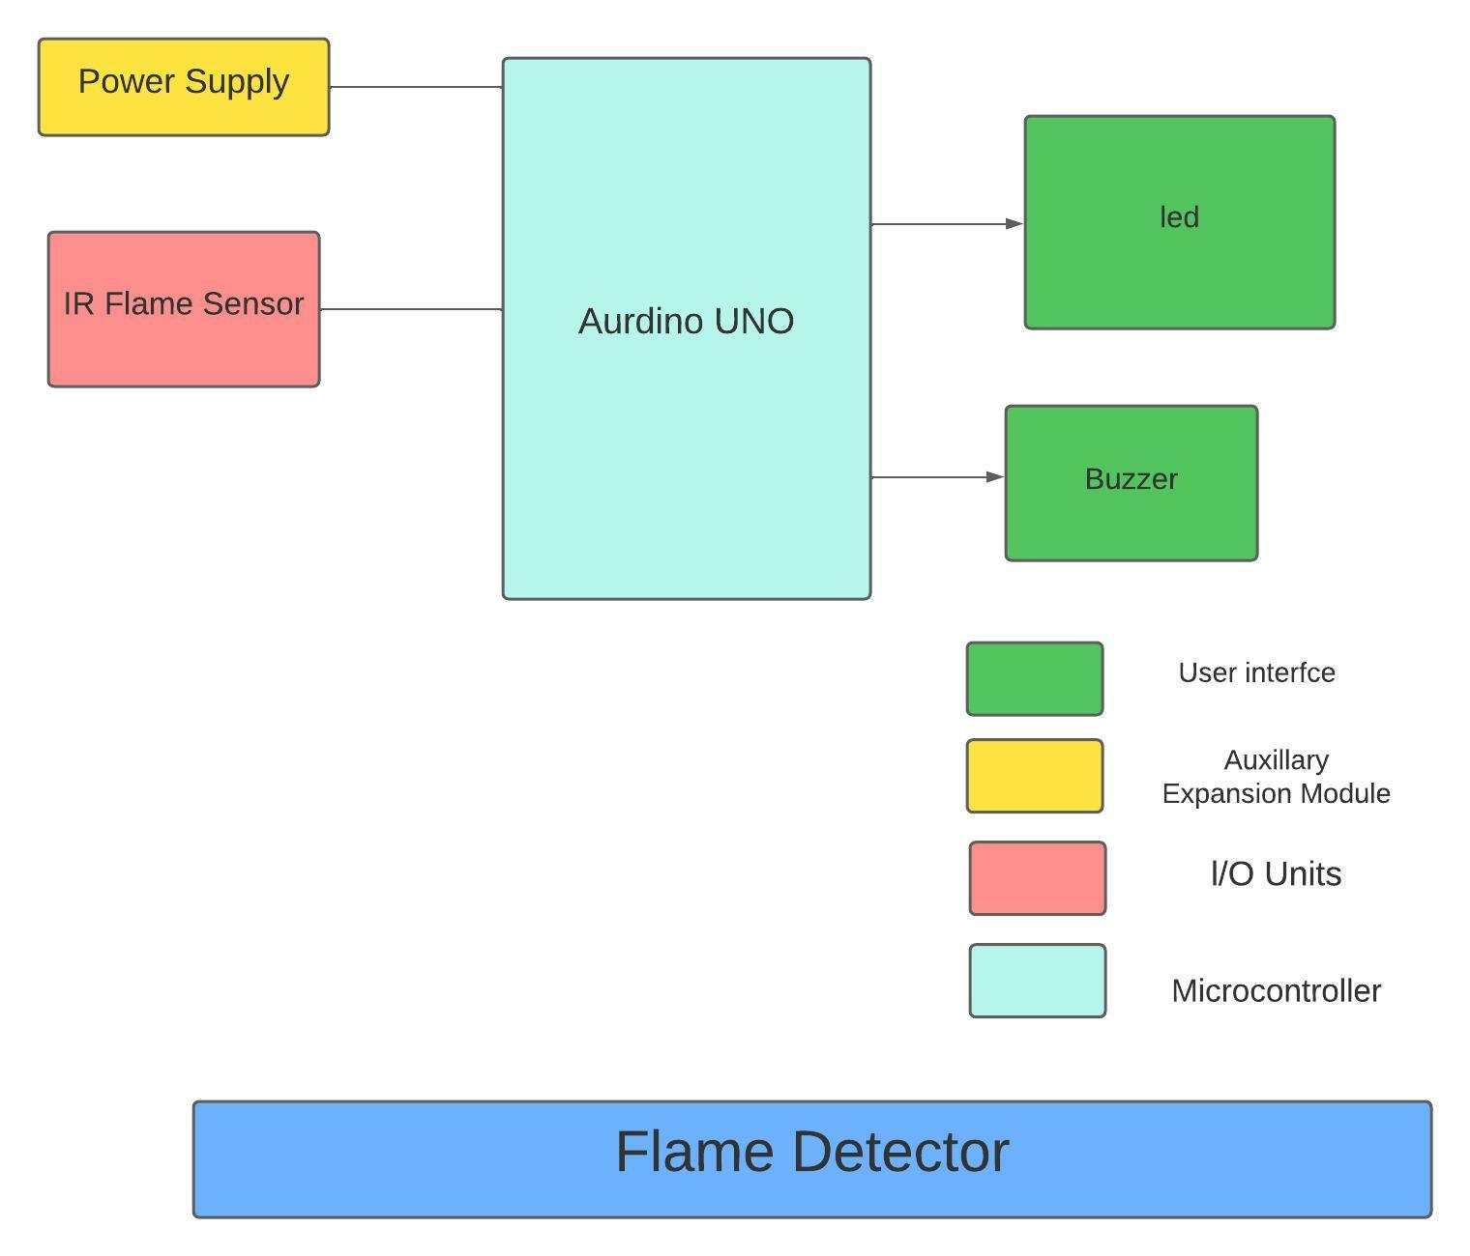

**Flowchart**

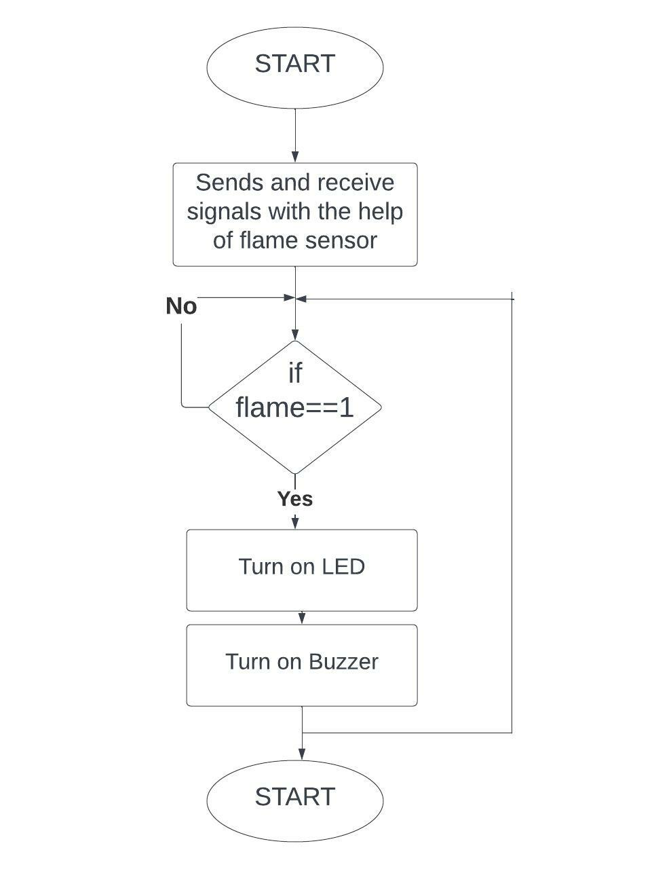

**Implementation (Power on and OFF)**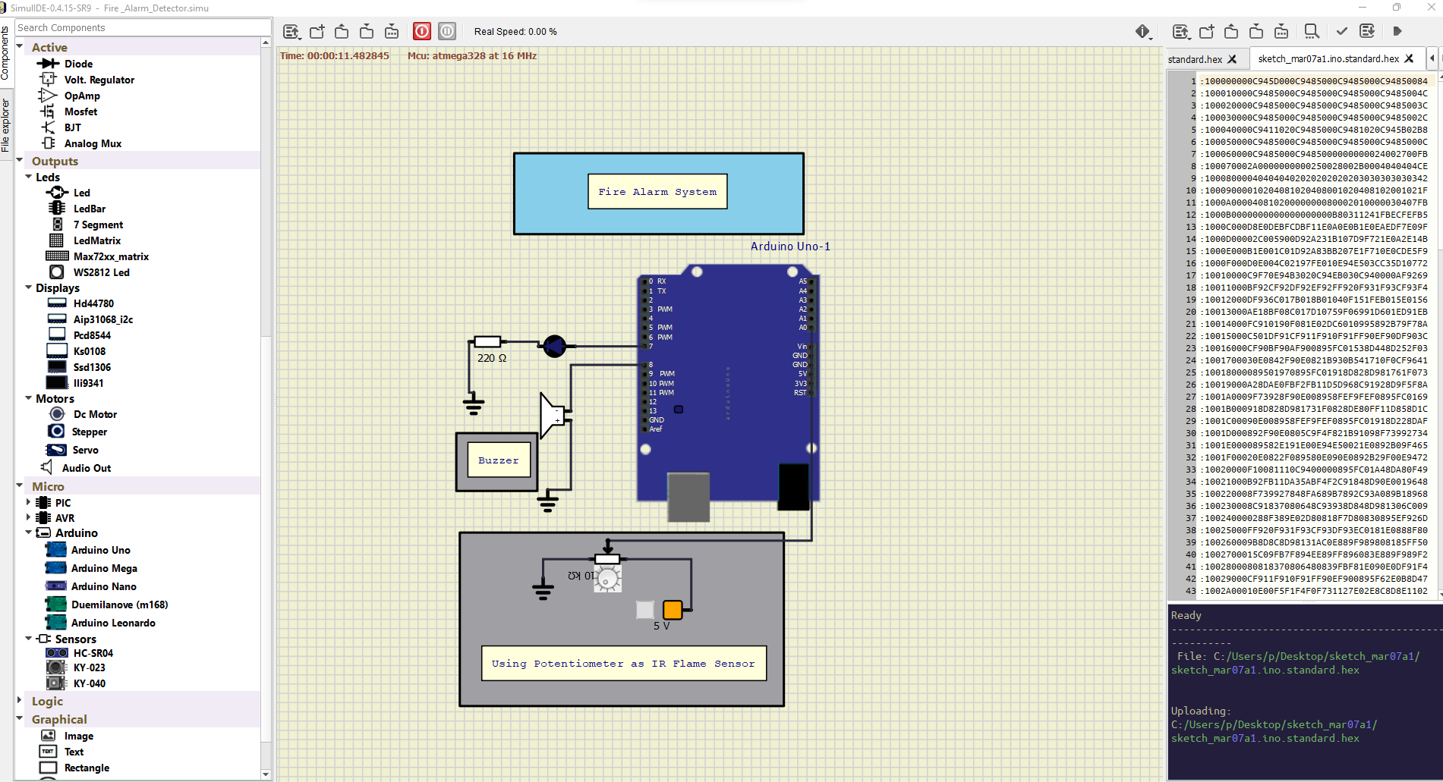

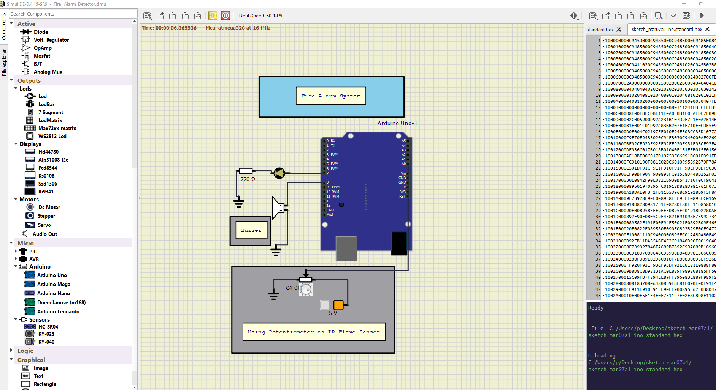

**Test And Outputs**

# DETAIL REQUIREMENTS

## Table no:1 High Level Requirements-

|  |  |  |  |  |  |
| --- | --- | --- | --- | --- | --- |
| **Test ID** | **Description** | **Exp I/P** | **ExpO/P** | **Actual Output** | **Type Of Test** |
| H_01 | Integrate Potentiometer (as Flame Sensor) with Microcontroller | None | successful Integration | Successful Integration | Requirement based |
| H_02 | Integrate Buzzer with Microcontroller | None | Successful Integration | Successful Integration | Requirement based |
| H_03 | Integrate LED with Microcontroller | None | Successful Integration | Successful Integration | Requirement based |

## Table no:2 Low Level Requirements-

|  |  |  |  |  |  |
| --- | --- | --- | --- | --- | --- |
| **Test ID** | **Description** | **Exp I/P** | **ExpO/P** | **Actual Output** | **Type Of Test** |
| L_01 | Use Potentiometer (as Flame Sensor) to give input to the Aurdino | **-** | **-** | **-** | Requirement based |
| L_02 | Detect Fire infront of the sensor | For simulation : Expected input for Flame sensor is given with help of potentiometer | LED Turns on | LED Turns on | Requirement based |
| L_03 | To power the buzzer if fire is detected close to the sensor | Fire is detected close to the sensor | Buzzer sound | Buzzer Sound | Requirement based |