**NAME : PRATEEK RAJ**

**CSE 12**

**ASSIGNMENT 3**

**WT**

Q1:- 1.Draw a circle by four different color of arc using applet in Java.

CODE

import java.awt.Color; import java.awt.Color;

import java.awt.Graphics;

import java.applet.Applet;

public class circle extends Applet

{

public void paint(Graphics g)

{

int diameter = 600;

int x = (getWidth() - diameter) / 2;

int y = (getHeight() - diameter) / 2;

g.setColor(Color.BLACK);

g.drawOval(x, y, diameter, diameter);

g.setColor(Color.blue);

g.fillArc(x, y, diameter, diameter, 0, 90);

g.setColor(Color.red);

g.fillArc(x, y, diameter, diameter, 90, 90);

g.setColor(Color.orange);

g.fillArc(x, y, diameter, diameter, 180, 90);

g.setColor(Color.black);

g.fillArc(x, y, diameter, diameter, 270, 90);

}

}

/*

<html>

<head>

</head>

<body>

<applet code = "circle.class" width = "320" height = "480"></applet>

</body>

</html>*/

OUTPUT:

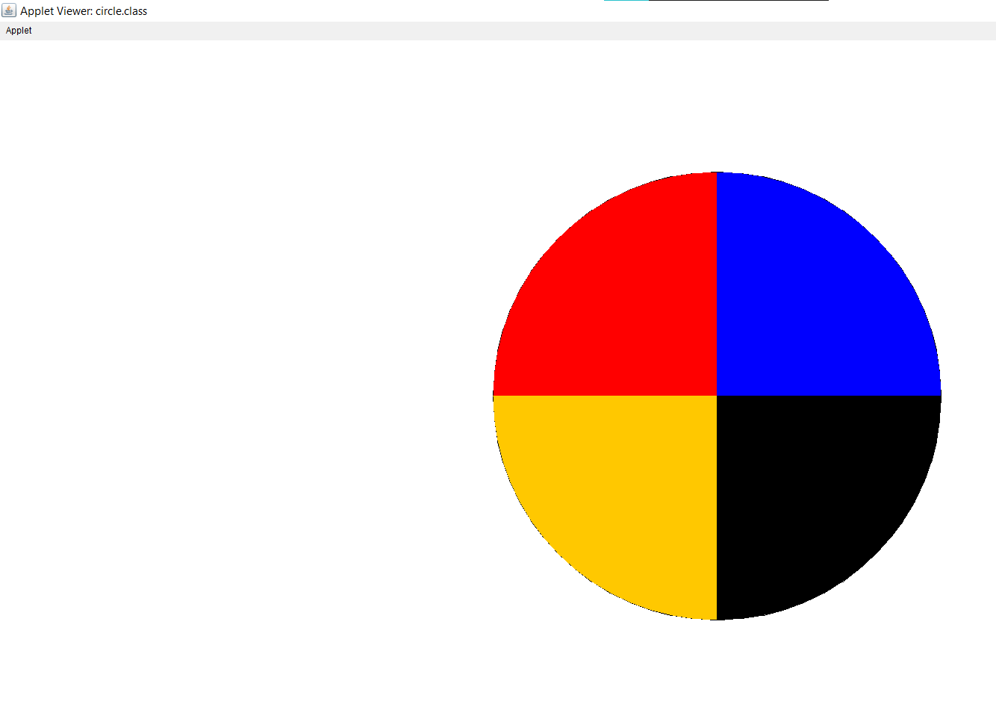

Q2 Write a java program that uses the draw Polygon() method of

Graphics class to draw a triangle with endpoints (25,30),( 75,80)

and (50,50).

CODE:

import java.awt.Graphics;

import javax.swing.JFrame;

import javax.swing.JPanel;

public class triangle extends JPanel {

public void paintComponent(Graphics g) {

super.paintComponent(g);

int[] x = {25, 75, 50};

int[] y = {30, 80, 50};

int side = 3;

g.drawPolygon(x, y, side);

}

public static void main(String[] args) {

JFrame frame = new JFrame("Triangle Drawing");

frame.setDefaultCloseOperation(JFrame.EXIT_ON_CLOSE);

frame.add(new triangle());

frame.setSize(200, 200);

frame.setVisible(true);

}

}

OUTPUT:

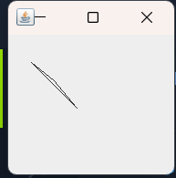

Q3:- Draw an Olympic symbol in java Applet.

CODE:

import java.awt.Color;

import java.awt.Graphics;

import java.util.concurrent.BlockingQueue;

import java.applet.Applet;

public class olympic extends Applet {

public void paint(Graphics g) {

setBackground(Color.WHITE);

g.setColor(Color.BLACK);

g.setColor(Color.blue);

g.drawOval(50, 50, 100, 100);

g.setColor(Color.black);

g.drawOval(150, 50, 100, 100);

g.setColor(Color.red);

g.drawOval(250, 50, 100, 100);

g.setColor(Color.yellow);

g.drawOval(100, 100, 100, 100);

g.setColor(Color.green);

g.drawOval(200, 100, 100, 100);

}

}

/*<html>

<head>

</head>

<body>

<applet code = "olympic.class" width = "320" height = "480"></applet>

</body>

</html>*/

OUTPUT:

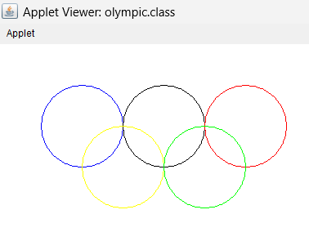

Q4: Draw Smiling Face in java Applet.

CODE:

import java.applet.*;

import java.awt.*;

public class smile extends Applet {

public void paint(Graphics g) {

g.setColor(Color.yellow);

g.fillOval(50,50,200,200);

g.setColor(Color.black);

g.fillOval(100, 100, 20, 20);

g.fillOval(180, 100, 20, 20);

g.fillArc(90, 150, 120, 50, 0, -180);

}

}

/*

<html>

<head>

</head>

<body>

<applet code = "smile.class" width = "320" height = "480"></applet>

</body>

</html>*/

OUTPUT:

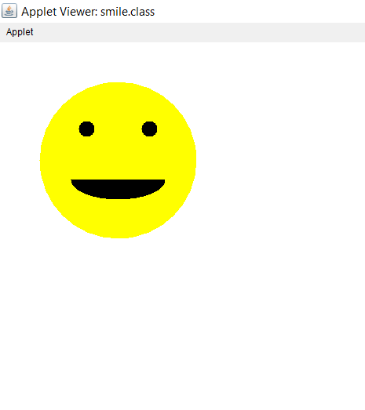

Q5: Draw the bellow figure in java Applet.

CODE:

import java.awt.Color;

import java.awt.Graphics;

import java.applet.Applet;

public class pacman extends Applet {

public void paint(Graphics g) {

int x = getWidth() / 2;

int y = getHeight() / 2;

int diameter = Math.min(getWidth(), getHeight()) / 2;

g.setColor(Color.gray);

g.fillArc(x - diameter, y - diameter, diameter * 2, diameter * 2, 30, 300);

}

}

/*<html>

<head>

</head>

<body>

<applet code = "pacman.class" width = "320" height = "480"></applet>

</body>

</html>*/

OUTPUT:

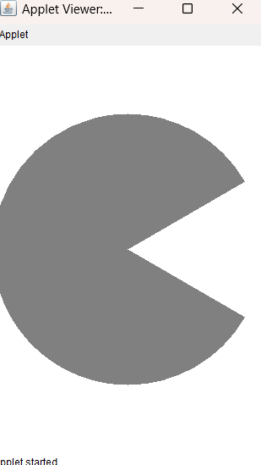

Q6: Java code o draw the following diagram

CODE:

import java.applet.Applet;

import java.awt.*;

public class q6 extends Applet{

public void paint(Graphics g) {

g.setColor(Color.blue);

g.fillArc(30, 50, 80, 80, 0, -180);

g.fillArc(30+80, 50, 80, 80, 0, +180);

g.fillArc(30+160, 50, 80, 80, 0, -180);

g.fillArc(30+240, 50, 80, 80, 0, +180);

}

}

/*<html>

<head>

</head>

<body>

<applet code = "q6.class" width = "320" height = "480"></applet>

</body>

</html>*/

OUTPUT:

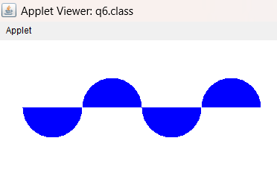

Q7: DRAW THE DIAGRAM USING APPLET

CODE:

import java.applet.Applet;

import java.awt.*;

public class q7 extends Applet {

public void paint(Graphics g) {

g.setColor(Color.black);

g.fillArc(50, 50, 100, 100, 0, 360);

g.setColor(getBackground());

g.fillArc(75, 75, 50, 50, 0, 360);

}

}

/*<html>

<head>

</head>

<body>

<applet code = "q7.class" width = "320" height = "480"></applet>

</body>

</html>*/

OUTPUT:

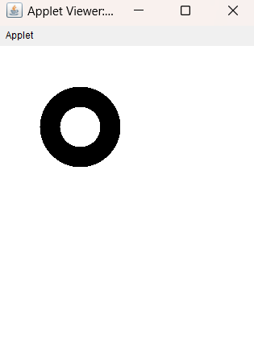

Q8:WRITE APPLET CODE TO DRAW THE DIAGRAM

CODE: import java.applet.Applet;

import java.awt.*;

public class q8 extends Applet {

public void paint(Graphics g) {

g.setColor(Color.yellow);

g.fillArc(200, 30, 30, 80, 0, 360);

g.setColor(Color.red);

g.fillArc(200, 80, 80, 30, 0, 360);

g.setColor(Color.pink);

g.fillArc(150, 80, 80, 30, 0, 360);

g.setColor(Color.orange);

g.fillArc(200, 80, 30, 80, 0, 360);

g.setColor(getBackground());

g.fillArc(200, 80, 30, 30, 0, 360);

}

}

/*<html>

<head>

</head>

<body>

<applet code = "q8.class" width = "320" height = "480"></applet>

</body>

</html>*/

OUTPUT:

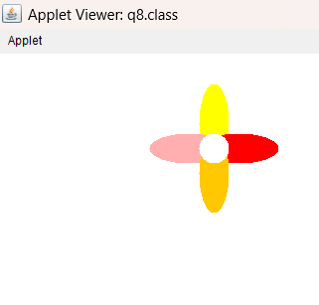

Q9: Draw the diagram

CODE:

import java.awt.Color;

import java.awt.Graphics;

import java.applet.Applet;

public class rect extends Applet {

public void paint(Graphics g) {

int x = 1000 / 2;

int y = 600 / 2;

int size = Math.min(2000, 1200) / 2;

int width = size / 2;

int height = size / 4;

g.setColor(Color.RED);

g.fillRect(x - width / 2, y - height / 2, width, height);

g.setColor(Color.BLUE);

int diameter = Math.min(width, height) * 3 / 4;

int circleX = x - diameter / 2;

int circleY = y - diameter / 2;

g.fillOval(circleX, circleY, diameter, diameter);

}

}

/*<html>

<head>

</head>

<body>

<applet code = "rect.class" width = "320" height = "480"></applet>

</body>

</html>*/

OUTPUT:

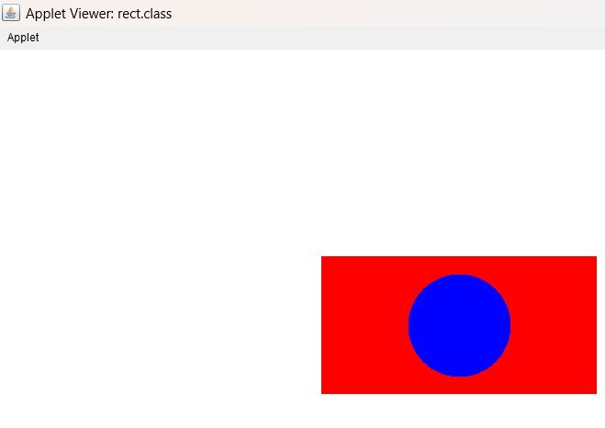

Q10: DRAW THE DIAGRAM:

CODE:

import java.awt.Color; import java.awt.Color;

import java.awt.Graphics;

import java.applet.Applet;

public class circle2 extends Applet

{

public void paint(Graphics g)

{

int diameter = 300;

int x = (getWidth() - diameter) / 2;

int y = (getHeight() - diameter) / 2;

g.setColor(Color.BLACK);

g.drawOval(x, y, diameter, diameter);

g.setColor(Color.blue);

g.fillArc(x, y, diameter, diameter, 0, 90);

g.setColor(Color.red);

g.fillArc(x, y, diameter, diameter, 90, 90);

g.setColor(Color.yellow);

g.fillArc(x, y, diameter, diameter, 180, 90);

g.setColor(Color.green);

g.fillArc(x, y, diameter, diameter, 270, 90);

}

}

/*

<html>

<head>

</head>

<body>

<applet code = "circle2.class" width = "320" height = "480"></applet>

</body>

</html>*/

OUTPUT:

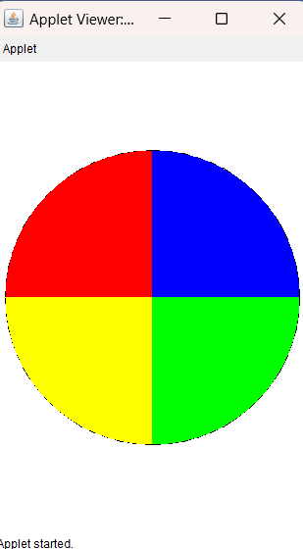

Q11: DRAW BELOW DIAGRAM USING APPLET

CODE:

import java.applet.Applet;

import java.awt.BasicStroke;

import java.awt.Color;

import java.awt.Graphics;

import java.awt.Graphics2D;

import java.awt.Stroke;

public class q11 extends Applet {

public void paint(Graphics g) {

Color[] colors = { Color.RED, Color.ORANGE, Color.YELLOW, Color.GREEN, Color.BLUE, Color.MAGENTA };

Graphics2D g2 = (Graphics2D) g;

g2.setStroke(new BasicStroke(12));

for (int i = 0;i<5;i++) {

g2.setColor(colors[i]);

g2.drawArc(30+(i*10), 30+(i*10), 200-(i*10), 100-(i*10), 180, -180);

}

}

}

/*<html>

<head>

</head>

<body>

<applet code = "q11.class" width = "320" height = "480"></applet>

</body>

</html>*/

OUTPUT:

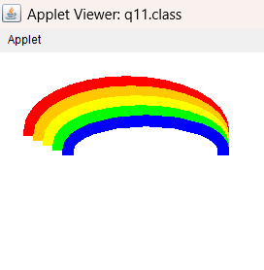

Q12 Draw the below diagram in java Applet.

CODE:

import java.applet.Applet;

import java.awt.*;

public class Q12 extends Applet {

public void paint(Graphics g) {

g.setColor(Color.blue);

g.fillOval(50, 150, 200, 200);

g.setColor(Color.red);

g.fillOval(50, 250, 200, 200);

}

}

/*<html>

<head>

</head>

<body>

<applet code = "Q12.class" width = "320" height = "480"></applet>

</body>

</html>*/

OUTPUT:

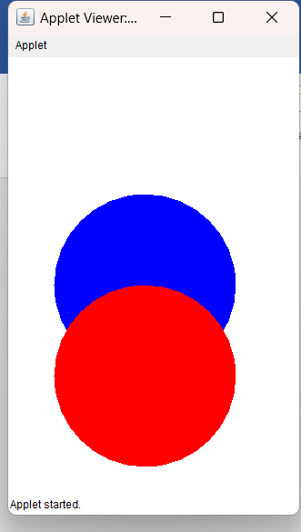

Q13 Draw the below diagram in java Applet.

CODE:

import java.applet.Applet;

import java.awt.*;

public class Q13 extends Applet {

public void paint(Graphics g) {

g.setColor(Color.red);

g.fillRect(50, 150, 300, 100);

g.setColor(Color.green);

g.fillOval(165, 100, 100, 100);

g.setColor(Color.blue);

g.fillOval(175, 175, 10, 10);

}

}

/*<html>

<head>

</head>

<body>

<applet code = "Q13.class" width = "320" height = "480"></applet>

</body>

</html>*/

OUTPUT:

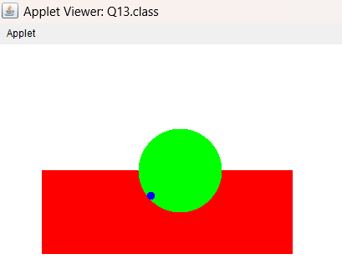

Q14: Draw polygon method to draw hexagon

CODE:

import java.awt.Graphics;

import javax.swing.JFrame;

import javax.swing.JPanel;

public class polygon extends JPanel {

public void paintComponent(Graphics g) {

super.paintComponent(g);

int[] x = { 100, 150, 200, 200, 150, 100 };

int[] y = { 100, 50, 100, 150, 200, 150 };

g.drawPolygon(x, y, 6);

}

public static void main(String[] args) {

JFrame frame = new JFrame("Hexagon");

frame.setDefaultCloseOperation(JFrame.EXIT_ON_CLOSE);

polygon hexagon = new polygon();

hexagon.setSize(300, 300);

frame.add(hexagon);

frame.pack();

frame.setVisible(true);

}

}

OUTPUT:

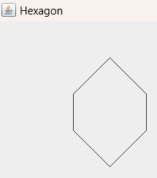

Q15 DRAW THE GIVEN DIAGRAM

CODE:

import java.applet.Applet;

import java.awt.*;

public class Q15 extends Applet {

public void paint(Graphics g) {

Graphics2D g2 = (Graphics2D) g;

g2.setStroke(new BasicStroke(3));

int[] x1 = {30, 30, 60};

int[] y1 = {100, 150, 125};

g2.drawPolygon(x1, y1, 3);

g2.setColor(Color.green);

g2.fillPolygon(x1, y1, 3);

g2.setColor(Color.black);

int[] x2 = {30, 60, 60};

int[] y2 = {150, 175, 125};

g2.drawPolygon(x2, y2, 3);

g2.setColor(Color.yellow);

g2.fillPolygon(x2, y2, 3);

g2.setColor(Color.black);

int[] x3 = {60, 90, 60};

int[] y3 = {175, 150, 125};

g2.drawPolygon(x3, y3, 3);

g2.setColor(Color.blue);

g2.fillPolygon(x3, y3, 3);

g2.setColor(Color.black);

int[] x4 = {90, 90, 60};

int[] y4 = {150, 100, 125};

g2.drawPolygon(x4, y4, 3);

g2.setColor(Color.green);

g2.fillPolygon(x4, y4, 3);

g2.setColor(Color.black);

int[] x5 = {90, 60, 60};

int[] y5 = {100, 70, 125};

g2.drawPolygon(x5, y5, 3);

g2.setColor(Color.yellow);

g2.fillPolygon(x5, y5, 3);

g2.setColor(Color.black);

int[] x6 = {60, 30, 60};

int[] y6 = {70, 100, 125};

g2.drawPolygon(x6, y6, 3);

g2.setColor(Color.red);

g2.fillPolygon(x6, y6, 3);

g2.setColor(Color.black);

}

}

/*<html>

<head>

</head>

<body>

<applet code = "Q15.class" width = "320" height = "480"></applet>

</body>

</html>*/

OUTPUT:

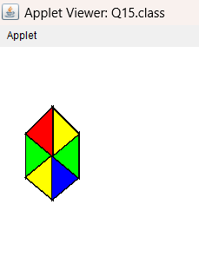

Q16 DRAW THE GIVEN DIAGRAM

CODE:

import java.applet.Applet;

import java.awt.*;

public class Q16 extends Applet {

public void paint(Graphics g) {

Graphics2D g2 = (Graphics2D) g;

g2.setStroke(new BasicStroke(5));

g2.setColor(Color.green);

g2.drawRoundRect(25, 30, 250, 100, 20, 20);

g2.setColor(Color.black);

g2.fillRoundRect(25, 30, 250, 100, 20, 20);

g2.setColor(Color.green);

g2.drawRoundRect(75, 65, 175, 50, 20, 20);

g2.setColor(Color.blue);

g2.fillRoundRect(75, 65, 175, 50, 20, 20);

g2.setColor(Color.green);

g2.drawOval(100, 85, 45, 20);

g2.setColor(Color.red);

g2.fillOval(100, 85, 45, 20);

}

}

/*<html>

<head>

</head>

<body>

<applet code = "Q16.class" width = "320" height = "480"></applet>

</body>

</html>*/

OUTPUT:

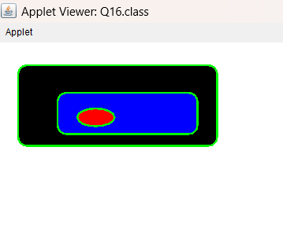

Q17 DRAW THE FOLLOWING DIAGRAM

CODE:

import java.applet.Applet;

import java.awt.*;

public class Q17 extends Applet {

public void paint(Graphics g) {

Graphics2D g2 = (Graphics2D) g;

g2.setStroke(new BasicStroke(5));

int[] x = {100, 150, 100, 50};

int[] y = {100, 150, 200, 150};

g2.drawPolygon(x, y, 4);

g2.setColor(Color.red);

g2.fillPolygon(x, y, 4);

g2.setColor(Color.black);

g2.drawRoundRect(75, 135, 50, 30, 10, 10);

g2.setColor(Color.blue);

g2.fillRoundRect(75, 135, 50, 30, 10, 10);

g2.setColor(Color.red);

g2.drawOval(85, 140, 30, 20);

g2.setColor(Color.black);

g2.fillOval(85, 140, 30, 20);

}

}

/*<html>

<head>

</head>

<body>

<applet code = "Q17.class" width = "320" height = "480"></applet>

</body>

</html>*/  
OUTPUT:

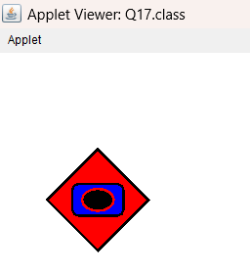

Q18 DRAW THE FOLLOWING DIAGRAM

CODE:

import java.applet.Applet;

import java.awt.*;

public class Q18 extends Applet {

public void paint(Graphics g) {

Graphics2D g2 = (Graphics2D) g;

setBackground(Color.green);

g2.setStroke(new BasicStroke(5));

g2.setColor(Color.red);

g2.drawLine(30, 175, 230, 175);

g2.setColor(Color.black);

g2.fillArc(30, 150, 50, 50, 0, -180);

g2.setColor(Color.red);

g2.drawArc(30, 150, 50, 50, 0, -180);

g2.fillArc(80, 150, 50, 50, 0, 180);

g2.setColor(Color.red);

g2.drawArc(80, 150, 50, 50, 0, 180);

g2.setColor(Color.blue);

g2.fillArc(130, 150, 50, 50, 0, -180);

g2.setColor(Color.red);

g2.drawArc(130, 150, 50, 50, 0, -180);

g2.setColor(Color.yellow);

g2.fillArc(180, 150, 50, 50, 0, 180);

g2.setColor(Color.red);

g2.drawArc(180, 150, 50, 50, 0, 180);

}

}

/*<html>

<head>

</head>

<body>

<applet code = "Q18.class" width = "320" height = "480"></applet>

</body>

</html>*/

OUTPUT:

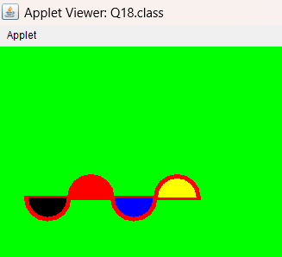

Q19 DRAW THE FOLLOWING DIAGRAM

CODE:

Q20

Q(A): Write a program to find out a+b, a-b, a*b, and a/b using swing.

CODE:

import javax.swing.*;

import java.awt.*;

import java.awt.event.*;

public class calc extends JFrame implements ActionListener {

private JLabel resultLabel;

private JTextField num1Field, num2Field;

private JButton addButton, subtractButton, multiplyButton, divideButton;

public calc() {

setTitle("Simple Calculator");

setDefaultCloseOperation(JFrame.EXIT_ON_CLOSE);

setSize(300, 200);

num1Field = new JTextField(10);

num2Field = new JTextField(10);

addButton = new JButton("+");

subtractButton = new JButton("-");

multiplyButton = new JButton("*");

divideButton = new JButton("/");

resultLabel = new JLabel("Result: ");

Container contentPane = getContentPane();

contentPane.setLayout(new FlowLayout());

contentPane.add(new JLabel("Number 1: "));

contentPane.add(num1Field);

contentPane.add(new JLabel("Number 2: "));

contentPane.add(num2Field);

contentPane.add(addButton);

contentPane.add(subtractButton);

contentPane.add(multiplyButton);

contentPane.add(divideButton);

contentPane.add(resultLabel);

addButton.addActionListener(this);

subtractButton.addActionListener(this);

multiplyButton.addActionListener(this);

divideButton.addActionListener(this);

setVisible(true);

}

public void actionPerformed(ActionEvent e) {

try {

double num1 = Double.parseDouble(num1Field.getText());

double num2 = Double.parseDouble(num2Field.getText());

if (e.getSource() == addButton) {

resultLabel.setText("Result: " + (num1 + num2));

} else if (e.getSource() == subtractButton) {

resultLabel.setText("Result: " + (num1 - num2));

} else if (e.getSource() == multiplyButton) {

resultLabel.setText("Result: " + (num1 * num2));

} else if (e.getSource() == divideButton) {

resultLabel.setText("Result: " + (num1 / num2));

}

} catch (NumberFormatException ex) {

resultLabel.setText("Result: Invalid input");

}

}

public static void main(String[] args) {

new calc();

}

}

OUTPUT:

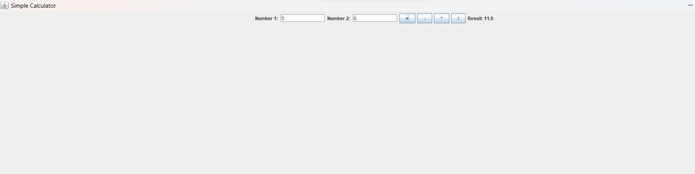

Q B Find factorial using swing

CODE:  
import javax.swing.*;

import java.awt.*;

import java.awt.event.*;

public class factorial extends JFrame implements ActionListener {

private JTextField inputField;

private JButton calculateButton;

private JLabel resultLabel;

public factorial() {

setTitle("Factorial Calculator");

setDefaultCloseOperation(JFrame.EXIT_ON_CLOSE);

setSize(300, 200);

inputField = new JTextField(10);

calculateButton = new JButton("Calculate");

resultLabel = new JLabel("Result: ");

Container contentPane = getContentPane();

contentPane.setLayout(new FlowLayout());

contentPane.add(new JLabel("Enter a number: "));

contentPane.add(inputField);

contentPane.add(calculateButton);

contentPane.add(resultLabel);

calculateButton.addActionListener(this);

setVisible(true);

}

public void actionPerformed(ActionEvent e) {

try {

int num = Integer.parseInt(inputField.getText());

int factorial = 1;

for (int i = 2; i <= num; i++) {

factorial *= i;

}

resultLabel.setText("Result: " + factorial);

} catch (NumberFormatException ex) {

resultLabel.setText("Result: Invalid input");

}

}

public static void main(String[] args) {

new factorial();

}

}

OUTPUT:

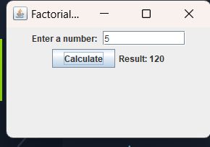

Q C: Applet.

C. Write a java program to create two tabs like in first tab you will take user input of two numbers and division pf those two numbers then a next button will come which will take us to 2nd tab where again you will take user input of two numbers and perform multiplication of those two numbers.

CODE:

import java.awt.GridLayout;

import java.awt.event.ActionEvent;

import java.awt.event.ActionListener;

import javax.swing.JButton;

import javax.swing.JFrame;

import javax.swing.JLabel;

import javax.swing.JPanel;

import javax.swing.JTextField;

public class division extends JFrame implements ActionListener

{

JTextField num1, num2, result;

JButton divBtn;

JButton next;

JLabel a1,a2,a3;

public division() {

super("Division");

setDefaultCloseOperation(JFrame.EXIT_ON_CLOSE);

setSize(500, 500);

setVisible(true);

num1 = new JTextField(10);

num2 = new JTextField(10);

result = new JTextField(10);

result.setEditable(false);

divBtn = new JButton("DIVIDE");

next = new JButton("NEXT PAGE");

a1=new JLabel("Enter first number:");

a2=new JLabel("Enter second number:");

a3=new JLabel("Result:");

setLayout(new GridLayout(7,1));

JPanel panel;

panel=new JPanel();

panel.add(a1);

panel.add(num1);add(panel);

panel=new JPanel();

panel.add(a2);

panel.add(num2);add(panel);

panel=new JPanel();

panel.add(a3);

panel=new JPanel();

panel.add(result);add(panel);

panel=new JPanel();

panel.add(divBtn);

panel.add(next);add(panel);

divBtn.addActionListener(this);

next.addActionListener(this);

}

public static void main(String[] args) {

new division();

}

public void actionPerformed(ActionEvent e)

{

int a = Integer.parseInt(num1.getText());

int b = Integer.parseInt(num2.getText());

if (e.getSource() == divBtn) {

result.setText(Integer.toString(a / b));

} else if (e.getSource() == next) {

setVisible(false);

multiply mul=new multiply();

mul.setVisible(true);

}

}

}

MULTIPLY PAGE CODE:

import java.awt.GridLayout;

import java.awt.event.ActionEvent;

import java.awt.event.ActionListener;

import javax.swing.JButton;

import javax.swing.JFrame;

import javax.swing.JLabel;

import javax.swing.JOptionPane;

import javax.swing.JPanel;

import javax.swing.JPasswordField;

import javax.swing.JTextField;

public class multiply extends JFrame implements ActionListener

{

JTextField num1, num2, result;

JButton mulBtn;

JLabel a1, a2, a3;

public multiply() {

super("multiplication");

setDefaultCloseOperation(JFrame.EXIT_ON_CLOSE);

setSize(500, 500);

num1 = new JTextField(10);

num2 = new JTextField(10);

result = new JTextField(10);

result.setEditable(false);

mulBtn = new JButton("MULTIPLY");

a1=new JLabel("Enter first number: ");

a2=new JLabel("Enter second number: ");

a3=new JLabel("Result: ");

setLayout(new GridLayout(7,1));

JPanel panel;

panel=new JPanel();

panel.add(a1);

panel.add(num1);add(panel);

panel=new JPanel();

panel.add(a2);

panel.add(num2);add(panel);

panel=new JPanel();

panel.add(a3);

panel.add(result);add(panel);

panel=new JPanel();

panel.add(mulBtn);add(panel);

mulBtn.addActionListener(this);

}

public void actionPerformed(ActionEvent e)

{

int a = Integer.parseInt(num1.getText());

int b = Integer.parseInt(num2.getText());

if (e.getSource() == mulBtn) {

result.setText(Integer.toString(a * b));

}

}

}

OUTPUT:

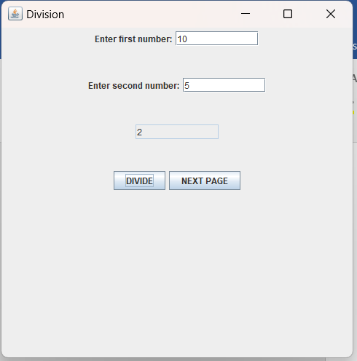

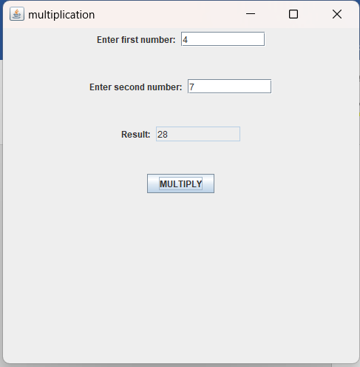

Q D: Write a program that helps in creating 3 push buttons the names of 3 colour (Yellow, Blue, Pink).When a button is clicked, that particular color is set as background color in the frame.

CODE:

import java.awt.Color;

import java.awt.event.ActionEvent;

import java.awt.event.ActionListener;

import javax.swing.JButton;

import javax.swing.JFrame;

import javax.swing.JPanel;

public class color extends JFrame implements ActionListener

{

JButton yellow, blue, pink;

JPanel p;

public color()

{

setSize(500, 500);

p = new JPanel();

yellow = new JButton("Yellow");

blue = new JButton("Blue");

pink = new JButton("Pink");

yellow.addActionListener(this);

blue.addActionListener(this);

pink.addActionListener(this);

p.add(yellow);

p.add(blue);

p.add(pink);

add(p);

setVisible(true);

}

public void actionPerformed(ActionEvent e)

{

if (e.getSource() == yellow)

{

p.setBackground(Color.yellow);

}

else if (e.getSource() == blue)

{

p.setBackground(Color.blue);

}

else if (e.getSource() == pink)

{

p.setBackground(Color.pink);

}

}

public static void main(String[] args) {

new color();

}

}

OUTPUT:

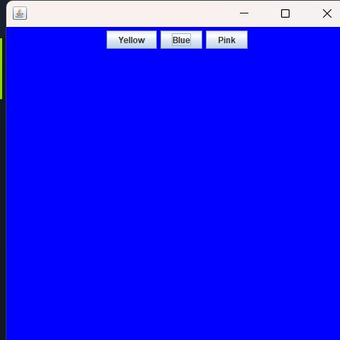

Q E Write a program to find out the compound interest using swing.

CODE:

import javax.swing.*;

import java.awt.*;

import java.awt.event.*;

public class ci extends JFrame {

private JTextField principalField, rateField, yearsField, timesPerYearField;

private JButton calculateButton;

private JLabel resultLabel;

public ci() {

setTitle("Compound Interest Calculator");

setDefaultCloseOperation(JFrame.EXIT_ON_CLOSE);

setSize(400, 300);

principalField = new JTextField(10);

rateField = new JTextField(10);

yearsField = new JTextField(10);

timesPerYearField = new JTextField(10);

calculateButton = new JButton("Calculate");

resultLabel = new JLabel("");

calculateButton.addActionListener(new ActionListener() {

public void actionPerformed(ActionEvent e) {

try {

double principal = Double.parseDouble(principalField.getText());

double rate = Double.parseDouble(rateField.getText());

double years = Double.parseDouble(yearsField.getText());

double timesPerYear = Double.parseDouble(timesPerYearField.getText());

double compoundInterest = principal * Math.pow(1 + (rate / timesPerYear), timesPerYear * years) - principal;

resultLabel.setText("Compound Interest: " + compoundInterest);

} catch (NumberFormatException ex) {

resultLabel.setText("Invalid input");

}

}

});

JPanel panel = new JPanel();

panel.setLayout(new GridLayout(5, 2));

panel.add(new JLabel("Principal: "));

panel.add(principalField);

panel.add(new JLabel("Rate: "));

panel.add(rateField);

panel.add(new JLabel("Years: "));

panel.add(yearsField);

panel.add(new JLabel("Times per year: "));

panel.add(timesPerYearField);

panel.add(calculateButton);

panel.add(resultLabel);

// add panel to frame

getContentPane().add(panel);

setVisible(true);

}

public static void main(String[] args) {

new ci();

}

}

OUTPUT:

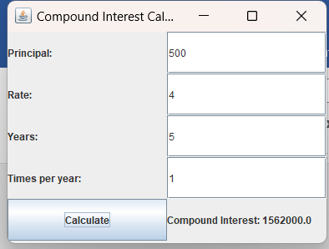

Q F: Applet Write a program convert Celsius to Fahrenheit and vice-vers using swing.

CODE:

import javax.swing.*;

import java.awt.*;

import java.awt.event.*;

public class temprature extends JFrame implements ActionListener {

private JLabel celsiusLabel, fahrenheitLabel;

private JTextField celsiusField, fahrenheitField;

private JButton celsiusToFahrenheitBtn, fahrenheitToCelsiusBtn;

public temprature() {

setTitle("Temprature Converter");

setDefaultCloseOperation(JFrame.EXIT_ON_CLOSE);

celsiusLabel = new JLabel("Celsius");

fahrenheitLabel = new JLabel("Fahrenheit");

celsiusField = new JTextField(10);

fahrenheitField = new JTextField(10);

celsiusToFahrenheitBtn = new JButton("Convert to Fahrenheit");

fahrenheitToCelsiusBtn = new JButton("Convert to Celsius");

celsiusToFahrenheitBtn.addActionListener(this);

fahrenheitToCelsiusBtn.addActionListener(this);

JPanel mainPanel = new JPanel(new GridLayout(3, 2));

mainPanel.add(celsiusLabel);

mainPanel.add(celsiusField);

mainPanel.add(celsiusToFahrenheitBtn);

mainPanel.add(fahrenheitLabel);

mainPanel.add(fahrenheitField);

mainPanel.add(fahrenheitToCelsiusBtn);

setTitle("Temperature Converter");

setDefaultCloseOperation(JFrame.EXIT_ON_CLOSE);

setSize(300, 150);

setResizable(false);

setLocationRelativeTo(null);

setContentPane(mainPanel);

setVisible(true);

}

public void actionPerformed(ActionEvent e) {

if (e.getSource() == celsiusToFahrenheitBtn) {

try {

double celsius = Double.parseDouble(celsiusField.getText());

double fahrenheit = (celsius * 1.8) + 32;

fahrenheitField.setText(String.format("%.2f", fahrenheit));

} catch (NumberFormatException ex) {

JOptionPane.showMessageDialog(this, "Please enter a valid number for Celsius.");

}

} else if (e.getSource() == fahrenheitToCelsiusBtn) {

try {

double fahrenheit = Double.parseDouble(fahrenheitField.getText());

double celsius = (fahrenheit - 32) / 1.8;

celsiusField.setText(String.format("%.2f", celsius));

} catch (NumberFormatException ex) {

JOptionPane.showMessageDialog(this, "Please enter a valid number for Fahrenheit.");

}

}

}

public static void main(String[] args) {

new temprature();

}

}

OUTPUT:

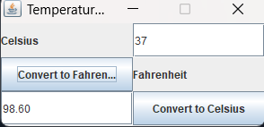

Q G Write a java program to find out the maximum of three number

using swing.

CODE:

import javax.swing.*;

import java.awt.*;

import java.awt.event.*;

public class max extends JFrame implements ActionListener {

private JTextField n1f, n2f, n3f;

private JLabel resultLabel;

public max() {

// Create UI elements

JLabel n1 = new JLabel("First Number:");

n1f = new JTextField(10);

JLabel n2 = new JLabel("Second Number:");

n2f = new JTextField(10);

JLabel n3 = new JLabel("Third Number:");

n3f = new JTextField(10);

JButton calculate = new JButton("Calculate");

calculate.addActionListener(this);

resultLabel = new JLabel("");

JPanel mainPanel = new JPanel(new GridLayout(4, 2));

mainPanel.add(n1);

mainPanel.add(n1f);

mainPanel.add(n2);

mainPanel.add(n2f);

mainPanel.add(n3);

mainPanel.add(n3f);

mainPanel.add(calculate);

mainPanel.add(resultLabel);

setTitle("Max of Three");

setDefaultCloseOperation(JFrame.EXIT_ON_CLOSE);

setSize(300, 150);

setResizable(false);

setLocationRelativeTo(null);

setContentPane(mainPanel);

setVisible(true);

}

public void actionPerformed(ActionEvent e) {

try {

double num1 = Double.parseDouble(n1f.getText());

double num2 = Double.parseDouble(n2f.getText());

double num3 = Double.parseDouble(n3f.getText());

double max = Math.max(num1, Math.max(num2, num3));

resultLabel.setText("Maximum number is " + max);

} catch (NumberFormatException ex) {

JOptionPane.showMessageDialog(this, "Please enter valid numbers for all three fields.");

}

}

public static void main(String[] args) {

new max();

}

}

OUTPUT:

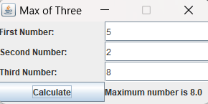

Q H: Write a java program check given year is leap year or not

using swing.

CODE:

import javax.swing.*;

import java.awt.*;

import java.awt.event.*;

public class leap extends JFrame implements ActionListener {

private JTextField yrf;

private JLabel resultLabel;

public leap() {

JLabel year = new JLabel("Enter a year:");

yrf = new JTextField(10);

JButton checkBtn = new JButton("Check");

checkBtn.addActionListener(this);

resultLabel = new JLabel("");

JPanel mainPanel = new JPanel(new GridLayout(2, 2));

mainPanel.add(year);

mainPanel.add(yrf);

mainPanel.add(checkBtn);

mainPanel.add(resultLabel);

setTitle("Leap Year Checker");

setDefaultCloseOperation(JFrame.EXIT_ON_CLOSE);

setSize(300, 100);

setResizable(false);

setLocationRelativeTo(null);

setContentPane(mainPanel);

setVisible(true);

}

public void actionPerformed(ActionEvent e) {

try {

int year = Integer.parseInt(yrf.getText());

boolean isLeapYear = ((year % 4 == 0) && (year % 100 != 0)) || (year % 400 == 0);

if (isLeapYear) {

resultLabel.setText(year + " is a leap year.");

} else {

resultLabel.setText(year + " is not a leap year.");

}

} catch (NumberFormatException ex) {

JOptionPane.showMessageDialog(this, "Please enter a valid year.");

}

}

public static void main(String[] args) {

new leap();

}

}

OUTPUT:



Q I. Write a java program to find out the GCD of three number using swing.

CODE:

import javax.swing.*;

import java.awt.*;

import java.awt.event.*;

public class gcd extends JFrame implements ActionListener {

private JTextField num1Field, num2Field, num3Field;

private JLabel resultLabel;

public gcd() {

JLabel num1Label = new JLabel("First Number:");

num1Field = new JTextField(10);

JLabel num2Label = new JLabel("Second Number:");

num2Field = new JTextField(10);

JLabel num3Label = new JLabel("Third Number:");

num3Field = new JTextField(10);

JButton calculateBtn = new JButton("Calculate");

calculateBtn.addActionListener(this);

resultLabel = new JLabel("");

JPanel mainPanel = new JPanel(new GridLayout(4, 2));

mainPanel.add(num1Label);

mainPanel.add(num1Field);

mainPanel.add(num2Label);

mainPanel.add(num2Field);

mainPanel.add(num3Label);

mainPanel.add(num3Field);

mainPanel.add(calculateBtn);

mainPanel.add(resultLabel);

setTitle("GCD of Three");

setDefaultCloseOperation(JFrame.EXIT_ON_CLOSE);

setSize(500, 500);

setResizable(false);

setLocationRelativeTo(null);

setContentPane(mainPanel);

setVisible(true);

}

public void actionPerformed(ActionEvent e) {

try {

int num1 = Integer.parseInt(num1Field.getText());

int num2 = Integer.parseInt(num2Field.getText());

int num3 = Integer.parseInt(num3Field.getText());

int gcd = findGCD(num1, num2, num3);

resultLabel.setText("GCD of three numbers is " + gcd);

} catch (NumberFormatException ex) {

JOptionPane.showMessageDialog(this, "Please enter valid numbers for all three fields.");

}

}

public int findGCD(int a, int b, int c) {

int gcdAB = findGCD(a, b);

return findGCD(gcdAB, c);

}

public int findGCD(int a, int b) {

if (b == 0) {

return a;

} else {

return findGCD(b, a % b);

}

}

public static void main(String[] args) {

new gcd();

}

}

OUTPUT:

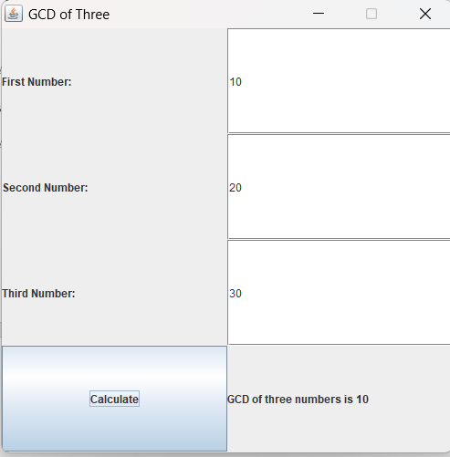

Q J. Write a program swap two number without using third variable using swing.

CODE:

import javax.swing.*;

import java.awt.*;

import java.awt.event.*;

public class swap extends JFrame implements ActionListener {

private JTextField num1Field, num2Field;

public swap() {

JLabel num1Label = new JLabel("First Number:");

num1Field = new JTextField(10);

JLabel num2Label = new JLabel("Second Number:");

num2Field = new JTextField(10);

JButton swapBtn = new JButton("Swap");

swapBtn.addActionListener(this);

JPanel mainPanel = new JPanel(new GridLayout(3, 2));

mainPanel.add(num1Label);

mainPanel.add(num1Field);

mainPanel.add(num2Label);

mainPanel.add(num2Field);

mainPanel.add(swapBtn);

setTitle("Swap Numbers");

setDefaultCloseOperation(JFrame.EXIT_ON_CLOSE);

setSize(300, 300);

setResizable(false);

setLocationRelativeTo(null);

setContentPane(mainPanel);

setVisible(true);

}

public void actionPerformed(ActionEvent e) {

try {

int num1 = Integer.parseInt(num1Field.getText());

int num2 = Integer.parseInt(num2Field.getText());

num1 = num1 + num2;

num2 = num1 - num2;

num1 = num1 - num2;

num1Field.setText(Integer.toString(num1));

num2Field.setText(Integer.toString(num2));

} catch (NumberFormatException ex) {

JOptionPane.showMessageDialog(this, "Please enter valid numbers for both fields.");

}

}

public static void main(String[] args) {

new swap();

}

}

OUTPUT:

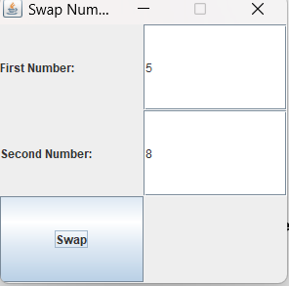

Q Write a java program to find out the minimum of three number

using swing.

CODE:

import javax.swing.*;

import java.awt.*;

import java.awt.event.*;

public class min extends JFrame implements ActionListener {

private JTextField num1Field, num2Field, num3Field;

private JLabel resultLabel;

public min() {

JLabel num1Label = new JLabel("First Number:");

num1Field = new JTextField(10);

JLabel num2Label = new JLabel("Second Number:");

num2Field = new JTextField(10);

JLabel num3Label = new JLabel("Third Number:");

num3Field = new JTextField(10);

JButton findBtn = new JButton("Find Minimum");

findBtn.addActionListener(this);

resultLabel = new JLabel();

JPanel mainPanel = new JPanel(new GridLayout(4, 2));

mainPanel.add(num1Label);

mainPanel.add(num1Field);

mainPanel.add(num2Label);

mainPanel.add(num2Field);

mainPanel.add(num3Label);

mainPanel.add(num3Field);

mainPanel.add(findBtn);

mainPanel.add(resultLabel);

setTitle("Minimum of Three Numbers");

setDefaultCloseOperation(JFrame.EXIT_ON_CLOSE);

setSize(500, 200);

setResizable(false);

setLocationRelativeTo(null);

setContentPane(mainPanel);

setVisible(true);

}

public void actionPerformed(ActionEvent e) {

try {

int num1 = Integer.parseInt(num1Field.getText());

int num2 = Integer.parseInt(num2Field.getText());

int num3 = Integer.parseInt(num3Field.getText());

int min = Math.min(Math.min(num1, num2), num3);

resultLabel.setText("Minimum of " + num1 + ", " + num2 + ", and " + num3 + " is " + min + ".");

} catch (NumberFormatException ex) {

JOptionPane.showMessageDialog(this, "Please enter valid numbers for all three fields.");

}

}

public static void main(String[] args) {

new min();

}

}

OUTPUT:

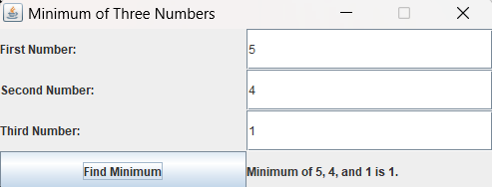

Q L.Write a java program to find out the monthly payment using

swing. Input P,Y,R.

CODE:

import javax.swing.*;

import java.awt.*;

import java.awt.event.*;

import java.text.DecimalFormat;

import java.util.Locale;

public class loan extends JFrame implements ActionListener {

private JTextField principalField, yearsField, rateField;

private JLabel resultLabel;

public loan() {

JLabel principalLabel = new JLabel("Principal amount:");

principalField = new JTextField(10);

JLabel yearsLabel = new JLabel("Number of years:");

yearsField = new JTextField(10);

JLabel rateLabel = new JLabel("Annual interest rate (%):");

rateField = new JTextField(10);

JButton calculateBtn = new JButton("Calculate");

calculateBtn.addActionListener(this);

resultLabel = new JLabel();

JPanel mainPanel = new JPanel(new GridLayout(4, 2));

mainPanel.add(principalLabel);

mainPanel.add(principalField);

mainPanel.add(yearsLabel);

mainPanel.add(yearsField);

mainPanel.add(rateLabel);

mainPanel.add(rateField);

mainPanel.add(calculateBtn);

mainPanel.add(resultLabel);

setTitle("Monthly Payment Calculator (INR)");

setDefaultCloseOperation(JFrame.EXIT_ON_CLOSE);

setSize(500, 200);

setResizable(false);

setLocationRelativeTo(null);

setContentPane(mainPanel);

setVisible(true);

}

public void actionPerformed(ActionEvent e) {

try {

double principal = Double.parseDouble(principalField.getText());

double years = Double.parseDouble(yearsField.getText());

double rate = Double.parseDouble(rateField.getText());

double monthlyRate = rate / (12 * 100);

double months = years * 12;

double monthlyPayment = (principal * monthlyRate) / (1 - Math.pow(1 + monthlyRate, -months));

Locale indiaLocale = new Locale("en", "IN");

DecimalFormat inrFormat = (DecimalFormat) DecimalFormat.getCurrencyInstance(indiaLocale);

String result = String.format("Monthly payment: %s", inrFormat.format(monthlyPayment));

resultLabel.setText(result);

} catch (NumberFormatException ex) {

JOptionPane.showMessageDialog(this, "Please enter valid numbers for all three fields.");

}

}

public static void main(String[] args) {

new loan();

}

}

OUTPUT:

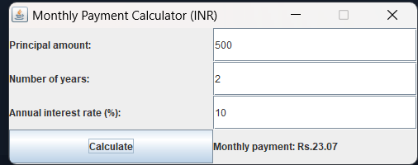

Q M.Write a java program to find out the average marks of 5 subject and display grad according to KIIT grad scale,using swing.

CODE:

import javax.swing.*;

import java.awt.*;

import java.awt.event.*;

public class grade extends JFrame implements ActionListener {

private JTextField[] subjectFields;

private JLabel resultLabel;

public grade() {

JLabel[] subjectLabels = new JLabel[5];

subjectFields = new JTextField[5];

for (int i = 0; i < 5; i++) {

subjectLabels[i] = new JLabel("Subject " + (i + 1) + " marks:");

subjectFields[i] = new JTextField(10);

}

JButton calculateBtn = new JButton("Calculate");

calculateBtn.addActionListener(this);

resultLabel = new JLabel();

JPanel mainPanel = new JPanel(new GridLayout(7, 1));

for (int i = 0; i < 5; i++) {

JPanel subjectPanel = new JPanel(new FlowLayout());

subjectPanel.add(subjectLabels[i]);

subjectPanel.add(subjectFields[i]);

mainPanel.add(subjectPanel);

}

mainPanel.add(calculateBtn);

mainPanel.add(resultLabel);

setTitle("Grade Calculator");

setDefaultCloseOperation(JFrame.EXIT_ON_CLOSE);

setSize(300, 300);

setResizable(false);

setLocationRelativeTo(null);

setContentPane(mainPanel);

setVisible(true);

}

public void actionPerformed(ActionEvent e) {

try {

// Get marks from text fields and calculate average

double totalMarks = 0;

for (int i = 0; i < 5; i++) {

totalMarks += Double.parseDouble(subjectFields[i].getText());

}

double averageMarks = totalMarks / 5;

String grade;

if (averageMarks >= 90) {

grade = "O";

} else if (averageMarks >= 80) {

grade = "E";

} else if (averageMarks >= 70) {

grade = "A";

} else if (averageMarks >= 60) {

grade = "B";

} else if (averageMarks >= 50) {

grade = "C";

} else if (averageMarks >= 40) {

grade = "D";

} else {

grade = "F";

}

String result = String.format("Average marks: %.2f\nGrade: %s", averageMarks, grade);

resultLabel.setText(result);

} catch (NumberFormatException ex) {

JOptionPane.showMessageDialog(this, "Please enter valid marks for all five subjects.");

}

}

public static void main(String[] args) {

new grade();

}

}

OUTPUT:

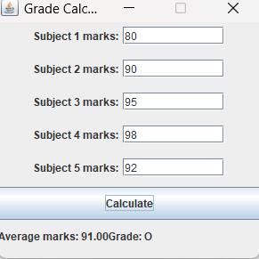

Q N: . Write a java Program to calculate the sum digits of a number using swing.

Code:

import javax.swing.*;

import java.awt.*;

import java.awt.event.*;

public class sum extends JFrame implements ActionListener {

private JTextField numField;

private JLabel resultLabel;

public sum() {

JLabel numLabel = new JLabel("Enter a number:");

numField = new JTextField(10);

JButton calculateBtn = new JButton("Calculate");

calculateBtn.addActionListener(this);

resultLabel = new JLabel();

JPanel mainPanel = new JPanel(new GridLayout(3, 1));

JPanel numPanel = new JPanel(new FlowLayout());

numPanel.add(numLabel);

numPanel.add(numField);

mainPanel.add(numPanel);

mainPanel.add(calculateBtn);

mainPanel.add(resultLabel);

setTitle("Digit Sum Calculator");

setDefaultCloseOperation(JFrame.EXIT_ON_CLOSE);

setSize(300, 200);

setResizable(false);

setLocationRelativeTo(null);

setContentPane(mainPanel);

setVisible(true);

}

public void actionPerformed(ActionEvent e) {

try {

int num = Integer.parseInt(numField.getText());

int digitSum = 0;

while (num != 0) {

digitSum += num % 10;

num /= 10;

}

String result = String.format("The sum of digits is: %d", digitSum);

resultLabel.setText(result);

} catch (NumberFormatException ex) {

JOptionPane.showMessageDialog(this, "Please enter a valid integer.");

}

}

public static void main(String[] args) {

new sum();

}

}

OUTPUT:

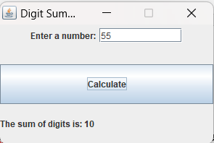

Q O: FIND SECOND LARGEST USING SWING

CODE:

import javax.swing.*;

import java.awt.*;

import java.awt.event.*;

public class secondlargest extends JFrame implements ActionListener {

private JTextField num1Field, num2Field, num3Field;

private JLabel resultLabel;

public secondlargest() {

JLabel n1 = new JLabel("Enter first number:");

num1Field = new JTextField(10);

JLabel n2 = new JLabel("Enter second number:");

num2Field = new JTextField(10);

JLabel n3 = new JLabel("Enter third number:");

num3Field = new JTextField(10);

JButton calculateBtn = new JButton("Find Second Largest");

calculateBtn.addActionListener(this);

resultLabel = new JLabel();

JPanel mainPanel = new JPanel(new GridLayout(5, 1));

JPanel num1Panel = new JPanel(new FlowLayout());

num1Panel.add(n1);

num1Panel.add(num1Field);

mainPanel.add(num1Panel);

JPanel num2Panel = new JPanel(new FlowLayout());

num2Panel.add(n2);

num2Panel.add(num2Field);

mainPanel.add(num2Panel);

JPanel num3Panel = new JPanel(new FlowLayout());

num3Panel.add(n3);

num3Panel.add(num3Field);

mainPanel.add(num3Panel);

mainPanel.add(calculateBtn);

mainPanel.add(resultLabel);

setTitle("Second Largest Number Finder");

setDefaultCloseOperation(JFrame.EXIT_ON_CLOSE);

setSize(400, 250);

setResizable(false);

setLocationRelativeTo(null);

setContentPane(mainPanel);

setVisible(true);

}

public void actionPerformed(ActionEvent e) {

try {

int num1 = Integer.parseInt(num1Field.getText());

int num2 = Integer.parseInt(num2Field.getText());

int num3 = Integer.parseInt(num3Field.getText());

int secondLargest;

if (num1 >= num2 && num1 >= num3) {

secondLargest = Math.max(num2, num3);

} else if (num2 >= num1 && num2 >= num3) {

secondLargest = Math.max(num1, num3);

} else {

secondLargest = Math.max(num1, num2);

}

String result = String.format("The second largest number is: %d", secondLargest);

resultLabel.setText(result);

} catch (NumberFormatException ex) {

JOptionPane.showMessageDialog(this, "Please enter valid integers.");

}

}

public static void main(String[] args) {

new secondlargest();

}

}

OUTPUT:

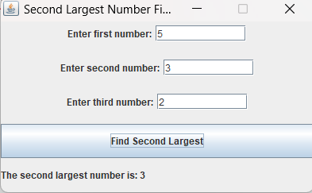

Q P Write a java Program to check the number is armstrong number or

not using swing.

CODE:

import javax.swing.*;

import java.awt.*;

import java.awt.event.*;

public class armstrong extends JFrame implements ActionListener {

private JTextField numField;

private JLabel resultLabel;

public armstrong() {

JLabel numLabel = new JLabel("Enter a number:");

numField = new JTextField(10);

JButton checkBtn = new JButton("Check if Strong");

checkBtn.addActionListener(this);

resultLabel = new JLabel();

JPanel mainPanel = new JPanel(new GridLayout(3, 1));

JPanel numPanel = new JPanel(new FlowLayout());

numPanel.add(numLabel);

numPanel.add(numField);

mainPanel.add(numPanel);

mainPanel.add(checkBtn);

mainPanel.add(resultLabel);

setTitle("Strong Number Checker");

setDefaultCloseOperation(JFrame.EXIT_ON_CLOSE);

setSize(400, 200);

setResizable(false);

setLocationRelativeTo(null);

setContentPane(mainPanel);

setVisible(true);

}

public void actionPerformed(ActionEvent e) {

try {

int num = Integer.parseInt(numField.getText());

int sum = 0;

int temp = num;

while (temp > 0) {

int digit = temp % 10;

int fact = 1;

for (int i = 1; i <= digit; i++) {

fact *= i;

}

sum += fact;

temp /= 10;

}

if (sum == num) {

resultLabel.setText("The number is a strong number.");

} else {

resultLabel.setText("The number is not a strong number.");

}

} catch (NumberFormatException ex) {

JOptionPane.showMessageDialog(this, "Please enter a valid integer.");

}

}

public static void main(String[] args) {

new armstrong();

}

}

OUTPUT:

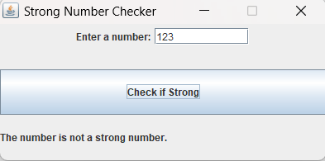

Q Q: Write a java program to find out the LCM of three number using swing.

CODE:

import javax.swing.*;

import java.awt.*;

import java.awt.event.*;

public class lcm extends JFrame implements ActionListener {

private JTextField num1Field, num2Field, num3Field;

private JLabel resultLabel;

public lcm() {

JLabel num1Label = new JLabel("Enter first number:");

num1Field = new JTextField(10);

JLabel num2Label = new JLabel("Enter second number:");

num2Field = new JTextField(10);

JLabel num3Label = new JLabel("Enter third number:");

num3Field = new JTextField(10);

JButton calcBtn = new JButton("Calculate LCM");

calcBtn.addActionListener(this);

resultLabel = new JLabel();

JPanel mainPanel = new JPanel(new GridLayout(5, 1));

JPanel num1Panel = new JPanel(new FlowLayout());

num1Panel.add(num1Label);

num1Panel.add(num1Field);

mainPanel.add(num1Panel);

JPanel num2Panel = new JPanel(new FlowLayout());

num2Panel.add(num2Label);

num2Panel.add(num2Field);

mainPanel.add(num2Panel);

JPanel num3Panel = new JPanel(new FlowLayout());

num3Panel.add(num3Label);

num3Panel.add(num3Field);

mainPanel.add(num3Panel);

mainPanel.add(calcBtn);

mainPanel.add(resultLabel);

setTitle("LCM Calculator");

setDefaultCloseOperation(JFrame.EXIT_ON_CLOSE);

setSize(400, 250);

setResizable(false);

setLocationRelativeTo(null);

setContentPane(mainPanel);

setVisible(true);

}

public void actionPerformed(ActionEvent e) {

try {

int num1 = Integer.parseInt(num1Field.getText());

int num2 = Integer.parseInt(num2Field.getText());

int num3 = Integer.parseInt(num3Field.getText());

int max = Math.max(Math.max(num1, num2), num3);

int lcm = max;

while (true) {

if (lcm % num1 == 0 && lcm % num2 == 0 && lcm % num3 == 0) {

resultLabel.setText("The LCM is " + lcm + ".");

break;

}

lcm += max;

}

} catch (NumberFormatException ex) {

JOptionPane.showMessageDialog(this, "Please enter valid integers.");

}

}

public static void main(String[] args) {

new lcm();

}

}

OUTPUT:

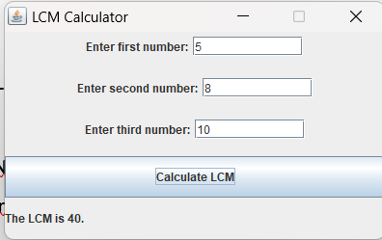

Q JAVA PROGRAM TO FIND SECOND MINIMUM

CODE:

import javax.swing.*;

import java.awt.*;

import java.awt.event.*;

public class secondminimum extends JFrame implements ActionListener {

private JTextField num1Field, num2Field, num3Field;

private JLabel resultLabel;

public secondminimum() {

JLabel n1 = new JLabel("Enter first number:");

num1Field = new JTextField(10);

JLabel n2 = new JLabel("Enter second number:");

num2Field = new JTextField(10);

JLabel n3 = new JLabel("Enter third number:");

num3Field = new JTextField(10);

JButton calculateBtn = new JButton("Find Second Minimum");

calculateBtn.addActionListener(this);

resultLabel = new JLabel();

JPanel mainPanel = new JPanel(new GridLayout(5, 1));

JPanel num1Panel = new JPanel(new FlowLayout());

num1Panel.add(n1);

num1Panel.add(num1Field);

mainPanel.add(num1Panel);

JPanel num2Panel = new JPanel(new FlowLayout());

num2Panel.add(n2);

num2Panel.add(num2Field);

mainPanel.add(num2Panel);

JPanel num3Panel = new JPanel(new FlowLayout());

num3Panel.add(n3);

num3Panel.add(num3Field);

mainPanel.add(num3Panel);

mainPanel.add(calculateBtn);

mainPanel.add(resultLabel);

setTitle("Second Largest Number Finder");

setDefaultCloseOperation(JFrame.EXIT_ON_CLOSE);

setSize(400, 250);

setResizable(false);

setLocationRelativeTo(null);

setContentPane(mainPanel);

setVisible(true);

}

public void actionPerformed(ActionEvent e) {

try {

int num1 = Integer.parseInt(num1Field.getText());

int num2 = Integer.parseInt(num2Field.getText());

int num3 = Integer.parseInt(num3Field.getText());

int secondLargest;

if (num1 <= num2 && num1 <= num3) {

secondLargest = Math.min(num2, num3);

} else if (num2 <= num1 && num2 <= num3) {

secondLargest = Math.min(num1, num3);

} else {

secondLargest = Math.min(num1, num2);

}

String result = String.format("The second minimum number is: %d", secondLargest);

resultLabel.setText(result);

} catch (NumberFormatException ex) {

JOptionPane.showMessageDialog(this, "Please enter valid integers.");

}

}

public static void main(String[] args) {

new secondlargest();

}

}

OUTPUT:

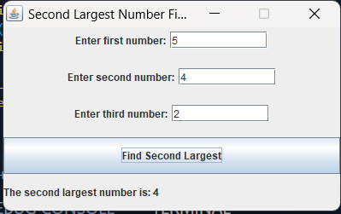

Q S. Write a program that helps in creating 3 push buttons the names of 3 colour (Yellow, Blue, Pink).When a button is clicked, that particular color is set as background color in the frame.

CODE:

import java.awt.Color;

import java.awt.event.ActionEvent;

import java.awt.event.ActionListener;

import javax.swing.JButton;

import javax.swing.JFrame;

import javax.swing.JPanel;

public class color extends JFrame implements ActionListener

{

JButton yellow, blue, pink;

JPanel p;

public color()

{

setSize(500, 500);

p = new JPanel();

yellow = new JButton("Yellow");

blue = new JButton("Blue");

pink = new JButton("Pink");

yellow.addActionListener(this);

blue.addActionListener(this);

pink.addActionListener(this);

p.add(yellow);

p.add(blue);

p.add(pink);

add(p);

setVisible(true);

}

public void actionPerformed(ActionEvent e)

{

if (e.getSource() == yellow)

{

p.setBackground(Color.yellow);

}

else if (e.getSource() == blue)

{

p.setBackground(Color.blue);

}

else if (e.getSource() == pink)

{

p.setBackground(Color.pink);

}

}

public static void main(String[] args) {

new color();

}

}

OUTPUT:



Q T: Write a java program to create two tabs like in first tab you will take user input of two numbers and division pf those two numbers then a next button will come which will take us to 2nd tab where again you will take user input of two numbers and perform multiplication of those two numbers.

CODE:

import java.awt.GridLayout;

import java.awt.event.ActionEvent;

import java.awt.event.ActionListener;

import javax.swing.JButton;

import javax.swing.JFrame;

import javax.swing.JLabel;

import javax.swing.JPanel;

import javax.swing.JTextField;

public class division extends JFrame implements ActionListener

{

JTextField num1, num2, result;

JButton divBtn;

JButton next;

JLabel a1,a2,a3;

public division() {

super("Division");

setDefaultCloseOperation(JFrame.EXIT_ON_CLOSE);

setSize(500, 500);

setVisible(true);

num1 = new JTextField(10);

num2 = new JTextField(10);

result = new JTextField(10);

result.setEditable(false);

divBtn = new JButton("DIVIDE");

next = new JButton("NEXT PAGE");

a1=new JLabel("Enter first number:");

a2=new JLabel("Enter second number:");

a3=new JLabel("Result:");

setLayout(new GridLayout(7,1));

JPanel panel;

panel=new JPanel();

panel.add(a1);

panel.add(num1);add(panel);

panel=new JPanel();

panel.add(a2);

panel.add(num2);add(panel);

panel=new JPanel();

panel.add(a3);

panel=new JPanel();

panel.add(result);add(panel);

panel=new JPanel();

panel.add(divBtn);

panel.add(next);add(panel);

divBtn.addActionListener(this);

next.addActionListener(this);

}

public static void main(String[] args) {

new division();

}

public void actionPerformed(ActionEvent e)

{

int a = Integer.parseInt(num1.getText());

int b = Integer.parseInt(num2.getText());

if (e.getSource() == divBtn) {

result.setText(Integer.toString(a / b));

} else if (e.getSource() == next) {

setVisible(false);

multiply mul=new multiply();

mul.setVisible(true);

}

}

}

MULTIPLY PAGE CODE:

import java.awt.GridLayout;

import java.awt.event.ActionEvent;

import java.awt.event.ActionListener;

import javax.swing.JButton;

import javax.swing.JFrame;

import javax.swing.JLabel;

import javax.swing.JOptionPane;

import javax.swing.JPanel;

import javax.swing.JPasswordField;

import javax.swing.JTextField;

public class multiply extends JFrame implements ActionListener

{

JTextField num1, num2, result;

JButton mulBtn;

JLabel a1, a2, a3;

public multiply() {

super("multiplication");

setDefaultCloseOperation(JFrame.EXIT_ON_CLOSE);

setSize(500, 500);

num1 = new JTextField(10);

num2 = new JTextField(10);

result = new JTextField(10);

result.setEditable(false);

mulBtn = new JButton("MULTIPLY");

a1=new JLabel("Enter first number: ");

a2=new JLabel("Enter second number: ");

a3=new JLabel("Result: ");

setLayout(new GridLayout(7,1));

JPanel panel;

panel=new JPanel();

panel.add(a1);

panel.add(num1);add(panel);

panel=new JPanel();

panel.add(a2);

panel.add(num2);add(panel);

panel=new JPanel();

panel.add(a3);

panel.add(result);add(panel);

panel=new JPanel();

panel.add(mulBtn);add(panel);

mulBtn.addActionListener(this);

}

public void actionPerformed(ActionEvent e)

{

int a = Integer.parseInt(num1.getText());

int b = Integer.parseInt(num2.getText());

if (e.getSource() == mulBtn) {

result.setText(Integer.toString(a * b));

}

}

}

OUTPUT:



