



Document Name | Project Document  Project - Camato  Client - Crealytics
Version No | 1.4
Release Date | 03/15/2018
Document ID | Doc_FEF
Classification | Internal

This document of Cybage Software Pvt. Ltd. is for restricted circulation. No part of this publication may be reproduced, stored in a retrieval system or transmitted in any form or by any means – recording, photocopying, electronic and mechanical, without prior written permission of Cybage Software Pvt. Ltd.
Doc_Front_End_Flow (Doc_FEF)

Document history

Ver. No | Release Date | Current Project Phase | Created By / Modified By and Date | Reviewed By and Date | Approved By and Date | Remarks and Changes Made
1.0 | 03/15/2018 | Construction | Shekhar Bendre/15-Mar-2018 | Ajay Pawar | Disha Patel

Distribution List
Sr. No. | Name | Role | Organization Name
1. | Disha Patel | Project Manager | Cybage Software Pvt. Ltd.
2. | Ahmad Hamza | System Analyst | Cybage Software Pvt. Ltd.
3. | Trupti Jangam | Sr. Software Engineer | Cybage Software Pvt. Ltd.
4. | Shekhar Bendre | Sr. Software Engineer | Cybage Software Pvt. Ltd.
5. | Rahul Pawar | QA Engineer | Cybage Software Pvt. Ltd.
Table of Contents

1. Introduction 4
2. Development Stack 4
3. Project Structure 6
4. Building Blocks 7
5. Modules 8
5.1 Overview 6
5.2 Module Structure 6
6. Components 9
7.Tools 11
8.Configurations 21

Introduction
This document covers the updated understanding information based on information such as code base, conference calls, emails etc. exchanged with the client.

Development Stack
Camato frontend uses following development stack –















Project Structure
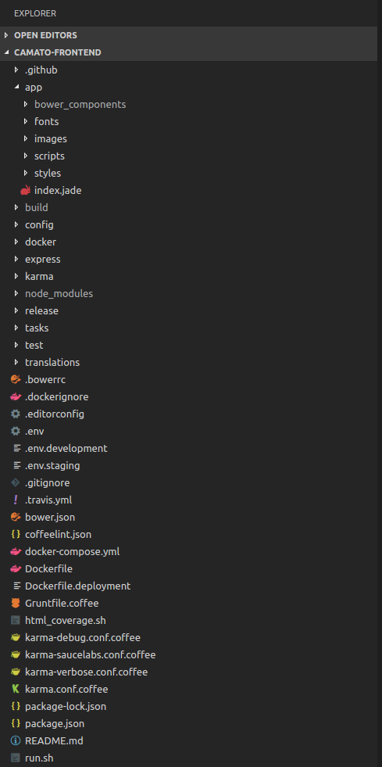

Building Blocks
Camato frontend contains following folder structure –

- App – Serves as an entry point for the source code folder structure.
  - bower_components – This folder serves the packages needed for development.
  - fonts - This folder serves fonts.
  - images – This folder serves all images
  - scripts – This folder serves source code and further contains subfolders like base, collections, components, layouts, etc.
  - styles - This folder serves stylesheets (SAAS).
  - index.jade – This file is a main entry point for webpage. All other pages will be loaded dynamically in this page.

- build – This folder serves build that means compiled output files. Like SAAS is compiled into CSS, .coffee files in .js, etc.

- config – This folder serves configurations for various purposes like specifying the build configuration for grunt, etc.

- docker – This folder contains dependencies for docker. It includes different configurations for different environment.

- express – This folder serves the API response locally without depending on any other API server.

- karma – This folder serves configuration for unit testing.

- node_modules – This folder serves the libraries/packages for development.

- release –

- tasks – This folder serves grunt tasks for the build purpose.

- test – This folder serves the actual unit test cases.

- translations – This folder serves translations.

Modules
5.1 Overview
Module folder provides the main modules of Camato frontend application. It has following main modules –

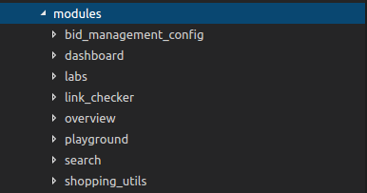

5.2 Module Structure
Module folder composed by following folder structure –

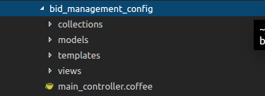

collections:
This folder serves collection for a particular module. The module has its own collections in this folder.

models:
This folder serves API interactions for a particular module.

templates:
This folder serves jade templates for modules.

views:
This folder serves bindings for templates.

main_controller.coffee:
App routers can only use one controller object. You can either specify this directly in the router definition.

Components
This folder serves common reusable code/component which we can use throughout the application. It has following structure -

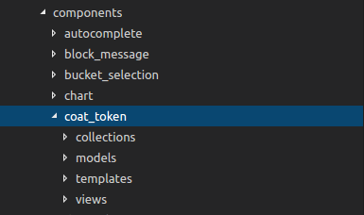

collections:
This folder serves collection for a particular module. The module has its own collections in this folder.

models:
This folder serves collection for a particular module. The module has its own collections in this folder.

templates:
This folder serves collection for a particular module. The module has its own collections in this folder.

views:
This folder serves collection for a particular module. The module has its own collections in this folder.

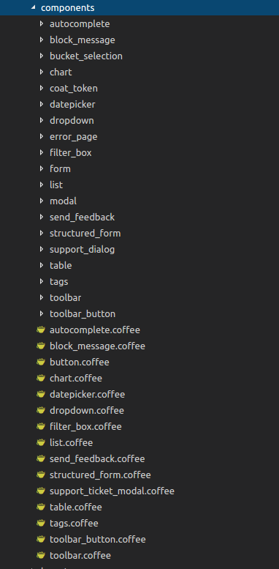

Tools
7.1 PhraseApp
PhraseApp is a proprietary web-based translation management system, also known as Globalization Management System (GMS).
It is targeted at open source and commercial software projects and allows the automation of translation workflows through a token-based API.
Use following command for sending API token to PhraseApp. It will fetch the translations in the project directory.

> export PHRASEAPP_TOKEN=73b11b0d03a253506978662d25eda00b2485cd929636b7d8b4b84e602e6de4aa && grunt i18n:update
Phrase App interface –

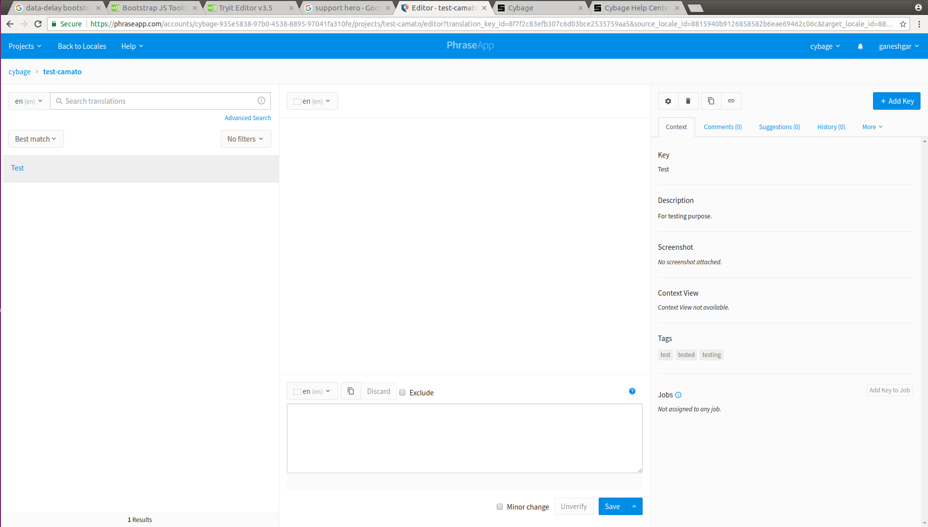

7.2 SupportHero
SupportHero show your knowledge base where your users need it the most, right within your app and reduce the number of incoming support tickets
SupportHero Interface - .

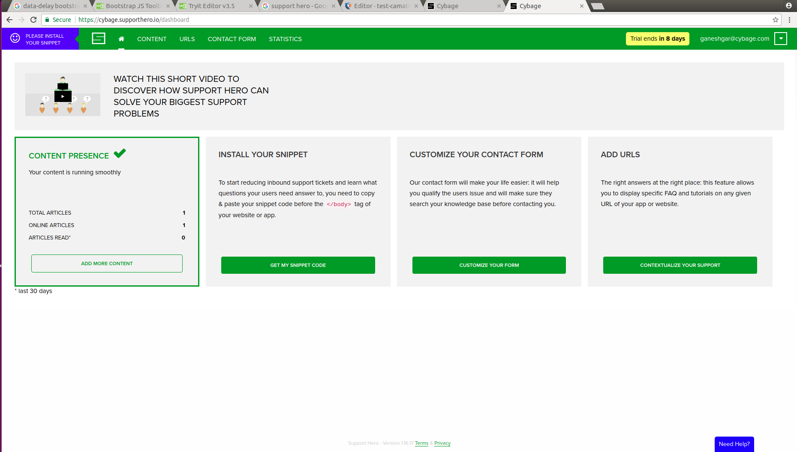

Theme

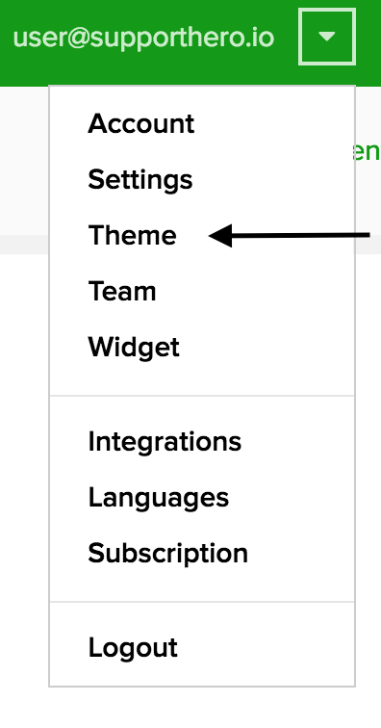
You'll find there two sections: "Theme style", where you'll be able to customize your skin with your own design, and "Content options" where you can define what you want to show on your Help Center home page.

1) Theme style
- Theme color
The first option of this screen is the main color of your Help Center. This color will be applied to every links and skinned section of your Help Center to match your own design requirements. This is the same option you had previously.

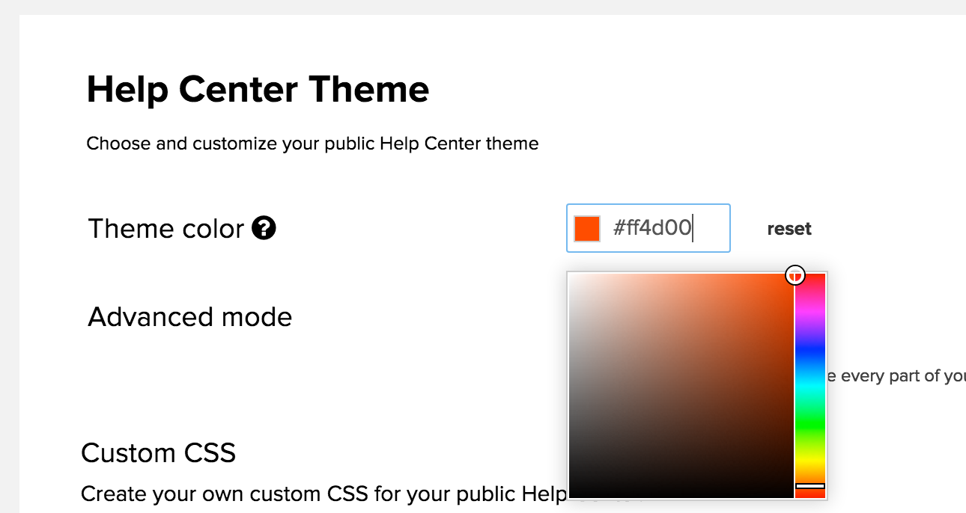

- Custom CSS
Now you have the ability to set your own custom CSS if you want to. Just check the Advanced mode checkbox, and write your CSS in the text area below. Our inline CSS editor will help you format your CSS properties and ensure that it's a valid stylesheet.

On the example below, you can see a few options to customize your Help Center.

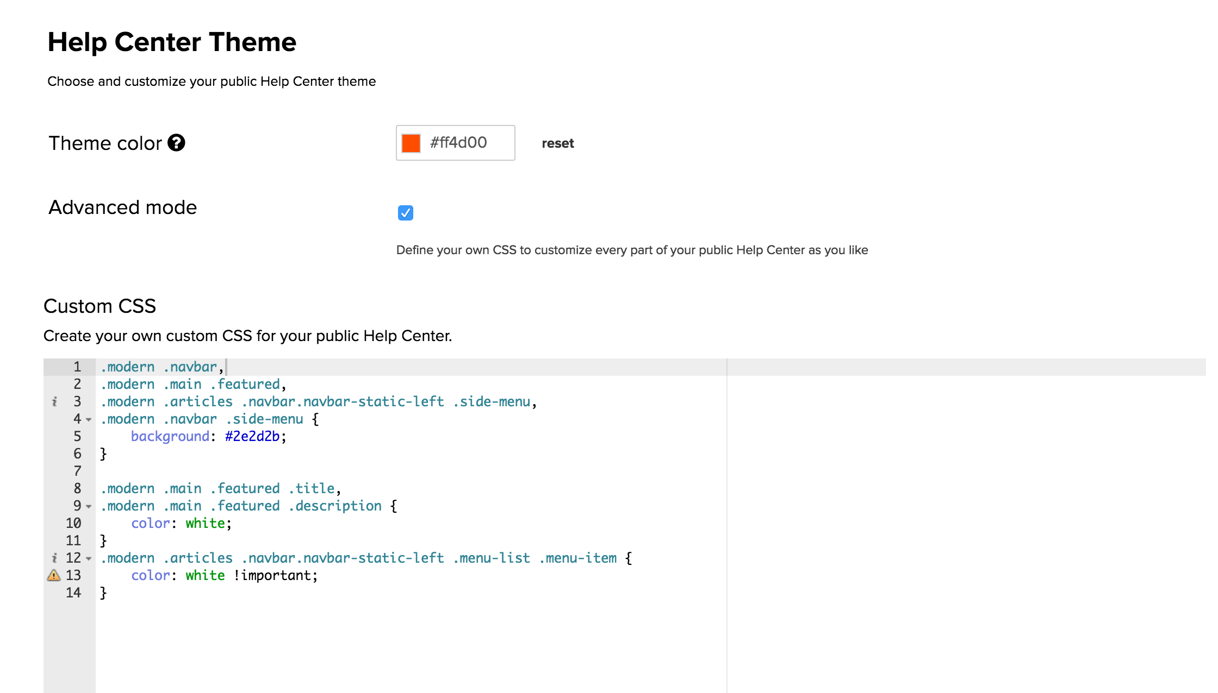

Here we used only a few lines of CSS as follow:

First, we add a black background on our navigation bar

.modern .navbar,
.modern .main .featured,
.modern .articles .navbar.navbar-static-left .side-menu,
.modern .navbar .side-menu {
background: #2e2d2b;
}
Then we need to set a white color on the title and description on the Home page as our background is black.
.modern .main .featured .title,
.modern .main .featured .description {
color: white;
}

Finally, we add the white color again on the menu links of the other pages, still because of our new black background, to keep everything readable (note here that we use the !important to be sure to override other styles. It may be the case on some elements of the page)

.modern .articles .navbar.navbar-static-left .menu-list .menu-item {
color: white !important;
}
And this is how it looks when you go to the Help Center home page:

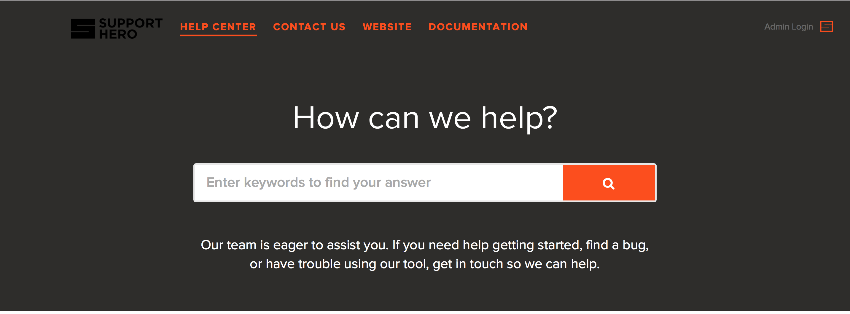

2) Following CSS classes can be used for adding styling to tables in SupportHero.
1] .table-orange -
This CSS class can be used to add styling for table with orange background. The example is given below.
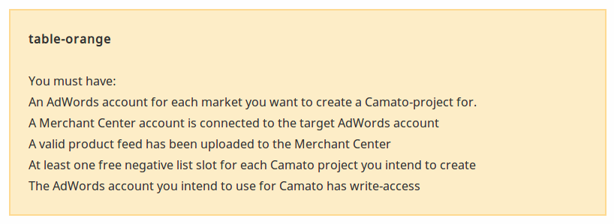
Use of .table-orange class –

<table class="table-orange">
<tbody>
<tr>
<td>
<strong>table-orange<br></strong>
<br>You must have:<br> An AdWords account for each market you want to create a Camato-project for.<br>
A Merchant Center account is connected to the target AdWords account
<br>A valid product feed has been uploaded to the Merchant Center
<br>At least one free negative list slot for each Camato project you intend to create
<br>The AdWords account you intend to use for Camato has write-access
</td>
</tr>
</tbody>
</table>
2] .table-gray -
This CSS class can be used to add styling for table with gray background. The example is given below.

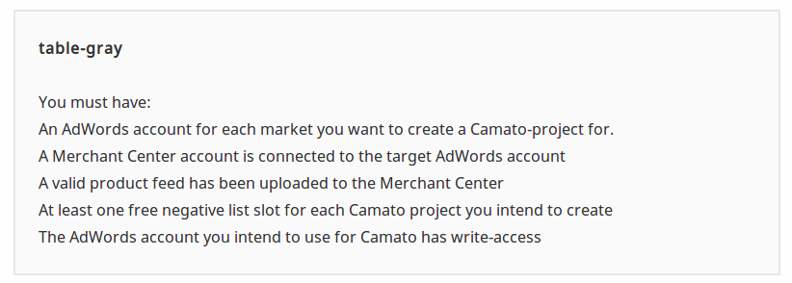

Use of .table-gray class –
<table class="table-gray">
<tbody>
<tr>
<td>
<strong>table-gray<br></strong>
<br>You must have:<br>An AdWords account for each market you want to create a Camato-project for.
<br>A Merchant Center account is connected to the target AdWords account&nbsp;
<br>A valid product feed has been uploaded to the Merchant Center&nbsp;
<br>At least one free negative list slot for each Camato project you intend to create&nbsp;
<br>The AdWords account you intend to use for Camato has write- access
</td>
</tr>
</tbody>
</table>

3] .table-flat -
This CSS class can be used to add styling for table with gray table header. The example is given below.
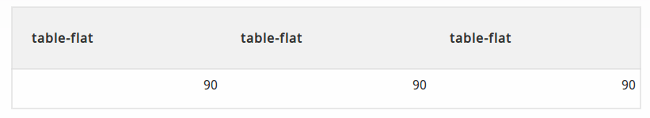
Use of .table-flat class –

<table class="table-flat">
<thead>
<tr>
<th>table-flat</th>
<th><strong>table-flat</strong></th>
<th><strong>table-flat</strong></th>
</tr>
</thead>
<tbody>
<tr>
<td>90</td>
<td>90</td>
<td>90</td>
</tr>
<tr>
<td></td>
<td></td>
<td></td>
</tr>
</tbody>
</table>

Configurations
- Commands –

- Starting Project -
Go to project root directory and type following command to start the application.

> sudo ./run.sh

- Starting Unit Testing -
Go to project root directory and type following command to start the unit testing.

> sudo ./test_single.sh
- PhraseApp -
Go to project root directory and type following command to use PhraseApp.

> PHRASEAPP_TOKEN=73b11b0d03a253506978662d25eda00b2485cd929636b7d8b4b84e602e6de4aa && grunt i18n:update
- Unit Testing Coverage -
Go to project root directory and type following command to get the unit testing coverage report.

> grunt test:coverage_html
Report Directory –

camato-frontend/test/coverage/html/index.html>
- React-Monorepo specific configurations –

Modify docker-compose.yml file by removing following highlighted fields.

version: '2'
networks:
default:
external:
name: crealytics
services:
# build/deployment
camato_frontend_build:
build:
context: .
environment:
- SSH_AUTH_SOCK=/ssh-agent
volumes:
- $SSH_AUTH_SOCK:/ssh-agent
- .:/app
command: './docker/build.sh'

## development
# base
camato_frontend_dev_base: &camato_frontend_dev_base
build:
context: .
volumes:
- .:/app:delegated
- $SSH_AUTH_SOCK:/ssh-agent

# integration server
camato_frontend_app:
<<: *camato_frontend_dev_base
command: './docker/dev_app.sh'
env_file: '.env'
ports:
- 127.0.0.1:12041:9001
- 127.0.0.1:12049:12049

# development server
camato_frontend_dev_server:
<<: *camato_frontend_dev_base
command: './docker/dev_server.sh'
env_file: '.env.development'
ports:
- 127.0.0.1:12041:9001
- 127.0.0.1:12048:9000
- 127.0.0.1:12049:12049

# test runner
camato_frontend_dev_test:
<<: *camato_frontend_dev_base
command: './docker/dev_test.sh'
environment:
- MESOS_ENVIRONMENT=test
ports:
- 127.0.0.1:12047:9876

# single test run
camato_frontend_dev_test_single:
<<: *camato_frontend_dev_base
environment:
- MESOS_ENVIRONMENT=test
command: './docker/dev_test_single.sh'

# generate html coverage report
camato_frontend_dev_html_coverage:
<<: *camato_frontend_dev_base
environment:
- MESOS_ENVIRONMENT=test
command: './docker/dev_html_coverage.sh'

Also copy following folders in project root directory –

> camato-react-common

> camato-react-web

