* the menu of the food and beverage offered (if applicable)

- We will provide this a few days before opening the hotel.

* details of the events and facilities offered

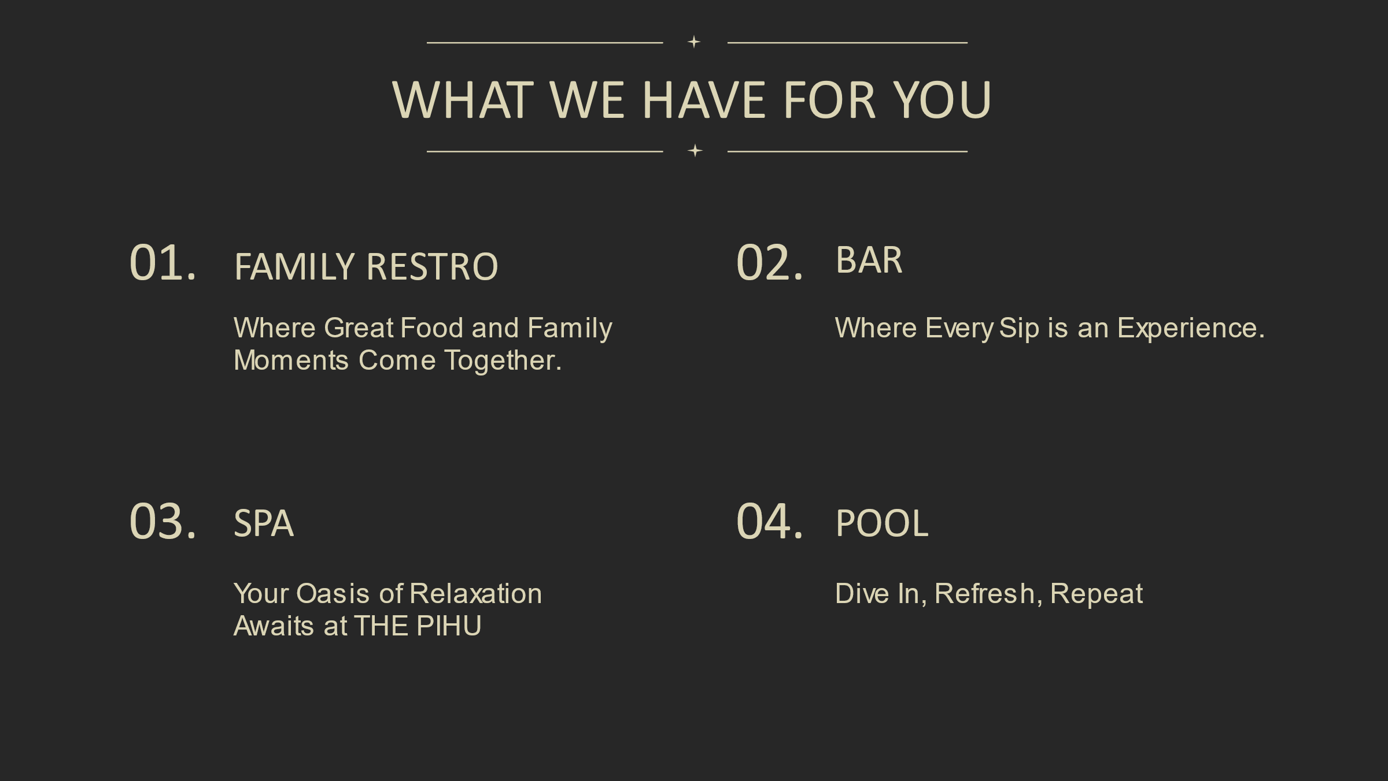

1. . we have a multi cuisine restaurant. where we provide various type of food like Indian Chinese Thai continental.
2. You can now enjoy a variety of drinks like beer, wine, whiskey at our bar and make your experience even more memorable.
3. Enjoy the tranquility as our efficient spa works to melt away your stress, leaving you refreshed and rejuvenated.
4. Relax and unwind by our exquisite hotel pool, where sparkling waters and serene surroundings await to rejuvenate your senses
5. Unveil the beauty of nature and celebrate under the open sky at our enchanting event lawn. Where moments become memories and dreams take flight
6. Get ready to dance the night away with your electrifying beats, brought to you by your sensational new DJ. Feel the rhythm, embrace the music, and let the party ignite at The Pihu

Also we have events on daliy basis ( like we will invite some popular dancers , singers and some celebrities )

* brief information on the features we intend on implementing in the future?

Features: 1. Exciting membership plans

2. pre planed daily events

3. free pick up and drop on request

4. all new concept in this area

5. Bar and cocktail hour counter

6. spa

7. DJ and Dance floor

Our planning for the future is that we will change the theme of our hotel every 6 months so that you can get rid of the trouble of getting bored with the same one again and again.

* high resolution images and videos of the resort

- We will provide this a few days before opening the hotel.

* high resolution logo of the resort
* information on the location and surrounding areas
* contact details (eg. email, phone numbers etc)
* the t&c and privacy policy