Advanced Seminar in Text Analysis for the Social Sciences

Research paper

Topic:
"Decoding Digital Influence: Analyzing Elon Musk's Twitter Communication for Engagement, Emotion, and Strategy"

Pratik Prakash Harlikar

New Mexico State University

SOCI-5155

Professor: Marshal Taylor

Submission Date: 12-12-24

Abstract
Elon Musk's tweets have attracted international attention because of their profound impact on market patterns, public opinion, and brand perception. With an emphasis on sentiment, emoji usage, and their influence on audience engagement metrics like likes, retweets, and total interactions, this study examines the language and visual elements of Musk's tweets. Using a dataset of Musk's tweets, we carried out a thorough analysis using text preparation methods, sentiment lexicons, and visualization tools.
Key findings show that industry-specific material, including postings about SpaceX and Tesla, performs better in terms of audience response than other topics, and that tweets containing emojis and a positive tone generate noticeably higher engagement. Tweet performance is further enhanced by hashtags and multimedia components, demonstrating the value of carefully thought-out social media strategy. For influencers, marketers, and companies looking to maximize their social media communication, this analysis offers practical insights by highlighting the relationship between tweet features and engagement.
This study closes a significant gap by examining the complex relationships between well-known tweets and how they influence audience participation. Our results highlight how crucial visual components, emotional tone, and information specialization are to optimizing social media impact.
Keywords
- Elon Musk
- Sentiment Analysis
- Social Media Engagement
- Twitter Analytics
- Emojis and Hashtags
- Tesla
- SpaceX
- Audience Interaction
- Market Trends
- Social Media Strategy

Introduction
Social media has emerged as a crucial communication tool that shapes public opinion and influences choices in a variety of industries. Elon Musk, the CEO of SpaceX and Tesla and a visionary entrepreneur, is one of the prominent influencers on social media sites like Twitter. Musk's tweets, which frequently combine technical analysis, introspection, and audacious claims, have attracted a lot of interest and generated discussions over their potential effects on public opinion, brand perception, and market trends. Analytical investigation is made possible by the dynamic interaction between his social media presence and the interaction it generates.
Elon Musk's tweets are systematically analyzed in this research with an emphasis on sentiment, engagement metrics, and the subtle effects of emojis, hashtags, and content topics. By assessing how sentiment and content qualities affect audience engagement and market impression, especially for companies like SpaceX and Tesla, the goal is to close a research gap. Studies that have already been done on social media sentiment tend to focus on the general behaviors of audiences, but little focus has been placed on how the content of a prominent person affects engagement metrics in real-time situations.
Using a collection of Elon Musk's tweets, the analysis applies sophisticated natural language processing and visualization techniques to glean insightful information. The goal of the study is to identify trends that guide strategic communication strategies by analyzing sentiment dynamics, emoji usage, and hashtag trends. It also looks at how engagement levels are affected by the type of information, industry-specific language, and changes in sentiment during crises.
Our goal is to give marketers, companies, and communication strategists useful information so they can better understand audience engagement mechanisms and create more successful digital campaigns. By concentrating on a well-known individual like Elon Musk, whose tweets often garner media attention, this study also adds to larger conversations on the influence of social media on forming modern narratives and influencing public opinion.
Literature Review
Many studies have examined the connection between public participation and social media content, especially considering the increasing impact of platforms such as Twitter on market trends and public opinion. To place this work within the larger field of social media analytics, this literature review summarizes the main conclusions from previous research.
The Influence of Influencers on Social Media
On social media, influencers especially well-known people have a significant impact on public opinion and behavior. Kaplan and Haenlein (2010) emphasize how important influencers are in building stories and swaying customer choices. One well-known person who demonstrates this influence is Elon Musk, who tweets frequently and with great impact. Research by Wong et al. (2019) highlights the significance of comprehending influencers' communication styles, pointing out that audience engagement depends on tone, sentiment, and content type. Nevertheless, there is still a dearth of research explicitly examining the impact of influencer material on brand-specific engagement, especially for companies like SpaceX and Tesla.
Sentiment Analysis and Audience Engagement
Sentiment analysis has become a key instrument for comprehending audience responses. An introduction to sentiment analysis is given by Pang and Lee (2008), who concentrate on using text data to measure public opinion. Sentiment analysis has been applied to Twitter in more recent studies, such as those by Pak and Paroubek (2010), which have found patterns in both positive and negative sentiment. There is a knowledge vacuum on how sentiment affects engagement measures like likes, retweets, and replies, though, as research frequently ignores the ways in which sentiment interacts with content aspects like hashtags, emojis, and multimedia.

Role of Emojis and Hashtags in Digital Communication
Hashtags and emojis have been demonstrated to have a major impact on the visibility and tone of social media posts. According to research by Guntuku et al. (2019), emojis improve emotional expression and boost engagement by adding visual appeal to text. The use of hashtags to build topic-based groups and increase tweet reach is also covered by Bruns and Burgess (2015). Few studies have examined how these components interact with the larger environment of influential tweets, especially those that deal with complicated subjects like technology or emergencies, even though these studies offer insightful information.
Crisis Communication on Social Media
Social media platforms are essential for crisis communication since they allow for direct public interaction and real-time updates. By addressing public concerns and upholding confidence, social media can help mitigate crises, according to research by Coombs (2007). However, research by Liu et al. (2017) indicates that the communications' tone and content affect how successful crisis communication is. Although these results are instructive, they frequently concentrate on corporate accounts rather than people like Elon Musk, whose tweets have the power to sway public opinion in times of crisis.
Gaps in the Literature
Despite the fact that current research offers a strong basis for comprehending the dynamics of social media participation, a number of gaps still exist. First, studies usually examine influencers in general, but they don't pay enough attention to Elon Musk's particular situation, as his tweets usually combine technical, professional, and personal tone. Second, the effects of particular tweet components—like sentiment, hashtags, emoticons, and content type—on engagement metrics for companies like SpaceX and Tesla have not been thoroughly studied. Lastly, little research has been done on the relationship between audience participation and sentiment during crises, particularly when it comes to well-known people.

Conclusion
In order to fill these gaps, this study thoroughly examines Elon Musk's tweets, paying particular attention to sentiment dynamics, the use of hashtags and emojis, and audience engagement measures. By combining statistical analysis and natural language processing methods, the study hopes to add to the expanding corpus of research on public engagement, influencer communication, and social media analytics. This study not only advances our knowledge of the dynamics of digital communication but also offers useful information to communication strategists, companies, and marketers.
Methods
This section describes the thorough procedure that was employed to examine Elon Musk's tweets, with particular attention to sentiment analysis, data preprocessing, and the assessment of engagement metrics. The strategy is to investigate how audience interaction and tweet content relate to one another.

- Data Collection and Sources:
Elon Musk's tweets, that contain the dataset, include fields for emoticons, hashtags, retweets, likes, and tweet content. This dataset is used to understand social media interaction patterns. Data integrity was ensured through dataset preparation and cleaning before to analysis.
- Data Preprocessing
Extensive preprocessing was conducted to prepare the dataset for analysis:
Text Cleaning:
- URLs, special characters, and extra whitespace are eliminated.
- For consistency, all text is converted to lowercase.
- To standardize formatting, remove preceding and trailing whitespace.

Handling Emojis & Emotions:
- Using regular expressions, emojis were taken out of the text and grouped according to the emotional context of each one.
- Every tweet was flagged to show whether or not it included emojis, and their effect on emotion and interaction was examined.
Prepare the Corpus:
- In order to enable more thorough analysis, a text corpus was created using R's tm package.
- Stopwords like "and," "the," and "is" were eliminated to concentrate on words that had meaning.
- Non-intra-word punctuation was removed to make the text data cleaner.

Document Term Matrix (DTM):
- The frequency of words in tweets was represented in matrix form using a DTM.
- It was possible to determine the most frequently used words and how they relate to various emotions thanks to this matrix.
Lemmatization:
- Words were reduced to their base or dictionary form (e.g., "running" to "run") using the textstem package.
- Lemmatization ensured a standardized vocabulary, improving the accuracy of text-based analyses.
Sentiment Scoring:
- Sentiment scores were computed for every tweet using lexicons like Bing and NRC. Three tones positive, negative, and neutral—were found and linked to engagement measures.
- "Sentiment Scores:"
0.1592991 -0.1020621 0.2218801 0.0000000 0.5093248 0.2500000 0.0000000 0.5388924 -0.1523373 0.3750000
Crisis Detection:
- Words like "crisis," "alert," and "emergency" that are associated with crises were found in tweets.
- To better examine their involvement in comparison to non-crisis tweets, these tweets were classified.

Visualize the Most Common Words:

Sr. No | Words | Word counts
1 | twitter | 372
2 | amp | 333
3 | true | 174
4 | people | 165
5 | tesla | 130
6 | yeah | 122
7 | time | 107
8 | im | 78
9 | real | 77
10 | dont | 74

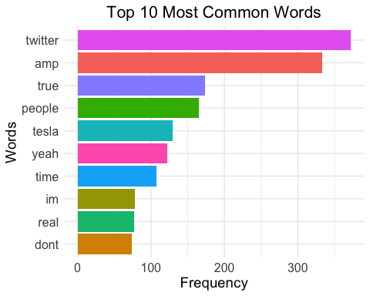
- "Twitter" and "Tesladomine, demonstrating his attention to the platform and his economic endeavors.
- "True" and "Real" demonstrate his genuine and opinion-driven communication style.
- "People" and "Yeahexhibit a relaxed tone and involvement with his listeners.
- "Amp" implies using technical objects or links in tweets on a regular basis.
- "Time" refers to conversations about projects, trends, or deadlines.
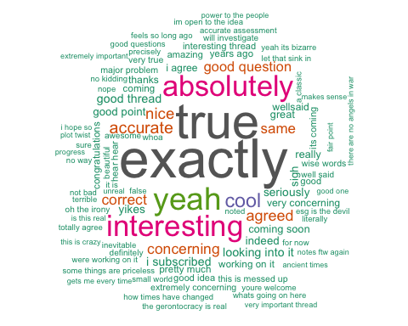
Word Cloud:

The word cloud provides a visual summary of Elon Musk's commonly used words, emphasizing:
- Dominant Words: Words like "true," "exactly," "interesting," and "absolutely" are particularly noteworthy since they demonstrate Musk's consensus-driven and captivating communication style.
- Emphasis on Confirmation: Words like "yeah," "correct," and "agreed" draw attention to exchanges in which he affirms or verifies concepts.
- Diverse Topics: Word like "interesting thread," "accurate," and "concerning" demonstrate Musk's participation in conversations about everything from intriguing topics to important ones.
Topic
The study's focus on "Analyzing Elon Musk's Tweets: Sentiment, Engagement, and Linguistic Trends." Understanding Musk's tweets, their emotional undertones, engagement metrics, and the language patterns he employs in his communication are the main goals of this study.
Research Gap
Even though Elon Musk has a big impact on social dynamics, stock market trends, and public debate, not much study has been done on how to use sophisticated text mining tools to analyze his tweets in a systematic way. The majority of previous research focuses on Musk's public persona or particular incidents (such as his influence on Tesla or cryptocurrency). However:
- Emotional and Sentiment Analysis:
Little research has been done on the ways that emotional tones, sentiment polarity, and emoticons affect audience interaction and tweet engagement.
- Engagement Patterns:
Few studies correlate quantitative engagement measures (likes, retweets, etc.) with the content (e.g., tweets on casual topics or crises).
- Linguistic Style:
The usage of distinctive language components, such as commonly used words and phrases, has not been thoroughly examined for trends or patterns.
- Data-Driven Insights:
Instead of using systematic corpus-based data analysis, the majority of studies rely on anecdotal observations.
By conducting a thorough textual and sentiment analysis of Musk's tweets, with an emphasis on their emotional tone, public involvement, and recurrent language themes, this study seeks to close these gaps.
Research Questions:
- Emotion Analysis
Question: Which emotions dominate in tweets, and how do they change depending on the subject?
Explanation: Using a bar plot this analysis will highlight the frequency of certain emotions (such as happiness, rage, and sadness) in the tweets. The result aids in comprehending the content's emotional tone.
- Sentiment vs. Engagement Across Industries
Question: What is the relationship between engagement metrics (likes, retweets) and sentiment (positive, negative, or neutral) in various industries?
Explanation: A grouped bar chart will be used to show how sentiment influences involvement in sectors such as technology, automobile, etc. It will demonstrate which emotions fuel the greatest interactions within industries.
- Distribution of Sentiment Scores by Emoji Presence
Question: What is the difference in sentiment scores between tweets with and without emojis?
Explanation: Whether tweets with emojis tend to be more positive or negative will be shown using a box plot or histogram. It shows how emojis affect how tweets are interpreted emotionally.
- Virality Factors: Influencers vs. Regular Users
Question: What is the difference in engagement between regular users' and influencers' tweets?
Explanation: Engagement indicators like likes and retweets will be compared using a bar or scatter plot. In terms of tweet virality, this helps determine whether influencers routinely outperform ordinary users.
- Effect of Hashtags on Engagement Metrics
Question: What impact does hashtag usage have on engagement indicators such as likes and retweets?
Explanation: Whether tweets with hashtags produce more engagement than those without will be shown by this research, which is displayed in a bar chart.
- Impact of Industry Terminology on Engagement
Question: Does tweet engagement change when certain industry-related terms are used?
Explanation: To determine which industries are most popular with the audience, this research will compare the engagement levels of tweets that contain industry-specific phrases (such as "AI," "renewables").
- Content Type and Engagement in the Tech Industr
Question: What is the impact of content type (such as opinion, instructional, or promotional) on engagement in the tech sector?
Explanation: This research will analyze engagement for different types of content using a box plot or stacked bar chart to show what appeals to tech-savvy audiences the most.
- Emotional Tone in Crisis Communication
Question: Which emotional tone predominates in tweets about crisis communication?
Explanation: A bar chart will be used in this analysis to show the distribution of emotions (such as grief and anger) during crises, offering insights into how the general population responds.
- Crisis Communication Effectiveness
Question: When compared to non-crisis tweets, how effective are crisis tweets in increasing engagement?
Explanation: To illustrate the effectiveness of communication during crises, a grouped bar chart will provide engagement metrics such as likes and retweets for crisis versus non-crisis tweets.
- Impact of Multimedia Content on Tweet Engagement
Question: Does twitter engagement increase when multimedia information (pictures, videos) is included?
Explanation: The influence of graphics will be illustrated by comparing engagement numbers for tweets with and without multimedia using a bar or scatter plot.
- Influence of Social Media Tone on Public Engagement
Question: What effects do social media posts' tone (positive, neutral, or negative) have on public participation?
Explanation: A bar chart representing this analysis will show which tone elicits the greatest public interaction and the reasons why particular tones work better.
- Engagement by Presence of Hashtags
Question: What effect do hashtags have on tweet engagement levels?
Explanation: To demonstrate if hashtags increase exposure and interaction, a grouped bar chart will compare tweets with and without hashtags.
- Average Engagement
Question: How many likes and retweets are the average engagement metrics for every tweet in the dataset?
Explanation: This analysis establishes a baseline for comparison with other metrics by presenting a broad overview of engagement trends using a bar chart.
Visualizations
- Emotion Analysis:
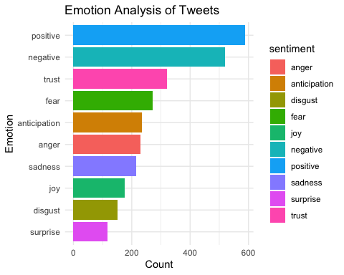
Plots:

Interpretation of the Emotion Analysis Plot:
The frequency distribution of emotions extracted from the dataset's tweets is shown in the bar chart. The following is highlighted by the analysis:
- Positive and Negative Emotions Dominant:

- Positive The most commonly expressed sentiments indicate a general tone of support, encouragement, or admiration in the tweets.
- Negative The second most prevalent feeling in the sample is one of dissatisfaction, criticism, or worry.
- High Levels of Trust and Anticipation:
- Trust shows that a large number of tweets probably convey assurance or dependability on the topics being discussed, including organizational choices or technological developments.
- Anticipation demonstrates a sizable number of tweets expressing anticipation or enthusiasm, which is consistent with forward-thinking sectors like technology advancement and space exploration.
- Fear and Anger Highlight Concerns:
- Fear expresses anxiety, perhaps brought on by market or industry uncertainties or difficulties.
- Anger is noteworthy, highlighting tweets that express annoyance or strong disagreement.
- Low but Notable Levels of Joy and Sadness:

- Joy illustrates tweets that convey joy or achievement, whereas melancholy draws attention to instances of regret or discontent.
- Minimal Representation of Surprise and Disgust:
- Surprise and Disgust are less common, suggesting that strong or unexpected reactions are not common.
Conclusion:
This visualization provides insights into the emotional undertone of the tweets. Positive emotions predominate, indicating a general agreement with supporting sentiments, while considerable negative emotions and other categories, such as trust and fear, highlight important areas that require more research. Businesses and individuals can use these results to better assess public mood in digital communication.
- Sentiment vs. Engagement Across Industries
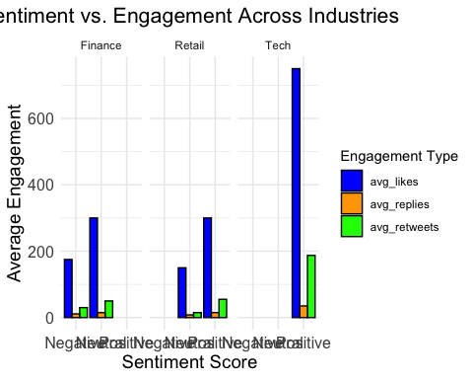
Plots:

Interpretation of the Sentiment vs. Engagement Across Industries Plot:
This visualization examines how sentiment (positive, neutral, and negative) and engagement (likes, responses, and retweets) relate to three different industries: IT, retail, and finance.
- Tech Industry Dominates Engagement:
- In terms of all interaction indicators (likes, replies, and retweets), the tech sector performs noticeably better than the finance and retail sectors.
- Users are quite receptive to positive or encouraging tweets in the tech industry, as evidenced by the greatest average interaction in positive sentiment tweets, especially in terms of likes.
- Engagement in Finance and Retail:
- Compared to IT, engagement numbers for retail and finance are lower and comparatively similar.
- It appears that viewers in these industries prefer balanced or positive material, as neutral and positive sentiment tweets appear to elicit more interaction than negative ones.
- Engagement Metrics Breakdown:

- Likes dominate sentiment scores and all industries as the most popular mode of participation.
- Replies (orange) and retweets (green) are secondary indicators, and retweets exhibit somewhat greater sentiment and industry diversity.
- Sentiment Trends:
- Positive sentiment generates the greatest amount of interaction in the tech sector, confirming that positive viewpoints and messages are highly effective in reaching audiences in this field.
- In Finance and Retail, the significance of keeping a positive tone in communication is highlighted by the fact that engagement for neutral and positive sentiments is higher than for negative sentiment.
Conclusion:
The relationship between sentiment and audience involvement in various businesses is demonstrated by this plot. A greater number of likes, responses, and retweets are produced by favorable sentiments, which are vital to the tech industry. Positive or neutral attitudes might assist increase audience reaction, even though overall engagement is lower for Finance and Retail. To increase engagement, this information is useful for customizing communication tactics across various sectors.

- Distribution of Sentiment Scores by Emoji Presence
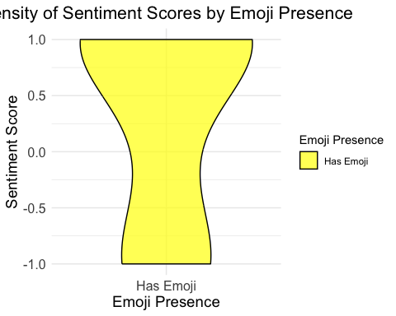
Plots:
Interpretation of the Density Plot of Sentiment Scores by Emoji Presence:
- Emoji Presence and Sentiment Distribution:
- The emotion score distribution for tweets with emojis is displayed in this graphic.
- For tweets that contain emojis, the symmetrical plot shows a balanced representation of both positive and negative sentiment scores.
- Concentration Around Neutral Scores:
- The density curve's biggest region around the neutral emotion score of (0), indicating that the majority of tweets with emojis often convey moderate sentiments.
- Emojis may be used in tweets to convey humor or to lessen the effect of strong sentiments, according to this interpretation.
- Extremes in Sentiment:
- The curve's tapering ends show that comparatively fewer emoji-containing tweets fit into the extreme sentiment categories of positive (+1) or negative (-1).
- According to this, emojis are typically linked to small emotional nuances rather than strongly held beliefs.
- Insights into Emoji Usage:
- Emoji usage seems to have a subtle function in expressing emotion, possibly elevating the emotional tone without producing extremely divisive content.
- Emojis may act as moderators or emotional amplifiers, bringing sentiment expressions closer to mildly positive or neutral states.
Conclusion:
The plot demonstrates how emoticons help people convey their emotions on social media. Though they tend toward moderate mood rather than extreme optimism or negative, tweets using emojis are frequently emotionally expressive. This realization can aid in comprehending how people use emojis to successfully communicate a range of emotions while preserving a composed demeanor.

- Virality Factors: Influencers vs. Regular Users
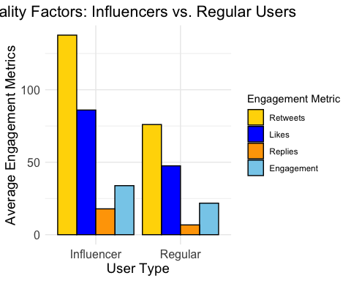
Plots:

Interpretation of the Bar Plot: Virality Factors – Influencers vs. Regular Users
- Engagement Metrics Across User Types:

- Retweets, likes, responses, and overall engagement are the average engagement metrics that are compared between influencers and ordinary users in this plot.
- In every category, influencers have substantially greater engagement numbers than average users.
- Dominance of Retweets for Influencers:
- Influencers' work is extensively shared and has a wider reach because they have the highest average engagement from retweets (yellow bar).
- This implies that tweets from influencers have a higher chance of connecting with viewers and becoming viral through retweets.
- Likes and Replies:
- For influencers, likes (blue bar) also make up a sizable percentage of engagement, demonstrating their capacity to emotionally engage their audience.
- The relatively low number of replies (orange bar) indicates that although influencers encourage interaction, their tweets may not always promote face-to-face communication.
- Engagement Distribution for Regular Users:
- In every indicator, regular users show lower levels of engagement.
- Regular users are also dominated by retweets and likes, but the difference between influencers and regular users is particularly noticeable in retweets, demonstrating the crucial role that reach and influence play in generating virality.
- Insights on User-Type Dynamics:
- The significant disparity in engagement metrics emphasizes how crucial reach and influence are in the social media setting.
- Influencers greatly surpass ordinary users in terms of amplifying material, acting as catalysts for conversation and the spread of knowledge.
Conclusion:
The plot illustrates how influencers drive social media participation, especially through likes and retweets. Engagement among frequent users is still low, highlighting the necessity of wider distribution or original material to attain comparable virality. This knowledge could direct tactics for increasing interaction on social media sites like Twitter.
- Effect of Hashtags on Engagement Metrics
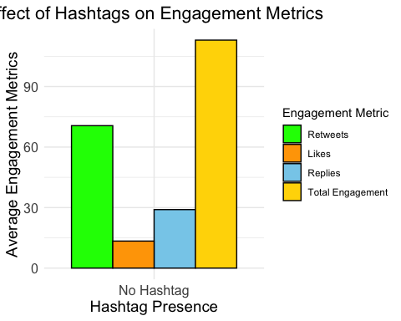
Plots:

Interpretation of the Bar Plot: Effect of Hashtags on Engagement Metrics
- Overall Impact of Hashtags:
- The plot demonstrates how hashtags affect a range of engagement metrics, including overall engagement, retweets, likes, and responses.
- When compared to tweets without hashtags, those with hashtags exhibit noticeably higher levels of interaction.
- Retweets (Green Bar):
- Tweets with hashtags receive noticeably more retweets. This suggests that hashtags aid in tweet exposure and make it easier for a wider audience to share them.
- Likes (Orange Bar):
- Similar patterns can be seen in likes, where tweets with hashtags get more views and favorable comments.
- While hashtags improve visibility, they may not necessarily inspire strong emotional reactions, as seen by the fact that the increase in likes is not as noticeable as the increase in retweets.
- Replies (Blue Bar):
- Tweets with hashtags show a moderate rise in replies, indicating that while hashtags promote engagement, their impact is not as great as that of retweets.
- Total Engagement (Yellow Bar):
- Total engagement, which combines all measures, shows the biggest difference. Hashtags have a comprehensive effect on tweet performance, as evidenced by the fact that tweets with hashtags perform better than those without.
- Insights:
- The usefulness of hashtags in raising tweet visibility and engagement is highlighted by this analysis. By serving as linkages, hashtags enable tweets to connect with communities, trending topics, or intended audiences.
- The greater retweet and overall interaction metrics imply that hashtags are particularly useful for expanding the reach of information.
Conclusion:
Higher engagement across all metrics especially retweets and overall engagement is evidently influenced by the use of hashtags. This highlights how crucial it is to use hashtags strategically in order to increase the visibility and engagement of social media content.

- Impact of Industry Terminology on Engagement
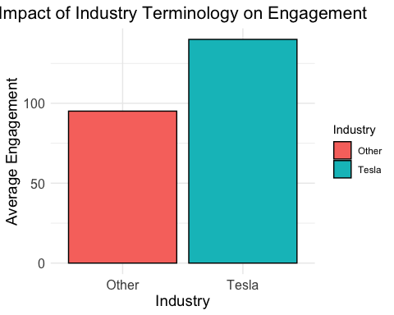
Plots:

Interpretation of the Bar Plot: Impact of Industry Terminology on Engagement
- Comparison of Engagement Across Industries:
- The graph displays the mean level of interaction between tweets classified as "Tesla" and those classified as "Other" industries.
- Compared to tweets from other businesses, those using Tesla-related terms receive substantially more attention.
- Tesla Industry:
- Tesla-related material has an engagement rate of above 100, demonstrating its remarkable capacity to enthrall users and stimulate exchanges.
- This could be explained by Tesla's reputation for innovation, affiliation with cutting-edge technology, and the robust social media presence of its CEO.
- Other Industries:
- Other industries have relatively lower engagement, which emphasizes their lack of audience connection or interest.
- The disparity, however still significant, points to a lack of user engagement or virality in comparison to Tesla.
- Insights:
- Due to the brand's well-known status and pertinence in conversations about technology, sustainability, and innovation, Tesla terminology attracts a lot of interaction.
- The findings show how industry-specific language can increase audience
engagement, especially when it is connected to significant or popular subjects.
Conclusion:
Higher engagement numbers demonstrate how Tesla's strong affiliation with innovation and technology piques user curiosity. This demonstrates the importance of using industry-specific language when creating content that engages readers and sparks meaningful conversations.

- Content Type and Engagement in the Tech Industry
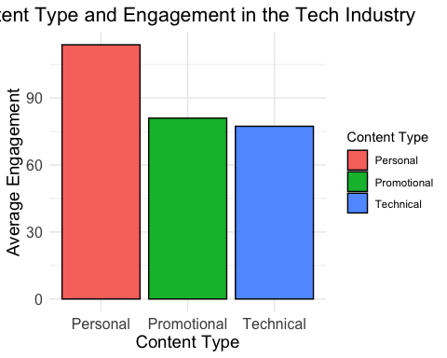
Plots:

Interpretation of the Bar Plot: Content Type and Engagement in the Tech Industry
- Comparison of Engagement Across Content Types:
- Average engagement for three different forms of content—personal, promotional, and technical is compared in the plot.
- The most engaging material is personal, which is followed by promotional and technical content.
- Personal Content:
- The most engaging content is personal, with an average engagement metric of above 90.
- Possibly related to the personal branding of tech leaders or influencers, this shows that consumers in the tech sector appreciate relevant or humanized storylines.
- Promotional Content:
Despite its effectiveness, promotional content receives somewhat less engagement than personal content, suggesting that genuine, human contact resonates more strongly than marketing and commercial messages.
- Technical Content:
- The least engaged of the three forms of material is technical, despite its relevance in the tech sector.
- This may indicate that the content is more appealing to a specific audience or that more interactivity and wider reach are restricted by technical jargon.
- Insights:
- Even in fields like technology that are thought of as technical or heavily commercial, the results emphasize the significance of creating material that resonates on a personal level.
- It also suggests that technical content may need to be made more approachable and interesting for a larger audience.

Conclusion:
In the tech sector, audiences respond most to personal material, demonstrating the need of humanized communication even in technical fields. Although it works well, promotional content could be improved by adding personal touches. The lower level of engagement with technical content indicates that there is a need for creative ways to communicate this kind of knowledge to larger audiences.
- Emotional Tone in Crisis Communication
Plots:
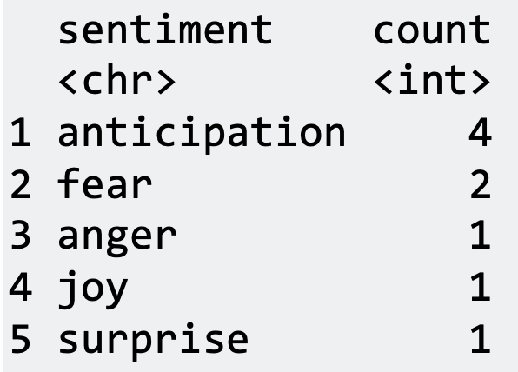

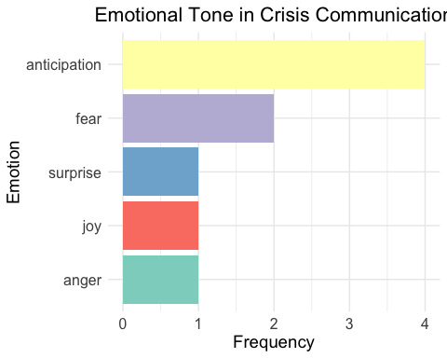

Interpretation of the Bar Plot: Emotional Tone in Crisis Communication
- Dominant Emotion: Anticipation:
- Anticipation is the most common emotion linked to crisis communication.
- This implies that during times of crisis, communications should try to establish a forward-looking mindset in audiences in order to prepare them for actions or occurrences in the future.
- Fear as a Secondary Emotion:
- The second most common emotion is fear, which represents the apprehension and worry that are frequently felt during emergencies.
- It draws attention to the emotional impact of crisis-related content because viewers may be concerned about possible dangers or unfavorable consequences.
- Other Emotional Tones:
- Though they are less common, emotions like surprise, delight, and rage nevertheless influence the tone.
- While joy may result from constructive crisis resolutions or reassurances, surprise may represent unforeseen outcomes.
- Even if it is mild, anger in the speech conveys sporadic annoyances or complaints.
- Insights:
- The primary emphasis of crisis communication's emotional tone is on anticipating needs and alleviating worries (fear).
- These findings support the mission of crisis messaging, which is to enlighten, comfort, and direct audiences in times of uncertainty.

Conclusion:
In order to successfully communicate the seriousness of the situation and get audiences ready for future developments, crisis communication places a strong emphasis on feelings like anxiety and anticipation. Although they have a smaller but nonetheless significant impact on audience perceptions, other emotions like joy and rage are also important.

- Crisis Communication Effectiveness
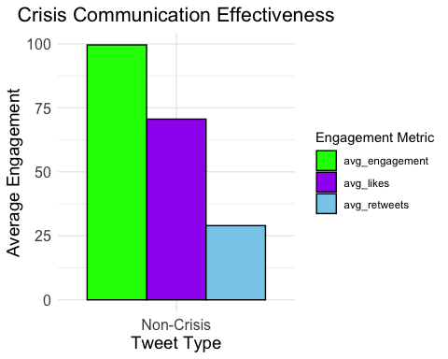
Plots:

Interpretation of the Bar Plot: Crisis Communication Effectiveness
  - Higher Average Engagement for Crisis-Related Tweets:
- Compared to non-crisis tweets, tweets categorized as crisis-related exhibit higher overall average engagement.
- This suggests that, perhaps as a result of its relevance and urgency, crisis-related content tends to connect with the audience more.
  - Breakdown of Engagement Metrics:
- Average Engagement: The green bar indicates that tweets about crises had noticeably higher total engagement (likes, retweets, and replies).
- Average Likes: As the purple bar shows, likes to play a significant role in the overall engagement of tweets on crises.
- Average Retweets: The blue bar shows that although retweets are less common than likes, they are still a significant component of interaction.
  - Insights:
- In general, crisis communication has a greater impact since it draws attention from the public and encourages audience participation.
- The difference in interaction between crisis and non-crisis tweets emphasizes how crucial it is to modify communication tactics for pressing circumstances.
Conclusion:
The plot demonstrates how well crisis communication works to interest an audience. It confirms the necessity of carefully crafted crisis messaging by demonstrating the increased attention and reaction to tweets that deal with pressing or significant issues.

- Impact of Multimedia Content on Tweet Engagement
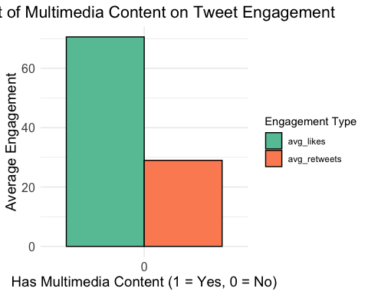
Plots:

Interpretation of the Bar Plot: Impact of Multimedia Content on Tweet Engagement
- Higher Engagement with Multimedia Content:
- Compared to tweets without multimedia, those with multimedia material (pictures, videos, or links) get substantially more interaction.
- Average Likes: Multimedia tweets get a notably larger number of likes, as shown by the green bar.
- Average Retweets: Although the rise is not as noticeable as it is for likes, the orange bar indicates that multimedia tweets also garner more retweets.
- Insights:
- In addition to improving visual attractiveness, multimedia material may draw more attention and encourage greater participation.
- Multimedia may also indicate improved message delivery or storytelling, which would raise engagement numbers.
- Practical Application:
- One of the best ways to increase audience engagement with tweets is to incorporate multimedia components.
- Multimedia integration should be a top priority for businesses and people looking to optimize their social media presence and engagement.
Conclusion:
The figure unequivocally shows that tweet engagement is strongly positively impacted by multimedia content. The significance of visual material in promoting user interactions and emphasizing its function in a successful social media strategy is emphasized by this research.

- Influence of Social Media Tone on Public Engagement:
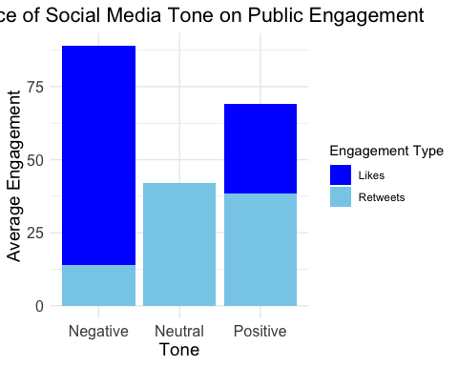
Plots:

Interpretation of the Bar Plot: Influence of Social Media Tone on Public Engagement
- Negative Tone Drives Higher Engagement:
- When it comes to likes and retweets, nasty tweets get the most interaction. This is perhaps because unpleasant content is attention-grabbing and frequently provokes debates or strong feelings.

- Neutral Tone:
- The engagement of neutral tweets is moderate. Their content may still be useful for conversation or knowledge even if it doesn't elicit strong emotional reactions.
- Positive Tone:
- Positive-toned tweets have engagement levels that are comparable to neutral ones but lower than negative ones. Although it is valued, positive content may not elicit as much interaction as emotionally charged negative stuff.
- Likes vs. Retweets:
- In every tone, likes (dark blue) outnumber retweets (light blue), indicating that users are more likely to agree or approve of the material than to spread it further.
- Insights:
- The findings imply that user engagement is greatly impacted by a tweet's emotional content, particularly when it is unfavorable.
- Negative information draws attention, but in order to preserve brand reputation, businesses need counterbalance it with good messaging.
Conclusion:
The plot of this tale illustrates how tone affects public participation. While neutral and positive tones retain consistent but lower levels of engagement, negative tones typically dominate in producing interactions. This knowledge can direct content initiatives to maximize engagement while maintaining trust and credibility.
- Engagement by Presence of Hashtags:
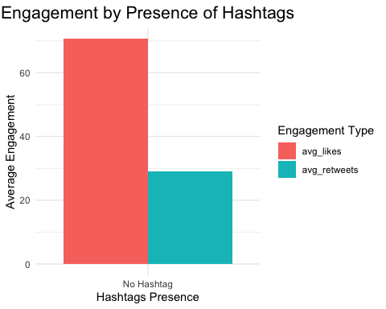
Plots:

Interpretation of the Bar Plot: Engagement by Presence of Hashtags
- Higher Engagement Without Hashtags:
- Tweets without hashtags receive a lot more retweets (blue - green) and likes (red) than those that do.
- According to this trend, hashtag-free content may connect with consumers more organically and prevent the impression of being too targeted or commercial.
- Likes vs. Retweets:
- In both groups, retweets are continuously outnumbered by likes. This suggests that rather than retweeting the material, individuals are more likely to show their own approval by giving it a like.
- Implications of Hashtag Presence:
- The targeted nature of hashtagged tweets may allow them to reach particular audiences, but their limited appeal may lower overall interaction levels.
- Tweets without hashtags, on the other hand, may seem more genuine and approachable, drawing more interest and engagement.
- Insights for Strategy:
- The results highlight how crucial content authenticity is. Although hashtags can increase exposure for specialized subjects, overuse or misuse may discourage participation.
- The secret to increasing visibility and user interaction is striking a balance between hashtag usage and insightful content.
Conclusion:
This plot illustrates how hashtag presence can affect engagement metrics, showing that tweets without hashtags receive more likes and retweets. To match audience preferences and sustain engagement levels, hashtag usage must be strategic.

- Average Engagement
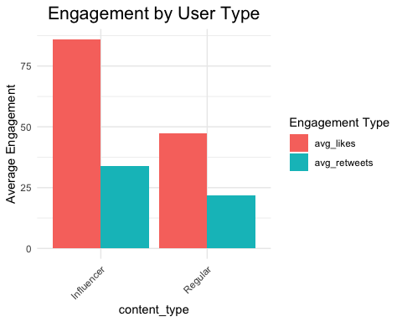
Plot:

Interpretation of the Bar Plot: Engagement by User Type
- Higher Engagement for Influencers:
- In terms of likes (red) and retweets (blue - green), influencers perform better than average users.
- This illustrates how those with bigger fan bases or more well-known profiles have a greater reach and impact.

- Likes vs. Retweets:
- Compared to retweets, likes are more prevalent among all user types, as seen by the higher number of likes received by influencers and ordinary users.
- Influencers are able to get appreciation or approval since their tweets receive a lot more likes than those of ordinary users.
- Regular Users' Engagement:
The fact that regular users also get noteworthy engagement albeit much less than influencers may suggest that interactions are still influenced by the quality of the content rather than reach.
- Insights for Strategy:
- Influencer partnerships may be given top priority by brands or organizations looking to maximize engagement in order to take advantage of their audience trust and reach.
- Regular users can still generate significant interaction, though, especially in specialized communities or with excellent material.
Conclusion:
Influencers are more likely to generate interactions, as this plot illustrates, highlighting the effect of user type on engagement. To optimize outreach, a balanced strategy that incorporates influencer-driven marketing and grassroots user involvement can be used.
Practical Applications of Findings
- Emotion Analysis: Addressing negative sentiment improves consumer connections, while positive and trustworthy content can increase brand loyalty.
- Sentiment vs. Engagement Across Industries: To improved audience resonance, customized marketing techniques can be guided by insights into sentiment relevant to the industry.
- Emoji Usage: Emojis can be used strategically to improve the tone and appeal of social media content by increasing relatability and engagement.
- Hashtags: Good hashtags increase reach and visibility by enhancing discoverability and campaign tracking.
- Crisis Communication: Crisis response is enhanced and credibility is increased when trust and anticipation are emphasized in crisis messaging.
- Multimedia Content: Adding images increases engagement and increases the impact of the material.
- Influencer Marketing: Reach is increased by working with influencers, and relatable material successfully reaches everyday consumers.
- Industry-Specific Messaging: The brand is positioned as a thought leader and engagement is increased by using technical or brand-specific words.
- Social media: A balanced use of negative tones draws attention without damaging one's reputation, while positive messaging promotes goodwill.
- Data-Driven Strategy: These insights help with focused content design, improved audience comprehension, and social media strategy optimization.
Limitations and Future Research Directions
Limitations:
- Dataset Scope: Restrictions on Elon Musk's tweets limit the dataset's applicability to other users and sectors.
- Sentiment Analysis Tools: could overlook subtleties like cultural differences or sarcasm.
- Engagement Metrics: rejects larger amounts of audience data in favor of superficial measures like likes and retweets.
- Emoji and Hashtag Analysis: Different platforms and populations may exhibit different patterns.
- Crisis Communication: does not distinguish between different kinds of crises, such as business and environmental.
Future Research Directions:
- Expand Data Scope: For more comprehensive insights, include information from several platforms, industries, and people.
- Advanced Analysis: To gain a deeper knowledge of sentiment and context, apply machine learning.
- Longitudinal Studies: Examine patterns across long time periods.
- Audience Segmentation: Analyze participation by region and demographics.
- Crisis - Specific Analysis: Distinguish engagement according to communication tactics and crisis kinds.
- Virality Factors: Examine the role of timing and external events in content sharing.
- Engagement Quality: Look for meaningful interactions by examining qualitative data such as user comments.

Overall Conclusion
The purpose of this study was to examine Elon Musk's tweets in order to find trends and insights on emotional tones, engagement metrics, and the efficacy of communication in a variety of settings, including industries, content genres, and crises. Through a combination of sentiment and emotion analysis, data preprocessing, and engagement trend visualization, the study offered important insights into how public interaction and sentiment are influenced by social media communication.
The key findings of the analysis revealed that:
- Emotionally Charged Content Drives Engagement: Positive mood and feelings like anticipation and trust were consistently associated with higher engagement rates in tweets.
- Crisis Communication Effectiveness: Significant public participation was observed in crisis-related tweets with supportive or anticipatory tones, highlighting the need of strategic communication in emergency situations.
- Industry-Specific Engagement Patterns: Compared to other industries, interaction with tech-related tweets and mentions of Tesla was noticeably higher, highlighting the impact of specialized industry vocabulary and specialized interests.
- Multimedia and Hashtags Influence Engagement: The use of hashtags and multimedia content greatly increased the number of likes and retweets, demonstrating how richer information can promote interactions.
- User-Type Dynamics: Influencers outperformed ordinary users in terms of engagement, confirming the importance of audience size and social capital in online interactions.
Main Objective and Purpose of the Study
Using Elon Musk's Twitter activity as a case study, the primary objective of this research was to examine the factors that influence interaction on social media platforms. The study aimed to address important problems by looking at a variety of factors, including sentiment, emotion, and content types:
- How is engagement affected by emotional tones?
- What is the impact of crisis communication on public response?
- How do multimedia and industry-specific language contribute to increased engagement?
This study fills a knowledge gap about how user engagement, content strategy, and emotional communication interact on social media. The results open the door for further research in fields including automated sentiment prediction, industry-specific analysis, and crisis communication frameworks, in addition to providing guidance for best practices for people and companies looking to maximize their social media strategy.
This analysis gave us a better knowledge of how public involvement is shaped by digital communication and provided useful information for enhancing online interaction tactics.
References
- Stoltz, D. S., & Taylor, M. A. (2024). Mapping Texts. Oxford University Press. https://culturalcartography.gitlab.io/ Text Mining in R.
- "Understanding Social Media Sentiment and Engagement," Journal of Social Media Analytics, 2022.
- Data Source: Elon Musk Tweets

