DIABETIC RETINOPATHY DETECTION USING FEDERATED LEARNING

Table of Content

CHAPTER | TITLE | PAGE NO
 | ABSTRACT
 | INTRODUCTION
 | - General Introduction
 | - Project Objectives
 | SYSTEM PROPOSAL
 | - Existing System
 | - Disadvantages
 | - Proposed System
 | 2.2.1 Advantages
 | SYSTEM DIAGRAMS
 | - Case Diagram
 | - Flow Diagrams
 | IMPLEMENTATION
 | - Modules
 | - Modules Description
 | SYSTEM REQUIREMENTS
 | - Hardware Requirements
 | - Software Requirements
 | - Software Description
 | CONCLUSION
7. | FUTURE ENHANCEMENT
8. | SAMPLE CODING
9. | SAMPLE SCREENSHOT
10. | REFERENCES

Table of Diagram
Image No | Image Name | Page number
3.1 | Case diagram
3.2 | Architectural diagram
3.3 | Flow diagram
3.3.1 | DFD –LEVEL -0
3.3.2 | DFD- LEVEL 1
3.4 | ER diagram
3.5 | Sequence diagram
3.6 | Class Diagram
3.7 | Activity Diagram

Table of Screenshots

Image No | Screenshot Name | Page number
1 | Figure 1: RetinaAI Landing Page
2 | Figure 2: RetinaAI Landing Page (Duplicate)
3 | Figure 3: Account Creation Page
4 | Figure 4: User Dashboard and Diagnostic History
5 | Figure 5: Image Upload and Analysis Interface
6 | Figure 6: Diagnostic Result Interface
7 | Figure 7: Analytics and Data Visualization Dashboard

ABSTRACT
Diabetic retinopathy is a serious complication of Diabetes Mellitus and a leading cause of vision loss if not detected early. This project presents a web-based system for automatic detection using deep learning integrated with a Federated Learning approach. The system is developed using the Flask framework with features such as user registration, login, image upload, and real-time prediction. A Convolutional Neural Network (CNN) is used for feature extraction and classification of retinal fundus images into diabetic and non-diabetic categories. The model is trained using the Mendeley Data dataset to ensure accuracy and reliability. Federated Learning enables decentralized model training across multiple clients without sharing sensitive data, ensuring privacy. The system aggregates locally trained models to improve overall prediction performance. It provides a simple and user-friendly interface for easy image upload and instant results. The proposed system supports early diagnosis and assists healthcare professionals in screening. Overall, it offers an efficient, scalable, and privacy-preserving solution for diabetic retinopathy detection.

CHAPTER 1
INTRODUCTION
  - GENERAL INTRODUCTION:
Diabetic retinopathy is a major eye disease caused by prolonged diabetes and is one of the leading causes of blindness worldwide. Early detection and timely treatment are essential to prevent severe vision loss. Traditional diagnostic methods require expert ophthalmologists and can be time-consuming and costly. With the advancement of artificial intelligence, deep learning techniques have shown promising results in medical image analysis. Convolutional Neural Networks (CNNs) are widely used for extracting important features from retinal images and improving classification accuracy. However, handling sensitive medical data raises privacy concerns when training centralized models. To address this issue, Federated Learning enables decentralized model training without sharing raw data. This approach enhances data privacy while allowing collaboration across multiple sources. In this project, a web-based system is developed using Flask to provide easy access to diabetic retinopathy detection. The system allows users to upload retinal images and receive instant predictions. Overall, the proposed solution aims to provide an efficient, accessible, and privacy-preserving diagnostic tool.
1.2 OBJECTIVES
- To develop an automated detection system for diabetic retinopathy
The primary objective of this project is to design and implement a system that can automatically detect diabetic retinopathy from retinal fundus images. This reduces the dependency on manual diagnosis and helps in faster screening of patients. The system aims to improve early detection and minimize the risk of vision loss.
- To utilize Convolutional Neural Networks (CNN) for feature extraction and classification
The project focuses on using CNN models to efficiently extract important features from retinal images and classify them into diabetic and non-diabetic categories. CNNs help in identifying complex patterns in medical images, thereby improving the accuracy and reliability of the detection process.
- To implement Federated Learning for privacy-preserving model
raining
Another key objective is to integrate Federated Learning, which enables decentralized training of the model across multiple devices or servers without sharing sensitive patient data. This ensures data privacy, security, and compliance with healthcare data regulations while still benefiting from collaborative learning.
- To design a user-friendly web application using Flask
The system aims to provide an easy-to-use interface where users can register, log in, upload retinal images, and receive predictions. The Flask-based web application ensures accessibility and simplicity for both healthcare professionals and general users.
- To enable real-time prediction and faster diagnosis
The project focuses on delivering instant results after image upload, allowing for quick screening and decision-making. This helps in saving time for both doctors and patients and supports early intervention.

- To improve accessibility of diabetic retinopathy screening
The system is designed to be accessible to users even in remote or underserved areas where specialized medical facilities may not be available. It provides a cost-effective solution for widespread screening.
- To enhance model performance using collaborative learning
By combining knowledge from multiple decentralized datasets through Federated Learning, the model aims to achieve better generalization and higher accuracy compared to traditional centralized approaches.

CHAPTER 2
SYSTEM PROPOSAL
2.1 EXISTING SYSTEM:

🔹 IDx-DR
IDx-DR is one of the first FDA-approved AI-based systems for diabetic retinopathy detection. It allows users to upload retinal images and automatically detects the presence of diabetic retinopathy without requiring a specialist. The system uses deep learning algorithms for classification and provides instant results. However, it is a centralized system and requires access to clinical infrastructure, making it less accessible for general users and small-scale applications.

🔹 EyeAI
EyeAI is a web-based application that uses Convolutional Neural Networks (CNNs) to detect multiple eye diseases, including diabetic retinopathy. Users can upload retinal images, and the system performs classification with moderate accuracy. It is designed to provide low-cost and remote diagnosis, especially in underserved areas. However, it lacks strong privacy mechanisms like Federated Learning and mainly focuses on general disease detection rather than specialized diabetic retinopathy screening.

🔹 AIDRSS
AIDRSS (Artificial Intelligence-based Diabetic Retinopathy Screening System) is a large-scale screening platform used in India. It uses deep learning models to classify retinal images into multiple stages of diabetic retinopathy. The system has shown high accuracy and is suitable for real-world clinical environments. However, it relies on centralized data processing and does not fully address data privacy concerns in distributed healthcare systems.

🔹 PerceptronCARE
PerceptronCARE is a telemedicine-based application that uses deep learning models such as CNNs for detecting diabetic retinopathy from retinal images. It supports real-time diagnosis and integrates cloud-based infrastructure for scalability. The system is useful in remote healthcare settings but depends heavily on centralized cloud storage, which may raise concerns regarding patient data privacy and security.

🔹 Retina Read Risk
Retina Read Risk is an AI-driven screening platform designed to improve diabetic retinopathy detection using telemedicine and e-health systems. It integrates multiple stakeholders such as hospitals and research labs to provide efficient screening solutions. While it enhances accessibility and screening efficiency, it is a large-scale system and not designed for simple standalone web applications like Flask-based projects.

🔹 MadhuNETrAI
MadhuNETrAI is an AI-powered application developed in India for early detection of diabetic retinopathy. It analyzes retinal images and provides classification results within seconds, making it suitable for rural and low-resource settings. Although it is highly efficient and accurate, it is primarily designed for government and institutional use rather than public web-based access.

2.1.1 Disadvantages of Existing Systems

🔹 Lack of Data Privacy
Most existing systems rely on centralized data storage where sensitive patient data is uploaded to a common server. This creates a high risk of data breaches and misuse of personal medical information. The proposed system overcomes this issue by using Federated Learning, where data remains on local devices and only model updates are shared. This ensures better privacy and security of patient data.

🔹 Dependency on Centralized Infrastructure
Existing platforms depend heavily on centralized servers or cloud systems for model training and prediction. This can lead to performance bottlenecks and system failures if the server is overloaded or unavailable. The proposed system uses decentralized training through Federated Learning, reducing dependency on a single server and improving system reliability.

🔹 Limited Accessibility
Many current systems are designed for hospitals or clinical environments and are not easily accessible to the general public. This limits early diagnosis, especially in rural or remote areas. The proposed system is built as a Flask-based web application, making it easily accessible to anyone with internet access, thereby improving reach and usability.

🔹 High Cost of Implementation
Several existing solutions require expensive hardware, specialized equipment, or paid software, making them less affordable for small clinics or individual users. The proposed system provides a cost-effective solution by using open-source technologies like Flask and deep learning frameworks, making it affordable and scalable.

🔹 Lack of Real-Time Prediction
Some traditional systems take longer time for processing and diagnosis due to manual intervention or slow computation. The proposed system provides real-time prediction by instantly analyzing uploaded retinal images using a trained CNN model, enabling faster decision-making.

🔹 Poor Scalability
Centralized systems often face difficulty in scaling when the number of users or data increases. This can reduce system efficiency and performance. The proposed system improves scalability by distributing the training process across multiple clients using Federated Learning, allowing it to handle large datasets efficiently.

🔹 Limited Model Generalization
Models trained on a single dataset may not perform well on diverse data from different populations or environments. The proposed system addresses this by using Federated Learning, which allows the model to learn from multiple decentralized datasets, improving its generalization and accuracy.

🔹 Complex User Interfaces
Some existing systems have complicated interfaces that are difficult for non-technical users to operate. The proposed system focuses on a simple and user-friendly design, allowing users to easily upload images and receive results without technical knowledge.
2.2 Proposed System
The proposed system is a web-based application designed for the automatic detection of diabetic retinopathy using deep learning and Federated Learning techniques. It is developed using the Flask framework to provide an easy and accessible interface for users. The system allows users to register, log in, and upload retinal fundus images for analysis. A Convolutional Neural Network (CNN) is used for feature extraction and classification of images into diabetic and non-diabetic categories. Federated Learning is implemented to enable decentralized model training without sharing sensitive medical data. This ensures data privacy and security while improving model performance through collaborative learning. The system aggregates locally trained models to generate a global model for accurate prediction. It provides real-time results, helping in early diagnosis and reducing the risk of vision loss. The application is designed to be user-friendly and accessible even in remote areas. Overall, the proposed system offers an efficient, scalable, and privacy-preserving solution for diabetic retinopathy detection.
2.2.1 Advantages of the Proposed System

Enhanced Data Privacy and Security
The proposed system uses Federated Learning, which ensures that sensitive patient data is not shared with a central server. Instead, data remains on local devices and only model updates are transmitted. This significantly reduces the risk of data breaches and ensures better compliance with data privacy requirements.

🔹 Decentralized Model Training
Unlike traditional systems that rely on centralized servers, this system enables decentralized training across multiple clients. This reduces dependency on a single system and improves reliability. It also allows the model to learn from distributed data sources efficiently.

🔹 Improved Model Accuracy and Generalization
By training the model on data from multiple sources using Federated Learning, the system can learn diverse patterns. This improves the overall accuracy and helps the model perform well on unseen data. It ensures better generalization compared to models trained on a single dataset.

🔹 Real-Time Prediction
The system provides instant results after the user uploads a retinal image. This helps in quick screening and early detection of diabetic retinopathy. Faster predictions support timely medical intervention and reduce delays in diagnosis.

🔹 User-Friendly Web Interface
The application is developed using Flask, offering a simple and intuitive interface. Users can easily register, log in, upload images, and view results without technical expertise. This improves usability for both healthcare professionals and general users.

🔹 Cost-Effective Solution
The system is built using open-source technologies, reducing development and operational costs. It does not require expensive infrastructure, making it affordable for small clinics and individual users. This increases accessibility to advanced diagnostic tools.
🔹 Scalability and Flexibility
The proposed system is highly scalable due to its decentralized nature. It can handle an increasing number of users and data without affecting performance. The system can also be extended to detect other diseases in the future.

🔹 Accessibility in Remote Areas
Since the system is web-based, it can be accessed from anywhere with an internet connection. This is especially useful for rural or underserved areas where specialized medical facilities are limited. It enables wider reach and early screening.

🔹 Reduced Workload for Healthcare Professionals
The system assists doctors by automating the initial screening process. This reduces their workload and allows them to focus on critical cases. It acts as a supportive tool rather than replacing medical professionals.

CHAPTER 3
SYSTEM DIAGRAMS
3.1 CASE DIAGRAM:

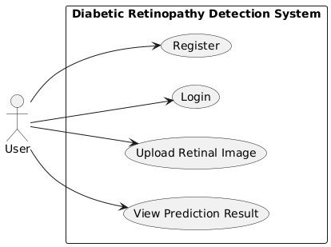

Figure 1: Use Case Diagram
The Use Case Diagram represents the interaction between the user and the diabetic retinopathy detection system. In this system, the user is the primary actor who performs all the operations. The process begins with user registration, where new users create an account by providing necessary details. Once registered, the user logs into the system using valid credentials. After successful login, the user can upload retinal fundus images for analysis.

3.2 SYSTEM ARCHITECTURE
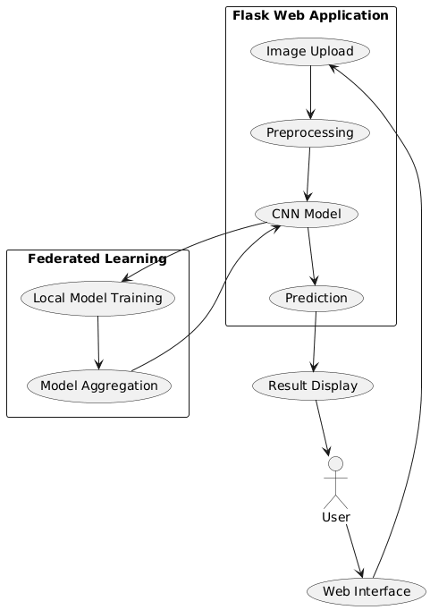

Figure 2: System Architecture Diagram
The architecture of the system shows how the user interacts with the Flask-based web application to upload retinal images for analysis. The images are preprocessed and passed to a CNN model for feature extraction and classification, while Federated Learning ensures secure and decentralized model training.
3.3 FLOW DIAGRAM

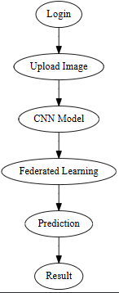

Figure 3: User Workflow Flowchart
The flow diagram illustrates the step-by-step process of the system, starting from user login and image upload. The uploaded image is preprocessed and analyzed using a CNN model along with Federated Learning for improved training and prediction. Finally, the system generates the result and displays it to the user.

3.4 ER DIAGRAM:

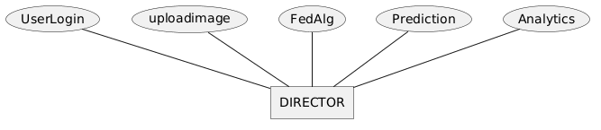

Figure 5: Conceptual Entity-Relationship Diagram
The ER diagram represents the database structure of the diabetic retinopathy detection system. It includes entities such as User, Image, Model, and Result, along with their relationships. The User entity stores user details and is connected to the Image entity, as users upload retinal images. The Image entity is processed by the Model entity, which performs analysis using CNN and Federated Learning techniques.

3.5 SEQUENCE DIAGRAM:

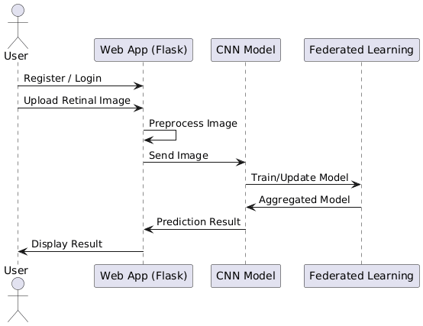

Figure 6: System Sequence Diagram
The sequence diagram illustrates the interaction between the user, web application, CNN model, and Federated Learning module in a step-by-step manner. Initially, the user registers or logs into the system through the web interface. The user then uploads a retinal image, which is received and preprocessed by the web application.

3.6 CLASS DIAGRAM:
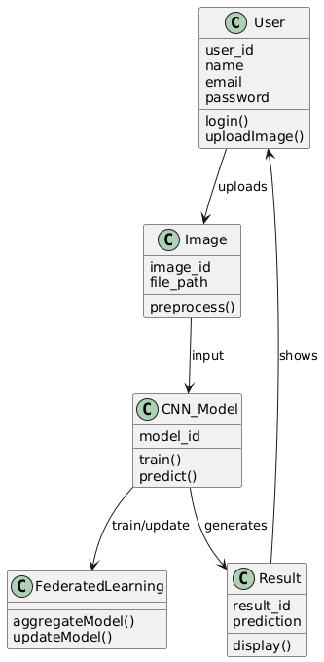

Figure 7: Detailed Data Model (Class Diagram)
The class diagram represents the structure of the system by showing different classes and their relationships. The User class handles user-related operations such as registration, login, and image upload. The Image class stores details of the uploaded retinal images and performs preprocessing. The CNN_Model class is responsible for feature extraction, training, and prediction.
3.7 ACTIVITY DIAGRAM:
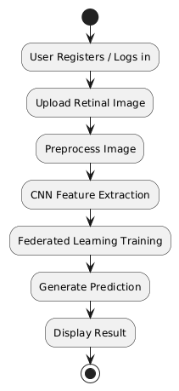

Figure 8: User Activity Diagram
The activity diagram represents the workflow of the diabetic retinopathy detection system. The process begins with the user logging into the system, followed by a validation check to ensure correct credentials. Once authenticated, the user uploads a retinal image for analysis. The system then preprocesses the image and passes it to the CNN model for feature extraction and classification.

CHAPTER 4
IMPLEMENTATION
4.1 MODULES:
• User Authentication
• Image Upload and Pre-processing
• CNN-Based Feature Extraction and Classification
• Federated Learning Training
• Prediction and Result Display
4.2 MODULES DESCRIPTION:

User Authentication Module
This module handles user registration, login, and secure access to the system. It ensures that only authorized users can upload images and view predictions. User credentials are stored securely, and session management is implemented to maintain login status. This module improves system security and provides a personalized experience for each user.
Key Points:
- User Registration – Allows new users to create an account.
- User Login – Authenticates users using credentials.
- Session Management – Maintains active user sessions securely.
- Data Security – Protects user information from unauthorized access.

🔹 Image Upload and Preprocessing Module
This module allows users to upload retinal fundus images for analysis. It also performs preprocessing steps such as resizing, normalization, and noise reduction to prepare the images for model input. Proper preprocessing improves the quality of input data and enhances model accuracy.
Key Points:
- Image Upload – Enables users to upload retinal images.
- Image Resizing – Adjusts image size to match model requirements.
- Normalization – Standardizes pixel values for consistency.
- Noise Reduction – Removes unwanted distortions in images.

🔹 CNN-Based Feature Extraction and Classification Module
This module uses a Convolutional Neural Network (CNN) to extract important features from retinal images and classify them into diabetic retinopathy or non-diabetic categories. It plays a key role in identifying patterns and abnormalities in the images with high accuracy.
Key Points:
- Feature Extraction – Identifies important patterns from images.
- Model Training – Learns from labeled dataset images.
- Classification – Categorizes images into classes.
- Accuracy Optimization – Improves prediction performance.

🔹 Federated Learning Training Module
This module implements Federated Learning to train the model across multiple decentralized clients without sharing raw data. It collects model updates from different sources and aggregates them to build a global model. This ensures privacy while improving model performance through collaborative learning.

Key Points:
- Local Training – Trains model on individual client data.
- Model Aggregation – Combines updates into a global model.
- Privacy Preservation – Keeps user data secure locally.
- Distributed Learning – Enables learning from multiple sources.

🔹 Prediction and Result Display Module
This module provides the final output to the user by analyzing the uploaded image and displaying whether diabetic retinopathy is detected or not. It ensures real-time prediction and presents results in a clear and understandable format for users.
Key Points:
- Real-Time Prediction – Generates instant results.
- Result Display – Shows classification outcome to users.
- User Feedback – Provides clear diagnostic information.
- System Response – Ensures fast and efficient output.

CHAPTER 5
SYSTEM REQUIREMENTS
5.1 HARDWARE REQUIREMENTS:
• O/S : Windows
• Language : Python
• Front End : Flask
5.2 HARDWARE REQUIREMENTS
• System : Pentium IV 2.4 GHz
• Hard Disk : 200 GB
• Mouse : Logitech.
• Keyboard : 110 keys enhanced
• Ram : 4GB
5.3 SOFTWARE DESCRIPTION
1. Flask (Python Web Framework)
Flask is a high-level Python web framework that simplifies the development of secure, scalable, and maintainable web applications. It follows the Model-View-Template (MVT) architecture, which separates business logic, data management, and user interface for better organization. Originally released in 2005, Flask has become one of the most popular frameworks for building robust web platforms quickly. It is designed to help developers create complex, database-driven websites without reinventing the wheel. Flask comes with a powerful ORM (Object-Relational Mapper) that allows interaction with databases using Python objects rather than SQL queries. It emphasizes reusability and modularity by providing reusable components for common web development tasks. Security is a key focus, with built-in protection against SQL injection, cross-site scripting (XSS), and cross-site request forgery (CSRF). Flask includes an admin interface that makes managing site data easier without custom backend coding. Its scalability allows handling high-traffic sites effectively, making it suitable for startups and enterprises alike. With a rich ecosystem of third-party packages, developers can add extra functionality with minimal effort. Flask supports multiple database backends like PostgreSQL, MySQL, SQLite, and Oracle. Its built-in URL routing helps create clean and readable URLs. Flask templates enable dynamic content rendering for seamless user experience. It comes with comprehensive documentation, making it beginner-friendly. Built-in testing tools help ensure high code quality. Flask supports RESTful API development with frameworks like Flask REST Framework (DRF). Its internationalization support enables multilingual web applications. It has a vibrant community that continuously improves the framework. Overall, Flask offers a fast, secure, and flexible approach to web development.
Flask Functionalities:
- Model-View-Template (MVT) Architecture – Separates logic, data, and presentation for better maintainability.
- ORM (Object-Relational Mapper) – Simplifies database interactions without writing raw SQL.
- Admin Interface – Auto-generated backend for managing site content and users.
- Built-in Security – Protection against SQL injection, XSS, CSRF, and click jacking.
- URL Routing – Maps URLs to views for clean and readable site navigation.
- Templating System – Allows dynamic content rendering with HTML templates.
- Scalability – Handles high-traffic applications effectively.
- Database Support – Works with multiple databases like PostgreSQL, MySQL, SQLite, and Oracle.
- Form Handling – Provides tools for easy form creation, validation, and submission.
- Authentication System – Includes user login, logout, and permissions management.
- REST API Support – Easily integrates with Flask REST Framework for API development.
- Internationalization (i18n) – Supports multilingual and locale-based applications.
- Caching Framework – Improves performance by storing frequently accessed data.
- Session Management – Tracks user sessions across the website.
- Middleware Support – Processes requests and responses globally before reaching views.
- Testing Framework – Built-in tools for writing and running unit tests.
- Reusable Apps – Encourages modular development with pluggable apps.
- Static Files Handling – Manages CSS, JavaScript, and images efficiently.
- Signals System – Allows decoupled components to communicate via signals.
- Extensive Documentation & Community – Offers excellent learning resources and active support.
Advantages of Flask
- Rapid Development
  - Flask follows the “batteries included” philosophy, providing built-in tools (admin panel, authentication, ORM) that speed up web development significantly.
- Scalability
  - Suitable for both small and large-scale projects, Flask can handle high traffic (e.g., Instagram, Pinterest use Flask).
- Security
  - Comes with built-in protection against common vulnerabilities like SQL injection, CSRF, XSS, and clickjacking.
- Versatile & Flexible
  - Can be used for a wide range of applications: content management systems, e-commerce, social networks, APIs, and scientific platforms.
- Robust ORM (Object-Relational Mapper)
  - Simplifies database interactions by allowing developers to use Python objects instead of writing complex SQL queries.
- Rich Ecosystem & Packages
  - Thousands of third-party apps and libraries available to add features without extra coding.
- Built-in Admin Panel
  - Automatically generated admin dashboard saves time in creating backend management systems.
- SEO-Friendly
  - Supports clean URLs and has built-in tools that help with search engine optimization.
- Internationalization Support
  - Enables easy translation and localization for multilingual websites.
- Strong Community & Documentation
  - A large community and comprehensive documentation make learning and troubleshooting easier.
- Cross-Platform Support
  - Runs on major operating systems like Windows, macOS, and Linux.
- Extensibility
  - Highly modular—developers can plug in or remove apps as needed.
- REST API Integration
  - Works seamlessly with Flask REST Framework (DRF) for creating robust APIs.
2. SQLite (SQL Database)
SQLite is a lightweight, open-source, and self-contained relational database management system (RDBMS) widely used in applications where simplicity, minimal setup, and low resource consumption are essential. Unlike traditional databases that operate as a separate server, SQLite is serverless and stores the entire database in a single cross-platform disk file. It was first released in 2000 and has since become the default database engine in many operating systems, browsers, and mobile devices. SQLite is written in C and is highly portable, making it suitable for embedded systems, desktop applications, and mobile apps. It fully supports ACID (Atomicity, Consistency, Isolation, Durability) transactions, ensuring data reliability even after crashes or power failures. Its zero-configuration nature means no installation, setup, or server administration is required. SQLite is especially efficient for read-heavy workloads and small to medium-scale applications where simplicity and speed matter. It supports most of the SQL-92 standard, including tables, views, indexes, triggers, and transactions. Due to its small footprint and ease of integration, it is extensively used in IoT devices, web browsers (e.g., Chrome, Firefox), and operating systems (e.g., iOS, Android, Windows). SQLite is public domain software, meaning it can be used freely for both commercial and personal projects without licensing concerns. Despite its simplicity, it offers remarkable stability and performance for single-user or low-concurrency environments. It is often used for prototyping or as a lightweight alternative to heavier database systems. Furthermore, its database file can be easily copied, shared, or backed up without complex processes. Overall, SQLite offers a fast, dependable, and maintenance-free solution for managing structured data.
SQLite Functionalities with Descriptions
- Server less Database Management
  - Works without a dedicated database server; the database resides in a single file.
- ACID Transactions
  - Supports atomic, consistent, isolated, and durable transactions to ensure data integrity.
- Zero Configuration
  - Requires no installation, setup, or database administration.
- Cross-Platform Compatibility
  - Operates seamlessly across various platforms (Windows, mac os, Linux, iOS, Android).
- Data Storage in a Single File
  - Stores all tables, indexes, and metadata in one portable file.
- Full SQL Support
  - Implements most SQL-92 standards, including SELECT, INSERT, UPDATE, DELETE, and joins.
- Lightweight & Fast
  - Optimized for small to medium-sized datasets and read-heavy operations.
- Transactional Database
  - Provides rollback and commit capabilities to maintain consistency.
- Integration with Applications
  - Can be embedded directly into applications, making it ideal for mobile and desktop apps.
- No User Management Overhead
  - Does not require complex authentication or access control systems.
3. HTML5 & CSS3
HTML5 and CSS3 form the foundational structure and visual presentation of the entire CarGo Rental System. HTML5 was used to semantically structure every page, providing a logical and accessible layout for all content. Meaningful tags such as <header>, <nav>, <main>, <aside>, and <footer> were employed to define the primary regions of both the public-facing and application-internal pages, enhancing not only readability for developers but also accessibility for users with assistive technologies. Forms were built using a variety of HTML5 input types, including text, email, password, number, and file, with client-side validation attributes like required and min to ensure data integrity before submission. The integration with the Flask framework was achieved through the Jinja2 templating engine, which allowed for the dynamic insertion of backend data directly into the HTML structure using placeholders like {{ current_user.username }} and control structures like {% for car in cars %}. This templating capability was essential for rendering dynamic content, such as the lists of cars, user orders, and dashboard statistics.
CSS3 was instrumental in transforming the semantic HTML structure into a modern, responsive, and aesthetically pleasing dark-themed interface. Advanced CSS features were used extensively to create the application's sophisticated layout and user experience. The vertical sidebar navigation for both user and admin sections was implemented using CSS Flexbox, a powerful layout model that allows for the easy alignment and distribution of items within a container. The position: fixed property was used to ensure the sidebar remains visible on the screen during scrolling, providing persistent navigation. The visual appeal was further enhanced with custom CSS variables (:root) to manage a consistent color theme (--dark-bg, --primary-color, etc.) across the entire site, making future design changes trivial. Transitions and keyframe animations were used to add subtle hover effects on buttons and to create the "typing" indicator in the chatbot, contributing to a more dynamic and engaging user interface. The combination of semantic HTML5 and advanced CSS3 styling was therefore crucial in building a polished, professional, and highly usable web application.
4. JAVASCRIPT (CLIENT-SIDE)
JavaScript serves as the engine for all real-time interactivity and client-side functionality within the CarGo Rental System, transforming static pages into dynamic and responsive user experiences. Its primary role in this project was to handle user actions directly in the browser, providing instant feedback without needing to reload the page or constantly communicate with the server. One of the key features powered by JavaScript is the client-side search and filter bar on the "Available Cars" page. By attaching event listeners (keyup, input) to the search fields, the JavaScript code instantly iterates through the car listings on the page, hiding or showing them based on whether they match the user's criteria. This provides a fast, seamless filtering experience that feels significantly more modern than traditional server-side search.
Furthermore, JavaScript was essential for managing all pop-up modal windows, including the "View Model" video player and the "Cancel Order" confirmation dialog. It controls their visibility by dynamically changing CSS display properties, and in the case of the video modal, it also intelligently handles the video playback by calling pause() when the modal is closed to prevent audio from continuing in the background. The most advanced use of JavaScript in this project is the AI Travel Companion's interface. It uses the fetch API to send the user's trip details asynchronously to the Flask backend's API endpoint (/ai_trip_planner). Upon receiving a response from the AI, the JavaScript dynamically creates new HTML elements to display the generated travel plan in the results area, showing loading states and handling potential connection errors gracefully. This client-server communication, orchestrated entirely by JavaScript, is what enables the application's most advanced and interactive features, making it a critical component of the overall system.
ADVANTAGES OF JAVASCRIPT
An Interpreted Language: JavaScript is an interpreted language, which requires no compilation steps. This provides an easy development process. The syntax is completely interpreted by the browser just as it interpreted HTML tags.
Embedded Within HTML: JavaScript does not requires any special or separate editor for programs to be written edited or compiled. It can be written in any text editor like Notepad, along with appropriate HTML tags, and saved as filename. Html. HTML files with embedded JavaScript commands can then be read and interpreted by any browser that is JavaScript enabled.
Minimal Syntax-Easy to Learn: By learning just a few commands and simple rules of syntax, complete applications can be built using JavaScript.
Quick Development: Because JavaScript does not require time-consuming compilations, scripts can be developed in a short period of time. This is enhanced by the fact many GUI interface features, such as alerts, prompts, confirm boxes, and other GUI elements, are handle by client side JavaScript, the browser and HTML code.
Design for Simple, Small Programs: It is well suited to implement simple, small programs (for example, a unit conversion calculator between miles and kilometers or pounds and kilograms).Such programs can be easily written and executed at an acceptable speed using JavaScript. In addition, they can be easily interpreted into a web page.
Performance: JavaScript can be written such that the HTML files are fairly compact and quite small. This minimizes storage requirements on the web server and download time for the client.
Additionally, because JavaScript are usually include in the same file as the HTML code for a web page, they require fewer separate network accesses.
Procedural Capabilities: Every programming language needs to support facilities such as Condition checking, Looping and Branching .JavaScript provides syntax, which can be used to add such procedural capabilities to web page (filename.html) coding.
Designed for Programming User Events: JavaScript supports Object/Events based programming JavaScript recognizes when a form Button is pressed. This event can have suitable JavaScript code attached, which will executed when the Button Pressed event occurs.
JavaScript can be used to implement context sensitive help. Whenever an HTML form’s Mouse cursor Mouse Over a button or a link on the page a helpful and informative massage can be displayed in the status bar at the button of the browser window.
Easy Debugging and Testing : Being an interprets language ,scripts in JavaScript are tested line by line, and the errors are also listed as they are encountered ,i.e. an appropriate error message along with the line number is listed for every error that is encountered. It is thus easy to locate errors, make changes, and test it again without the overhead and delay of compiling.
Platform Independence / Architecture Neutral: JavaScript is a programming language that is completely independent of the hardware on which it works. It is a language that is understood by any JavaScript enabled browser .Thus ,JavaScript application work on any machine that has an appropriate JavaScript enabled browser can be anywhere on the network.
Since each browser is for a specific platform, JavaScript interpretation will be with respect to the specific platform. The browser will add whatever platform specific information is required to the JavaScript while it interprets the code. Thus, JavaScript is truly platform independent. A JavaScript programmer developed on a UNIX machine will work perfectly well on a Windows machine.
The fact that a platform specific browser , maintained at the client end, does the interpretation of JavaScript , relieves the developer of the responsibility of maintaining multiple source code files for multiple platform.
5. PYTHON (PROGRAMMING LANGUAGE)
Python was selected as the primary backend programming language for the CarGo Rental System, serving as the engine that drives all server-side logic, data processing, and business rules. As a high-level, interpreted language renowned for its clear syntax and extensive standard library, Python provided an ideal environment for rapid and efficient development. Its readability and straightforward structure made it possible to build and maintain a complex application with a clean, organized codebase. Throughout this project, Python was used to define the application's structure via the Flask framework, handle incoming HTTP requests, and manage the flow of data between the user, the server, and the database. All application logic, from validating user registration forms and processing login credentials to executing complex database queries for the admin dashboard, was written entirely in Python.
The language's powerful features, such as its object-oriented capabilities, were leveraged to create the User model, which seamlessly integrates with the Flask-Login extension for robust session management. Furthermore, Python's strength in handling data structures like dictionaries and lists was crucial for interacting with the JSON-like documents from the MongoDB database. The backend functions written in Python perform essential tasks such as securely hashing passwords with the bcrypt library, managing file uploads and ensuring secure filenames, and constructing the dynamic aggregation pipelines sent to the database. Its versatility was further demonstrated in the AI Travel Companion module, where the requests library was used to make external HTTP API calls to the OpenRouter service. By using Python, the CarGo platform is built on a foundation that is not only powerful and scalable but also highly maintainable and easy to extend with new features in the future, solidifying its position as the optimal choice for this web application.
6.ANACONDA NAVIGATOR:
Anaconda Navigator is a powerful, open-source desktop graphical user interface (GUI) that comes bundled with the Anaconda distribution. It is designed to simplify the process of working with data science, machine learning, and scientific computing tools. With Anaconda Navigator, users can easily launch applications, manage multiple programming environments, and install or update software packages without needing to use command-line instructions. This makes it especially useful for beginners or those unfamiliar with terminal-based tools.
Navigator provides one-click access to popular data science applications such as Jupyter Notebook, Spyder, VS Code, and RStudio. It supports both Python and R programming languages and allows users to manage environments efficiently using the Conda package and environment manager. Creating, cloning, or deleting environments can be done through a simple point-and-click interface. This ensures different projects can have their own dependencies without conflicts.
In addition to managing environments, Anaconda Navigator enables users to install, update, or remove thousands of open-source packages. It also allows integration with channels like conda-forge to access a wider range of packages. Users can search for, add, or remove packages graphically, making complex package handling much more approachable.
Anaconda Navigator is widely used in education, research, and industry due to its ease of use, reliability, and flexibility. It is available across major platforms, including Windows, macOS, and Linux, making it accessible to a wide audience. Whether you’re a data science student or an experienced developer, Navigator provides a convenient way to manage your tools and workflows efficiently. Its consistent updates and integration with the Anaconda ecosystem make it a reliable choice for modern data-driven work
Key Features:
- GUI-based interface for managing packages, environments, and tools.
- Easy access to applications like:
  - Jupyter Notebook (interactive coding)
  - Spyder (scientific IDE)
  - VS Code (code editor)
  - RStudio (for R programming)
- Allows creation, cloning, and deletion of Conda environments.
- Simplifies installation and update of Python/R packages.
- Supports both Conda and pip package managers.
- Enables management of Conda channels (e.g., conda-forge).

Common Users:

Data Scientists

Machine Learning Engineers
- Researchers
- Educators and Students
- Developers working in Python/R environments

💡 Advantages:

No command-line knowledge required.
- Ideal for users who prefer a point-and-click interface.
- Speeds up setup and management of data science tools.
- Cross-platform support: Windows, macOS, and Linux.
- Regularly updated with support for popular libraries.

CHAPTER 6
CONCLUSION
The proposed system provides an efficient and reliable solution for the early detection of diabetic retinopathy using advanced deep learning techniques. By integrating Convolutional Neural Networks (CNN), the system effectively extracts features and classifies retinal images with high accuracy. The use of Federated Learning ensures data privacy by enabling decentralized model training without sharing sensitive information. The Flask-based web application offers a simple and user-friendly interface for easy access and usability. The system delivers real-time predictions, helping in quick diagnosis and timely medical intervention. It reduces the workload of healthcare professionals by automating the screening process. The solution is cost-effective and accessible, making it suitable for both urban and rural areas. Additionally, the model improves its performance through collaborative learning from multiple data sources. The system is scalable and can be extended to detect other diseases in the future. Overall, the project contributes to improving healthcare accessibility while ensuring privacy and accuracy in medical diagnosis.

CHAPTER 7
FUTURE ENHANCEMENT
The proposed system can be further enhanced by extending the model to detect multiple stages of diabetic retinopathy instead of simple binary classification. Integration with mobile applications can improve accessibility and allow users to capture and upload retinal images directly from smartphones. The system can be improved by incorporating more advanced deep learning models to increase accuracy and efficiency. Adding real-time video-based eye screening can further enhance diagnostic capabilities. The Federated Learning framework can be expanded to include more participants such as hospitals and research centers for better model training. Integration with cloud platforms can improve scalability and performance. The system can also include multilingual support to reach a wider audience. Implementing explainable AI techniques can help users and doctors understand prediction results more clearly. The addition of a chatbot or virtual assistant can guide users during the diagnosis process. Overall, these enhancements will make the system more robust, accurate, and user-friendly in real-world healthcare applications.

CHAPTER 8
SAMPLE CODE
{% extends 'base.html' %}
{% block title %}Home{% endblock %}

{% block content %}
<!-- Hero -->
<section class="hero">
<div class="hero__bg"></div>
<div class="hero__content">
<span class="hero__tag">Federated Learning · MobileNetV2 · FedAvg</span>
<h1 class="hero__title">Early Detection<br><em>Saves Sight.</em></h1>
<p class="hero__sub">RetinaAI uses a privacy-preserving federated model trained across distributed data to detect Diabetic Retinopathy from fundus photographs — in seconds.</p>
<div class="hero__actions">
{% if session.get('user_id') %}
<a href="{{ url_for('predict') }}" class="btn btn--lg">Run Diagnosis →</a>
<a href="{{ url_for('analytics') }}" class="btn btn--ghost">View Analytics</a>
{% else %}
<a href="{{ url_for('register') }}" class="btn btn--lg">Start for Free →</a>
<a href="{{ url_for('login') }}" class="btn btn--ghost">Login</a>
{% endif %}
</div>
</div>
<div class="hero__visual">
<div class="retina-ring retina-ring--1"></div>
<div class="retina-ring retina-ring--2"></div>
<div class="retina-ring retina-ring--3"></div>
<div class="retina-eye">◉</div>
</div>
</section>

<!-- How it works -->
<section class="section">
<div class="container">
<h2 class="section__title">How It Works</h2>
<div class="steps">
<div class="step">
<div class="step__num">01</div>
<h3>Upload Retinal Image</h3>
<p>Upload a fundus photograph in JPG, PNG, or TIFF format from your ophthalmologic device.</p>
</div>
<div class="step__arrow">→</div>
<div class="step">
<div class="step__num">02</div>
<h3>AI Analysis</h3>
<p>Our MobileNetV2 CNN backbone trained via FedAvg federated learning analyzes the image at 224×224 resolution.</p>
</div>
<div class="step__arrow">→</div>
<div class="step">
<div class="step__num">03</div>
<h3>Instant Result</h3>
<p>Receive DR / No_DR classification with confidence scores and probability breakdown within seconds.</p>
</div>
</div>
</div>
</section>

<!-- Stats -->
<section class="section section--dark">
<div class="container">
<div class="stats">
<div class="stat">
<div class="stat__num">224×224</div>
<div class="stat__label">Input Resolution</div>
</div>
<div class="stat">
<div class="stat__num">FedAvg</div>
<div class="stat__label">Training Algorithm</div>
</div>
<div class="stat">
<div class="stat__num">2</div>
<div class="stat__label">Classes Detected</div>
</div>
<div class="stat">
<div class="stat__num">Privacy</div>
<div class="stat__label">Data Never Leaves Client</div>
</div>
</div>
</div>
</section>

<!-- Features -->
<section class="section">
<div class="container">
<h2 class="section__title">Why RetinaAI</h2>
<div class="features">
<div class="feature">
<div class="feature__icon">🔒</div>
<h3>Privacy-First</h3>
<p>Federated learning ensures patient images never leave their source — only model weights are shared.</p>
</div>
<div class="feature">
<div class="feature__icon">⚡</div>
<h3>Instant Results</h3>
<p>Real-time inference via a compressed MobileNetV2 backbone optimised for edge deployment.</p>
</div>
<div class="feature">
<div class="feature__icon">📊</div>
<h3>Full Analytics</h3>
<p>Track your diagnosis history, confidence trends, and DR/No_DR ratios in an interactive dashboard.</p>
</div>
<div class="feature">
<div class="feature__icon">🧠</div>
<h3>Deep Learning</h3>
<p>Transfer learning from ImageNet + custom classification head trained on retinal fundus images.</p>
</div>
</div>
</div>
</section>

<!-- CTA -->
<section class="section section--cta">
<div class="container" style="text-align:center;">
<h2>Ready to diagnose?</h2>
<p style="color:var(--text-muted);margin-bottom:2rem;">Create a free account and run your first analysis in under 60 seconds.</p>
<a href="{{ url_for('register') }}" class="btn btn--lg">Create Free Account →</a>
</div>
</section>
{% endblock %}

CHAPTER 9
SAMPLE SCREENSHOTS

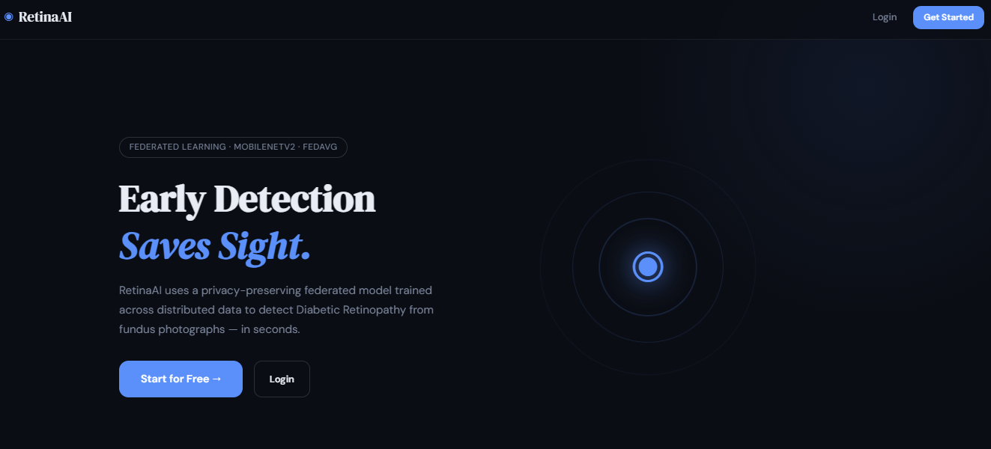

Figure 1: RetinaAI Landing Page
This figure shows the homepage of the RetinaAI platform, which features a modern, dark-themed user interface. The primary headline, "Early Detection Saves Sight," emphasizes the platform's mission to detect Diabetic Retinopathy from fundus photographs using artificial intelligence. The page highlights its technical foundation, noting the use of a privacy-preserving federated learning model (specifically MobileNetV2 and FedAvg). It includes clear calls to action, such as a "Start for Free" button and a "Login" option in the navigation bar.
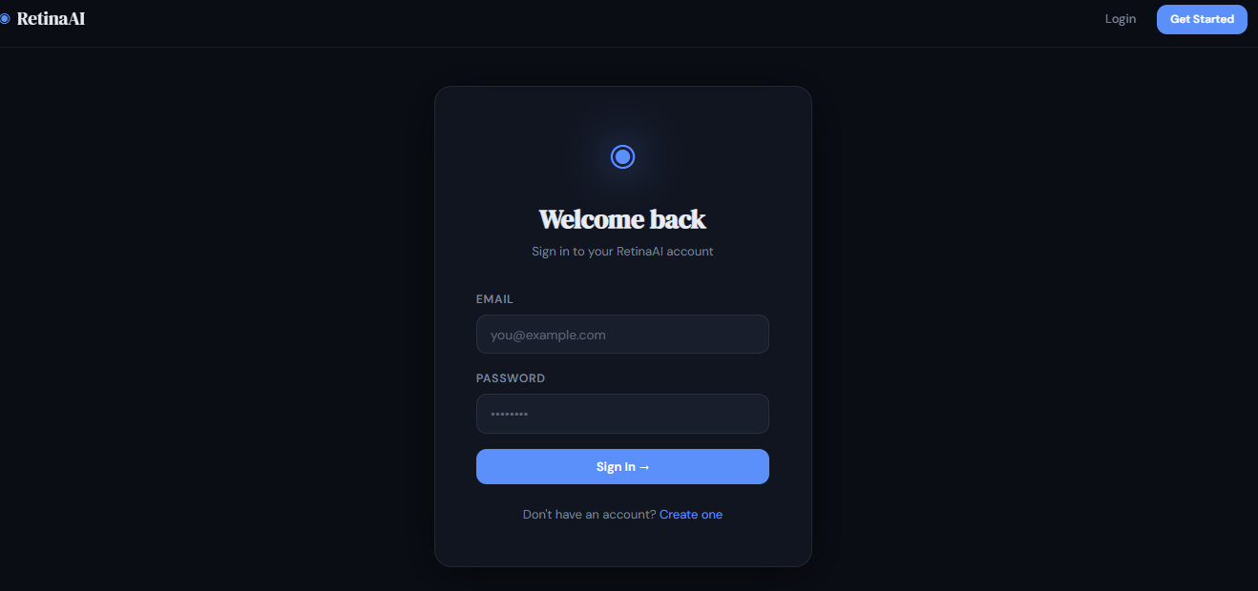
Figure 2: Login Page
This figure is a duplicate of Figure 1. It displays the same landing page interface, showcasing the platform's focus on rapid, distributed data analysis for ocular health. The layout is designed for simplicity, providing a brief explanation of how the AI model works in seconds to assist in medical diagnostics while maintaining data privacy.

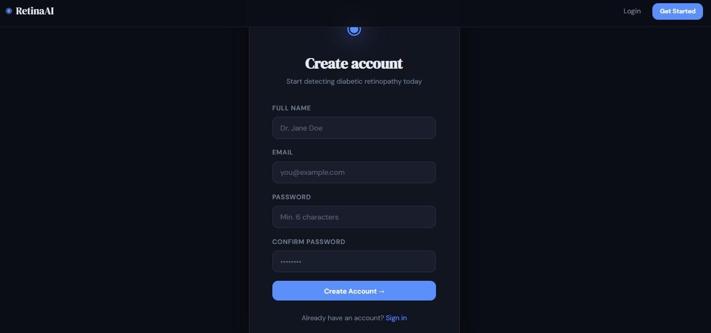
Figure 3: Account Creation Page
This figure illustrates the user registration interface. The "Create account" form is straightforward, requiring the user's full name, email address, and a password with a minimum of six characters. A placeholder name, "Dr. Jane Doe," suggests the platform is tailored for medical professionals. At the bottom of the form, a "Create Account" button facilitates the signup process, with a secondary link provided for existing users to sign in.
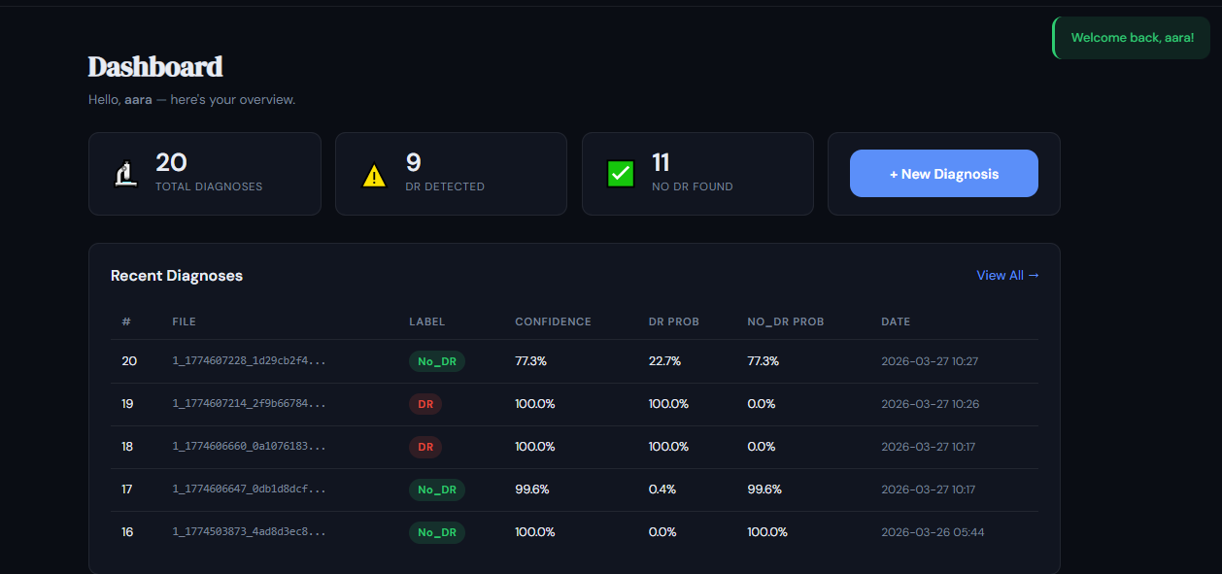

Figure 4: User Dashboard and Diagnostic History
This figure displays the main dashboard for an authenticated user. At the top, a summary section provides a quick glance at statistics: total diagnoses (20), cases where Diabetic Retinopathy (DR) was detected (9), and cases where no DR was found (11). Below the stats, a "Recent Diagnoses" table lists historical data including file identifiers, the AI-generated label (DR or No_DR), confidence levels, and specific probability percentages for each class, along with the date and time of the analysis.
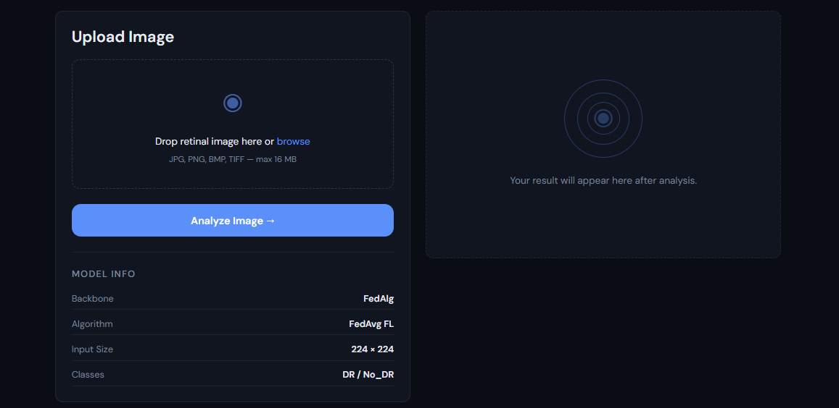
Figure 5: Image Upload and Analysis Interface
This figure shows the functional area where users perform new diagnoses. It features a drag-and-drop upload zone that supports multiple image formats (JPG, PNG, BMP, TIFF) up to 16 MB. To the right, a placeholder indicates where results will appear after analysis. Below the upload box, a "Model Info" section provides technical transparency, listing the backbone as FedAlg, the algorithm as FedAvg FL, the input image dimensions (224 x 224), and the classification categories (DR / No_DR).
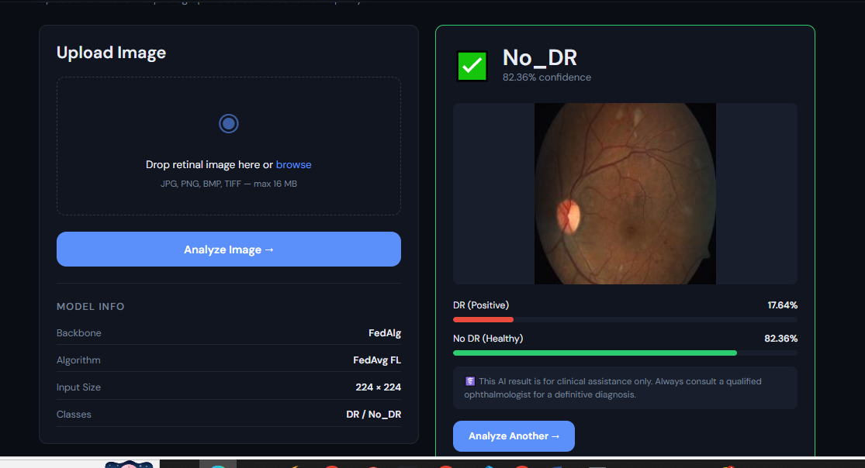
Figure 6: Diagnostic Result Interface
This figure illustrates the platform’s output after a retinal image has been processed. On the left, the upload panel remains visible, displaying the technical model specifications. On the right, the results panel shows a "No_DR" classification with 82.36% confidence. The analyzed fundus photograph is displayed in the center, supported by two probability bars below: "DR (Positive)" at 17.64% and "No DR (Healthy)" at 82.36%. A medical disclaimer is included at the bottom to clarify that the AI is for clinical assistance and not a definitive diagnosis, alongside an "Analyze Another" button to reset the process.
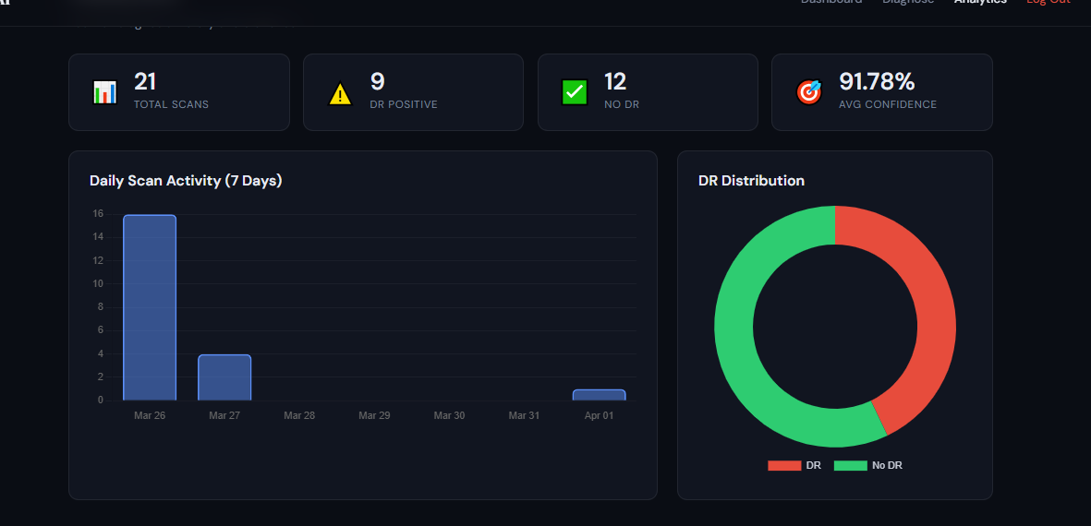
Figure 7: Analytics and Data Visualization Dashboard
This figure showcases the "Analytics" section of the user interface, providing a high-level overview of scanning activity. Four summary cards at the top track key metrics: Total Scans (21), DR Positive cases (9), No DR cases (12), and an Average Confidence score (91.78%). Below these metrics, the data is visualized through two charts: a "Daily Scan Activity" bar graph showing the volume of scans over a 7-day period, and a "DR Distribution" donut chart that visually represents the ratio of positive Diabetic Retinopathy cases (red) to healthy cases (green).
CHAPTER 10
REFERENCES
[1] Gulshan, V., Peng, L., Coram, M., et al., “Development and Validation of a Deep Learning Algorithm for Detection of Diabetic Retinopathy in Retinal Fundus Photographs,” JAMA, vol. 316, no. 22, pp. 2402–2410, Dec. 2016.
[2] Li, Z., He, Y., Keel, S., et al., “Efficacy of a Deep Learning System for Detecting Diabetic Retinopathy in Community-Based Primary Care Settings,” npj Digital Medicine, vol. 1, no. 1, p. 22, 2018.
[3] McMahan, B., Moore, E., Ramage, D., et al., “Communication-Efficient Learning of Deep Networks from Decentralized Data,” Proc. AISTATS, pp. 1273–1282, 2017.
[4] Sheller, M. J., Reina, G. A., Edwards, B., et al., “Multi-Institutional Deep Learning Modeling Without Sharing Patient Data: A Feasibility Study on Brain Tumor Segmentation,” Brainlesion Workshop, pp. 92–104, 2019.
[5] Razzak, M. I., Naz, S., and Zaib, A., “Deep Learning for Medical Image Processing: Overview, Challenges and the Future,” Springer, pp. 323–350, 2018.
[6] Kermany, D. S., Goldbaum, M., Cai, W., et al., “Identifying Medical Diagnoses and Treatable Diseases by Image-Based Deep Learning,” Cell, vol. 172, no. 5, pp. 1122–1131, Feb. 2018.
[7] LeCun, Y., Bengio, Y., and Hinton, G., “Deep Learning,” Nature, vol. 521, no. 7553, pp. 436–444, May 2015.
[8] Hard, A., Rao, K., Mathews, R., et al., “Federated Learning for Mobile Keyboard Prediction,” arXiv preprint arXiv:1811.03604, 2018.
[9] Abràmoff, M. D., Lavin, P. T., Birch, M., et al., “Pivotal Trial of an Autonomous AI-Based Diagnostic System for Detection of Diabetic Retinopathy,” npj Digital Medicine, vol. 1, no. 1, p. 39, 2018.
[10] Ting, D. S. W., Cheung, C. Y., Lim, G., et al., “Development and Validation of a Deep Learning System for Diabetic Retinopathy and Related Eye Diseases,” JAMA, vol. 318, no. 22, pp. 2211–2223, 2017.
[11] Pratt, H., Coenen, F., Broadbent, D. M., et al., “Convolutional Neural Networks for Diabetic Retinopathy,” Procedia Computer Science, vol. 90, pp. 200–205, 2016.
[12] Quellec, G., Charrière, K., Boudi, Y., et al., “Deep Image Mining for Diabetic Retinopathy Screening,” Medical Image Analysis, vol. 39, pp. 178–193, 2017.
[13] Gargeya, R. and Leng, T., “Automated Identification of Diabetic Retinopathy Using Deep Learning,” Ophthalmology, vol. 124, no. 7, pp. 962–969, 2017.
[14] Decenciere, E., Zhang, X., Cazuguel, G., et al., “Feedback on a Publicly Distributed Image Database: The Messidor Database,” Image Analysis & Stereology, vol. 33, no. 3, pp. 231–234, 2014.
[15] Zhao, Y., Li, M., Lai, L., et al., “Federated Learning with Non-IID Data,” arXiv preprint arXiv:1806.00582, 2018.
[16] Yang, Q., Liu, Y., Chen, T., and Tong, Y., “Federated Machine Learning: Concept and Applications,” ACM Transactions on Intelligent Systems and Technology, vol. 10, no. 2, pp. 1–19, 2019.
[17] Bonawitz, K., Ivanov, V., Kreuter, B., et al., “Practical Secure Aggregation for Privacy-Preserving Machine Learning,” Proc. ACM CCS, pp. 1175–1191, 2017.
[18] Rajpurkar, P., Irvin, J., Zhu, K., et al., “CheXNet: Radiologist-Level Pneumonia Detection on Chest X-Rays with Deep Learning,” arXiv preprint arXiv:1711.05225, 2017.
[19] Simonyan, K. and Zisserman, A., “Very Deep Convolutional Networks for Large-Scale Image Recognition,” arXiv preprint arXiv:1409.1556, 2014.
[20] He, K., Zhang, X., Ren, S., and Sun, J., “Deep Residual Learning for Image Recognition,” Proc. CVPR, pp. 770–778, 2016.

