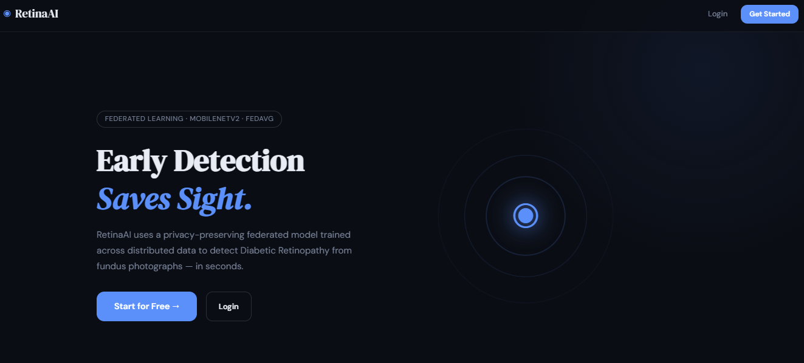

Figure 1: RetinaAI Landing Page
This figure shows the homepage of the RetinaAI platform, which features a modern, dark-themed user interface. The primary headline, "Early Detection Saves Sight," emphasizes the platform's mission to detect Diabetic Retinopathy from fundus photographs using artificial intelligence. The page highlights its technical foundation, noting the use of a privacy-preserving federated learning model (specifically MobileNetV2 and FedAvg). It includes clear calls to action, such as a "Start for Free" button and a "Login" option in the navigation bar.
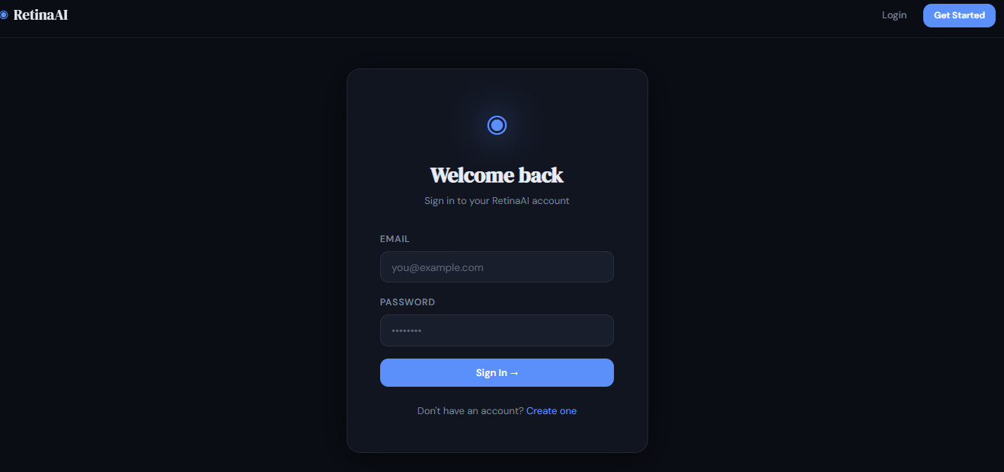
Figure 2: Login Page
This figure is a duplicate of Figure 1. It displays the same landing page interface, showcasing the platform's focus on rapid, distributed data analysis for ocular health. The layout is designed for simplicity, providing a brief explanation of how the AI model works in seconds to assist in medical diagnostics while maintaining data privacy.

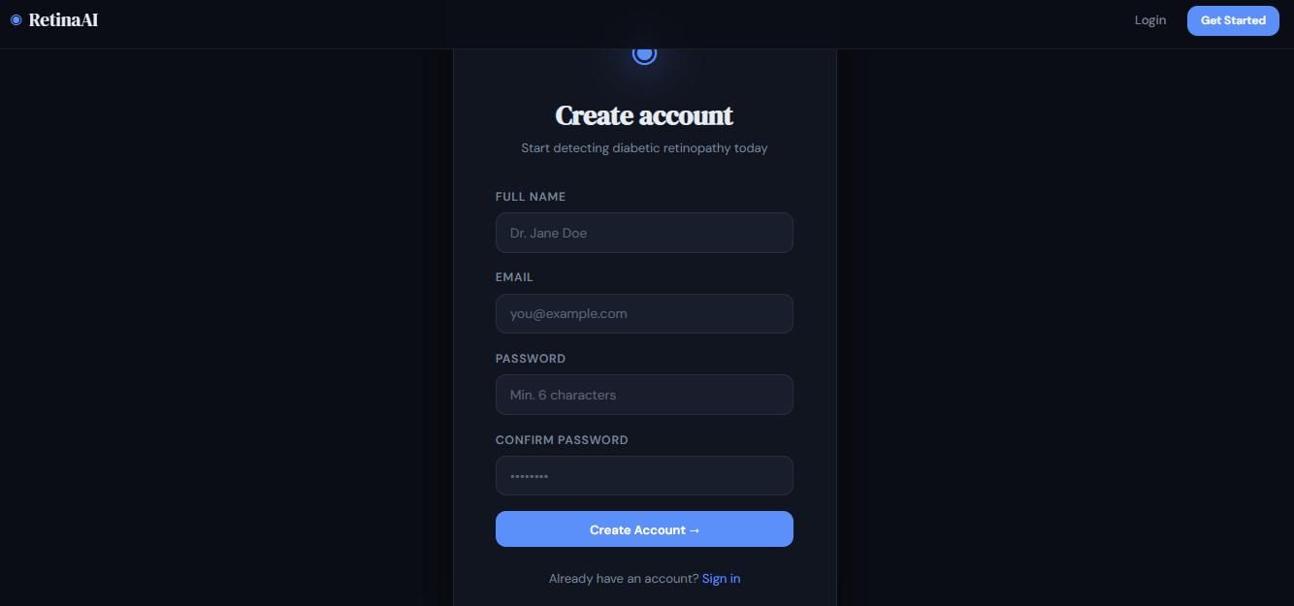
Figure 3: Account Creation Page
This figure illustrates the user registration interface. The "Create account" form is straightforward, requiring the user's full name, email address, and a password with a minimum of six characters. A placeholder name, "Dr. Jane Doe," suggests the platform is tailored for medical professionals. At the bottom of the form, a "Create Account" button facilitates the signup process, with a secondary link provided for existing users to sign in.
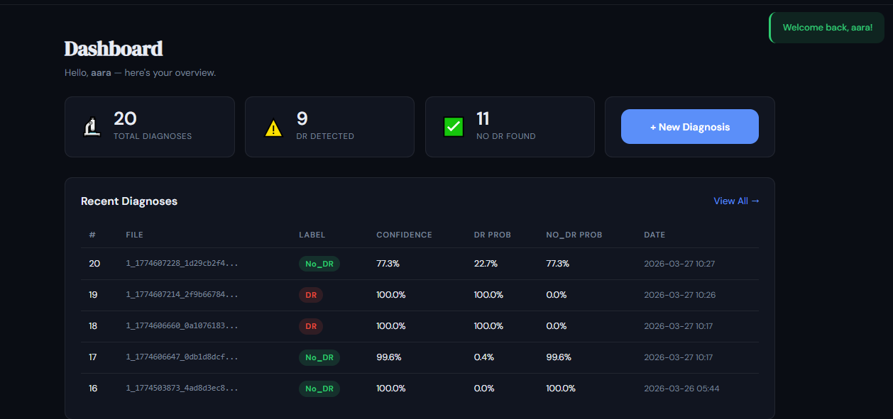

Figure 4: User Dashboard and Diagnostic History
This figure displays the main dashboard for an authenticated user. At the top, a summary section provides a quick glance at statistics: total diagnoses (20), cases where Diabetic Retinopathy (DR) was detected (9), and cases where no DR was found (11). Below the stats, a "Recent Diagnoses" table lists historical data including file identifiers, the AI-generated label (DR or No_DR), confidence levels, and specific probability percentages for each class, along with the date and time of the analysis.
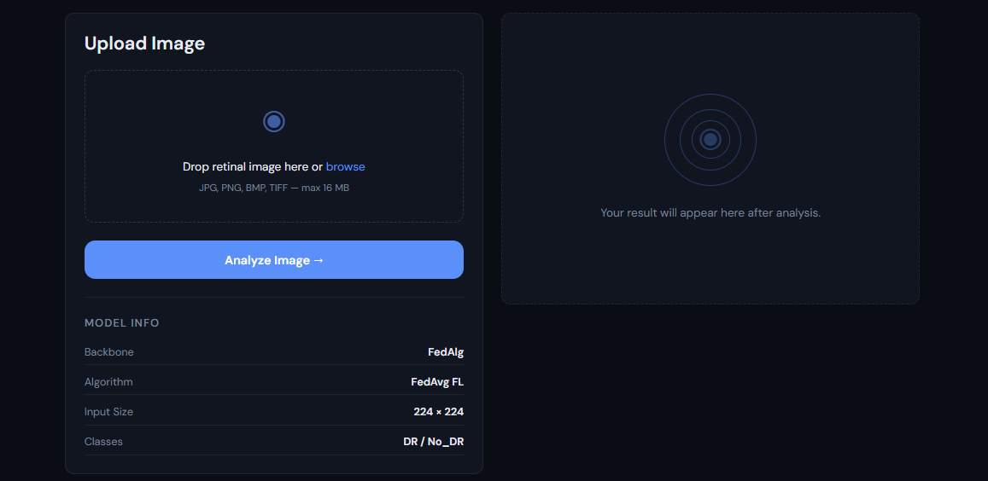
Figure 5: Image Upload and Analysis Interface
This figure shows the functional area where users perform new diagnoses. It features a drag-and-drop upload zone that supports multiple image formats (JPG, PNG, BMP, TIFF) up to 16 MB. To the right, a placeholder indicates where results will appear after analysis. Below the upload box, a "Model Info" section provides technical transparency, listing the backbone as FedAlg, the algorithm as FedAvg FL, the input image dimensions (224 x 224), and the classification categories (DR / No_DR).
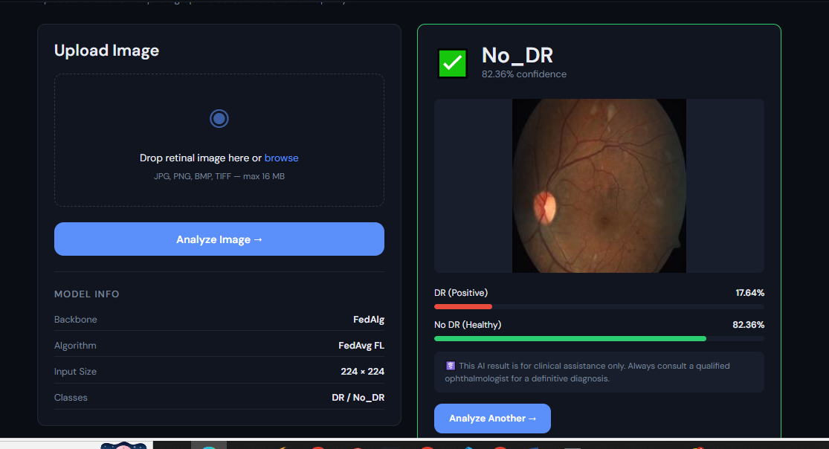
Figure 6: Diagnostic Result Interface
This figure illustrates the platform’s output after a retinal image has been processed. On the left, the upload panel remains visible, displaying the technical model specifications. On the right, the results panel shows a "No_DR" classification with 82.36% confidence. The analyzed fundus photograph is displayed in the center, supported by two probability bars below: "DR (Positive)" at 17.64% and "No DR (Healthy)" at 82.36%. A medical disclaimer is included at the bottom to clarify that the AI is for clinical assistance and not a definitive diagnosis, alongside an "Analyze Another" button to reset the process.
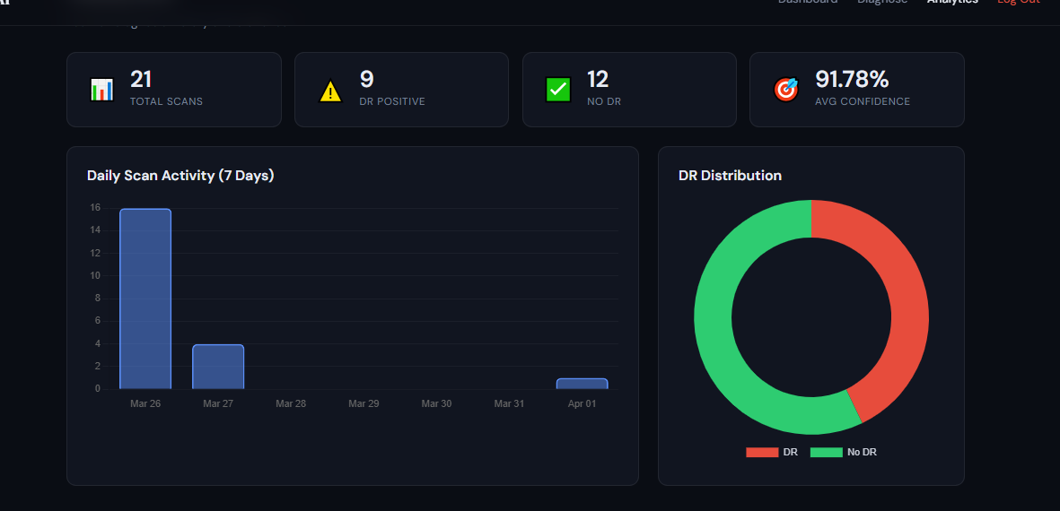
Figure 7: Analytics and Data Visualization Dashboard
This figure showcases the "Analytics" section of the user interface, providing a high-level overview of scanning activity. Four summary cards at the top track key metrics: Total Scans (21), DR Positive cases (9), No DR cases (12), and an Average Confidence score (91.78%). Below these metrics, the data is visualized through two charts: a "Daily Scan Activity" bar graph showing the volume of scans over a 7-day period, and a "DR Distribution" donut chart that visually represents the ratio of positive Diabetic Retinopathy cases (red) to healthy cases (green).

