SOURCE CODE AND OUTPUTS
Learning Community Analytics using NLP Topics and Knowledge Diffusion Networks
Capstone project: program listings with their outputs
Prateek Chauhan
Guide: ______________________
Department / Institute: ______________________
September 2026

Contents
Contents 2
1. Project Structure and How to Run 3
2. Configuration Files 4
3. Data Collection (collect_data.py) 6
4. Database Schema and Loading (schema.sql, load_to_postgres.py) 10
5. Text Preprocessing (preprocess.py) 15
6. Topic Modeling (topic_model.py) 18
7. Knowledge Network (network.py) 25
8. Knowledge Diffusion (diffusion.py) 33
9. Answer Prediction (predict.py) 41
10. Expert Finder (recommender.py) 45
11. Figures and the Pipeline Runner (figures.py, run_pipeline.py) 48
12. SQL Analysis Queries (queries.sql) 55
13. Interactive Dashboard (streamlit_app.py) 60

1. Project Structure and How to Run
The project is a pipeline of Python programs. Each program reads the output of the previous one, so they are listed below in the order they run. All programs are in the src/ folder, the dashboard is in app/, and the SQL files are in sql/.
learning-community-analytics/
├── app/streamlit_app.py Interactive dashboard (7 pages)
├── src/
│ ├── config.py Shared paths and settings
│ ├── db.py PostgreSQL connection (.env)
│ ├── collect_data.py Step 1 Download data from the Stack Exchange API
│ ├── load_to_postgres.py Step 2 Load data + results into PostgreSQL
│ ├── data_loader.py Read tables from PostgreSQL or CSV
│ ├── preprocess.py Step 3 Text cleaning and features
│ ├── topic_model.py Step 4 LDA and BERTopic topic modeling
│ ├── network.py Step 5 Knowledge network analysis
│ ├── diffusion.py Step 6 Knowledge diffusion analysis
│ ├── predict.py Step 7 Answer prediction models
│ ├── recommender.py Step 8 Expert finder
│ ├── figures.py Step 9 Report figures
│ └── run_pipeline.py Runs steps 3-9 in order
├── sql/schema.sql Table definitions
├── sql/queries.sql 11 analysis queries (pgAdmin)
├── data/raw/cs50/ Downloaded CSV files
├── data/processed/ Cleaned data, embeddings, features
├── outputs/ , outputs/figures/ Result tables and figures
└── docs/ Report, presentation, black book

Commands
pip install -r requirements.txt # install libraries
python src/collect_data.py --site cs50 --max-questions 4000 # step 1 (optional, data included)
python src/run_pipeline.py # steps 3-9 (about 10 minutes)
python src/load_to_postgres.py # step 2: load everything into PostgreSQL
streamlit run app/streamlit_app.py # start the dashboard

Software used
Python 3.14 (tested; 3.12 recommended on the laptop), PostgreSQL with pgAdmin, pandas, NumPy, scikit-learn, NLTK, BeautifulSoup, sentence-transformers (all-MiniLM-L6-v2), BERTopic, UMAP, HDBSCAN, NetworkX, SciPy, XGBoost, Matplotlib, Plotly, PyVis, Streamlit, SQLAlchemy and psycopg2.

2. Configuration Files
config.py holds the folder paths and settings shared by all programs: the random seed that makes results reproducible, the sentence-embedding model, and the 80/20 time split used for evaluation. db.py builds the PostgreSQL connection from the .env file, so the password is never written in the code. These two files only define settings and print nothing.
Source code: src/config.py (21 lines)
1 """Shared paths and settings for the whole pipeline."""
2
3 from pathlib import Path
4
5 PROJECT_ROOT = Path(__file__).resolve().parent.parent
6 SITE = "cs50"
7
8 RAW_DIR = PROJECT_ROOT / "data" / "raw" / SITE
9 PROCESSED_DIR = PROJECT_ROOT / "data" / "processed"
10 OUTPUT_DIR = PROJECT_ROOT / "outputs"
11 FIGURE_DIR = OUTPUT_DIR / "figures"
12
13 RANDOM_SEED = 42
14 EMBEDDING_MODEL = "all-MiniLM-L6-v2"
15
16 # Share of the timeline (oldest first) used for training in the prediction
17 # and recommender evaluations; the newest part is held out as the test set.
18 TRAIN_FRACTION = 0.8
19
20 for _d in (PROCESSED_DIR, OUTPUT_DIR, FIGURE_DIR):
21 _d.mkdir(parents=True, exist_ok=True)

Source code: src/db.py (23 lines)
1 """PostgreSQL connection, configured from the .env file in the project root."""
2
3 import os
4 from pathlib import Path
5
6 from dotenv import load_dotenv
7 from sqlalchemy import create_engine
8 from sqlalchemy.engine import URL
9
10 PROJECT_ROOT = Path(__file__).resolve().parent.parent
11 load_dotenv(PROJECT_ROOT / ".env")
12
13
14 def get_engine():
15 url = URL.create(
16 "postgresql+psycopg2",
17 username=os.getenv("DB_USER", "postgres"),
18 password=os.getenv("DB_PASSWORD"),
19 host=os.getenv("DB_HOST", "localhost"),
20 port=int(os.getenv("DB_PORT", "5432")),
21 database=os.getenv("DB_NAME", "learning_community"),
22 )
23 return create_engine(url)

Source code: .env.example (7 lines)
1 # Copy this file to .env and fill in your PostgreSQL details.
2 # .env is ignored by git, so your password never gets uploaded.
3 DB_HOST=localhost
4 DB_PORT=5432
5 DB_NAME=learning_community
6 DB_USER=postgres
7 DB_PASSWORD=your_postgres_password_here

Source code: requirements.txt (30 lines)
1 # Tested with Python 3.12-3.14. Install with: pip install -r requirements.txt
2
3 # data + database
4 requests>=2.31
5 pandas>=2.2,<3
6 numpy>=1.26
7 pyarrow>=15
8 SQLAlchemy>=2.0
9 psycopg2-binary>=2.9
10 python-dotenv>=1.0
11
12 # NLP + topic modeling
13 beautifulsoup4>=4.12
14 nltk>=3.8
15 scikit-learn>=1.4
16 scipy>=1.11
17 sentence-transformers>=2.7
18 bertopic>=0.16
19 umap-learn>=0.5.5
20 hdbscan>=0.8.33
21
22 # networks, diffusion, prediction
23 networkx>=3.2
24 xgboost>=2.0
25
26 # figures + dashboard
27 matplotlib>=3.8
28 plotly>=5.20
29 streamlit>=1.40
30 pyvis>=0.3.2

3. Data Collection (collect_data.py)
Aim: download the questions, answers and comments of the CS50 Stack Exchange site through the public Stack Exchange API and save them as CSV files. Without an API key the API serves only 25 pages per query, so the program walks backwards through time in date windows. It also builds the interactions table (who answered or commented on whose post), which is the edge list of the knowledge network.
Run: python src/collect_data.py --site cs50 --max-questions 4000
Source code: src/collect_data.py (205 lines)
1 """
2 Collect a learning-community dataset from the Stack Exchange API.
3
4 Downloads questions, answers, and comments from one Stack Exchange site and
5 saves them as CSV files that the rest of the project (topic modeling,
6 network analysis, diffusion) builds on.
7
8 Usage:
9 python src/collect_data.py --site datascience --max-questions 2000
10
11 Without an API key you get 300 requests/day, which is enough for ~5,000
12 questions. Register a free key at https://stackapps.com/apps/oauth/register
13 to get 10,000 requests/day, then pass it with --key.
14 """
15
16 import argparse
17 import html
18 import time
19 from pathlib import Path
20
21 import pandas as pd
22 import requests
23
24 API = "https://api.stackexchange.com/2.3"
25 # Built-in filter that includes the post body text.
26 FILTER = "withbody"
27 MAX_PAGE_WITHOUT_KEY = 25
28 OUT_DIR = Path(__file__).resolve().parent.parent / "data" / "raw"
29
30 class StackExchangeClient:
31 def __init__(self, site, key=None):
32 self.site = site
33 self.key = key
34 self.quota_remaining = None
35
36 def get(self, endpoint, **params):
37 """Yield every item from a paginated endpoint."""
38 params.update(site=self.site, filter=FILTER, pagesize=100, page=1)
39 if self.key:
40 params["key"] = self.key
41 # Without a key the API refuses pages above 25.
42 max_page = None if self.key else MAX_PAGE_WITHOUT_KEY
43 while max_page is None or params["page"] <= max_page:
44 resp = requests.get(f"{API}/{endpoint}", params=params, timeout=30)
45 data = resp.json()
46 if "error_id" in data:
47 raise RuntimeError(f"API error {data['error_id']}: {data.get('error_message')}")
48 self.quota_remaining = data.get("quota_remaining")
49 yield from data.get("items", [])
50 # The API asks clients to wait when it sends a backoff value.
51 if data.get("backoff"):
52 time.sleep(data["backoff"])
53 if not data.get("has_more"):
54 break
55 params["page"] += 1
56 time.sleep(0.1)
57
58
59 def owner_fields(item):
60 owner = item.get("owner", {})
61 return {
62 "user_id": owner.get("user_id"),
63 "user_name": html.unescape(owner.get("display_name", "")),
64 "user_reputation": owner.get("reputation"),
65 }
66
67
68 def fetch_questions(client, max_questions):
69 """
70 Newest questions first. The API only serves 25 pages per query without a
71 key, so after each 25-page window we continue from the oldest date seen.
72 """
73 rows = {}
74 todate = None
75 while len(rows) < max_questions:
76 params = {"order": "desc", "sort": "creation"}
77 if todate:
78 params["todate"] = todate
79 before = len(rows)
80 for q in client.get("questions", **params):
81 rows[q["question_id"]] = {
82 "post_id": q["question_id"],
83 "title": html.unescape(q.get("title", "")),
84 "body": q.get("body", ""),
85 "tags": "|".join(q.get("tags", [])),
86 "score": q.get("score"),
87 "view_count": q.get("view_count"),
88 "answer_count": q.get("answer_count"),
89 "is_answered": q.get("is_answered"),
90 "accepted_answer_id": q.get("accepted_answer_id"),
91 "created_at": q.get("creation_date"),
92 **owner_fields(q),
93 }
94 if len(rows) >= max_questions:
95 break
96 if len(rows) % 500 == 0:
97 print(f" questions: {len(rows)} (quota left: {client.quota_remaining})")
98 if len(rows) == before:
99 break # no older questions left
100 todate = min(r["created_at"] for r in rows.values())
101 return pd.DataFrame(list(rows.values()))
102
103
104 def fetch_by_ids(client, endpoint_template, ids, parse):
105 """Call an '{ids}' endpoint in batches of 100 ids (the API maximum)."""
106 rows = []
107 ids = [str(i) for i in ids]
108 for start in range(0, len(ids), 100):
109 batch = ";".join(ids[start:start + 100])
110 rows.extend(parse(item) for item in client.get(endpoint_template.format(ids=batch)))
111 print(f" {endpoint_template.split('/')[-1]}: {min(start + 100, len(ids))}/{len(ids)} parents "
112 f"(quota left: {client.quota_remaining})")
113 return pd.DataFrame(rows)
114
115
116 def parse_answer(a):
117 return {
118 "post_id": a["answer_id"],
119 "question_id": a["question_id"],
120 "body": a.get("body", ""),
121 "score": a.get("score"),
122 "is_accepted": a.get("is_accepted"),
123 "created_at": a.get("creation_date"),
124 **owner_fields(a),
125 }
126
127
128 def parse_comment(c):
129 reply_to = c.get("reply_to_user", {})
130 return {
131 "comment_id": c["comment_id"],
132 "post_id": c["post_id"],
133 "body": c.get("body", ""),
134 "score": c.get("score"),
135 "reply_to_user_id": reply_to.get("user_id"),
136 "created_at": c.get("creation_date"),
137 **owner_fields(c),
138 }
139
140
141 def build_interactions(questions, answers, comments):
142 """
143 One row per 'source user helped/replied to target user' event.
144 This is the edge list for the knowledge network.
145 """
146 post_owner = pd.concat([
147 questions[["post_id", "user_id"]],
148 answers[["post_id", "user_id"]],
149 ]).dropna().drop_duplicates("post_id").set_index("post_id")["user_id"]
150 q_owner = questions.set_index("post_id")["user_id"]
151
152 edges = []
153 for a in answers.itertuples():
154 edges.append((a.user_id, q_owner.get(a.question_id), "answer", a.post_id, a.question_id, a.created_at))
155 for c in comments.itertuples():
156 target = c.reply_to_user_id if pd.notna(c.reply_to_user_id) else post_owner.get(c.post_id)
157 edges.append((c.user_id, target, "comment", c.comment_id, c.post_id, c.created_at))
158
159 df = pd.DataFrame(edges, columns=["source_user", "target_user", "type", "id", "parent_post_id", "created_at"])
160 df = df.dropna(subset=["source_user", "target_user"])
161 return df[df.source_user != df.target_user]
162
163
164 def main():
165 parser = argparse.ArgumentParser(description=__doc__, formatter_class=argparse.RawDescriptionHelpFormatter)
166 parser.add_argument("--site", default="datascience", help="Stack Exchange site, e.g. datascience, ai, stats, cs50")
167 parser.add_argument("--max-questions", type=int, default=2000)
168 parser.add_argument("--key", default=None, help="Optional Stack Apps API key for a higher quota")
169 args = parser.parse_args()
170
171 out = OUT_DIR / args.site
172 out.mkdir(parents=True, exist_ok=True)
173 client = StackExchangeClient(args.site, args.key)
174
175 print(f"Fetching up to {args.max_questions} questions from {args.site}.stackexchange.com ...")
176 questions = fetch_questions(client, args.max_questions)
177 questions.to_csv(out / "questions.csv", index=False)
178 print(f"Saved {len(questions)} questions")
179
180 print("Fetching answers ...")
181 answers = fetch_by_ids(client, "questions/{ids}/answers", questions.post_id, parse_answer)
182 answers.to_csv(out / "answers.csv", index=False)
183 print(f"Saved {len(answers)} answers")
184
185 print("Fetching comments ...")
186 all_post_ids = pd.concat([questions.post_id, answers.post_id])
187 comments = fetch_by_ids(client, "posts/{ids}/comments", all_post_ids, parse_comment)
188 comments.to_csv(out / "comments.csv", index=False)
189 print(f"Saved {len(comments)} comments")
190
191 interactions = build_interactions(questions, answers, comments)
192 interactions.to_csv(out / "interactions.csv", index=False)
193
194 users = pd.concat([questions, answers, comments])[["user_id", "user_name", "user_reputation"]]
195 users = users.dropna(subset=["user_id"]).sort_values("user_reputation").drop_duplicates("user_id", keep="last")
196 users.to_csv(out / "users.csv", index=False)
197
198 print(f"\nDone. Files in {out}")
199 print(f" questions={len(questions)} answers={len(answers)} comments={len(comments)} "
200 f"users={len(users)} interactions={len(interactions)}")
201 print(f" API quota remaining today: {client.quota_remaining}")
202
203
204 if __name__ == "__main__":
205 main()

Output (final lines of the run that produced the project's dataset)
Fetching up to 4000 questions from cs50.stackexchange.com ...
...
Fetching answers ...
Saved 4253 answers
Fetching comments ...
Saved 7168 comments

Done. Files in C:\Users\pc\python codes\Capstone project\data\raw\cs50
questions=4000 answers=4253 comments=7168 users=3003 interactions=10477
API quota remaining today: 15

Table 1. Sample rows of data/raw/cs50/questions.csv
post_id | title | tags | score | answer_count | created_at
45579 | How to Choose the Right Creative 2D Animation Service | 2danimation|creativeservices | 0 | 0 | 2026-09-18
45577 | adieu.py check50 fails on first "input of EOF halts program" check despite correct output | check50|python|cs50p | 0 | 0 | 2026-09-13
45573 | Revounts Australia | digital | 0 | 0 | 2026-08-19
45572 | Why use a for loop instead of string multiplication? | cs50p | 0 | 0 | 2026-08-18
45571 | Why is submit50 claiming I have no links, when I have at least 4 links in all of my html pages? | pset8|html|homepage | 0 | 0 | 2026-08-13
45563 | CS50x 2026 gradebook not showing my previous submissions | cs50x | 1 | 0 | 2026-07-24

Table 2. Sample rows of data/raw/cs50/interactions.csv (knowledge-network edges)
source_user | target_user | type | id | parent_post_id | created_at
48554 | 43820 | answer | 45574 | 45343 | 2026-08-25
1090 | 47412 | answer | 45528 | 45527 | 2026-04-03
4847 | 47311 | answer | 45525 | 45524 | 2026-03-07
4847 | 47251 | answer | 45520 | 45517 | 2026-02-19
47251 | 45886 | answer | 45519 | 45455 | 2026-02-19
38661 | 46831 | answer | 45500 | 45492 | 2025-12-17

4. Database Schema and Loading (schema.sql, load_to_postgres.py)
Aim: store the raw data in PostgreSQL with primary and foreign keys, then load the analysis results (topics, user metrics, model evaluations) as extra tables. The program recreates the tables on every run, so it is safe to run again. The data loader lets every analysis program read from PostgreSQL when it is connected, and from the CSV files otherwise.
Run: python src/load_to_postgres.py (needs the .env file with the PostgreSQL password)
Source code: sql/schema.sql (63 lines)
1 -- Schema for the learning-community database.
2 -- Running this file recreates the tables from scratch (existing data is removed).
3
4 DROP TABLE IF EXISTS interactions, comments, answers, questions, users CASCADE;
5
6 CREATE TABLE users (
7 user_id BIGINT PRIMARY KEY,
8 user_name TEXT,
9 user_reputation INTEGER
10 );
11
12 CREATE TABLE questions (
13 post_id BIGINT PRIMARY KEY,
14 title TEXT,
15 body TEXT,
16 tags TEXT, -- pipe-separated, e.g. 'pset1|c|cs50'
17 score INTEGER,
18 view_count INTEGER,
19 answer_count INTEGER,
20 is_answered BOOLEAN,
21 accepted_answer_id BIGINT,
22 created_at TIMESTAMP,
23 user_id BIGINT REFERENCES users(user_id)
24 );
25
26 CREATE TABLE answers (
27 post_id BIGINT PRIMARY KEY,
28 question_id BIGINT NOT NULL REFERENCES questions(post_id),
29 body TEXT,
30 score INTEGER,
31 is_accepted BOOLEAN,
32 created_at TIMESTAMP,
33 user_id BIGINT REFERENCES users(user_id)
34 );
35
36 -- A comment can belong to a question or an answer, so post_id has no foreign key.
37 CREATE TABLE comments (
38 comment_id BIGINT PRIMARY KEY,
39 post_id BIGINT NOT NULL,
40 body TEXT,
41 score INTEGER,
42 reply_to_user_id BIGINT,
43 created_at TIMESTAMP,
44 user_id BIGINT REFERENCES users(user_id)
45 );
46
47 -- Edge list of the knowledge network: source_user helped / replied to target_user.
48 -- target_user may be someone with no posts in the sample, so no foreign key here.
49 CREATE TABLE interactions (
50 interaction_id SERIAL PRIMARY KEY,
51 source_user BIGINT NOT NULL,
52 target_user BIGINT NOT NULL,
53 type TEXT NOT NULL CHECK (type IN ('answer', 'comment')),
54 id BIGINT NOT NULL, -- answer or comment id
55 parent_post_id BIGINT NOT NULL,
56 created_at TIMESTAMP
57 );
58
59 CREATE INDEX idx_questions_created ON questions(created_at);
60 CREATE INDEX idx_answers_question ON answers(question_id);
61 CREATE INDEX idx_comments_post ON comments(post_id);
62 CREATE INDEX idx_interactions_src ON interactions(source_user);
63 CREATE INDEX idx_interactions_tgt ON interactions(target_user);

Source code: src/load_to_postgres.py (114 lines)
1 """
2 Load the raw CSV files (src/collect_data.py) and the analysis results (outputs/) into PostgreSQL.
3
4 Usage:
5 python src/load_to_postgres.py --site cs50
6
7 Needs a .env file with your database details (copy .env.example).
8 The tables are recreated each run, so it is safe to run again.
9
10 Raw tables: users, questions, answers, comments, interactions (sql/schema.sql)
11 Result tables: topics, question_topics, user_metrics, topic_trends, help_edges, and the
12 model evaluation tables — created from the files in outputs/.
13 """
14
15 import argparse
16 from pathlib import Path
17
18 import pandas as pd
19 from sqlalchemy import text
20
21 from db import PROJECT_ROOT, get_engine
22
23 SCHEMA_FILE = PROJECT_ROOT / "sql" / "schema.sql"
24 # Load order matters: users first, because other tables reference them.
25 TABLES = ["users", "questions", "answers", "comments", "interactions"]
26 ID_COLUMNS = ["user_id", "post_id", "question_id", "comment_id", "accepted_answer_id",
27 "reply_to_user_id", "source_user", "target_user", "id", "parent_post_id",
28 "user_reputation", "score", "view_count", "answer_count"]
29 PRIMARY_KEYS = {"users": "user_id", "questions": "post_id", "answers": "post_id", "comments": "comment_id"}
30
31 OUTPUT_DIR = PROJECT_ROOT / "outputs"
32 PROCESSED_DIR = PROJECT_ROOT / "data" / "processed"
33 # table name -> (file, primary key or None, extra SQL run after loading)
34 RESULT_TABLES = {
35 "topics": (OUTPUT_DIR / "topics.csv", "topic", None),
36 "question_topics": (PROCESSED_DIR / "question_topics.parquet", "post_id",
37 "ALTER TABLE question_topics ADD FOREIGN KEY (post_id) REFERENCES questions(post_id)"),
38 "user_metrics": (OUTPUT_DIR / "user_metrics.csv", "user_id", None),
39 "help_edges": (OUTPUT_DIR / "help_edges.csv", None, None),
40 "topic_trends": (OUTPUT_DIR / "topic_trends.csv", None, None),
41 "network_over_time": (OUTPUT_DIR / "network_over_time.csv", "year", None),
42 "topic_model_comparison": (OUTPUT_DIR / "topic_model_comparison.csv", None, None),
43 "diffusion_exposure_test": (OUTPUT_DIR / "diffusion_exposure_test.csv", "topic", None),
44 "influence_maximization": (OUTPUT_DIR / "influence_maximization.csv", None, None),
45 "prediction_metrics": (OUTPUT_DIR / "prediction_metrics.csv", "model", None),
46 "recommender_eval": (OUTPUT_DIR / "recommender_eval.csv", "method", None),
47 }
48
49
50 def prepare_tables(data_dir: Path) -> dict[str, pd.DataFrame]:
51 """Read the CSVs and convert types so they match sql/schema.sql."""
52 tables = {}
53 for name in TABLES:
54 df = pd.read_csv(data_dir / f"{name}.csv")
55 if name != "users":
56 # User details live only in the users table.
57 df = df.drop(columns=["user_name", "user_reputation"], errors="ignore")
58 # IDs are read as floats when a column has blanks; make them whole numbers again.
59 for col in df.columns.intersection(ID_COLUMNS):
60 df[col] = df[col].astype("Int64")
61 if "created_at" in df:
62 df["created_at"] = pd.to_datetime(df["created_at"], unit="s")
63 if name in PRIMARY_KEYS:
64 # The API can return the same post twice while paging.
65 df = df.drop_duplicates(PRIMARY_KEYS[name])
66 tables[name] = df
67 return tables
68
69
70 def load_results(conn):
71 """Load analysis results when they exist (run src/run_pipeline.py to create them)."""
72 present = {name: spec for name, spec in RESULT_TABLES.items() if spec[0].exists()}
73 if not present:
74 print("No analysis results found in outputs/ (run python src/run_pipeline.py first).")
75 return
76 print("Loading analysis results ...")
77 for name, (path, key, extra) in present.items():
78 df = pd.read_parquet(path) if path.suffix == ".parquet" else pd.read_csv(path)
79 for col in df.columns.intersection(["first_at", "last_at", "first_seen", "last_seen"]):
80 df[col] = pd.to_datetime(df[col])
81 conn.execute(text(f"DROP TABLE IF EXISTS {name} CASCADE"))
82 df.to_sql(name, conn, index=False, chunksize=1000)
83 if key:
84 conn.execute(text(f"ALTER TABLE {name} ADD PRIMARY KEY ({key})"))
85 if extra:
86 conn.execute(text(extra))
87 print(f" {name}: {len(df)} rows")
88
89
90 def main():
91 parser = argparse.ArgumentParser(description=__doc__, formatter_class=argparse.RawDescriptionHelpFormatter)
92 parser.add_argument("--site", default="cs50", help="Folder name under data/raw/")
93 args = parser.parse_args()
94
95 data_dir = PROJECT_ROOT / "data" / "raw" / args.site
96 if not data_dir.exists():
97 raise SystemExit(f"No data in {data_dir}. Run: python src/collect_data.py --site {args.site}")
98
99 tables = prepare_tables(data_dir)
100 engine = get_engine()
101
102 with engine.begin() as conn:
103 print("Creating tables ...")
104 conn.execute(text(SCHEMA_FILE.read_text()))
105 for name in TABLES:
106 tables[name].to_sql(name, conn, if_exists="append", index=False, chunksize=1000)
107 print(f" {name}: {len(tables[name])} rows")
108 load_results(conn)
109
110 print("\nDone. Open pgAdmin -> learning_community -> Schemas -> public -> Tables to see the data.")
111
112
113 if __name__ == "__main__":
114 main()

Source code: src/data_loader.py (82 lines)
1 """
2 Load the raw community tables from PostgreSQL when it is configured, and from
3 the CSV files otherwise, so the pipeline runs with or without a database.
4 """
5
6 import os
7 from functools import lru_cache
8
9 import pandas as pd
10
11 from config import PROJECT_ROOT, RAW_DIR
12
13 RAW_TABLES = ["users", "questions", "answers", "comments", "interactions"]
14
15
16 @lru_cache(maxsize=1)
17 def get_db_engine():
18 """Return a working SQLAlchemy engine, or None when no database is reachable."""
19 if not (PROJECT_ROOT / ".env").exists():
20 return None
21 try:
22 from sqlalchemy import text
23
24 from db import get_engine
25
26 engine = get_engine()
27 with engine.connect() as conn:
28 conn.execute(text("SELECT 1"))
29 return engine
30 except Exception as exc: # no driver, wrong password, server down, ...
31 if os.getenv("DEBUG_DB"):
32 print(f"[data_loader] PostgreSQL not available: {exc}")
33 return None
34
35
36 def data_source() -> str:
37 return "PostgreSQL" if get_db_engine() is not None else "CSV files"
38
39
40 def _table_in_db(engine, name):
41 from sqlalchemy import inspect
42 return inspect(engine).has_table(name)
43
44
45 def load_table(name: str) -> pd.DataFrame:
46 engine = get_db_engine()
47 if engine is not None and _table_in_db(engine, name):
48 df = pd.read_sql_table(name, engine)
49 df = df.drop(columns=["interaction_id"], errors="ignore")
50 else:
51 df = pd.read_csv(RAW_DIR / f"{name}.csv")
52 if "created_at" in df:
53 df["created_at"] = pd.to_datetime(df["created_at"], unit="s")
54 for col in ("user_id", "source_user", "target_user", "reply_to_user_id", "accepted_answer_id"):
55 if col in df:
56 df[col] = df[col].astype("Int64")
57 return df
58
59
60 def load_raw() -> dict[str, pd.DataFrame]:
61 return {name: load_table(name) for name in RAW_TABLES}
62
63
64 def help_interactions(raw: dict[str, pd.DataFrame]) -> pd.DataFrame:
65 """
66 Interactions that pass knowledge from a helper to a learner: every answer, plus
67 comments written by someone other than the person who asked the thread's question.
68 (An asker replying "thanks, still broken" to a helper is not the asker helping.)
69 """
70 q, a = raw["questions"], raw["answers"]
71 inter = raw["interactions"].dropna(subset=["source_user", "target_user"]).copy()
72 post_to_question = pd.concat([
73 pd.Series(q["post_id"].to_numpy(), index=q["post_id"]),
74 pd.Series(a["question_id"].to_numpy(), index=a["post_id"]),
75 ])
76 asker = q.set_index("post_id")["user_id"]
77 thread_asker = inter["parent_post_id"].map(post_to_question).map(asker)
78 keep = (inter["type"] == "answer") | (inter["source_user"] != thread_asker)
79 inter = inter[keep.fillna(True)]
80 inter["source_user"] = inter["source_user"].astype("int64")
81 inter["target_user"] = inter["target_user"].astype("int64")
82 return inter

Expected output (row counts from the dataset; replace with a screenshot of your own run)
Creating tables ...
users: 3003 rows
questions: 4000 rows
answers: 4253 rows
comments: 7168 rows
interactions: 10477 rows
Loading analysis results ...
topics: 19 rows
question_topics: 3960 rows
user_metrics: 2891 rows
...

Done. Open pgAdmin -> learning_community -> Schemas -> public -> Tables to see the data.

Paste screenshot: Command Prompt after running python src/load_to_postgres.py

Paste screenshot: pgAdmin → learning_community → Schemas → public → Tables (16 tables)

5. Text Preprocessing (preprocess.py)
Aim: clean the question text and compute features. HTML and code blocks are removed (the number of code lines is kept as a feature), the text is lemmatised and filtered with English and domain stopwords, and each question gets a VADER sentiment score, a confusion score (phrases such as “stuck” or “don't understand”), an error flag and a check50-failure flag. The time to the first answer is also computed.
Run: python src/preprocess.py (or as step 1 of run_pipeline.py)
Source code: src/preprocess.py (152 lines)
1 """
2 Step 1: clean the question text and build per-question features.
3
4 Output: data/processed/questions_clean.parquet
5 text_clean natural text (title + body without code blocks), for BERTopic and embeddings
6 tokens lower-cased lemmas without stopwords, for LDA and TF-IDF
7 + structure, sentiment/confusion and outcome columns used by later steps
8 """
9
10 import html
11 import re
12 import warnings
13
14 import numpy as np
15 import pandas as pd
16 from bs4 import BeautifulSoup, MarkupResemblesLocatorWarning
17
18 from config import PROCESSED_DIR
19 from data_loader import load_raw
20
21 warnings.filterwarnings("ignore", category=MarkupResemblesLocatorWarning)
22
23 URL_RE = re.compile(r"https?://\S+|www\.\S+")
24 TOKEN_RE = re.compile(r"[a-z][a-z0-9_]+")
25 ERROR_RE = re.compile(r"error|segmentation fault|traceback|exception|undefined reference|"
26 r"core dumped|valgrind|leak|warning:", re.I)
27 # check50 prints ":(" for each failed test.
28 CHECK50_FAIL_RE = re.compile(r":\(")
29
30 # Words that appear in almost every question and carry no topic information.
31 DOMAIN_STOPWORDS = {
32 "cs50", "cs50x", "cs50p", "cs50w", "cs50ai", "pset", "problem", "set", "hi", "hello", "hey",
33 "thanks", "thank", "please", "help", "question", "trying", "try", "tried", "get", "got", "know",
34 "like", "want", "need", "would", "could", "work", "working", "works", "way", "anyone", "one",
35 "also", "use", "using", "used", "make", "see", "seem", "seems", "im", "ive", "dont", "doesnt",
36 "cant", "didnt", "isnt", "wont", "thats", "it", "code", "program", "run", "running", "fine",
37 "able", "still", "time", "thing", "something", "anything", "everything", "think", "idea",
38 "sure", "understand", "problem", "issue", "wrong", "right", "correct", "help", "appreciated",
39 "advance", "much", "lot", "really", "just", "even", "though", "however", "first", "second",
40 "new", "line", "lines", "every", "since", "keep", "keeps", "going", "look", "looks", "take",
41 "said", "say", "says", "well", "good", "okay", "ok", "yes", "no", "without", "back", "made",
42 "doe", "wa", "ha", "u", "le", "go", "come", "give", "gives", "given", "put", "let", "went",
43 "getting", "following", "find", "found", "result", "correctly", "expected", "check", "error",
44 "output", "print", "printing", "return", "returns", "function", "file", "value", "number",
45 "actual", "instead", "part", "far", "done", "write", "wrote", "written", "change", "changed",
46 "reason", "happen", "happens", "example", "may", "might", "must", "another", "anymore", "ever",
47 "hope", "somebody", "someone", "maybe", "probably", "already", "yet", "able", "currently",
48 "tell", "told", "stuck", "confused", "call", "called", "don", "doesn", "didn", "isn",
49 }
50
51 # Phrases that signal a confused or stuck learner.
52 CONFUSION_TERMS = [
53 "confused", "confusing", "stuck", "don't understand", "dont understand", "do not understand",
54 "not sure", "no idea", "lost", "struggling", "frustrated", "can't figure", "cant figure",
55 "cannot figure", "doesn't work", "doesnt work", "not working", "what am i doing wrong",
56 "what is wrong", "what's wrong", "why does", "why is", "hours", "days", "desperate", "hopeless",
57 ]
58
59
60 def _nltk_resources():
61 """Stopwords, lemmatizer and sentiment analyser, downloading NLTK data if needed."""
62 import nltk
63 for pkg, path in [("stopwords", "corpora/stopwords"), ("wordnet", "corpora/wordnet"),
64 ("omw-1.4", "corpora/omw-1.4"), ("vader_lexicon", "sentiment/vader_lexicon")]:
65 try:
66 nltk.data.find(path)
67 except LookupError:
68 nltk.download(pkg, quiet=True)
69 from nltk.corpus import stopwords
70 from nltk.sentiment import SentimentIntensityAnalyzer
71 from nltk.stem import WordNetLemmatizer
72 return set(stopwords.words("english")), WordNetLemmatizer(), SentimentIntensityAnalyzer()
73
74
75 def split_html(body: str) -> tuple[str, int]:
76 """Return (text without code blocks, number of code lines)."""
77 soup = BeautifulSoup(body or "", "html.parser")
78 code_lines = 0
79 for pre in soup.find_all("pre"):
80 code_lines += len([ln for ln in pre.get_text().splitlines() if ln.strip()])
81 pre.decompose()
82 text = soup.get_text(" ")
83 text = URL_RE.sub(" ", html.unescape(text))
84 return re.sub(r"\s+", " ", text).strip(), code_lines
85
86
87 def clean_questions(questions: pd.DataFrame, answers: pd.DataFrame) -> pd.DataFrame:
88 stop_words, lemmatizer, vader = _nltk_resources()
89 stop_words |= DOMAIN_STOPWORDS
90
91 df = questions.copy()
92 df["title"] = df["title"].fillna("").map(html.unescape)
93 parts = df["body"].fillna("").map(split_html)
94 df["body_text"] = parts.str[0]
95 df["n_code_lines"] = parts.str[1]
96 df["text_clean"] = (df["title"] + ". " + df["body_text"]).str.strip()
97
98 lemma_cache = {}
99
100 def tokenize(text):
101 out = []
102 for tok in TOKEN_RE.findall(text.lower()):
103 if tok not in lemma_cache:
104 lemma_cache[tok] = lemmatizer.lemmatize(tok)
105 lem = lemma_cache[tok]
106 if lem not in stop_words and tok not in stop_words and len(lem) > 2:
107 out.append(lem)
108 return " ".join(out)
109
110 df["tokens"] = df["text_clean"].map(tokenize)
111
112 raw_text = df["body"].fillna("").map(lambda b: BeautifulSoup(b, "html.parser").get_text(" "))
113 lower = df["text_clean"].str.lower()
114 df["n_words"] = df["text_clean"].str.split().str.len()
115 df["title_words"] = df["title"].str.split().str.len()
116 df["has_code"] = df["n_code_lines"] > 0
117 df["has_error_msg"] = raw_text.str.contains(ERROR_RE)
118 df["has_check50_fail"] = raw_text.str.contains(CHECK50_FAIL_RE)
119 df["n_question_marks"] = df["text_clean"].str.count(r"\?")
120 df["n_tags"] = df["tags"].fillna("").str.split("|").map(lambda t: len([x for x in t if x]))
121 df["sentiment"] = df["text_clean"].map(lambda t: vader.polarity_scores(t)["compound"])
122 df["confusion_score"] = lower.map(lambda t: sum(t.count(term) for term in CONFUSION_TERMS))
123 df["confusion_score"] = df["confusion_score"] / np.sqrt(df["n_words"].clip(lower=1)) * 10
124
125 # Outcomes: first answer time and who gave it.
126 first = (answers.sort_values("created_at")
127 .groupby("question_id")
128 .agg(first_answer_at=("created_at", "first"), first_answerer=("user_id", "first")))
129 df = df.merge(first, left_on="post_id", right_index=True, how="left")
130 df["hours_to_first_answer"] = (df["first_answer_at"] - df["created_at"]).dt.total_seconds() / 3600
131 df["has_accepted"] = df["accepted_answer_id"].notna()
132 df["is_answered"] = df["is_answered"].astype(bool)
133
134 keep = ["post_id", "user_id", "created_at", "title", "tags", "text_clean", "tokens",
135 "n_words", "title_words", "n_code_lines", "has_code", "has_error_msg", "has_check50_fail",
136 "n_question_marks", "n_tags", "sentiment", "confusion_score", "score", "view_count",
137 "answer_count", "is_answered", "has_accepted", "accepted_answer_id",
138 "first_answer_at", "first_answerer", "hours_to_first_answer"]
139 return df[keep].sort_values("created_at").reset_index(drop=True)
140
141
142 def run():
143 raw = load_raw()
144 df = clean_questions(raw["questions"], raw["answers"])
145 df.to_parquet(PROCESSED_DIR / "questions_clean.parquet", index=False)
146 print(f"[preprocess] {len(df)} questions cleaned "
147 f"({df.has_code.mean():.0%} contain code, {df.has_error_msg.mean():.0%} mention an error)")
148 return df
149
150
151 if __name__ == "__main__":
152 run()

Output
=== preprocess: clean text and build question features
[preprocess] 4000 questions cleaned (80% contain code, 46% mention an error)
=== preprocess done in 29s

Table 3. Sample rows of data/processed/questions_clean.parquet
post_id | n_words | n_code_lines | has_error_msg | sentiment | confusion_score | tokens
32630 | 27 | 32 | False | 0.908 | 0.0 | compile pointer…
32633 | 135 | 20 | False | -0.264 | 0.861 | key looping vigenere reached final step vigenere loop key pl…
32634 | 50 | 24 | False | -0.392 | 1.414 | recover explanation implement byte jpeg completely implement…
32639 | 34 | 53 | True | -0.365 | 3.43 | recovered image match pset3 figure recovered image jpg jpg s…
32642 | 87 | 0 | False | 0.504 | 0.0 | expression always true test four byte buffer match header jp…
32644 | 63 | 21 | False | 0.271 | 0.0 | pset8 finance calculaton sell implementing sell calculation …

6. Topic Modeling (topic_model.py)
Aim: discover the discussion topics. LDA is fitted for k = 6 to 20 and the best k is chosen by NPMI coherence × diversity. BERTopic embeds each question with a sentence transformer, reduces the embeddings with UMAP and clusters them with HDBSCAN. Both models are scored on the same vocabulary with NPMI coherence, topic diversity and agreement (NMI) with the course's problem-set tags. The program also computes a difficulty index and topic trends for each topic.
Run: python src/topic_model.py
Source code: src/topic_model.py (285 lines)
1 """
2 Step 2: discover discussion topics with LDA (baseline) and BERTopic (transformer based).
3
4 Both models are scored with the same metrics so they can be compared fairly:
5 NPMI coherence do a topic's top words really occur together? (-1..1, higher is better)
6 Topic diversity share of unique words across all topics' top-25 words (0..1)
7 NMI vs tags agreement with the course's own problem-set tags (0..1)
8
9 Outputs:
10 data/processed/question_topics.parquet topic of every question (both models)
11 data/processed/embeddings.npy sentence embeddings, reused by the recommender
12 outputs/topics.csv BERTopic topics + difficulty metrics
13 outputs/lda_topics.csv, outputs/lda_model_selection.csv
14 outputs/topic_model_comparison.csv, outputs/topic_trends.csv, outputs/topic_map.csv
15 """
16
17 import itertools
18 import warnings
19
20 import numpy as np
21 import pandas as pd
22 from scipy import sparse
23 from sklearn.decomposition import LatentDirichletAllocation
24 from sklearn.feature_extraction.text import CountVectorizer
25 from sklearn.metrics import normalized_mutual_info_score
26
27 from config import EMBEDDING_MODEL, OUTPUT_DIR, PROCESSED_DIR, RANDOM_SEED
28
29 warnings.filterwarnings("ignore", category=FutureWarning)
30
31 LDA_K_GRID = [6, 8, 10, 12, 14, 16, 18, 20]
32 TOP_N_COHERENCE = 10
33 TOP_N_DIVERSITY = 25
34 # 20 requested; one of them is the outlier topic (-1), so 19 real topics remain.
35 BERTOPIC_N_TOPICS = 20
36
37 # Course-structure tags used to validate topics against the CS50 syllabus.
38 COURSE_TAGS = {
39 "pset1": "Week 1 (C basics)", "mario": "Week 1 (C basics)", "cash": "Week 1 (C basics)",
40 "credit": "Week 1 (C basics)", "pset2": "Week 2 (Arrays)", "caesar": "Week 2 (Arrays)",
41 "readability": "Week 2 (Arrays)", "substitution": "Week 2 (Arrays)", "vigenere": "Week 2 (Arrays)",
42 "scrabble": "Week 2 (Arrays)", "pset3": "Week 3 (Algorithms)", "plurality": "Week 3 (Algorithms)",
43 "runoff": "Week 3 (Algorithms)", "tideman": "Week 3 (Algorithms)", "sort": "Week 3 (Algorithms)",
44 "pset4": "Week 4 (Memory)", "recover": "Week 4 (Memory)", "filter": "Week 4 (Memory)",
45 "volume": "Week 4 (Memory)", "blur": "Week 4 (Memory)", "pset4recover": "Week 4 (Memory)",
46 "pset4filter": "Week 4 (Memory)", "pset5": "Week 5 (Data structures)",
47 "speller": "Week 5 (Data structures)", "inheritance": "Week 5 (Data structures)",
48 "pset6": "Week 6 (Python)", "dna": "Week 6 (Python)", "python": "Week 6 (Python)",
49 "pset7": "Week 7 (SQL)", "sql": "Week 7 (SQL)", "movies": "Week 7 (SQL)", "fiftyville": "Week 7 (SQL)",
50 "songs": "Week 7 (SQL)", "pset8": "Week 8-9 (Web / Flask)", "pset9": "Week 8-9 (Web / Flask)",
51 "finance": "Week 8-9 (Web / Flask)", "flask": "Week 8-9 (Web / Flask)", "html": "Week 8-9 (Web / Flask)",
52 "homepage": "Week 8-9 (Web / Flask)", "birthdays": "Week 8-9 (Web / Flask)",
53 "javascript": "Week 8-9 (Web / Flask)", "cs50p": "CS50P (Python course)",
54 "cs50w": "CS50W (Web course)", "cs50ai": "CS50AI (AI course)", "final-project": "Final project",
55 "check50": "Tools (check50 / IDE)", "cs50-ide": "Tools (check50 / IDE)",
56 "codespaces": "Tools (check50 / IDE)", "submit50": "Tools (check50 / IDE)",
57 }
58
59
60 def course_unit(tags: str) -> str | None:
61 """Map a question's tags to its course unit (specific tags win over generic ones)."""
62 units = [COURSE_TAGS[t] for t in str(tags).split("|") if t in COURSE_TAGS]
63 specific = [u for u in units if not u.startswith("Tools")]
64 return (specific or units or [None])[0]
65
66
67 # --------------------------------------------------------------------------- metrics
68
69 def npmi_coherence(topic_words: list[list[str]], doc_term: sparse.csr_matrix, vocab: dict) -> list[float]:
70 """Average normalised PMI of all word pairs, using document co-occurrence."""
71 binary = (doc_term > 0).astype(np.float32).tocsc()
72 n_docs = binary.shape[0]
73 doc_freq = np.asarray(binary.sum(axis=0)).ravel()
74 scores = []
75 for words in topic_words:
76 idx = [vocab[w] for w in words if w in vocab]
77 pair_scores = []
78 for i, j in itertools.combinations(idx, 2):
79 co = binary[:, i].multiply(binary[:, j]).sum()
80 if co == 0:
81 pair_scores.append(-1.0)
82 continue
83 p_ij = co / n_docs
84 pmi = np.log(p_ij / ((doc_freq[i] / n_docs) * (doc_freq[j] / n_docs)))
85 pair_scores.append(pmi / -np.log(p_ij))
86 scores.append(float(np.mean(pair_scores)) if pair_scores else 0.0)
87 return scores
88
89
90 def topic_diversity(topic_words: list[list[str]]) -> float:
91 words = [w for topic in topic_words for w in topic[:TOP_N_DIVERSITY]]
92 return len(set(words)) / max(len(words), 1)
93
94
95 def tag_nmi(topics: pd.Series, units: pd.Series) -> float:
96 mask = units.notna() & (topics != -1)
97 return float(normalized_mutual_info_score(units[mask], topics[mask]))
98
99
100 # --------------------------------------------------------------------------- LDA
101
102 def make_vectorizer(min_df=5):
103 return CountVectorizer(token_pattern=r"\S+", ngram_range=(1, 2), min_df=min_df,
104 max_df=0.4, max_features=6000)
105
106
107 def fit_lda(tokens: pd.Series, units: pd.Series):
108 vectorizer = make_vectorizer()
109 doc_term = vectorizer.fit_transform(tokens)
110 vocab = vectorizer.vocabulary_
111 words = vectorizer.get_feature_names_out()
112
113 rows, best = [], None
114 for k in LDA_K_GRID:
115 lda = LatentDirichletAllocation(n_components=k, learning_method="batch", max_iter=40,
116 random_state=RANDOM_SEED, n_jobs=-1)
117 doc_topic = lda.fit_transform(doc_term)
118 top_words = [[words[i] for i in comp.argsort()[::-1][:TOP_N_DIVERSITY]] for comp in lda.components_]
119 npmi = float(np.mean(npmi_coherence([w[:TOP_N_COHERENCE] for w in top_words], doc_term, vocab)))
120 row = {"k": k, "npmi": npmi, "diversity": topic_diversity(top_words),
121 "perplexity": float(lda.perplexity(doc_term)),
122 "nmi_vs_tags": tag_nmi(pd.Series(doc_topic.argmax(1)), units)}
123 rows.append(row)
124 print(f" LDA k={k:2d} NPMI={npmi:.3f} diversity={row['diversity']:.2f}")
125 # Select on coherence x diversity so we don't pick many near-duplicate topics.
126 score = npmi * row["diversity"]
127 if best is None or score > best[0]:
128 best = (score, k, lda, doc_topic, top_words)
129
130 _, k, lda, doc_topic, top_words = best
131 selection = pd.DataFrame(rows)
132 topics = pd.DataFrame({
133 "lda_topic": range(k),
134 "top_words": [", ".join(w[:10]) for w in top_words],
135 "npmi": npmi_coherence([w[:TOP_N_COHERENCE] for w in top_words], doc_term, vocab),
136 "n_questions": np.bincount(doc_topic.argmax(1), minlength=k),
137 })
138 return selection, topics, doc_topic, doc_term, vocab
139
140
141 # --------------------------------------------------------------------------- BERTopic
142
143 def compute_embeddings(texts: list[str], post_ids: np.ndarray) -> np.ndarray:
144 """Sentence embeddings, cached on disk and reused when the questions are unchanged."""
145 path, ids_path = PROCESSED_DIR / "embeddings.npy", PROCESSED_DIR / "embedding_post_ids.npy"
146 if path.exists() and ids_path.exists() and np.array_equal(np.load(ids_path), post_ids):
147 return np.load(path)
148 from sentence_transformers import SentenceTransformer
149 model = SentenceTransformer(EMBEDDING_MODEL)
150 emb = model.encode(texts, batch_size=64, show_progress_bar=True, normalize_embeddings=True)
151 np.save(path, emb.astype(np.float32))
152 np.save(ids_path, post_ids)
153 return emb
154
155
156 def ctfidf_vectorizer():
157 # BERTopic fits this on one merged document per topic, so min_df counts topics, not
158 # questions: keep it at 1 and filter to the shared reference vocabulary afterwards.
159 return CountVectorizer(token_pattern=r"\S+", ngram_range=(1, 2), min_df=1)
160
161
162 def fit_bertopic(tokens: list[str], embeddings: np.ndarray):
163 from bertopic import BERTopic
164 from bertopic.vectorizers import ClassTfidfTransformer
165 from hdbscan import HDBSCAN
166 from umap import UMAP
167
168 umap_model = UMAP(n_neighbors=15, n_components=5, min_dist=0.0, metric="cosine",
169 random_state=RANDOM_SEED)
170 hdbscan_model = HDBSCAN(min_cluster_size=30, min_samples=10, metric="euclidean",
171 cluster_selection_method="eom", prediction_data=True)
172 model = BERTopic(
173 embedding_model=None, # embeddings are precomputed
174 umap_model=umap_model,
175 hdbscan_model=hdbscan_model,
176 vectorizer_model=ctfidf_vectorizer(),
177 ctfidf_model=ClassTfidfTransformer(reduce_frequent_words=True),
178 top_n_words=100,
179 calculate_probabilities=False,
180 )
181 # Topic words come from the cleaned tokens; clustering uses the full-sentence embeddings.
182 topics, _ = model.fit_transform(tokens, embeddings)
183 outlier_share = float(np.mean(np.array(topics) == -1))
184 # Merge near-duplicate clusters (e.g. several 'recover' clusters) to a size comparable with LDA.
185 model.reduce_topics(tokens, nr_topics=BERTOPIC_N_TOPICS)
186 # Give outlier questions the topic whose centre is closest in embedding space.
187 topics = model.reduce_outliers(tokens, model.topics_, strategy="embeddings", embeddings=embeddings)
188 model.update_topics(tokens, topics=topics, vectorizer_model=ctfidf_vectorizer(),
189 ctfidf_model=ClassTfidfTransformer(reduce_frequent_words=True), top_n_words=100)
190 return model, np.array(topics), outlier_share
191
192
193 # --------------------------------------------------------------------------- analysis
194
195 def topic_difficulty(q: pd.DataFrame) -> pd.DataFrame:
196 """Per-topic signals of how hard learners find it."""
197 g = q.groupby("topic")
198 out = pd.DataFrame({
199 "n_questions": g.size(),
200 "pct_unanswered": 100 * (1 - g["is_answered"].mean()),
201 "pct_accepted": 100 * g["has_accepted"].mean(),
202 "median_hours_to_answer": g["hours_to_first_answer"].median(),
203 "avg_confusion": g["confusion_score"].mean(),
204 "avg_sentiment": g["sentiment"].mean(),
205 "pct_with_error": 100 * g["has_error_msg"].mean(),
206 "avg_views": g["view_count"].mean(),
207 })
208 z = lambda s: (s - s.mean()) / (s.std() or 1)
209 out["difficulty_index"] = (z(out["pct_unanswered"]) + z(np.log1p(out["median_hours_to_answer"]))
210 + z(out["avg_confusion"])) / 3
211 return out.round(3)
212
213
214 def run():
215 q = pd.read_parquet(PROCESSED_DIR / "questions_clean.parquet")
216 q = q[q["tokens"].str.split().str.len() >= 3].reset_index(drop=True)
217 q["course_unit"] = q["tags"].map(course_unit)
218 print(f"[topics] {len(q)} questions, {q.course_unit.notna().mean():.0%} mapped to a course unit")
219
220 # ---- LDA baseline
221 selection, lda_topics, doc_topic, doc_term, vocab = fit_lda(q["tokens"], q["course_unit"])
222 q["lda_topic"] = doc_topic.argmax(1)
223 q["lda_prob"] = doc_topic.max(1)
224 selection.to_csv(OUTPUT_DIR / "lda_model_selection.csv", index=False)
225 lda_topics.to_csv(OUTPUT_DIR / "lda_topics.csv", index=False)
226
227 # ---- BERTopic
228 embeddings = compute_embeddings(q["text_clean"].tolist(), q["post_id"].to_numpy())
229 model, topics, outlier_share = fit_bertopic(q["tokens"].tolist(), embeddings)
230 q["topic"] = topics
231 topic_ids = sorted(t for t in set(topics) if t != -1)
232 # Keep words from the shared reference vocabulary (>= 5 questions) so both models are scored alike.
233 top_words = {t: [w for w, _ in model.get_topic(t) if w in vocab][:TOP_N_DIVERSITY] for t in topic_ids}
234
235 # ---- labels: dominant course unit + top words
236 info = pd.DataFrame({"topic": topic_ids})
237 info["top_words"] = info["topic"].map(lambda t: ", ".join(top_words[t][:10]))
238 dominant = (q.dropna(subset=["course_unit"]).groupby("topic")["course_unit"]
239 .agg(lambda s: s.value_counts().index[0]))
240 purity = (q.dropna(subset=["course_unit"]).groupby("topic")["course_unit"]
241 .agg(lambda s: s.value_counts(normalize=True).iloc[0]))
242 info["course_unit"] = info["topic"].map(dominant)
243 info["unit_purity"] = info["topic"].map(purity).round(3)
244 info["label"] = info["topic"].map(lambda t: " / ".join(top_words[t][:3]))
245 info["npmi"] = npmi_coherence([top_words[t][:TOP_N_COHERENCE] for t in topic_ids], doc_term, vocab)
246 info = info.merge(topic_difficulty(q), left_on="topic", right_index=True)
247 info = info.sort_values("n_questions", ascending=False)
248 info.to_csv(OUTPUT_DIR / "topics.csv", index=False)
249 q["topic_label"] = q["topic"].map(info.set_index("topic")["label"])
250
251 # ---- model comparison
252 best_lda = selection.loc[selection["k"] == len(lda_topics)].iloc[0]
253 comparison = pd.DataFrame([
254 {"model": f"LDA (k={len(lda_topics)})", "n_topics": len(lda_topics), "npmi": best_lda["npmi"],
255 "diversity": best_lda["diversity"], "nmi_vs_course_tags": best_lda["nmi_vs_tags"],
256 "outlier_share_before_reduction": 0.0},
257 {"model": "BERTopic (MiniLM + UMAP + HDBSCAN)", "n_topics": len(topic_ids),
258 "npmi": float(info["npmi"].mean()), "diversity": topic_diversity(list(top_words.values())),
259 "nmi_vs_course_tags": tag_nmi(q["topic"], q["course_unit"]),
260 "outlier_share_before_reduction": outlier_share},
261 ]).round(4)
262 comparison.to_csv(OUTPUT_DIR / "topic_model_comparison.csv", index=False)
263
264 # ---- topic trends per quarter
265 q["period"] = q["created_at"].dt.to_period("Q").astype(str)
266 trends = q.groupby(["period", "topic"]).size().rename("n_questions").reset_index()
267 trends["share"] = trends["n_questions"] / trends.groupby("period")["n_questions"].transform("sum")
268 trends.to_csv(OUTPUT_DIR / "topic_trends.csv", index=False)
269
270 # ---- 2-D map of all questions for the dashboard
271 from umap import UMAP
272 xy = UMAP(n_neighbors=15, n_components=2, min_dist=0.1, metric="cosine",
273 random_state=RANDOM_SEED).fit_transform(embeddings)
274 pd.DataFrame({"post_id": q["post_id"], "x": xy[:, 0], "y": xy[:, 1], "topic": q["topic"],
275 "title": q["title"]}).to_csv(OUTPUT_DIR / "topic_map.csv", index=False)
276
277 q[["post_id", "topic", "topic_label", "lda_topic", "lda_prob", "course_unit"]].to_parquet(
278 PROCESSED_DIR / "question_topics.parquet", index=False)
279
280 print(comparison.to_string(index=False))
281 return info
282
283
284 if __name__ == "__main__":
285 run()

Output
=== topics: LDA + BERTopic topic modeling (~5 min)
[topics] 3960 questions, 82% mapped to a course unit
LDA k= 6 NPMI=0.063 diversity=0.89
LDA k= 8 NPMI=0.142 diversity=0.84
LDA k=10 NPMI=0.119 diversity=0.82
LDA k=12 NPMI=0.176 diversity=0.77
LDA k=14 NPMI=0.185 diversity=0.78
LDA k=16 NPMI=0.176 diversity=0.77
LDA k=18 NPMI=0.173 diversity=0.74
LDA k=20 NPMI=0.243 diversity=0.73
model n_topics npmi diversity nmi_vs_course_tags outlier_share_before_reduction
LDA (k=20) 20 0.2426 0.7300 0.3839 0.0000
BERTopic (MiniLM + UMAP + HDBSCAN) 19 0.3099 0.8653 0.5613 0.1192
=== topics done in 134s

Table 4. LDA model selection (outputs/lda_model_selection.csv)
k | npmi | diversity | perplexity | nmi_vs_tags
6 | 0.063 | 0.893 | 1184.368 | 0.263
8 | 0.142 | 0.84 | 1118.858 | 0.312
10 | 0.119 | 0.82 | 1068.342 | 0.329
12 | 0.176 | 0.77 | 1041.21 | 0.329
14 | 0.185 | 0.783 | 1020.49 | 0.345
16 | 0.176 | 0.768 | 1009.161 | 0.345
18 | 0.173 | 0.744 | 1008.433 | 0.348
20 | 0.243 | 0.73 | 964.648 | 0.384

Table 5. LDA vs BERTopic (outputs/topic_model_comparison.csv)
model | n_topics | npmi | diversity | nmi_vs_course_tags
LDA (k=20) | 20 | 0.243 | 0.73 | 0.384
BERTopic (MiniLM + UMAP + HDBSCAN) | 19 | 0.31 | 0.865 | 0.561

Table 6. BERTopic topics with difficulty measures (outputs/topics.csv)
topic | label | course_unit | n_questions | pct_unanswered | median_hours_to_answer | difficulty_index
0 | mario / ide / project | Week 1 (C basics) | 758 | 41.69 | 5.56 | 0.04
1 | speller / word / dictionary | Week 5 (Data structures) | 553 | 28.57 | 2.96 | -0.41
3 | caesar / key / character | Week 2 (Arrays) | 334 | 25.45 | 2.89 | -0.68
2 | filter / blur / pixel | Week 4 (Memory) | 301 | 29.24 | 4.13 | -0.04
4 | recover / pset4 recover / pset4 | Week 4 (Memory) | 290 | 26.55 | 2.7 | -0.45
5 | credit / cash / cent | Week 1 (C basics) | 230 | 26.52 | 4.68 | -0.26
6 | buy / finance / stock | Week 8-9 (Web / Flask) | 220 | 42.73 | 7.76 | 0.47
7 | vote / candidate / winner | Week 3 (Algorithms) | 189 | 33.86 | 4.78 | -0.16
9 | loop / array / string | Week 1 (C basics) | 178 | 33.15 | 3.84 | -0.29
8 | readability / grade / sentence | Week 2 (Arrays) | 161 | 34.16 | 2.35 | -0.32
17 | html / flask / form | Week 8-9 (Web / Flask) | 113 | 55.75 | 12.1 | 1.1
14 | identifier / int / lecture | Week 2 (Arrays) | 112 | 30.36 | 2.61 | -0.49
10 | dna / sequence / str | Week 6 (Python) | 90 | 44.44 | 9.07 | 0.5
13 | jpg / recover / image | Week 4 (Memory) | 81 | 19.75 | 2.52 | -0.29
11 | resize / bmp / resize less | Week 3 (Algorithms) | 79 | 21.52 | 3.67 | 0.1
12 | register / username / register html | Week 8-9 (Web / Flask) | 77 | 44.16 | 8.28 | 0.92
16 | import / sql / database | Week 7 (SQL) | 70 | 44.29 | 2.62 | -0.69
18 | pair / tideman / sort | Week 3 (Algorithms) | 67 | 44.78 | 12.68 | 1.3
15 | sql / movie / query | Week 7 (SQL) | 57 | 35.09 | 5.07 | -0.35

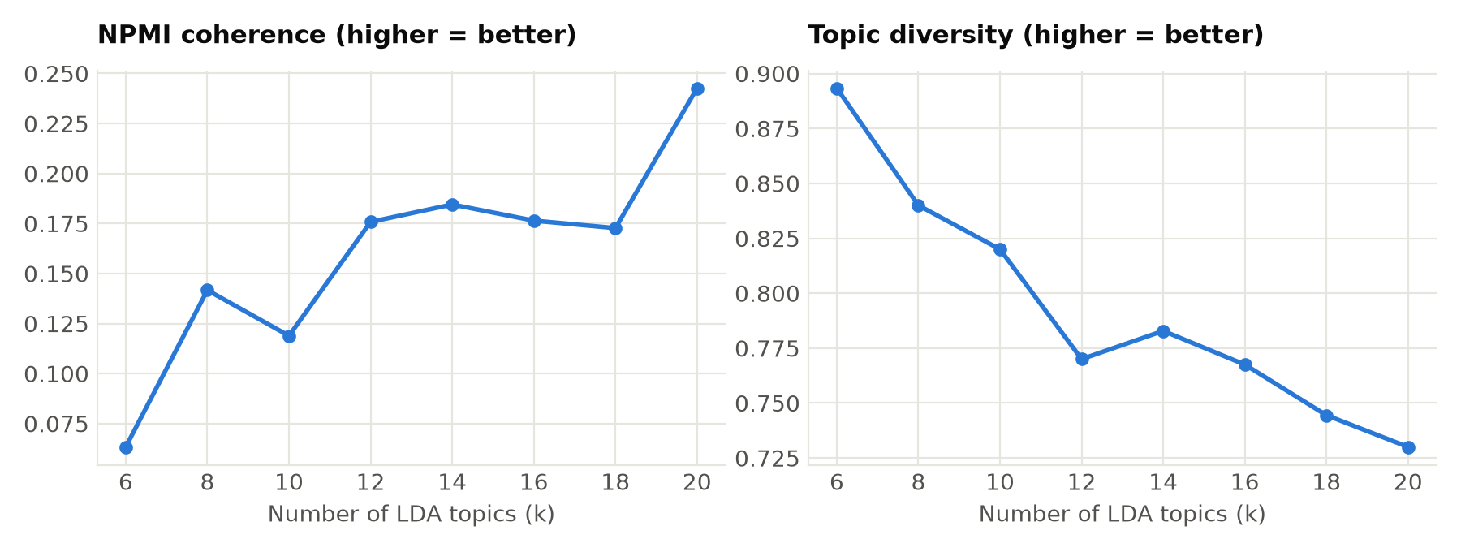
Figure 1. LDA coherence and diversity for each number of topics
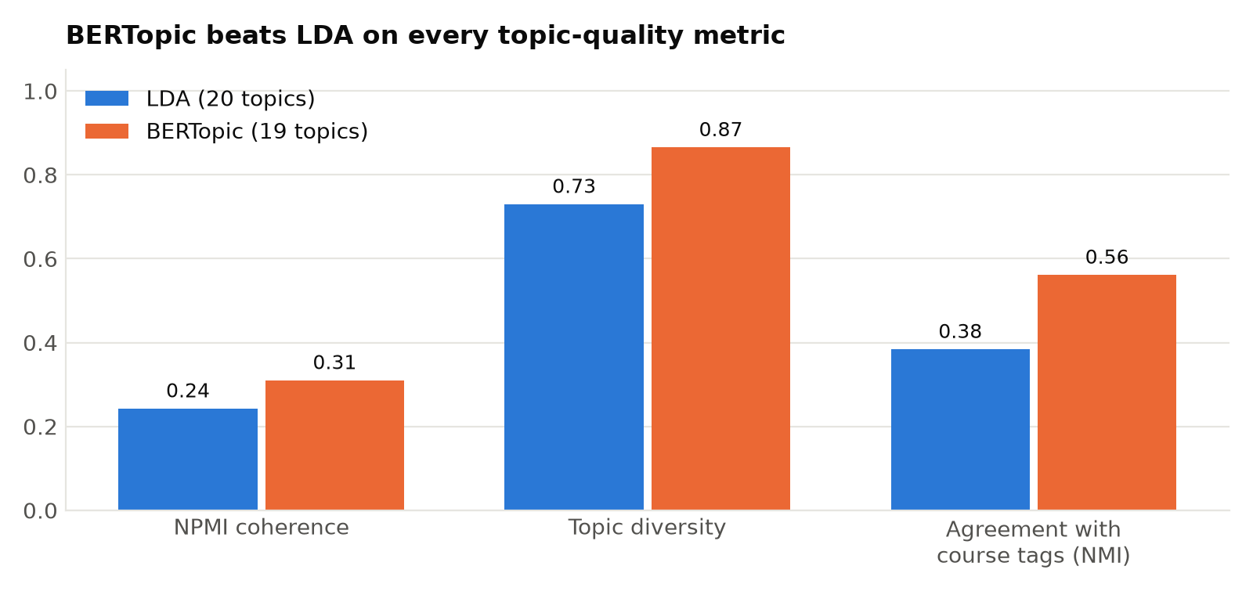
Figure 2. BERTopic vs LDA on the three quality metrics
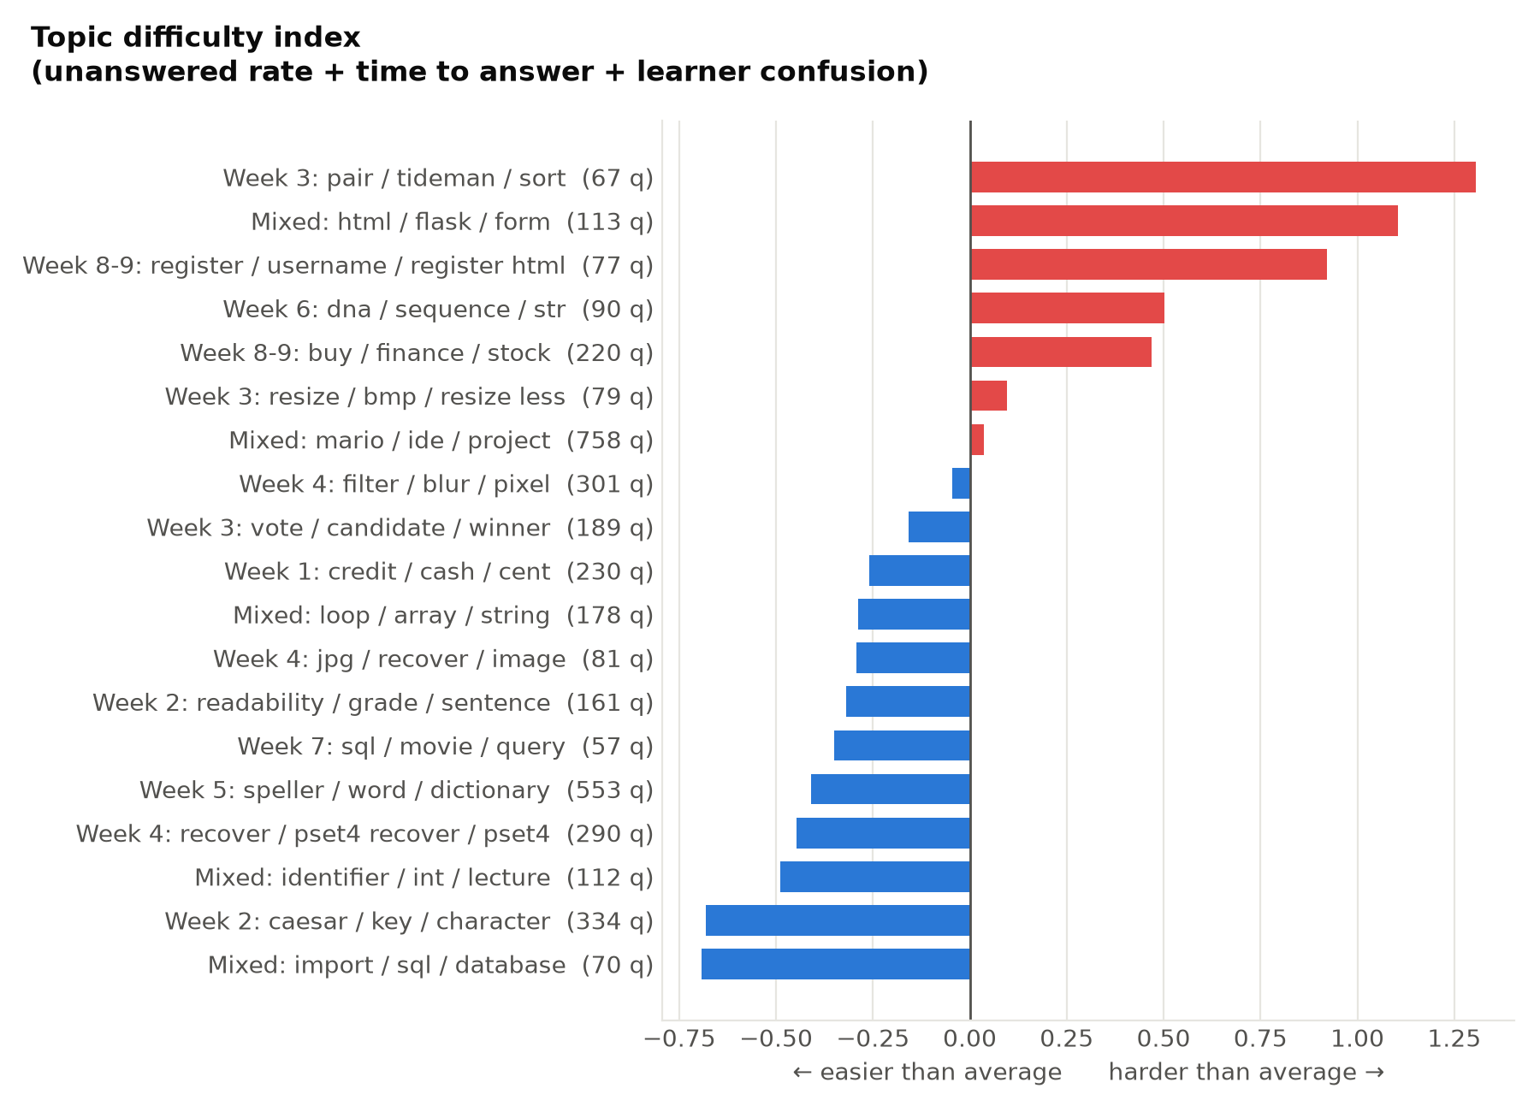
Figure 3. Topic difficulty index
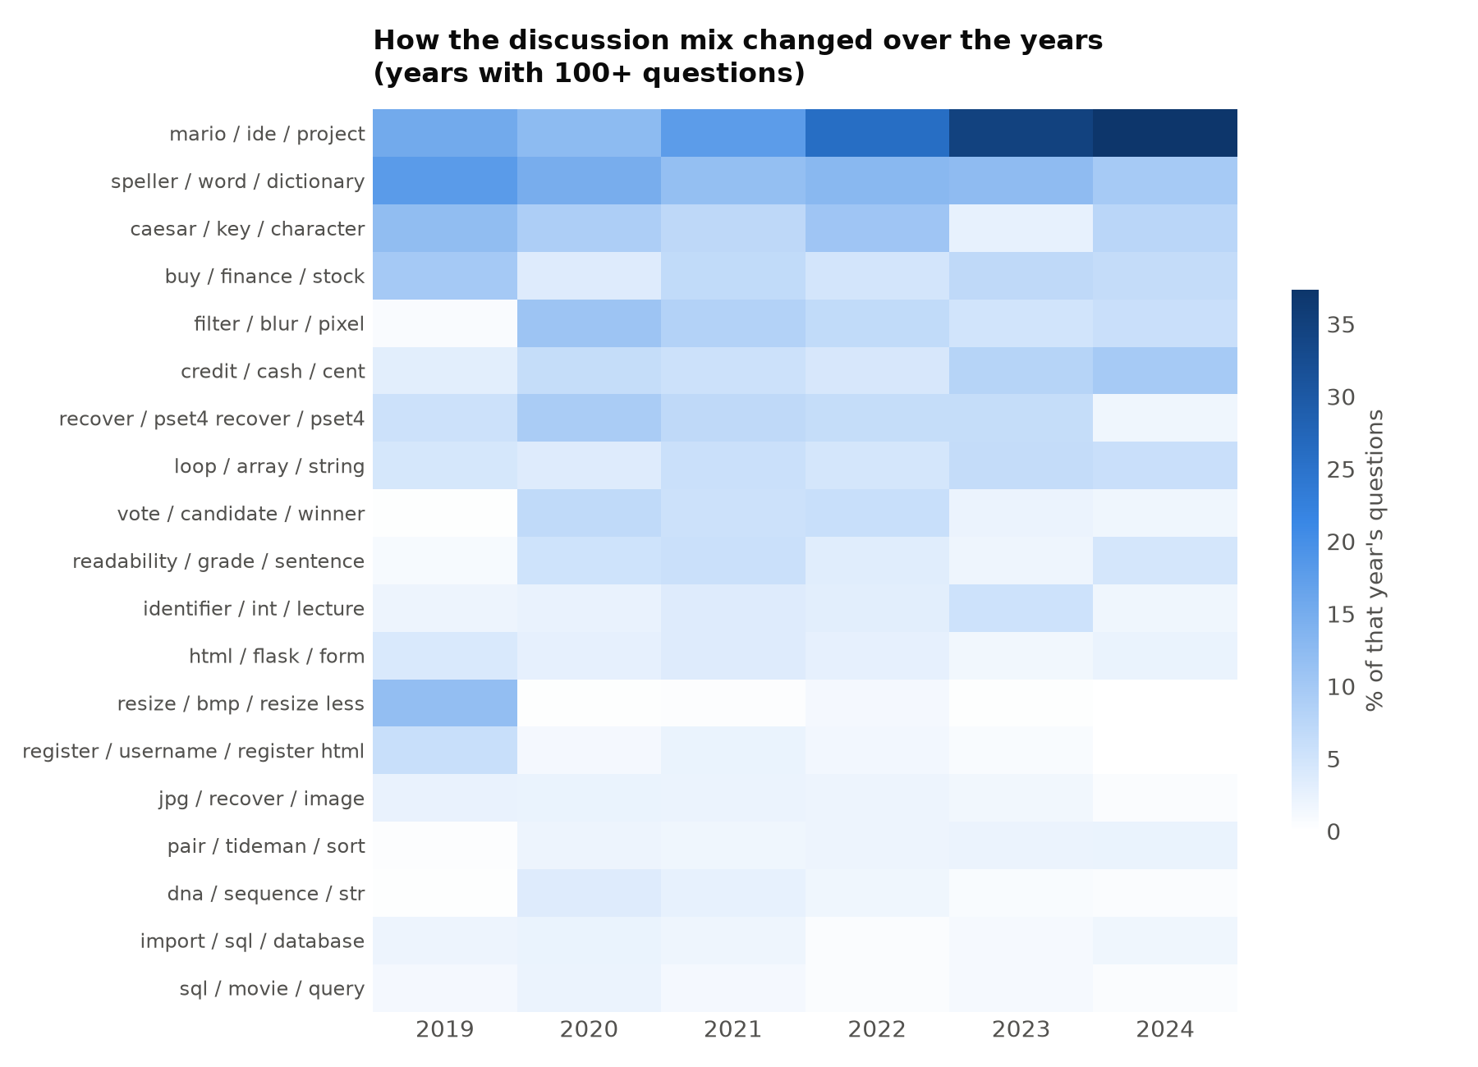
Figure 4. Topic share by year

7. Knowledge Network (network.py)
Aim: build the directed helper → learner network (answers, and comments by someone other than the thread's asker) and measure it. For every user the program computes degree and strength, ExpertiseRank (PageRank on learner → helper links), PageRank, betweenness, clustering, k-core number, Louvain community, participation coefficient and a rule-based role. It then validates the measures against Stack Exchange reputation and accepted answers, and builds yearly snapshots.
Run: python src/network.py
Source code: src/network.py (267 lines)
1 """
2 Step 3: build the knowledge network (who helps whom) and measure its structure.
3
4 Graph: directed, edge helper -> learner, weight = number of interactions. Only
5 knowledge-giving interactions are used (answers, and comments by someone other than the
6 thread's asker), see data_loader.help_interactions.
7
8 Outputs:
9 outputs/user_metrics.csv centrality, community and role of every user
10 outputs/help_edges.csv aggregated weighted edge list
11 outputs/network_stats.json global statistics of the network
12 outputs/network_over_time.csv yearly snapshots
13 outputs/community_topics.csv what each community talks about
14 outputs/topic_network_edges.csv topics linked by shared helpers
15 outputs/network_validation.csv do centrality scores agree with reputation?
16 """
17
18 import json
19
20 import networkx as nx
21 import numpy as np
22 import pandas as pd
23 from scipy.stats import spearmanr
24
25 from config import OUTPUT_DIR, PROCESSED_DIR, RANDOM_SEED
26 from data_loader import help_interactions, load_raw
27
28
29 def gini(values) -> float:
30 x = np.sort(np.asarray(values, dtype=float))
31 if x.sum() == 0:
32 return 0.0
33 n = len(x)
34 return float((2 * np.arange(1, n + 1) - n - 1).dot(x) / (n * x.sum()))
35
36
37 def aggregate_edges(interactions: pd.DataFrame) -> pd.DataFrame:
38 return (interactions.groupby(["source_user", "target_user"])
39 .agg(weight=("id", "size"),
40 n_answers=("type", lambda s: int((s == "answer").sum())),
41 first_at=("created_at", "min"), last_at=("created_at", "max"))
42 .reset_index())
43
44
45 def build_graph(edges: pd.DataFrame) -> nx.DiGraph:
46 g = nx.DiGraph()
47 for e in edges.itertuples():
48 g.add_edge(int(e.source_user), int(e.target_user), weight=int(e.weight))
49 return g
50
51
52 def user_activity(raw) -> pd.DataFrame:
53 q, a, c = raw["questions"], raw["answers"], raw["comments"]
54 act = pd.DataFrame({
55 "n_questions": q.groupby("user_id").size(),
56 "n_answers": a.groupby("user_id").size(),
57 "n_accepted": a[a["is_accepted"].astype(bool)].groupby("user_id").size(),
58 "n_comments": c.groupby("user_id").size(),
59 "answer_score": a.groupby("user_id")["score"].sum(),
60 }).fillna(0).astype(int)
61 first_seen = pd.concat([q[["user_id", "created_at"]], a[["user_id", "created_at"]],
62 c[["user_id", "created_at"]]]).groupby("user_id")["created_at"]
63 act["first_seen"] = first_seen.min()
64 act["last_seen"] = first_seen.max()
65 act.index = act.index.astype("int64")
66 return act
67
68
69 def participation_coefficient(ug: nx.Graph, community: dict) -> dict:
70 """Share of a node's links that go to other communities (0 = inward, ~1 = bridge)."""
71 out = {}
72 for node in ug:
73 nbrs = list(ug[node])
74 if not nbrs:
75 out[node] = 0.0
76 continue
77 counts = pd.Series([community[n] for n in nbrs]).value_counts(normalize=True)
78 out[node] = float(1 - (counts ** 2).sum())
79 return out
80
81
82 def assign_roles(m: pd.DataFrame) -> pd.Series:
83 """Rule-based roles, from most to least specific."""
84 top_help = m["out_strength"].quantile(0.98)
85 top_betw = m["betweenness"].quantile(0.95)
86 role = pd.Series("Peripheral learner", index=m.index)
87 role[(m["out_strength"] >= 1) & (m["in_strength"] >= 1)] = "Active participant"
88 role[(m["out_strength"] >= 3) & (m["out_strength"] > m["in_strength"])] = "Helper"
89 role[(m["betweenness"] >= top_betw) & (m["participation_coef"] >= 0.3) & (m["out_strength"] >= 3)] = "Bridge"
90 role[(m["out_strength"] >= max(top_help, 10)) & (m["n_answers"] >= 10)] = "Core expert"
91 role[(m["out_strength"] == 0) & (m["in_strength"] == 0)] = "Isolated"
92 return role
93
94
95 def global_stats(g: nx.DiGraph, ug: nx.Graph, communities, m: pd.DataFrame) -> dict:
96 giant = max(nx.weakly_connected_components(g), key=len)
97 help_given = m["out_strength"].sort_values(ascending=False)
98 total = help_given.sum()
99 n = len(help_given)
100 out_deg = np.array([d for _, d in g.out_degree() if d > 0])
101 # Slope of the log-log complementary CDF: a straight line means a heavy-tailed (scale-free-like) network.
102 vals = np.sort(np.unique(out_deg))
103 ccdf = np.array([(out_deg >= v).mean() for v in vals])
104 slope = float(np.polyfit(np.log(vals), np.log(ccdf), 1)[0]) if len(vals) > 2 else None
105 helpers = (m["out_strength"] > 0).sum()
106 return {
107 "n_users": g.number_of_nodes(),
108 "n_edges": g.number_of_edges(),
109 "n_interactions": int(sum(d["weight"] for _, _, d in g.edges(data=True))),
110 "density": nx.density(g),
111 "reciprocity": nx.reciprocity(g),
112 "avg_clustering": nx.average_clustering(ug),
113 "transitivity": nx.transitivity(ug),
114 "degree_assortativity": nx.degree_assortativity_coefficient(ug),
115 "giant_component_share": len(giant) / g.number_of_nodes(),
116 "n_communities": len(communities),
117 "n_communities_10plus": sum(len(c) >= 10 for c in communities),
118 "modularity": nx.community.modularity(ug, communities, weight="weight"),
119 "n_helpers": int(helpers),
120 "pct_users_who_help": helpers / n,
121 "help_share_top1pct": float(help_given.iloc[: max(1, n // 100)].sum() / total),
122 "help_share_top10pct": float(help_given.iloc[: max(1, n // 10)].sum() / total),
123 "gini_help_given": gini(help_given),
124 "out_degree_ccdf_slope": slope,
125 }
126
127
128 def snapshots(interactions: pd.DataFrame) -> pd.DataFrame:
129 rows = []
130 for year, part in interactions.groupby(interactions["created_at"].dt.year):
131 e = aggregate_edges(part)
132 g = build_graph(e)
133 if g.number_of_nodes() < 5:
134 continue
135 ug = g.to_undirected()
136 comms = nx.community.louvain_communities(ug, weight="weight", seed=RANDOM_SEED)
137 strength = pd.Series(dict(g.out_degree(weight="weight"))).sort_values(ascending=False)
138 rows.append({
139 "year": int(year), "active_users": g.number_of_nodes(), "edges": g.number_of_edges(),
140 "interactions": int(e["weight"].sum()), "density": nx.density(g),
141 "reciprocity": nx.reciprocity(g), "avg_clustering": nx.average_clustering(ug),
142 "giant_component_share": len(max(nx.weakly_connected_components(g), key=len)) / g.number_of_nodes(),
143 "modularity": nx.community.modularity(ug, comms, weight="weight"),
144 "n_helpers": int((strength > 0).sum()),
145 "help_share_top10pct": float(strength.iloc[: max(1, len(strength) // 10)].sum() / strength.sum()),
146 })
147 return pd.DataFrame(rows)
148
149
150 def topic_participation(raw, qt: pd.DataFrame) -> pd.DataFrame:
151 """One row per (user, topic, role): who asks about and who helps with each topic."""
152 q = raw["questions"][["post_id", "user_id"]].merge(qt[["post_id", "topic"]], on="post_id")
153 a = raw["answers"][["question_id", "user_id"]].merge(
154 qt[["post_id", "topic"]], left_on="question_id", right_on="post_id")
155 asks = q.assign(role="ask")[["user_id", "topic", "role"]]
156 helps = a.assign(role="help")[["user_id", "topic", "role"]]
157 return pd.concat([asks, helps]).dropna(subset=["user_id"])
158
159
160 def run():
161 raw = load_raw()
162 inter = help_interactions(raw)
163
164 edges = aggregate_edges(inter)
165 edges.to_csv(OUTPUT_DIR / "help_edges.csv", index=False)
166 g = build_graph(edges)
167 ug = nx.Graph()
168 for u, v, d in g.edges(data=True):
169 w = ug[u][v]["weight"] + d["weight"] if ug.has_edge(u, v) else d["weight"]
170 ug.add_edge(u, v, weight=w)
171 print(f"[network] {g.number_of_nodes()} users, {g.number_of_edges()} helper->learner links")
172
173 # ---- centrality
174 m = pd.DataFrame(index=pd.Index(list(g.nodes), name="user_id"))
175 m["out_degree"] = pd.Series(dict(g.out_degree()))
176 m["in_degree"] = pd.Series(dict(g.in_degree()))
177 m["out_strength"] = pd.Series(dict(g.out_degree(weight="weight")))
178 m["in_strength"] = pd.Series(dict(g.in_degree(weight="weight")))
179 # ExpertiseRank: PageRank on learner -> helper links, so helping people who themselves
180 # help others counts more (Zhang, Ackerman & Adamic, 2007).
181 m["expertise_rank"] = pd.Series(nx.pagerank(g.reverse(copy=False), weight="weight"))
182 m["pagerank"] = pd.Series(nx.pagerank(g, weight="weight"))
183 m["betweenness"] = pd.Series(nx.betweenness_centrality(ug, k=min(1000, len(ug)), seed=RANDOM_SEED))
184 m["clustering"] = pd.Series(nx.clustering(ug))
185 simple = nx.Graph(ug)
186 simple.remove_edges_from(nx.selfloop_edges(simple))
187 m["core_number"] = pd.Series(nx.core_number(simple))
188
189 # ---- communities
190 communities = nx.community.louvain_communities(ug, weight="weight", seed=RANDOM_SEED)
191 communities = sorted(communities, key=len, reverse=True)
192 community_of = {node: i for i, c in enumerate(communities) for node in c}
193 m["community"] = pd.Series(community_of)
194 m["participation_coef"] = pd.Series(participation_coefficient(ug, community_of))
195
196 # ---- activity, reputation, roles
197 users = raw["users"].dropna(subset=["user_id"]).assign(user_id=lambda d: d.user_id.astype("int64"))
198 m = m.join(users.set_index("user_id")[["user_name", "user_reputation"]]).join(user_activity(raw))
199 m[["n_questions", "n_answers", "n_accepted", "n_comments", "answer_score"]] = (
200 m[["n_questions", "n_answers", "n_accepted", "n_comments", "answer_score"]].fillna(0).astype(int))
201 m["role"] = assign_roles(m)
202
203 # Main topic each user helps with (from the topic model, when available).
204 qt_path = PROCESSED_DIR / "question_topics.parquet"
205 if qt_path.exists():
206 qt = pd.read_parquet(qt_path)
207 part = topic_participation(raw, qt)
208 part["user_id"] = part["user_id"].astype("int64")
209 main_help = part[part.role == "help"].groupby("user_id")["topic"].agg(lambda s: s.value_counts().index[0])
210 m["main_help_topic"] = main_help.astype("Int64")
211 m["n_topics_helped"] = part[part.role == "help"].groupby("user_id")["topic"].nunique()
212 m["n_topics_helped"] = m["n_topics_helped"].fillna(0).astype(int)
213
214 # Community profiles: which topics each community's members ask about or help with.
215 cp = part.merge(m[["community"]], left_on="user_id", right_index=True)
216 prof = cp.groupby(["community", "topic"]).size().rename("n").reset_index()
217 prof["share"] = prof["n"] / prof.groupby("community")["n"].transform("sum")
218 prof = prof[prof["community"].isin(range(15))].sort_values(["community", "share"], ascending=[True, False])
219 prof.groupby("community").head(5).to_csv(OUTPUT_DIR / "community_topics.csv", index=False)
220
221 # Topic network: two topics are linked when the same people help with both.
222 helpers = part[part.role == "help"].drop_duplicates(["user_id", "topic"])
223 pairs = helpers.merge(helpers, on="user_id")
224 pairs = pairs[pairs.topic_x < pairs.topic_y]
225 tn = pairs.groupby(["topic_x", "topic_y"]).size().rename("shared_helpers").reset_index()
226 tn.rename(columns={"topic_x": "topic_a", "topic_y": "topic_b"}).to_csv(
227 OUTPUT_DIR / "topic_network_edges.csv", index=False)
228
229 m = m.sort_values("expertise_rank", ascending=False)
230 m.reset_index().to_csv(OUTPUT_DIR / "user_metrics.csv", index=False)
231
232 # ---- communities summary
233 comm = (m.groupby("community")
234 .agg(size=("out_strength", "size"), help_given=("out_strength", "sum"),
235 top_member=("user_name", "first"))
236 .sort_values("size", ascending=False))
237 comm.reset_index().to_csv(OUTPUT_DIR / "communities.csv", index=False)
238
239 # ---- global stats, validation, time
240 stats = global_stats(g, ug, communities, m)
241 stats["role_counts"] = m["role"].value_counts().to_dict()
242 with open(OUTPUT_DIR / "network_stats.json", "w") as f:
243 json.dump(stats, f, indent=2, default=float)
244
245 # Validate on helpers only: most users never answer, and thousands of tied zeros would
246 # swamp the rank correlation.
247 val = []
248 helpers = m[(m["n_answers"] > 0) & m["user_reputation"].notna()]
249 for metric in ["expertise_rank", "pagerank", "out_strength", "betweenness", "core_number"]:
250 for target in ["user_reputation", "n_accepted"]:
251 rho, p = spearmanr(helpers[metric], helpers[target])
252 top_metric = set(helpers.nlargest(20, metric).index)
253 top_target = set(helpers.nlargest(20, target).index)
254 val.append({"metric": metric, "compared_with": target, "n_helpers": len(helpers),
255 "spearman_rho": rho, "p_value": p,
256 "top20_overlap": len(top_metric & top_target) / 20})
257 pd.DataFrame(val).round(4).to_csv(OUTPUT_DIR / "network_validation.csv", index=False)
258
259 snapshots(inter).round(4).to_csv(OUTPUT_DIR / "network_over_time.csv", index=False)
260
261 print(f"[network] {stats['n_communities']} communities (modularity {stats['modularity']:.2f}); "
262 f"top 10% of users give {stats['help_share_top10pct']:.0%} of all help")
263 return m
264
265
266 if __name__ == "__main__":
267 run()

Output
=== network: knowledge network, centrality, communities (~1 min)
[network] 2891 users, 4245 helper->learner links
[network] 118 communities (modularity 0.60); top 10% of users give 92% of all help
=== network done in 8s

Table 7. Global network statistics (outputs/network_stats.json)
Measure | Value
n_users | 2891
n_edges | 4245
n_interactions | 6930
density | 0.0005
reciprocity | 0.0353
avg_clustering | 0.1575
transitivity | 0.0043
degree_assortativity | -0.3045
giant_component_share | 0.9339
n_communities | 118
n_communities_10plus | 16
modularity | 0.6042
n_helpers | 872
pct_users_who_help | 0.3016
help_share_top1pct | 0.8063
help_share_top10pct | 0.9159
gini_help_given | 0.955
out_degree_ccdf_slope | -0.7879

Table 8. Top 10 users by ExpertiseRank (outputs/user_metrics.csv)
user_name | role | out_strength | in_strength | n_answers | n_accepted | expertise_rank | betweenness | community
Cliff B | Core expert | 1861 | 107 | 1160 | 809 | 0.1756 | 0.5724 | 0
UpAndAdam | Core expert | 558 | 19 | 140 | 52 | 0.075 | 0.0808 | 2
DinoCoderSaurus | Core expert | 1043 | 50 | 523 | 282 | 0.0591 | 0.2944 | 1
curiouskiwi | Core expert | 295 | 35 | 191 | 112 | 0.0276 | 0.0916 | 5
kcw78 | Core expert | 97 | 22 | 44 | 16 | 0.022 | 0.0252 | 9
Blauelf | Core expert | 409 | 24 | 249 | 160 | 0.0217 | 0.0807 | 3
Robert S. Pratt | Core expert | 182 | 17 | 84 | 59 | 0.0139 | 0.031 | 7
Tritum | Core expert | 157 | 13 | 101 | 51 | 0.0127 | 0.0359 | 4
Andreas Wenzel | Core expert | 32 | 6 | 11 | 4 | 0.0109 | 0.0071 | 2
Fuelled_By_Coffee | Core expert | 70 | 5 | 38 | 15 | 0.0093 | 0.021 | 10

Table 9. Largest communities (outputs/communities.csv)
community | size | help_given | top_member
0 | 648 | 2000 | Cliff B
1 | 474 | 1258 | DinoCoderSaurus
2 | 220 | 682 | UpAndAdam
3 | 215 | 509 | Blauelf
4 | 190 | 457 | Tritum
5 | 167 | 372 | curiouskiwi
6 | 129 | 277 | Vsjain
7 | 99 | 268 | Robert S. Pratt

Table 10. Validation of network measures (outputs/network_validation.csv)
metric | compared_with | n_helpers | spearman_rho | top20_overlap
expertise_rank | user_reputation | 821 | 0.232 | 0.7
expertise_rank | n_accepted | 821 | 0.154 | 0.85
pagerank | user_reputation | 821 | 0.298 | 0.35
pagerank | n_accepted | 821 | 0.204 | 0.4
out_strength | user_reputation | 821 | 0.253 | 0.7
out_strength | n_accepted | 821 | 0.206 | 0.95
betweenness | user_reputation | 821 | 0.407 | 0.7
betweenness | n_accepted | 821 | 0.309 | 0.85
core_number | user_reputation | 821 | 0.369 | 0.5
core_number | n_accepted | 821 | 0.346 | 0.7

Table 11. Network by year (outputs/network_over_time.csv)
year | active_users | edges | interactions | reciprocity | modularity | n_helpers | help_share_top10pct
2019 | 345 | 510 | 885 | 0.043 | 0.513 | 69 | 0.96
2020 | 1180 | 1805 | 2871 | 0.038 | 0.569 | 354 | 0.912
2021 | 522 | 702 | 1115 | 0.043 | 0.601 | 144 | 0.918
2022 | 472 | 506 | 682 | 0.028 | 0.651 | 148 | 0.852
2023 | 442 | 496 | 787 | 0.024 | 0.616 | 135 | 0.884
2024 | 213 | 249 | 511 | 0.04 | 0.408 | 60 | 0.924
2025 | 52 | 50 | 64 | 0.04 | 0.582 | 16 | 0.812
2026 | 18 | 13 | 15 | 0.0 | 0.731 | 7 | 0.267

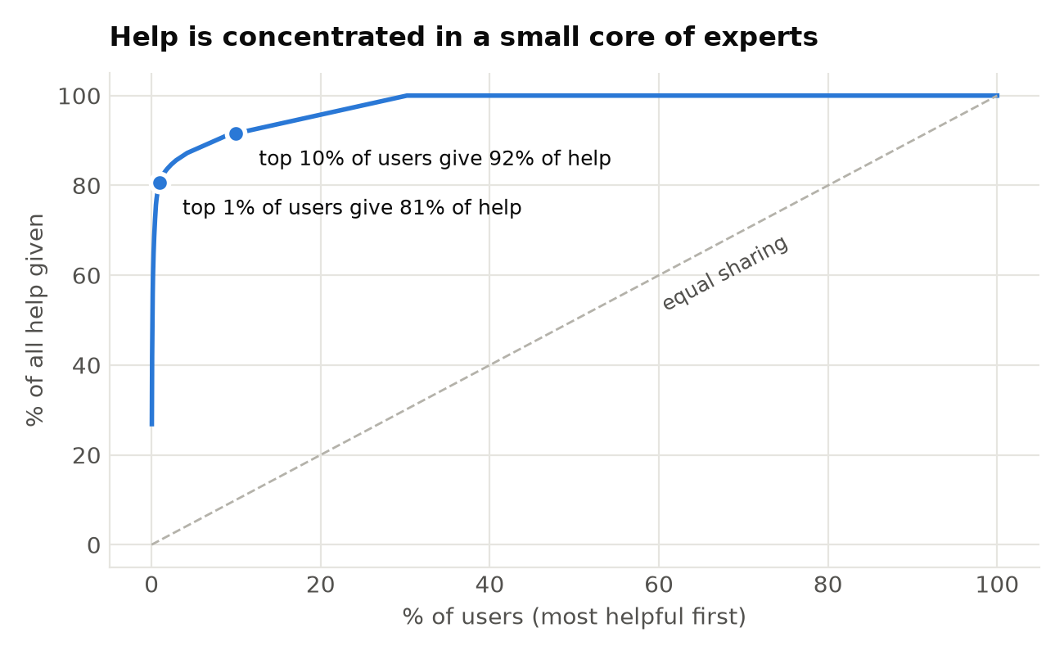
Figure 5. Help concentration
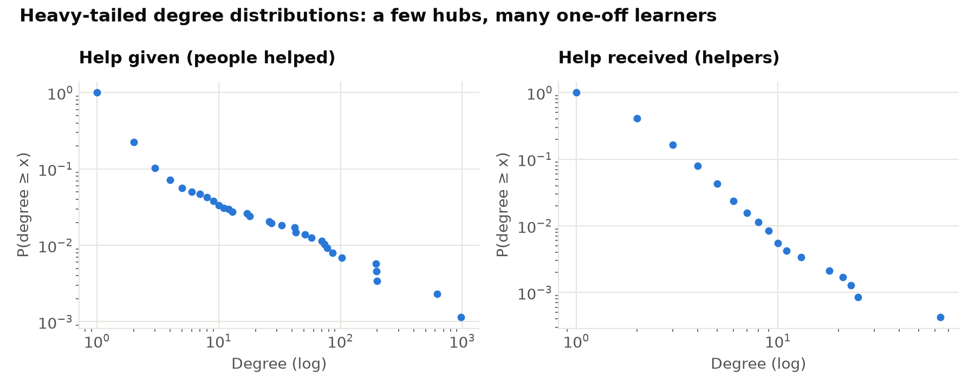
Figure 6. Degree distributions (log scale)
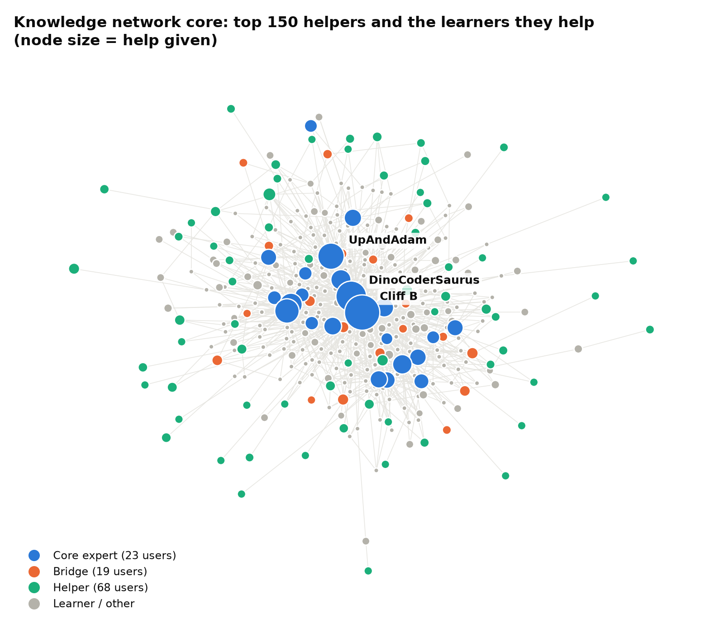
Figure 7. Core of the knowledge network, coloured by role
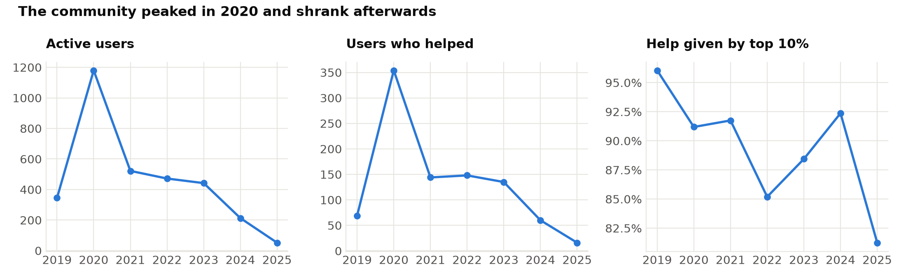
Figure 8. The network over time

8. Knowledge Diffusion (diffusion.py)
Aim: test whether knowledge spreads through contact, and simulate diffusion. The exposure test compares how often adopters of a topic had earlier contact with an adopter against 200 random shuffles of the adoption times, and combines the topics with Stouffer's method. The learner → helper test uses a chi-square test. The Independent Cascade and Linear Threshold models are simulated with Monte Carlo runs, seeds are chosen by CELF greedy and compared with centrality rankings, and the simulation is validated against observed time-respecting reach.
Run: python src/diffusion.py (about 6 minutes)
Source code: src/diffusion.py (364 lines)
1 """
2 Step 4: knowledge diffusion — how topics and help spread through the community.
3
4 A. Observed diffusion
5 - Topic adoption curves: when each user first takes part in a topic.
6 - Social exposure test: were adopters more often in contact with earlier adopters than
7 chance predicts? (time-shuffle test, Anagnostopoulos et al., 2008)
8 - Learner -> helper transition: do learners who receive help go on to help others?
9 - Thread cascades: how large the discussion grows around each question.
10 B. Simulated diffusion on the help network
11 - Independent Cascade (IC, p = 1 - (1 - beta)^interactions) and Linear Threshold (LT)
12 models (Kempe et al., 2003).
13 - Influence maximisation with CELF greedy vs. centrality heuristics and random seeds.
14 - Validation: does simulated influence match observed time-respecting reach?
15 """
16
17 import json
18
19 import numpy as np
20 import pandas as pd
21 from scipy.stats import spearmanr
22
23 from config import OUTPUT_DIR, PROCESSED_DIR, RANDOM_SEED
24 from data_loader import help_interactions, load_raw
25
26 N_SHUFFLES = 200
27 MC_RUNS_SELECT = 200 # Monte Carlo runs while choosing seeds
28 MC_RUNS_EVAL = 300 # Monte Carlo runs when reporting spread
29 N_CANDIDATES = 150 # seed candidates: most active helpers
30 MAX_SEEDS = 10
31 IC_BETA = 0.1 # IC: chance that one interaction passes the knowledge on
32
33 rng = np.random.default_rng(RANDOM_SEED)
34
35
36 # =========================================================================== A. observed
37
38 def participation_events(raw, qt):
39 """(user, topic, time, kind): asking a question or answering one in a topic."""
40 q = raw["questions"][["post_id", "user_id", "created_at"]].merge(qt[["post_id", "topic"]], on="post_id")
41 a = raw["answers"][["question_id", "user_id", "created_at"]].merge(
42 qt[["post_id", "topic"]], left_on="question_id", right_on="post_id")
43 ev = pd.concat([q.assign(kind="ask")[["user_id", "topic", "created_at", "kind"]],
44 a.assign(kind="help")[["user_id", "topic", "created_at", "kind"]]])
45 ev = ev.dropna(subset=["user_id"])
46 ev["user_id"] = ev["user_id"].astype("int64")
47 return ev
48
49
50 def contact_arrays(inter, user_index):
51 """Every interaction in both directions as parallel arrays (u, v, time in days)."""
52 s = inter["source_user"].map(user_index).to_numpy()
53 t = inter["target_user"].map(user_index).to_numpy()
54 ts = (inter["created_at"].astype("int64") // 10**9 / 86400).to_numpy()
55 ok = ~(np.isnan(s.astype(float)) | np.isnan(t.astype(float)))
56 s, t, ts = s[ok].astype(int), t[ok].astype(int), ts[ok]
57 return np.concatenate([s, t]), np.concatenate([t, s]), np.concatenate([ts, ts])
58
59
60 def exposed_share(adopt_time, adopters, cu, cv, ct):
61 """Share of adopters who, before adopting, had contact with someone who adopted earlier."""
62 hit = (adopt_time[cv] < ct) & (ct < adopt_time[cu])
63 exposed = np.intersect1d(np.unique(cu[hit]), adopters)
64 first = adopters[np.argmin(adopt_time[adopters])]
65 return len(np.setdiff1d(exposed, [first])) / max(len(adopters) - 1, 1)
66
67
68 def exposure_test(events, inter, topics):
69 users = np.unique(np.concatenate([events["user_id"].unique(),
70 inter["source_user"].unique(), inter["target_user"].unique()]))
71 user_index = pd.Series(np.arange(len(users)), index=users)
72 cu, cv, ct = contact_arrays(inter, user_index)
73 first = events.groupby(["topic", "user_id"])["created_at"].min().reset_index()
74 first["day"] = first["created_at"].astype("int64") // 10**9 / 86400
75
76 rows = []
77 for topic, grp in first.groupby("topic"):
78 if len(grp) < 30:
79 continue
80 idx = user_index[grp["user_id"]].to_numpy()
81 adopt = np.full(len(users), np.inf)
82 adopt[idx] = grp["day"].to_numpy()
83 observed = exposed_share(adopt, idx, cu, cv, ct)
84 null = []
85 for _ in range(N_SHUFFLES):
86 shuffled = np.full(len(users), np.inf)
87 shuffled[idx] = rng.permutation(grp["day"].to_numpy())
88 null.append(exposed_share(shuffled, idx, cu, cv, ct))
89 null = np.array(null)
90 rows.append({
91 "topic": topic, "n_adopters": len(grp), "observed_exposed_share": observed,
92 "null_mean": null.mean(), "null_std": null.std(),
93 "z_score": (observed - null.mean()) / (null.std() or np.nan),
94 "p_value": (np.sum(null >= observed) + 1) / (N_SHUFFLES + 1),
95 })
96 out = pd.DataFrame(rows)
97 return out.merge(topics[["topic", "label"]], on="topic", how="left") if len(out) else out
98
99
100 def combine_exposure(exposure: pd.DataFrame) -> dict:
101 """Stouffer's method: one overall z-score from the per-topic tests."""
102 from scipy.stats import norm
103 z = exposure["z_score"].replace([np.inf, -np.inf], np.nan).dropna()
104 z_all = float(z.sum() / np.sqrt(len(z)))
105 return {"exposure_stouffer_z": z_all, "exposure_stouffer_p": float(norm.sf(z_all)),
106 "exposure_significant_topics": exposure.loc[exposure["p_value"] < 0.05, "label"].tolist()}
107
108
109 def adoption_curves(events, communities):
110 first = events.groupby(["topic", "user_id"])["created_at"].min().reset_index()
111 first["period"] = first["created_at"].dt.to_period("Q").astype(str)
112 first["community"] = first["user_id"].map(communities)
113 curve = first.groupby(["topic", "period"]).agg(
114 new_adopters=("user_id", "size"),
115 communities_reached=("community", lambda s: s.dropna().nunique())).reset_index()
116 curve["cumulative_adopters"] = curve.groupby("topic")["new_adopters"].cumsum()
117 curve["share_of_final"] = curve["cumulative_adopters"] / curve.groupby("topic")["new_adopters"].transform("sum")
118 return curve
119
120
121 def learner_to_helper(raw):
122 """Do learners whose first question got answered later become helpers themselves?"""
123 q = raw["questions"].dropna(subset=["user_id"]).sort_values("created_at")
124 a = raw["answers"].dropna(subset=["user_id"])
125 first_q = q.groupby("user_id").first()[["post_id", "created_at"]]
126 answered_ids = set(a["question_id"])
127 accepted_ids = set(q.loc[q["accepted_answer_id"].notna(), "post_id"])
128 first_q["got_answer"] = first_q["post_id"].isin(answered_ids)
129 first_q["got_accepted"] = first_q["post_id"].isin(accepted_ids)
130 asker = q.set_index("post_id")["user_id"]
131 a = a[a["question_id"].map(asker) != a["user_id"]] # answering your own question is not helping others
132 first_help = a.groupby("user_id")["created_at"].min()
133 first_q["first_help_at"] = first_help.reindex(first_q.index)
134 first_q["became_helper"] = first_q["first_help_at"] > first_q["created_at"]
135 first_q["days_to_helper"] = (first_q["first_help_at"] - first_q["created_at"]).dt.days
136
137 rate = first_q.groupby("got_answer")["became_helper"].mean()
138 table = pd.crosstab(first_q["got_answer"], first_q["became_helper"])
139 from scipy.stats import chi2_contingency
140 chi2, p, _, _ = chi2_contingency(table) if table.shape == (2, 2) else (np.nan, np.nan, None, None)
141 helpers = first_q[first_q["became_helper"]]
142 return {
143 "n_learners": int(len(first_q)),
144 "n_became_helpers": int(first_q["became_helper"].sum()),
145 "pct_became_helpers": float(first_q["became_helper"].mean()),
146 "pct_helper_if_first_question_answered": float(rate.get(True, np.nan)),
147 "pct_helper_if_first_question_unanswered": float(rate.get(False, np.nan)),
148 "chi2": float(chi2), "p_value": float(p),
149 "median_days_to_become_helper": float(helpers["days_to_helper"].median()) if len(helpers) else None,
150 }
151
152
153 def thread_cascades(raw, qt):
154 """Size of the discussion around each question (answers + comments on the thread)."""
155 q, a, c = raw["questions"], raw["answers"], raw["comments"]
156 post_to_q = pd.concat([q[["post_id"]].assign(question_id=q["post_id"]),
157 a[["post_id", "question_id"]]])
158 cm = c.merge(post_to_q, on="post_id")
159 size = (a.groupby("question_id").size().rename("n_answers").to_frame()
160 .join(cm.groupby("question_id").size().rename("n_comments"), how="outer").fillna(0))
161 people = pd.concat([a[["question_id", "user_id"]], cm[["question_id", "user_id"]]])
162 size["n_participants"] = people.dropna().groupby("question_id")["user_id"].nunique()
163 size = size.fillna(0)
164 size["cascade_size"] = size["n_answers"] + size["n_comments"]
165 size = size.reset_index().rename(columns={"index": "question_id"})
166 size = q[["post_id"]].merge(size, left_on="post_id", right_on="question_id", how="left").fillna(0)
167 size = size.merge(qt[["post_id", "topic"]], on="post_id", how="left")
168 size = size.dropna(subset=["topic"]).astype({"topic": int})
169 per_topic = size.groupby("topic").agg(
170 n_threads=("post_id", "size"), mean_cascade_size=("cascade_size", "mean"),
171 max_cascade_size=("cascade_size", "max"), mean_participants=("n_participants", "mean")).reset_index()
172 distribution = size["cascade_size"].value_counts().sort_index().rename("n_threads").reset_index()
173 return per_topic, distribution
174
175
176 # =========================================================================== B. simulated
177
178 class HelpNetwork:
179 """Compact adjacency lists for fast Monte Carlo simulation (knowledge flows helper -> learner)."""
180
181 def __init__(self, edges: pd.DataFrame):
182 nodes = pd.Index(pd.unique(pd.concat([edges.source_user, edges.target_user])))
183 self.nodes = nodes
184 self.n = len(nodes)
185 src = nodes.get_indexer(edges.source_user)
186 dst = nodes.get_indexer(edges.target_user)
187 w = edges["weight"].to_numpy(float)
188 in_strength = np.bincount(dst, weights=w, minlength=self.n)
189 # IC: each of the w interactions independently passes knowledge with probability beta.
190 p_ic = 1 - (1 - IC_BETA) ** w
191 # LT: influence weights w_uv / in_strength(v), which sum to 1 over v's helpers.
192 b_lt = w / in_strength[dst]
193 order = np.argsort(src, kind="stable")
194 self.src, self.dst = src[order], dst[order]
195 self.p_ic, self.b_lt = p_ic[order], b_lt[order]
196 self.ptr = np.searchsorted(self.src, np.arange(self.n + 1))
197
198 def out(self, u, weights):
199 a, b = self.ptr[u], self.ptr[u + 1]
200 return self.dst[a:b], weights[a:b]
201
202 def ic(self, seeds, runs):
203 total = 0
204 for _ in range(runs):
205 active = np.zeros(self.n, bool)
206 active[seeds] = True
207 frontier = list(seeds)
208 while frontier:
209 nxt = []
210 for u in frontier:
211 v, p = self.out(u, self.p_ic)
212 hit = v[(~active[v]) & (rng.random(len(v)) < p)]
213 active[hit] = True
214 nxt.extend(hit.tolist())
215 frontier = nxt
216 total += active.sum()
217 return total / runs
218
219 def lt(self, seeds, runs):
220 total = 0
221 for _ in range(runs):
222 threshold = rng.random(self.n)
223 pressure = np.zeros(self.n)
224 active = np.zeros(self.n, bool)
225 active[seeds] = True
226 frontier = list(seeds)
227 while frontier:
228 nxt = []
229 for u in frontier:
230 v, p = self.out(u, self.b_lt)
231 pressure[v] += p
232 new = v[(~active[v]) & (pressure[v] >= threshold[v])]
233 active[new] = True
234 nxt.extend(new.tolist())
235 frontier = nxt
236 total += active.sum()
237 return total / runs
238
239
240 def celf(net: HelpNetwork, candidates, k, model="ic"):
241 """CELF lazy-greedy influence maximisation (Leskovec et al., 2007)."""
242 sim = net.ic if model == "ic" else net.lt
243 gains = sorted(((sim([c], MC_RUNS_SELECT), c) for c in candidates), reverse=True)
244 seeds, spread = [gains[0][1]], gains[0][0]
245 gains = gains[1:]
246 while len(seeds) < k and gains:
247 while True:
248 _, c = gains.pop(0)
249 gain = sim(seeds + [c], MC_RUNS_SELECT) - spread
250 if not gains or gain >= gains[0][0]:
251 seeds.append(c)
252 spread += gain
253 break
254 gains.append((gain, c))
255 gains.sort(reverse=True)
256 return seeds
257
258
259 def observed_reach(inter, sources):
260 """Users reachable from each source by time-respecting helper -> learner paths."""
261 ev = inter.sort_values("created_at")
262 s, t = ev["source_user"].to_numpy(), ev["target_user"].to_numpy()
263 ts = ev["created_at"].astype("int64").to_numpy()
264 reach = {}
265 for src in sources:
266 arrival = {src: -np.inf}
267 for a, b, time in zip(s, t, ts):
268 if a in arrival and arrival[a] <= time and b not in arrival:
269 arrival[b] = time
270 reach[src] = len(arrival) - 1
271 return pd.Series(reach)
272
273
274 def run():
275 raw = load_raw()
276 qt = pd.read_parquet(PROCESSED_DIR / "question_topics.parquet")
277 topics = pd.read_csv(OUTPUT_DIR / "topics.csv")
278 metrics = pd.read_csv(OUTPUT_DIR / "user_metrics.csv").set_index("user_id")
279 edges = pd.read_csv(OUTPUT_DIR / "help_edges.csv")
280 # Any contact (either direction) can expose a user to a topic; only help carries knowledge on.
281 contacts = raw["interactions"].dropna(subset=["source_user", "target_user"]).copy()
282 contacts["source_user"] = contacts["source_user"].astype("int64")
283 contacts["target_user"] = contacts["target_user"].astype("int64")
284 inter = help_interactions(raw)
285 summary = {}
286
287 # ---------------- A. observed
288 events = participation_events(raw, qt)
289 exposure = exposure_test(events, contacts, topics)
290 exposure.round(4).to_csv(OUTPUT_DIR / "diffusion_exposure_test.csv", index=False)
291 summary["exposure_topics_tested"] = int(len(exposure))
292 summary["exposure_topics_significant"] = int((exposure["p_value"] < 0.05).sum())
293 summary["exposure_mean_observed"] = float(exposure["observed_exposed_share"].mean())
294 summary["exposure_mean_null"] = float(exposure["null_mean"].mean())
295 summary.update(combine_exposure(exposure))
296 print(f"[diffusion] exposure test: {summary['exposure_topics_significant']}/{len(exposure)} topics "
297 f"show more contact with earlier adopters than chance")
298
299 adoption_curves(events, metrics["community"]).to_csv(OUTPUT_DIR / "topic_adoption_curves.csv", index=False)
300 summary["learner_to_helper"] = learner_to_helper(raw)
301 per_topic, dist = thread_cascades(raw, qt)
302 per_topic.round(3).to_csv(OUTPUT_DIR / "cascade_by_topic.csv", index=False)
303 dist.to_csv(OUTPUT_DIR / "cascade_size_distribution.csv", index=False)
304
305 # ---------------- B. simulated
306 net = HelpNetwork(edges)
307 idx = pd.Series(np.arange(net.n), index=net.nodes)
308 in_net = metrics.index.intersection(net.nodes)
309 candidates_ids = metrics.loc[in_net].sort_values("out_strength", ascending=False).index[:N_CANDIDATES]
310 candidates = idx[candidates_ids].tolist()
311
312 strategies = {}
313 for name, col in [("Top out-degree", "out_strength"), ("Top ExpertiseRank", "expertise_rank"),
314 ("Top betweenness", "betweenness"), ("Top PageRank", "pagerank")]:
315 strategies[name] = idx[metrics.loc[in_net].sort_values(col, ascending=False).index[:MAX_SEEDS]].tolist()
316
317 rows, seed_sets = [], {}
318 for model in ["ic", "lt"]:
319 print(f"[diffusion] influence maximisation ({model.upper()}) ...")
320 model_strategies = dict(strategies)
321 model_strategies["CELF greedy"] = celf(net, candidates, MAX_SEEDS, model)
322 sim = net.ic if model == "ic" else net.lt
323 for name, seeds in model_strategies.items():
324 for k in range(1, MAX_SEEDS + 1):
325 rows.append({"model": model.upper(), "strategy": name, "k": k, "spread": sim(seeds[:k], MC_RUNS_EVAL)})
326 random_spread = np.zeros(MAX_SEEDS)
327 for _ in range(20):
328 seeds = rng.choice(net.n, MAX_SEEDS, replace=False).tolist()
329 random_spread += [sim(seeds[:k], MC_RUNS_EVAL // 10) for k in range(1, MAX_SEEDS + 1)]
330 rows += [{"model": model.upper(), "strategy": "Random", "k": k + 1, "spread": s / 20}
331 for k, s in enumerate(random_spread)]
332 seed_sets[model.upper()] = {name: [int(net.nodes[i]) for i in s] for name, s in model_strategies.items()}
333
334 im = pd.DataFrame(rows)
335 im["spread_pct_of_users"] = 100 * im["spread"] / net.n
336 im.round(3).to_csv(OUTPUT_DIR / "influence_maximization.csv", index=False)
337 with open(OUTPUT_DIR / "seed_sets.json", "w") as f:
338 json.dump(seed_sets, f, indent=2)
339
340 # ---------------- validation: simulated vs observed
341 print("[diffusion] validating simulated influence against observed reach ...")
342 sim_single = pd.Series({net.nodes[c]: net.ic([c], MC_RUNS_SELECT) for c in candidates})
343 obs = observed_reach(inter, sim_single.index)
344 valid = pd.DataFrame({"simulated_ic_spread": sim_single, "observed_reach": obs})
345 valid = valid.join(metrics[["user_name", "out_strength", "expertise_rank", "betweenness"]])
346 valid.index.name = "user_id"
347 valid.reset_index().round(4).to_csv(OUTPUT_DIR / "diffusion_validation.csv", index=False)
348 summary["validation"] = {
349 col: float(spearmanr(valid[col], valid["observed_reach"])[0])
350 for col in ["simulated_ic_spread", "out_strength", "expertise_rank", "betweenness"]
351 }
352 k10 = im[im.k == MAX_SEEDS].set_index(["model", "strategy"])["spread"]
353 summary["spread_at_k10"] = {f"{m}|{s}": float(v) for (m, s), v in k10.items()}
354 summary["network_users"] = int(net.n)
355
356 with open(OUTPUT_DIR / "diffusion_summary.json", "w") as f:
357 json.dump(summary, f, indent=2, default=float)
358 print(f"[diffusion] simulated influence vs observed reach: Spearman rho = "
359 f"{summary['validation']['simulated_ic_spread']:.2f}")
360 return summary
361
362
363 if __name__ == "__main__":
364 run()

Output
=== diffusion: diffusion tests and IC/LT simulation (~8 min)
[diffusion] exposure test: 3/19 topics show more contact with earlier adopters than chance
[diffusion] influence maximisation (IC) ...
[diffusion] influence maximisation (LT) ...
[diffusion] validating simulated influence against observed reach ...
[diffusion] simulated influence vs observed reach: Spearman rho = 0.86
=== diffusion done in 336s

Table 12. Social exposure test per topic (outputs/diffusion_exposure_test.csv)
label | n_adopters | observed_exposed_share | null_mean | z_score | p_value
sql / movie / query | 79 | 0.487 | 0.294 | 2.766 | 0.005
dna / sequence / str | 116 | 0.487 | 0.293 | 3.513 | 0.005
buy / finance / stock | 197 | 0.424 | 0.276 | 1.673 | 0.03
register / username / register html | 77 | 0.447 | 0.315 | 1.568 | 0.06
import / sql / database | 86 | 0.329 | 0.244 | 1.508 | 0.09
speller / word / dictionary | 496 | 0.346 | 0.256 | 1.187 | 0.144
pair / tideman / sort | 96 | 0.295 | 0.259 | 0.916 | 0.224
identifier / int / lecture | 128 | 0.339 | 0.292 | 0.726 | 0.264
html / flask / form | 139 | 0.239 | 0.216 | 0.451 | 0.338
loop / array / string | 191 | 0.295 | 0.281 | 0.267 | 0.383
resize / bmp / resize less | 86 | 0.306 | 0.288 | 0.191 | 0.438
recover / pset4 recover / pset4 | 296 | 0.271 | 0.266 | 0.087 | 0.453
caesar / key / character | 335 | 0.254 | 0.257 | -0.047 | 0.502
readability / grade / sentence | 187 | 0.296 | 0.291 | 0.081 | 0.517
filter / blur / pixel | 319 | 0.255 | 0.26 | -0.103 | 0.517
vote / candidate / winner | 210 | 0.278 | 0.283 | -0.128 | 0.567
jpg / recover / image | 96 | 0.263 | 0.279 | -0.19 | 0.592
mario / ide / project | 831 | 0.17 | 0.23 | -1.369 | 0.93
credit / cash / cent | 256 | 0.188 | 0.268 | -1.402 | 0.94

Table 13. Diffusion summary (outputs/diffusion_summary.json)
Measure | Value
n_learners | 2374
n_became_helpers | 125
pct_became_helpers | 0.0527
pct_helper_if_first_question_answered | 0.0519
pct_helper_if_first_question_unanswered | 0.0599
chi2 | 0.1173
p_value | 0.732
median_days_to_become_helper | 4
exposure_stouffer_z | 2.683
exposure_stouffer_p | 0.0036
validation_spearman_simulated_ic | 0.8576

Table 14. Share of users reached with 10 seed users (outputs/influence_maximization.csv)
model | strategy | spread | spread_pct_of_users
IC | Top out-degree | 415.75 | 14.38
IC | Top ExpertiseRank | 415.01 | 14.36
IC | Top betweenness | 418.3 | 14.47
IC | Top PageRank | 391.06 | 13.53
IC | CELF greedy | 421.56 | 14.58
IC | Random | 22.26 | 0.77
LT | Top out-degree | 1960.54 | 67.82
LT | Top ExpertiseRank | 1969.0 | 68.11
LT | Top betweenness | 1971.49 | 68.19
LT | Top PageRank | 1866.03 | 64.55
LT | CELF greedy | 1953.48 | 67.57
LT | Random | 26.8 | 0.93

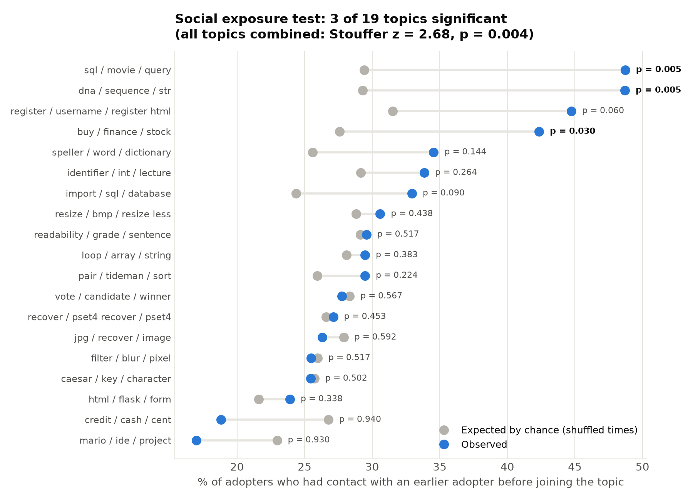
Figure 9. Social exposure test
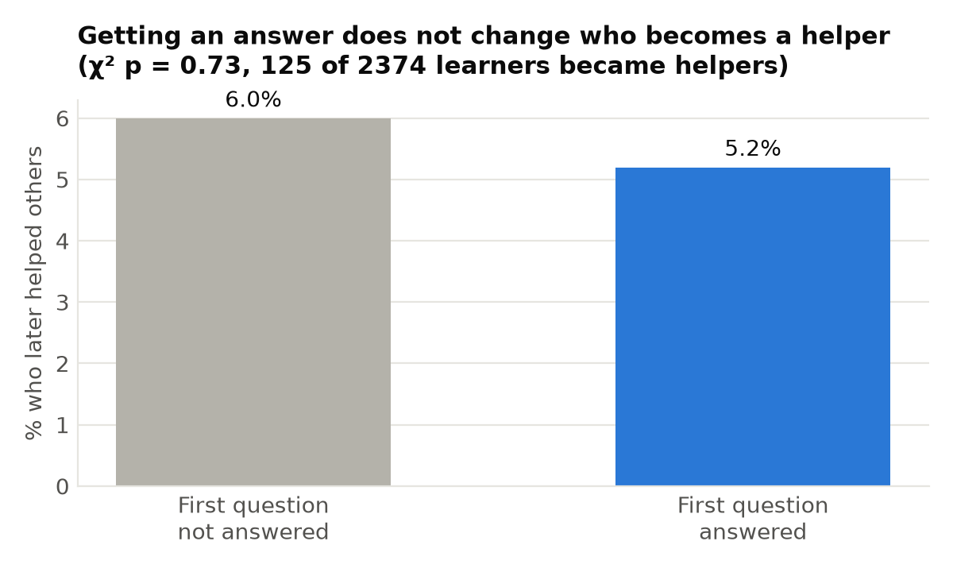
Figure 10. Learner → helper transition
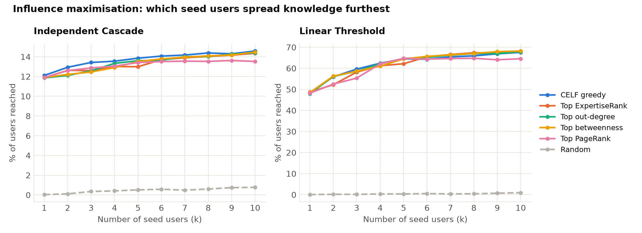
Figure 11. Influence maximisation
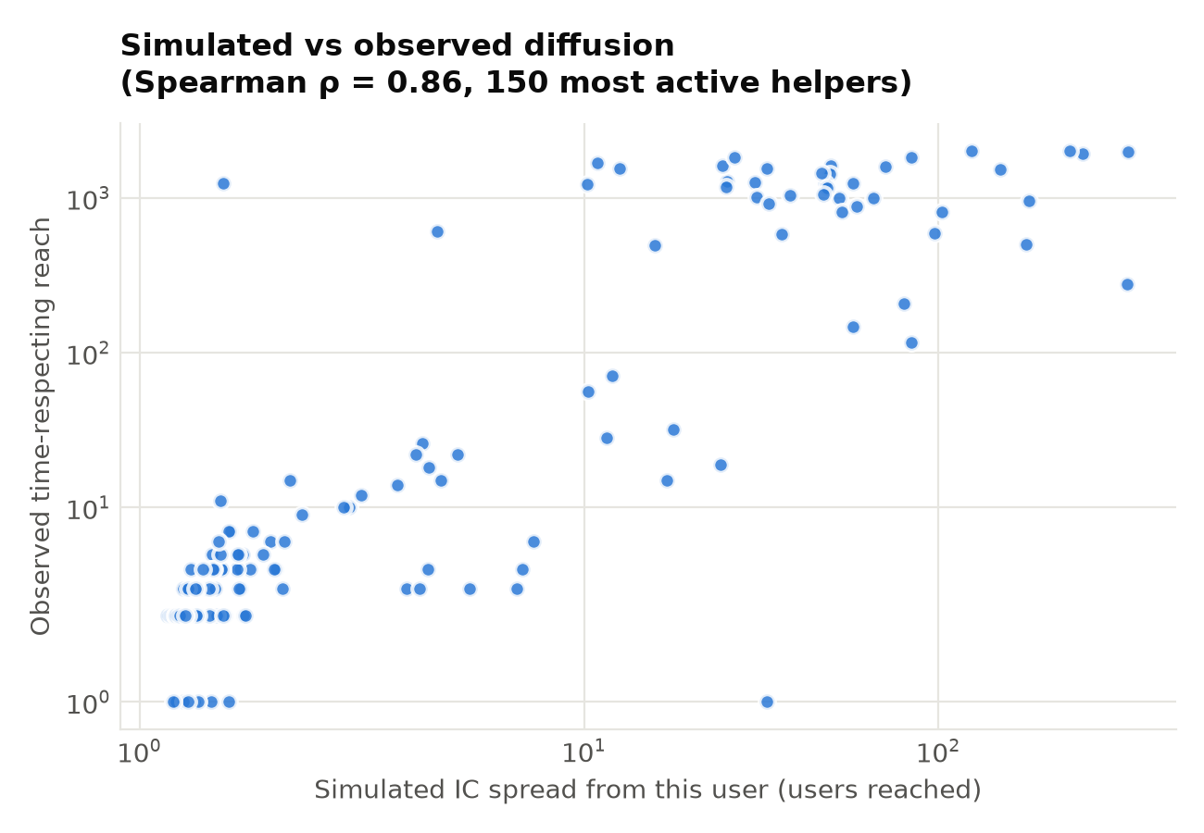
Figure 12. Simulated vs observed reach

9. Answer Prediction (predict.py)
Aim: predict whether a new question will be answered, using only information available when it is posted. The data is split in time (oldest 80% for training, newest 20% for testing). The program compares a majority-class baseline, Logistic Regression, Random Forest and XGBoost, runs 5-fold cross-validation on the training period, and measures permutation feature importance.
Run: python src/predict.py
Source code: src/predict.py (164 lines)
1 """
2 Step 5: predict whether a new question will get a good answer (Stack Exchange's `is_answered`).
3
4 Only information available at the moment a question is posted is used (no scores, views
5 or answer counts), and the evaluation is temporal: train on the oldest 80% of questions,
6 test on the newest 20%, the way the model would be used in practice.
7
8 Outputs:
9 outputs/prediction_metrics.csv model comparison on the held-out future questions
10 outputs/prediction_cv.csv 5-fold cross-validation on the training period
11 outputs/prediction_importance.csv permutation importance of each feature
12 outputs/prediction_roc.csv ROC curve points for every model
13 data/processed/prediction_features.parquet
14 """
15
16 import numpy as np
17 import pandas as pd
18 from sklearn.compose import ColumnTransformer
19 from sklearn.dummy import DummyClassifier
20 from sklearn.ensemble import RandomForestClassifier
21 from sklearn.inspection import permutation_importance
22 from sklearn.linear_model import LogisticRegression
23 from sklearn.metrics import (accuracy_score, average_precision_score, balanced_accuracy_score,
24 f1_score, roc_auc_score, roc_curve)
25 from sklearn.model_selection import StratifiedKFold, cross_val_score
26 from sklearn.pipeline import Pipeline
27 from sklearn.preprocessing import OneHotEncoder, StandardScaler
28 from xgboost import XGBClassifier
29
30 from config import OUTPUT_DIR, PROCESSED_DIR, RANDOM_SEED, TRAIN_FRACTION
31 from data_loader import load_raw
32
33 TARGET = "is_answered"
34 NUMERIC = [
35 "n_words", "title_words", "n_code_lines", "n_question_marks", "n_tags", "sentiment",
36 "confusion_score", "has_code", "has_error_msg", "has_check50_fail",
37 "asker_prior_questions", "asker_prior_answers", "asker_is_new", "asker_prior_answered_rate",
38 "questions_last_30d", "helpers_last_30d", "topic_prior_answered_rate", "hour", "weekday",
39 ]
40 CATEGORICAL = ["topic", "course_unit"]
41
42
43 def count_before(times_by_user: dict, users, at) -> np.ndarray:
44 """For each (user, time): how many of the user's events happened strictly before time."""
45 out = np.zeros(len(users), dtype=int)
46 for i, (u, t) in enumerate(zip(users, at)):
47 arr = times_by_user.get(u)
48 if arr is not None:
49 out[i] = np.searchsorted(arr, t, side="left")
50 return out
51
52
53 def build_features(q: pd.DataFrame, answers: pd.DataFrame) -> pd.DataFrame:
54 q = q.sort_values("created_at").reset_index(drop=True).copy()
55 t = q["created_at"].astype("int64").to_numpy()
56 user = q["user_id"].fillna(-1).astype("int64").to_numpy()
57
58 # Asker's history before this question.
59 q["asker_prior_questions"] = q.groupby(user).cumcount()
60 q.loc[user == -1, "asker_prior_questions"] = 0
61 q["asker_is_new"] = (q["asker_prior_questions"] == 0).astype(int)
62 ans = answers.dropna(subset=["user_id"]).sort_values("created_at")
63 ans_times = {u: g["created_at"].astype("int64").to_numpy()
64 for u, g in ans.groupby(ans["user_id"].astype("int64"))}
65 q["asker_prior_answers"] = count_before(ans_times, user, t)
66 prior_rate = q.groupby(user)[TARGET].transform(lambda s: s.shift().expanding().mean())
67 q["asker_prior_answered_rate"] = prior_rate.fillna(-1) # -1 = no earlier question
68
69 # How busy the community was in the 30 days before the question.
70 month = np.int64(30 * 86400 * 10**9)
71 q["questions_last_30d"] = np.searchsorted(t, t, side="left") - np.searchsorted(t, t - month, side="left")
72 a_t = ans["created_at"].astype("int64").to_numpy()
73 a_u = ans["user_id"].astype("int64").to_numpy()
74 lo, hi = np.searchsorted(a_t, t - month), np.searchsorted(a_t, t)
75 q["helpers_last_30d"] = [len(np.unique(a_u[i:j])) for i, j in zip(lo, hi)]
76
77 # How often this topic's earlier questions got answered.
78 q["topic_prior_answered_rate"] = (q.groupby("topic")[TARGET]
79 .transform(lambda s: s.shift().expanding().mean()))
80 q["topic_prior_answered_rate"] = q["topic_prior_answered_rate"].fillna(q[TARGET].mean())
81
82 q["hour"] = q["created_at"].dt.hour
83 q["weekday"] = q["created_at"].dt.weekday
84 for col in ["has_code", "has_error_msg", "has_check50_fail"]:
85 q[col] = q[col].astype(int)
86 q["topic"] = q["topic"].astype(str)
87 q["course_unit"] = q["course_unit"].fillna("Unknown")
88 return q
89
90
91 def models():
92 pre_scaled = ColumnTransformer([
93 ("num", StandardScaler(), NUMERIC),
94 ("cat", OneHotEncoder(handle_unknown="ignore"), CATEGORICAL)])
95 pre_trees = ColumnTransformer([
96 ("num", "passthrough", NUMERIC),
97 ("cat", OneHotEncoder(handle_unknown="ignore"), CATEGORICAL)])
98 return {
99 "Baseline (majority class)": Pipeline([("pre", pre_trees), ("clf", DummyClassifier())]),
100 "Logistic Regression": Pipeline([("pre", pre_scaled), ("clf", LogisticRegression(
101 max_iter=2000, class_weight="balanced"))]),
102 "Random Forest": Pipeline([("pre", pre_trees), ("clf", RandomForestClassifier(
103 n_estimators=400, min_samples_leaf=5, class_weight="balanced", n_jobs=-1,
104 random_state=RANDOM_SEED))]),
105 "XGBoost": Pipeline([("pre", pre_trees), ("clf", XGBClassifier(
106 n_estimators=300, max_depth=4, learning_rate=0.05, subsample=0.8,
107 colsample_bytree=0.8, eval_metric="logloss", random_state=RANDOM_SEED, n_jobs=-1))]),
108 }
109
110
111 def run():
112 raw = load_raw()
113 q = pd.read_parquet(PROCESSED_DIR / "questions_clean.parquet")
114 qt = pd.read_parquet(PROCESSED_DIR / "question_topics.parquet")
115 q = q.merge(qt[["post_id", "topic", "course_unit"]], on="post_id", how="inner")
116 df = build_features(q, raw["answers"])
117 df.to_parquet(PROCESSED_DIR / "prediction_features.parquet", index=False)
118
119 cut = int(len(df) * TRAIN_FRACTION)
120 train, test = df.iloc[:cut], df.iloc[cut:]
121 X_train, y_train = train[NUMERIC + CATEGORICAL], train[TARGET].astype(int)
122 X_test, y_test = test[NUMERIC + CATEGORICAL], test[TARGET].astype(int)
123 print(f"[predict] train {len(train)} questions (until {train.created_at.max():%Y-%m}), "
124 f"test {len(test)} (answered rate {y_test.mean():.0%})")
125
126 rows, cv_rows, roc_rows, fitted = [], [], [], {}
127 cv = StratifiedKFold(n_splits=5, shuffle=True, random_state=RANDOM_SEED)
128 for name, model in models().items():
129 cv_auc = cross_val_score(model, X_train, y_train, cv=cv, scoring="roc_auc")
130 cv_rows.append({"model": name, "cv_roc_auc_mean": cv_auc.mean(), "cv_roc_auc_std": cv_auc.std()})
131 model.fit(X_train, y_train)
132 fitted[name] = model
133 prob = model.predict_proba(X_test)[:, 1]
134 pred = (prob >= 0.5).astype(int)
135 rows.append({
136 "model": name,
137 "roc_auc": roc_auc_score(y_test, prob),
138 "pr_auc": average_precision_score(y_test, prob),
139 "accuracy": accuracy_score(y_test, pred),
140 "balanced_accuracy": balanced_accuracy_score(y_test, pred),
141 "f1": f1_score(y_test, pred),
142 })
143 fpr, tpr, _ = roc_curve(y_test, prob)
144 roc_rows += [{"model": name, "fpr": a, "tpr": b} for a, b in zip(fpr, tpr)]
145 print(f" {name:28s} test ROC-AUC {rows[-1]['roc_auc']:.3f} CV {cv_auc.mean():.3f}")
146
147 metrics = pd.DataFrame(rows).round(4)
148 metrics.to_csv(OUTPUT_DIR / "prediction_metrics.csv", index=False)
149 pd.DataFrame(cv_rows).round(4).to_csv(OUTPUT_DIR / "prediction_cv.csv", index=False)
150 pd.DataFrame(roc_rows).round(4).to_csv(OUTPUT_DIR / "prediction_roc.csv", index=False)
151
152 best = metrics.iloc[1:].sort_values("roc_auc", ascending=False).iloc[0]["model"]
153 imp = permutation_importance(fitted[best], X_test, y_test, scoring="roc_auc", n_repeats=20,
154 random_state=RANDOM_SEED, n_jobs=-1)
155 importance = pd.DataFrame({"feature": NUMERIC + CATEGORICAL, "importance_mean": imp.importances_mean,
156 "importance_std": imp.importances_std, "model": best})
157 importance.sort_values("importance_mean", ascending=False).round(5).to_csv(
158 OUTPUT_DIR / "prediction_importance.csv", index=False)
159 print(f"[predict] best model: {best}")
160 return metrics
161
162
163 if __name__ == "__main__":
164 run()

Output
=== predict: answer prediction models (~1 min)
[predict] train 3168 questions (until 2022-08), test 792 (answered rate 59%)
Baseline (majority class) test ROC-AUC 0.500 CV 0.500
Logistic Regression test ROC-AUC 0.673 CV 0.592
Random Forest test ROC-AUC 0.675 CV 0.602
XGBoost test ROC-AUC 0.656 CV 0.599
[predict] best model: Random Forest
=== predict done in 29s

Table 15. Test-set results (outputs/prediction_metrics.csv)
model | roc_auc | pr_auc | accuracy | balanced_accuracy | f1
Baseline (majority class) | 0.5 | 0.591 | 0.591 | 0.5 | 0.743
Logistic Regression | 0.673 | 0.725 | 0.624 | 0.626 | 0.658
Random Forest | 0.675 | 0.725 | 0.61 | 0.629 | 0.613
XGBoost | 0.656 | 0.715 | 0.639 | 0.6 | 0.727

Table 16. Cross-validation on the training period (outputs/prediction_cv.csv)
model | cv_roc_auc_mean | cv_roc_auc_std
Baseline (majority class) | 0.5 | 0.0
Logistic Regression | 0.592 | 0.02
Random Forest | 0.602 | 0.013
XGBoost | 0.598 | 0.015

Table 17. Top 10 features (outputs/prediction_importance.csv)
feature | importance_mean | importance_std
topic_prior_answered_rate | 0.0238 | 0.0068
n_tags | 0.02 | 0.0063
asker_prior_answered_rate | 0.0172 | 0.0097
has_code | 0.0106 | 0.0036
n_code_lines | 0.0076 | 0.0072
topic | 0.0074 | 0.0034
n_words | 0.0073 | 0.0046
weekday | 0.0054 | 0.0026
title_words | 0.0052 | 0.0038
course_unit | 0.0032 | 0.0031

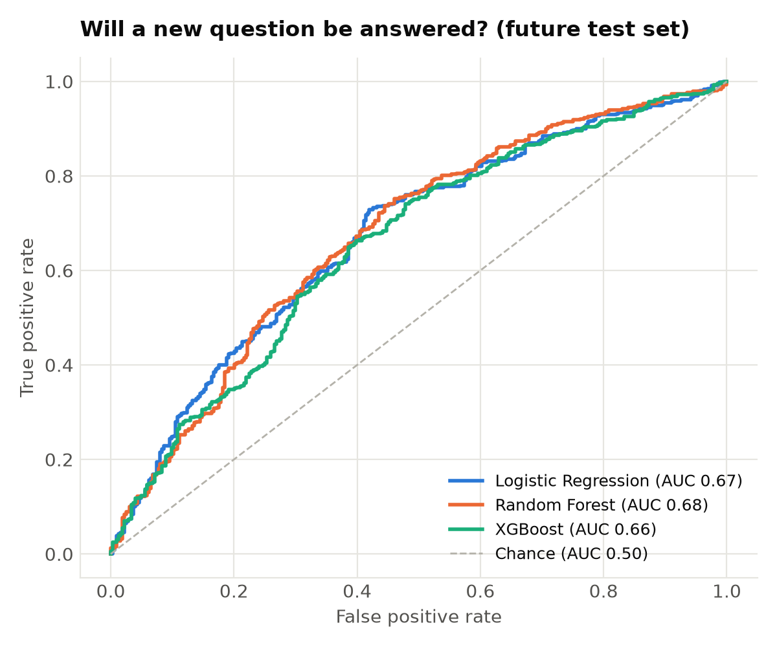
Figure 13. ROC curves
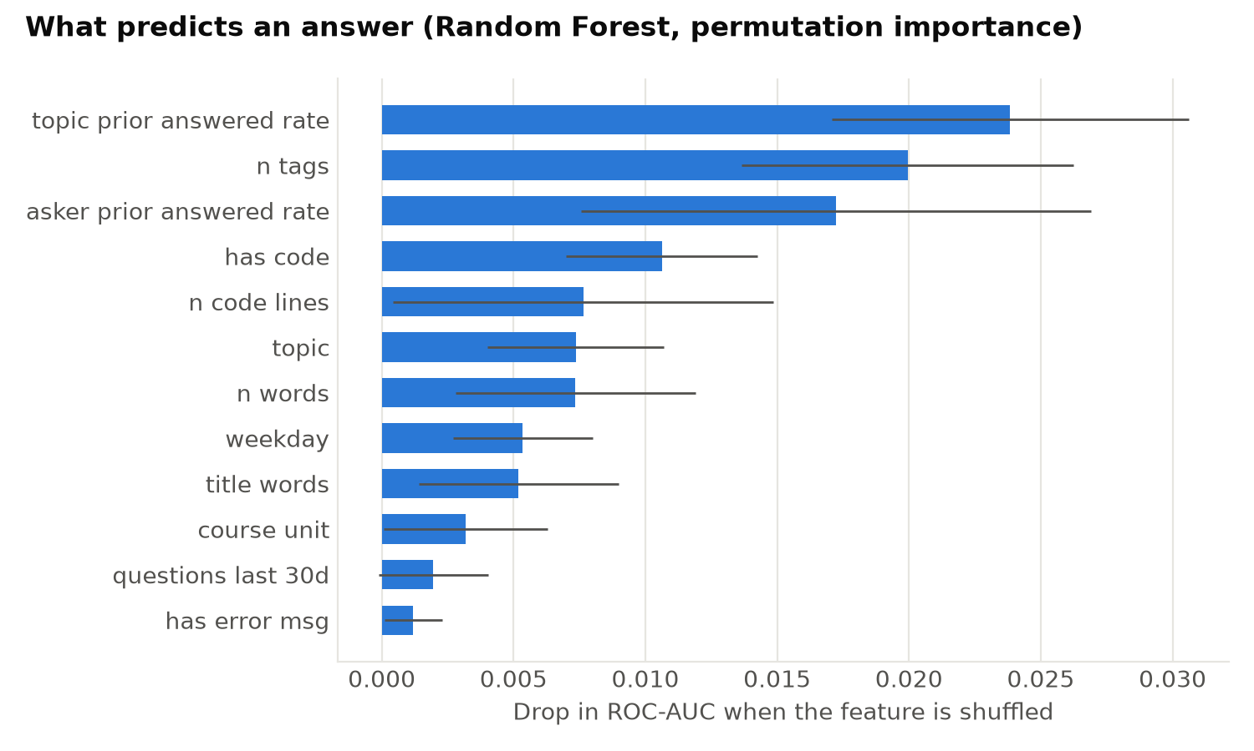
Figure 14. Permutation feature importance

10. Expert Finder (recommender.py)
Aim: recommend who can answer a new question. Similar past questions are found by cosine similarity (sentence embeddings or TF-IDF), each helper is scored on the similar questions they answered (accepted answers count double), and the hybrid score adds authority and recency. Evaluation on future questions reports Hit@1/5/10 and MRR.
Run: python src/recommender.py
Source code: src/recommender.py (144 lines)
1 """
2 Step 6: expert finder — recommend who can answer a new question.
3
4 For a new question we find similar past questions (by meaning) and score each helper by
5 how well they answered those questions, then blend in how active and how recently active
6 the helper is.
7
8 Evaluation (temporal): experts are learned from the oldest 80% of questions; for each newer
9 question we check whether a person who really answered it appears in the top-k list.
10 Metrics: Hit@k (share of questions where a real answerer is in the top k) and MRR.
11
12 Outputs: outputs/recommender_eval.csv
13 """
14
15 import numpy as np
16 import pandas as pd
17 from sklearn.feature_extraction.text import TfidfVectorizer
18 from sklearn.preprocessing import normalize
19
20 from config import EMBEDDING_MODEL, OUTPUT_DIR, PROCESSED_DIR, TRAIN_FRACTION
21 from data_loader import load_raw
22
23 N_SIMILAR = 50 # similar past questions considered per query
24 ACCEPTED_BONUS = 1.0 # an accepted answer counts double
25 RECENCY_DAYS = 365 # activity half-life style decay
26 HYBRID_WEIGHTS = {"content": 0.6, "authority": 0.2, "recency": 0.2}
27 KS = [1, 5, 10]
28
29
30 def _minmax(s: pd.Series) -> pd.Series:
31 rng = s.max() - s.min()
32 return (s - s.min()) / rng if rng > 0 else s * 0
33
34
35 class ExpertFinder:
36 """Content + authority + recency expert recommender over a set of past Q&A."""
37
38 def __init__(self, questions: pd.DataFrame, answers: pd.DataFrame, vectors: np.ndarray):
39 # questions: post_id, user_id, title, created_at (aligned row-by-row with vectors)
40 self.questions = questions.reset_index(drop=True)
41 self.vectors = normalize(vectors)
42 a = answers.dropna(subset=["user_id"]).copy()
43 a["user_id"] = a["user_id"].astype("int64")
44 asker = self.questions.set_index("post_id")["user_id"]
45 a = a[a["question_id"].isin(asker.index)]
46 a = a[a["question_id"].map(asker) != a["user_id"]] # ignore self-answers
47 a["credit"] = 1 + ACCEPTED_BONUS * a["is_accepted"].astype(float)
48 self.answers = a
49 row_of = pd.Series(np.arange(len(self.questions)), index=self.questions["post_id"])
50 self.answer_rows = row_of[a["question_id"]].to_numpy()
51 self.n_answers = a.groupby("user_id").size()
52 self.last_active = a.groupby("user_id")["created_at"].max()
53
54 def similar(self, query_vec: np.ndarray, n=N_SIMILAR):
55 sims = self.vectors @ normalize(query_vec.reshape(1, -1)).ravel()
56 top = np.argsort(sims)[::-1][:n]
57 return top, sims[top]
58
59 def score(self, query_vec, at=None, method="hybrid", exclude_user=None) -> pd.Series:
60 if method == "popularity":
61 scores = self.n_answers.astype(float)
62 else:
63 rows, sims = self.similar(query_vec)
64 sim_of_row = pd.Series(sims, index=rows)
65 hit = np.isin(self.answer_rows, rows)
66 part = self.answers[hit]
67 content = (part["credit"].to_numpy() * sim_of_row[self.answer_rows[hit]].to_numpy())
68 scores = pd.Series(content, index=part["user_id"].to_numpy()).groupby(level=0).sum()
69 if method == "hybrid":
70 users = self.n_answers.index
71 content = scores.reindex(users, fill_value=0)
72 authority = np.log1p(self.n_answers)
73 at = at if at is not None else self.last_active.max()
74 days = (at - self.last_active).dt.days.clip(lower=0)
75 recency = np.exp(-days / RECENCY_DAYS)
76 scores = (HYBRID_WEIGHTS["content"] * _minmax(content)
77 + HYBRID_WEIGHTS["authority"] * _minmax(authority)
78 + HYBRID_WEIGHTS["recency"] * _minmax(recency))
79 if exclude_user is not None:
80 scores = scores.drop(exclude_user, errors="ignore")
81 return scores.sort_values(ascending=False)
82
83
84 def load_vectors(kind: str, questions: pd.DataFrame, n_train=None):
85 """Embeddings from the topic step, or TF-IDF vectors (fitted on the first n_train rows)."""
86 if kind == "embedding":
87 emb = np.load(PROCESSED_DIR / "embeddings.npy")
88 ids = np.load(PROCESSED_DIR / "embedding_post_ids.npy")
89 idx = pd.Series(np.arange(len(ids)), index=ids)
90 return emb[idx[questions["post_id"]].to_numpy()], None
91 vec = TfidfVectorizer(token_pattern=r"\S+", ngram_range=(1, 2), min_df=2, sublinear_tf=True)
92 vec.fit(questions["tokens"].iloc[:n_train])
93 return vec.transform(questions["tokens"]).toarray().astype(np.float32), vec
94
95
96 def evaluate():
97 raw = load_raw()
98 q = pd.read_parquet(PROCESSED_DIR / "questions_clean.parquet")
99 ids = np.load(PROCESSED_DIR / "embedding_post_ids.npy")
100 q = q[q["post_id"].isin(ids)].sort_values("created_at").reset_index(drop=True)
101 cut = int(len(q) * TRAIN_FRACTION)
102 train, test = q.iloc[:cut], q.iloc[cut:]
103 answers = raw["answers"].dropna(subset=["user_id"]).copy()
104 answers["user_id"] = answers["user_id"].astype("int64")
105
106 truth = answers[answers["question_id"].isin(test["post_id"])].groupby("question_id")["user_id"].agg(set)
107 known = set(answers.loc[answers["question_id"].isin(train["post_id"]), "user_id"])
108 test = test[test["post_id"].isin(truth.index)].copy()
109 test["truth"] = test["post_id"].map(truth).map(lambda s: s & known)
110 reachable = test["truth"].str.len() > 0
111 print(f"[recommender] {len(test)} answered test questions, "
112 f"{reachable.mean():.0%} answered by someone already active before the cut-off")
113 test = test[reachable]
114
115 rows = []
116 for kind in ["tfidf", "embedding"]:
117 vectors, _ = load_vectors(kind, q, n_train=cut)
118 finder = ExpertFinder(train, answers, vectors[:cut])
119 methods = ["popularity", "content", "hybrid"] if kind == "embedding" else ["content", "hybrid"]
120 for method in methods:
121 ranks = []
122 for i, row in test.iterrows():
123 asker = int(row.user_id) if pd.notna(row.user_id) else None
124 ranking = finder.score(vectors[i], at=row.created_at, method=method, exclude_user=asker)
125 pos = [k for k, u in enumerate(ranking.index[:100], start=1) if u in row.truth]
126 ranks.append(pos[0] if pos else np.inf)
127 ranks = np.array(ranks)
128 name = "Popularity (most answers)" if method == "popularity" else f"{method.title()} ({kind})"
129 rec = {"method": name, "n_test_questions": len(ranks)}
130 rec.update({f"hit@{k}": float(np.mean(ranks <= k)) for k in KS})
131 rec["mrr"] = float(np.mean(np.where(np.isinf(ranks), 0, 1 / ranks)))
132 rows.append(rec)
133 print(f" {name:28s} Hit@5 {rec['hit@5']:.3f} Hit@10 {rec['hit@10']:.3f} MRR {rec['mrr']:.3f}")
134 out = pd.DataFrame(rows).drop_duplicates("method").round(4)
135 out.to_csv(OUTPUT_DIR / "recommender_eval.csv", index=False)
136 return out
137
138
139 def run():
140 return evaluate()
141
142
143 if __name__ == "__main__":
144 run()

Output
=== recommender: expert recommender evaluation
[recommender] 698 answered test questions, 77% answered by someone already active before the cut-off
Content (tfidf) Hit@5 0.689 Hit@10 0.710 MRR 0.596
Hybrid (tfidf) Hit@5 0.717 Hit@10 0.798 MRR 0.628
Popularity (most answers) Hit@5 0.702 Hit@10 0.702 MRR 0.582
Content (embedding) Hit@5 0.708 Hit@10 0.727 MRR 0.611
Hybrid (embedding) Hit@5 0.725 Hit@10 0.811 MRR 0.637
=== recommender done in 13s

Table 18. Expert finder evaluation (outputs/recommender_eval.csv)
method | n_test_questions | hit@1 | hit@5 | hit@10 | mrr
Content (tfidf) | 534 | 0.524 | 0.689 | 0.71 | 0.596
Hybrid (tfidf) | 534 | 0.528 | 0.717 | 0.798 | 0.628
Popularity (most answers) | 534 | 0.472 | 0.702 | 0.702 | 0.582
Content (embedding) | 534 | 0.53 | 0.708 | 0.727 | 0.61
Hybrid (embedding) | 534 | 0.536 | 0.725 | 0.811 | 0.637

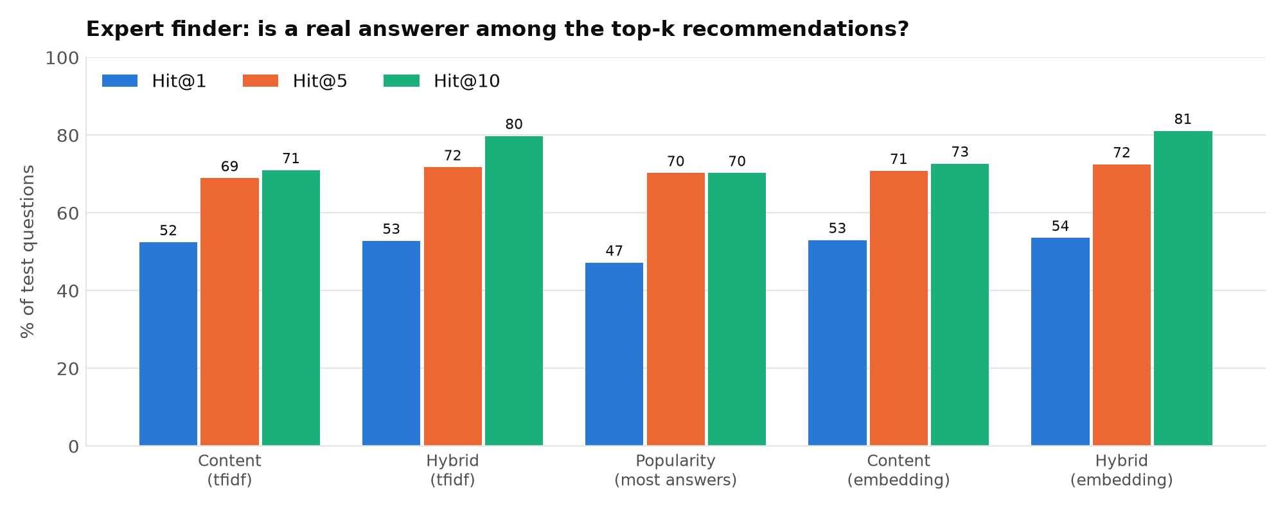
Figure 15. Hit@k of every method

11. Figures and the Pipeline Runner (figures.py, run_pipeline.py)
figures.py draws the 16 report figures shown in the previous chapters, using one colour-blind-safe palette. run_pipeline.py runs steps 3 to 9 in order with a single command and prints the time taken by each step.
Run: python src/run_pipeline.py
Source code: src/figures.py (374 lines)
1 """
2 Step 7: static figures for the report (PNG, 200 dpi) in outputs/figures/.
3
4 Colour roles follow one validated categorical order (never cycled); magnitude uses one
5 blue ramp, and signed values use a blue/red diverging pair around grey.
6 """
7
8 import json
9 import warnings
10
11 import matplotlib
12
13 matplotlib.use("Agg")
14 import matplotlib.pyplot as plt # noqa: E402
15 import networkx as nx # noqa: E402
16 import numpy as np # noqa: E402
17 import pandas as pd # noqa: E402
18
19 from config import FIGURE_DIR, OUTPUT_DIR, PROCESSED_DIR # noqa: E402
20
21 warnings.filterwarnings("ignore")
22
23 SERIES = ["#2a78d6", "#eb6834", "#1baf7a", "#eda100", "#e87ba4", "#008300", "#4a3aa7", "#e34948"]
24 OTHER = "#b4b2aa"
25 TEXT, TEXT_2, GRID, SURFACE = "#0b0b0b", "#52514e", "#e6e5e0", "#ffffff"
26 BLUE_RAMP = ["#cde2fb", "#9ec5f4", "#6da7ec", "#3987e5", "#256abf", "#184f95", "#0d366b"]
27 NEG, NEUTRAL, POS = "#2a78d6", "#f0efec", "#e34948"
28
29 plt.rcParams.update({
30 "figure.facecolor": SURFACE, "axes.facecolor": SURFACE, "savefig.facecolor": SURFACE,
31 "font.family": "DejaVu Sans", "font.size": 10, "text.color": TEXT,
32 "axes.edgecolor": GRID, "axes.labelcolor": TEXT_2, "axes.titleweight": "bold",
33 "axes.titlesize": 12, "axes.titlelocation": "left", "axes.titlepad": 12,
34 "axes.spines.top": False, "axes.spines.right": False, "axes.grid": True,
35 "grid.color": GRID, "grid.linewidth": 0.8, "axes.axisbelow": True,
36 "xtick.color": TEXT_2, "ytick.color": TEXT_2, "xtick.major.size": 0, "ytick.major.size": 0,
37 "legend.frameon": False, "lines.linewidth": 2,
38 })
39
40
41 def save(fig, name):
42 fig.tight_layout()
43 fig.savefig(FIGURE_DIR / f"{name}.png", dpi=200)
44 plt.close(fig)
45
46
47 def topic_names():
48 t = pd.read_csv(OUTPUT_DIR / "topics.csv")
49 return dict(zip(t["topic"], t["label"]))
50
51
52 # ------------------------------------------------------------------ community & topics
53
54 def fig_activity():
55 q = pd.read_parquet(PROCESSED_DIR / "questions_clean.parquet")
56 per = q.groupby(q["created_at"].dt.to_period("Q")).size()
57 fig, ax = plt.subplots(figsize=(9, 3.6))
58 ax.bar(per.index.astype(str), per.values, color=SERIES[0], width=0.8)
59 peak = per.idxmax()
60 ax.annotate(f"{per.max()} questions in {peak}\n(COVID-19 lockdown)", xy=(list(per.index).index(peak), per.max()),
61 xytext=(10, -5), textcoords="offset points", color=TEXT_2, fontsize=9, va="top")
62 ax.set_title("Questions asked per quarter, CS50 Stack Exchange")
63 ax.set_ylabel("Questions")
64 ax.set_xticks(range(0, len(per), 4))
65 ax.set_xticklabels([str(p) for p in per.index[::4]])
66 ax.grid(axis="x", visible=False)
67 save(fig, "01_activity_over_time")
68
69
70 def fig_lda_selection():
71 s = pd.read_csv(OUTPUT_DIR / "lda_model_selection.csv")
72 fig, axes = plt.subplots(1, 2, figsize=(9, 3.4))
73 for ax, col, title in [(axes[0], "npmi", "NPMI coherence (higher = better)"),
74 (axes[1], "diversity", "Topic diversity (higher = better)")]:
75 ax.plot(s["k"], s[col], color=SERIES[0], marker="o", markersize=5)
76 ax.set_title(title, fontsize=11)
77 ax.set_xlabel("Number of LDA topics (k)")
78 ax.set_xticks(s["k"])
79 save(fig, "02_lda_model_selection")
80
81
82 def fig_model_comparison():
83 c = pd.read_csv(OUTPUT_DIR / "topic_model_comparison.csv")
84 metrics = [("npmi", "NPMI coherence"), ("diversity", "Topic diversity"), ("nmi_vs_course_tags", "Agreement with\ncourse tags (NMI)")]
85 x = np.arange(len(metrics))
86 fig, ax = plt.subplots(figsize=(8, 3.8))
87 w = 0.36
88 for i, (_, row) in enumerate(c.iterrows()):
89 vals = [row[m] for m, _ in metrics]
90 label = row["model"].split(" (")[0] + (f" ({int(row['n_topics'])} topics)")
91 bars = ax.bar(x + (i - 0.5) * (w + 0.02), vals, w, color=SERIES[i], label=label)
92 ax.bar_label(bars, fmt="%.2f", padding=3, color=TEXT, fontsize=9)
93 ax.set_xticks(x)
94 ax.set_xticklabels([m[1] for m in metrics])
95 ax.set_ylim(0, 1.05)
96 ax.set_title("BERTopic beats LDA on every topic-quality metric")
97 ax.legend(loc="upper left")
98 ax.grid(axis="x", visible=False)
99 save(fig, "03_topic_model_comparison")
100
101
102 def fig_topic_difficulty():
103 t = pd.read_csv(OUTPUT_DIR / "topics.csv").sort_values("difficulty_index")
104 fig, ax = plt.subplots(figsize=(9, 6.5))
105 colors = [POS if v > 0 else NEG for v in t["difficulty_index"]]
106 # Name the course unit only when most of the topic's questions come from it.
107 names = [f"{u.split(' (')[0] if isinstance(u, str) and pur >= 0.5 else 'Mixed'}: {lbl} ({n} q)"
108 for u, pur, lbl, n in zip(t["course_unit"], t["unit_purity"], t["label"], t["n_questions"])]
109 ax.barh(names, t["difficulty_index"], color=colors, height=0.7)
110 ax.axvline(0, color=TEXT_2, linewidth=1)
111 fig.suptitle("Topic difficulty index\n(unanswered rate + time to answer + learner confusion)", x=0.02, ha="left", fontweight="bold", fontsize=12)
112 ax.set_xlabel("← easier than average harder than average →")
113 ax.grid(axis="y", visible=False)
114 save(fig, "04_topic_difficulty")
115
116
117 def fig_topic_trends():
118 tr = pd.read_csv(OUTPUT_DIR / "topic_trends.csv")
119 tr["year"] = tr["period"].str[:4]
120 y = tr.groupby(["topic", "year"])["n_questions"].sum().unstack(fill_value=0)
121 y = y.loc[:, y.sum(axis=0) >= 100] # years with too few questions give misleading shares
122 share = y / y.sum(axis=0)
123 names = topic_names()
124 share = share.loc[share.sum(axis=1).sort_values(ascending=False).index]
125 fig, ax = plt.subplots(figsize=(9, 6.5))
126 from matplotlib.colors import LinearSegmentedColormap
127 cmap = LinearSegmentedColormap.from_list("blue", ["#ffffff"] + BLUE_RAMP)
128 im = ax.imshow(share.values * 100, aspect="auto", cmap=cmap)
129 ax.set_yticks(range(len(share)))
130 ax.set_yticklabels([names.get(t, t) for t in share.index], fontsize=8.5)
131 ax.set_xticks(range(len(share.columns)))
132 ax.set_xticklabels(share.columns)
133 ax.grid(False)
134 for s in ax.spines.values():
135 s.set_visible(False)
136 cb = fig.colorbar(im, ax=ax, shrink=0.6)
137 cb.set_label("% of that year's questions")
138 cb.outline.set_visible(False)
139 ax.set_title("How the discussion mix changed over the years\n(years with 100+ questions)")
140 save(fig, "05_topic_trends")
141
142
143 # ------------------------------------------------------------------ network
144
145 def fig_help_concentration():
146 m = pd.read_csv(OUTPUT_DIR / "user_metrics.csv")
147 h = np.sort(m["out_strength"].to_numpy())[::-1]
148 cum = np.cumsum(h) / h.sum()
149 users = np.arange(1, len(h) + 1) / len(h)
150 fig, ax = plt.subplots(figsize=(6.5, 4))
151 ax.plot(users * 100, cum * 100, color=SERIES[0])
152 ax.plot([0, 100], [0, 100], color=OTHER, linestyle="--", linewidth=1)
153 for pct in [1, 10]:
154 i = max(int(len(h) * pct / 100) - 1, 0)
155 ax.plot(users[i] * 100, cum[i] * 100, "o", color=SERIES[0], markersize=8,
156 markeredgecolor=SURFACE, markeredgewidth=2)
157 ax.annotate(f"top {pct}% of users give {cum[i]:.0%} of help", (users[i] * 100, cum[i] * 100),
158 xytext=(10, -14), textcoords="offset points", fontsize=9, color=TEXT)
159 ax.text(60, 52, "equal sharing", color=TEXT_2, fontsize=9, rotation=28)
160 ax.set_xlabel("% of users (most helpful first)")
161 ax.set_ylabel("% of all help given")
162 ax.set_title("Help is concentrated in a small core of experts")
163 save(fig, "06_help_concentration")
164
165
166 def fig_degree_distribution():
167 m = pd.read_csv(OUTPUT_DIR / "user_metrics.csv")
168 fig, axes = plt.subplots(1, 2, figsize=(9, 3.6))
169 for ax, col, title in [(axes[0], "out_degree", "Help given (people helped)"),
170 (axes[1], "in_degree", "Help received (helpers)")]:
171 d = m[col][m[col] > 0].to_numpy()
172 vals = np.sort(np.unique(d))
173 ccdf = [(d >= v).mean() for v in vals]
174 ax.loglog(vals, ccdf, "o", color=SERIES[0], markersize=4)
175 ax.set_title(title, fontsize=11)
176 ax.set_xlabel("Degree (log)")
177 ax.set_ylabel("P(degree ≥ x)")
178 fig.suptitle("Heavy-tailed degree distributions: a few hubs, many one-off learners",
179 x=0.02, ha="left", fontweight="bold", fontsize=12)
180 save(fig, "07_degree_distribution")
181
182
183 def fig_network_graph():
184 m = pd.read_csv(OUTPUT_DIR / "user_metrics.csv").set_index("user_id")
185 e = pd.read_csv(OUTPUT_DIR / "help_edges.csv")
186 top = m.nlargest(150, "out_strength").index
187 sub = e[e.source_user.isin(top) | e.target_user.isin(top)]
188 keep = set(top) | set(sub.target_user.value_counts().index[:250])
189 sub = sub[sub.source_user.isin(keep) & sub.target_user.isin(keep)]
190 g = nx.Graph()
191 for r in sub.itertuples():
192 g.add_edge(r.source_user, r.target_user, weight=r.weight)
193 pos = nx.spring_layout(g, k=0.6, seed=42, weight="weight", iterations=150)
194 roles = ["Core expert", "Bridge", "Helper"]
195 color = {r: SERIES[i] for i, r in enumerate(roles)}
196 nodes = list(g.nodes)
197 fig, ax = plt.subplots(figsize=(8, 7))
198 nx.draw_networkx_edges(g, pos, ax=ax, edge_color=GRID, width=0.6, alpha=0.9)
199 sizes = [15 + 18 * np.sqrt(m.at[n, "out_strength"]) if n in m.index else 15 for n in nodes]
200 cols = [color.get(m.at[n, "role"], OTHER) if n in m.index else OTHER for n in nodes]
201 order = np.argsort(sizes) # draw big nodes last so they stay visible
202 nx.draw_networkx_nodes(g, pos, nodelist=[nodes[i] for i in order], node_size=[sizes[i] for i in order],
203 node_color=[cols[i] for i in order], ax=ax, edgecolors=SURFACE, linewidths=1)
204 for n in m.loc[m.index.isin(nodes)].nlargest(3, "out_strength").index:
205 ax.annotate(m.at[n, "user_name"], pos[n], xytext=(14, 10), textcoords="offset points",
206 fontsize=9, color=TEXT, fontweight="bold",
207 bbox=dict(boxstyle="round,pad=0.2", fc=SURFACE, ec="none", alpha=0.85))
208 counts = m["role"].value_counts()
209 handles = [plt.Line2D([], [], marker="o", linestyle="", color=color[r], markersize=8,
210 label=f"{r} ({counts.get(r, 0)} users)") for r in roles]
211 handles.append(plt.Line2D([], [], marker="o", linestyle="", color=OTHER, markersize=8, label="Learner / other"))
212 ax.legend(handles=handles, loc="lower left", fontsize=8.5)
213 ax.set_title("Knowledge network core: top 150 helpers and the learners they help\n(node size = help given)")
214 ax.axis("off")
215 save(fig, "08_network_core")
216
217
218 def fig_network_over_time():
219 t = pd.read_csv(OUTPUT_DIR / "network_over_time.csv")
220 t = t[t["active_users"] >= 50]
221 fig, axes = plt.subplots(1, 3, figsize=(11, 3.4))
222 for ax, col, title, fmt in [(axes[0], "active_users", "Active users", "{:.0f}"),
223 (axes[1], "n_helpers", "Users who helped", "{:.0f}"),
224 (axes[2], "help_share_top10pct", "Help given by top 10%", "{:.0%}")]:
225 ax.plot(t["year"], t[col], color=SERIES[0], marker="o", markersize=5)
226 ax.set_title(title, fontsize=11)
227 ax.set_xticks(t["year"])
228 if "share" in col:
229 ax.yaxis.set_major_formatter(matplotlib.ticker.PercentFormatter(1.0))
230 fig.suptitle("The community peaked in 2020 and shrank afterwards", x=0.02, ha="left",
231 fontweight="bold", fontsize=12)
232 save(fig, "09_network_over_time")
233
234
235 # ------------------------------------------------------------------ diffusion
236
237 def fig_exposure():
238 e = pd.read_csv(OUTPUT_DIR / "diffusion_exposure_test.csv").sort_values("observed_exposed_share")
239 summ = json.load(open(OUTPUT_DIR / "diffusion_summary.json"))
240 fig, ax = plt.subplots(figsize=(9, 6.5))
241 y = np.arange(len(e))
242 ax.hlines(y, e["null_mean"] * 100, e["observed_exposed_share"] * 100, color=GRID, linewidth=2)
243 ax.plot(e["null_mean"] * 100, y, "o", color=OTHER, markersize=8, label="Expected by chance (shuffled times)")
244 ax.plot(e["observed_exposed_share"] * 100, y, "o", color=SERIES[0], markersize=8, label="Observed")
245 for yi, (obs, null, p) in enumerate(zip(e["observed_exposed_share"], e["null_mean"], e["p_value"])):
246 ax.text(max(obs, null) * 100 + 0.8, yi, f"p = {p:.3f}", va="center", fontsize=8,
247 color=TEXT if p < 0.05 else TEXT_2, fontweight="bold" if p < 0.05 else "normal")
248 ax.set_yticks(y)
249 ax.set_yticklabels(e["label"], fontsize=8.5)
250 ax.set_xlabel("% of adopters who had contact with an earlier adopter before joining the topic")
251 ax.set_title(f"Social exposure test: {int((e.p_value < 0.05).sum())} of {len(e)} topics significant\n"
252 f"(all topics combined: Stouffer z = {summ['exposure_stouffer_z']:.2f}, "
253 f"p = {summ['exposure_stouffer_p']:.3f})")
254 ax.legend(loc="lower right", fontsize=9)
255 ax.grid(axis="y", visible=False)
256 save(fig, "10_exposure_test")
257
258
259 def fig_learner_to_helper():
260 s = json.load(open(OUTPUT_DIR / "diffusion_summary.json"))["learner_to_helper"]
261 vals = [s["pct_helper_if_first_question_unanswered"], s["pct_helper_if_first_question_answered"]]
262 fig, ax = plt.subplots(figsize=(6, 3.6))
263 bars = ax.bar(["First question\nnot answered", "First question\nanswered"], [v * 100 for v in vals],
264 color=[OTHER, SERIES[0]], width=0.55)
265 ax.bar_label(bars, labels=[f"{v:.1%}" for v in vals], padding=3, color=TEXT)
266 ax.set_ylabel("% who later helped others")
267 verdict = ("Learners whose first question was answered help others more often" if s["p_value"] < 0.05
268 else "Getting an answer does not change who becomes a helper")
269 ax.set_title(f"{verdict}\n(χ² p = {s['p_value']:.2f}, {s['n_became_helpers']} of {s['n_learners']} learners became helpers)",
270 fontsize=11)
271 ax.grid(axis="x", visible=False)
272 save(fig, "11_learner_to_helper")
273
274
275 def fig_influence():
276 im = pd.read_csv(OUTPUT_DIR / "influence_maximization.csv")
277 order = ["CELF greedy", "Top ExpertiseRank", "Top out-degree", "Top betweenness", "Top PageRank", "Random"]
278 fig, axes = plt.subplots(1, 2, figsize=(11, 4), sharey=False)
279 for ax, model, title in [(axes[0], "IC", "Independent Cascade"), (axes[1], "LT", "Linear Threshold")]:
280 d = im[im.model == model]
281 for i, strat in enumerate(order):
282 s = d[d.strategy == strat].sort_values("k")
283 color = OTHER if strat == "Random" else SERIES[i]
284 ax.plot(s["k"], s["spread_pct_of_users"], color=color, marker="o", markersize=4,
285 label=strat, linestyle="--" if strat == "Random" else "-")
286 ax.set_title(title, fontsize=11)
287 ax.set_xlabel("Number of seed users (k)")
288 ax.set_ylabel("% of users reached")
289 ax.set_xticks(range(1, 11))
290 axes[1].legend(loc="center left", bbox_to_anchor=(1.01, 0.5), fontsize=9)
291 fig.suptitle("Influence maximisation: which seed users spread knowledge furthest",
292 x=0.02, ha="left", fontweight="bold", fontsize=12)
293 save(fig, "12_influence_maximization")
294
295
296 def fig_diffusion_validation():
297 v = pd.read_csv(OUTPUT_DIR / "diffusion_validation.csv")
298 rho = json.load(open(OUTPUT_DIR / "diffusion_summary.json"))["validation"]["simulated_ic_spread"]
299 fig, ax = plt.subplots(figsize=(6.5, 4.5))
300 ax.scatter(v["simulated_ic_spread"], v["observed_reach"], s=36, color=SERIES[0],
301 edgecolors=SURFACE, linewidths=1.5, alpha=0.85)
302 ax.set_xscale("symlog")
303 ax.set_yscale("symlog")
304 ax.set_xlabel("Simulated IC spread from this user (users reached)")
305 ax.set_ylabel("Observed time-respecting reach")
306 ax.set_title(f"Simulated vs observed diffusion\n(Spearman ρ = {rho:.2f}, {len(v)} most active helpers)")
307 save(fig, "13_diffusion_validation")
308
309
310 # ------------------------------------------------------------------ prediction & recommender
311
312 def fig_prediction():
313 roc = pd.read_csv(OUTPUT_DIR / "prediction_roc.csv")
314 met = pd.read_csv(OUTPUT_DIR / "prediction_metrics.csv").set_index("model")
315 fig, ax = plt.subplots(figsize=(6, 5))
316 for i, model in enumerate([m for m in met.index if not m.startswith("Baseline")]):
317 d = roc[roc.model == model]
318 ax.plot(d["fpr"], d["tpr"], color=SERIES[i], label=f"{model} (AUC {met.at[model, 'roc_auc']:.2f})")
319 ax.plot([0, 1], [0, 1], color=OTHER, linestyle="--", linewidth=1, label="Chance (AUC 0.50)")
320 ax.set_xlabel("False positive rate")
321 ax.set_ylabel("True positive rate")
322 ax.set_title("Will a new question be answered? (future test set)")
323 ax.legend(loc="lower right", fontsize=9)
324 save(fig, "14_prediction_roc")
325
326 imp = pd.read_csv(OUTPUT_DIR / "prediction_importance.csv").head(12).iloc[::-1]
327 fig, ax = plt.subplots(figsize=(7.5, 4.5))
328 ax.barh(imp["feature"].str.replace("_", " "), imp["importance_mean"], xerr=imp["importance_std"],
329 color=SERIES[0], height=0.65, error_kw={"ecolor": TEXT_2, "elinewidth": 1})
330 ax.set_xlabel("Drop in ROC-AUC when the feature is shuffled")
331 fig.suptitle(f"What predicts an answer ({imp['model'].iloc[0]}, permutation importance)",
332 x=0.02, ha="left", fontweight="bold", fontsize=12)
333 ax.grid(axis="y", visible=False)
334 save(fig, "15_prediction_importance")
335
336
337 def fig_recommender():
338 r = pd.read_csv(OUTPUT_DIR / "recommender_eval.csv")
339 ks = ["hit@1", "hit@5", "hit@10"]
340 x = np.arange(len(r))
341 w = 0.26
342 fig, ax = plt.subplots(figsize=(10, 4))
343 for i, k in enumerate(ks):
344 bars = ax.bar(x + (i - 1) * (w + 0.015), r[k] * 100, w, color=SERIES[i], label=k.replace("hit@", "Hit@"))
345 ax.bar_label(bars, fmt="%.0f", padding=2, fontsize=8, color=TEXT)
346 ax.set_xticks(x)
347 ax.set_xticklabels(r["method"].str.replace(" (", "\n(", regex=False), fontsize=9)
348 ax.set_ylabel("% of test questions")
349 ax.set_ylim(0, 100)
350 ax.set_title("Expert finder: is a real answerer among the top-k recommendations?")
351 ax.legend(loc="upper left", ncol=3)
352 ax.grid(axis="x", visible=False)
353 save(fig, "16_recommender_eval")
354
355
356 FIGURES = [fig_activity, fig_lda_selection, fig_model_comparison, fig_topic_difficulty, fig_topic_trends,
357 fig_help_concentration, fig_degree_distribution, fig_network_graph, fig_network_over_time,
358 fig_exposure, fig_learner_to_helper, fig_influence, fig_diffusion_validation,
359 fig_prediction, fig_recommender]
360
361
362 def run():
363 ok = 0
364 for f in FIGURES:
365 try:
366 f()
367 ok += 1
368 except FileNotFoundError as exc:
369 print(f"[figures] skipped {f.__name__}: missing {exc.filename}")
370 print(f"[figures] {ok}/{len(FIGURES)} figure groups written to {FIGURE_DIR}")
371
372
373 if __name__ == "__main__":
374 run()

Output
=== figures: report figures
[figures] 15/15 figure groups written to C:\Users\pc\python codes\Capstone project\outputs\figures
=== figures done in 5s
Pipeline finished in 9.2 min. Results are in outputs/.

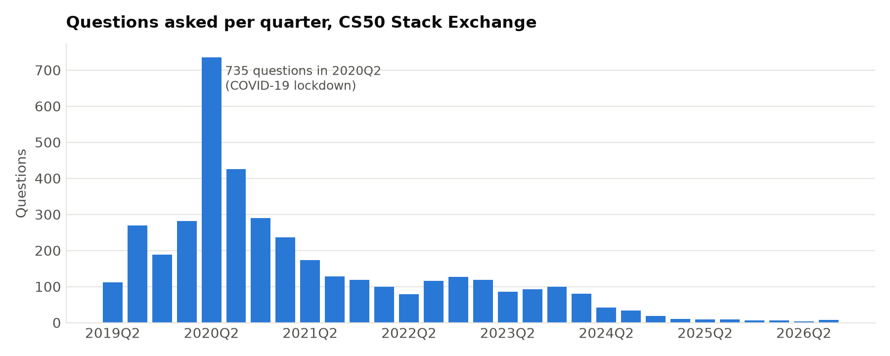
Figure 16. Questions per quarter (drawn by figures.py)
Source code: src/run_pipeline.py (55 lines)
1 """
2 Run the whole analysis in order.
3
4 Usage:
5 python src/run_pipeline.py # everything
6 python src/run_pipeline.py --from network # start at a later step
7 python src/run_pipeline.py --only figures # a single step
8
9 Input is read from PostgreSQL when .env is configured and reachable, otherwise from the
10 CSV files in data/raw/. Results go to outputs/ (and to PostgreSQL via load_to_postgres.py).
11 """
12
13 import argparse
14 import time
15
16 import diffusion
17 import figures
18 import network
19 import predict
20 import preprocess
21 import recommender
22 import topic_model
23 from data_loader import data_source
24
25 STEPS = [
26 ("preprocess", preprocess.run, "clean text and build question features"),
27 ("topics", topic_model.run, "LDA + BERTopic topic modeling (~5 min)"),
28 ("network", network.run, "knowledge network, centrality, communities (~1 min)"),
29 ("diffusion", diffusion.run, "diffusion tests and IC/LT simulation (~8 min)"),
30 ("predict", predict.run, "answer prediction models (~1 min)"),
31 ("recommender", recommender.run, "expert recommender evaluation"),
32 ("figures", figures.run, "report figures"),
33 ]
34
35
36 def main():
37 names = [s[0] for s in STEPS]
38 parser = argparse.ArgumentParser(description=__doc__, formatter_class=argparse.RawDescriptionHelpFormatter)
39 parser.add_argument("--from", dest="start", choices=names, default=names[0])
40 parser.add_argument("--only", choices=names)
41 args = parser.parse_args()
42
43 selected = [s for s in STEPS if s[0] == args.only] if args.only else STEPS[names.index(args.start):]
44 print(f"Data source: {data_source()}\n")
45 total = time.time()
46 for name, func, desc in selected:
47 print(f"=== {name}: {desc}")
48 t = time.time()
49 func()
50 print(f"=== {name} done in {time.time() - t:.0f}s\n")
51 print(f"Pipeline finished in {(time.time() - total) / 60:.1f} min. Results are in outputs/.")
52
53
54 if __name__ == "__main__":
55 main()

Output of the complete pipeline run
Data source: CSV files
=== preprocess: clean text and build question features
[preprocess] 4000 questions cleaned (80% contain code, 46% mention an error)
=== preprocess done in 29s
=== topics: LDA + BERTopic topic modeling (~5 min)
[topics] 3960 questions, 82% mapped to a course unit
LDA k= 6 NPMI=0.063 diversity=0.89
LDA k= 8 NPMI=0.142 diversity=0.84
LDA k=10 NPMI=0.119 diversity=0.82
LDA k=12 NPMI=0.176 diversity=0.77
LDA k=14 NPMI=0.185 diversity=0.78
LDA k=16 NPMI=0.176 diversity=0.77
LDA k=18 NPMI=0.173 diversity=0.74
LDA k=20 NPMI=0.243 diversity=0.73
model n_topics npmi diversity nmi_vs_course_tags outlier_share_before_reduction
LDA (k=20) 20 0.2426 0.7300 0.3839 0.0000
BERTopic (MiniLM + UMAP + HDBSCAN) 19 0.3099 0.8653 0.5613 0.1192
=== topics done in 134s
=== network: knowledge network, centrality, communities (~1 min)
[network] 2891 users, 4245 helper->learner links
[network] 118 communities (modularity 0.60); top 10% of users give 92% of all help
=== network done in 8s
=== diffusion: diffusion tests and IC/LT simulation (~8 min)
[diffusion] exposure test: 3/19 topics show more contact with earlier adopters than chance
[diffusion] influence maximisation (IC) ...
[diffusion] influence maximisation (LT) ...
[diffusion] validating simulated influence against observed reach ...
[diffusion] simulated influence vs observed reach: Spearman rho = 0.86
=== diffusion done in 336s
=== predict: answer prediction models (~1 min)
[predict] train 3168 questions (until 2022-08), test 792 (answered rate 59%)
Baseline (majority class) test ROC-AUC 0.500 CV 0.500
Logistic Regression test ROC-AUC 0.673 CV 0.592
Random Forest test ROC-AUC 0.675 CV 0.602
XGBoost test ROC-AUC 0.656 CV 0.599
[predict] best model: Random Forest
=== predict done in 29s
=== recommender: expert recommender evaluation
[recommender] 698 answered test questions, 77% answered by someone already active before the cut-off
Content (tfidf) Hit@5 0.689 Hit@10 0.710 MRR 0.596
Hybrid (tfidf) Hit@5 0.717 Hit@10 0.798 MRR 0.628
Popularity (most answers) Hit@5 0.702 Hit@10 0.702 MRR 0.582
Content (embedding) Hit@5 0.708 Hit@10 0.727 MRR 0.611
Hybrid (embedding) Hit@5 0.725 Hit@10 0.811 MRR 0.637
=== recommender done in 13s
=== figures: report figures
[figures] 15/15 figure groups written to C:\Users\pc\python codes\Capstone project\outputs\figures
=== figures done in 5s
Pipeline finished in 9.2 min. Results are in outputs/.

12. SQL Analysis Queries (queries.sql)
These queries run in pgAdmin (Tools → Query Tool) after load_to_postgres.py. Queries 1–6 use the raw tables; queries 7–11 use the result tables. All queries were checked with the PostgreSQL parser. Run each query on the laptop and paste the result screenshot in the box below it.

Query 1. Dataset overview
1 SELECT
2 (SELECT COUNT(*) FROM users) AS users,
3 (SELECT COUNT(*) FROM questions) AS questions,
4 (SELECT COUNT(*) FROM answers) AS answers,
5 (SELECT COUNT(*) FROM comments) AS comments,
6 (SELECT COUNT(*) FROM interactions) AS interactions

Paste screenshot: pgAdmin result of query 1

Query 2. Top 10 helpers: most answers, and how many were accepted
1 SELECT u.user_name,
2 u.user_reputation,
3 COUNT(*) AS answers_given,
4 COUNT(*) FILTER (WHERE a.is_accepted) AS accepted_answers
5 FROM answers a
6 JOIN users u ON u.user_id = a.user_id
7 GROUP BY u.user_id, u.user_name, u.user_reputation
8 ORDER BY answers_given DESC
9 LIMIT 10

Paste screenshot: pgAdmin result of query 2

Query 3. Most discussed tags and how often their questions go unanswered
1 SELECT tag,
2 COUNT(*) AS questions,
3 ROUND(100.0 * AVG(CASE WHEN q.is_answered THEN 0 ELSE 1 END), 1) AS pct_unanswered
4 FROM questions q,
5 unnest(string_to_array(q.tags, '|')) AS tag
6 GROUP BY tag
7 HAVING COUNT(*) >= 10
8 ORDER BY questions DESC
9 LIMIT 20

Paste screenshot: pgAdmin result of query 3

Query 4. Median hours until the first answer, per month
1 SELECT date_trunc('month', q.created_at)::date AS month,
2 COUNT(*) AS answered_questions,
3 ROUND((PERCENTILE_CONT(0.5) WITHIN GROUP (
4 ORDER BY EXTRACT(EPOCH FROM fa.first_answer - q.created_at) / 3600))::numeric, 1)
5 AS median_hours_to_first_answer
6 FROM questions q
7 JOIN (SELECT question_id, MIN(created_at) AS first_answer
8 FROM answers GROUP BY question_id) fa ON fa.question_id = q.post_id
9 GROUP BY month
10 ORDER BY month

Paste screenshot: pgAdmin result of query 4

Query 5. Knowledge diffusion: learners who first asked, and later became helpers
1 WITH first_question AS (
2 SELECT user_id, MIN(created_at) AS first_asked FROM questions GROUP BY user_id
3 ), first_answer AS (
4 SELECT user_id, MIN(created_at) AS first_answered FROM answers GROUP BY user_id
5 )
6 SELECT u.user_name,
7 fq.first_asked::date,
8 fa.first_answered::date,
9 fa.first_answered::date - fq.first_asked::date AS days_to_become_helper
10 FROM first_question fq
11 JOIN first_answer fa ON fa.user_id = fq.user_id AND fa.first_answered > fq.first_asked
12 JOIN users u ON u.user_id = fq.user_id
13 ORDER BY days_to_become_helper

Paste screenshot: pgAdmin result of query 5

Query 6. Strongest helper -> learner links in the knowledge network
1 SELECT s.user_name AS helper,
2 t.user_name AS learner,
3 COUNT(*) AS interactions
4 FROM interactions i
5 JOIN users s ON s.user_id = i.source_user
6 LEFT JOIN users t ON t.user_id = i.target_user
7 GROUP BY s.user_name, t.user_name
8 ORDER BY interactions DESC
9 LIMIT 15

Paste screenshot: pgAdmin result of query 6

Query 7. Hardest topics: unanswered rate, waiting time and confusion
1 SELECT label, course_unit, n_questions,
2 ROUND(pct_unanswered::numeric, 1) AS pct_unanswered,
3 ROUND(median_hours_to_answer::numeric, 1) AS median_hours_to_answer,
4 ROUND(difficulty_index::numeric, 2) AS difficulty_index
5 FROM topics
6 ORDER BY difficulty_index DESC

Paste screenshot: pgAdmin result of query 7

Query 8. Top 3 experts for every topic (who answers the most questions in it)
1 WITH per_topic AS (
2 SELECT qt.topic, a.user_id, COUNT(*) AS answers,
3 ROW_NUMBER() OVER (PARTITION BY qt.topic ORDER BY COUNT(*) DESC) AS rnk
4 FROM answers a
5 JOIN question_topics qt ON qt.post_id = a.question_id
6 GROUP BY qt.topic, a.user_id
7 )
8 SELECT t.label AS topic, u.user_name, p.answers
9 FROM per_topic p
10 JOIN topics t ON t.topic = p.topic
11 JOIN users u ON u.user_id = p.user_id
12 WHERE p.rnk <= 3
13 ORDER BY t.label, p.answers DESC

Paste screenshot: pgAdmin result of query 8

Query 9. Network roles: how many users play each role, and how much help they give
1 SELECT role,
2 COUNT(*) AS users,
3 SUM(out_strength) AS help_given,
4 ROUND(100.0 * SUM(out_strength) / SUM(SUM(out_strength)) OVER (), 1) AS pct_of_all_help
5 FROM user_metrics
6 GROUP BY role
7 ORDER BY help_given DESC

Paste screenshot: pgAdmin result of query 9

Query 10. Topic popularity by year (share of each year's questions)
1 SELECT LEFT(tt.period, 4) AS year, t.label AS topic, SUM(tt.n_questions) AS questions
2 FROM topic_trends tt
3 JOIN topics t ON t.topic = tt.topic
4 GROUP BY LEFT(tt.period, 4), t.label
5 ORDER BY year, questions DESC

Paste screenshot: pgAdmin result of query 10

Query 11. Model results at a glance
1 SELECT 'prediction' AS task, model AS method, ROUND(roc_auc::numeric, 3) AS score, 'ROC-AUC' AS metric
2 FROM prediction_metrics
3 UNION ALL
4 SELECT 'expert finder', method, ROUND("hit@10"::numeric, 3), 'Hit@10'
5 FROM recommender_eval
6 ORDER BY task, score DESC

Paste screenshot: pgAdmin result of query 11

13. Interactive Dashboard (streamlit_app.py)
Aim: present all results in a web app with seven pages. The Answer prediction page trains a Random Forest on all questions and estimates the chance that a newly typed question gets answered, with tips. The Expert finder page recommends experts and similar past questions for a problem description. The Database page runs the SQL queries when PostgreSQL is connected.
Run: streamlit run app/streamlit_app.py, then open http://localhost:8501
Source code: app/streamlit_app.py (559 lines)
1 """
2 Learning Community Analytics — interactive dashboard.
3
4 Run from the project folder:
5 streamlit run app/streamlit_app.py
6 """
7
8 import json
9 import re
10 import sys
11 from datetime import datetime
12 from pathlib import Path
13
14 import numpy as np
15 import pandas as pd
16 import plotly.express as px
17 import plotly.graph_objects as go
18 import streamlit as st
19
20 ROOT = Path(__file__).resolve().parent.parent
21 sys.path.insert(0, str(ROOT / "src"))
22
23 from config import OUTPUT_DIR, PROCESSED_DIR, TRAIN_FRACTION # noqa: E402
24 from data_loader import data_source, get_db_engine, load_raw # noqa: E402
25
26 st.set_page_config(page_title="Learning Community Analytics", page_icon="🎓", layout="wide")
27
28 SERIES = ["#2a78d6", "#eb6834", "#1baf7a", "#eda100", "#e87ba4", "#008300", "#4a3aa7", "#e34948"]
29 OTHER = "#b4b2aa"
30 BLUES = ["#cde2fb", "#9ec5f4", "#6da7ec", "#3987e5", "#256abf", "#184f95", "#0d366b"]
31
32
33 # =========================================================================== data
34
35 @st.cache_data(show_spinner="Loading community data ...")
36 def raw_data():
37 return load_raw()
38
39
40 @st.cache_data
41 def out(name):
42 path = OUTPUT_DIR / name
43 if not path.exists():
44 return None
45 if path.suffix == ".json":
46 return json.loads(path.read_text())
47 return pd.read_csv(path)
48
49
50 @st.cache_data
51 def processed(name):
52 path = PROCESSED_DIR / name
53 return pd.read_parquet(path) if path.exists() else None
54
55
56 def need(*frames):
57 if any(f is None for f in frames):
58 st.warning("Results are missing. Run `python src/run_pipeline.py` first.")
59 st.stop()
60
61
62 def plot(fig, height=None):
63 fig.update_layout(margin=dict(l=10, r=10, t=40, b=10), legend_title_text="",
64 font=dict(size=13), hoverlabel=dict(font_size=13))
65 if height:
66 fig.update_layout(height=height)
67 st.plotly_chart(fig, width="stretch", theme="streamlit")
68
69
70 def topic_labels():
71 t = out("topics.csv")
72 return {} if t is None else dict(zip(t["topic"], t["label"]))
73
74
75 # =========================================================================== text helpers
76
77 @st.cache_resource(show_spinner="Loading language model ...")
78 def encoder():
79 """Sentence-transformer if installed, else None (TF-IDF fallback)."""
80 try:
81 from sentence_transformers import SentenceTransformer
82 from config import EMBEDDING_MODEL
83 return SentenceTransformer(EMBEDDING_MODEL)
84 except Exception:
85 return None
86
87
88 @st.cache_resource
89 def text_tools():
90 from preprocess import DOMAIN_STOPWORDS, TOKEN_RE, _nltk_resources
91 stop, lemmatizer, vader = _nltk_resources()
92 stop = stop | DOMAIN_STOPWORDS
93
94 def tokenize(text):
95 toks = [lemmatizer.lemmatize(t) for t in TOKEN_RE.findall(text.lower())]
96 return " ".join(t for t in toks if t not in stop and len(t) > 2)
97 return tokenize, vader
98
99
100 @st.cache_resource(show_spinner="Building the expert finder ...")
101 def finder_and_vectors():
102 from recommender import ExpertFinder
103 from sklearn.feature_extraction.text import TfidfVectorizer
104 q = processed("questions_clean.parquet")
105 ids = np.load(PROCESSED_DIR / "embedding_post_ids.npy")
106 q = q[q["post_id"].isin(ids)].reset_index(drop=True)
107 if encoder() is not None:
108 emb = np.load(PROCESSED_DIR / "embeddings.npy")
109 idx = pd.Series(np.arange(len(ids)), index=ids)
110 vectors, mode, tfidf = emb[idx[q["post_id"]].to_numpy()], "sentence embeddings", None
111 else:
112 tfidf = TfidfVectorizer(token_pattern=r"\S+", ngram_range=(1, 2), min_df=2, sublinear_tf=True)
113 vectors, mode = tfidf.fit_transform(q["tokens"]).toarray().astype(np.float32), "TF-IDF"
114 answers = raw_data()["answers"]
115 return ExpertFinder(q, answers, vectors), q, vectors, mode, tfidf
116
117
118 def embed_query(text, tfidf):
119 enc = encoder()
120 if enc is not None:
121 return enc.encode([text], normalize_embeddings=True)[0]
122 tokenize, _ = text_tools()
123 return tfidf.transform([tokenize(text)]).toarray()[0]
124
125
126 # =========================================================================== pages
127
128 def page_overview():
129 raw = raw_data()
130 q, a, u = raw["questions"], raw["answers"], raw["users"]
131 st.title("🎓 Learning Community Analytics")
132 st.caption("NLP topics and knowledge-diffusion networks in the CS50 Stack Exchange learning community")
133
134 c = st.columns(5)
135 c[0].metric("Questions", f"{len(q):,}")
136 c[1].metric("Answers", f"{len(a):,}")
137 c[2].metric("Comments", f"{len(raw['comments']):,}")
138 c[3].metric("Users", f"{len(u):,}")
139 c[4].metric("Time span", f"{q.created_at.min():%Y} – {q.created_at.max():%Y}")
140
141 per = q.groupby(q["created_at"].dt.to_period("Q")).size()
142 fig = go.Figure(go.Bar(x=per.index.astype(str), y=per.values, marker_color=SERIES[0],
143 hovertemplate="%{x}: %{y} questions<extra></extra>"))
144 fig.update_layout(title="Questions per quarter (peak = COVID-19 lockdown, 2020)", yaxis_title="Questions")
145 plot(fig, 360)
146
147 st.subheader("Key findings")
148 comp, stats, diff = out("topic_model_comparison.csv"), out("network_stats.json"), out("diffusion_summary.json")
149 topics, pred, rec = out("topics.csv"), out("prediction_metrics.csv"), out("recommender_eval.csv")
150 lines = []
151 if comp is not None:
152 b = comp.iloc[1]
153 lines.append(f"**Topics:** BERTopic found {int(b.n_topics)} topics that match the course syllabus "
154 f"(NMI {b.nmi_vs_course_tags:.2f} vs {comp.iloc[0].nmi_vs_course_tags:.2f} for LDA).")
155 if topics is not None:
156 hard = topics.sort_values("difficulty_index", ascending=False).iloc[0]
157 unit = str(hard.course_unit).replace(" (", ", ").rstrip(")")
158 lines.append(f"**Hardest topic:** *{hard.label}* ({unit}): "
159 f"{hard.pct_unanswered:.0f}% of its questions stay unanswered.")
160 if stats is not None:
161 lines.append(f"**Network:** the top 1% of users give {stats['help_share_top1pct']:.0%} of all help; "
162 f"{stats['n_communities_10plus']} sub-communities (modularity {stats['modularity']:.2f}).")
163 if diff is not None:
164 l2h = diff["learner_to_helper"]
165 lines.append(f"**Diffusion:** a modest social-influence effect overall (combined z = "
166 f"{diff['exposure_stouffer_z']:.2f}, p = {diff['exposure_stouffer_p']:.3f}), significant in "
167 f"{diff['exposure_topics_significant']} of {diff['exposure_topics_tested']} topics: "
168 f"{', '.join(diff['exposure_significant_topics'])}.")
169 lines.append(f"**Simulation check:** simulated influence matches observed time-respecting reach "
170 f"(Spearman ρ = {diff['validation']['simulated_ic_spread']:.2f}).")
171 lines.append(f"**Learners → helpers:** {l2h['pct_became_helpers']:.1%} of learners later helped others "
172 f"(median {l2h['median_days_to_become_helper']:.0f} days); getting an answer to the first "
173 f"question made {'a significant' if l2h['p_value'] < 0.05 else 'no significant'} difference "
174 f"(p = {l2h['p_value']:.2f}).")
175 if pred is not None:
176 best = pred.iloc[1:].sort_values("roc_auc").iloc[-1]
177 lines.append(f"**Prediction:** {best.model} predicts whether a new question gets answered "
178 f"(ROC-AUC {best.roc_auc:.2f} on future questions).")
179 if rec is not None:
180 best = rec.sort_values("hit@10").iloc[-1]
181 lines.append(f"**Expert finder:** a real answerer is in the top 10 for {best['hit@10']:.0%} of new questions.")
182 for line in lines:
183 st.markdown(f"- {line}")
184
185
186 def page_topics():
187 st.title("🧠 Discussion topics")
188 topics, comp, tmap, trends = out("topics.csv"), out("topic_model_comparison.csv"), out("topic_map.csv"), out("topic_trends.csv")
189 need(topics, comp, tmap, trends)
190 names = topic_labels()
191
192 st.subheader("Model comparison: LDA vs BERTopic")
193 st.dataframe(comp.rename(columns={"npmi": "NPMI coherence", "diversity": "Topic diversity",
194 "nmi_vs_course_tags": "NMI vs course tags"}),
195 hide_index=True, width="stretch")
196
197 st.subheader("Topic map")
198 choice = st.selectbox("Highlight a topic", topics["topic"], format_func=lambda t: f"{t}: {names[t]}")
199 tmap = tmap.assign(highlight=np.where(tmap["topic"] == choice, names[choice], "Other topics"))
200 fig = px.scatter(tmap, x="x", y="y", color="highlight", hover_name="title",
201 color_discrete_map={names[choice]: SERIES[0], "Other topics": OTHER},
202 category_orders={"highlight": ["Other topics", names[choice]]})
203 fig.update_traces(marker=dict(size=6, line=dict(width=0.5, color="white")))
204 fig.update_xaxes(visible=False)
205 fig.update_yaxes(visible=False)
206 fig.update_layout(title="Every question, placed by meaning (UMAP of sentence embeddings)")
207 plot(fig, 500)
208
209 row = topics.set_index("topic").loc[choice]
210 c = st.columns(4)
211 c[0].metric("Questions", int(row.n_questions))
212 c[1].metric("Unanswered", f"{row.pct_unanswered:.0f}%")
213 c[2].metric("Median wait for answer", f"{row.median_hours_to_answer:.1f} h")
214 # Name a course unit only when most of the topic's tagged questions come from it.
215 c[3].metric("Course unit", str(row.course_unit) if row.unit_purity >= 0.5 else "Mixed")
216 st.markdown(f"**Top words:** {row.top_words}")
217 q = processed("questions_clean.parquet")
218 qt = processed("question_topics.parquet")
219 sample = q.merge(qt[qt.topic == choice][["post_id"]], on="post_id").nlargest(8, "view_count")
220 st.markdown("**Most viewed questions in this topic**")
221 for r in sample.itertuples():
222 st.markdown(f"- [{r.title}](https://cs50.stackexchange.com/q/{r.post_id}) · {r.view_count:,} views")
223
224 st.subheader("Topic difficulty")
225 d = topics.sort_values("difficulty_index")
226 fig = go.Figure(go.Bar(x=d["difficulty_index"], y=d["label"], orientation="h",
227 marker_color=[SERIES[7] if v > 0 else SERIES[0] for v in d["difficulty_index"]],
228 customdata=d[["pct_unanswered", "median_hours_to_answer", "n_questions"]],
229 hovertemplate="%{y}<br>difficulty %{x:.2f}<br>unanswered %{customdata[0]:.0f}%"
230 "<br>median wait %{customdata[1]:.1f} h<br>%{customdata[2]} questions<extra></extra>"))
231 fig.update_layout(title="Difficulty index (unanswered rate + wait time + confusion), higher = harder")
232 plot(fig, 560)
233
234 st.subheader("How topics changed over time")
235 trends["year"] = trends["period"].str[:4]
236 y = trends.groupby(["topic", "year"])["n_questions"].sum().reset_index()
237 per_year = y.groupby("year")["n_questions"].transform("sum")
238 y = y[per_year >= 100] # years with very few questions give misleading shares
239 y["share"] = 100 * y["n_questions"] / y.groupby("year")["n_questions"].transform("sum")
240 y["label"] = y["topic"].map(names)
241 heat = y.pivot(index="label", columns="year", values="share").fillna(0)
242 fig = px.imshow(heat, color_continuous_scale=["#ffffff"] + BLUES, aspect="auto",
243 labels=dict(color="% of year's questions"))
244 fig.update_traces(hovertemplate="%{y}<br>%{x}: %{z:.1f}% of questions<extra></extra>")
245 st.caption("Only years with at least 100 questions are shown.")
246 plot(fig, 560)
247
248
249 def network_html(metrics, edges, n_top):
250 from pyvis.network import Network
251 top = metrics.nlargest(n_top, "out_strength")
252 ids = set(top["user_id"])
253 sub = edges[edges.source_user.isin(ids) & edges.target_user.isin(ids)]
254 comms = metrics["community"].value_counts().index[:3].tolist()
255 color = {c: SERIES[i] for i, c in enumerate(comms)}
256 net = Network(height="620px", width="100%", directed=True, bgcolor="#ffffff", font_color="#0b0b0b",
257 cdn_resources="in_line")
258 net.barnes_hut(gravity=-6000, spring_length=140)
259 for r in top.itertuples():
260 net.add_node(int(r.user_id), label=str(r.user_name), size=8 + 3 * np.sqrt(r.out_strength),
261 color=color.get(r.community, OTHER),
262 title=f"{r.user_name}\nrole: {r.role}\nhelped: {r.out_strength}\ncommunity: {r.community}")
263 for r in sub.itertuples():
264 net.add_edge(int(r.source_user), int(r.target_user), value=int(r.weight), color="#cccccc")
265 # generate_html avoids writing a file (pyvis would use the Windows code page and fail on names).
266 return net.generate_html(notebook=False), comms
267
268
269 def page_network():
270 st.title("🕸️ Knowledge network")
271 stats, m, edges, over, val = (out("network_stats.json"), out("user_metrics.csv"), out("help_edges.csv"),
272 out("network_over_time.csv"), out("network_validation.csv"))
273 need(stats, m, edges, over, val)
274 c = st.columns(5)
275 c[0].metric("Users in network", f"{stats['n_users']:,}")
276 c[1].metric("Helper → learner links", f"{stats['n_edges']:,}")
277 c[2].metric("Help from top 1%", f"{stats['help_share_top1pct']:.0%}")
278 c[3].metric("Communities (10+ users)", stats["n_communities_10plus"])
279 c[4].metric("Modularity", f"{stats['modularity']:.2f}")
280
281 st.subheader("Interactive network of the most active helpers")
282 n_top = st.slider("Number of users to show", 30, 200, 80, step=10)
283 html, comms = network_html(m, edges, n_top)
284 st.caption("Drag nodes, scroll to zoom, hover for details. Colours = the three largest communities "
285 f"({', '.join(map(str, comms))}); grey = other communities. Node size = help given.")
286 st.components.v1.html(html, height=640, scrolling=False)
287
288 left, right = st.columns([3, 2])
289 with left:
290 st.subheader("Top experts (ExpertiseRank)")
291 names = topic_labels()
292 show = m.head(20)[["user_name", "role", "out_strength", "n_answers", "n_accepted",
293 "expertise_rank", "betweenness", "community", "main_help_topic"]].copy()
294 show["main_help_topic"] = show["main_help_topic"].map(names)
295 st.dataframe(show, hide_index=True, width="stretch")
296 with right:
297 st.subheader("User roles")
298 roles = m["role"].value_counts()
299 fig = go.Figure(go.Bar(x=roles.values, y=roles.index, orientation="h", marker_color=SERIES[0],
300 hovertemplate="%{y}: %{x} users<extra></extra>"))
301 plot(fig, 330)
302
303 st.subheader("The network over time")
304 metric = st.radio("Measure", ["active_users", "n_helpers", "help_share_top10pct", "modularity", "reciprocity"],
305 horizontal=True, format_func=lambda s: s.replace("_", " "))
306 fig = go.Figure(go.Scatter(x=over["year"], y=over[metric], mode="lines+markers", line=dict(color=SERIES[0], width=2),
307 marker=dict(size=8)))
308 fig.update_layout(yaxis_title=metric.replace("_", " "))
309 plot(fig, 330)
310
311 st.subheader("Validation: do network scores agree with Stack Exchange reputation?")
312 st.dataframe(val, hide_index=True, width="stretch")
313
314
315 def page_diffusion():
316 st.title("🌊 Knowledge diffusion")
317 summ, exp, im, curves, valid = (out("diffusion_summary.json"), out("diffusion_exposure_test.csv"),
318 out("influence_maximization.csv"), out("topic_adoption_curves.csv"),
319 out("diffusion_validation.csv"))
320 need(summ, exp, im, curves, valid)
321 l2h = summ["learner_to_helper"]
322 c = st.columns(4)
323 c[0].metric("Topics with social-influence signal", f"{summ['exposure_topics_significant']} / {summ['exposure_topics_tested']}",
324 f"combined p = {summ['exposure_stouffer_p']:.3f}", delta_color="off")
325 c[1].metric("Learners who became helpers", f"{l2h['pct_became_helpers']:.0%}")
326 c[2].metric("…if first question answered", f"{l2h['pct_helper_if_first_question_answered']:.1%}",
327 f"vs {l2h['pct_helper_if_first_question_unanswered']:.1%} unanswered", delta_color="off")
328 c[3].metric("Simulation vs reality (ρ)", f"{summ['validation']['simulated_ic_spread']:.2f}")
329
330 st.subheader("Social exposure test")
331 st.caption("For each topic: the share of users who, before first joining the topic, had talked with someone "
332 "who had already joined it — compared with 200 random re-orderings of the joining times.")
333 e = exp.sort_values("observed_exposed_share")
334 fig = go.Figure()
335 fig.add_trace(go.Scatter(x=100 * e["null_mean"], y=e["label"], mode="markers", name="Expected by chance",
336 marker=dict(color=OTHER, size=10)))
337 fig.add_trace(go.Scatter(x=100 * e["observed_exposed_share"], y=e["label"], mode="markers", name="Observed",
338 marker=dict(color=SERIES[0], size=10), customdata=e[["p_value"]],
339 hovertemplate="%{y}<br>observed %{x:.1f}%<br>p = %{customdata[0]:.3f}<extra></extra>"))
340 fig.update_layout(xaxis_title="% of adopters exposed to an earlier adopter")
341 plot(fig, 560)
342
343 st.subheader("Topic adoption curves")
344 names = topic_labels()
345 pick = st.multiselect("Topics", sorted(curves["topic"].unique()), default=sorted(curves["topic"].unique())[:3],
346 format_func=lambda t: names.get(t, t), max_selections=8)
347 fig = go.Figure()
348 for i, t in enumerate(pick):
349 d = curves[curves.topic == t]
350 fig.add_trace(go.Scatter(x=d["period"], y=d["cumulative_adopters"], name=names.get(t, t),
351 mode="lines", line=dict(color=SERIES[i], width=2)))
352 fig.update_layout(yaxis_title="Users who have joined the topic", hovermode="x unified")
353 plot(fig, 380)
354
355 st.subheader("Influence maximisation (simulation)")
356 model = st.radio("Diffusion model", ["IC", "LT"], horizontal=True,
357 format_func=lambda s: {"IC": "Independent Cascade", "LT": "Linear Threshold"}[s])
358 d = im[im.model == model]
359 order = ["CELF greedy", "Top ExpertiseRank", "Top out-degree", "Top betweenness", "Top PageRank", "Random"]
360 fig = go.Figure()
361 for i, s in enumerate(order):
362 x = d[d.strategy == s].sort_values("k")
363 fig.add_trace(go.Scatter(x=x["k"], y=x["spread_pct_of_users"], name=s, mode="lines+markers",
364 line=dict(color=OTHER if s == "Random" else SERIES[i], width=2,
365 dash="dash" if s == "Random" else "solid")))
366 fig.update_layout(xaxis_title="Seed users", yaxis_title="% of users reached", hovermode="x unified")
367 plot(fig, 400)
368 seeds = json.loads((OUTPUT_DIR / "seed_sets.json").read_text())[model]["CELF greedy"]
369 m = out("user_metrics.csv").set_index("user_id")
370 st.markdown("**Best seed users (CELF):** " + ", ".join(str(m.at[s, "user_name"]) for s in seeds if s in m.index))
371
372 st.subheader("Does the simulation match what really happened?")
373 fig = px.scatter(valid, x="simulated_ic_spread", y="observed_reach", hover_name="user_name",
374 log_x=True, log_y=True, color_discrete_sequence=[SERIES[0]])
375 fig.update_layout(xaxis_title="Simulated spread from user", yaxis_title="Observed time-respecting reach")
376 plot(fig, 420)
377
378
379 @st.cache_resource(show_spinner="Training the answer-prediction model ...")
380 def answer_model():
381 from sklearn.ensemble import RandomForestClassifier
382 from sklearn.pipeline import Pipeline
383 from predict import CATEGORICAL, NUMERIC, TARGET, models
384 df = processed("prediction_features.parquet")
385 model = models()["Random Forest"]
386 model.fit(df[NUMERIC + CATEGORICAL], df[TARGET].astype(int))
387 return model, df
388
389
390 def page_prediction():
391 st.title("🔮 Will this question get answered?")
392 met, imp, roc = out("prediction_metrics.csv"), out("prediction_importance.csv"), out("prediction_roc.csv")
393 need(met, imp, roc)
394
395 st.subheader("Check your question")
396 title = st.text_input("Title", "Segmentation fault in recover when reading the memory card")
397 body = st.text_area("Question body", "I'm stuck on recover. My code compiles but I get a segmentation fault "
398 "when I run it. I use fread into a buffer of 512 bytes. What am I doing wrong?", height=120)
399 tags = st.text_input("Tags (separated by spaces)", "pset4 recover segmentation-fault")
400 has_code = st.checkbox("I include my code", value=True)
401 if st.button("Predict", type="primary"):
402 from predict import CATEGORICAL, NUMERIC
403 from preprocess import CONFUSION_TERMS, ERROR_RE
404 from topic_model import course_unit
405 model, df = answer_model()
406 tokenize, vader = text_tools()
407 text = f"{title}. {body}"
408 finder, q, vectors, mode, tfidf = finder_and_vectors()
409 qt = processed("question_topics.parquet").set_index("post_id")
410 rows, _ = finder.similar(embed_query(text, tfidf), n=15)
411 topic = qt.loc[q.loc[rows, "post_id"], "topic"].mode().iloc[0]
412 words = max(len(text.split()), 1)
413 tag_str = "|".join(tags.split())
414 topics = out("topics.csv").set_index("topic")
415 recent = df.iloc[-200:]
416 feat = pd.DataFrame([{
417 "n_words": words, "title_words": len(title.split()), "n_code_lines": 20 if has_code else 0,
418 "n_question_marks": text.count("?"), "n_tags": len(tags.split()),
419 "sentiment": vader.polarity_scores(text)["compound"],
420 "confusion_score": sum(text.lower().count(t) for t in CONFUSION_TERMS) / np.sqrt(words) * 10,
421 "has_code": int(has_code), "has_error_msg": int(bool(ERROR_RE.search(text))),
422 "has_check50_fail": int(":(" in text), "asker_prior_questions": 0, "asker_prior_answers": 0,
423 "asker_is_new": 1, "asker_prior_answered_rate": -1,
424 "questions_last_30d": recent["questions_last_30d"].median(),
425 "helpers_last_30d": recent["helpers_last_30d"].median(),
426 "topic_prior_answered_rate": 1 - topics.at[topic, "pct_unanswered"] / 100,
427 "hour": datetime.now().hour, "weekday": datetime.now().weekday(),
428 "topic": str(topic), "course_unit": course_unit(tag_str) or "Unknown",
429 }])
430 p = model.predict_proba(feat[NUMERIC + CATEGORICAL])[0, 1]
431 c = st.columns(3)
432 c[0].metric("Chance of a good answer", f"{p:.0%}")
433 c[1].metric("Detected topic", topic_labels()[topic])
434 c[2].metric("Course unit", course_unit(tag_str) or "Unknown")
435 tips = []
436 if not has_code:
437 tips.append("Include the relevant part of your code: questions with code are answered more often.")
438 if len(tags.split()) < 3:
439 tips.append("Add more tags (problem set + concept), e.g. `pset4 recover malloc`.")
440 if words < 40:
441 tips.append("Describe what you expected, what happened, and what you already tried.")
442 for t in tips:
443 st.info(t)
444 st.caption("Assumes a first-time asker posting now. Model: Random Forest trained on all questions.")
445
446 st.subheader("Model evaluation on future questions")
447 st.dataframe(met, hide_index=True, width="stretch")
448 left, right = st.columns(2)
449 with left:
450 fig = go.Figure()
451 for i, mname in enumerate([m for m in met.model if not m.startswith("Baseline")]):
452 d = roc[roc.model == mname]
453 fig.add_trace(go.Scatter(x=d.fpr, y=d.tpr, name=mname, mode="lines", line=dict(color=SERIES[i], width=2)))
454 fig.add_trace(go.Scatter(x=[0, 1], y=[0, 1], name="Chance", mode="lines", line=dict(color=OTHER, dash="dash")))
455 fig.update_layout(title="ROC curves", xaxis_title="False positive rate", yaxis_title="True positive rate")
456 plot(fig, 420)
457 with right:
458 d = imp.head(12).iloc[::-1]
459 fig = go.Figure(go.Bar(x=d.importance_mean, y=d.feature, orientation="h", marker_color=SERIES[0],
460 error_x=dict(type="data", array=d.importance_std, color="#52514e")))
461 fig.update_layout(title="Feature importance (permutation)", xaxis_title="Drop in ROC-AUC")
462 plot(fig, 420)
463
464
465 def page_experts():
466 st.title("🧑‍🏫 Expert finder")
467 finder, q, vectors, mode, tfidf = finder_and_vectors()
468 st.caption(f"Matching by {mode}. Experts are scored on similar past questions they answered, "
469 "how much they help overall and how recently they were active.")
470 text = st.text_area("Describe your problem", "My hash table in speller leaks memory according to valgrind", height=100)
471 if st.button("Find experts", type="primary") and text.strip():
472 vec = embed_query(text, tfidf)
473 ranking = finder.score(vec, method="hybrid").head(10)
474 m = out("user_metrics.csv").set_index("user_id")
475 names = topic_labels()
476 experts = pd.DataFrame({"score": ranking.round(3)})
477 experts = experts.join(m[["user_name", "role", "n_answers", "n_accepted", "main_help_topic"]], how="left")
478 experts["main_help_topic"] = experts["main_help_topic"].map(names)
479 left, right = st.columns([3, 2])
480 with left:
481 st.subheader("Recommended experts")
482 st.dataframe(experts.reset_index(drop=True), hide_index=True, width="stretch")
483 with right:
484 st.subheader("Similar past questions")
485 rows, sims = finder.similar(vec, n=8)
486 for r, s in zip(rows, sims):
487 st.markdown(f"- [{q.at[r, 'title']}](https://cs50.stackexchange.com/q/{q.at[r, 'post_id']}) · {s:.2f}")
488
489 ev = out("recommender_eval.csv")
490 if ev is not None:
491 st.subheader("How good are the recommendations? (future questions)")
492 long = ev.melt(id_vars="method", value_vars=["hit@1", "hit@5", "hit@10"], var_name="metric", value_name="value")
493 fig = px.bar(long, x="method", y="value", color="metric", barmode="group",
494 color_discrete_sequence=SERIES[:3])
495 fig.update_layout(yaxis_tickformat=".0%", xaxis_title="", yaxis_title="Real answerer in top k")
496 plot(fig, 400)
497 st.dataframe(ev, hide_index=True, width="stretch")
498
499
500 def sql_queries():
501 text = (ROOT / "sql" / "queries.sql").read_text(encoding="utf-8")
502 blocks = re.split(r"\n(?=-- \d+\. )", text)
503 out_ = {}
504 for b in blocks:
505 m = re.match(r"-- (\d+\. .+)\n", b)
506 if m:
507 out_[m.group(1)] = b[m.end():].split(";")[0].strip()
508 return out_
509
510
511 def page_database():
512 st.title("🗄️ PostgreSQL database")
513 engine = get_db_engine()
514 if engine is None:
515 st.info("No PostgreSQL connection. The dashboard is using the CSV files.\n\n"
516 "To connect: create the `learning_community` database in pgAdmin, fill in `.env`, then run "
517 "`python src/load_to_postgres.py` and restart the dashboard.")
518 return
519 from sqlalchemy import inspect, text
520 st.success("Connected to PostgreSQL")
521 tables = inspect(engine).get_table_names()
522 with engine.connect() as conn:
523 counts = {t: conn.execute(text(f'SELECT COUNT(*) FROM "{t}"')).scalar() for t in sorted(tables)}
524 st.dataframe(pd.DataFrame({"table": counts.keys(), "rows": counts.values()}), hide_index=True)
525
526 queries = sql_queries()
527 name = st.selectbox("Ready-made analysis query", list(queries))
528 sql = st.text_area("SQL (read-only)", queries[name], height=220)
529 if st.button("Run query", type="primary"):
530 if not re.match(r"^\s*(select|with)\b", sql, re.I) or ";" in sql.strip().rstrip(";"):
531 st.error("Only a single SELECT query is allowed here.")
532 else:
533 with engine.connect() as conn:
534 conn.execute(text("SET TRANSACTION READ ONLY"))
535 st.dataframe(pd.read_sql(text(sql), conn), hide_index=True, width="stretch")
536
537
538 PAGES = {
539 "Overview": page_overview,
540 "Topics (NLP)": page_topics,
541 "Knowledge network": page_network,
542 "Knowledge diffusion": page_diffusion,
543 "Answer prediction": page_prediction,
544 "Expert finder": page_experts,
545 "Database (SQL)": page_database,
546 }
547
548 with st.sidebar:
549 st.header("Learning Community Analytics")
550 # ?page=<name> in the URL opens that page directly (handy for links and screenshots).
551 requested = st.query_params.get("page", "")
552 names = list(PAGES)
553 start = next((i for i, p in enumerate(names) if p.lower().startswith(requested.lower())), 0) if requested else 0
554 page = st.radio("Page", names, index=start, label_visibility="collapsed")
555 st.divider()
556 st.caption(f"Data source: **{data_source()}**")
557 st.caption("CS50 Stack Exchange · 2019–2026")
558
559 PAGES[page]()

Output: dashboard screenshots
The screenshots below were taken from the running dashboard with the CSV data source. On the laptop, after connecting PostgreSQL, the sidebar shows Data source: PostgreSQL and the Database page lists the tables.
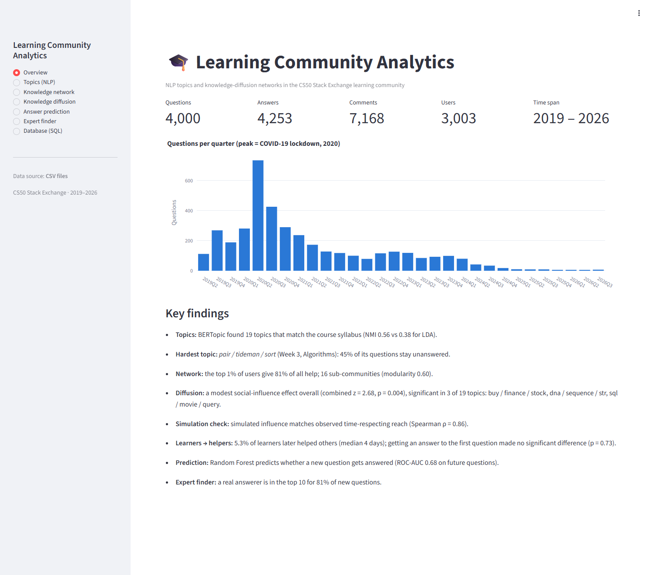
Figure 17. Dashboard: Overview page
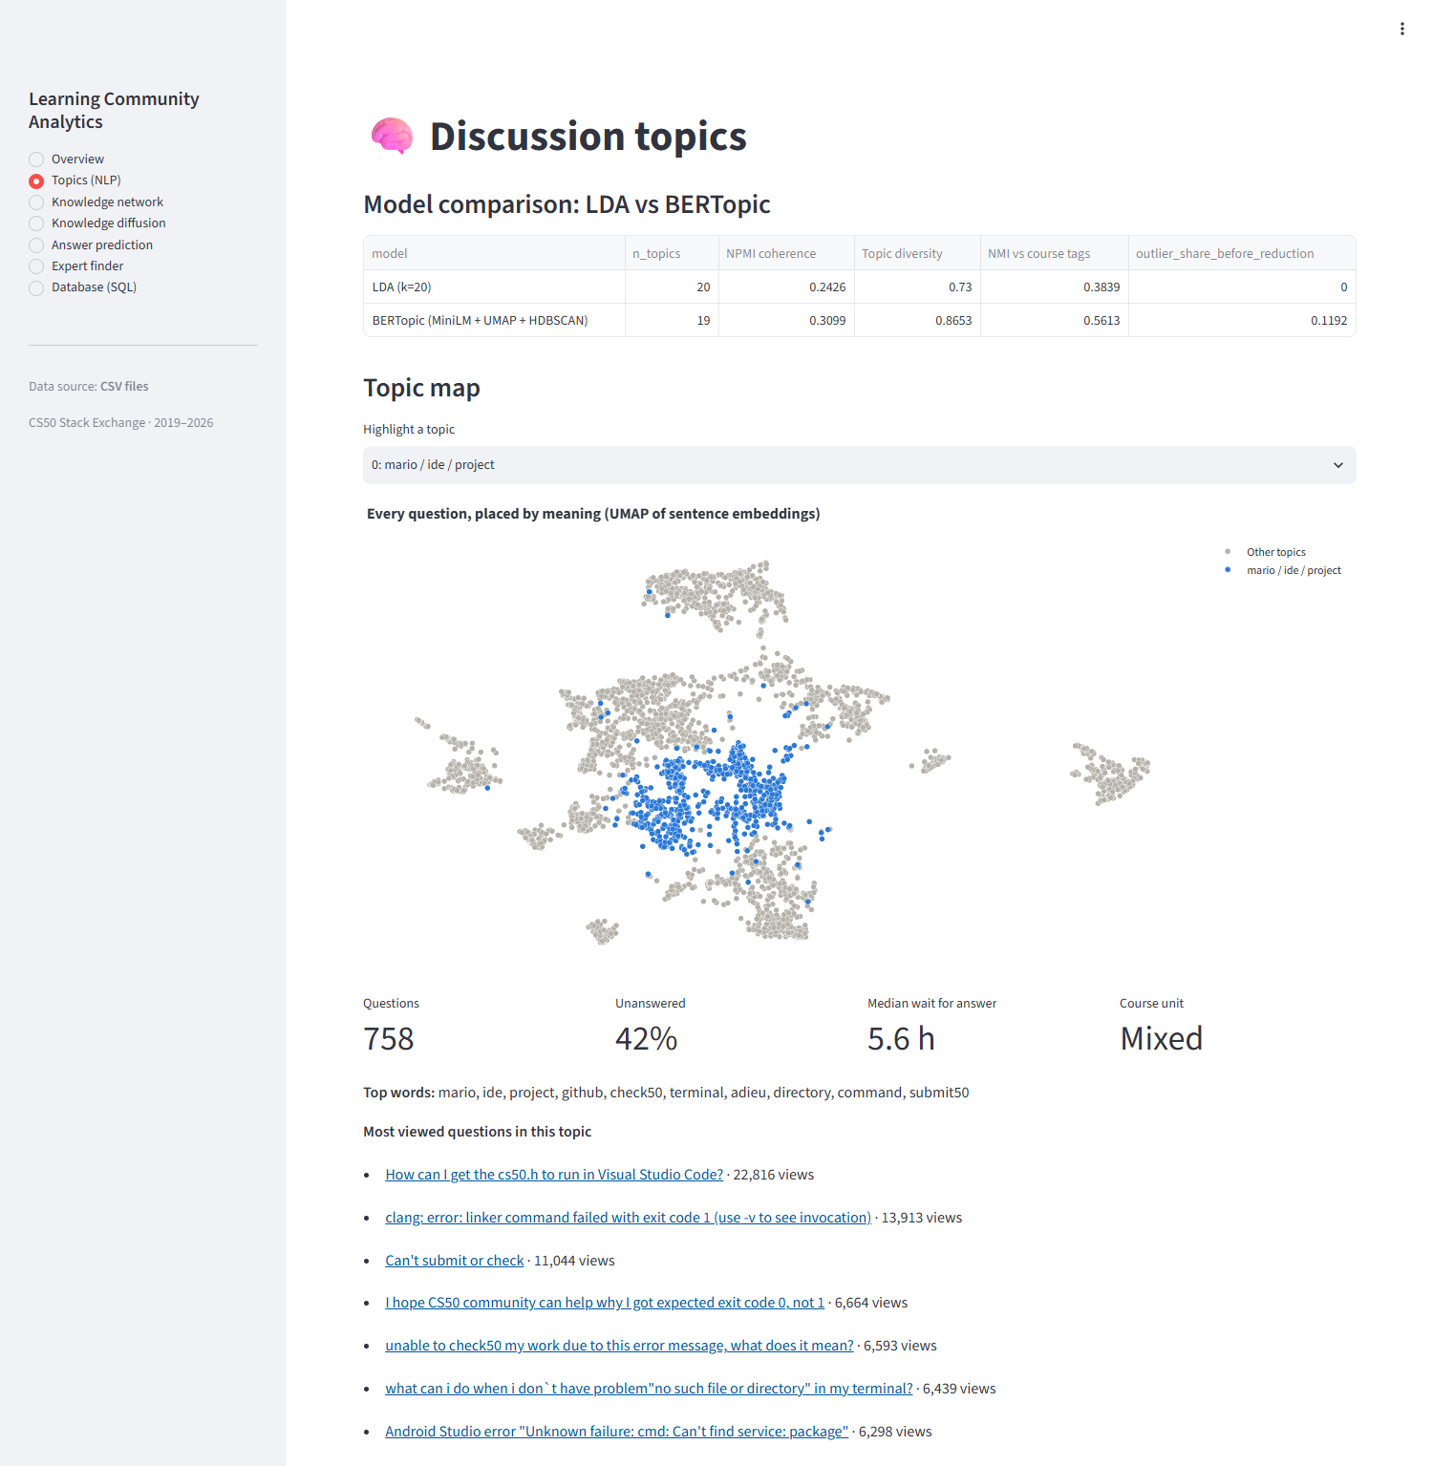
Figure 18. Dashboard: Topics page (topic map, difficulty, trends) (part 1 of 2)
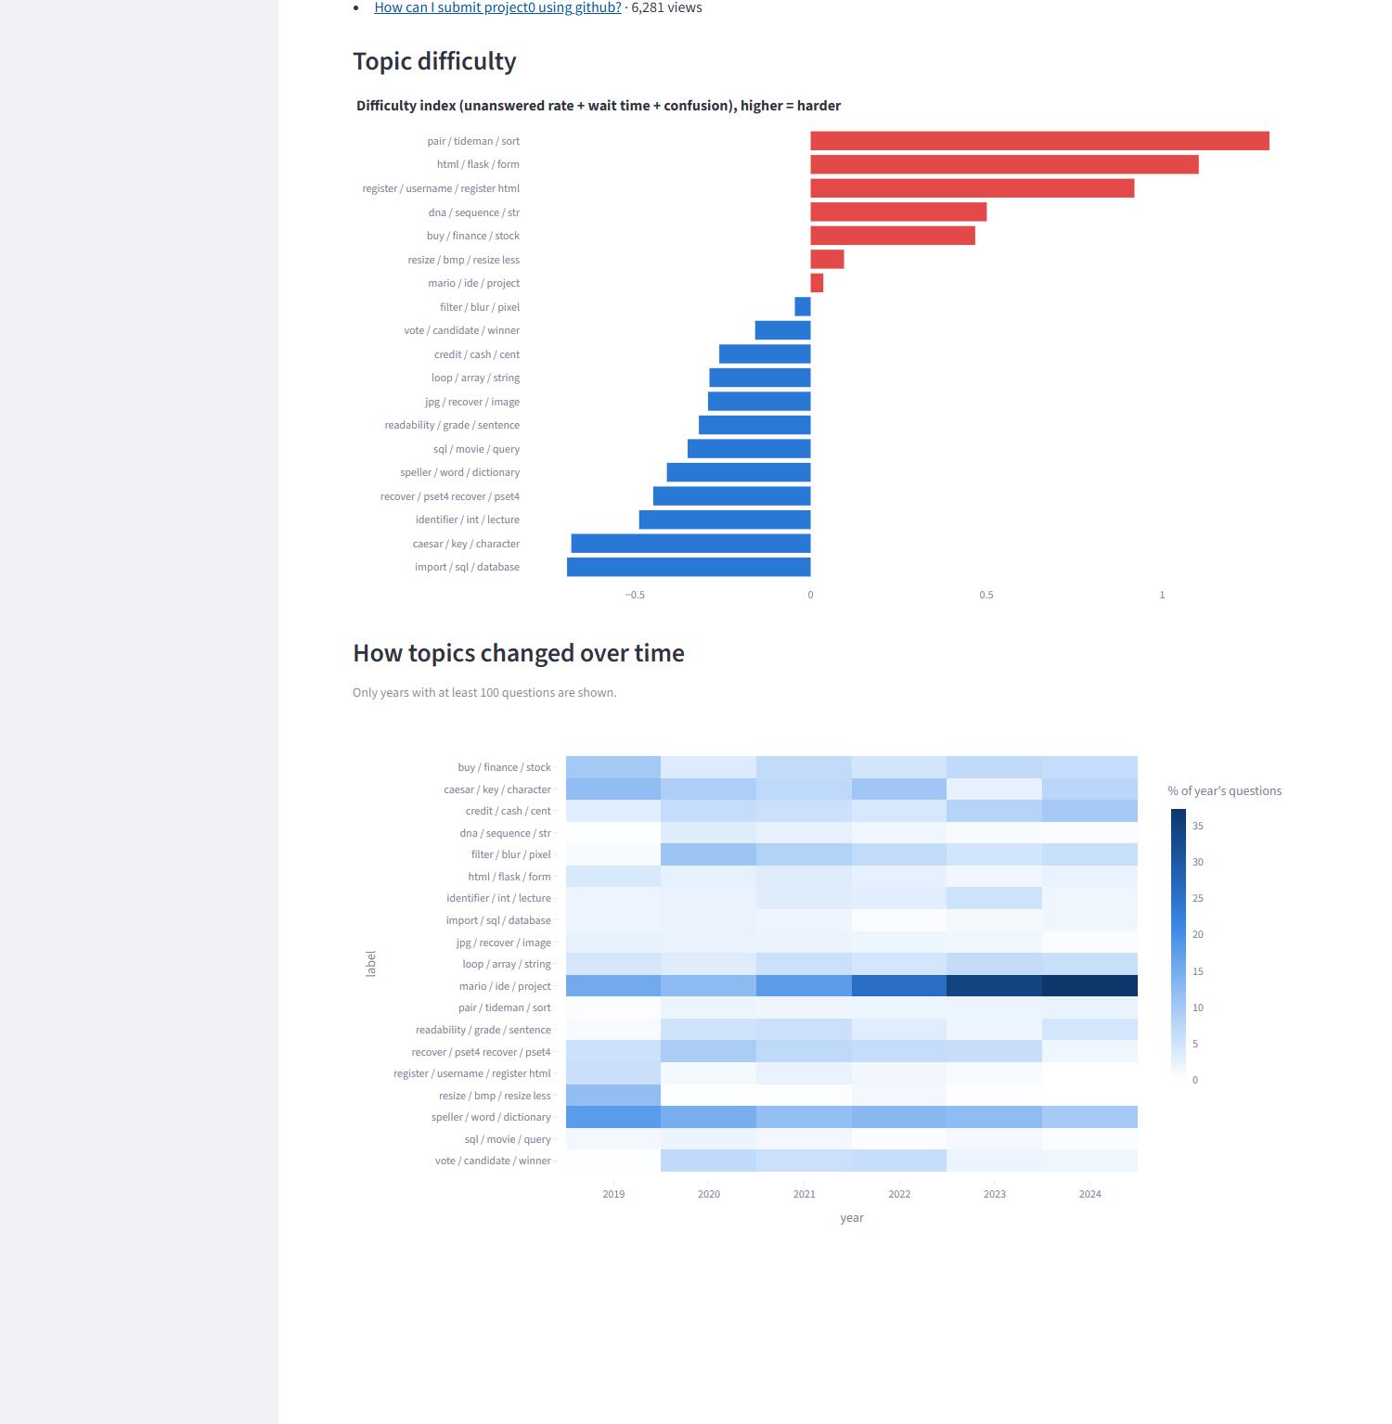
Figure 19. Dashboard: Topics page (topic map, difficulty, trends) (part 2 of 2)
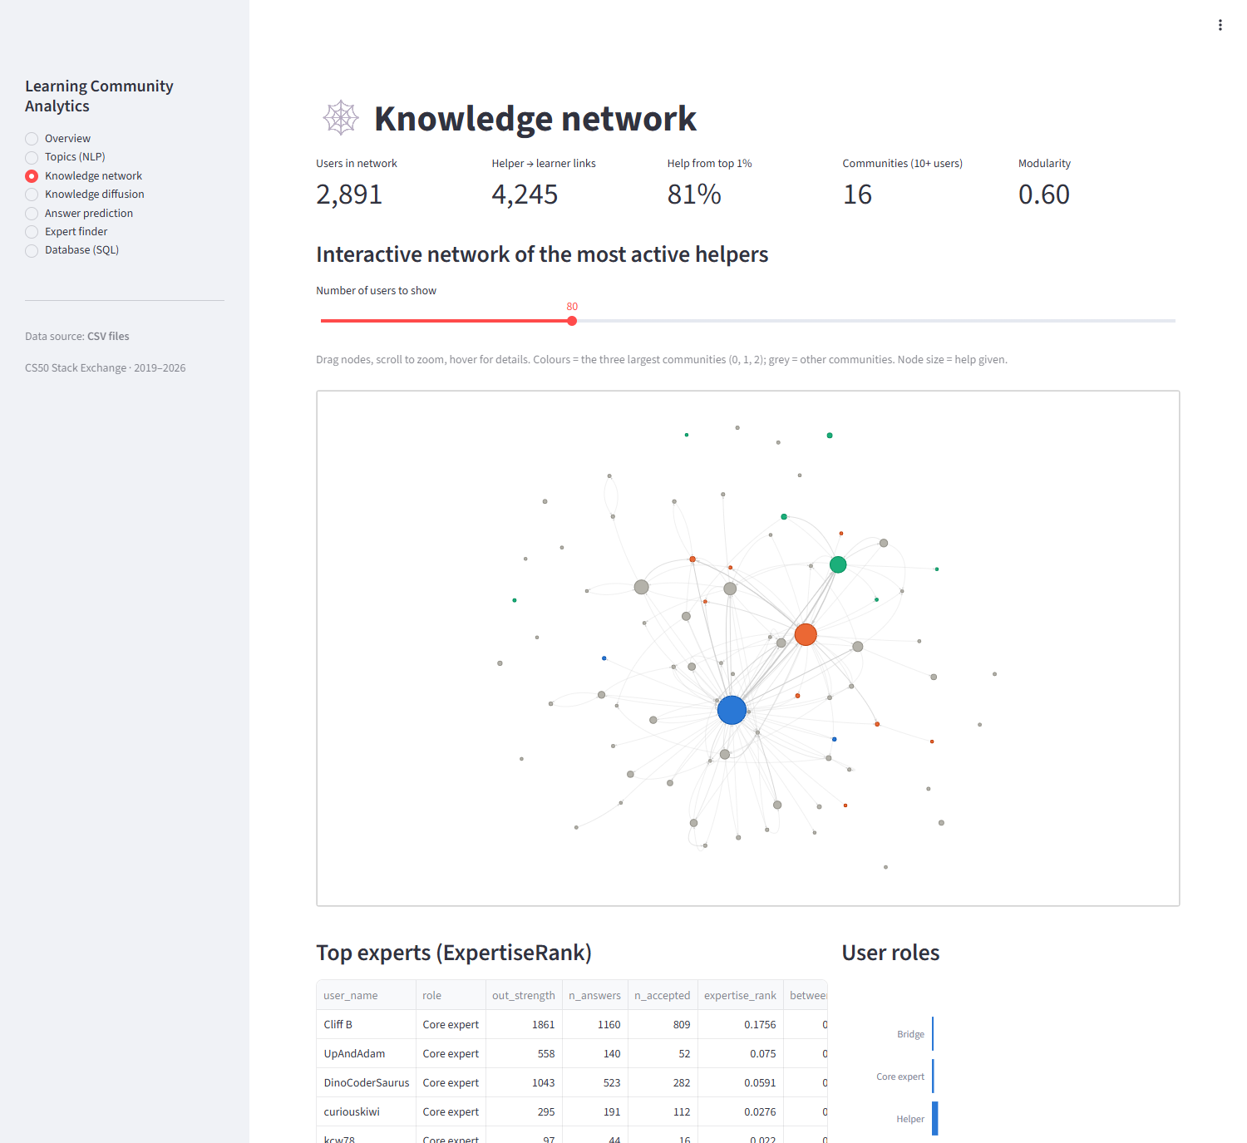
Figure 20. Dashboard: Knowledge network page (interactive graph) (part 1 of 2)
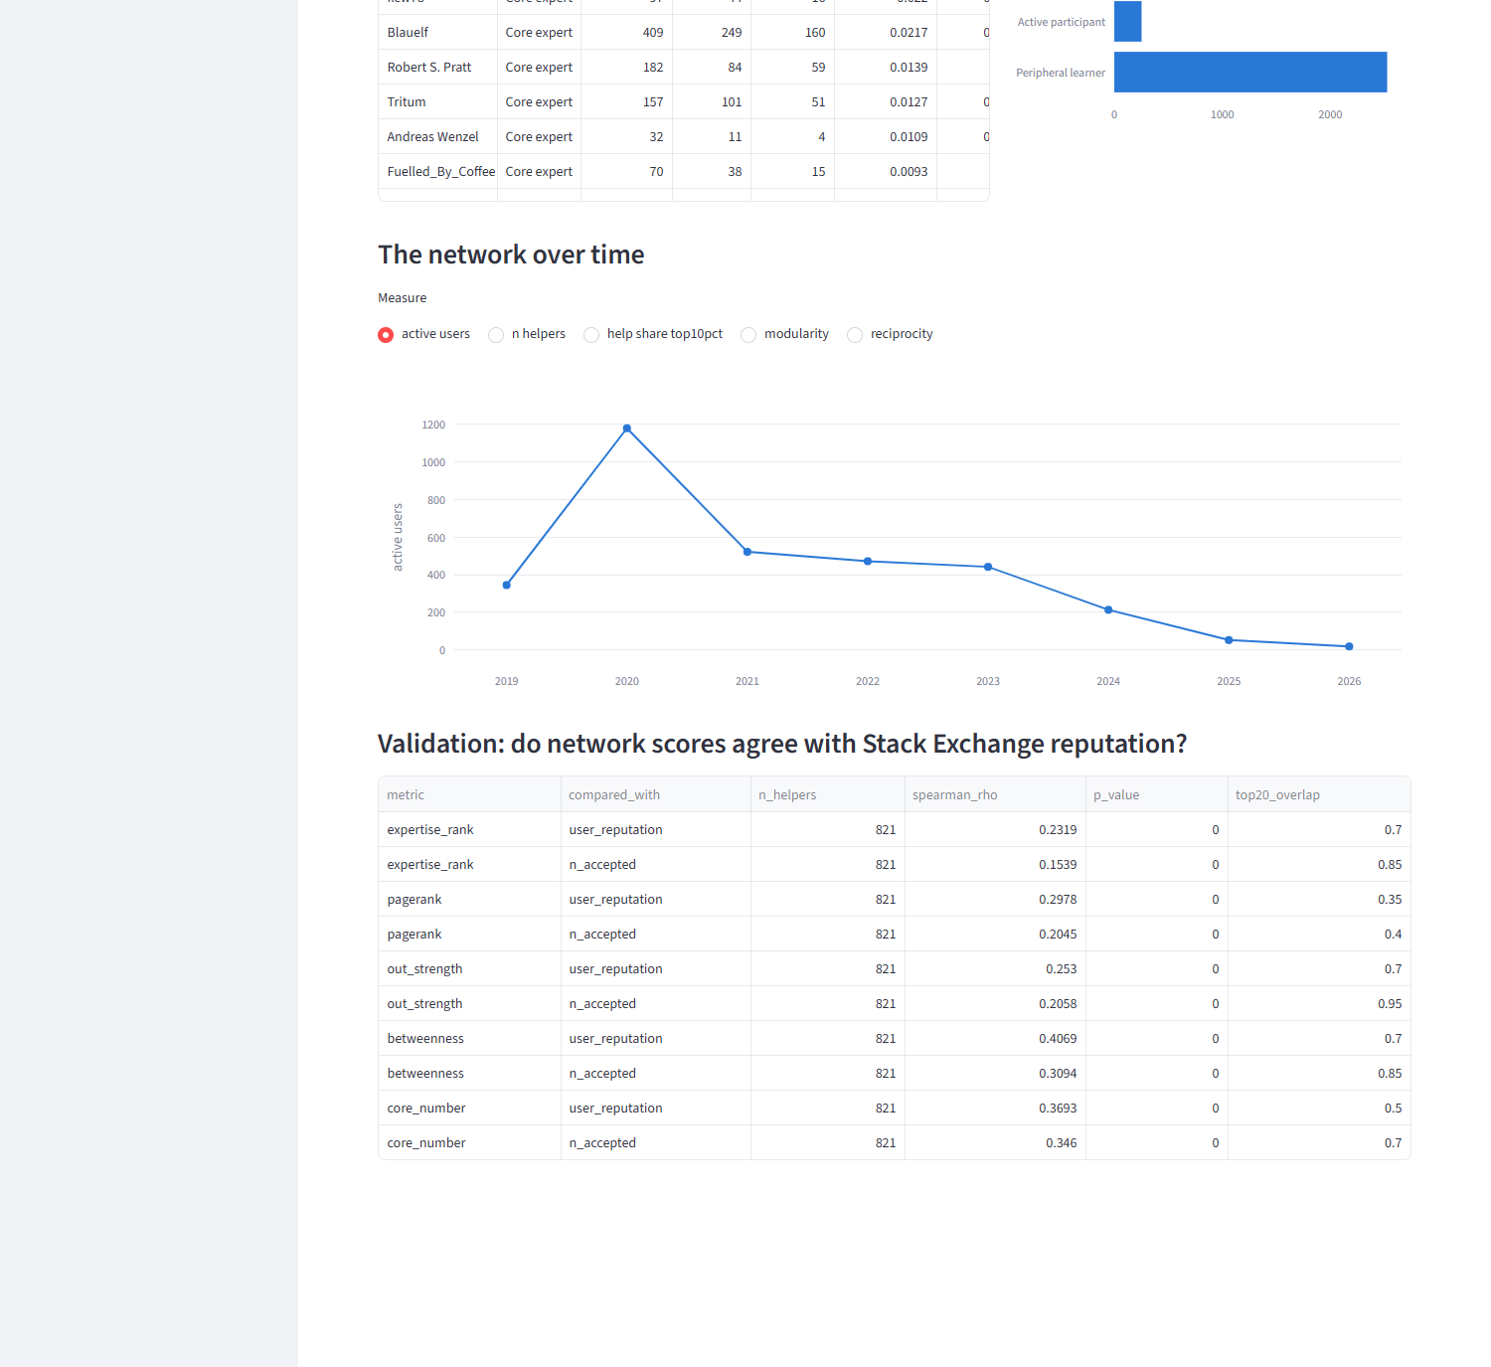
Figure 21. Dashboard: Knowledge network page (interactive graph) (part 2 of 2)
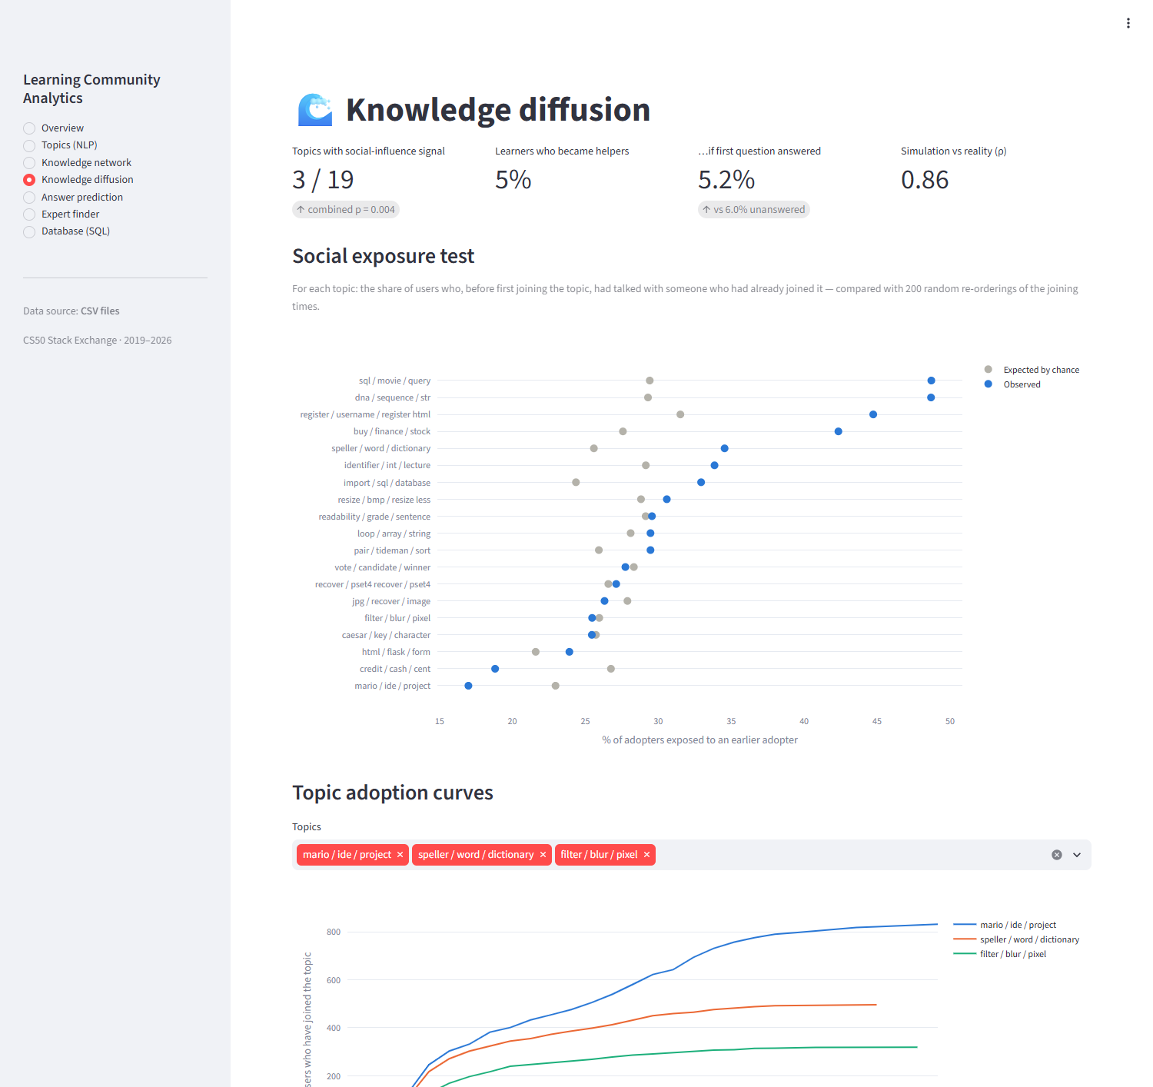
Figure 22. Dashboard: Knowledge diffusion page (part 1 of 2)
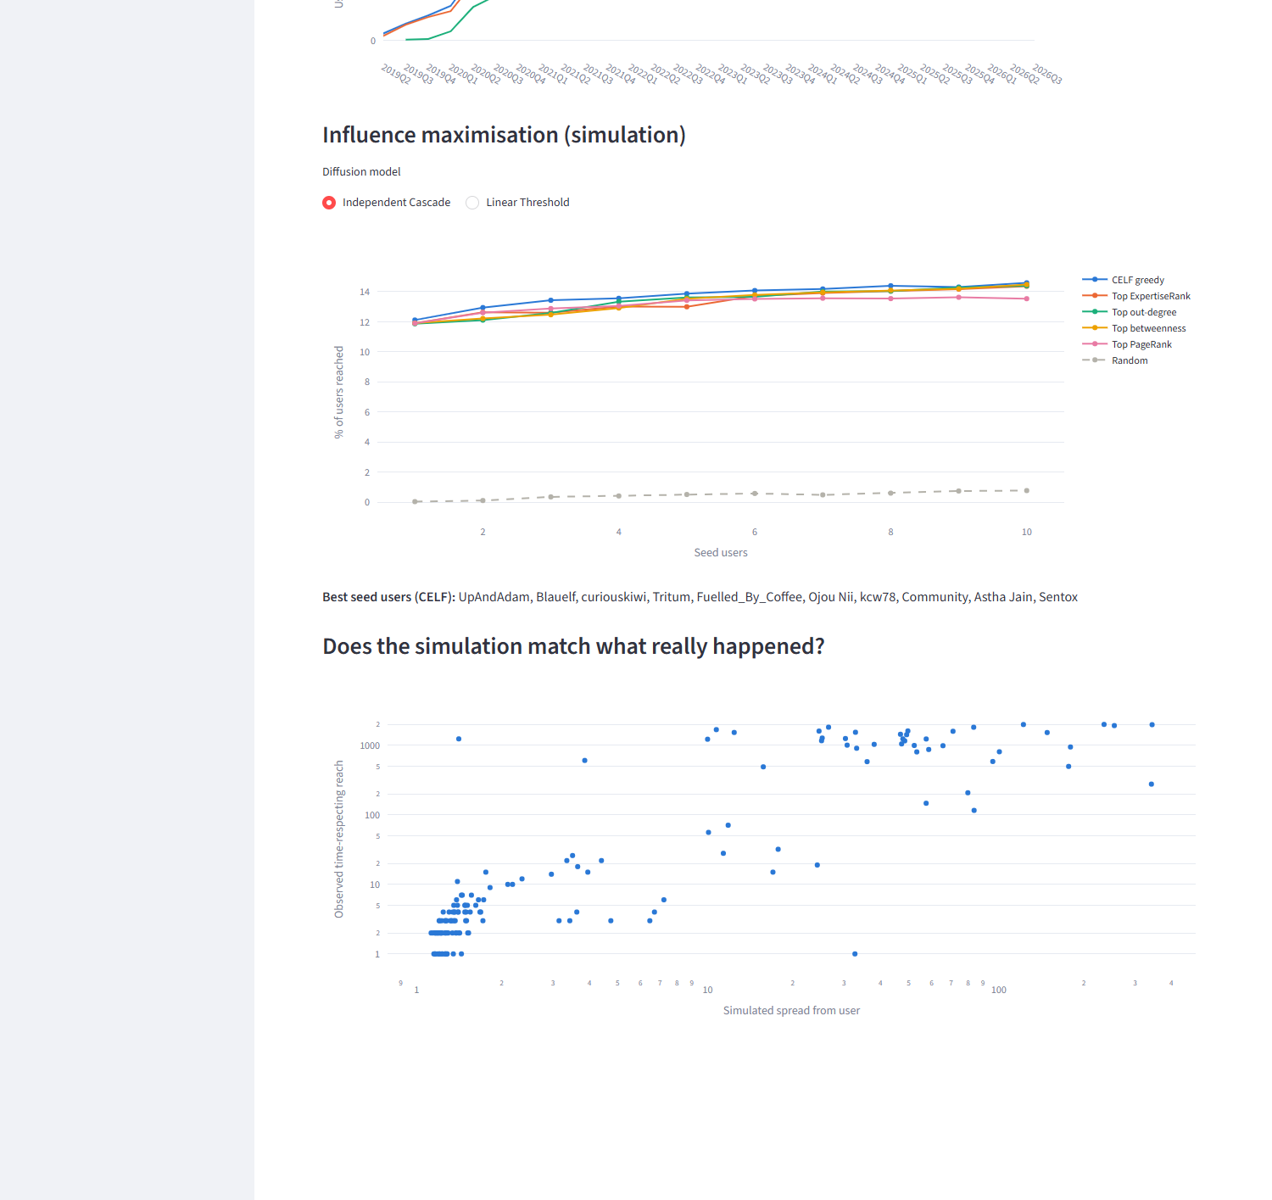
Figure 23. Dashboard: Knowledge diffusion page (part 2 of 2)
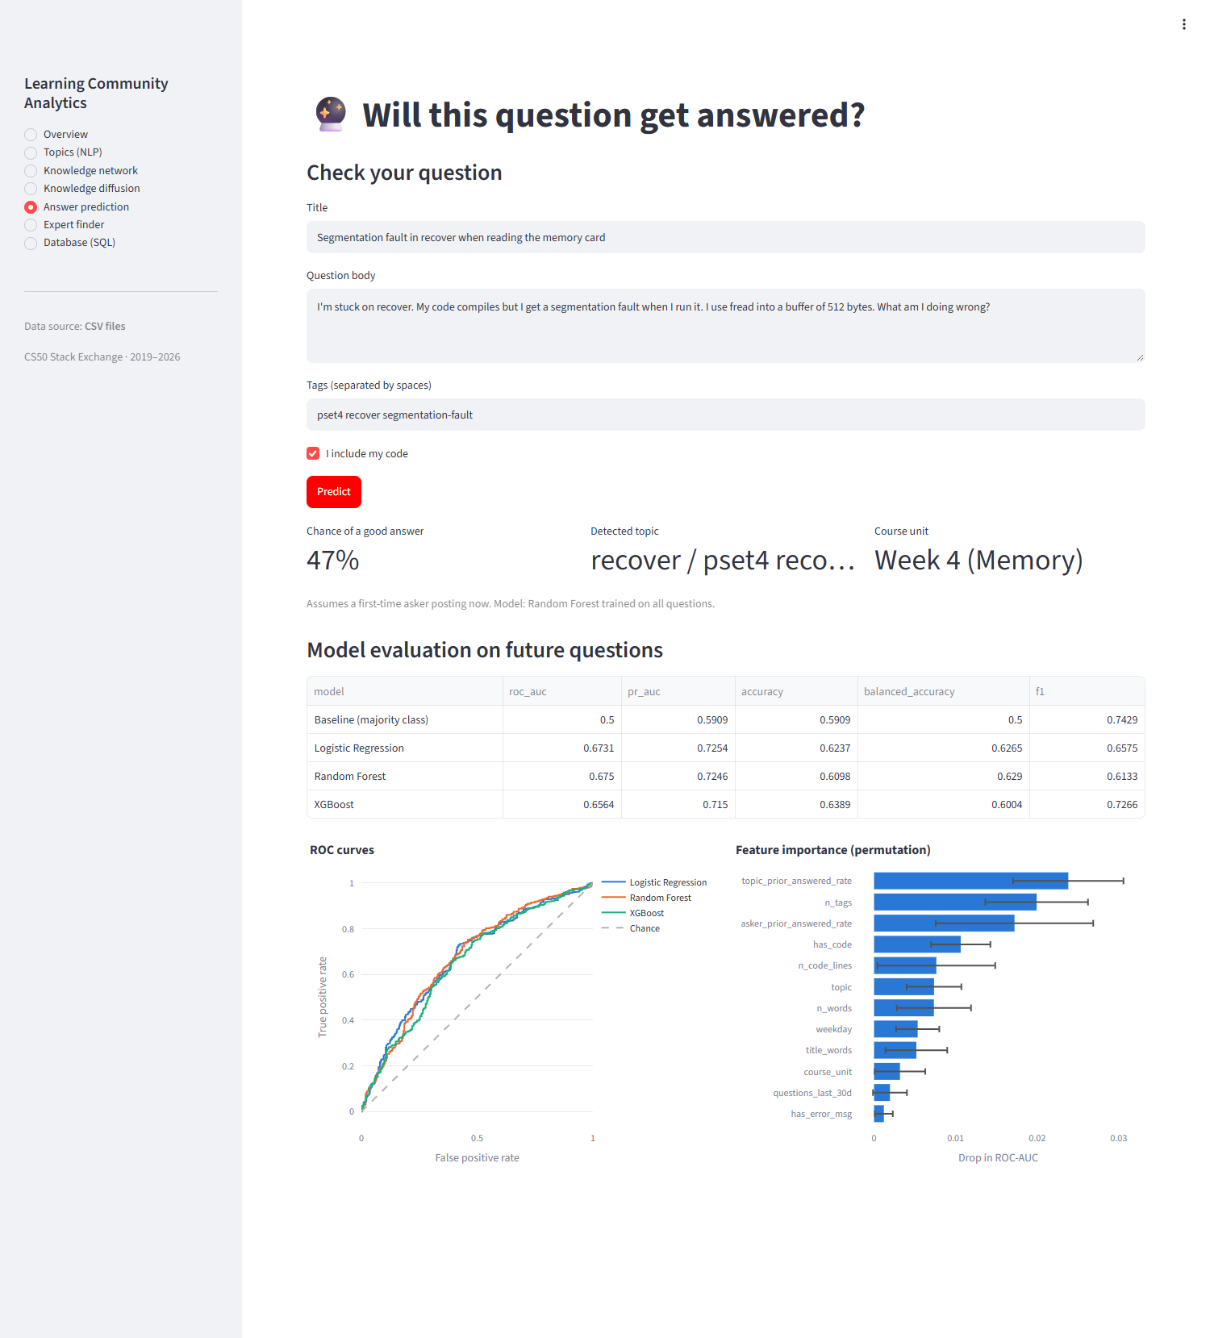
Figure 24. Dashboard: Answer prediction, result for a sample question
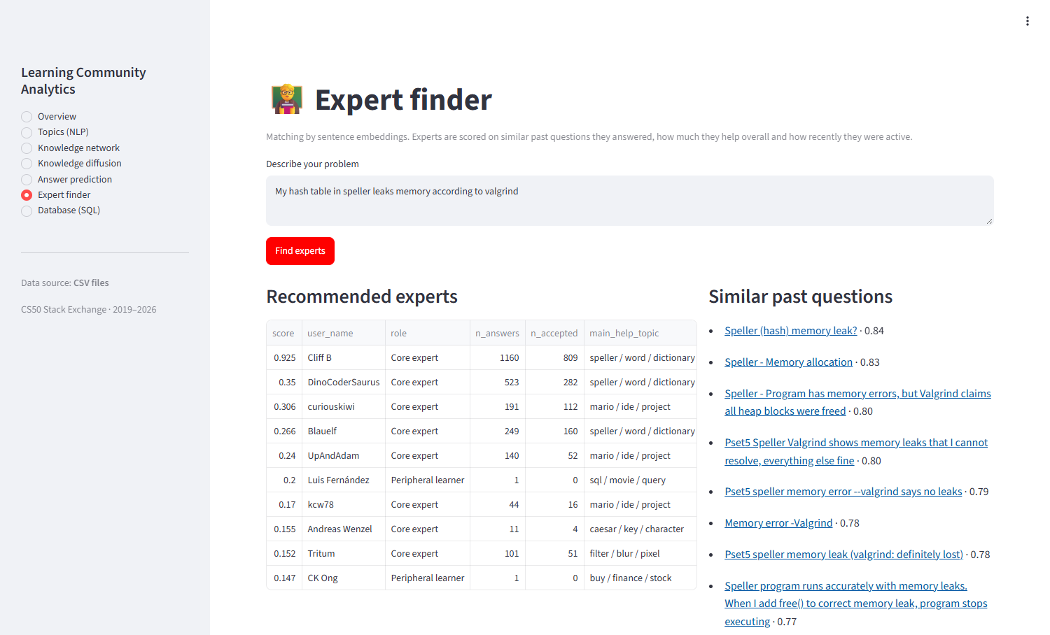
Figure 25. Dashboard: Expert finder, result for a sample problem (part 1 of 2)
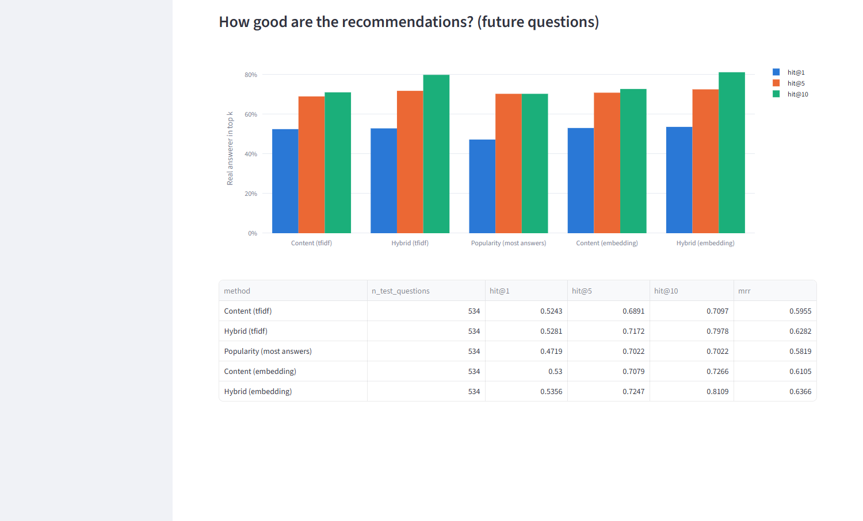
Figure 26. Dashboard: Expert finder, result for a sample problem (part 2 of 2)
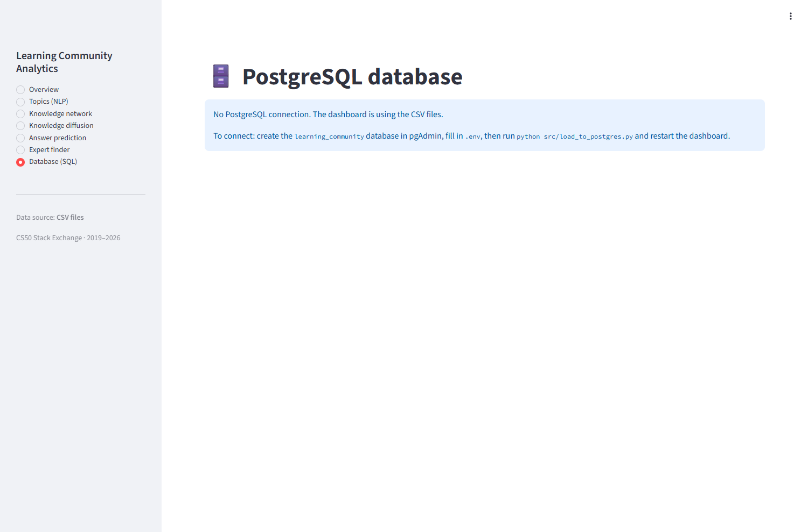
Figure 27. Dashboard: Database page without a PostgreSQL connection
Paste screenshot: Database page on the laptop, connected to PostgreSQL, after running a query

