Battle of Neighborhoods- Capstone Project
Title- “Determining Appropriate Location for Warehouse of Restaurant Raw Materials Supplies Business”
By: Prateek Vashishtha
June 13, 2019
Contents:
- Introduction to Problem Statement
- Introduction to Data and its Source
- Methodology & Data Analysis
- Results
- Discussion
- Conclusion
- References
1. Introduction to Problem Statement
1.1 Background
Restaurants, places where we enjoy tasty food treats and spend leisure time with friends, family, etc. The food we eat is prepared in restaurants with great care and using special quality raw materials that makes it taste good and different from food prepared at home. These special ingredients and other raw materials are supplied to restaurants by various vendors. In recent times, business related to single vendor supplying all required raw material have started where raw material is supplied to all client restaurants generally on daily basis or sometimes more than once a day.
Such vendors are called “Restaurant Suppliers” in north India, especially New Delhi, the capital city of India. When raw materials are supplied by restaurant suppliers, it incurs transportation cost to them when more restaurants are far away from their warehouse. Therefore, suppliers look to build warehouse in close vicinity to majority of restaurants, that means in area where high density restaurant neighborhoods are close enough to reduce supply transportation cost.

1.2 Problem Definition
Fooracles Pvt Ltd Company is planning to start restaurant supplier business in New Delhi, India (capital city of India) and thus, wish to build a warehouse for restaurant supplies in an area where they can be assured to incur as less as possible cost of transportation of supplies on daily basis. Fooracles CEO has decided three location where they can avail space to build warehouse viz. New Delhi Central, East Delhi, South West Delhi.
They approached us to help them decide appropriate place to build their warehouse so that transportation cost can be reduced and they can approach maximum restaurants in less time. Therefore, our location analysis can be used to determine best place to approach to supplies from Fooracles.
1.3 Proposed Solution
The knowledge of data science and geo location analysis using neighborhood data can be used to determine solution to the above stated problem. We can compare different neighborhoods for coverage of maximum restaurants in close vicinity to reduce time and cost of transportation. We will have comparative analysis of neighborhood of central, east and south New Delhi respectively and generate conclusion to select one hot destination to start and build warehouse of Fooracles for restaurant supplies.
2. Introduction to Data and its Source
2.1 Data Source and Acquisition
Data required for the proposed solution is geo location data that can be acquired through Foursquare API using account created on foursquare portal. This data can only be fetched using request URL and as a result a JSON file is received. The sample JSON is as follows:
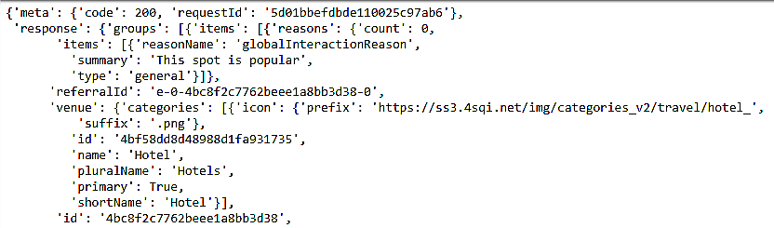
Data from JSON file can be read through python API calls that fetches data and converts it into Pandas Data Frame. This data frame data can be cleaned and pre-processed to form required data set that helps in geo location plotting of neighborhoods. Data includes Neighborhood Name, Neighborhood Latitude and Longitude, Neighborhood Boroughs.
2.2 Data Description
This data having latitude and longitude values of neighborhoods in New Delhi can be used to fetch deeper level of information from similar API calls and get data frame with addition information like Venues Name, Venues Category and Latitude & Longitude of Venues in various Neighborhoods.
Following is sample data:
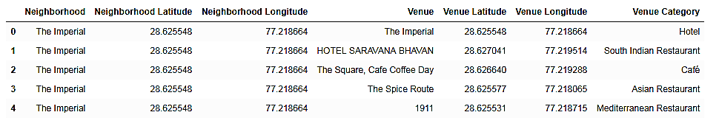
3. Methodology and Analysis
3.1 Methodology
The methodology used includes geo location data analysis to get the coordinates of location of neighborhoods in New Delhi. Firstly, we select all the data related to various types of restaurants in New Delhi and then it requires selecting a center point of warehouse establishment and then calculating distance of all restaurants in New Delhi from chosen center.
We then estimate number of restaurants in vicinity of 2km, 4km and 6km from chosen center. The neighborhood that has higher number of restaurants in max vicinity of 6km is considered to incur less transportation cost and greater service in less time.
3.2 Analysis
The analysis includes working on three center location to compare the approach of supplies from chosen location as warehouse.
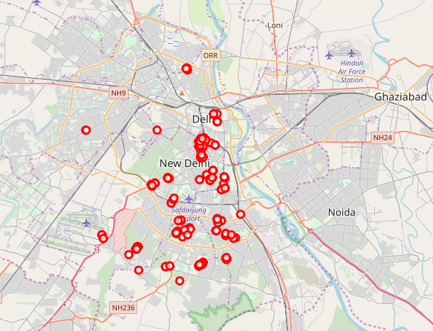
Figure 1: Restaurants in New Delhi
We have taken New Delhi Central, Sevilla and Rajinder da Dhaba as three locations. Our analysis shows following output plots:

- New Delhi Central:
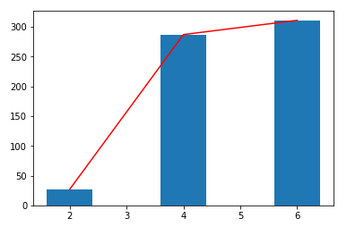
Figure 2: Cumulative count in New Delhi Central
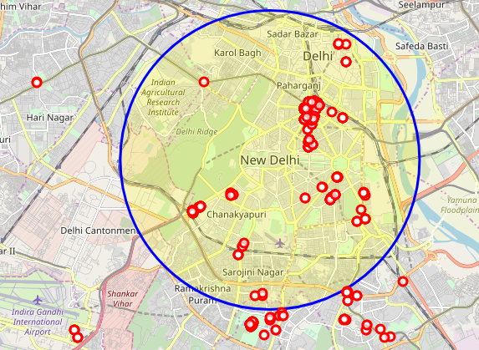
Figure 3: New Delhi Central Coverage
- Sevilla
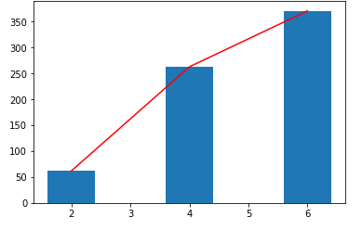
Figure 4: Cumulative Count in Sevilla
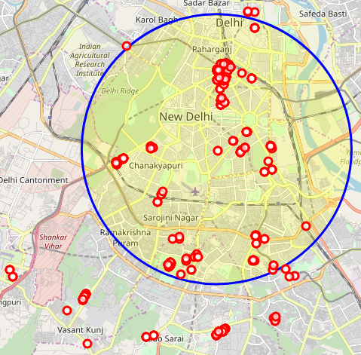
Figure 5: Center as Sevilla Coverage

- Rajinder da Dhaba
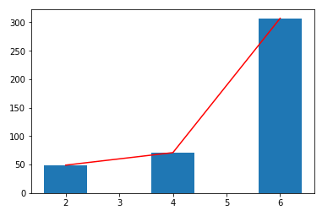
Figure 6: cumulatice Count in Rajinder da Dahaba
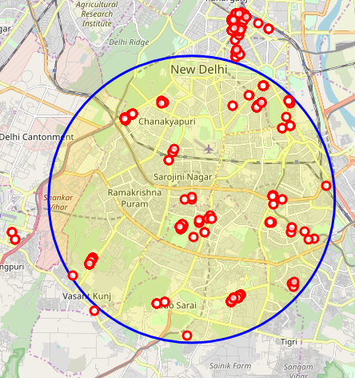
Figure 7: Coverage in Rajinder da Dhaba
4. Results
4.1 Result Analysis
Results include visualization data and data related to count of restaurants in close vicinity to chosen centers. We have also analyzed average number of restaurants in different chosen neighborhoods and thus made conclusions f4o it.
The data related to count and average number of restaurants in different neighborhoods is shown in table below:
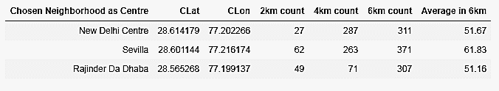
Figure 8: Table of comparison of Neighborhoods that includes count in 2km, 4km and 6km range from chosen center. Also, average restaurants in max 6km range.
5. Discussion
5.1 Results & Analysis Discussion
The results shows data in different neighborhoods chosen as center for warehouse setup. The counts in vicinity of 2km, 4km and 6km respectively has been shown that is fairly good analysis to help decide the place more suitable for building and setting up warehouse of Fooracles company business for purpose of restaurants supplies.
We can further use more analytical study if more detail data is provided.
6. Conclusion
6.1 Conclusion Remarks
Conclusion includes a suggestion to Fooracles about setting up warehouse for business purpose of restaurants supplies. The best location chosen is “Sevilla” neighborhood taken from Foursqaure API.
More detail study of location data and data about restaurants in New Delhi would be useful to decide exact location. Further, we can enhance our results combining data about prices of land or rented properties.
7. References
[1] Foursquare API
[2] Kaggle data for New Delhi Restaurants
[3] matplotlib library documentation
[4] pandas documentation
[5] folium documentation

