# **CSC 431 – <E.P.E.>** StockWise Software Requirements Specification (SRS)

|  |
| --- |
|  |
| Eltonia Leonard |
| Everett Xu |
| Prateek Gupta |
|  |

# Version History

|  |  |  |  |
| --- | --- | --- | --- |
| Version | Date | Author(s) | Change Comments |
| 0.1 | 02/21/2025 | Everett | Initial draft, team information |
| 0.2 | 02/22/2025 | Everett | Added sections 2.1, 2.2, 2.3, 2.4 |
| 0.3 | 02/23/25 | Everett | Added sections 2.5, 2.6, 2.7, 2.8, 2.9 |
| 0.4 | 02/23/25 | Eltonia | Added sections 1.1.1, 1.1.2, 1.1.3, 1.1.4, 1.1.5, 1.1.6,1.1.7 |
| 0.5 | 02/24/25 | Eltonia | Added sections 1.2.1, 1.2.2, 1.2.3, 1.2.4, 1.2.5, 1.2.6, 1.2.7 |
| 0.6 | 02/24/25 | Everett | Edited and formatted the document |
| 0.7 | 02/24/25 | Eltonia | Edited and reformatted |
| 0.8 | 02/25/25 | Eltonia | Added section 3.1 |
| 0.9 | 2/25/25 | Prateek | Added Sections 3.2, 4.1, 4.2 |
| 1.0 | 2/25/25 | Eltonia | Reformatted |
| 1.1 | 2/27/25 | Eltonia, Prateek,  Everett | Proofread and Readjusted Use Case Diagrams |

**TABLE OF CONTENTS**

1. System Requirements 5

1.1 Functional Requirements 5

1.1.1 Live Inventory Updates and Monitoring 5

1.1.2 Low Stock Signal and Automatic Order Placement 6

1.1.3 Product and Supplier Management 7

1.1.4 Universal Platform Access 8

1.1.5 Offline Access and Data Synchronization 9

1.1.6 Statistical Insights and Reports 10

1.1.7 Account Access and Permission Management 11

1.2 Non-Functional Requirements 12

1.2.1 User Friendliness 12

1.2.2 System Responsiveness 12

1.2.3 Consistent Performance and Availability 13

1.2.4 Data Protection & Privacy 13

1.2.5 Multi-User Accessibility 13

1.2.6 Maintainability 14

1.2.7 Portability 14

2. System Constraints 15

2.1 Tool Constraints 15

2.1.1 Version Control Tool 15

2.1.2 Development Environment Tool 15

2.2 Language Constraints 16

2.2.1 Back-End Programming Language 16

2.2.2 Front-end Framework 16

2.3 Platform Constraints 17

2.3.1 Web Application 17

2.3.2 Cross-OS Compatibility 17

2.3.3 Mobile OS Support 17

2.4 Hardware Constraints 18

2.4.1 Minimum PC Specifications 18

2.4.2 Minimum Mobile Device Specification 18

2.5 Network Constraints 19

2.5.1 Internet Connectivity 19

2.5.2 Offline Mode 19

2.6 Deployment Constraints 20

2.6.1 Cloud Hosting 20

2.6.2 On-Premises Option 20

2.7 Transition & Support Constraints 21

2.7.1 Data Migration Support 21

2.7.2 User Training 21

2.8 Budget & Schedule Constraints 22

2.8.1 Development Budget 22

2.8.2 Completion Timeline 22

2.9 Miscellaneous Constraints 23

2.9.1 Licensing 23

2.9.2 Localization 23

3. Requirements Modeling 24

3.1 Use-Case Diagrams for functional system requirements 24

3.1.1 Live Inventory Updates and Monitoring 25

3.1.2 Low Stock Signal and Automatic Order Placement 26

3.1.3 Product and Supplier Management 26

3.1.4 Universal Platform Access 27

3.1.5 Offline Access and Data Synchronization 27

3.1.6 Statistical Insights and Reports 28

3.1.7 Account Access and Permission Management 28

3.2 Use-Case Diagrams for functional evolutionary requirements 29

3.2.1 AI-Based Demand Forecasting 29

3.2.2 Supplier Performance Analytics 29

3.2.3 Blockchain for Inventory Tracking 30

3.2.4 Automated Supplier Selection 30

3.2.5 Real Time Shipment Tracking 31

3.2.6 Automated Return and Refund Processing 31

4. Evolutionary Requirements 32

4.1 Functional Requirements 32

4.1.1 AI-Based Demand Forecasting 32

4.1.2 Supplier Performance Analytics 32

4.1.3 Blockchain for Inventory Tracking 33

4.1.4 Automated Supplier Selection 33

4.1.5 Real Time Shipment Tracking 34

4.1.6 Automated Return and Refund Processing 34

4.2 Non-Functional Requirements 35

4.2.1 Scalability 35

4.2.2 AI-Driven User Assistance 35

4.2.3 Global Compliance Adaptability 35

4.2.4 High availability and Disaster Recovery 36

4.2.5 Third-Party Accounting Software Integration 36

4.2.6 Adaptive UI for Management Roles 36

### System Requirements

#### Functional Requirements

##### ****Live Inventory Updates and Monitoring****

##### 

|  |  |
| --- | --- |
| Title | **Live Inventory Updates and Monitoring** |
| Description | The system is automatically triggered to update the number of items in stock as soon as there is a new sale, return or restock. |
| Priority | 0 (highest) |
| Precondition(s) | * The user's authentication is verified, and the user is granted the rights to view or modify inventory. * There are already products in the system, along with their starting stock levels. |
| Basic Flow | 1. A transaction, whether a sale, return, or restock, is initiated by either the user or an external POS system. 2. Based on the transaction (type and quantity), the system computes the new inventory level 3. The system updates the database with the current amount of inventory that is now in stock. 4. Authorized users are provided with a real time display of the updated stock levels. |
| Postconditions(s) | * The inventory database reflects the new, accurate stock levels and these are immediately visible to all authorized users * Any relevant alerts are triggered if thresholds are crossed. |
| Use Case Diagram | 3.1.1 |

##### Low Stock Signal and Automatic Order Placement

|  |  |
| --- | --- |
| Title | **Low Stock Signal and Automatic Order Placement** |
| Description | The system should track inventory levels and trigger notifications once an item falls beneath a predefined limit, and if enabled, automatically submit a reorder request to suppliers. |
| Priority | 1 |
| Precondition(s) | * The system has a reorder threshold along with each item’s supplier information attached * The user has specified their alert preferences, such as receiving notifications by email, text or push. |
| Basic Flow | 1. The system continuously monitors stock levels following every inventory update. 2. Should the stock fall under the predefined threshold, the system issues a low stock alert. 3. If the automatic reorder feature is activated, the system immediately sends a reorder request, including the needed quantity, to the designated supplier. 4. The system documents the alert along with the details of any reorder. |
| Postconditions(s) | * Notifications for low stock items are delivered to the user. * If enabled, an automatic reorder request is sent, and the item is queued for restocking. |
| Use Case Diagram | 3.1.2 |

##### Product and Supplier Management

|  |  |
| --- | --- |
| Title | **Product and Supplier Management** |
| Description | The system should provide functionality for users to add, view, modify, and remove details regarding products and the relevant supplier information |
| Priority | 1 |
| Precondition(s) | * The user has admin or manager privileges * For editing or deleting, a valid record for an item or supplier is required to be selected |
| Basic Flow | 1. The user navigates to the relevant management module for products or suppliers. 2. The user opts to either create a new item/supplier record or update/remove an existing one. 3. The system validates the input. 4. Once validated, the system saves the changes and shows the user a success notification. |
| Postconditions(s) | * The database for products and suppliers reflects the newly added or modified details. |
| Use Case Diagram | 3.1.3 |

##### Universal Platform Access

|  |  |
| --- | --- |
| Title | **Universal Platform Access** |
| Description | The system should support access through multiple platforms like desktop applications, web interfaces, and mobile applications. |
| Priority | 2 |
| Precondition(s) | * The necessary application or browser is installed on the user's device. * The system has been implemented across all targeted platforms. |
| Basic Flow | 1. The user initiates the system on a preferred platform. 2. The user logs in using authorized credentials. 3. The system loads the user interface, displaying the inventory dashboard to the user. |
| Postconditions(s) | * Inventory can be viewed and managed by the user on any platform that is supported by the system. |
| Use Case Diagram | 3.1.4 |

##### Offline Access and Data Synchronization

|  |  |
| --- | --- |
| Title | **Offline Access and Data Synchronization** |
| Description | The system should permit key inventory operations to be executed offline and ensure data is synchronized as soon as it is reconnected to the internet. |
| Priority | 2 |
| Precondition(s) | * The device supports offline storage functionality. * The user has already downloaded or cached the required data prior to losing network connectivity. |
| Basic Flow | 1. The system detects a loss of internet connectivity, and switches to offline mode. 2. The user performs necessary operations as they normally would, like updating stock and adding new items during this period. 3. When the internet is restored, the system automatically transfers all offline operations to the central database. |
| Postconditions(s) | * After reconnection, the central database is updated to include any changes made while offline. |
| Use Case Diagram | 3.1.5 |

##### Statistical Insights and Reports

|  |  |
| --- | --- |
| Title | **Statistical Insights and Reports** |
| Description | The system should provide detailed analytical reporting on the most popular items, sales trends, seasonal demand, and other critical sales indicators, while also enabling users to export these reports. |
| Priority | 3 |
| Precondition(s) | * The user holds manager or administrative privileges. * The system has accumulated enough historical sales and inventory data for analysis |
| Basic Flow | 1. The user navigates to the “Analytics/Reports” interface. 2. The user selects a desired report, such as best-selling items or seasonal trends. 3. The system receives and processes the request 4. The system displays the results as charts, graphs, or tables. 5. The user has the option to download and/or export the report in supported formats like PDF or CSV. |
| Postconditions(s) | * The user obtains valuable insights into inventory performance and can export or share the resulting reports. |
| Use Case Diagram | 3.1.6 |

##### Account Access and Permission Management

|  |  |
| --- | --- |
| Title | **Account Access and Permission Management** |
| Description | The system should support the setup of numerous user accounts with differentiated roles (like admin, manager, staff), applying role-specific restrictions to protect sensitive functions. |
| Priority | 0 (highest) |
| Precondition(s) | * The system's user roles are structured in a defined hierarchy * An admin is signed in to oversee and manage user roles. |
| Basic Flow | 1. The admin navigates to the “User management” interface. 2. The admin initiates the creation of a new user or modifies the role of an existing user. 3. The system applies role-based access controls to either restrict or grant access to functions such as inventory editing and reporting. |
| Postconditions(s) | * Access to particular parts of the system or functionalities is limited to users who have the necessary role-based permissions. |
| Use Case Diagram | 3.1.7 |

#### Non-Functional Requirements

##### ****User Friendliness****

|  |  |
| --- | --- |
| Title | **User Friendliness** |
| Description | The interface should be straightforward and easy to use, ensuring that even users with limited technical expertise can navigate it with little training. |
| Priority | 0 |
| Applicable FR(s) | All FRs:   * FR1 (Live Inventory Updates and Monitoring) * FR2 (Low Stock Signal and Automatic Order Placement) * FR3 (Product and Supplier Management) * FR4 (Universal Platform Access) * FR5 (Offline Access and Data Synchronization) * FR6 (Statistical Insights and Reports) * FR7 (Account Access and Permission Management) |

##### ****System Responsiveness****

|  |  |
| --- | --- |
| Title | **System Responsiveness** |
| Description | The system should efficiently process standard inventory updates within 2 seconds while delivering analytical reports for up to 10,000 items within a 5 second timeframe. |
| Priority | 1 |
| Applicable FR(s) | * FR1 (Live Inventory Updates and Monitoring) * FR2 (Low Stock Signal and Automatic Order Placement) * FR6 (Statistical Insights and Reports) |

##### Consistent Performance and Availability

|  |  |
| --- | --- |
| Title | **Consistent Performance and Availability** |
| Description | The system should achieve 99.9% uptime, with minimal scheduled maintenance and safeguards in place to support critical operations. |
| Priority | 1 |
| Applicable FR(s) | * FR1 (Live Inventory Updates and Monitoring) * FR5 (Offline Access and Data Synchronization) |

##### Data Protection & Privacy

|  |  |
| --- | --- |
| Title | **Data Protection & Privacy** |
| Description | The system should ensure the protection of user credentials and sensitive business data through the use of secure protocols like HTTPS, along with implementing very strict role-based access controls. |
| Priority | 2 |
| Applicable FR(s) | * FR1 (Live Inventory Updates and Monitoring) * FR7 (Account Access and Permission Management) |

##### Multi-User Accessibility

|  |  |
| --- | --- |
| Title | **Multi-User Accessibility** |
| Description | The system should permit simultaneous access for multiple users, ensuring that data remains consistent, and that the system responds promptly during concurrent operations |
| Priority | 2 |
| Applicable FR(s) | * FR7 (Account Access and Permission Management) * FR1 (Live Inventory Updates and Monitoring) * FR5 (Offline Access and Data Synchronization) |

##### Maintainability

|  |  |
| --- | --- |
| Title | **Maintainability** |
| Description | The system’s code should follow a modular design approach and include detailed documentation to facilitate the easy integration of new features or plugins. |
| Priority | 3 |
| Applicable FR(s) | * FR1 (Live Inventory Updates and Monitoring) * FR2 (Low Stock Signal and Automatic Order Placement) * FR3 (Product and Supplier Management) * FR4 (Universal Platform Access) * FR5 (Offline Access and Data Synchronization) * FR6 (Statistical Insights and Reports) * FR7 (Account Access and Permission Management) |

##### ****Portability****

|  |  |
| --- | --- |
| Title | Portability |
| Description | The system should operate across web, desktop, and mobile platforms with little modification, ensuring compatibility with various device types. |
| Priority | 3 |
| Applicable FR(s) | * FR4 (Universal Platform Access) |

### System Constraints

#### Tool Constraints

##### ****Version Control Tool****

|  |  |
| --- | --- |
| Title | **Version Control Tool** |
| Description | The development team shall use version control software to synchronize each team member’s work, allow branching for different versions, and review each other’s codes. |
| Priority | 1 |

##### ****Development Environment Tool****

|  |  |
| --- | --- |
| Title | **IDE Standardization** |
| Description | The development team shall use the same code editor, plugins, packages, and hardware to maintain program compatibility and portability during development. The chosen tool shall be modern, widely used, and known by every team member. |
| Priority | 2 |

#### Language Constraints

##### ****Back-End Programming Language****

|  |  |
| --- | --- |
| Title | **Server-Side Language** |
| Description | The development team shall use a high-level programming language to write scalable and readable code to allow any future development and update. The code should be commented on and documented. |
| Priority | 1 |

##### ****Front-end Framework****

|  |  |
| --- | --- |
| Title | **User Interface Language** |
| Description | The development team shall use a commonly used language that has pre-existing frameworks to minimize development costs and time. The language should be executable in mainstream browsers. |
| Priority | 2 |

#### 

#### Platform Constraints

##### ****Web Application****

|  |  |
| --- | --- |
| Title | **Web-based Platforms** |
| Description | The web application shall support most mainstream browsers. The UI shall adjust automatically according to the size of the window. The web application shall maintain the same functionality and UI design as other platforms. |
| Priority | 3 |

##### ****Cross-OS Compatibility****

|  |  |
| --- | --- |
| Title | **Desktop Platforms** |
| Description | The desktop application shall ensure compatibility with Windows, macOS, and major Linux distributions. The application shall maintain the same functionality and UI design across all platforms. Auto-update functionality shall be supported on all operating systems. The desktop app supports offline mode and local database. |
| Priority | 3 |

##### ****Mobile OS Support****

|  |  |
| --- | --- |
| Title | **Android and iOS Platforms** |
| Description | The mobile app shall have all the core functionality as other platforms, additionally, the mobile app includes a barcode scan function to track inventory changes. The mobile app has no offline database due to limited storage. |
| Priority | 4 |

#### Hardware Constraints

##### ****Minimum PC Specifications****

|  |  |
| --- | --- |
| Title | **Minimum PC Requirements** |
| Description | The desktop system shall run on personal computers with common operating systems installed. A monitor, keyboard, and mouse are required for information input and output. |
| Priority | 3 |

##### ****Minimum Mobile Device Specification****

|  |  |
| --- | --- |
| Title | **Basic Smartphone Requirements** |
| Description | The minimum hardware requirement for mobile devices is a touch screen, an Android or IOS system, an internet connection, and a camera. Data shall only be stored in cloud due to limited storage of mobile devices. |
| Priority | 4 |

#### Network Constraints

##### ****Internet Connectivity****

|  |  |
| --- | --- |
| Title | **Internet Speed Requirement** |
| Description | The system’s online features shall operate over consistent internet connections with minimum download and upload speeds, with an average latency not exceeding 200ms. The application shall implement data compression to reduce bandwidth usage. The data shall be stored both online and offline on the desktop application during online mode. |
| Priority | 2 |

##### ****Offline Mode****

|  |  |
| --- | --- |
| Title | **Local Data Storage** |
| Description | When offline, the application shall automatically switch to local storage mode. The offline mode shall support all offline operations including inventory updates, sales recording, etc. Upon reconnection, the application shall automatically sync local changes to the online database. |
| Priority | 3 |

#### Deployment Constraints

##### ****Cloud Hosting****

|  |  |
| --- | --- |
| Title | **Hosting on AWS** |
| Description | The primary deployment shall be using a cloud computing platform. The system shall contain security measures and basic software infrastructures. Administration panel for management. |
| Priority | 2 |

##### ****On-Premises Option****

|  |  |
| --- | --- |
| Title | **Local Server Deployment** |
| Description | The software shall be deployed on our company-owned servers. The server includes a web-based administration console, database solution, and automated backup functionality. |
| Priority | 4 |

#### Transition & Support Constraints

##### ****Data Migration Support****

|  |  |
| --- | --- |
| Title | **Spreadsheet Import/Export** |
| Description | The system shall provide data migration utilities supporting import and export to spreadsheets with options for full database export or filtered exports based on custom filters. |
| Priority | 2 |

##### ****User Training****

|  |  |
| --- | --- |
| Title | **Training Documentation** |
| Description | The team shall provide user training materials including: (1) an in-app tutorial with step-by-step guidance; (2) A searchable knowledge base with articles and FAQs; (3) Video tutorials for complex workflows; (4) Printable quick reference guides for common tasks. |
| Priority | 3 |

#### Budget & Schedule Constraints

##### ****Development Budget****

|  |  |
| --- | --- |
| Title | **Limited Financial Resources** |
| Description | The project’s total cost shall not exceed $100,000 USD, inclusive of all development activities, third-party services, and hardware costs. Solution choices shall be prioritized to minimize costs. Development costs shall be controlled with bi-weekly budget reviews. |
| Priority | 1 |

##### ****Completion Timeline****

|  |  |
| --- | --- |
| Title | **6-Month Development Cycle** |
| Description | The core functional system must be completed within six months. Month 1-2: Core feature development. Month 3-4: Web app and UI development; Month 5: Desktop and mobile application development; Month 6: Testing, bug fixing, reviewing. Project milestones shall be tracked using a project management tool with weekly progress reports. |
| Priority | 2 |

#### Miscellaneous Constraints

##### ****Licensing****

|  |  |
| --- | --- |
| Title | **Third-Party Services Licensing** |
| Description | All third-party libraries and components shall be used under licenses that allow commercial use. The system shall include an ”Attributions” section listing all third-party components and their respective licenses. |
| Priority | 3 |

##### ****Localization****

|  |  |
| --- | --- |
| Title | **Multi-Language Support** |
| Description | The system’s user interface shall come with initial language support for English and Spanish, with the ability to add additional languages easily without code modifications. Date, time, currency, and number formats shall adapt to regional settings. UI layouts shall be designed with text expansion/contraction functions. |
| Priority | 4 |

### Requirements Modeling

##### ****Use-Case Diagrams for functional system requirements****

##### ****Live Inventory Updates and Monitoring****

##### Low Stock Signal and Automatic Order Placement

##### Product and Supplier Management

##### Universal Platform Access

##### Offline Access and Data Synchronization

##### Statistical Insights and Reports

##### Account Access and Permission Management

##### ****Use-Case Diagrams for functional evolutionary requirements****

##### **3.2.1 AI-Based Demand Forecasting**

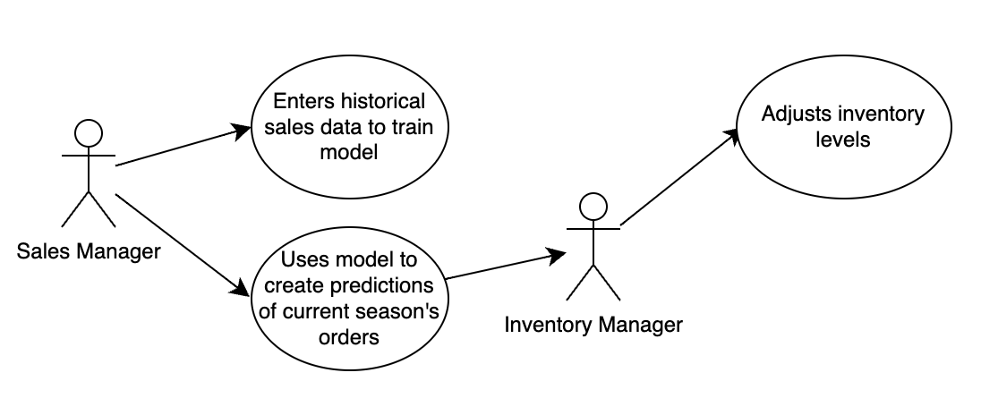

##### **Supplier Performance Analytics**

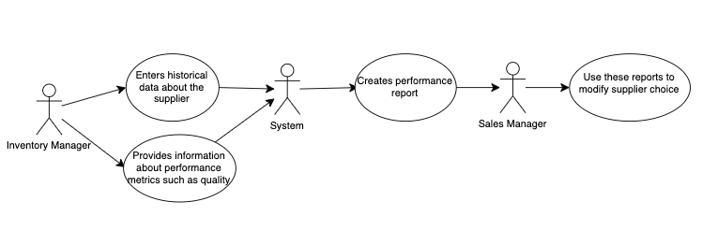

##### **Blockchain for Inventory Tracking**

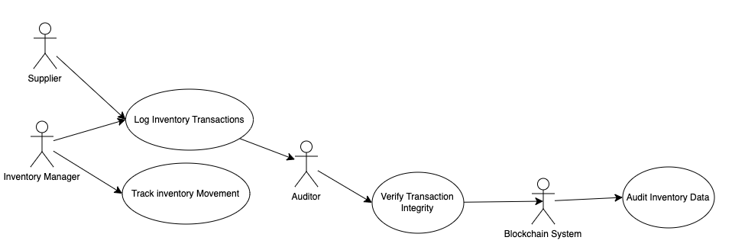

##### **Automated Supplier Selection**

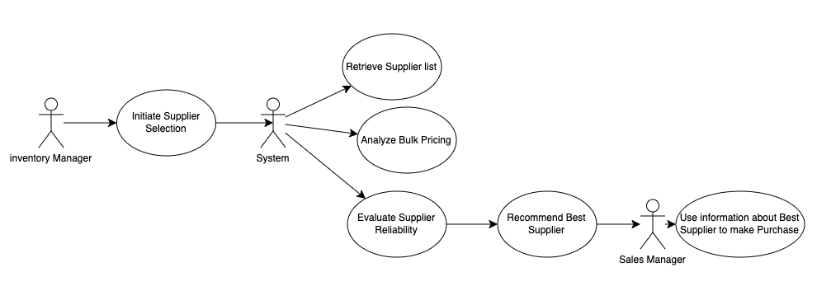

##### **Real Time Shipment Tracking**

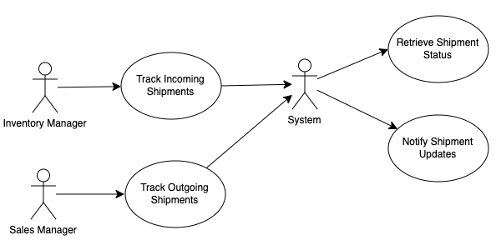

##### **Automated Return and Refund Processing**

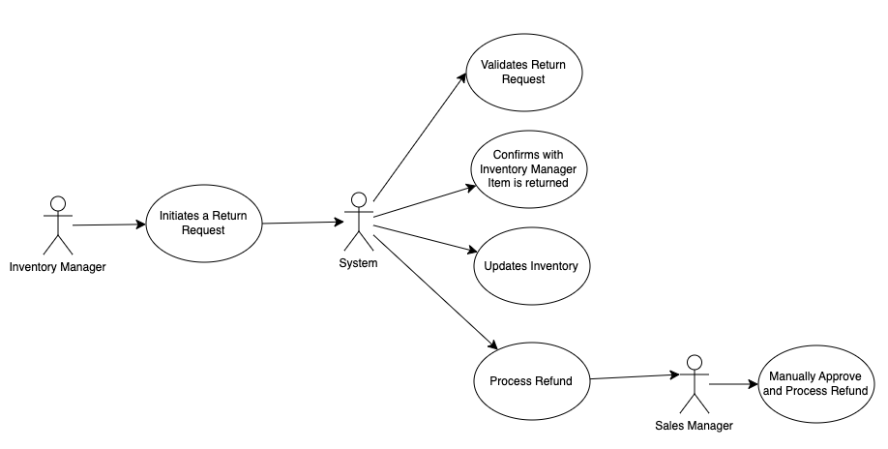

### Evolutionary Requirements

#### Functional Requirements

##### AI-Based Demand Forecasting

|  |  |
| --- | --- |
| Title | AI-Based Demand Forecasting |
| Description | Although manual demand forecasting is reliable in stable markets, it becomes hard to predict in volatile environments. By incorporating historical data of market sales, the system should be able to assist in predicting inventory needs to cut down on wastage and expenditure. |
| Priority | 1 |
| Precondition(s) | Data needs to be collected about sales and the model needs to be trained |
| Postconditions(s) | Users will be able to receive information about demand forecasts and suggested inventory levels to change how they reorder |
| Use Case Diagram | 3.2.1 |

##### Supplier Performance Analytics

|  |  |
| --- | --- |
| Title | Supplier Performance Analytics |
| Description | Users would be able to receive reports on supplier reliability based on delivery times and order accuracy. This system would track when an order is placed and received and whether the supplier is consistently providing the correct and quality goods. |
| Priority | 2 |
| Precondition(s) | The user would need to enter data around supply orders including quality of goods and timeliness. |
| Postconditions(s) | The system would create a detailed report around the reliability and consistency of the supplier to see whether they need to be replaced. |
| Use Case Diagram | 3.2.2 |

##### Blockchain for Inventory Tracking

|  |  |
| --- | --- |
| Title | Blockchain for Inventory Tracking |
| Description | The system could use blockchain technology to secure and transparent inventory tracking. This would prevent inventory data from being altered and thus preventing manipulation of stock levels, it allows for transparency with suppliers, managers and auditors and allows for enhanced traceability. |
| Priority | 2 |
| Precondition(s) | The system must support blockchain integration and each transaction and exchange would need to be logged. |
| Postconditions(s) | Inventory transactions would be impossible to tamper with creating a reliability with the business. Additionally, the transparency and traceability of the system would allow shareholders, auditors, managers and suppliers to always be on the same page. |
| Use Case Diagram | 3.2.3 |

##### Automated Supplier Selection

|  |  |
| --- | --- |
| Title | Automation Supplier Selection |
| Description | Based on the quantity of goods, the system should browse an existing database of suppliers for that good to see what the best bulk price available is for that good. This could also work hand in hand with the supplier performance analytics to incorporate data about supplier reliability. |
| Priority | 3 |
| Precondition(s) | The system has to have a collection of suppliers along with pricing information for each. Historical supplier data could also be useful |
| Postconditions(s) | The user would receive supplier recommendations for each product based on bulk pricing and reliability of the supplier. |
| Use Case Diagram | 3.2.4 |

##### Real Time Shipment Tracking

|  |  |
| --- | --- |
| Title | Real-Time Shipment Tracking |
| Description | The system should integrate with courier services like FedEx or UPS to provide in software real-time tracking for both incoming and outgoing shipments. |
| Priority | 4 |
| Precondition(s) | The system must have access to shipment APIs from logistics providers |
| Postconditions(s) | Users would be able to track their orders I real time. |
| Use Case Diagram | 3.2.5 |

##### Automated Return and Refund Processing

|  |  |
| --- | --- |
| Title | Automated Return and Refund Processing |
| Description | The system should streamline the return and refund process by validating return requests, updating inventory and triggering automated refunds. |
| Priority | 5 |
| Precondition(s) | The system would require a return request to be initiated by a customer. |
| Postconditions(s) | The inventory is updated, and the refund is processed after being sent for manual approval. |
| Use Case Diagram | 3.2.6 |

#### Non-Functional Requirements

##### **Scalability**

|  |  |
| --- | --- |
| Title | Scalability |
| Description | The system should be capable of handling at least 10 times increase in users and transactions without performance degradation |
| Priority | 1 |
| Applicable FR(s) | All of them as every portion of the system would need to be able to handle this capacity. |

##### **AI-Driven User Assistance**

|  |  |
| --- | --- |
| Title | AI-Driven User Assistance |
| Description | The system should include an AI Chatbot to help users navigate the software. These can ask as a chatbot to answer frequently asked questions or to assist with navigating inventory tasks. |
| Priority | 2 |
| Applicable FR(s) | Product and Supplier Management, Statistical Insights and Reports |

##### **Global Compliance Adaptability**

|  |  |
| --- | --- |
| Title | Global Compliance Adaptability |
| Description | By setting the region or country that the user is in or operating from, the system should be able to adapt to the laws and regulations of the countries it operates in. This could include ordering limits on certain items or reporting of certain transactions. |
| Priority | 3 |
| Applicable FR(s) | Statistical Insights and Reports, Low Stock Signal and Automatic Order Placement, Product and Supplier Management |

##### **High availability and Disaster Recovery**

|  |  |
| --- | --- |
| Title | High availability and Disaster Recovery |
| Description | The system should include backup mechanisms to recover data in case of failures, ensuring minimal downtime. |
| Priority | 1 |
| Applicable FR(s) | All Functional Requirements as they would all need to be backed up but especially Offline Access and Data Synchronization |

##### **Third-Party Accounting Software Integration**

|  |  |
| --- | --- |
| Title | Third-Party Accounting Software Integration |
| Description | By integrating with a software like QuickBooks, the system could make financial reporting much more seamless. |
| Priority | 3 |
| Applicable FR(s) | Statistical Insights and Reports, Low Stock Signal and Automatic Order Placement, Live Inventory Updates and Monitoring |

##### **Adaptive UI for Management Roles**

|  |  |
| --- | --- |
| Title | Adaptive UI for Management Roles |
| Description | The user should change dynamically based on the user’s role. For example, a manager/admin should have a different interface than a warehouse stuff placing heavier emphasis on reports for the former and on inventory for the latter. |
| Priority | 5 |
| Applicable FR(s) | Account Access and Permission Management, Universal Platform Access, Product and Supplier Management, |