Task -5
Website Hosting Using EC2 Instance
1. Launch an EC2 Instance
- Log in to AWS Console → EC2.
- Click Launch Instance.
- Enter Name instance.
- Choose Amazon Linux 2 AMI
- Select Instance type → t2.micro (Free Tier).
- Create Key pair (.pem file) → download
- Configure Security Group:
  - Allow SSH (22) – for remote login.
  - Allow HTTP (80) – for website access.
- Click Launch Instance.
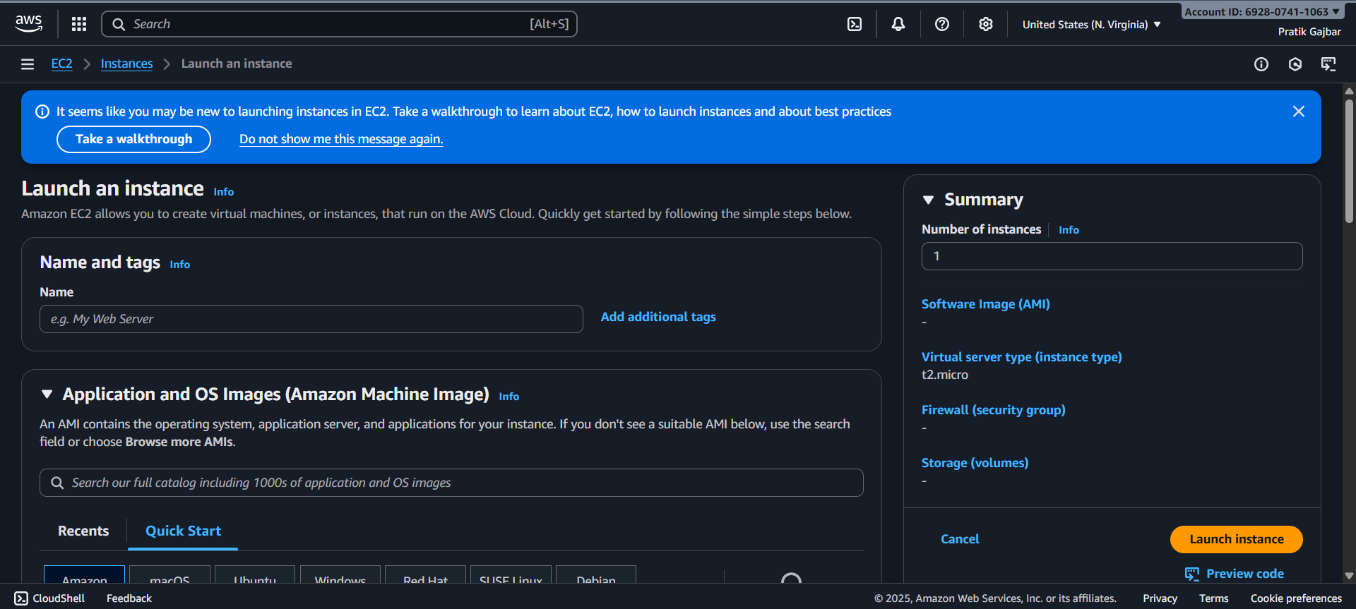

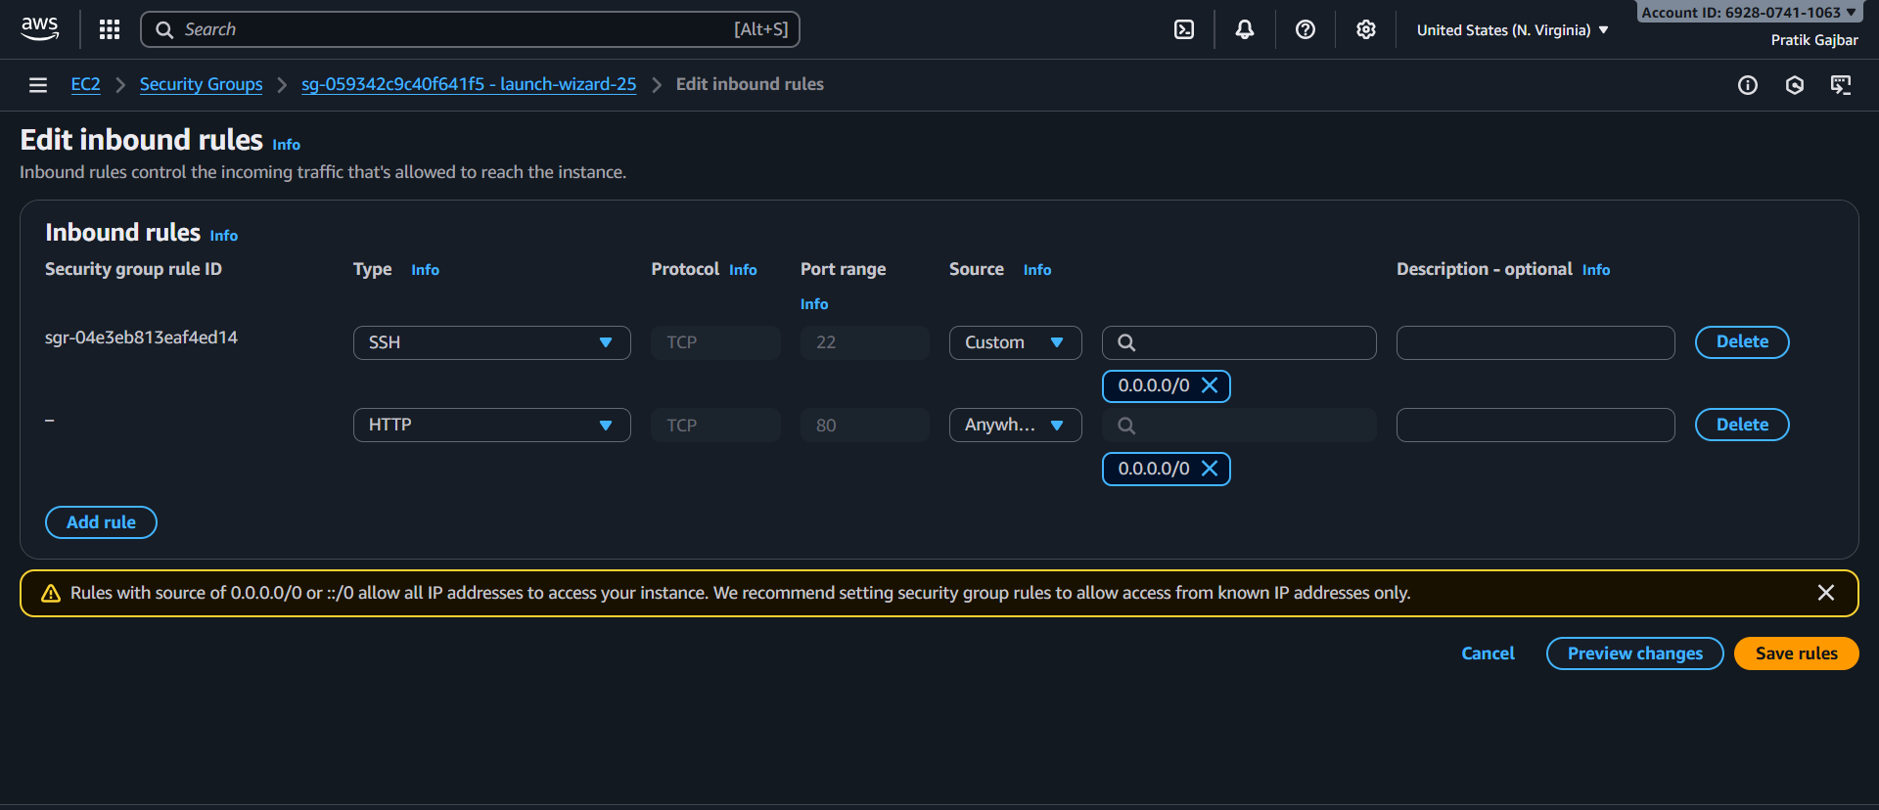
3. Install Web Server
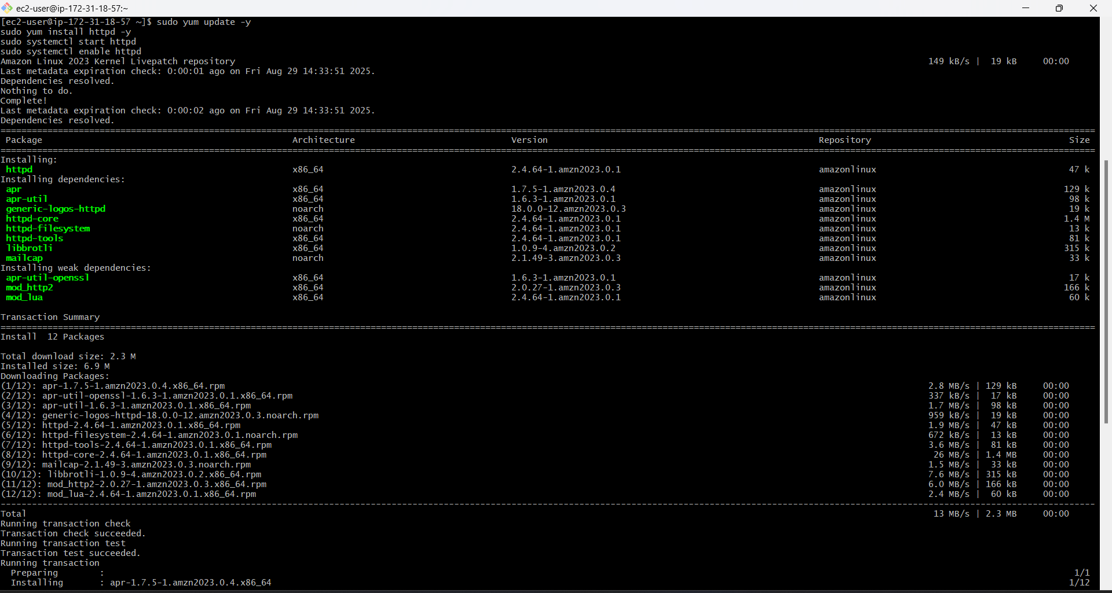
4. After launching the instance, copied public IP address and opened it in browser
