# MTP Performance Report

* Topic - Design aspects of lithium-ion batteries for electric vehicles.
* Supervisor - Dr Pattabhi Ramaiah

Firstly, data analysis on the temperatures of various Indian cities was done. The data was collected from the WORLD METEOROLOGICAL ORGANIZATION. Climatological information was based on monthly averages for the 48-year period 1953-2000. Data analysis was done with the help of the programming language, Python.

Afterwards, a thorough literature survey is being done. Some of the highlights have been presented below.

Li-ion is considered to be one of the most sophisticated pieces of technology in energy storage right now. It is also the most commercialized technology for its cost to performance ratio.

What we call Li-ion is a family of chemistries. They differ by Cathode material (mostly) or by Anode material. There are major variations that should be included in the Li-ion family or not is debatable, and then there are minor or very custom variations made for very specific purposes. The most common chemistries which are well known and commercialized by multiple companies are:

1. NMC (Nickel Manganese Cobalt)
2. LFP (Lithium Ferro Phosphate or Lithium Iron Phosphate)
3. NCA (Nickel Cobalt Aluminium Oxide)
4. LMO (Lithium Manganese Oxide)
5. LCO (Lithium Cobalt Oxide)

Li-ion cell is made of:

Cathode: NMC, LFP, LMO, NCA, or LCO

Anode: Carbon (In Graphite form) or LTO

Separator: Ceramic or similar material

Electrolyte: Lithium salt (e.g. LiPF6), in organic solvent (e.g. Ethylene Carbonate)

Current Collectors: Aluminium and Copper.

A summary of all the common chemistries has been presented below in a tabular and pictorial form.

| Battery | Energy Density  (Wh/kg) | Cyclability  (Cycles) | Advantages | Disadvantages |
| --- | --- | --- | --- | --- |
| LCO | 150–190 | 500–1000 | Technological maturity,  Low-self discharge,  High discharge voltage | High cost,  low inherent safety |
| LMO | 100–140 | 1000–1500 | High inherent safety,  Cobalt-free | Low energy density |
| LFP | 90–140 | up to 2000 | High inherent safety | Low energy density |
| NCA | 200–250 | 1000–1500 | Low cobalt content | Capacity fade at  elevated temperature |
| NMC | 140–200 | 1000–2000 | Low cobalt content | Safety issues in  Ni-rich batteries |

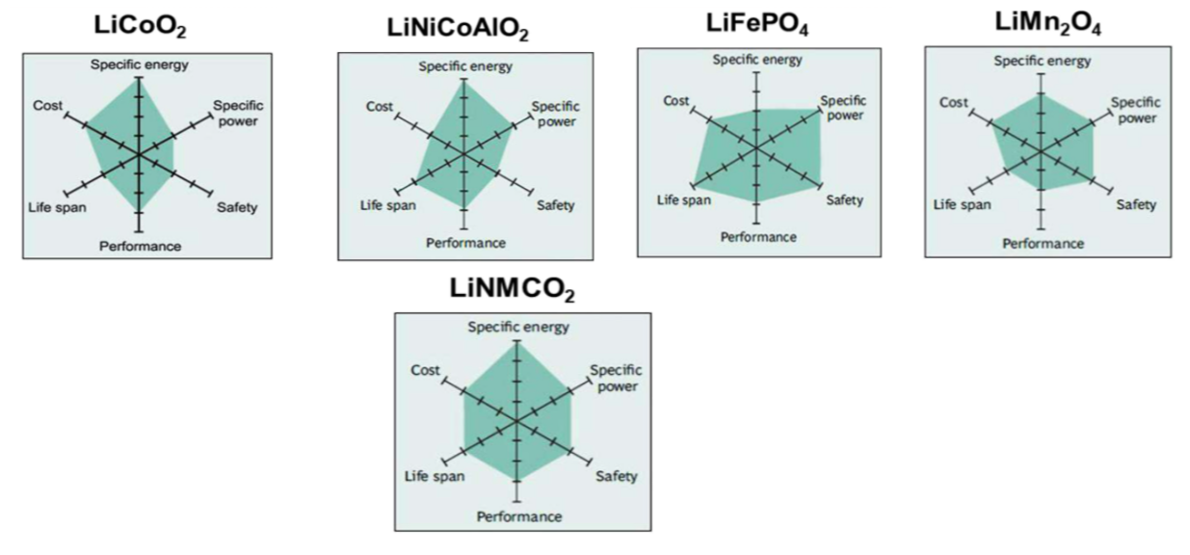

Figure: Comparisons of different types of Li-ion batteries used in EVs.

Clearly, Lithium Nickel Manganese Cobalt Oxide (NMC), Lithium Iron Phosphate (LiFePO4) and Lithium Manganese Oxide (LMO) stand out as being superior among these candidates.

Now I am working towards estimating the influence of cathode materials on the power output characteristics of Lithium-ion batteries. The factors influencing the crack formation and growth in Lithium ions, as well as the cathode material. The simulation of crack growth and hence the performance characteristics will be estimated through molecular dynamics simulations using Large-scale Atomic/Molecular Massively Parallel Simulator (LAMMPS).

References:

[1] M. S. Whittingham Lithium batteries and cathode materials, Chem. Rev., 2004, 104 , 4271 —4302

[2] S. Sun , T. Guan , B. Shen , K. Leng , Y. Gao , X. Cheng and G. Yin , Changes of degradation mechanisms of LiFePO4/graphite batteries cycled at different ambient temperatures, Electrochim. Acta, 2017, 237 , 248 —258

[3] C. M. Julien , K. Zaghib , A. Mauger and H. Groult , Enhanced electrochemical properties of LiFePO4 as positive electrode of Li-ion batteries for HEV application, Adv. Chem. Eng. Sci., 2012, 2 , 321

[4] J. M. Paulsen , C. L. Thomas and J. R. Dahn , Layered Li-Mn-Oxide with the O2 Structure: A Cathode Material for Li-Ion Cells which does not Convert to Spinel, J. Electrochem. Soc., 1999, 146 , 3560 —3565

Prateek Gandhi

20SD06011

MTech

Mechanical Systems Design