**USAGE OF THE WEBSITE**

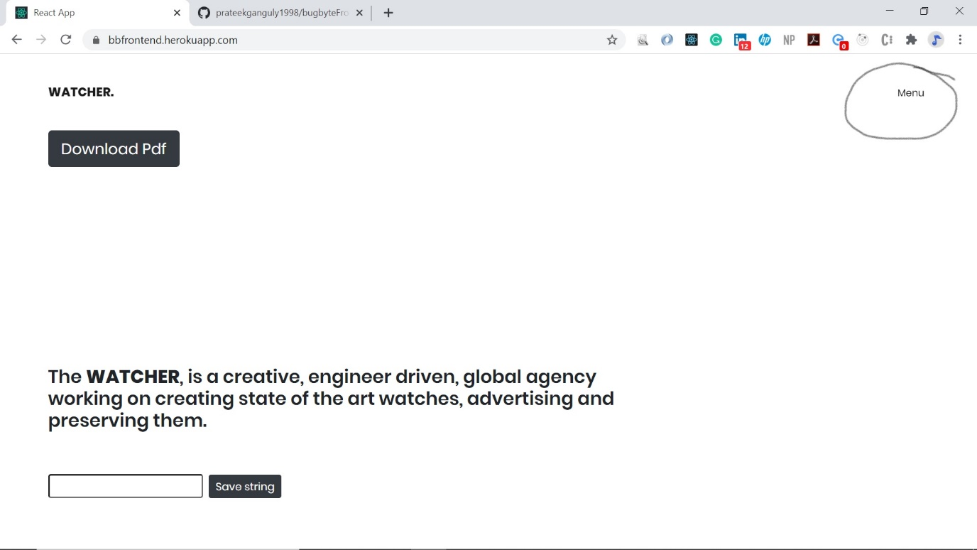

1. The **download pdf** button is used for downloading the pdf.
2. The save string button is used for storing the string temporary till window is closed (refresh enabled).
3. Menu button (circled on the top right corner is to drop down the nav bar)

**Hover Effects:**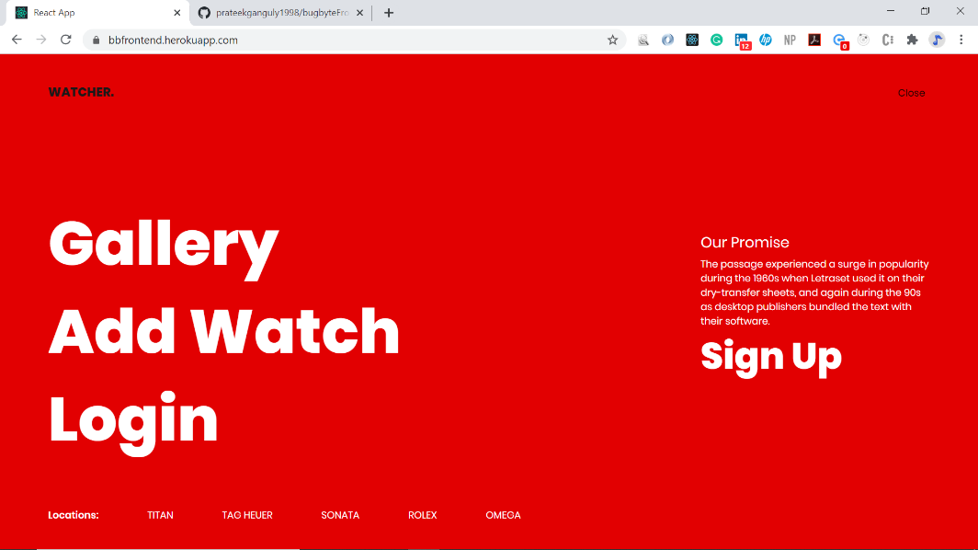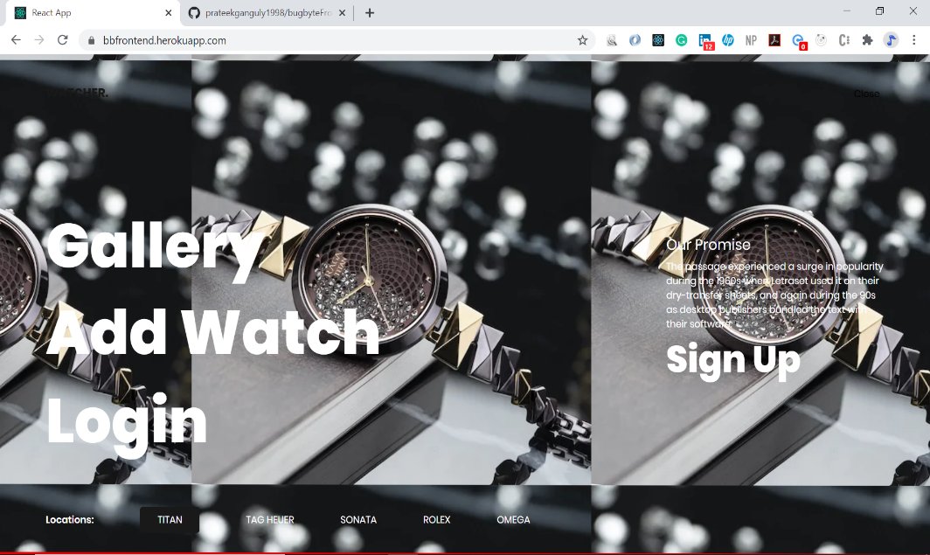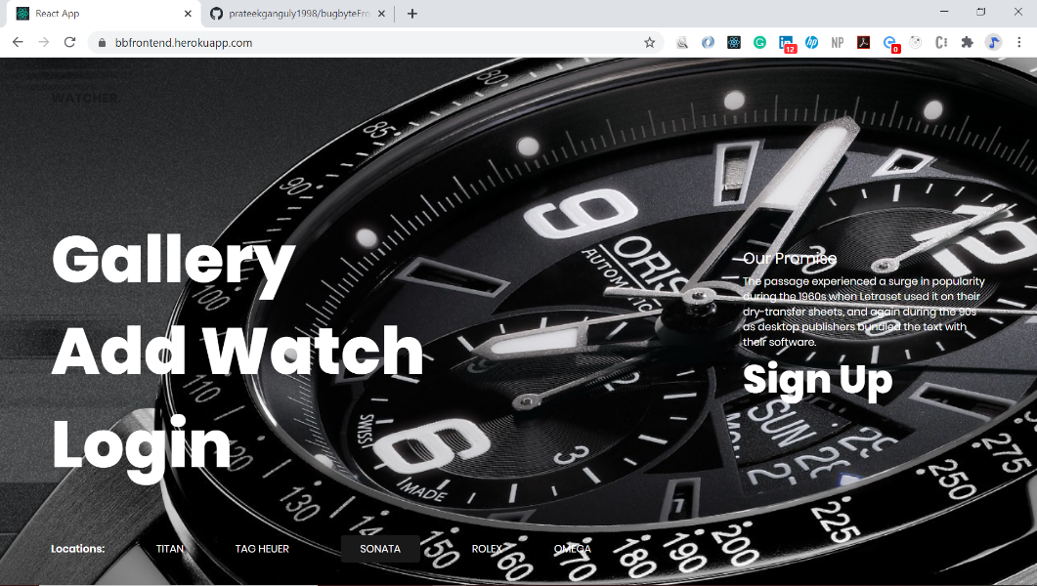

**Added watches are seen in Gallery :**

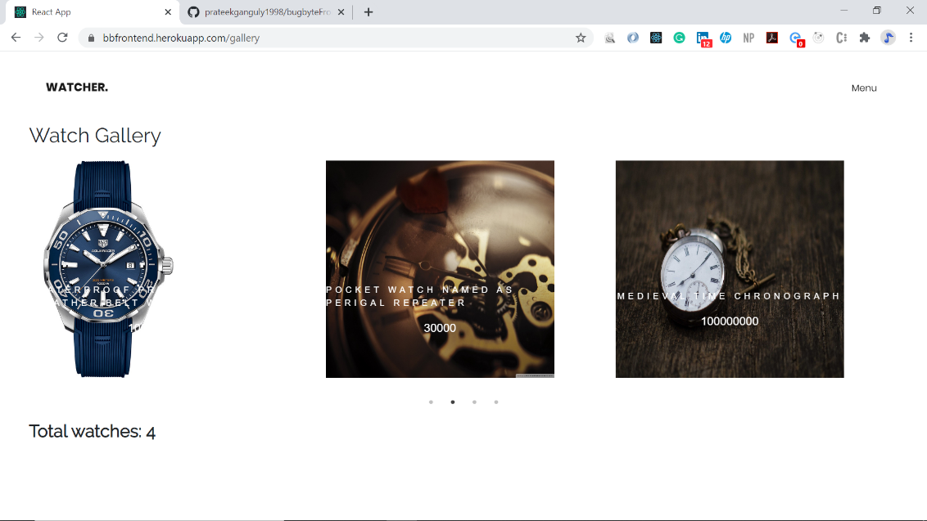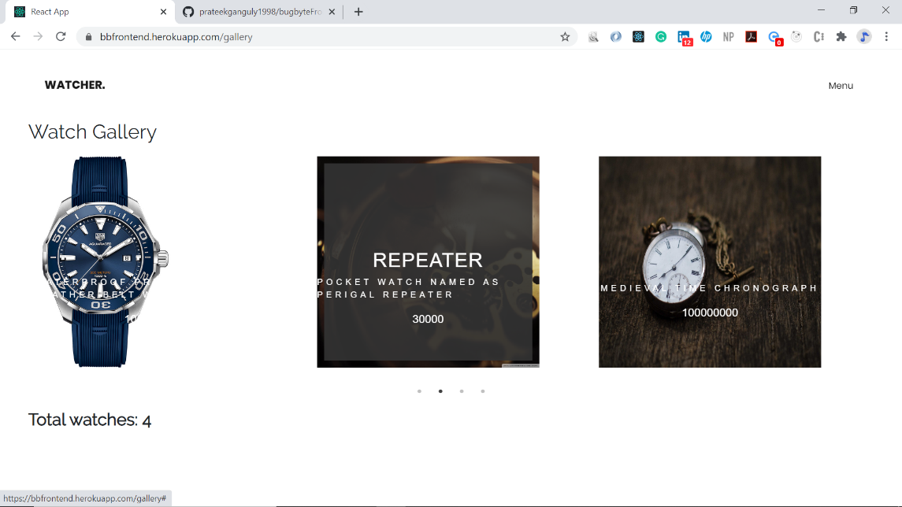

**Note:**  Hover on the watch images to see the title names of the watches and their respective descriptions.

* **IF AT ANY TIME REDIRECT LEADS TO A BLANK PAGE,**

**JUST REFRESH.**

* **ONLY LOGGED IN USER CAN ADD A WATCH**

**STEPS FOR AUTHENTICATION:**

1. **Sign up:**

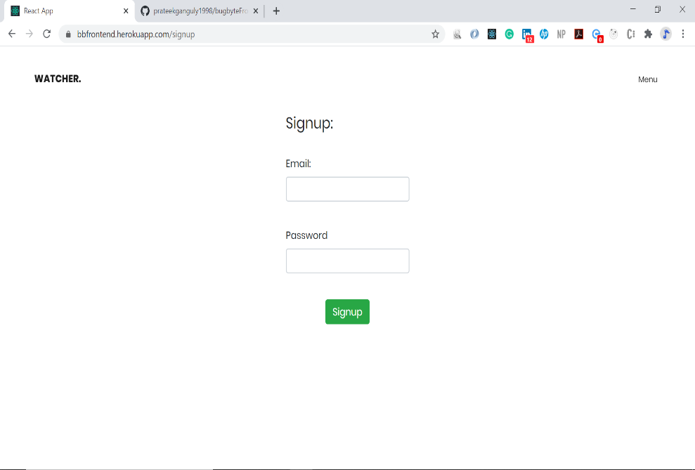

1. **Login:**

