PROJECT REPORT
Project 07
DESIGN AND IMPLEMENTATION OF A DATABASE MANAGEMENT SYSTEM FOR CANTEEN FOOD ORDERING AND BILLING MANAGEMENT SYSTEM
Course: Database Management Systems
Individual Project
Submitted by: Prateek
Roll No.: 25WU0102112
Submitted to: Prof. Sahithi
Department of Computer Science and Engineering
October 2026
GitHub: https://github.com/prateekgoud/Canteen-Food-Ordering-and-Billing-DBMS

Declaration
I hereby declare that the project report entitled "Design and Implementation of a Database Management System for Canteen Food Ordering and Billing Management System" is the result of my own work, carried out under the guidance of Prof. Sahithi. The work has not been submitted to any other institution for any degree, diploma or course.

Prateek
Roll No.: 25WU0102112
Date: 15-10-2026

Acknowledgement
I express my sincere gratitude to Prof. Sahithi for guidance, feedback and encouragement throughout this project. I also thank my department and friends for their support during the design, implementation and testing of the system.

Contents
Abstract 1
1. Introduction 2
2. Requirements Analysis 3
3. Conceptual Design 4
4. Logical Design and Normalization 6
5. Database Implementation 9
6. Sample Data and SQL Queries 12
7. Front-end Application 18
8. Testing 26
9. Conclusion and Future Scope 28
References 29

Abstract
A college canteen handles hundreds of orders every day. When orders are written on paper slips, they are delayed, duplicated or lost, and nobody knows how much stock is left until an item runs out. This project designs and implements a relational database management system that removes these problems.
The system models menu categories, food items, ingredients, recipes, customers, orders, order items, kitchen tasks, bills, payments and stock movements in twelve tables normalized to Third Normal Form. Business rules such as at least one item per order, positive quantities, no ordering of unavailable items, valid order-status transitions and payment limits are enforced inside the database through constraints and triggers. Reports are provided as views for daily sales, popular items, category sales, pending orders, ingredient consumption, cancellations and revenue.
The database is implemented in MySQL 8 and accessed through a Python Streamlit web application that supports menu maintenance, order entry, kitchen status updates, ingredient issue, billing, payment and sales reporting.

1. Introduction

1.1 Background
A canteen is a small business with a fast cycle: students order, the kitchen cooks, the cashier bills and stock is consumed. Each step depends on the previous one, so a single mistake, such as a lost slip or a wrong quantity, spreads to the rest of the process. A database that records every step once and checks it against rules is the natural solution.

1.2 Problem statement
Paper-based canteen operation causes delayed service, duplicate orders, billing disagreements and stock errors. The canteen needs a system that records menus, orders, kitchen work, bills, payments and ingredient stock reliably, and that prevents invalid operations such as ordering an unavailable item or paying more than the bill.

1.3 Objectives
- Identify the entities, attributes, relationships and user roles of a canteen.
- Design an ER model and convert it to a relational schema normalized to 3NF.
- Implement the schema in MySQL with primary keys, foreign keys, UNIQUE, NOT NULL, CHECK and DEFAULT constraints.
- Enforce business rules and ingredient consumption with triggers and a billing stored procedure.
- Provide SQL queries and views for meaningful reports.
- Build a front-end application and test it systematically.

1.4 Scope
The system covers a single canteen with a menu, registered or walk-in customers, kitchen workflow, ingredient stock, billing with 5% tax and CASH, UPI or CARD payments. Online payment gateways, delivery tracking and multi-canteen support are outside the scope.

2. Requirements Analysis

2.1 Users and roles
Role | Responsibilities
Admin | Maintains menu items, prices and availability; reads sales and stock reports.
Cashier | Registers customers, takes orders, generates bills and records payments.
Kitchen staff | Updates order status and issues or restocks ingredients.
Customer | Student or staff member who places orders, registered or walk-in.

2.2 Functional requirements
Module | Requirement
Menu maintenance | Add items, change price, mark items available or unavailable, search the menu.
Order entry | Select a customer or walk-in, choose available items and quantities, place the order as one transaction.
Kitchen status | Move an order through PLACED, PREPARING, READY and SERVED, or cancel it.
Ingredient issue | Issue ingredients to the kitchen, restock, and highlight items below the reorder level.
Billing and payment | Generate a bill with 5% tax, accept payments, mark the bill PAID when settled.
Sales reporting | Daily sales, popular items, category sales, pending orders, ingredient consumption, cancellations and revenue.

2.3 Business rules
No. | Rule
R1 | An order must contain at least one item before the kitchen starts it.
R2 | Item quantities must be positive.
R3 | Unavailable items cannot be ordered.
R4 | Order status may change only along the valid path: PLACED to PREPARING or CANCELLED, PREPARING to READY or CANCELLED, READY to SERVED.
R5 | A single payment cannot exceed 10,000 and the total paid cannot exceed the bill amount.
R6 | Ingredient stock can never become negative.
R7 | A cancelled order cannot be billed, and a bill can exist only once per order.

3. Conceptual Design

3.1 Entities
The conceptual model has the following principal entities.
Entity | Key attributes | Purpose
Category | category_id, name | Groups menu items such as Breakfast or Beverages.
Food item | item_id, name, price, is_available | A dish or drink that can be ordered.
Ingredient | ingredient_id, name, unit, stock_qty, reorder_level | Raw material held in stock.
Recipe | item_id, ingredient_id, qty_per_unit | Quantity of each ingredient needed per unit of a food item.
Customer | customer_id, name, phone | Registered customer.
Orders | order_id, customer_id, order_time, status | A request for food.
Order item | order_id, item_id, quantity, unit_price | One line of an order.
Kitchen task | task_id, order_id, item_id, status | Work item for the kitchen.
Bill | bill_id, order_id, subtotal, tax, total | Charge for an order.
Payment | payment_id, bill_id, amount, method | Money received against a bill.
Stock transaction | txn_id, ingredient_id, change_qty, txn_type | Record of every stock movement.
App user | user_id, username, role | System user with a role.

3.2 Relationships
Relationship | Cardinality | Note
Category and Food item | 1 : N | Each item belongs to one category.
Food item and Ingredient | M : N | Resolved by the Recipe table.
Customer and Orders | 1 : N | Optional: walk-in orders have no customer.
Orders and Order item | 1 : N | Order items are deleted with their order.
Food item and Order item | 1 : N | The price is copied to the order line.
Order item and Kitchen task | 1 : 1 | One task per ordered item.
Orders and Bill | 1 : 1 | At most one bill per order.
Bill and Payment | 1 : N | A bill can be paid in parts.
Ingredient and Stock transaction | 1 : N | Every change of stock is logged.

3.3 ER diagram
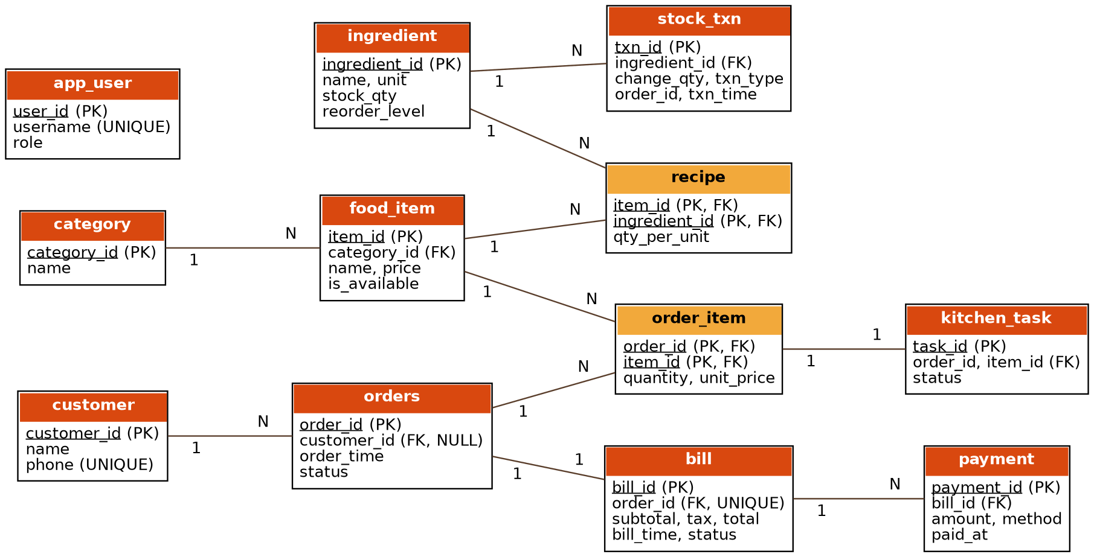
Figure 3.1: ER diagram of the canteen database (PK underlined, FK marked)

4. Logical Design and Normalization

4.1 Relational schema
Table | Primary key | Foreign keys
app_user | user_id | -
category | category_id | -
food_item | item_id | category_id
ingredient | ingredient_id | -
recipe | (item_id, ingredient_id) | item_id, ingredient_id
customer | customer_id | -
orders | order_id | customer_id
order_item | (order_id, item_id) | order_id, item_id
kitchen_task | task_id | (order_id, item_id)
bill | bill_id | order_id
payment | payment_id | bill_id
stock_txn | txn_id | ingredient_id

4.2 Functional dependencies
Determinant | Dependent attributes
order_id | customer_id, order_time, status
(order_id, item_id) | quantity, unit_price
item_id | name, category_id, price, is_available
category_id | name
ingredient_id | name, unit, stock_qty, reorder_level
(item_id, ingredient_id) | qty_per_unit
customer_id | name, phone
bill_id | order_id, subtotal, tax, total, bill_time, status
payment_id | bill_id, amount, method, paid_at

4.3 Normalization
First Normal Form (1NF). An initial design that stored an order as one row with repeating columns (item1, qty1, item2, qty2 and so on) was replaced by one row per order line in order_item, so every attribute holds a single atomic value.
Second Normal Form (2NF). In order_item the key is (order_id, item_id). Attributes such as the item name and category depend only on item_id, a part of the key, so they were moved to food_item. Only quantity and unit_price depend on the whole key and remain in order_item.
Third Normal Form (3NF). Customer name and phone depend on customer_id, not on order_id, so they live in customer. The category name depends on category_id, not item_id, so it lives in category. After these steps every non-key attribute depends on the key, the whole key and nothing but the key.
The unit_price stored in order_item is a deliberate snapshot of the price at order time, so later price changes do not alter past bills. It is set by a trigger and is not a normalization violation because it records a historical fact.

4.4 Data dictionary
Table | Column | Data type | Key and constraints
app_user | user_id | INT | PK, AUTO_INCREMENT
 | username | VARCHAR(30) | NOT NULL, UNIQUE
 | role | ENUM | ADMIN / CASHIER / KITCHEN, DEFAULT CASHIER
category | category_id | INT | PK, AUTO_INCREMENT
 | name | VARCHAR(40) | NOT NULL, UNIQUE
food_item | item_id | INT | PK, AUTO_INCREMENT
 | category_id | INT | FK to category, NOT NULL
 | name | VARCHAR(60) | NOT NULL, UNIQUE
 | price | DECIMAL(8,2) | NOT NULL, CHECK (price > 0)
 | is_available | BOOLEAN | NOT NULL, DEFAULT TRUE
ingredient | ingredient_id | INT | PK, AUTO_INCREMENT
 | name | VARCHAR(60) | NOT NULL, UNIQUE
 | unit | VARCHAR(10) | NOT NULL (kg, l, pcs)
 | stock_qty | DECIMAL(10,2) | NOT NULL, DEFAULT 0, CHECK (>= 0)
 | reorder_level | DECIMAL(10,2) | NOT NULL, DEFAULT 0, CHECK (>= 0)
recipe | item_id | INT | PK part, FK to food_item
 | ingredient_id | INT | PK part, FK to ingredient
 | qty_per_unit | DECIMAL(8,3) | NOT NULL, CHECK (> 0)
customer | customer_id | INT | PK, AUTO_INCREMENT
 | name | VARCHAR(60) | NOT NULL
 | phone | VARCHAR(10) | UNIQUE, CHECK 10 digits
orders | order_id | INT | PK, AUTO_INCREMENT
 | customer_id | INT | FK to customer, NULL for walk-in
 | order_time | DATETIME | NOT NULL, DEFAULT CURRENT_TIMESTAMP
 | status | ENUM | PLACED, PREPARING, READY, SERVED, CANCELLED; DEFAULT PLACED
order_item | order_id | INT | PK part, FK to orders (CASCADE)
 | item_id | INT | PK part, FK to food_item
 | quantity | INT | NOT NULL, CHECK (> 0)
 | unit_price | DECIMAL(8,2) | Set by trigger from food_item.price
kitchen_task | task_id | INT | PK, AUTO_INCREMENT
 | order_id, item_id | INT, INT | FK to order_item, UNIQUE pair
 | status | ENUM | PENDING, COOKING, DONE; DEFAULT PENDING
bill | bill_id | INT | PK, AUTO_INCREMENT
 | order_id | INT | FK to orders, NOT NULL, UNIQUE
 | subtotal | DECIMAL(10,2) | NOT NULL, CHECK (> 0)
 | tax | DECIMAL(10,2) | NOT NULL, DEFAULT 0, CHECK (>= 0)
 | total | DECIMAL(10,2) | NOT NULL, CHECK (total = subtotal + tax)
 | bill_time | DATETIME | NOT NULL, DEFAULT CURRENT_TIMESTAMP
 | status | ENUM | UNPAID / PAID, DEFAULT UNPAID
payment | payment_id | INT | PK, AUTO_INCREMENT
 | bill_id | INT | FK to bill, NOT NULL
 | amount | DECIMAL(10,2) | NOT NULL, CHECK (> 0)
 | method | ENUM | CASH / UPI / CARD, DEFAULT CASH
 | paid_at | DATETIME | NOT NULL, DEFAULT CURRENT_TIMESTAMP
stock_txn | txn_id | INT | PK, AUTO_INCREMENT
 | ingredient_id | INT | FK to ingredient, NOT NULL
 | change_qty | DECIMAL(10,2) | NOT NULL (negative = stock out)
 | txn_type | ENUM | ORDER_USE, ORDER_RETURN, ISSUE, RESTOCK
 | order_id | INT | NULL; order that caused the change
 | txn_time | DATETIME | NOT NULL, DEFAULT CURRENT_TIMESTAMP

5. Database Implementation

5.1 Environment
The database is implemented in MySQL 8 (CHECK constraints require version 8.0.16 or later). The design was tested on MySQL 8.0. The scripts are in the sql folder: 01_schema.sql creates the database, tables, indexes, triggers, the procedure and the views; 02_sample_data.sql loads sample data; 03_queries.sql contains the queries used for demonstration.

5.2 Tables and integrity constraints
Every table has a primary key. Foreign keys connect related tables. NOT NULL, UNIQUE, CHECK and DEFAULT constraints guard individual columns. The DDL for the orders and order_item tables is shown below.
CREATE TABLE orders (
order_id INT AUTO_INCREMENT PRIMARY KEY,
customer_id INT NULL, -- NULL = walk-in
order_time DATETIME NOT NULL DEFAULT CURRENT_TIMESTAMP,
status ENUM('PLACED','PREPARING','READY','SERVED','CANCELLED') NOT NULL DEFAULT 'PLACED',
FOREIGN KEY (customer_id) REFERENCES customer(customer_id) ON DELETE SET NULL
);
CREATE TABLE order_item (
order_id INT NOT NULL,
item_id INT NOT NULL,
quantity INT NOT NULL CHECK (quantity > 0),
unit_price DECIMAL(8,2) NOT NULL DEFAULT 0 CHECK (unit_price >= 0),
PRIMARY KEY (order_id, item_id),
FOREIGN KEY (order_id) REFERENCES orders(order_id) ON DELETE CASCADE,
FOREIGN KEY (item_id) REFERENCES food_item(item_id)
);
Listing 5.1: DDL of orders and order_item

5.3 Indexes
Index | Column(s) | Reason
idx_orders_time | orders(order_time) | Daily and date-range reports
idx_orders_status | orders(status) | Kitchen and pending-order screens
idx_orders_customer | orders(customer_id) | Customer history joins
idx_bill_time | bill(bill_time) | Daily sales report
idx_payment_bill | payment(bill_id) | Amount paid per bill
idx_stock_ing | stock_txn(ingredient_id) | Ingredient consumption report

5.4 Triggers
Trigger | Event | Purpose
trg_oi_bi | BEFORE INSERT on order_item | Rejects unavailable items, allows items only on PLACED orders, copies the current price.
trg_oi_ai | AFTER INSERT on order_item | Creates the kitchen task for the item.
trg_ord_bu | BEFORE UPDATE on orders | Validates status transitions and requires at least one item before PREPARING.
trg_ord_au | AFTER UPDATE on orders | Deducts ingredients when PREPARING, restores them on cancellation, updates kitchen tasks.
trg_pay_bi | BEFORE INSERT on payment | Enforces the 10,000 limit and prevents overpayment.
trg_pay_ai | AFTER INSERT on payment | Marks the bill PAID when fully settled.

The trigger that validates order-status changes is shown below.
CREATE TRIGGER trg_ord_bu BEFORE UPDATE ON orders FOR EACH ROW
BEGIN
DECLARE n INT;
IF NEW.status <> OLD.status THEN
IF NOT ((OLD.status = 'PLACED' AND NEW.status IN ('PREPARING','CANCELLED'))
OR (OLD.status = 'PREPARING' AND NEW.status IN ('READY','CANCELLED'))
OR (OLD.status = 'READY' AND NEW.status = 'SERVED')) THEN
SIGNAL SQLSTATE '45000' SET MESSAGE_TEXT = 'Invalid order status transition';
END IF;
IF NEW.status = 'PREPARING' THEN
SELECT COUNT(*) INTO n FROM order_item WHERE order_id = OLD.order_id;
IF n = 0 THEN
SIGNAL SQLSTATE '45000' SET MESSAGE_TEXT = 'An order must contain at least one item';
END IF;
END IF;
END IF;
END$$
Listing 5.2: Trigger trg_ord_bu

5.5 Stored procedure
The procedure generate_bill creates the bill for an order with 5% tax. It refuses to bill a cancelled or empty order.
CREATE PROCEDURE generate_bill(IN p_order INT)
BEGIN
DECLARE s DECIMAL(10,2); DECLARE st VARCHAR(15); DECLARE tx DECIMAL(10,2);
SELECT status INTO st FROM orders WHERE order_id = p_order;
IF st IS NULL OR st = 'CANCELLED' THEN
SIGNAL SQLSTATE '45000' SET MESSAGE_TEXT = 'Order not found or cancelled - cannot bill';
END IF;
SELECT SUM(quantity * unit_price) INTO s FROM order_item WHERE order_id = p_order;
IF s IS NULL THEN
SIGNAL SQLSTATE '45000' SET MESSAGE_TEXT = 'Order has no items - cannot bill';
END IF;
SET tx = ROUND(s * 0.05, 2);
INSERT INTO bill(order_id, subtotal, tax, total) VALUES (p_order, s, tx, s + tx);
END$$
Listing 5.3: Procedure generate_bill

5.6 Views
View | Purpose
v_daily_sales | Number of bills and revenue per day.
v_popular_items | Quantity sold and revenue per food item.
v_category_sales | Quantity sold and revenue per category.
v_pending_orders | Orders in PLACED, PREPARING or READY state with their items.
v_ingredient_consumption | Ingredient used, current stock and reorder level.
v_cancellations | Cancelled orders and the value lost.
v_revenue | Total billed, collected and outstanding.

CREATE VIEW v_pending_orders AS
SELECT o.order_id, o.order_time, o.status, COALESCE(c.name, 'Walk-in') AS customer,
GROUP_CONCAT(CONCAT(f.name, ' x', oi.quantity) SEPARATOR ', ') AS items
FROM orders o LEFT JOIN customer c ON c.customer_id = o.customer_id
JOIN order_item oi ON oi.order_id = o.order_id
JOIN food_item f ON f.item_id = oi.item_id
WHERE o.status IN ('PLACED','PREPARING','READY')
GROUP BY o.order_id, o.order_time, o.status, c.name;
Listing 5.4: View v_pending_orders

6. Sample Data and SQL Queries

6.1 Sample data
Realistic sample data was loaded to test the design: 4 categories, 10 food items, 11 ingredients with 24 recipe lines, 4 customers, 9 orders (served, cancelled, preparing and pending), 6 bills and 5 payments. The data deliberately contains an unavailable item, a cancelled order, a walk-in order, an unpaid bill and a low-stock ingredient so that every rule and report can be demonstrated.

6.2 Queries
Q1 JOIN: order details with customer, item and line total
Joins four tables to list every order line with its customer, item and line total.
SELECT o.order_id, COALESCE(c.name,'Walk-in') AS customer, f.name AS item, oi.quantity, oi.quantity*oi.unit_price AS line_total
FROM orders o LEFT JOIN customer c ON c.customer_id=o.customer_id
JOIN order_item oi ON oi.order_id=o.order_id JOIN food_item f ON f.item_id=oi.item_id ORDER BY o.order_id;

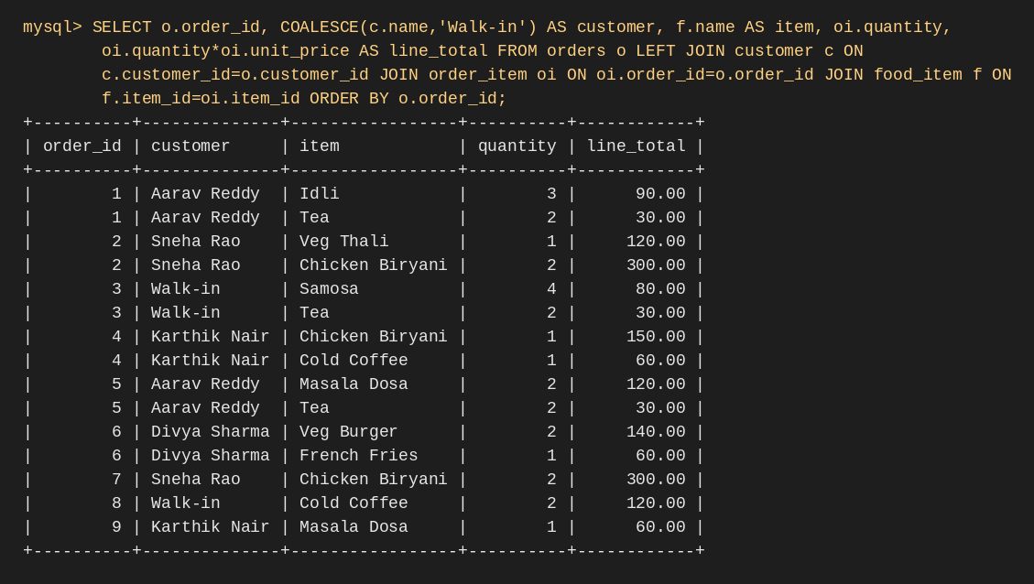
Output of Q1 (MySQL 8.0)
Q2 AGGREGATE + HAVING: customers who spent more than 200
Groups by customer and filters with HAVING to find customers who spent more than 200.
SELECT c.name, SUM(b.total) AS spent FROM customer c JOIN orders o ON o.customer_id=c.customer_id
JOIN bill b ON b.order_id=o.order_id GROUP BY c.customer_id, c.name HAVING SUM(b.total) > 200;

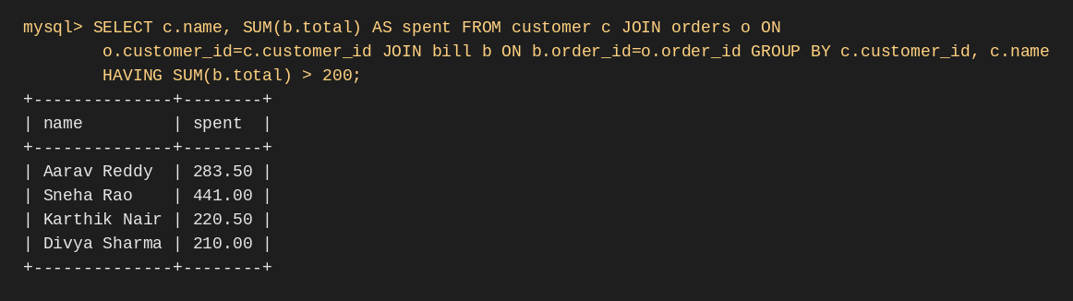
Output of Q2 (MySQL 8.0)
Q3 SUBQUERY: items priced above the average menu price
Uses a scalar subquery to list items priced above the average menu price.
SELECT name, price FROM food_item WHERE price > (SELECT AVG(price) FROM food_item);

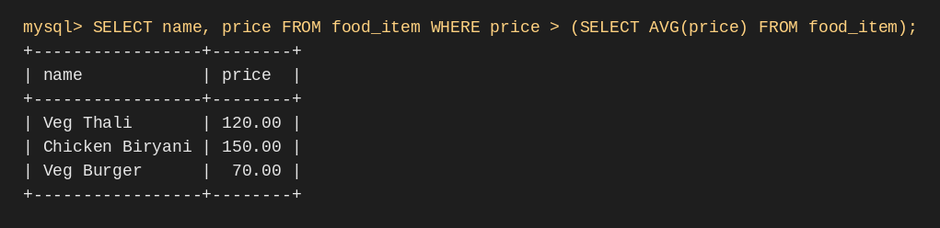
Output of Q3 (MySQL 8.0)
Q4 NESTED / NOT EXISTS: items never ordered
Uses NOT EXISTS to find items that were never ordered.
SELECT name FROM food_item f WHERE NOT EXISTS (SELECT 1 FROM order_item oi WHERE oi.item_id=f.item_id);

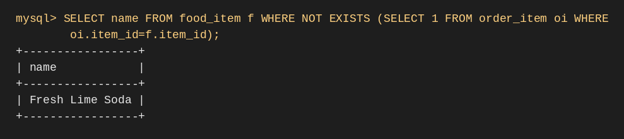
Output of Q4 (MySQL 8.0)
Q5 NESTED IN: orders containing any Beverage
Uses a nested IN subquery to find orders that contain a beverage.
SELECT order_id FROM orders WHERE order_id IN (
SELECT oi.order_id FROM order_item oi JOIN food_item f ON f.item_id=oi.item_id
JOIN category c ON c.category_id=f.category_id WHERE c.name='Beverages');

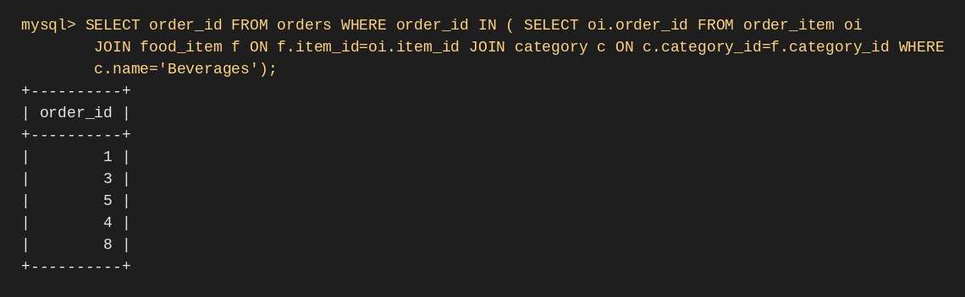
Output of Q5 (MySQL 8.0)
Q6 Unpaid bills with amount due
Left join with aggregation to show the amount due on each unpaid bill.
SELECT b.bill_id, b.order_id, b.total, b.total - COALESCE(SUM(p.amount),0) AS due
FROM bill b LEFT JOIN payment p ON p.bill_id=b.bill_id GROUP BY b.bill_id, b.order_id, b.total
HAVING due > 0;

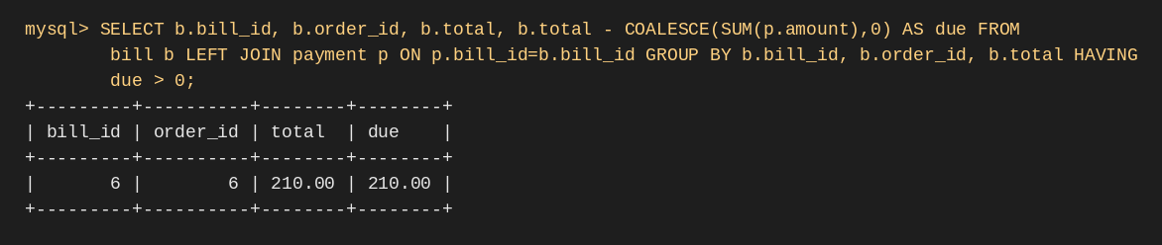
Output of Q6 (MySQL 8.0)
Q7 Low-stock ingredients
Lists ingredients at or below their reorder level.
SELECT name, stock_qty, reorder_level FROM ingredient WHERE stock_qty <= reorder_level;

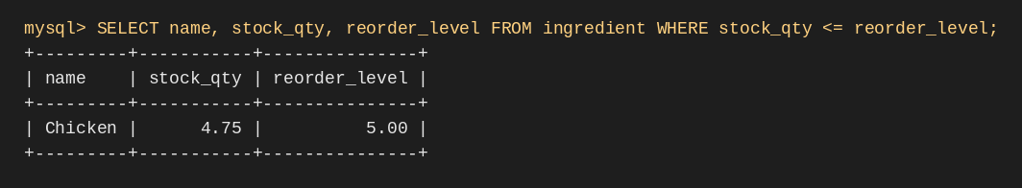
Output of Q7 (MySQL 8.0)
Q8 Payment method split
Aggregates payments by method.
SELECT method, COUNT(*) AS payments, SUM(amount) AS amount FROM payment GROUP BY method;

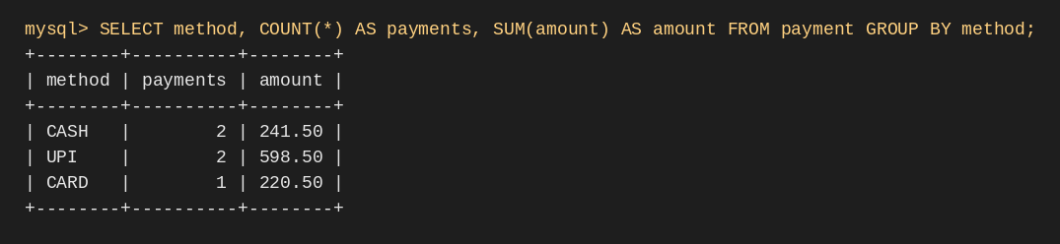
Output of Q8 (MySQL 8.0)

6.3 Report views
The seven views of Section 5.6 are queried with SELECT * FROM view_name. Their results are shown below and in the Reports page of the application (Chapter 7).
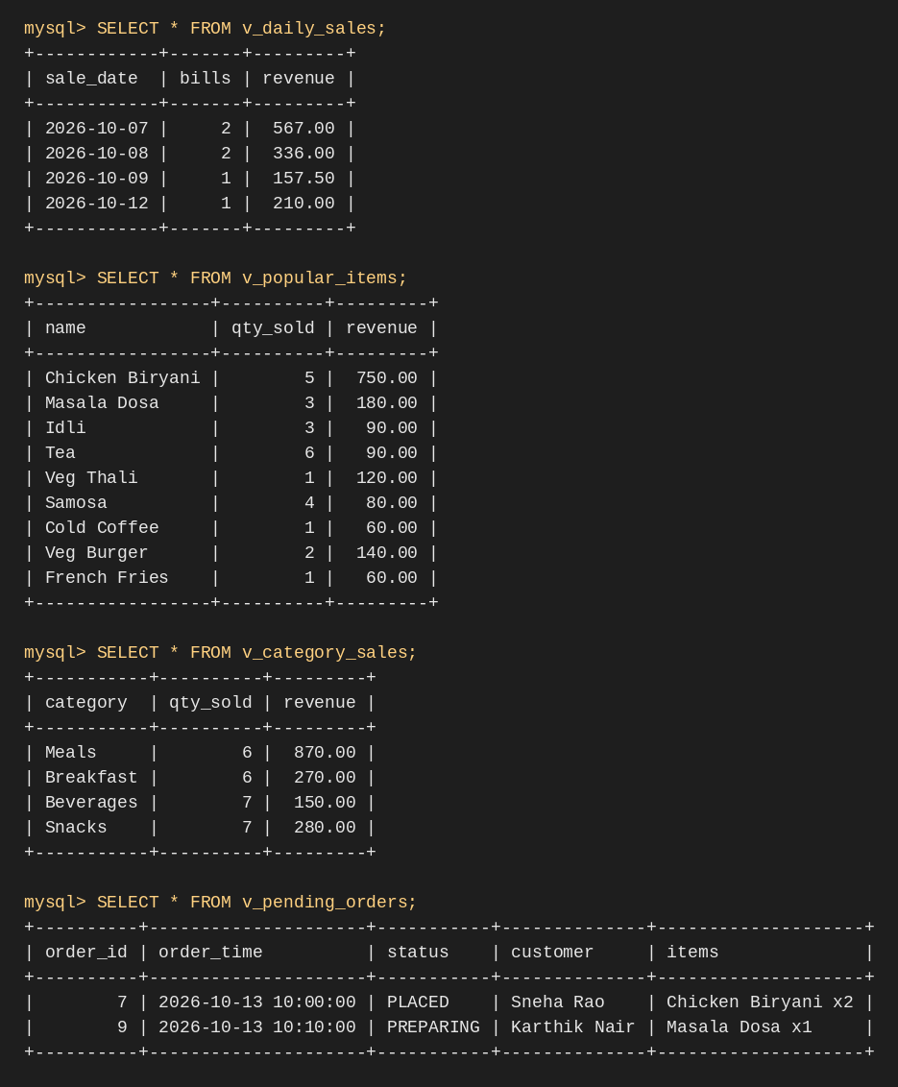
Output of the report views (1 of 2)
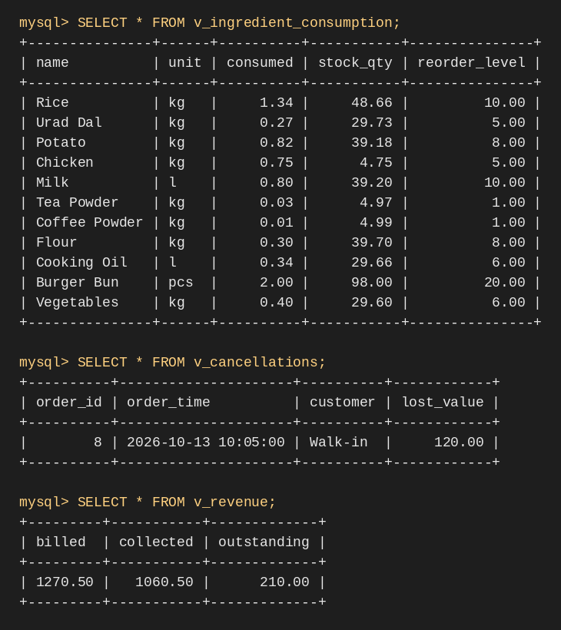
Output of the report views (2 of 2)

7. Front-end Application

7.1 Architecture
The application is written in Python with Streamlit. A browser talks to the Streamlit app (app/app.py), which uses the mysql-connector-python driver to run SQL against the MySQL database canteen_db. All business rules live in the database, so any client gets the same behaviour.

7.2 Modules
Page | Function
Dashboard | Shows billed, collected and outstanding amounts, pending orders and low-stock ingredients.
Menu | Searches the menu, adds items, updates price and availability.
New Order | Chooses a customer or walk-in, registers a customer, selects available items and quantities, places the order.
Kitchen | Lists pending orders and moves them to the next valid status.
Ingredients | Shows stock with a low-stock flag, issues or restocks ingredients.
Billing & Payment | Generates bills for unbilled orders and records payments.
Reports | Seven reports with charts, CSV download and an order search.

7.3 Transaction handling and validation
- An order and all its items are inserted in one transaction; any error rolls the whole order back.
- Stock changes and the matching stock_txn log row are committed together.
- Forms validate names, prices, quantities and 10-digit phone numbers before saving.
- Database errors are caught and shown to the user in plain language.

7.4 Application screens
The screens below were captured from the running application connected to the MySQL database loaded with the sample data.
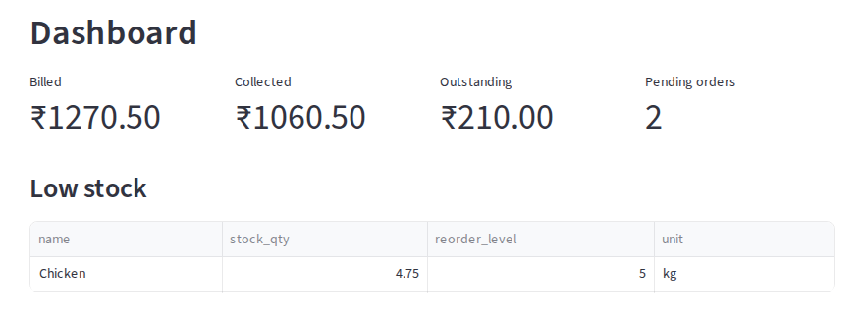
Figure 7.1: Dashboard page
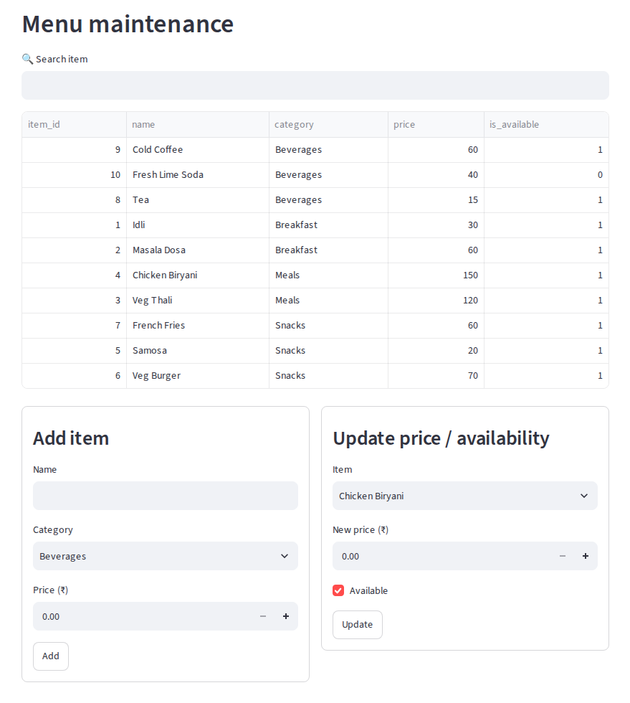
Figure 7.2: Menu maintenance page
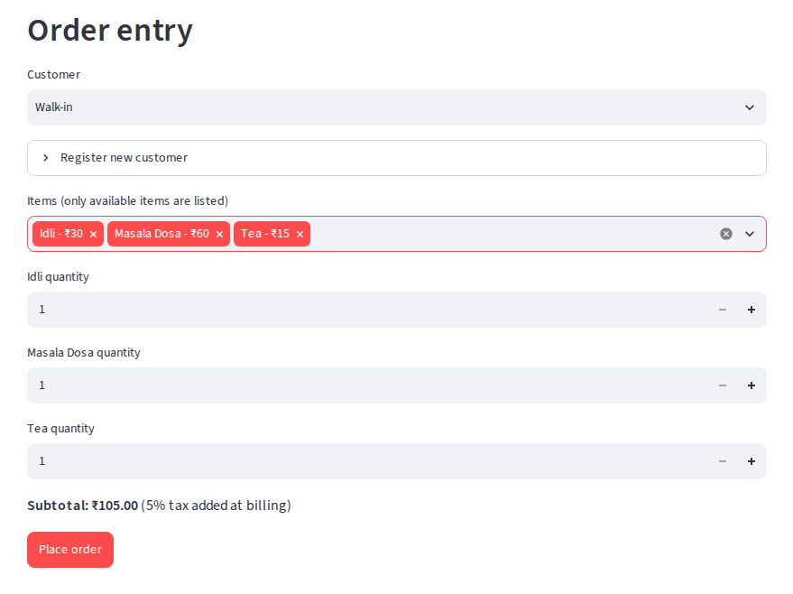
Figure 7.3: Order entry page (items selected, before placing)
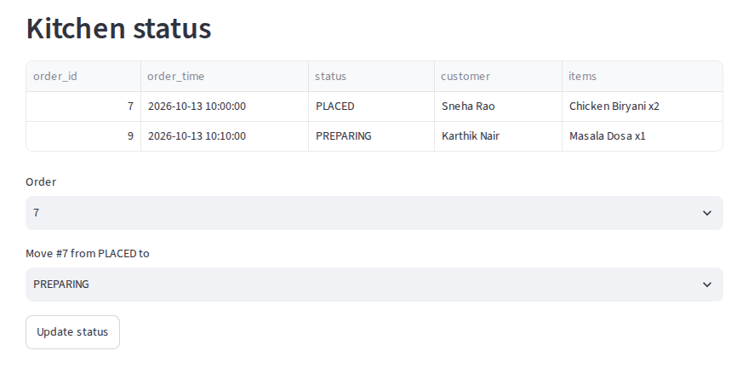
Figure 7.4: Kitchen status page
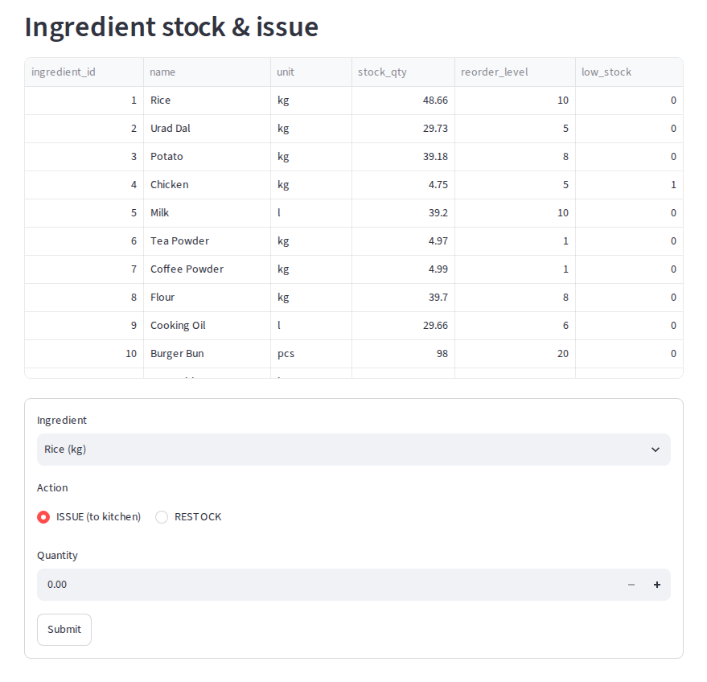
Figure 7.5: Ingredient stock and issue page
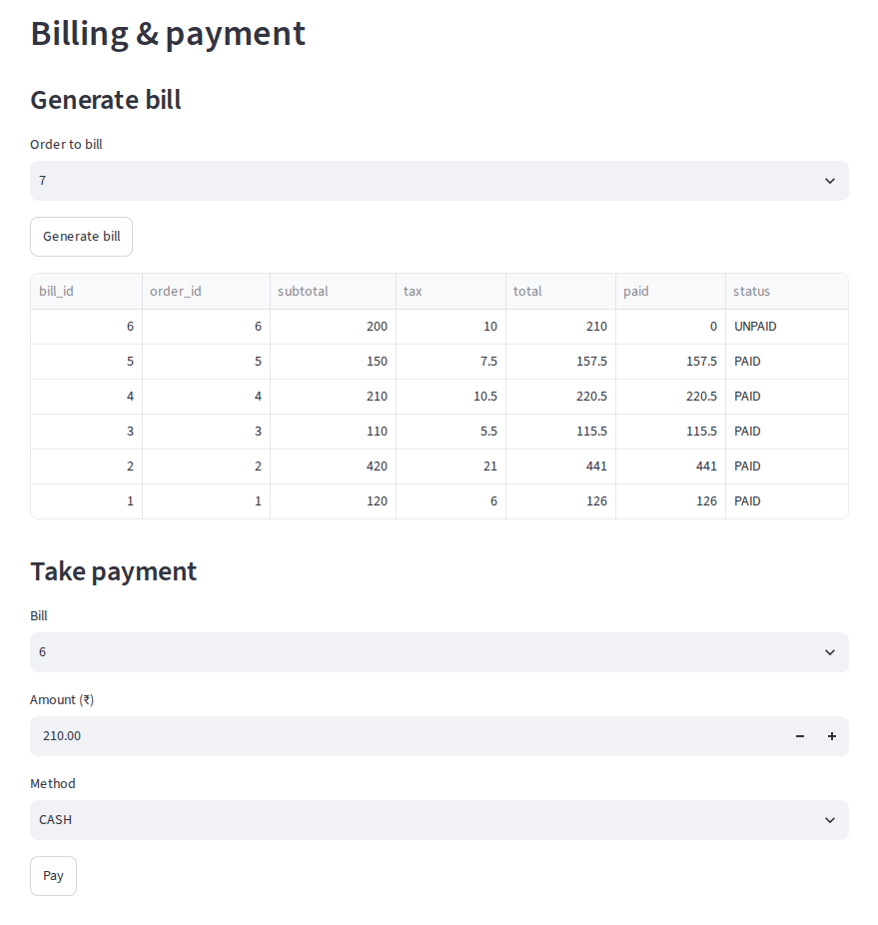
Figure 7.6: Billing and payment page
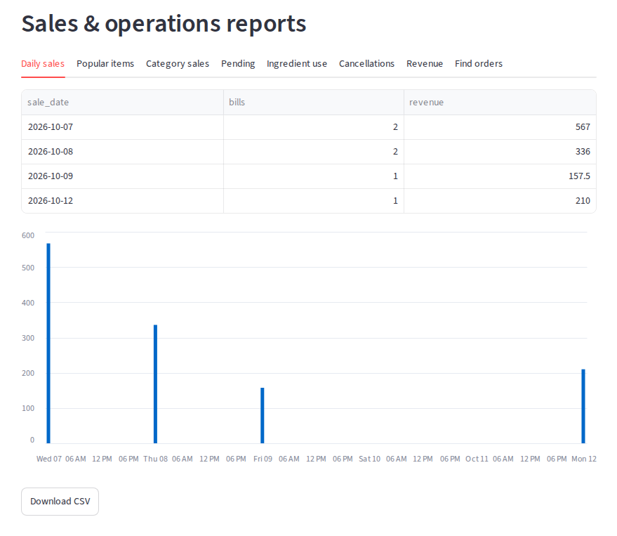
Figure 7.7: Reports page (daily sales)
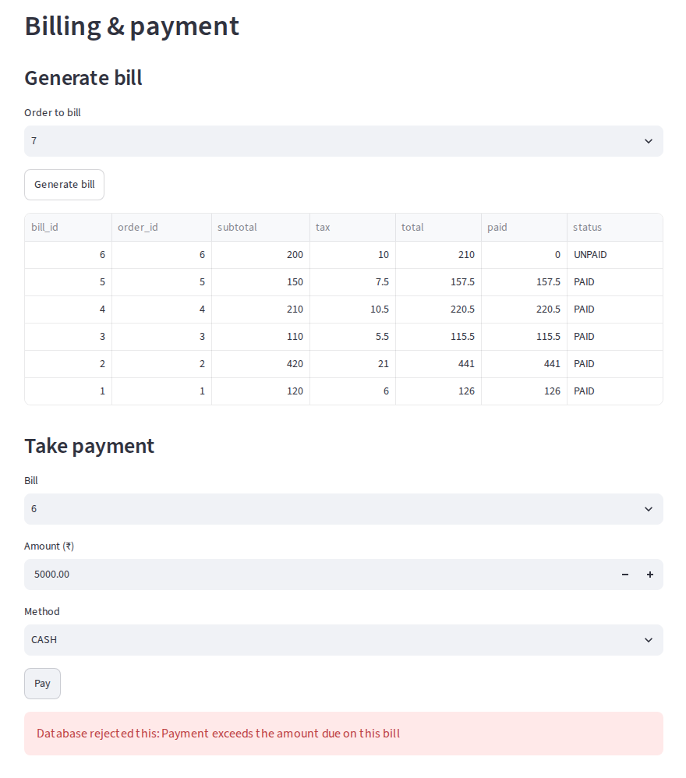
Figure 7.8: Error shown when a payment exceeds the amount due

8. Testing
Testing covered each business rule, input validation and the normal order-to-payment flow. All tests were run on MySQL 8.0 with the sample data; the Observed column records the result and the figures show the console output.
No. | Test case | Expected result | Observed
T1 | Order an unavailable item (Fresh Lime Soda) | Rejected: Item is unavailable and cannot be ordered | Rejected (error 1644): item unavailable
T2 | Add an order line with quantity 0 | Rejected by CHECK (quantity > 0) | Rejected (error 3819): CHECK constraint violated
T3 | Change a PLACED order directly to SERVED | Rejected: Invalid order status transition | Rejected (error 1644): invalid status transition
T4 | Start preparing an order that has no items | Rejected: An order must contain at least one item | Rejected (error 1644): at least one item required
T5 | Pay 99,999 on a bill | Rejected: Payment exceeds the per-transaction limit of 10000 | Rejected (error 1644): payment limit exceeded
T6 | Pay more than the amount due | Rejected: Payment exceeds the amount due on this bill | Rejected (error 1644): exceeds amount due
T7 | Issue more ingredient than is in stock | Rejected by CHECK (stock_qty >= 0); change rolled back | Rejected (error 3819): CHECK violated; stock unchanged
T8 | Generate a bill for a cancelled order | Rejected: Order not found or cancelled | Rejected (error 1644): cancelled order cannot be billed
T9 | Register a customer with a duplicate phone | Rejected by UNIQUE constraint | Rejected (error 1062): duplicate entry
T10 | Valid order, then bill, then full payment | Saved; bill status becomes PAID | Saved; bill 6 status became PAID

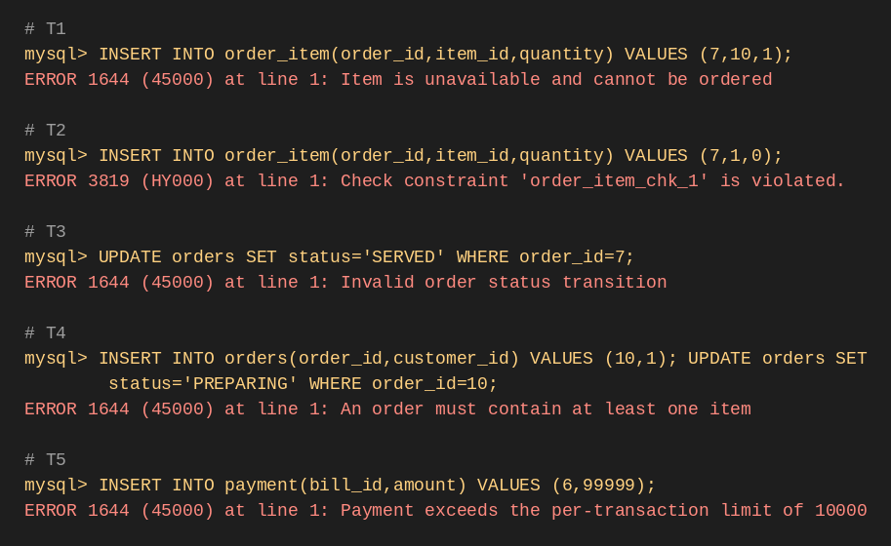
Output of tests T1 to T5 (MySQL 8.0)
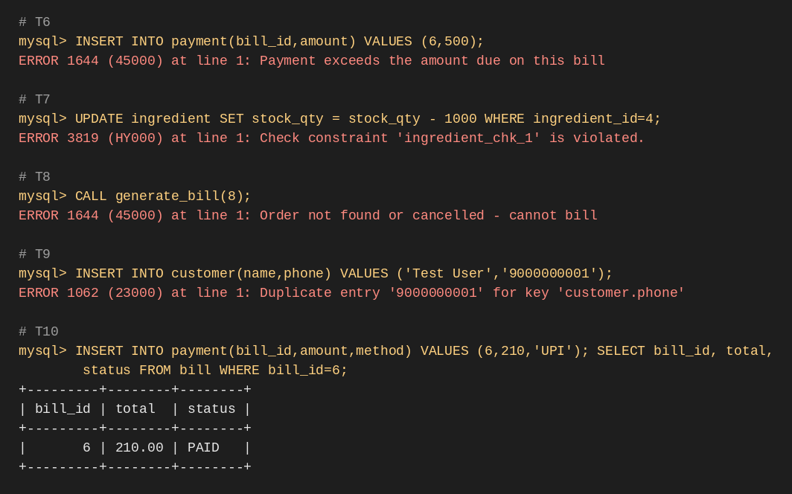
Output of tests T6 to T10 (MySQL 8.0)

9. Conclusion and Future Scope
The project delivers a normalized relational database for canteen ordering and billing, with integrity rules enforced inside the database, ingredient consumption tracked automatically, meaningful sales reports and a working web front-end. The design shows how constraints, triggers, transactions and indexing together keep operational data correct.
Possible extensions are role-based login for admin, cashier and kitchen staff, QR-code ordering from tables, UPI payment gateway integration, SMS alerts when an order is ready, and support for multiple canteens.

References
- Silberschatz, A., Korth, H. F. and Sudarshan, S., Database System Concepts, McGraw-Hill.
- Elmasri, R. and Navathe, S. B., Fundamentals of Database Systems, Pearson.
- MySQL 8.0 Reference Manual, https://dev.mysql.com/doc/refman/8.0/en/
- Streamlit Documentation, https://docs.streamlit.io/

Appendix: repository structure
Folder | Contents
sql/ | 01_schema.sql, 02_sample_data.sql, 03_queries.sql
app/ | app.py, the Streamlit application
presentations/ | Review 1, Review 2 and Review 3 slides
video/ | Video_Link.md with the public Google Drive link to the 5-minute demonstration
report/ | This project report
screenshots/ | Output screens used in this report

