**Assignment-Day 06**

1.Create Bank Application , with following menus

Accounts

FundTransfer

BillPay&Recharage

Offers

Rules;

1.when you click accounts display the following data

|  |  |  |  |  |  |  |
| --- | --- | --- | --- | --- | --- | --- |
| Date | Narration | Cheque/Ref. No. | Value Date | Withdrawal | Deposit | Closing Balance |

2.When you Select Fund Transfer, display the following data

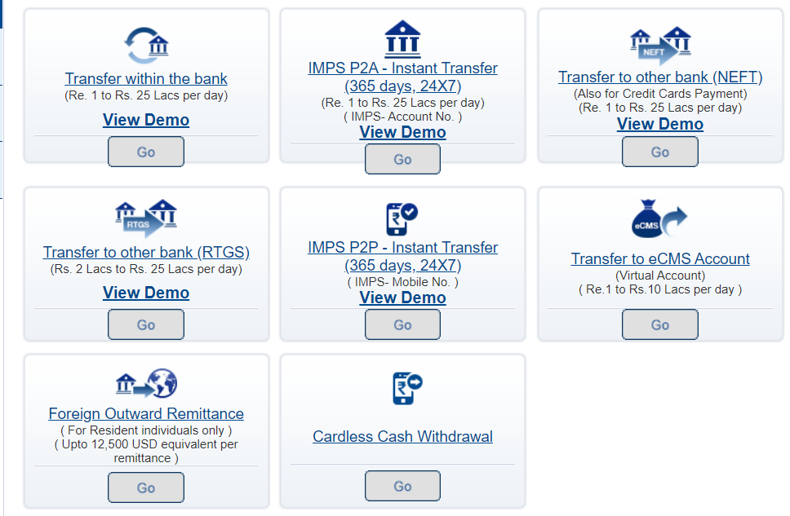

3.When click BillPay&Recharage

|  |
| --- |
| **ver this new BillPay, you can now make online payments to over 260 billers across various categories including:** |
| * Electricity Bills. * Telephone and Mobile Bills * Prepaid DTH/ Mobile Connection/ Data Card Recharge * Gas Bills * Mutual Funds. * Insurance Premiums. * Subscriptions. * Contribution to Charities.   Add billers and pay your bills through the enhanced BillPay service, powered by BillDesk. |

Please note your BillPay session will open in a new window while your NetBanking session here continues to remain active . Kindly ensure to also log out from your active NetBanking session here once you have exited the new enhanced BillPay module.  
  
Click on "Continue" to experience the new enhanced BillPay.

4.When you click offers,

