**BiteSwiftt**

**Project Overview**

The project aims to develop a user-friendly food delivery website to facilitate orders and deliveries. It will include features like user registration, food browsing, and order placement.

**User-Friendly Interface:**

The website will have an intuitive, easy-to-navigate interface to improve user experience.

**User Requirements:** The user requirements for the food delivery website include the ability to register, log in, browse available food options, place and edit orders, and provide feedback on the services.

**- User Registration**: Users should be able to register easily

using their email or social media accounts.

- **Order Placement**: Streamlined process for selecting items,

customizing orders, and adding delivery details.

**System Architecture** The system architecture will be based on the MERN stack, comprising MongoDB for the database, Express for the back-end, React for the front-end, and Node.js for server-side scripting.

**Front-End** - Responsive and interactive user interface** developed using React for enhanced user experience.

**Back-End** - Efficient server-side scripting using Node.js and Express to handle requests and interactions with the database.

**Database** - Robust and scalable data storage and retrieval using MongoDB for effective management of orders and user data.

**Front-end Design** The front-end design will focus on creating an engaging, responsive, and easy-to-use interface for a seamless user experience.

**1. User Interface:** Designing a visually appealing and intuitive

user interface to enhance user engagement and

satisfaction.

**2. Responsive Layout:** Ensuring the website is accessible

and functional across various devices and screen sizes for

a consistent experience.

**3. Interactive Elements:** Implementing interactive features to

make the browsing and ordering process more dynamic

and engaging.

**Back-end Design** The back-end design will prioritize efficient data processing and seamless interactions with the front-end

**1. Register / Login:** Includes user authentication, account

management features, and user experience.

**2. API Integration** Integrating multiple APIs for payment

processing, order management.

**Database Design** The database design will focus on creating an organized structure for storing user data, food information, orders, and transaction records.

**- User Data:** Stored user information for registration and

login purposes.

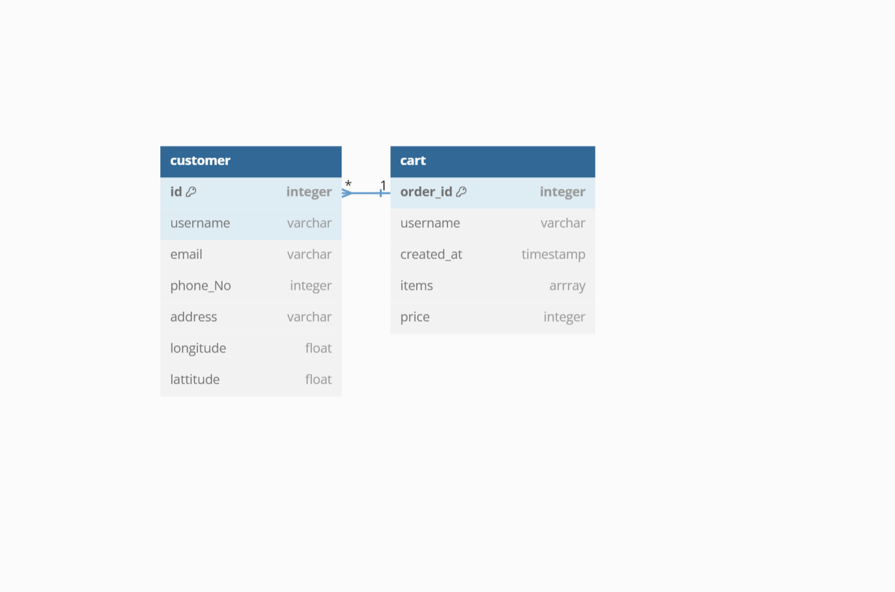

**Tech Stack:**-

1.Reactjs

2.Tailwind CSS

3.Expressjs

4.Nodejs

5.Mongodb

6.Mongoose

**Deployement** :- On Vercel

**Website Flow Diagram**

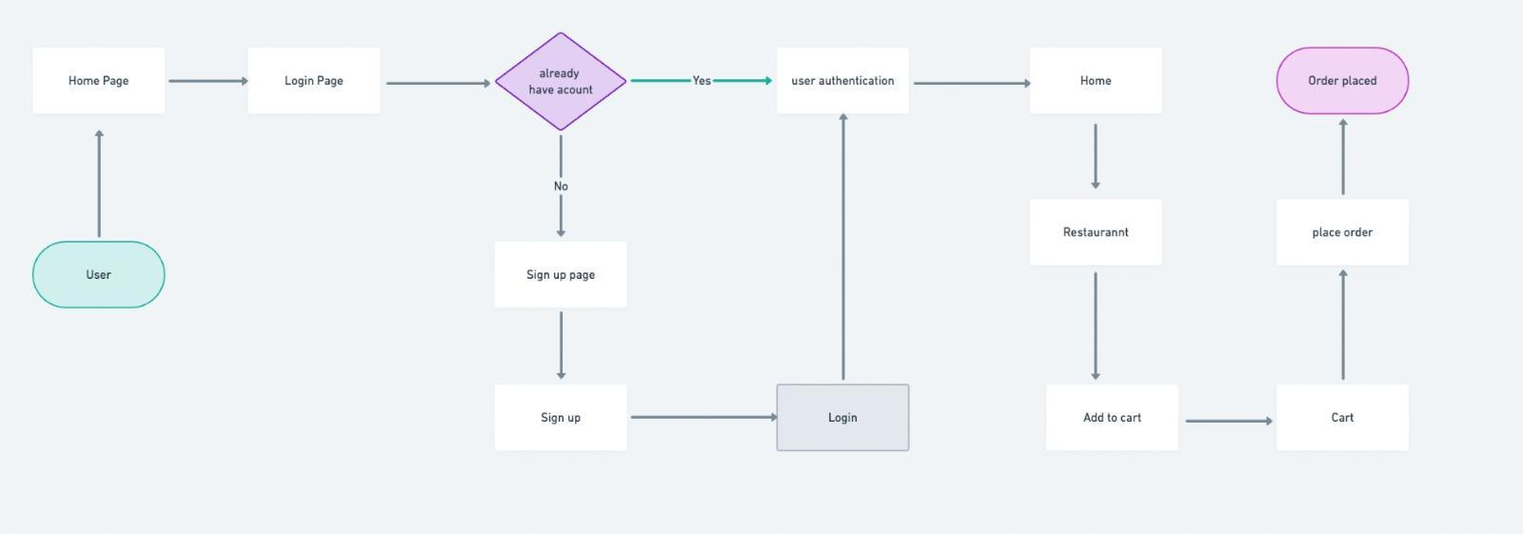

**Conclusion:**

In conclusion, the food delivery website design using the

MERN stack aims to provide a seamless, and enjoyable experience for users, administrators, and delivery personnel. The detailed planning and design considerations will ensure the successful development and deployment of the website.