**Gesture Recognition Project – Prateek Lakhiani**

**Problem Statement**

Imagine you are working as a data scientist at a home electronics company which manufactures state of the art smart televisions. You want to develop a cool feature in the smart-TV that can recognise five different gestures performed by the user which will help users control the TV without using a remote.

The gestures are continuously monitored by the webcam mounted on the TV. Each gesture corresponds to a specific command:

* Thumbs up: Increase the volume
* Thumbs down: Decrease the volume
* Left swipe: 'Jump' backwards 10 seconds
* Right swipe: 'Jump' forward 10 seconds
* Stop: Pause the movie

**Understanding the Dataset**

The training data consists of a few hundred videos categorised into one of the five classes. Each video (typically 2-3 seconds long) is divided into a sequence of 30 frames(images). These videos have been recorded by various people performing one of the five gestures in front of a webcam - similar to what the smart TV will use.

I have done various experiments to build a model to predict the gestures, and here is summry of them:

|  |  |  |  |  |  |
| --- | --- | --- | --- | --- | --- |
| # | Model | Layers | Batch_Size | Accuracy | Outcome |
| 1. | Conv3D | Conv3D(8), Maxpool3D, Flatten, Dense(16), Dense(5), | 150 | - | Error - out of Memory, needed to reduce batch size. Data should not be loaded at once. |
| 2. | Conv3D | Conv3D(8), Maxpool3D, Flatten, Dense(16), Dense(5), | 50 | Train = 23.34 %  Val = 97.0 % | Generator had issue. Method was returning incorrect data. |
| 3. | Conv3D | Conv3D(8), Maxpool3D, Flatten, Dense(16), Dense(5) | 50 | Train = 25%  Val = 0.0001 % (almost 0) | Need to add more layers. |
| 4. | Conv3D | 3 sets of (Conv3D, Max Poling and Batch Normalization)  Flatten layer  2 sets of dense layers | 50 | Train = 99%  Val = 62% | Overfitting  Need some dropout layers  Need to drop out some video frames |
| **5.** | **Conv3D** | **Added few dropouts in above #4**  **has 1.8 million params** | **Batch size 50, with alternate video frames (15 out of 30)** | **Train = 98%**  **Val = 86%** | **Overfitting maybe present. But this is best accuracy I have achieved. Adding more layers was increasing training time.** |
| 6. | Conv2D + RNN | TimeDistributed layers Conv2D, MapPool2D, Flatten, LSTM, Dense | 50 | Train = 23.67%  Val = 0.0001 % (almost 0) | Model not trained enough, need more layers |
| 7. | Conv2D + RNN | 3 sets of (TimeDistributed Conv3D, Max Poling and Batch Normalization)  Flatten, LSTM  2 sets of dense layers | 50 | Train = 99%  Val = 45% | Overfitting  Need some dropout layers  Need to drop out some video frames |
| 8. | Conv2D + RNN | Added dropouts in above #7  Has 15 million params | Batch size 50, with alternate video frames (15 out of 30) | Train = 88%  Val = 69% | Not the best accuracy. |

**Learnings:**

1. Generator function yeild method is a great way to control data going into the model. The way my generator function works is as below:

e.g. Total folders to read = 663, batch size = 50, So

for 1st batch - it skips 0 records and takes next 50 records

for 2nd batch – it skips 50 records and takes next 50 records

..

for 13th batch – it skips 600 records and takes next 50 records

for last 14th batch – it skips 650 records and takes next 13 records

steps per epoch is also calculating this total number of batches to pass on to fit_generator method.

1. Number of video frames we pass on to the model has big impact. It reduces the processing time, and keeps accuracy almost same. 30 frames in a video has lot of repeated information, so some frames can be skipped.
2. Batch size directly affects memory usage. To work on a system with low memory we can rely on small batch size.
3. Augumentaion like flipping/ mirroring not applied to this dataset as images orientation mean everything for this training. Left swipe right swipe are actual features we want to have differention in outcome.

**Submission Model**

**Model #5 has highest accuracy in my experiments and h5 file is submitted for the same model.**

Achieved good accuracy with Conv3D model with 1.8 million params Training = 98%, Validation = 86%. Loss reduced with each epoch. And accuracy also improved with each epoch.

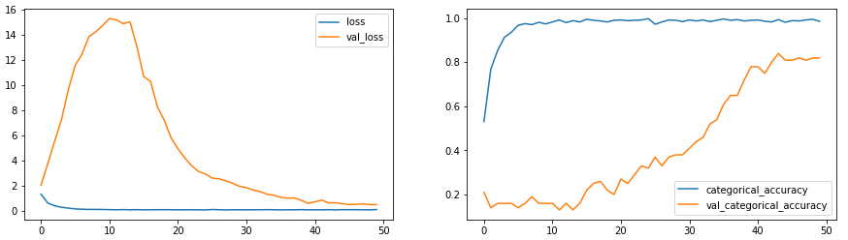

**Model Layers:**

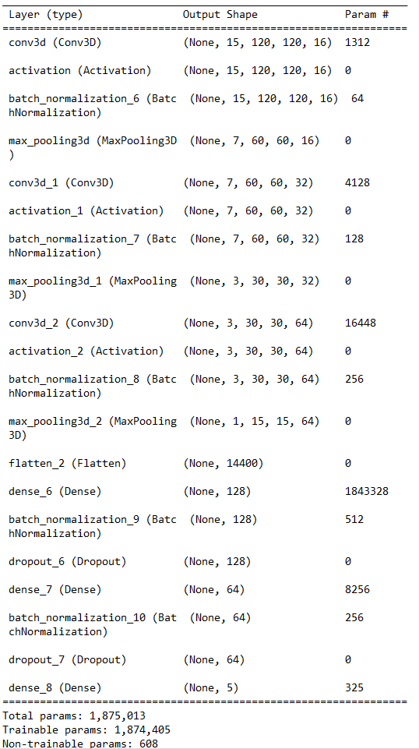

**Last epoch result –**



**Please Note:-**

I have selected my model from Conv3D and not from Conv2D. But both these two are present in my codework book.