**Team Carbon Crusaders**

EcoRewards

Prashant Anand

Timea Kadas

Liz Kent

Prateek Madnani

Alankrita Singh

MGS 613

Professor Keaton

August 9, 2024

**GP 1: Project Definition and Scope**

|  |  |
| --- | --- |
| **Carbon Crusaders** | |
| Mission Statement | Carbon Crusaders is focused on providing a product that can empower individuals to reduce their carbon footprint. We are dedicated to creating solutions that will make sustainable living accessible. |
| **Our Team** | |
| **Prashant Anand**   | Prashant Anand is a graduate student in Management Information Systems at the University at Buffalo. Previously, Prashant worked as an analyst at various companies where he improved database frameworks, analyzed data with SQL and Excel, and developed strategies that optimized business operations. Prashant holds a Bachelor of Technology in Electrical and Electronics Engineering. He enjoys swimming, running, and traveling. |
| **Timea Kadas** | Timea Kadas is passionate about using data to drive innovation and efficiency, especially in projects aimed at reducing carbon emissions and promoting sustainability. Her educational background includes a Bachelor of Science in Business Administration with a concentration in Management Information Systems from the University at Buffalo. Timea is currently pursuing a Master of Science in Management Information Systems at the University at Buffalo and expects to graduate in June 2025. Timea’s educational background combined with her work experience, has equipped her with a strong foundation in data analysis and database management. |
| **Liz Kent** | Liz Kent is a Buffalo native with a professional background in process improvement and implementation, system administration, and defect management. She is currently working as a Commercial Banking Business Data Consultant for a large regional bank. Liz is a mother of 4 and an animal lover owning a small hobby farm with dogs, pigs, and chickens. In her free time Liz is an amateur photographer, Buffalo Bills fan, and a plant rescuer. Liz completed her undergraduate degree in Business Management in 2017 and is now pursuing her Master of Science in Management Information Systems at the University at Buffalo so that she can grow her career in the field of data management and data architecture. |
| **Prateek Madnani** | Prateek Madnani comes from India with a professional background in Software Engineering. Prateek completed his undergraduate degree in Information Science and Engineering in 2020 and has been working in the software domain since then. He has four years of experience in India on multiple technologies with the focus on backend development. Prateek is currently pursuing his Master of Science in Management Information Systems at the University at Buffalo. Prateek is passionate about technology, is an avid learner and explorer. Prateek intends to work in the field of technical product management after completing his graduate program, so that he can leverage his technical skills from his experience and grow into leadership positions. |
| **Alankrita Singh** | Before coming to the United States, Alankrita worked as an Application Engineer in India for the past 2 years. She intends to change her career path to data analytics and security as these topics interest her. She completed her BTech in Electrical & Electronics Engineering in 2022 and is now pursuing an MS in MIS to transition into the career track she has chosen. She has worked on various technologies including SQL, JavaScript, HTML/CSS, Java. She is passionate about learning new things, adaptable and driven to excel. |

|  |  |
| --- | --- |
| **Project Plan** | |
| Project Name | EcoRewards |
| Problem Statement | Every day, many people live their lives ignorant of the impact their activities and lifestyle have on increasing greenhouse gases. The rising levels of greenhouse gases have far-reaching effects on climate change, global economies, agriculture, and human health. Our team’s goal is to raise awareness about the carbon emissions crisis on a personal level and empower individuals to make a difference.  We believe that all our individual actions can have an impact on the future of the planet, so we are driven to fundamentally change the steps people take in making their daily decisions, especially related to running errands. If people develop new habits that will collectively improve the state of our world, we can all create a ripple effect that extends beyond the small decisions we make every day. Preserving our natural resources and building a community of individuals who are dedicated and thoughtful about the environment is our goal. Mitigating the effects of climate change and creating safer, healthier environments for all of us and future generations to enjoy is at the heart of what we do. |
| Project Overview | Our project, EcoRewards, will inspire individuals to track the amount of carbon they are emitting by taking a look at their lifestyle and choice of activities. When our users become aware of the amount of carbon they are producing, they will be incentivized to use less by receiving rewards such as gift cards to various retailers. The overall goal is to improve the environment and create a greener planet. While people initially may be motivated by earning money, in the end they will feel a deeper connection to the cause of contributing to a less polluted planet.  People will be able to use our advanced technology to track and monitor various aspects of their daily lives, such as eating habits, transportation choices, clothing preferences, device usage, and other activities that impact the environment. Our system will evaluate the user’s choices and assign eco-points for making decisions that are environmentally conscientious. For example, choosing to walk, ride a bike, or take public transportation will be rewarded over driving a personal vehicle. Users have the option to connect their data from other apps they use throughout their day for an even more seamless and carefree experience that fits their lifestyle. We prioritize the privacy and data security of our users, so their information will only be shared to the extent that they agree upon. By making suitable decisions that encourage sustainability, users will receive positive reinforcement through the distribution of tangible rewards, which will include options such as donating to a charity, obtaining gift cards, or other goods. |
| Project Objectives | The goal of this project is to provide users with an easy-to-use application that will:  1) Calculate user’s average carbon emissions based on their activities  2) Suggest alternative activities and lifestyle modifications aimed at reducing their carbon footprint  3) Incentivize users to make smarter choices via a rewards-based point system redeemable for gift cards  The database will contain the following tables:  **UserInfo Table**   * This table will store data about the user, such as name, age, gender, BMI, etc.   **Activities Table**   * This table will contain the combined carbon emission of all the activities a user performs by calculating the total of carbon emission due to eating habits, fitness habits and the transportation-mode that a user used, for the day.   **Date Table**   * This table breaks down the date into different components such as day, month, year, and quarter.   **EatingHabits Table**   * EatingHabits Table will contain data on whether the user ate vegetarian or a non-vegetarian food for the day and also its carbon emission value.   **FitnessHabit Table**   * FitnessHabit Table will contain data for fitness activity performed by the user like whether the user used an air-conditioned gym to maintain his fitness or not, for that day, and also its carbon emission value.   **Recommendation Table**   * This table will provide information on activities the user should change to reduce their carbon footprint.   **DailyTracker Table**   * This table will record information about the user’s carbon emissions based on their activities for the day as well as points earned for that day, as well as the score.   Note: The score will be calculated by a predefined in-memory key-value storage for points to score.  **TransportationMode Table**   * TransportationMode Table will contain data on whether the user used public or private transport for travel, for the day, and also its carbon emission value.   Note: All the carbon emission values for the three different tables related to the user activities will come from pre-defined values stored in-memory.  **ActivityDate Table**   * This is an associative table to break the many to many relationship between Activity and DailyTracker tables.   **Transaction Table**   * This table will record information about points earned (+) and rewards redeemed (-), so that users can easily understand their points balance, and will include the date, timestamp, status, etc.   **DailyTrackerTransaction Table**   * This is an association table to break the many to many relationship between DailyTracker and Transaction tables.   **Redemption Table**   * This table will record redemption requests made by users and will track number of points being redeemed, date, email, and date. |
| Project Deliverables and Milestones | Project description and Scope - 07/16/2024  Detailed business rules and completed ER diagram - 07/23/2024  Database Schema and Physical Design - 07/30/2024  Populated Data and Query Output - 08/06/2024  Report and Analysis Output and Presentation - 08/15/2024 |
| Project Constraints | Completion date of August 15, 2024  There will be no user interface created  Data availability |
| Assumptions | All team members will participate  Project Plan will be approved  Technical resource availability  Applicable Data is sourceable |

**GP 2: Detailed Business Rules & Logical Diagram**

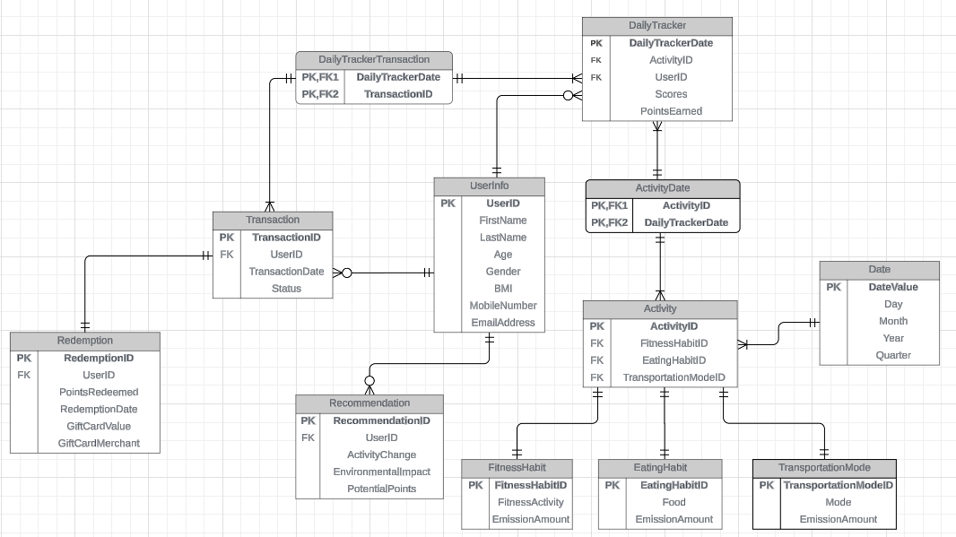

1. Each Activity must be linked to one and only one FitnessHabit, EatingHabit, or TransportationMode Table.
2. Each FitnessHabit Table must have one and only one fitness activity and its carbon emission amount.
3. Each EatingHabit Table must have one and only one fitness activity and its carbon emission amount.
4. Each TransportationMode Table must have one and only one fitness activity and its carbon emission amount.
5. Each DailyTracker entry must be linked to exactly one user (UserInfo) and must include a specific date (DailyTrackerDate).
6. Each Activity must have an ActivityDate linked to a DailyTrackerDate.
7. Each Redemption must be associated with one RedemptionTransaction.
8. Each RedemptionTransaction which must be associated with one Transaction.
9. Each Recommendation is associated with exactly one user (UserInfo).
10. Each user can receive multiple recommendations.
11. Many Transactions can be associated with one User.
12. Each User can have multiple DailyTracker records.
13. Multiple Activities can have the same DailyTrackerDate.
14. Multiple Activities by different Users can be performed on the same date.
15. Multiple transactions can be performed on the same day, having the same DailyTrackerDate.
16. Multiple Redemption can be performed on the same date, having the same DailyTrackerDate.

**GP3: DDL & Physical Diagram**

CREATE TABLE UserInfo (

UserID INT PRIMARY KEY,

FirstName VARCHAR(50),

LastName VARCHAR(50),

Age INT,

Gender CHAR(1),

BMI DECIMAL(4, 2),

MobileNumber VARCHAR(15),

EmailAddress VARCHAR(100)

);

CREATE TABLE FitnessHabit (

FitnessHabitID INT PRIMARY KEY,

FitnessActivity VARCHAR(100),

EmissionAmount DECIMAL(10, 2)

);

CREATE TABLE EatingHabit (

EatingHabitID INT PRIMARY KEY,

Food VARCHAR(100),

EmissionAmount DECIMAL(10, 2)

);

CREATE TABLE TransportationMode (

TransportationModeID INT PRIMARY KEY,

TransportationMode VARCHAR(50),

EmissionAmount DECIMAL(10, 2)

);

CREATE TABLE Activity (

ActivityID INT PRIMARY KEY,

FitnessHabitID INT,

EatingHabitID INT,

TransportationModeID INT,

FOREIGN KEY (FitnessHabitID) REFERENCES FitnessHabit(FitnessHabitID),

FOREIGN KEY (EatingHabitID) REFERENCES EatingHabit(EatingHabitID),

FOREIGN KEY (TransportationModeID) REFERENCES

TransportationMode(TransportationModeID)

);

CREATE TABLE DateTable (

DateValue DATE PRIMARY KEY,

Day INT,

Month INT,

Year INT,

Quarter INT

);

CREATE TABLE DailyTracker (

DailyTrackerDate DATE,

ActivityID INT,

UserID INT,

Scores DECIMAL(10, 2),

PointsEarned DECIMAL(10, 2),

PRIMARY KEY (DailyTrackerDate, ActivityID),

FOREIGN KEY (DailyTrackerDate) REFERENCES DateTable(DateValue),

FOREIGN KEY (ActivityID) REFERENCES Activity(ActivityID),

FOREIGN KEY (UserID) REFERENCES UserInfo(UserID)

);

CREATE TABLE ActivityDate (

ActivityId INT,

DailyTrackerDate DATE,

PRIMARY KEY (ActivityID, DailyTrackerDate),

FOREIGN KEY (ActivityID) REFERENCES Activity(ActivityID),

FOREIGN KEY (DailyTrackerDate, ActivityID) REFERENCES DailyTracker(DailyTrackerDate, ActivityID),

FOREIGN KEY (DailyTrackerDate) REFERENCES DateTable(DateValue)

);

CREATE TABLE Transaction (

TransactionID INT PRIMARY KEY,

UserID INT,

TransactionDate DATE,

Status VARCHAR(20),

FOREIGN KEY (UserID) REFERENCES UserInfo(UserID),

FOREIGN KEY (TransactionDate) REFERENCES DateTable(DateValue)

);

CREATE TABLE Redemption (

RedemptionID INT PRIMARY KEY,

UserID INT,

PointsRedeemed DECIMAL(10, 2),

RedemptionDate DATE,

GiftCardValue DECIMAL(10, 2),

GiftCardMerchant VARCHAR(100),

FOREIGN KEY (UserID) REFERENCES UserInfo(UserID),

FOREIGN KEY (RedemptionDate) REFERENCES DateTable(DateValue)

);

CREATE TABLE Recommendation (

RecommendationID INT PRIMARY KEY,

UserID INT,

ActivityChange VARCHAR(100),

EnvironmentalImpact DECIMAL(10, 2),PotentialPoints DECIMAL(10, 2),

FOREIGN KEY (UserID) REFERENCES UserInfo(UserID)

);

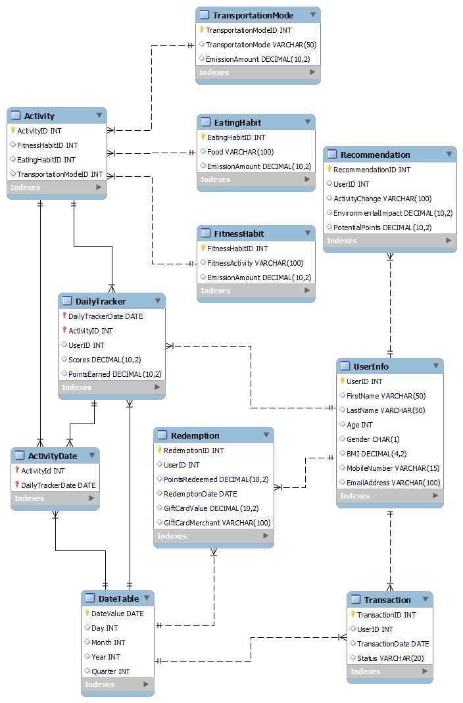

**GP4: Populated Data & Query Output**

-- Find users who have earned more than 50 points, include their rank based on total points earned, display their names in uppercase, and show their choice of gift card redemption, handling null values and ordering by total points

SELECT

UPPER(u.FirstName) || ' ' || UPPER(u.LastName) AS FullName,

SUM(d.PointsEarned) AS TotalPoints,

RANK() OVER (ORDER BY SUM(d.PointsEarned) DESC) AS Rank,

NVL(TO_CHAR(r.GiftCardValue), 'No Redemption') AS GiftCardValue,

NVL(r.GiftCardMerchant, 'No Redemption') AS GiftCardMerchant

FROM

DailyTracker d

JOIN

UserInfo u ON d.UserID = u.UserID

LEFT JOIN

Redemption r ON u.UserID = r.UserID

GROUP BY

u.UserID, u.FirstName, u.LastName, r.GiftCardValue, r.GiftCardMerchant

HAVING

SUM(d.PointsEarned) > 50

ORDER BY

TotalPoints DESC

|  |  |  |  |  |
| --- | --- | --- | --- | --- |
| **FULLNAME** | **TOTALPOINTS** | **RANK** | **GIFTCARDVALUE** | **GIFTCARDMERCHANT** |
| KEELEY SQUIRREL | 100 | 1 | No Redemption | No Redemption |
| DIANNA HANSMAN | 89 | 2 | No Redemption | No Redemption |
| CARLYN CALENDAR | 88 | 3 | 50 | Amazon |
| SALOMI HUGHLIN | 67 | 4 | 100 | Tops |
| OTHILIE OWLNER | 62 | 5 | 100 | Tops |
| OTHILIE OWLNER | 62 | 5 | 25 | Walmart |
| CYBIL ASLUM | 58 | 7 | 10 | Starbucks |
| HELENELIZABETH MONTFORD | 52 | 8 | No Redemption | No Redemption |

-- Find activities with emission amounts greater than 1000.0, alias the result, and order by total emissions ascending

SELECT

a.ActivityID AS Activity_ID,

f.FitnessActivity AS Fitness_Activity,

e.Food AS Food_Type,

t.TransportationMode AS Transport_Mode,

(f.EmissionAmount + e.EmissionAmount + t.EmissionAmount) AS Total_Emission

FROM

Activity a

JOIN

FitnessHabit f ON a.FitnessHabitID = f.FitnessHabitID

JOIN

EatingHabit e ON a.EatingHabitID = e.EatingHabitID

JOIN

TransportationMode t ON a.TransportationModeID = t.TransportationModeID

JOIN

DailyTracker d ON a.ActivityID = d.ActivityID

WHERE

(f.EmissionAmount + e.EmissionAmount + t.EmissionAmount) > 1000.0

ORDER BY

Total_Emission ASC;

|  |  |  |  |  |
| --- | --- | --- | --- | --- |
| **ACTIVITY_ID** | **FITNESS_ACTIVITY** | **FOOD_TYPE** | **TRANSPORT_MODE** | **TOTAL_EMISSION** |
| 33 | Virtual Meeting (1 hour) | Chicken Wings | Bicycle (Manual per mile) | 1051 |
| 88 | Virtual Meeting (1 hour) | Potatoes | Motorcycle | 1073 |
| 92 | Virtual Meeting (1 hour) | Chicken Breast | Car (electric per mile) | 1169 |
| 29 | Virtual Meeting (1 hour) | Carrots | Domestic Flight (per km) | 1254.3 |
| 74 | Virtual Meeting (1 hour) | Carrots | Domestic Flight (per km) | 1254.3 |
| 54 | Virtual Meeting (1 hour) | Broccoli | Domestic Flight (per km) | 1254.6 |
| 39 | Virtual Meeting (1 hour) | Bread | Domestic Flight (per km) | 1255.5 |

-- Retrieve distinct user details for those with BMI over 40, format names in uppercase, email in lowercase, replace null BMI with 0.0, and order by descending BMI

SELECT DISTINCT

UPPER(u.FirstName) || ' ' || UPPER(u.LastName) AS FullName,

LOWER(u.EmailAddress) AS Email,

NVL(TO_CHAR(u.BMI, '90.9'), '0.0') AS BMI_Value

FROM

UserInfo u

JOIN

DailyTracker d ON u.UserID = d.UserID

JOIN

Activity a ON d.ActivityID = a.ActivityID

WHERE

u.BMI > 40

ORDER BY

TO_NUMBER(NVL(TO_CHAR(u.BMI, '90.9'), '0.0')) DESC

|  |  |  |
| --- | --- | --- |
| **FULLNAME** | **EMAIL** | **BMI_VALUE** |
| CARLYN CALENDAR | ccalendarp@buzzfeed.com | 44.1 |
| ILYSE ANDRYUNIN | iandryunin1@pen.io | 43.9 |
| IDALINA ROYCE | iroyce1h@plala.or.jp | 41.7 |
| FREDELIA LEVERICH | fleverichc@japanpost.jp | 40.3 |

-- Find activities recorded in August 2024, calculate the total emission, and format the date

SELECT

TO_CHAR(d.DailyTrackerDate, 'DD-Mon-YYYY') AS FormattedDate,

a.ActivityID,

a.FitnessHabitID,

a.EatingHabitID,

a.TransportationModeID,

(f.EmissionAmount + e.EmissionAmount + t.EmissionAmount) AS Total_Emission,

u.UserID,

u.FirstName || ' ' || u.LastName AS FullName

FROM

Activity a

JOIN

FitnessHabit f ON a.FitnessHabitID = f.FitnessHabitID

JOIN

EatingHabit e ON a.EatingHabitID = e.EatingHabitID

JOIN

TransportationMode t ON a.TransportationModeID = t.TransportationModeID

JOIN

DailyTracker d ON a.ActivityID = d.ActivityID

JOIN

UserInfo u ON d.UserID = u.UserID

WHERE

TO_CHAR(d.DailyTrackerDate, 'MM-YYYY') = '08-2024'

|  |  |  |  |  |  |  |  |
| --- | --- | --- | --- | --- | --- | --- | --- |
| **FORMATTEDDATE** | **ACTIVITYID** | **FITNESSHABITID** | **EATINGHABITID** | **TRANSPORTATIONMODEID** | **TOTAL_EMISSION** | **USERID** | **FULLNAME** |
| 03-Aug-2024 | 98 | 2 | 8 | 11 | 159.5 | 50 | Salomi Hughlin |

-- Display user full name, age, replace null BMI with 0.0, include points, and filter by users younger than 24

SELECT

u.UserID,

u.FirstName || ' ' || u.LastName AS FullName,

NVL(TO_CHAR(u.BMI, '90.9'), '0.0') AS BMI_Value,

u.Age,

SUM(d.PointsEarned) AS TotalPointsEarned

FROM

UserInfo u

JOIN

DailyTracker d ON u.UserID = d.UserID

WHERE

u.Age < 24

GROUP BY

u.UserID, u.FirstName, u.LastName, u.BMI, u.Age

ORDER BY

u.LastName

|  |  |  |  |  |
| --- | --- | --- | --- | --- |
| **USERID** | **FULLNAME** | **BMI_VALUE** | **AGE** | **TOTALPOINTSEARNED** |
| 2 | Ilyse Andryunin | 43.9 | 20 | 45 |
| 71 | Zuzana Arons | 26.6 | 18 | 22 |
| 83 | Neda Dunseath | 38.5 | 22 | 44 |
| 25 | Lisetta Kerrigan | 37.6 | 20 | 20 |
| 7 | Monah Larmor | 30.5 | 20 | 21 |
| 21 | Hally Prantl | 18.0 | 19 | 43 |

-- Count and display distinct redemptions per user for 2023, grouped by user and month, and ordered by month and last name

SELECT DISTINCT

u.UserID,

u.FirstName,

u.LastName,

TO_CHAR(r.RedemptionDate, 'MM-YYYY') AS Month,

COUNT(r.RedemptionID) OVER (PARTITION BY u.UserID, TO_CHAR(r.RedemptionDate, 'MM-YYYY')) AS RedemptionCount

FROM

UserInfo u

JOIN

Redemption r ON u.UserID = r.UserID

WHERE

TO_CHAR(r.RedemptionDate, 'YYYY') = '2023'

ORDER BY

TO_CHAR(r.RedemptionDate, 'MM-YYYY'), u.LastName;

|  |  |  |  |  |
| --- | --- | --- | --- | --- |
| **USERID** | **FIRSTNAME** | **LASTNAME** | **MONTH** | **REDEMPTIONCOUNT** |
| 2 | Ilyse | Andryunin | 01-2023 | 1 |
| 11 | Audie | Dishmon | 01-2023 | 1 |
| 18 | Corinna | La Croce | 01-2023 | 1 |
| 16 | Bettye | Labeuil | 01-2023 | 1 |
| 7 | Monah | Larmor | 01-2023 | 1 |
| 10 | Bill | Le Marquand | 01-2023 | 1 |
| 1 | Othilie | Owlner | 01-2023 | 1 |
| 15 | Letitia | Tring | 01-2023 | 1 |
| 4 | Ardine | Turnell | 01-2023 | 1 |
| 3 | Kissiah | Dayborne | 02-2023 | 1 |
| 11 | Audie | Dishmon | 02-2023 | 1 |
| 14 | Honor | Hlavecek | 02-2023 | 2 |
| 7 | Monah | Larmor | 02-2023 | 1 |
| 2 | Ilyse | Andryunin | 03-2023 | 1 |
| 11 | Audie | Dishmon | 03-2023 | 1 |
| 14 | Honor | Hlavecek | 03-2023 | 1 |
| 1 | Othilie | Owlner | 03-2023 | 1 |
| 5 | Cammi | Ruseworth | 03-2023 | 1 |
| 2 | Ilyse | Andryunin | 04-2023 | 1 |
| 11 | Audie | Dishmon | 04-2023 | 1 |
| 17 | Blanch | Dougharty | 04-2023 | 1 |
| 10 | Bill | Le Marquand | 04-2023 | 1 |
| 19 | Lyndel | Norvill | 04-2023 | 1 |
| 1 | Othilie | Owlner | 04-2023 | 1 |
| 3 | Kissiah | Dayborne | 05-2023 | 1 |
| 11 | Audie | Dishmon | 05-2023 | 1 |
| 8 | Anatola | Ferran | 05-2023 | 1 |
| 14 | Honor | Hlavecek | 05-2023 | 1 |
| 18 | Corinna | La Croce | 05-2023 | 1 |
| 16 | Bettye | Labeuil | 05-2023 | 1 |
| 7 | Monah | Larmor | 05-2023 | 1 |
| 19 | Lyndel | Norvill | 05-2023 | 2 |
| 12 | Marney | Umfrey | 05-2023 | 1 |
| 20 | Elspeth | Attwater | 06-2023 | 1 |
| 11 | Audie | Dishmon | 06-2023 | 1 |
| 10 | Bill | Le Marquand | 06-2023 | 1 |
| 12 | Marney | Umfrey | 06-2023 | 1 |
| 20 | Elspeth | Attwater | 07-2023 | 1 |
| 3 | Kissiah | Dayborne | 07-2023 | 1 |
| 11 | Audie | Dishmon | 07-2023 | 1 |
| 14 | Honor | Hlavecek | 07-2023 | 1 |
| 7 | Monah | Larmor | 07-2023 | 1 |