Orchestration: Automated arrangement , coordination and management of computer systems , middleware and services.

Docker: Contaninerization tool

Kubernetes: Tool for managing containers (orchestration tool)

Kubernetes Rest api

POD

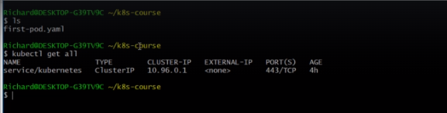

NOTE: Pods are not intended to be visible outside the kubernetes cluster.
Hence a port exposed by a port cannot be directly called by a browser

SERVICE

Pods are ephemeral , they can easily stop working .
But services have stable fixed ports and IP address .
Hence services are attached to pods

Both Pods and services have key value pairs.
In Pod the key value pairs are called Labels
While in Services the key value pairs are called as selector

So through the selector , the service will try to find a match in labels of the Pod.

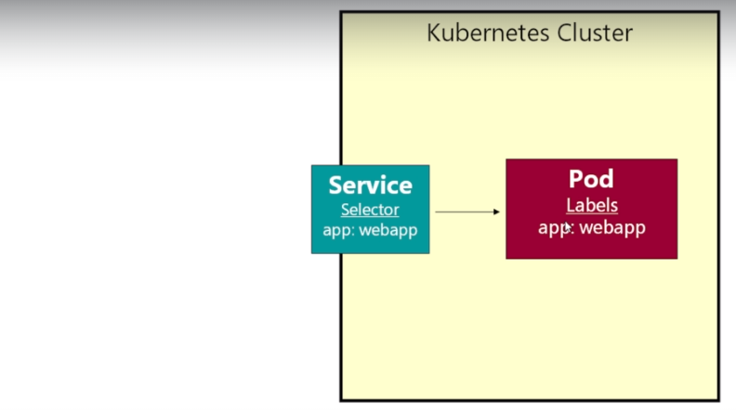

REPLICASET

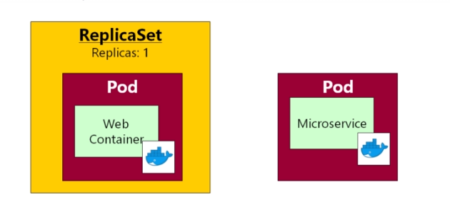

DEPLOYMENTS

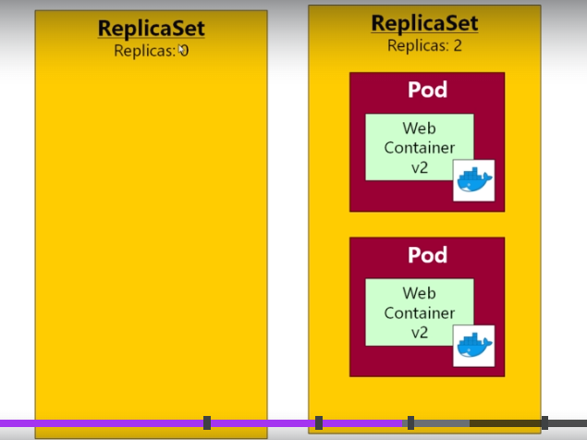

Deployments create multiple replicaset , hence unabling rollout updates without any downtime.
Moreover we can also rollback to the previous versions

KUBERNETES NETWORKING

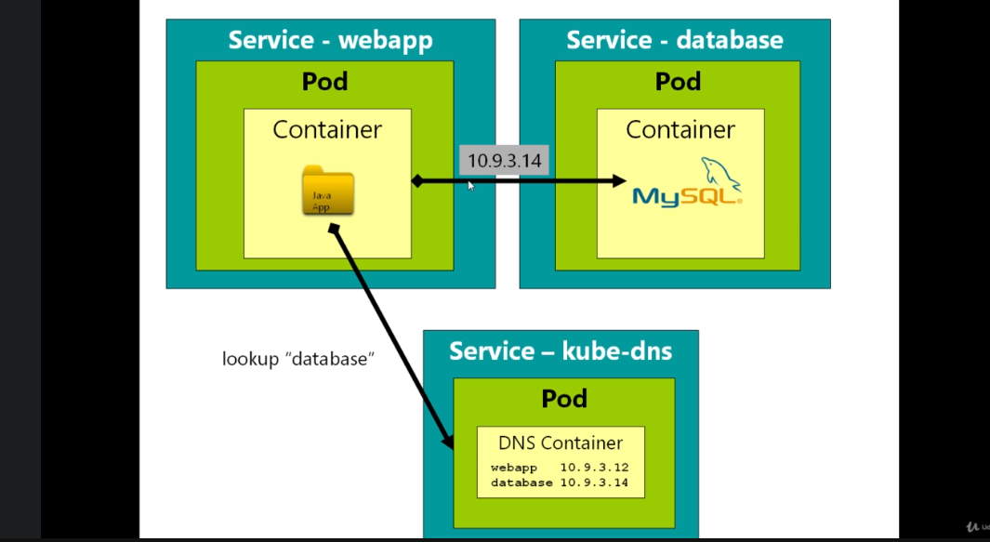

Kubernetes maintains an internal DNS service , which is helpful if one container within a Pod wants to communicate with another container in another Pod

IMPORTANT CONCEPT: Namespaces

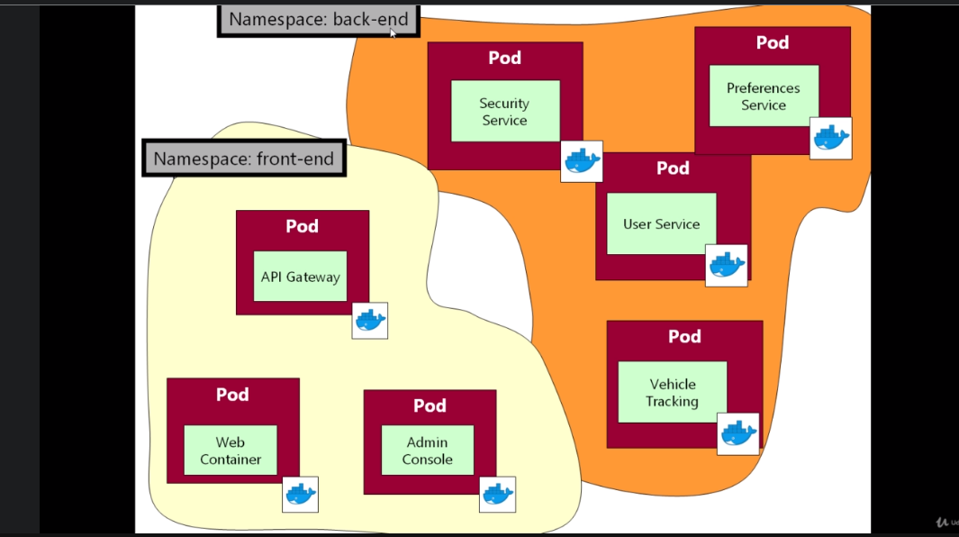

MICROSERVICES-ARCHITECTURE

