**SMART HOME IOT DEVICE AUTOMATION**

**Authors:**

* Prateek Patel
* Charchika Mishra
* Nidhi Jain
* N. Bala Yashaswini

Abstract:

Smart home robotization grounded on IoT is getting decreasingly wide in ultramodern homes. Because of advancements in computer networking technology, smart homes allow druggies to manage and ever cover a range of ménage bias and appliances. The integration of IoT bias with home robotization systems has bettered energy effectiveness, security, and comfort in living surroundings. druggies may painlessly control and automate their homes with IoT bias similar as smart thermostats, smart lighting, smart security systems, and voice sidekicks. Wireless communication technologies similar as Wi- Fi and Bluetooth enable connectivity between these bias. The relinquishment of smart home robotization technology is anticipated to grow dramatically in the coming times as a consequence of its multiple benefits, including comfort, convenience, and energy savings while also adding overall quality of life.

Introduction:

A device that can be remotely managed and controlled by the computer network, such as Wi-Fi or Bluetooth, is referred to as a smart home appliance. These gadgets are made to the improve a home's usefulness and convenience, making daily tasks simpler and more effective.

A central hub or smart speaker, which may be operated by voice commands or a mobile app, can be used to connect smart home products. These appliances can also change settings in response to external factors like temperature and humidity with the aid of sensors.

Computer networks are essential for facilities communication between smart home appliances and other devices in the house. Additionally, they give consumers a way to access and manage these devices remotely.

Computer networks serve as the foundation of a smart home ecosystem in this situation, enabling customers to benefit from a more connected and intelligent house. The options for smart home products connected to computer networks are essentially endless, ranging from smart thermostats and lighting systems to security cameras and home entertainment equipment.

Background of the research problem:

The following factors can be used to pinpoint the origins of the intelligent home equipment research problem:

As technology advances, intelligent homes are becoming more popular. The owners are provided with a quick and effective way to manage their homes to the household intelligent equipment including intelligent thermostats, WIFI system, lighting systems, and security cameras. However, there are so many issues and challenges that must be resolved/faced in order to make intelligent homes more dependable, secure, and energy-efficient.

The lack of standardization and interoperability among the many intelligent home device and system is one of the main issues with intelligent homes. Numerous intelligent home appliances use various communication protocols, which makes it difficult for them to communicate with one another. This lack of interoperability may result in compatibility issues and restrict the functionality of domestic intelligent systems.

Another issue with smart home appliances is the security and privacy risks associated with these devices. Numerous intelligent domestic appliances are connected to the Internet, making them vulnerable to cyberattacks and piracy attempts. The owners' and their families' security and privacy may be compromised as a result.

Literature Review/Related Work:

The field of smart home requirements in computer networks:

"A systematic review of the requirements engineering for smart homes" by Khan et al. (2020): This research paper provides a comprehensive overview of the existing literature on requirements engineering for smart houses. The authors are to analyze and synthesize the findings from 51 studies, highlighting the challenges, best practices, and future research directions in this field.

"Smart house requirements analysis and the specification: A case study" by Hammad et al. (2019): This paper presents a case study of requirements analysis and specification process for a smart house system. The authors discuss the methodology used, including stakeholder analysis, scenario-based analysis, and use case modeling, and highlight the challenges and lessons learned.

"An ontology-based approach for the smart house requirements elicitation" by Arslan et al. (2021): This paper proposes an ontology-based approach for requirements elicitation in smart home systems. The authors discuss the ontology design, the requirements elicitation process, and the evaluation of the approach, demonstrating its effectiveness in capturing and formalizing the requirements of smart home systems.

"User-centered requirements engineering for smart home technology: A case study" by Tang et al. (2018): This paper presents a case study of user-centered requirements engineering for smart home technology. The authors to be discuss the methodology used, including user interviews, contextual inquiry, and participatory design, and highlight the importance of involving users in the requirements engineering process.

Overall, these studies emphasize the importance of requirements engineering for smart house systems, and highlight the challenges and best practices in this field and also more benefits. Researchers are exploring various approaches, including ontology-based approaches and user-centered approaches, to capture, formalize, and validate the requirements of smart home systems.

Study Area & Data Resources:

The study area for your smart home appliances system design would probably include motifs similar as Internet of effects (IoT) , home  robotization, wireless communication protocols, and data analytics. You may also need to consider security and sequestration issues related to the smart home system.   As for data coffers, you may need to collect data on the  operation patterns of different appliances in a typical  ménage. This could include information similar as energy consumption, time of day  operation, and  frequency of use. You may also need to gather data on rainfall conditions and other external factors that could impact appliance operation.   The specific dataset you use will depend on the compass and objects of your  design. You could collect data through detectors and monitoring  bias installed in a real- world smart home system, or you could use simulated data generated through software. There are also intimately available datasets related to smart home systems that you could use for  exploration purposes.   In terms of programming languages and platforms, you may need to use a combination of different tools and technologies depending on your  design conditions. Some generally used languages for IoT and data analytics include Python, Java, and R. You may also need to work with platforms  similar as Arduino or Raspberry Pi for  tackle integration and data collection. also, you may need to use  pall- grounded services  similar as Amazon Web Services( AWS) or Microsoft Azure for data  storehouse and analysis.

Methodology:

Architecture Diagram:

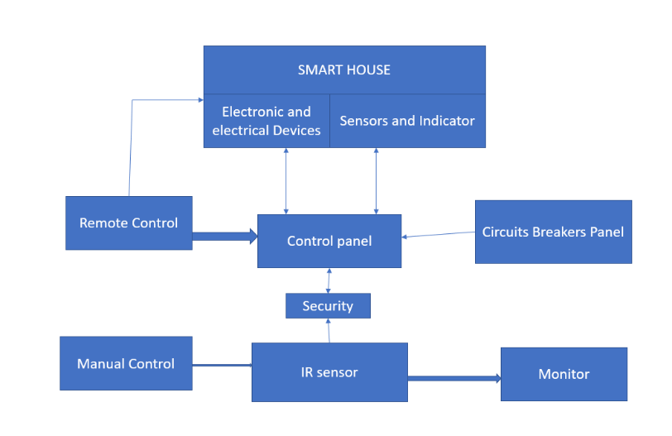

Technical details:

Wireless Network Smart home IoT  bias are connected to a wireless network using Wi- Fi or Bluetooth connectivity. The network needs to be secure to  help unauthorized access to the  bias and data.   Smart Home Hub A smart home  mecca acts as a central control system for all the connected  bias. It connects to the internet and controls the  bias through a mobile app or voice commands.   Detectors Smart home IoT bias use detectors to  descry and cover  colorful environmental parameters,  similar as temperature,  moisture, light, and  stir. Detectors can be bedded in  bias  similar as thermostats, doorbells, cameras, and smart lighting.    Smart Plugs Smart entrapments can be used to automate bias that do not have smart features. The draw can be controlled through a mobile app or voice commands and can be used to turn on/ off appliances similar as coffee makers, lights, and suckers.   robotization Rules robotization rules can be set up to detector conduct grounded on certain events or conditions. For illustration, turning off the lights when no bone

             is in the room or conforming the thermostat grounded on the temperature outdoors.   Voice sidekicks Smart home IoT bias can be controlled through voice sidekicks similar as Amazon Alexa, Google Assistant, or Apple Siri. Voice commands can be used to turn on/ off bias, set the temperature, or lock the doors.   Security Smart home IoT bias need to be secured to help hacking and unauthorized access. Security measures can include strong watchwords, two- factor authentication, firmware updates, and encryption of data transmission.

SMART HOME IOT DEVICE AUTOMATION

Home automation is building automation for a home, called a smart home or smart house. The home automation system will control lighting and appliances it also includes home security such as access control and alarm systems when connected to the Internet, home devices are an important constituent of the Internet of Things.

Objectives:

A smart home will be automated. Our smart home can make life easier and more secure. It also can save energy and time. The house is monitored all the time by some automated webcam that we are added to the house. And the most important thing is the owner of the house can access the house from anywhere in the world by using his smartphone.

Tools:

• Server

• Access Pointer

• Router

• Smart Phone

• IOT Devices: Webcam, Street Lamp, Fan, Light, Coffee-Maker, Sensor, etc.

• Motion Detector

• Switch

• Lawn Sprinkler

• Water Drain

• Wind Detector

• Smart Car

• Air Conditioner

• LED Light

Simulator:

• Cisco Packet Tracer

Implementation Details :

1. Taking servers, IoT devices, routers, switches, smartphones, wires, etc for making IOT – Smart Home.

2. We will connect all the routers. After that, we will connect the routers with the switches. Then we will connect all the switches & then all switches will connect with all IOT devices/home devices, servers & smartphones.

3. Now we will configure router 0 for giving dynamic IP address by using the DHCP protocol in Figure 1 & Figure 2.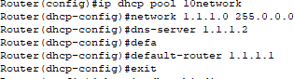

**Figure – 1 :** Configuration of DHCP protocol in router 0.

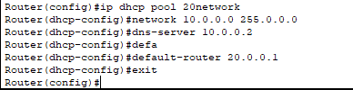

**Figure – 2 :** Configuration of DHCP protocol in router 0.

1. Now we will configure router 1 for giving dynamic ip address by using DHCP protocol in figure 3 & figure 4.

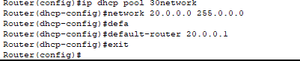

**Figure – 3 :** Configuration of DHCP protocol in router 1.

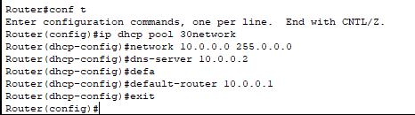

**Figure – 4 :** Configuration of DHCP protocol in router 1.

1. Now we will configure routing protocol EIGRP in router 0 so that owner of the house can access his home from any where in the world over the internet by using his smart phone in figure 5.

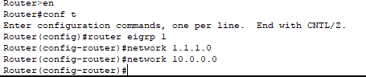

**Figure – 5 :** Configuration of EIGRP routing protocol in router 0.

1. Now we will configure routing protocol EIGRP in router 1 so that owner of the house can access his home from any where in the world over the internet by using his smart phone in figure 6.



**Figure – 6 :** Configuration of EIGRP routing protocol in router 1.

1. Smart phone accessing the server by using EIGRP routing protocol in figure 7.

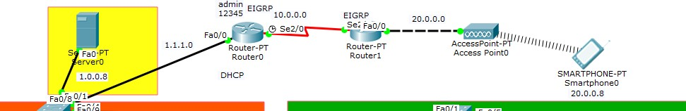

**Figure – 7 :** phone accessing the server by using EIGRP routing protocol.

1. Now we will register an account in the server for connecting all the IOT devices/home devices by giving user name & password in figure 8.

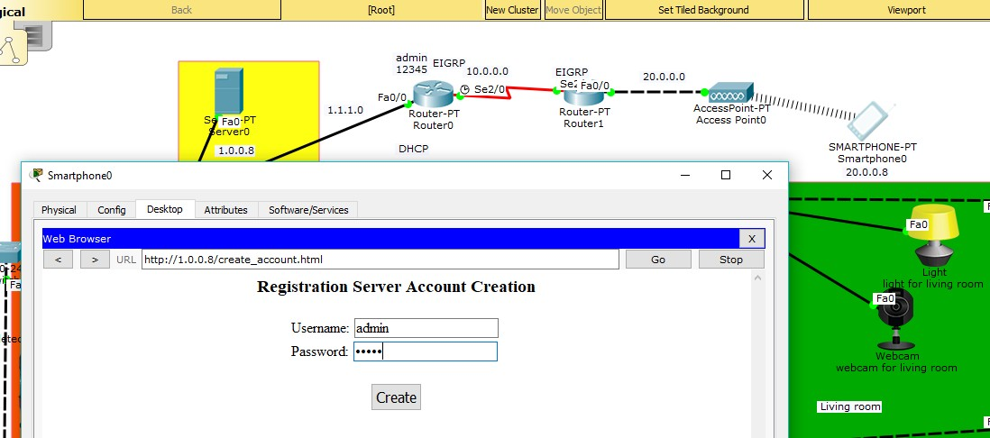

**Figure – 8 :**Registration of an account in the server.

1. Smart phone accessing the home by sign in to the server in figure 9.

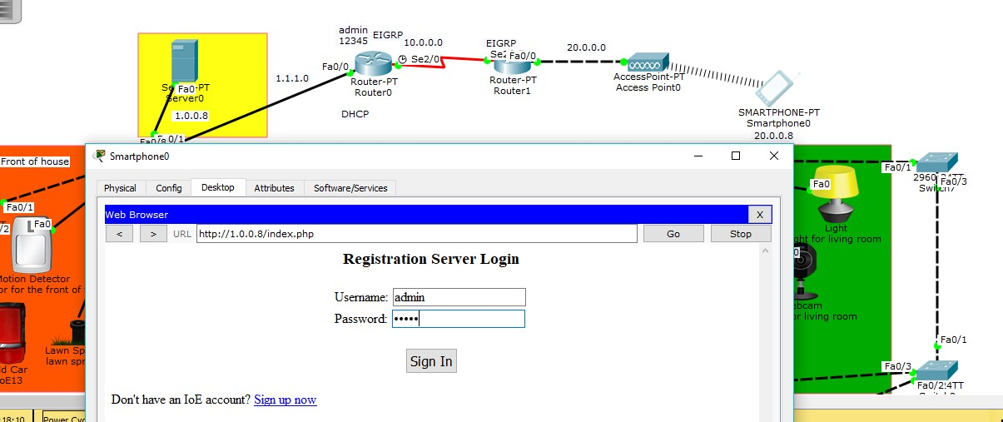

**Figure – 9 :** Smart phone accessing the home by sign in to the server.

1. After sign in to the server by using smart phone in figure 10.

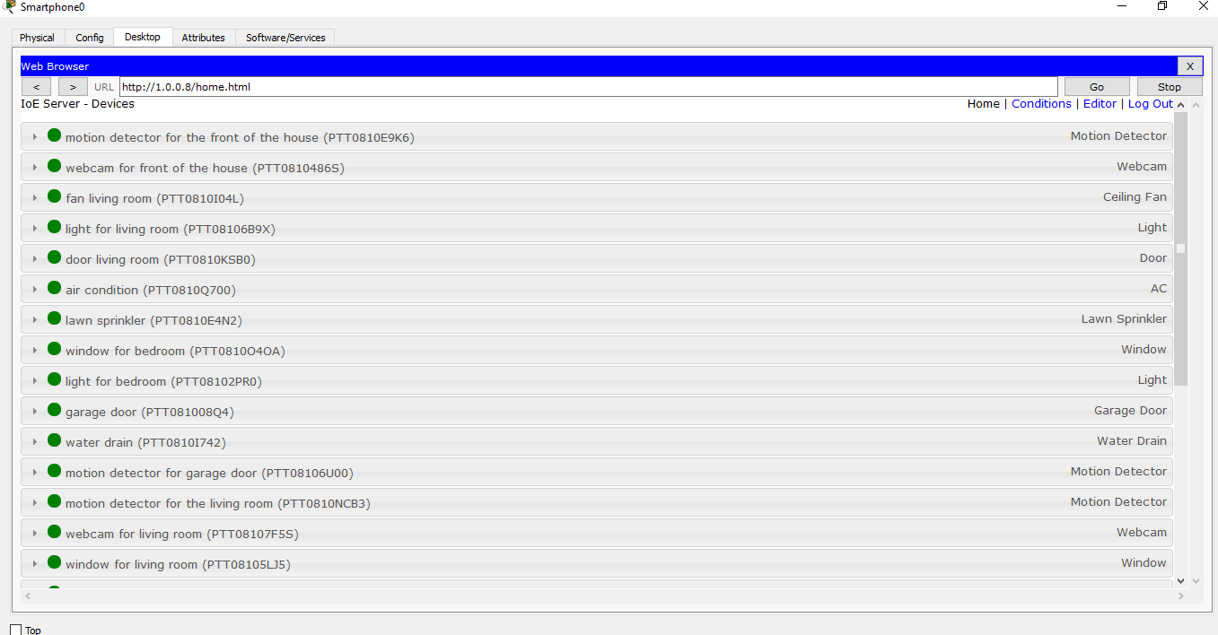

**Figure – 10 :** After sign in to the server by using smart phone.

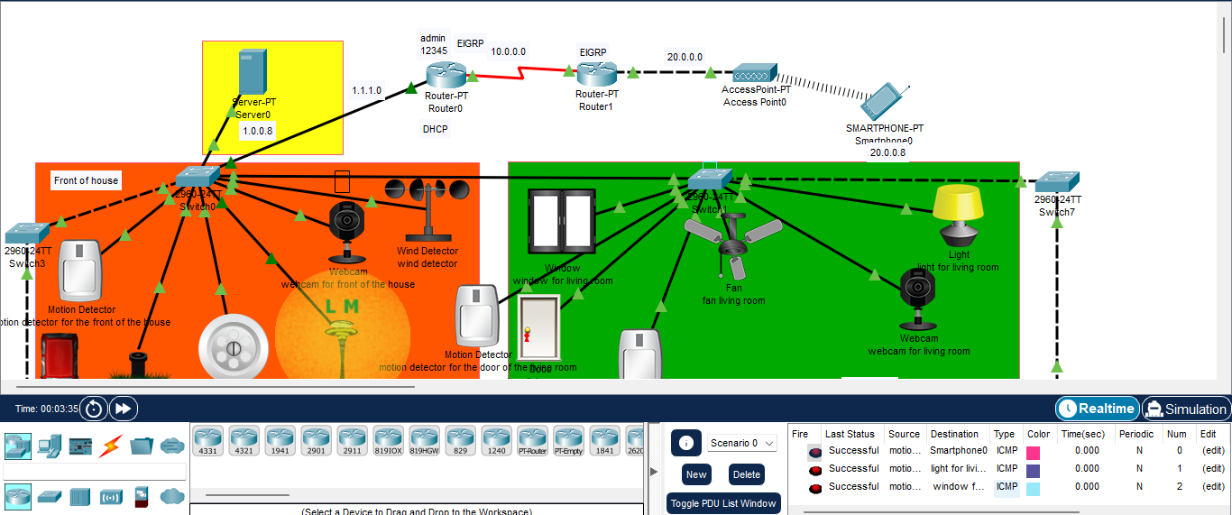

Figure-10 Packet transfer successfully from motion detector to home appliances.

# Now we will implements all the logics / conditions in the server for making automated house.

**Logics / Conditions:**

1. In front of the house when there will be someone,motion detector will detect that and webcam will be automatically on.
2. In front of the house when there will be nobody,motion detector will be off and also webcam will be automatically off.
3. In front of the house when lawn sprinkler will be on then automatically water drain will be on.
4. In front of the house when lawn sprinkler will be off then automatically water drain will be off.

In front of the house when the wind sensor detects high wind also all the windows of the house will be out. 6. When there's someone in front of the door of the living room the stir sensor will descry that & the door of the living room automatically will be on. 7. When there's nothing in front of the door of the living room also the stir sensor will be off & the door of the living room automatically will be out. 8. When there will be someone in the living room the stir sensor of the living room will descry that & all the suckers, lights, windows & webcams of the living room will be automatically on. 9. When there's nothing in the living room also the stir sensor of the living room will be off & all the suckers, lights, windows & webcams of the living room will be automatically out. 10. When there's someone in front of the door of the bedroom also a stir sensor will descry that & the door of the bedroom automatically will be on. 11. When there's nothing in front of the door of the bedroom also the stir sensor will be off & the door of the bedroom automatically will be out. 12. When there's someone in the bedroom also the stir sensor of the bedroom will descry that & all the suckers, lights & windows of the bedroom will be automatically on. 13. When there's nothing in the bedroom also the stir sensor of the bedroom will be off & all the suckers, lights & windows of the bedroom will be automatically out. 14. When the air conditioner of the bedroom is on also the window of the bedroom will automatically be out. 15. When there's any auto or anyone in the front of the garage also a stir sensor will descry that & the door of the garage automatically will be on.

16. When there is no car or nobody in the front of the garage then the motion detector will be off & the door of the garage automatically will be off.

17. When there's someone in front of the door of the kitchen the stir sensor will descry that & the door of the kitchen automatically will be on.

18. When there's nothing in front of the door of the kitchen also the stir sensor will be off & the door of the kitchen automatically will be out.

# All the conditions in figure 11

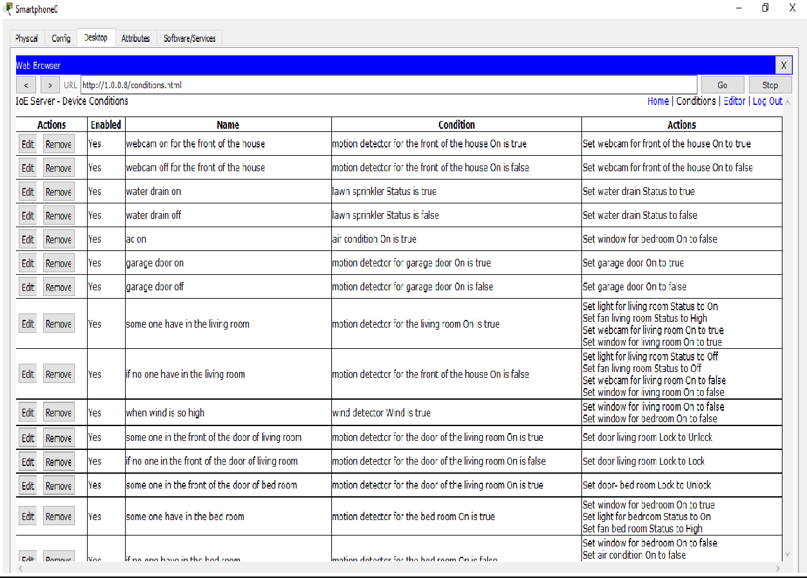

**Figure – 11 :** All the conditions.

**Design Diagram:**

**User Case Diagram-**

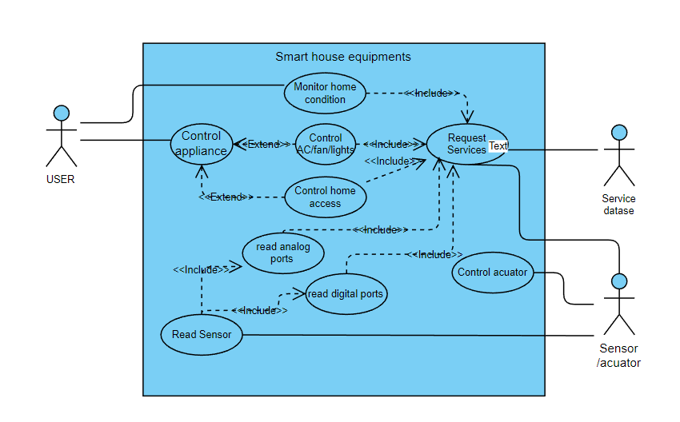

**Class Diagram-**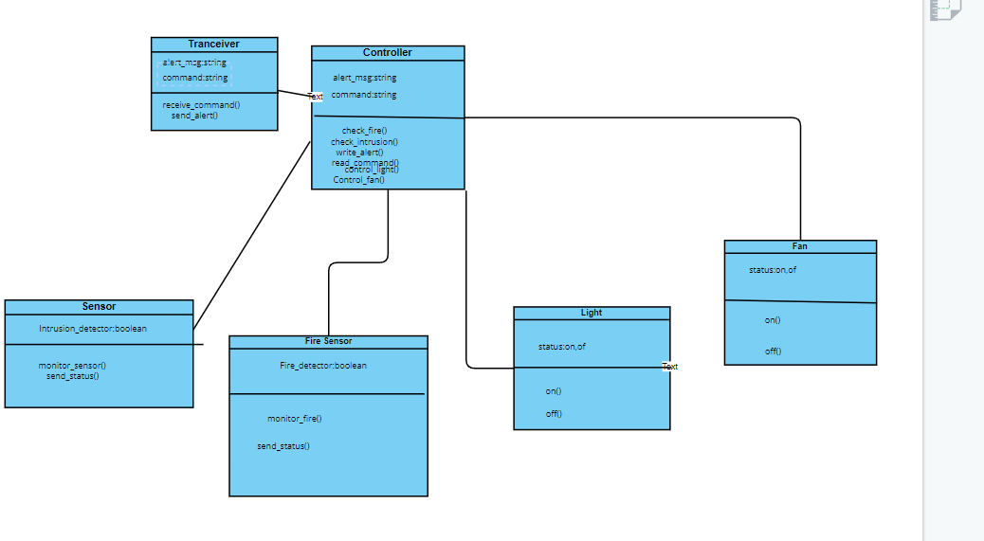

**Block Diagram-**

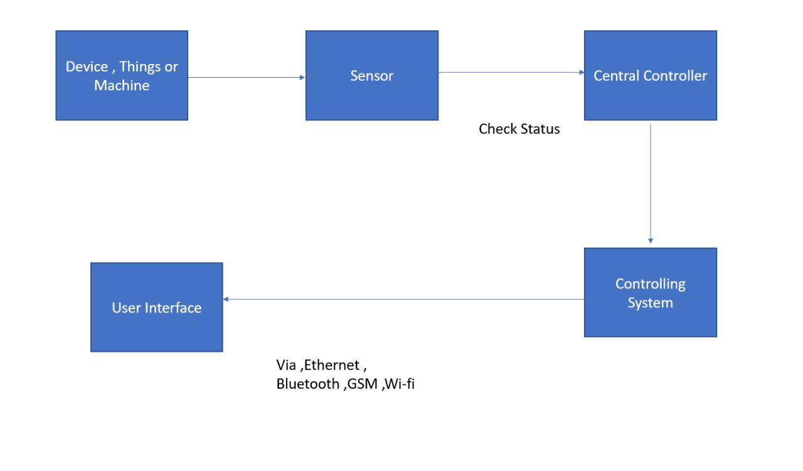

**Flow Chart-**

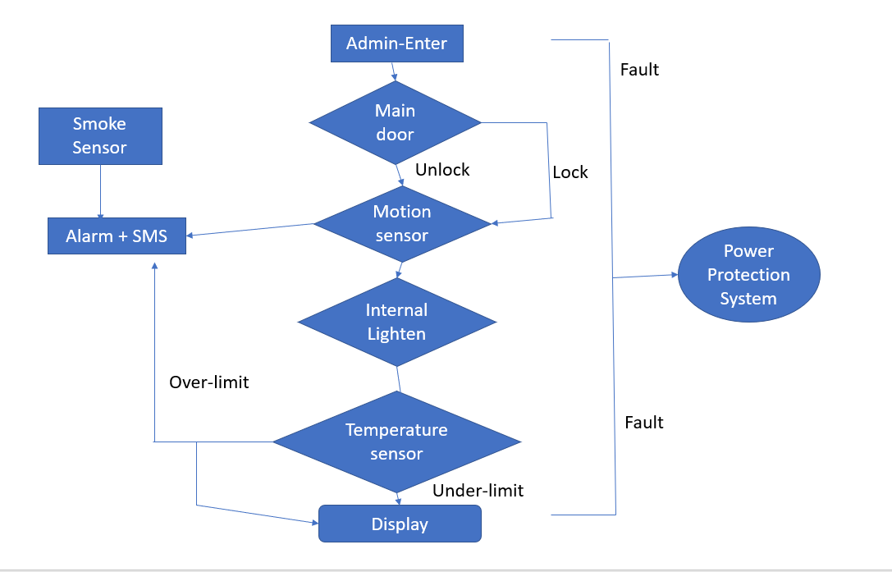

**References:**

* J. RajasekharM. Trinath BasuN. S.S. Sowjanya

Materials Today: Proceedings (2022),10.1016/j.matpr.2020.11.359

* K. NimmySriram Sankaran[...]Prasad Calyam

IEEE Access (2022),10.1109/ACCESS.2021.3137175

* Pia S. de BoerAlexander J.A.M. van DeursenThomas J.L. van Rompay

New Media and Society (2022),10.1177/14614448221133737

* Xuan DaiJian Mao[...]Jianwei Liu

Wireless Communications and Mobile Computing (2022),10.1155/2022/8022033

* Sushant Kumar PattnaikSoumya Ranjan Samal[...]Vladimir Poulkov

Sensors (2022),10.3390/s22093438

* Zhanserik NurlanTamara Zhukabayeva[...]Nurkhat Zhakiyev

IEEE Access (2022),10.1109/ACCESS.2021.3137341

* Ishan MistrySudeep Tanwar[...]Neeraj Kumar

Mechanical Systems and Signal Processing (2020),10.1016/j.ymssp.2019.106382

* Soram KimMyungseo Park[...]Jongsung Kim

Electronics (Switzerland) (2020),10.3390/electronics9081215

* Naba M. AllifahImran A. Zualkernan

IEEE Access (2022),10.1109/ACCESS.2022.3148140

* Ananya MishraJay Ghayar[...]Shilpa Shinde

ITM Web of Conferences (2022),10.1051/itmconf/20224401008

* Mustafa A. OmranBashar J. HamzaWasan K. Saad

Materials Today: Proceedings (2022),10.1016/j.matpr.2021.08.038

* Waheb A. JabbarTee Kok Kian[...]Soltan Alharbi

IEEE Access (2019),10.1109/ACCESS.2019.2942846

* Rizwan MajeedNurul Azma Abdullah[...]Muhammad Umer

Scientific Programming (2020),10.1155/2020/4579291

* Afrizal ZeinEmi Sita Eriana SAINSTECH: JURNAL PENELITIAN DAN PENGKAJIAN SAINS DAN TEKNOLOGI (2022),10.37277/stch.v31i2.1156
* Samrah ArifM. Arif Khan[...]Muhammad Imran

IEEE Access (2020),10.1109/ACCESS.2020.3004662

* Sameer AlaniSarmad Nozad Mahmood[...]Azzam Amer Dhannoon International Journal of Electrical and Computer Engineering (2021),10.11591/ijece.v11i1.pp442-450
* Mansoor NasirKhan Muhammad[...]Muhammad Sajjad Neurocomputing (2022),10.1016/j.neucom.2021.04.138
* Suriya Priya R. AsaithambiSitalakshmi VenkatramanRamanathan Venkatraman

Big Data and Cognitive Computing (2021),10.3390/bdcc5010006

* Cristina Stolojescu-CrisanCalin CrisanBogdan Petru Butunoi

High-Confidence Computing (2022),10.1016/j.hcc.2021.100036

* Rajiv P.Raj R.Chandra M.

Perspectives in Science (2016)

* Yang Y.Xu C.Shi H.2022 2nd International Conference on Consumer Electronics and Computer Engineering, ICCECE 2022 (2022)
* Hamza N.Al-Harthi A. K.Al-Safri M. H.International Journal of Computer Applications Technology and Research (2018)
* Le T.Mutka M. W.IoTDI 2019 - Proceedings of the 2019 Internet of Things Design and Implementation (2019)
* Kanchi S.Karlapalem K.CODASPY 2021 - Proceedings of the 11th ACM Conference on Data and Application Security and Privacy (2021)

# Result and discussion :

In our smart home we are taking front of the house, living room, bed room, Garage, and Kitchen and also making them automated.We are using the server for the main connection and to connect smart phone we are using router. For routing we are using EIGRP.

***Front of the House:** In the front of the house we have,

* + Motion sensor
  + Webcam
  + Wind Detector
  + Street Lamp
  + Lawn Sprinkler
  + Water Drain
  + Car

Initially all things are off.

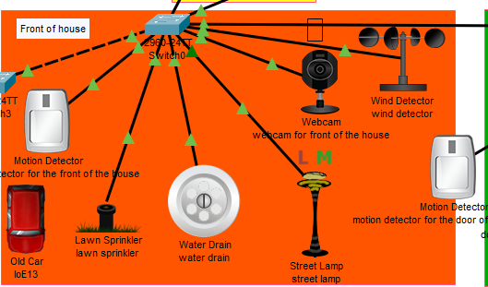

**Figure 12: Front of the house before turned on**

When a motion is detected by the motion detector, then the webcam, street light and wind detector will turned on. Automatic water drain will be opened when the water sprinkler is turned on and drain the excess water.

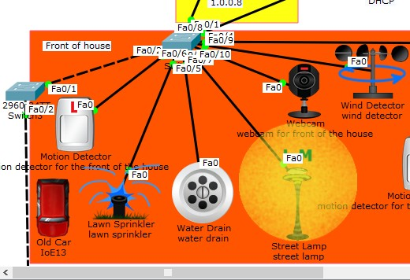

**Figure 13:Front of the house after turned on**

***Living room:** In the living room we have,

* + Motion sensor
  + Door
  + Webcam
  + Fan
  + Window
  + Light

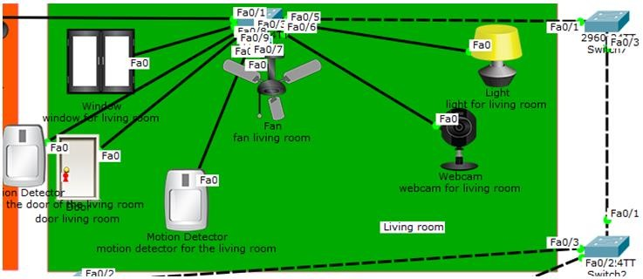Initially all things are off.

**Figure 14: Living room**

When the motion happens in front of the door of the living room, the door itself is open automatically. After entering the room, light, fan, webcam and window will run. If it needed then user can control light, fan by his smart phone.When we will be out of the room, the lamp, fan, window, webcam will then turn off itself.

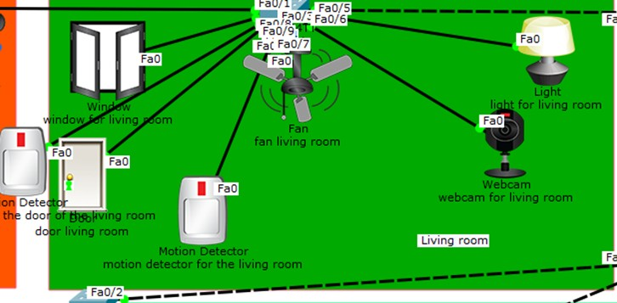

**Figure 15: living room fan, light, webcam is running and window is open**

***Bedroom:** In bed room we are taking,

* + - Motion detector
    - Door
    - Window
    - Light
    - Fan
    - Air conditioner

At the first point all the IOT device will stay in turn off.

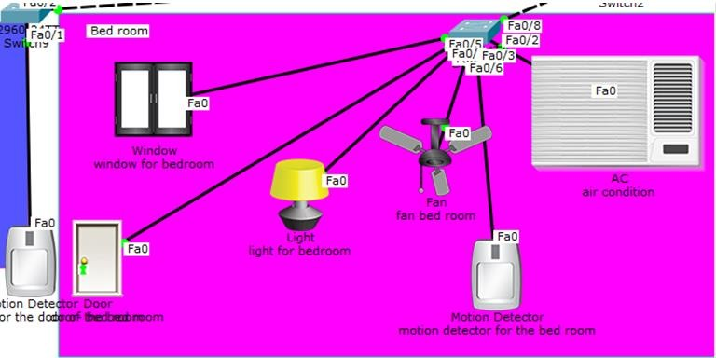

**Figure 16: Bedroom, initial state**

When the motion happens in front of the door of the living room, the door itself is open automatically.After entering the room, light, fan, window will run.

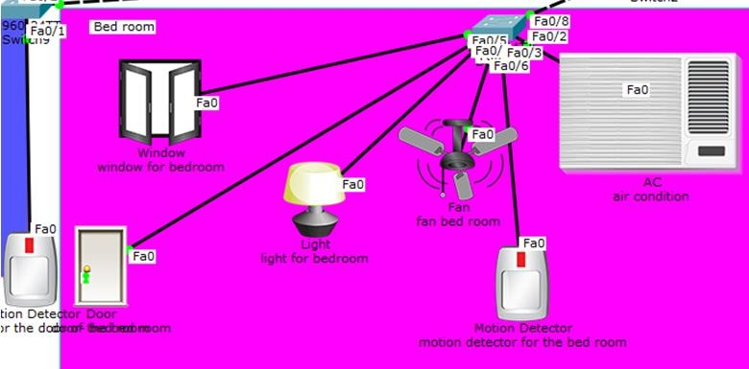

**Figure 17: Bedroom light, fan, window on**

But when the users turn on the air conditioner, bedroom fan and window will automatically turn off.

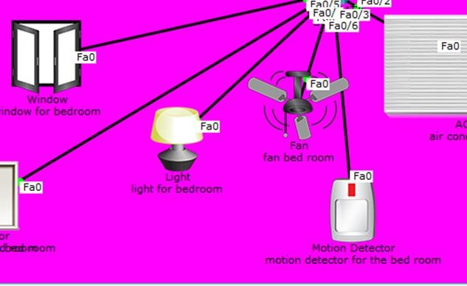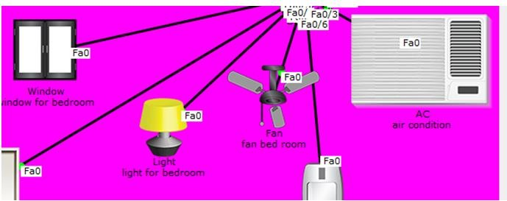

**Figure 19: Bedroom AC off, fan, window on**

**Figure 18: Bedroom AC on and fan, window off**

* **Garage:**

* + - Car
    - Garage Door
    - Motion Detector

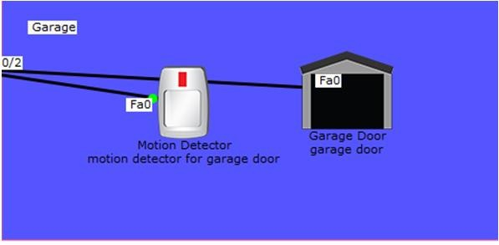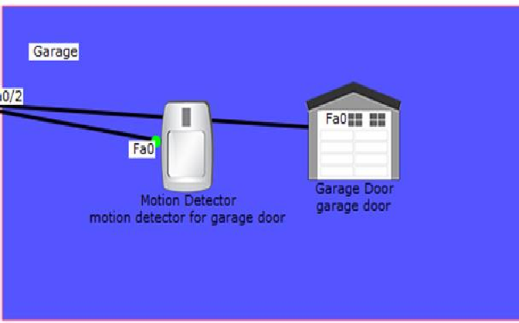If the car stays In front of the door of the garage, the garage door will open itself.

**Figure 21: Garage door closed Figure 20: Garage door open**

# Kitchen:

* **Kitchen:**

* + - Motion detector
    - Kitchen Door
    - Coffee Maker
    - Other IOT devices

As other rooms kitchen door will open itself. And after entering the kitchen Coffee maker and other IOT device will turn on as well.

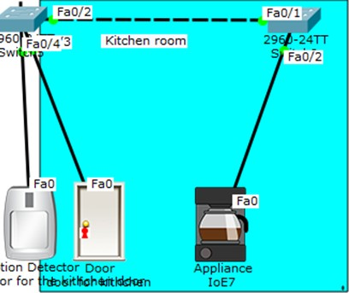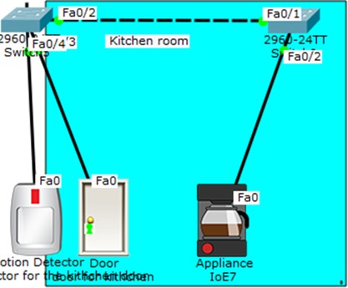

**Figure 23: Kitchen Figure 22: Every device of the kitchen is turned on.**

# Conclusion:

In the IOT-Smart Home project we have tried to build an automated home that can make life easier, secure, and comfortable. And the house also will save power. The owner of the house can access the house from anywhere of the world by using his smart phone. Though it is a costly project but after implemented it, our life will be easier and time saving.