QUANTITATIVE SYSTEM DESIGN

Cash-Equity Intraday
Alpha Discovery System
  - A meta-algorithm architecture for bounded strategy search, universe selection, turnover economics, robust validation, and Python-to-Rust deployment
NSE cash equities • scalping-to-intraday • capital below ₹10 lakh
Research | Production | Market data | Execution contexts
Python | Rust | ICICI Direct Breeze* | Flattrade / Zerodha

*Separate market-data and order APIs; see the pre-live data-use check in this blueprint.
Version 1.0 | Information verified through 27 August 2026

Contents
A decision-oriented reading map. Section numbers follow the build sequence from mandate through live operation; appendices make the protocol executable.
Foundations and discovery | Validation, deployment and operation
Executive decision | 8. Simulator, costs and turnover
1. Mandate and boundary | 9. Portfolio construction below ₹10 lakh
2. Meta-algorithm architecture | 10. Validation architecture
3. Data architecture and Breeze feasibility | 11. Multiple testing and overfitting control
4. Point-in-time universe selection | 12. Choosing the top three to five bundles
5. Typed alpha-component library | 13. Python research to Rust production
6. Sessions, market state and regime routing | 14. Risk architecture
7. Bounded search without brute-force bias | 15. Regulatory and broker controls
Appendix A — Meta-search pseudocode | 16. Staged go-to-market plan
Appendix B — StrategyBundle manifest | 17. Concrete first research campaign
Appendix C — Pre-live checklist | 18. Operating cadence and rejection list
Appendix D — Source register | Source notes and verification dates

Decision path
1 · Define | 2 · Discover | 3 · Disprove | 4 · Release
Freeze scope, data, costs and search grammar. | Generate causal, typed pipelines within fixed budgets. | Stress costs, regimes, folds and multiple testing. | Promote only diverse bundles through shadow and live gates.

HOW TO USE THIS DOCUMENT Parts I–III define what may be searched. Parts IV–VIII define how it is simulated and validated. Parts IX–XII define promotion, live architecture, risk, and staged launch. The appendices provide the concrete starter protocol, bundle schema, pseudocode, and source register.

Executive decision
RECOMMENDATION Build a research factory that produces a small set of versioned StrategyBundles—not a single all-purpose bot and not a leaderboard of thousands of backtests. Each bundle must bind its universe policy, session, signal graph, broker/capital cost model, portfolio rules, execution policy, risk limits, and validation evidence.

The system can comprehensively explore a declared search grammar, but it cannot find a globally optimal strategy over an unbounded space. Testing more variants without statistical discipline increases the probability of selecting noise. The honest target is the most robust non-dominated set within a predeclared, economically plausible, causally valid search space.
Optimal = arg max {robust net utility | data version, universe policy, broker costs, capital, risk constraints, search budget}
- Output. Up to three to five deployable, mutually useful StrategyBundles. If only one or two clear the gates, promote only those.
- Initial research floor. One-minute causal replay for roughly 3–120 minute holding periods; true sub-minute scalping waits for collected quote/trade/depth data and calibrated fills.
- Breadth. Search dynamic liquidity-ranked universes of 50, 100, 150, and 300 NSE names; do not optimize a hand-picked ticker list.
- Turnover. Make rebalancing, holding time, no-trade bands, position count, and ticket size endogenous. Optimize net capital efficiency, not trade count.
- Broker context. Run every surviving strategy separately at ₹2 lakh, ₹5 lakh, and ₹10 lakh under current Flattrade and Zerodha cost/operational assumptions.
- Technology. Python owns data, research, fitting, search, and reports. Rust owns the live state machine, risk, orders, recovery, and reconciliation.
- No generative AI. The research and production loops are deterministic/statistical. They need no LLM or generative component.

Pre-live data-use check for the separate-API design
GATE 0 — DATA-USE AUTHORITY The chosen architecture uses Breeze only as a read-only market-data API and a separate broker API for orders; no Breeze quote needs to be sent to the execution broker. ICICI’s current FAQ nevertheless says Breeze is for individual/personal trading and prohibits integration with third-party applications for trading. It explicitly supports self-built code on the customer’s own computer, but publishes no data-only exception for signals executed through another broker. Obtain written ICICI clarification before live release; otherwise use the execution broker’s feed or a separately licensed source. Never redistribute Breeze quotes. ^{[S3] [S4] [S5]}

The blueprint preserves this exact technical split: BreezeDataAdapter is read-only, while FlattradeOrderAdapter and ZerodhaOrderAdapter have the only order permissions. The permission check is a pre-live release gate, not an architecture change. Zerodha’s Connect tier currently includes live WebSocket data and historical candles for ₹500/month; Flattrade advertises a free API/data context. These remain fallback inputs if their own terms and entitlements are confirmed for the intended personal algorithm. ^{[S13] [S17]}

What success looks like
Deliverable | Acceptance meaning
Search protocol | Frozen grammar, budgets, folds, costs, seeds, promotion rules, and one-use lockbox before finalist testing.
Research registry | Every completed, failed, abandoned, and manually viewed trial is logged under a content hash.
Top 3–5 bundles | Pareto-diverse candidates with full broker/capital context, not five nearby parameter variants.
Rust release | Golden replay matches Python bars, features, regimes, forecasts, targets, order intents, and risk rejections.
Operational proof | Shadow/paper evidence, actual slippage, recovery drills, reconciled positions, and zero unintended overnight exposure.

1. Mandate and boundary

1.1 Frozen initial mandate
- Instrument class: NSE cash equities; BSE stays out until an independently verified entitlement and instrument history are available.
- Horizon: fast intraday through end-of-day; every position flat before the broker-, product-, side-, and instrument-specific cutoff.
- Directions: long/flat plus intraday long/short only where current broker and exchange eligibility permit it.
- Capital contexts: ₹2 lakh, ₹5 lakh, and ₹10 lakh; initial limited live operation is unlevered.
- Execution: limit or protected marketable-limit logic; pure algo market orders are not assumed to be available.
- Excluded initially: overnight inventory, derivatives/options, market making, sub-second queue alpha, and passive-fill claims unsupported by historical order-book data.
Breeze’s current API reference lists NSE support and says BSE/MCX are unavailable, while parts of the SDK contain conflicting examples. The safe scope is NSE cash until account-level testing or written confirmation resolves that conflict. ^{[S1] [S2]}

1.2 What ‘scalping’ may honestly mean
Research lane | Data required | Credible claims | Not credible yet
1-minute bar lane | Completed 1-minute OHLCV; next-event fills | 3–120 minute forecasts, aggressive-limit scenarios, cost sensitivity | Queue position, same-bar stop ordering, sub-minute spread capture
1-second bar lane | 1-second OHLCV/LTP bars plus live spread calibration | Fast price/volume features with conservative execution stress | Historical bid/ask/depth or precise passive fills
Tick/depth lane | Locally captured quotes, depth, trades, receive timestamps, gaps | Sub-minute execution and microstructure research after calibration | Exchange-colocation/HFT assumptions

CAUSALITY RULE A signal computed from completed bar t cannot fill on bar t. Its earliest simulated fill is the next executable event after decision and broker latency. If both stop and target occur inside one OHLC bar, use tick replay or the adverse sequence.

1.3 Formal objective: edge × rotation, after reality
Turnover is useful only while incremental opportunities retain positive net edge. As rotation rises, weaker signals are admitted, tickets fragment, spread/impact rise, and correlated positions compete for the same capital. The optimizer must model actual capital reuse through time rather than multiplying a backtest edge by an arbitrary trade count.
E[r_day^net] ≈ R · [e(R) − c(R)] and R* = arg max_R R[e(R) − c(R)]
Net P&L_t = q_(t−1)ᵀ(P_t−P_(t−1)) − C_b(Δq_t, market state_t)
Metric | Definition | Why it matters
Net return on NAV | Daily net P&L ÷ start-of-day equity | Actual ROI; traded notional is not capital.
Gross-notional turnover | Σ |executed notional| ÷ average equity | Measures trading load and costs.
Round-trip rotation | Gross-notional turnover ÷ 2 | Approximate capital recycling when buys and sells pair.
Net bps per turnover | Net P&L ÷ gross traded notional | Separates edge quality from activity.
Capital-time efficiency | Net P&L ÷ exposure integrated over session | Rewards rapid reuse without pretending idle capital was deployed.

2. Meta-algorithm architecture
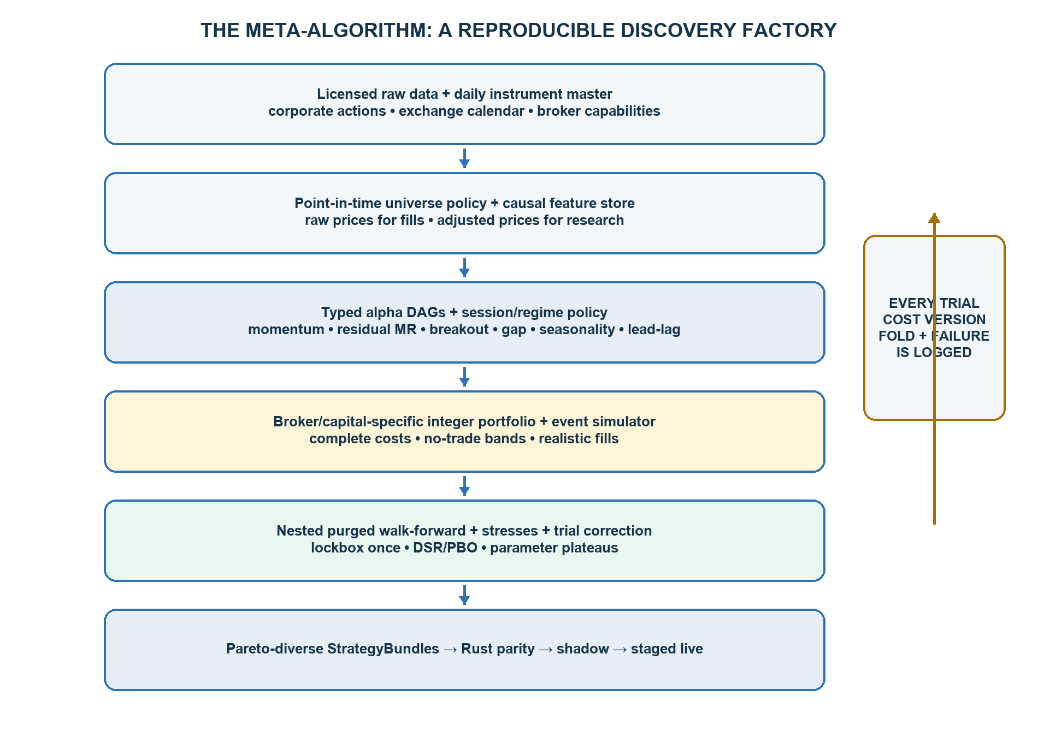
Figure 1. The discovery system produces auditable StrategyBundles; validation and stress results feed back into the registered research process.

2.1 The unit of discovery is a StrategyBundle
A StrategyBundle is a complete deployable specification, not an isolated signal. It binds the following items under one immutable identity:
- Point-in-time universe policy and daily membership snapshot.
- Bar resolution, decision clock, feature graph, warm-up, missing-data policy, and numerical version.
- Session buckets, regime inputs, forecast calibration, and forecast expiry.
- Portfolio constraints, integer rounding, entry/rebalance/exit logic, and turnover controls.
- Broker, capital tier, fee schedule, fill model, latency model, and cost-stress version.
- Independent risk-policy reference, new-entry cutoff, flatten schedule, and failure behaviour.
- Code/data/split hashes, trial lineage, validation evidence, golden fixture, and bundle checksum.

2.2 Typed pipeline grammar
UniversePolicy
→ BarBuilder → DataQualityGate → RawFeatureBlocks
→ [FactorResidualizer] → Normalizer → AlphaFamilyModules+
→ ForecastCalibrator / Ensembler → [SessionRegimeGate]
→ PortfolioWrapper → ExecutionPolicy → ExitPolicy → RiskPolicy
‘Any method in any order’ is not a useful search space. The grammar permits only semantically valid compositions. Residualizing raw returns before computing momentum is distinct from computing raw momentum and then sector-demeaning its score; each has a canonical graph identity. Algebraically duplicate graphs hash to one trial.
Module contract | Required declaration
Input/output | Typed fields, units, time semantics, cross-sectional vs time-series scope
Causality | Maximum lookback, warm-up, decision availability, forbidden future fields
State | Rolling buffers, reset rules, fold-boundary handling, restart serialization
Missing data | Skip, stale, carry-forward, or impute policy; every policy explicit
Parameters | Bounded schema, permitted transforms, default and search distribution
Implementation | Version, numerical precision, rounding, Python/Rust parity tolerance

3. Data foundation and feasibility

3.1 What Breeze can and cannot supply
Capability | Current official statement | Engineering consequence
REST quota | 100 calls/minute and 5,000/day; a marketing page still says 75/minute | Throttle to ≤75/min until confirmed; cache every response.
Historical v2 | 1-second, 1-minute, 5-minute, 30-minute, 1-day; 1,000 candles/request | Chunk by candle count; broad one-second history is slow to acquire.
History depth | Landing pages say 3 years; SDK README claims 10 years | Budget on 3 years; probe earliest valid date per symbol.
Corporate actions | Historical series are not adjusted | Maintain raw and adjusted prices; never use adjusted prices for fills.
Live stream | Tick-by-tick quotes, best bid/ask, quantities, aggregate volume; live depth channel exists | Capture locally with exchange and receive timestamps; no public SLA/replay guarantee.
Subscriptions | Up to 2,000 scripts across OHLC/live streaming | A 300-name universe is nominally feasible; load-test combined quote/depth channels.
Instrument master | Daily security master updated around 08:00 | Snapshot it every day; never overwrite history.
Service warranty | Timeliness, sequence, accuracy, completeness and availability are not guaranteed | Staleness/gap controls and independent reconciliation are mandatory.

Official sources conflict on history depth, supported exchanges, and the minute-level request limit. A feasibility probe must become a saved artifact before the search budget is approved. ^{[S1] [S2] [S5]}

3.2 Backfill economics
The 1,000-candle response cap and 5,000-call daily quota make one-second breadth expensive even when the endpoint technically supports it. The estimates below are lower bounds: 250 trading days/year, 375 one-minute bars/day, 22,500 one-second bars/day, full 1,000-candle responses, no retries, and constant symbol history.
Resolution / scope | Approx. calls | Minimum quota days | Use
1-minute • 100 names • 3 years | 28,200 | 5.6 | Primary broad research lane
1-minute • 300 names • 3 years | 84,600 | 16.9 | Extended universe / robustness
1-minute • 100 names • 5 years | 47,000 | 9.4 | Longer regime history if available
1-second • 100 names • 1 year | 562,500 | 112.5 | Too slow for naïve broad backfill
1-second • 300 names • 1 year | 1,687,500 | 337.5 | Not a practical first milestone

DATA PLAN Backfill 1-minute data for the dynamic 100/150/300 research pools, then begin a forward raw quote/depth capture immediately. Use one-second/tick research only on a smaller, predeclared liquid subset until a sufficient forward archive exists.

3.3 Canonical point-in-time store
Dataset | Minimum fields / rule
instrument_master_daily | date, exchange token, stable instrument ID, symbol, ISIN, series, tick, price band, listing/delisting, sector, broker product eligibility
bars_raw | instrument, interval, start/end, raw OHLCV, source, ingest time, completeness flags
quotes_ticks | exchange timestamp, receive timestamp, bid/ask + size, LTP/LTQ, cumulative volume, depth, validity/gap flags
corporate_actions | announcement/ex date, split/bonus/dividend terms, point-in-time source, adjustment factor
exchange_calendar | normal/special sessions, CAS eligibility, holidays, halts, pre-open and close transitions
broker_capability | effective date, instrument/product/side eligibility, leverage/margin, cutoff, order types, rate limits
orders_fills | intent, submission/ack/exchange/fill timestamps, status transitions, fees, rejection, slippage, broker truth

- Append-only raw partitions; corrected data creates a new snapshot, never a silent overwrite.
- Asia/Kolkata exchange calendar plus UTC storage; clock sync and receive timestamps are mandatory.
- Adjusted series for return/factor research; raw traded prices for tick rounding, quantities, price filters, fills, fees and P&L.
- Every missing or stale interval is explicit. A zero-volume bar is not interchangeable with a missing bar.
- Cross-sectional normalization waits for a decision cutoff, then uses only instruments whose bar was available by that cutoff.

4. Point-in-time universe discovery

4.1 Universe is a daily policy, not today’s constituent list
Eligible_(i,d) = 1{listed ∧ series allowed ∧ broker-MIS allowed ∧ history sufficient ∧ data valid ∧ restrictions clear}
L_(i,d) = z(log median ₹-volume) − 0.75z(spread_bps) − 0.50z(Amihud) − 0.25z(gap_rate)
U_d(N) = Top-N liquidity scores computed only from information available by close d−1
Do not search individual stock inclusion as an alpha parameter. That is a high-dimensional route to selection bias. Search a small set of interpretable, execution-oriented policies; their weights are fixed or stress-tested for liquidity, not tuned to maximize strategy P&L.
Policy dimension | Starter values | Guardrail
N | 50, 100, 150, 300 | Equal development budget; 200 may be added only if useful.
Liquidity lookback | 20, 40, 60 sessions | Use prior sessions; prefer median/lower quartile over one-day volume.
Refresh | weekly, monthly; daily as stress | Membership fixed for each session.
Listing history | 60, 120, 250 sessions | Warm-up requirement binds.
Stable-core buffer | enter above N−k; exit below N+k | Reduces membership churn and hidden warm-up effects.
Sector balance | unconstrained vs minimum/maximum per sector | Policy must be point-in-time.
Shortable lane | current broker/exchange whitelist | Cash naked-short assumptions are prohibited.

4.2 Daily eligibility gates
- EQ/approved series, normal continuous trading, not suspended, and not forced into an incompatible auction/trade-to-trade process.
- Current broker product and side eligibility; short availability must be explicit and may differ from long eligibility.
- No unresolved token/symbol change, insufficient history, or warm-up gap.
- Prior-day liquidity and spread proxy above operational floors; price and volatility within broad predeclared bounds.
- Corporate-action and extraordinary-session flags available before the open; exclude when adjustment/auction handling is uncertain.
- Intraday causal liquidity gate may veto a trade, but the completed day’s volume cannot retrospectively add a stock to that day’s universe.
SURVIVORSHIP AUDIT If the available history contains only currently listed names or current broker eligibility, label every result survivorship-biased. No candidate may be promoted until listings, delistings, token changes, corporate actions and daily eligibility have adequate archival coverage.

5. Injectable alpha library

5.1 Common forecast contract
Forecast {
strategy_id, family_id, instrument_id, decision_time,
expected_return_bps, confidence, forecast_horizon,
half_life, valid_until, capacity_notional, validity_flags
}
Every alpha outputs expected return in basis points and an expiry, independent of order logic. The portfolio layer can then compare forecasts on a common economic scale, net them across families, and decline trades whose expected benefit does not clear marginal cost and uncertainty.

5.2 Initial families and bounded hypotheses
Family | Core causal features | Starter knobs | Primary risks
Cross-sectional momentum | Vol-scaled 3–120m returns; sector/market relative strength; volume/breadth | lookback, skip, rank cut, hold, cadence | micro-reversal, crowded open, churn
Residual momentum | Market + sector regression or trailing PCA residual sums | factor window, residual horizon, shrinkage | unstable betas, factor leakage
Residual mean reversion | Robust residual z-score, half-life, liquidity/volume/event gates | 2–60m residual window, entry/exit z, cooldown | new information mistaken for dislocation
Breakout / vol expansion | Prior range, compression, volume shock, breadth and sector confirmation | range 5–90m, compression/volume thresholds | false breaks and late fills
Gap / open digestion | Gap vs market/sector, opening volume, opening range, peer response | gap bins, 5–60m window, continue/fade as separate families | open spread and timestamp errors
Seasonality | Stock/sector × same time-slot returns, day/session effects | slot width, shrinkage, minimum history | weak effect, multiple testing
Slow lead-lag | Index/sector/large leader lags into stock returns | 1–15m lags, residual control, horizon | synchronous-clock artefacts
Microstructure later | Spread, imbalance, depth change, trade sign and replenishment | only after tick/depth archive | no historical queue; latency race

5.3 Robust normalization and combination
z_(k,i,t) = clip[(α_(k,i,t) − median_i α) / (1.4826·MAD_i α + ε), −z_max, z_max]
μ̂_(i,t) = κ_(regime,session) · Σ_k w_(k,regime,session) z_(k,i,t)
- Always-on equal-weight and ridge-weighted ensembles are mandatory baselines.
- Use ridge/elastic-net shrinkage, maximum family weights, and leave-one-family-out ablation.
- Fit scalers, winsor limits, factor exposures, weights, calibrators, and regime thresholds inside each training fold.
- Combine only forecasts evaluated on identical folds, costs, latency and capital contexts.
- A two- or three-family ensemble advances only when its incremental net value survives ablation and cost stress.
- Complex session/regime weights shrink toward one global weight; no small regime receives a free parameter set.

6. Sessions and regimes

6.1 Session state is an input, not an afterthought
State | Initial research window | Typical hypotheses | Operational note
OPEN_SHOCK | 09:15–09:30 | gap continuation/reversal, opening imbalance, range expansion | Highest spread/slippage; next-event fills only.
OPEN_DIGEST | 09:30–10:30 | momentum, opening range, sector confirmation | Separate from first 15 minutes.
MID | 10:30–14:30 | residual MR, slower lead-lag, seasonality | Often lower spread and volatility.
LATE_CTS | 14:30 to broker/CAS cutoff | continuation, rebalance/flow proxies | Cut short by product-specific RMS.
CAS | NSE F&O-eligible cash names: 15:15–15:35 | auction imbalance/forced flow only with specific data/fill model | Phase 1 CAS is separate from continuous trading.
FLATTEN_ONLY | Configurable safety buffer | No alpha entries | Independent risk layer owns exits.

NSE’s current Closing Auction Session applies in Phase 1 to cash stocks with derivative contracts. It runs 15:15–15:35, with order entry and matching subperiods. Zerodha currently starts MIS square-off for CAS stocks at 15:12, so a normal MIS strategy cannot assume it can carry those positions into the auction. Flattrade’s published cutoff material is internally inconsistent. Session eligibility must therefore be broker × product × instrument × side, snapshotted daily—not a single hard-coded time. ^{[S7] [S14] [S20]}
CLOSING RULE Until auction-specific data, broker support, and fills are validated, treat 15:15 CAS as a separate future strategy family. Phase 1 should flatten CAS-eligible MIS exposure before the earliest broker cutoff and never rely on broker auto-square-off.

6.2 Regime policy
Start with two to four interpretable, causal states using index volatility percentile, cross-sectional dispersion, breadth, trend, gap, volume/liquidity and spread proxies. Percentiles and classifier parameters are training-only.
μ̂_(i,t) = Σ_g p_(g,t) μ̂_(i,t,g), where p_g is a soft, trailing-data regime probability
- Minimum independent trading days per regime; hard gates with tiny samples are rejected.
- Every gated strategy is compared with its always-on parent on identical outer folds.
- Add a complexity penalty for every split; prefer soft shrinkage and hysteresis to rapid on/off switching.
- A gate advances only if incremental net value is positive in most outer folds and not driven by one event.

7. Bounded comprehensive search
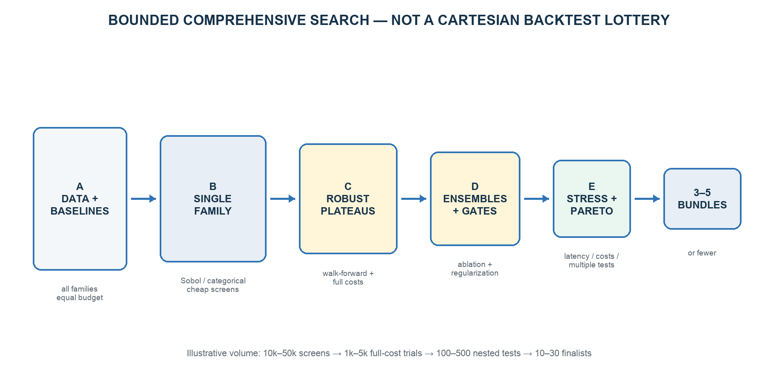
Figure 2. Search depth rises as candidate count falls; expensive nested validation is reserved for stable survivors.

7.1 Why not a full Cartesian product
A Cartesian product of universes, bar sizes, lookbacks, thresholds, exits, regimes, portfolio wrappers and broker settings creates millions of highly correlated trials. That is neither unbiased nor exhaustive in a meaningful sense. It mostly increases compute, selection bias and duplicated hypotheses.
Use exhaustive enumeration for small categorical choices, low-discrepancy Sobol/random sampling for continuous parameters, successive halving inside development folds, and local refinement around stable parameter plateaus. Bayesian optimization may operate only on inner-development scores; it never sees an outer test or lockbox.

7.2 Search stages
- Foundation: verify data, simulator accounting, cost schedules, universe policies, and simple session baselines.
- Single-family discovery: give every family equal compute, no regime gate, and a simple common portfolio wrapper.
- Within-family refinement: locate broad stable parameter plateaus; add exit hysteresis and forecast calibration.
- Cross-family combinations: test two-family pairs first; allow three-family ensembles only after ablation evidence.
- Session/regime gating: add to surviving always-on candidates and charge a complexity/sample-fragmentation penalty.
- Portfolio/broker optimization: integer holdings, no-trade bands, ticket thresholds, capital tiers, and full fees/fills.
- Stress and promotion: nested outer tests, latency/fill/cost stresses, multiple-test correction, correlation clustering and Pareto selection.

7.3 Trial identity and cache
trial_hash = SHA256(
code_commit + data_snapshot + instrument_master + corporate_actions +
pipeline_DAG + universe_policy + parameters + split_definition +
cost_model + fill_model + capital + seed + runtime_versions
)
Re-running an existing content hash returns the prior result. Failed and manually abandoned trials remain in the registry and count toward selection-bias correction. Feature nodes are cached by their own content hashes so thousands of pipelines can share the same causal transforms.

8. Simulator, costs and turnover

8.1 Event-driven fill rules
- Signal on completed data; earliest fill after decision + broker latency.
- Integer shares and tick-size rounding; rejected/unfilled orders leave the prior position intact.
- Protected marketable limits as the portable default; timeout/cancel/reprice is capped and costed.
- Partial fills, open-order exposure, cancellations, modification limits, and unknown order state are simulated.
- Passive limit fills require quote/depth calibration; an OHLC touch is never an automatic fill.
- Spread, impact, latency and adverse selection vary by stock, size, session and regime.
- Circuit/price-band states, halts, missing feed, short eligibility and broker RMS are explicit.
- An independent flatten scheduler closes before the earliest effective cutoff; broker auto-square-off is a failure path with extra charges.
Cost_order = brokerage + STT + exchange + SEBI + IPFT + stamp + GST + spread + impact + latency + adverse selection

8.2 Current broker/cost context
Item | Flattrade | Zerodha | Model rule
Intraday brokerage | ₹0 | min(0.03% of turnover, ₹20) per executed order | Exact by side/order; include GST base.
Trading API/data | Advertised free API | Orders free; live + historical Connect ₹500/month/app | Subscription is operating cost, not per-trade cost.
Order rate | 10/sec, 40/min | 10/sec, 400/min, 5,000/day | Use shared token bucket below broker maximum.
Order type | Official support: limit only | Market request requires protection | Portable protected limit state machine.
Auto-square | Published material conflicts; treat as dynamic | CAS 15:12; non-CAS 15:25 | Flatten earlier; daily capability snapshot.
Admin square-off fee | ₹50 or 0.03% + GST, lower, per executed order | ₹50 + GST per square-off order | Count as incident cost, never baseline.

Current cash-intraday statutory rates include sell-side STT 0.025%, NSE transaction outflow around 0.00307% per side, SEBI fee, buy-side stamp duty 0.003%, and GST on the defined fee base. Effective-dated schedules and contract-note rounding must be reproduced. NSE changed the IPFT/transaction split from 1 March 2026, while Flattrade’s current public page still displays an inconsistent IPFT line; validate a real contract note before freezing production costs. ^{[S12] [S16] [S21]}
ILLUSTRATIVE HARD COST At current published rates, a ₹1 lakh NSE buy plus ₹1 lakh same-day sell is approximately ₹35.48 at Flattrade and ₹82.68 at Zerodha before spread, impact, slippage and rounding differences. This is a model check, not a permanent tariff. ^{[S12] [S16] [S21]}

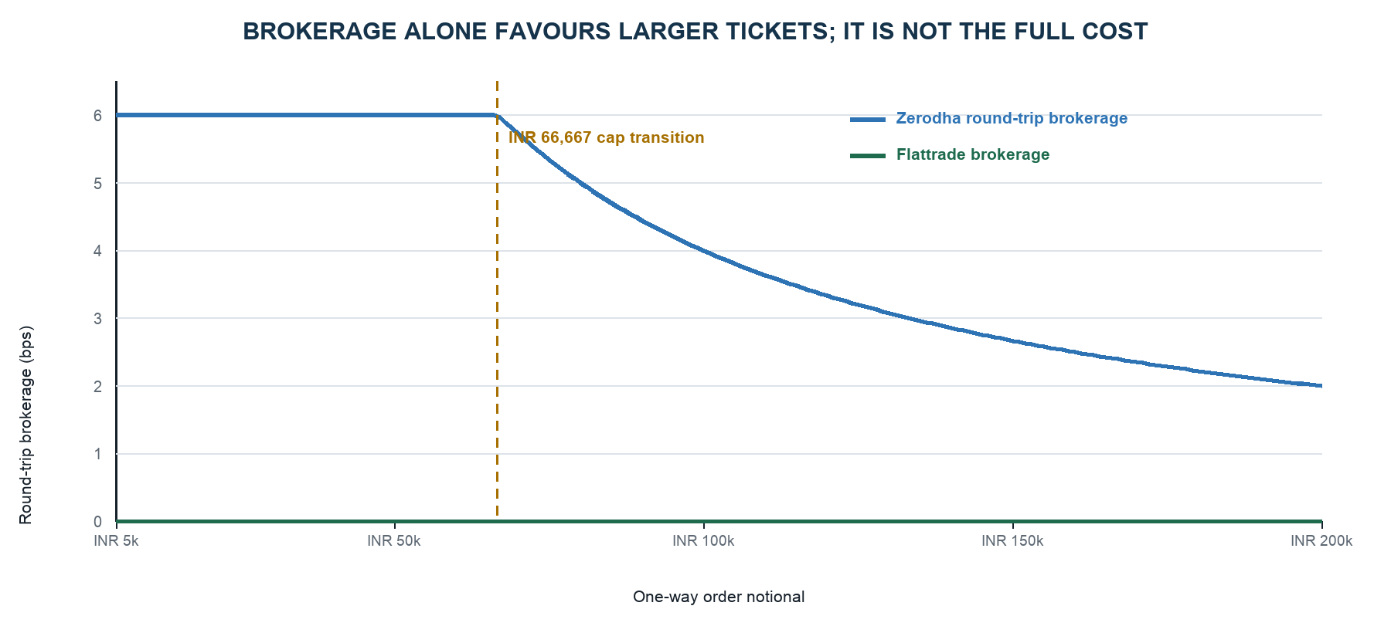
Figure 3. Brokerage component only. Zerodha is 6 bps round trip below the ₹20 cap transition, then declines with ticket size; statutory and execution costs remain additional.

8.3 Turnover is a portfolio decision
Trade Δx_i only if expected incremental benefit > stressed marginal cost + uncertainty buffer
- Search rebalance cadence, entry threshold, exit hysteresis, minimum/maximum holding, cooldown and forecast expiry.
- Set a minimum economic ticket and maximum number of concurrent names; fixed fees punish fragmentation at small capital.
- Net opposing alpha intents before routing; batch compatible changes into one order when safe.
- Use no-trade bands around current targets so small score changes do not churn the book.
- Report the full net-return surface over turnover × cost stress; select the centre of a plateau, not a sharp best point.
- Treat broker and capital as part of the experiment identity—never select gross alpha first and retrofit fees later.

9. Portfolio construction below ₹10 lakh

9.1 Cost-aware integer target
q* = arg max_q [ μ̂ᵀx − (λ/2)xᵀΣx − TC_b(x−x₀) − δ·TailRisk(x) ], x_i = q_i·P_i
Fixed per-order fees make the exact problem non-convex. For this capital range, use an auditable two-stage method rather than a large opaque mixed-integer solver:
- Solve a continuous, cost-aware target under gross/net/name/sector/beta/liquidity constraints.
- Drop trades below the minimum economic notional or forecast-cost buffer.
- Round to integer shares and tick-valid prices.
- Recalculate cash, margin, exposure, fees, cost and expected benefit after rounding.
- Run local add/drop/swap improvements; reject any portfolio that violates risk or loses positive net benefit.

9.2 Portfolio wrappers to compare
Wrapper | Purpose | Small-capital caveat
Long/flat | Simplest execution; cap market and sector risk | Directional beta may dominate stock-selection alpha.
Top/bottom-k | Transparent cross-sectional spread | Short/product eligibility and duplicate order costs bind.
Dollar-neutral tolerance | Reduces market direction | Exact neutrality may require uneconomic tickets.
Beta/sector-neutral tolerance | Targets idiosyncratic alpha | Use soft bands; factor estimates and rounding are noisy.
Forecast/risk optimizer | Combines calibrated forecasts with covariance and costs | Complexity must earn stable incremental value.

9.3 Conservative launch ranges
RESEARCH DEFAULTS, NOT OPTIMAL SETTINGS Begin limited live unlevered. Search per-name caps of 5–10% NAV, maximum 5–15 concurrent positions, interval participation of 0.25–1%, and a new-entry stop 15–30 minutes before the effective flatten deadline. Leverage is a later, separately validated overlay.

Risk limits are hard constraints, not hyperparameters optimized for return. A daily loss stop in the 0.5–1.0% NAV research range may be precommitted for pilot testing, then set through risk appetite and live evidence—not relaxed to rescue a backtest.

10. Validation without leakage

10.1 Recommended chronology
- Reserve the final 3–6 months or 15–20% of history as a one-use lockbox.
- On earlier data, use nested chronological walk-forward selection; never random rows.
- Fit universe policy, factor exposures, transformations, model weights, calibrators and regimes inside each training fold.
- Purge every training label whose return interval overlaps validation/test; embargo at least the maximum holding horizon plus live order duration.
- Refit only on the permitted rolling window and roll exactly at the intended live retraining cadence.
- Freeze the shortlist, use the lockbox once, then forward shadow/paper trade for at least 6–8 weeks.
Layer | Illustrative schedule | Purpose
Training | 6, 9 or 12 rolling months; longer for weak seasonality | Fit all state and parameters.
Inner validation | 1 month blocks | Choose parameters/graphs inside development only.
Outer test | 1 month blocks | Estimate the performance of the complete selection process.
Lockbox | Final 3–6 months; one use | Final unbiased check after bundle freeze.
Forward shadow/paper | 6–8 weeks minimum | Calibrate latency/fills and expose operational failure modes.

10.2 Automated causality assertions
- Rolling features never read timestamps after the decision cutoff.
- Daily VWAP/volume features are cumulative through decision time, never full-day values.
- Same-clock volume surprise compares with historical volume through the same clock slot.
- Cross-sectional ranks exclude late/missing bars and record the actual denominator.
- Position state cannot cross fold or session boundaries except through explicitly modelled warm-up.
- No adjusted execution price, present-day constituent list, current-only instrument master, or current eligibility leaks into past fills.

10.3 Required stress grid
Stress | Levels | Failure interpretation
All-in variable costs | 1.0×, 1.5×, 2.0× | Negative at 1.5× means fragile implementation edge.
Decision/order delay | baseline, +1 bar, +2 bars | Fast decay or timestamp dependence.
Spread/impact | session × liquidity quantiles; widened tails | Cost concentration in open/close or smaller names.
Fill | partial, timeout, capped reprices, missed fills | OHLC-touch optimism or excessive chasing.
Universe | N±buffer, stable-core vs dynamic, leave-sector-out | Universe cherry-pick or concentration.
Parameters | neighbourhood heat map | Reject isolated spikes; prefer plateaus.
Bootstrap | day/week blocks | Confidence intervals and tail dependence.
Operational | feed gap, broker reject, restart, close cutoff | Strategy must fail safe and reconcile.

11. Multiple testing and robust promotion

11.1 Every viewed variant is a trial
The trial count includes completed, failed, abandoned, hand-tuned, alternative-universe, fee/fill, and seed variants that influenced the next decision. Preserve candidate daily returns so the effective number of independent trials can be estimated from their correlation eigenvalues.
M_eff = (Σ_j λ_j)² / Σ_j λ_j²
- Probabilistic and Deflated Sharpe on daily net returns; do not annualize minute observations as independent.
- Hansen SPA or White Reality Check for finalist return differentials.
- Embargoed combinatorial/purged CV or equivalent probability-of-backtest-overfitting estimate.
- Stationary/block bootstrap by day or week and null search simulations over the maximum selected score.
- Family-level false-discovery control, predeclared search budgets, and one-use lockbox.

11.2 Hard gates before ranking
Gate | Example precommitted requirement
Integrity | Accounting reconciles; no leakage; point-in-time universe and corporate actions pass audit.
Feasibility | Current broker/product/side/session allowed; integer tickets and margin valid.
Evidence | Adequate independent days/trades; positive net result in a majority of outer folds.
Selection bias | DSR probability target (illustratively ≥95%) and acceptable PBO/SPA evidence.
Cost/latency | Positive after 1.5× cost and survives +1-bar delay; 2× result disclosed.
Stability | Neighbouring parameters and nearby universe policies support the result.
Concentration | No single stock/day/session/regime dominates net P&L.
Production | Rust parity, risk tests, restart/reconciliation and flatten drills pass.

TOP FIVE IS A MAXIMUM If fewer than three candidates clear all gates, deploy fewer. Never weaken thresholds to fill a quota, and never call five nearby parameter settings five different strategies.

12. Selecting and combining the top 3–5

12.1 Pareto selection
Final ranking is multi-objective. Use non-dominated sorting across net return, Deflated Sharpe, drawdown/CVaR, cost share, turnover/order count, fold/regime stability, broker robustness and complexity. Then cluster outer-test daily net returns using 1−correlation.
- Treat close hyperparameter variants as one strategy cluster.
- Select a stable knee-point near the centre of a parameter plateau.
- Add another bundle only if it contributes diversification, a distinct session, a distinct family, or broker/capital robustness.
- Prefer the simpler graph whenever performance confidence intervals overlap.
- Re-optimize combined capital allocation with fixed-order costs; five simultaneous strategies can be worse than two below ₹10 lakh.

12.2 Bundle report card
Field | Required content
Identity | Strategy ID/hash, family graph, parents, code/data/cost versions
Trade context | Universe policy, session/regime, horizon, broker, capital range, side/product
Economics | Net return, DSR, MDD, CVaR, gross-to-net, cost share, breakeven edge, rotation, orders
Stability | Outer folds, bootstrap CI, parameter plateau, universe sensitivity, concentration
Stress | 1.5×/2× cost, +1/+2 bar delay, fill degradation, outage/restart tests
Capacity | Minimum economic ticket, positions, participation, capital-time use
Operations | Entry cutoff, flatten deadline, broker limits, failure modes, kill thresholds
Decision | Promotion/rejection rationale and correlation cluster

13. Python research / Rust production
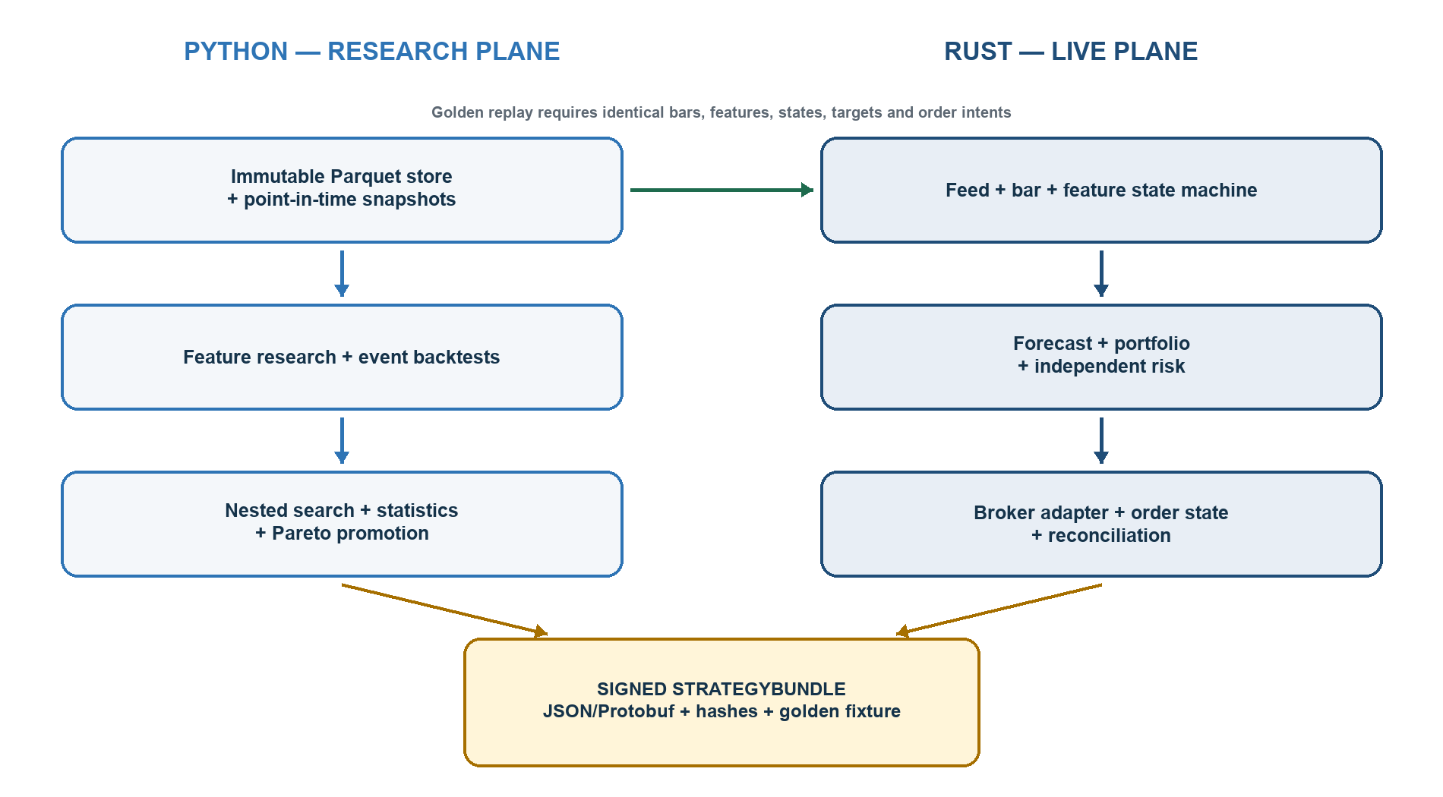
Figure 4. The live process contains no Python pickle or notebook state. Only a versioned bundle and validated feature/state contract cross the boundary.

13.1 Responsibility split
Python research plane | Rust live plane
Backfill, quality reports, immutable snapshots | Live feed adapter, timestamp/gap checks, raw capture
Feature research, statistical fitting, universe reconstruction | Canonical bar/feature engine and state serialization
Event backtests, walk-forward orchestration, search registry | Forecast evaluation and session/regime state
Multiple-test correction, Pareto selection, reports | Integer portfolio, independent risk, broker capability checks
Bundle export and golden fixtures | Order state, idempotency, reconciliation, recovery and flatten

Best drift control: implement the canonical causal feature/state engine in Rust and expose it to Python for replay/fitting via a narrow binding. Acceptable alternative: a tightly specified feature DSL implemented twice, with golden vectors. The bundle loader rejects unsupported nodes, incompatible schema, missing cost/risk versions, bad checksum, or parity failure.

13.2 Minimum StrategyBundle schema
schema_version, strategy_id, parent_experiment_ids
code_hash, data_hash, universe_hash, cost_hash, risk_policy_hash
valid_from, valid_until, broker_context, capital_range
bar_spec, feature_DAG, warmups, normalizers, factor_parameters
alpha_weights, calibration, session_regime_policy
portfolio_constraints, execution_policy, exit_policy
rounding_rules, golden_fixture_hash, bundle_checksum/signature

13.3 Order intent contract
OrderIntent {
idempotency_key, strategy_id, instrument_id, side, product,
quantity, limit_price_ticks, time_in_force, expiry_time,
expected_edge_bps, stressed_cost_bps, reason_code
}
Never blindly retry an unknown order. Query the broker order book and positions, reconcile broker truth, and only then decide whether a new idempotent intent is needed. Cross-broker failover is blocked until the original broker state is positively reconciled.

14. Independent production risk

14.1 State machine
BOOT → AUTHENTICATED → WARMUP → READY → TRADING → RISK_ONLY → FLATTENING → FLAT
↘ HALTED / INCIDENT_PAUSED ↗

14.2 Risk controls
Layer | Controls
Pre-trade | eligibility, stale/crossed data, tick/price band, stressed edge>cost, quantity, cash/margin, name/sector/gross/net, participation, open-order exposure, rate and turnover limits
Intraday | daily loss/drawdown, heartbeat, reject spike, slippage divergence, spread shock, abnormal feature, concentration, broker/position mismatch, market halt/circuit
Close | new-entry cutoff, independent flatten attempts, no new risk, broker reconciliation, unresolved-position alert, closing P&L snapshot
Release | approved bundle only, parity, capability snapshot, static IP/auth, clock sync, audit logging, rollback package

14.3 Failure response matrix
Failure | Required response
Breeze/feed stale or gap | Stop new decisions; invalidate features; cancel nonessential entries; preserve/reconcile position state.
Feed vs broker prices diverge | Pause affected symbols/system; do not choose the price that favours a trade.
Order timeout / unknown | Query orders and positions; never resend blindly.
Broker disconnect with exposure | Enter risk-only; reconnect/reconcile; controlled flatten only when state is known.
Restart/crash | Replay log/checkpoint, then reconcile broker truth before any new intent.
Position mismatch | Cancel new risk, reconcile, and require explicit resolution.
Repeated rejects/slippage breach | Circuit-break the strategy or adapter; recalibrate offline.
Price near circuit / liquidity collapse | No new entry; controlled exit; escalate unresolved short risk.
Clock drift | Halt timestamp-sensitive decisions until synchronized.
Daily loss/kill threshold | Cancel entries and flatten under the independent risk policy.

SHORT-SALE TAIL Cash short eligibility must come from the current exchange/broker whitelist. A short trapped at an upper circuit can become a delivery/auction obligation. The simulator and live risk layer must model this as a distinct tail event, not a normal stop-loss fill. ^{[S22]}

15. Regulatory and broker operating gate
SEBI’s retail-algo framework became mandatory for stockbrokers on 1 April 2026. Under NSE’s implementation standards, all client-API orders are algo orders and must be tagged. At not more than 10 orders/second per exchange/segment, a self-developed retail strategy uses the registration-free/generic algo-ID route; above that threshold it must be registered through the broker. Brokers may impose lower limits. ^{[S8] [S9] [S10] [S11]}
Requirement | Blueprint control
Static IP | One primary plus permitted secondary; fixed-egress host; weekly change restriction; deployment blocks on mismatch.
OPS threshold | Shared exchange/segment token bucket; target well below 10/sec; place/modify/cancel/square-off all count.
Algo tagging | Broker onboarding confirmation and logged generic/registered algo identity for every API order.
Authentication | OAuth/allowed mechanism, 2FA, daily session lifecycle, secrets outside bundles/logs.
Order types | Protected limit logic; no assumption of pure algo market orders.
Audit trail | Signal, state, intent, order, fill, config and identity retained for at least five years where required.
Broker responsibility | Current broker capability and RMS policy is authoritative; refresh before every session.
Data terms | Breeze raw data remains private; cross-broker execution requires ICICI approval or a licensed substitute feed.

BEFORE ANY LIVE API ORDER Obtain written broker confirmation of self-developed algo onboarding, algo-ID/tagging, static-IP mapping, allowed order types, rate limits, short/MIS universe, CAS handling and square-off times. Capital below ₹10 lakh does not create a separate exemption.

16. Staged algorithm GTM
Phase | Indicative duration | Deliverables | Exit gate
0 • Authority + protocol | 1–2 weeks | ICICI data-use answer; broker/API onboarding; frozen mandate, metrics, risks, budgets | Legal/terms path and minimum credible horizon confirmed
1 • Data foundation | 3–4 weeks | raw store, point-in-time master, corporate actions, calendar, quality dashboard | sample days reconcile; gaps explicit
2 • Costed simulator | 3–5 weeks | broker fee versions, order/fill state, integer holdings, latency/fill stresses, EOD close | cash/equity accounting reconciles to rounding
3 • Alpha baselines | 4–6 weeks | family modules, causal tests, common forecasts, ablations | every module has net fold reports
4 • Meta-search | 5–8 weeks | typed grammar, registry, nested WFO, multiple-test controls, robust surfaces | shortlist frozen without lockbox
5 • Portfolio + bundles | 3–5 weeks | turnover optimizer, Pareto clusters, final 3–5 or fewer bundles | hard gates and one-shot lockbox pass
6 • Rust + shadow | 4–6 weeks | bundle loader, live engine, parity, recovery, reconciliation | golden parity and failure drills pass
7 • Paper | 6–8 weeks min. | actual latency/fills/rejects/cost calibration; operational runbook | no critical incident; costs inside stress bands
8 • Limited live | evidence-driven | 10–20% → 25% → 50% → approved full allocation | advance by sample/risk evidence, not elapsed days

16.1 Limited-live advancement
- Unlevered and one champion first; challengers remain shadow-only.
- No unintended overnight position, ambiguous order retry, or unresolved reconciliation incident.
- Observed spread/slippage and reject/fill rates remain within approved stress bands over a predeclared trade sample.
- Live decision parity against replay is stable; cost-to-gross and turnover match the expected range.
- Drawdown, concentration and session/regime attribution remain inside the bundle’s risk envelope.
- Any material feature, alpha, universe, execution or risk change creates a new bundle and restarts the appropriate gate.

17. Concrete first research campaign

17.1 Pre-registered search matrix
Dimension | Starter space
Capital | ₹2L, ₹5L, ₹10L; 1× gross initial
Universe | N=50/100/150/300; 20/40/60-day liquidity; weekly/monthly refresh; stable-core/dynamic
Bar | 1, 2, 3, 5, 10, 15 minutes, subject to source fidelity
Hold | 2, 3, 5, 10, 15, 30, 60, 120 minutes; truncated before flatten
Rebalance | 1, 2, 3, 5, 10, 15 minutes
Momentum | lookback 3/5/10/20/30/60 bars; skip 0/1/2
Residual MR | lookback 2/3/5/10/20 bars; robust z; entry/exit/cooldown
Breakout | range 5/10/20/30/60 bars; compression, volume, breadth confirmation
Entry breadth | top/bottom 5%, 10%, 20% or k=3/5/8/10
Turnover controls | cost buffer 1.0/1.25/1.5/2.0×; cooldown 0/1/2/5; minimum ticket; no-trade band
Risk/capacity | name 5/7.5/10%; participation 0.25/0.5/1%; max 5/8/10/15 positions
Stress | cost 1/1.5/2×; delay base/+1/+2 bars; fill degradation; nearby universes

17.2 Compute budget and promotion funnel
Pass | Illustrative budget | Simulation fidelity | Keep rule
Coarse | 10k–50k unique manifests | vectorized causal returns + conservative rough cost | family-balanced stability and economic sign
Full-cost | 1k–5k | event fills, integer shares, fees, session/broker constraints | positive development utility + plateau
Nested | 100–500 | purged inner/outer WFO, full stresses | fold consistency, DSR/PBO, ablation
Finalist | 10–30 | complete broker/capital contexts + operational tests | hard gates + Pareto diversity
Promoted | 0–5 | lockbox once + forward shadow/paper | release board/risk sign-off

FIRST LIKELY DELIVERABLE Not ‘the winner.’ The first trustworthy output is a map of where net edge survives: family × session × universe × capital × broker × turnover. That map determines which 100–500 candidates deserve the expensive validation pass.

18. Operating cadence after launch
Cadence | Activity | Rule
Every session | capability/eligibility snapshot, auth/static IP, data health, risk limits, close schedule | No READY state unless all preflights pass.
Intraday | forecast drift, feed age, costs, fills, rejects, exposure, drawdown, reconciliation | Throttling/pausing only; no live self-retraining.
Daily | P&L/cost attribution, broker contract-note reconciliation, incident review | Any unresolved position/order discrepancy blocks next session.
Weekly | champion vs shadow challengers, parameter/state health, data gaps | No promotion based on one week of P&L.
Monthly/quarterly | offline retraining/search per predeclared cadence, new bundle candidate | Full lineage and promotion path repeat.
Incident | freeze bundle, preserve logs, reconcile, root-cause, replay | Restart only after explicit acceptance criteria pass.

18.1 Non-negotiable rejection list
- Present-day constituent lists applied through history; random train/test rows; same-bar signal and fill.
- Full-day VWAP/volume used intraday; current-only instrument/product eligibility projected backward.
- Brokerage-only costs; optimistic passive fills from OHLC touches; guaranteed market-order assumptions.
- Minute-level Sharpe annualized as if observations were independent.
- Selecting on all history and renaming it out-of-sample; reusing a lockbox after tuning.
- Ignoring failed/manual trials; unlimited grids branded as exhaustive; five clones branded as diversified.
- Exact neutrality regardless of cost; leverage added to rescue return; broker auto-square-off as primary exit.
- Sub-minute alpha claims without quote/trade/depth and realistic fill data.
- Automatic live retraining, blind retry after timeout, or failover without broker-state reconciliation.
- Breeze-derived orders at another broker without explicit ICICI permission or a licensed substitute data path.

Appendix A — Meta-search pseudocode
def discover(protocol):
data = freeze_and_hash(protocol.data)
development, lockbox = chronological_lockbox(data)
outer_reports = []
for outer in purged_walk_forward(development, protocol.outer):
trials = propose_from_typed_grammar(
budget=protocol.fixed_budget, seed=outer.seed)
for theta in trials:
inner = []
for fold in purged_walk_forward(outer.train, protocol.inner):
fitted = fit_all_state(theta, fold.train)
inner.append(event_backtest(
fitted, fold.validation, theta.broker, theta.capital))
registry.record(theta, inner)
selected = locked_inner_selection(registry, outer.id)
refit = fit_all_state(selected, outer.train)
outer_reports.append(event_backtest(
refit, outer.test, selected.broker, selected.capital))
shortlist = pareto_diverse_selection(outer_reports)
bundles = freeze_bundles(shortlist)
lockbox_reports = evaluate_once(bundles, lockbox)
return apply_promotion_gates(bundles, lockbox_reports)

Appendix B — Example experiment manifest
experiment:
protocol: intraday_discovery_v1
data_snapshot: nse_cash_1m_2023_2026_sha256...
universe: {policy: liquidity_ranked, n: 100, lookback_days: 40, refresh: weekly}
session: MID
alpha:
family: residual_mean_reversion
residualizer: {factors: [market, sector], window_days: 60}
z_lookback_min: 30
entry_z: 1.75
exit_z: 0.35
portfolio: {wrapper: beta_sector_tolerance, max_positions: 10, name_cap: 0.10}
execution: {policy: protected_marketable_limit, timeout_ms: 1500, max_reprices: 2}
context: {broker: zerodha, capital_inr: 500000, costs: zerodha_2026_08_27}
validation: {split: nested_purged_wfo_v1, seed: 1407}
status: PROPOSED

Appendix C — Acceptance checklist
Area | Release checklist
Authority | Written Breeze cross-broker approval OR licensed substitute feed; broker algo onboarding complete.
Data | Point-in-time instruments/corporate actions; raw/adjusted split; gaps; clock/calendar; source checksums.
Research | Frozen grammar/budget/folds; registry includes failures; lockbox unused; daily-return statistics.
Simulation | Next-event fills; fees/rounding; integer positions; partial/reject/timeout; circuits; close.
Selection | Hard gates; DSR/PBO; 1.5× cost/+1 bar; plateaus; concentration; Pareto clusters.
Bundle | Complete schema, hashes, validity, risk reference, golden fixture, checksum/signature.
Rust | Parity, idempotency, persistence, restart, reconciliation, rate limiting, independent risk.
Operations | Static IP/auth, data and broker health, alerts, kill/flatten, runbook, incident retention.
Pilot | Shadow/paper evidence; actual costs; zero critical open incidents; staged unlevered capital.

Appendix D — Primary sources and current facts
All broker, API, exchange and regulatory facts were checked against primary sources on 27 August 2026. Tariffs, limits, eligibility and square-off times can change; store effective-dated snapshots and confirm them before production use. This source register supports the current-context statements in the blueprint.
[S1] ICICI Direct Breeze API Reference — rate limits, supported segments, live streams, instruments, static-IP and order restrictions
[S2] Official Breeze Python SDK README — historical intervals, 1,000-candle cap, unadjusted history, WebSocket and SDK behaviour
[S3] ICICI FAQ — third-party platform via Breeze — personal-use and third-party integration restriction
[S4] ICICI FAQ — create and deploy self-built Breeze strategies — private self-built deployment on the customer’s computer
[S5] ICICI resident account terms — individual-use quote entitlement, proprietary data interests and service disclaimers
[S6] NSE market timings — normal cash-market and exchange session timings
[S7] NSE Closing Auction Session — Phase 1 eligibility, 15:15–15:35 auction phases and order/fill rules
[S8] SEBI — safer participation of retail investors in algorithmic trading — retail API/algo regulatory framework
[S9] SEBI — final retail-algo implementation timeline — mandatory framework application from 1 April 2026
[S10] NSE implementation standards for retail algos — static IP, 10 OPS, tagging, authentication, audit and controls
[S11] NSE retail-algo FAQ — tech-savvy client hosting, tagging and API order classification
[S12] Flattrade charges — brokerage, statutory rates and administrative square-off charges
[S13] Flattrade algo/API — free API context and published rate limits
[S14] Flattrade risk-management policy — margin/RMS and time-based square-off policy; public inconsistencies noted
[S15] Flattrade API order types — limit-only API rule
[S16] Zerodha charges — intraday brokerage and statutory fee schedule
[S17] Zerodha Kite API pricing — free personal order tier and ₹500/month live/historical Connect tier
[S18] Kite Connect rate limits and exceptions — 10/sec, 400/min, 5,000/day and 25 modifications/order
[S19] Kite Connect WebSocket — live data fields and subscription capacity
[S20] Zerodha intraday auto-square-off timings — CAS/non-CAS cutoffs and administrative charge
[S21] NSE transaction/IPFT revision effective 1 March 2026 — current exchange transaction and IPFT split
[S22] SEBI short-selling framework — cash short-sale framework and delivery obligation context

Closing note
THE CORRECT PRODUCT A repeatable discovery machine that can say ‘no strategy passed’ is more valuable than a bot guaranteed to return five attractive backtests. The edge is the combination of causal data, controlled breadth, complete costs, disciplined selection, small-capital portfolio economics, and operational execution—not the number of indicators in the pipe.

This is an engineering and research blueprint, not investment, legal, tax or regulatory advice and not a promise of profitability. Confirm current exchange, broker, API and data-entitlement requirements before implementation and trading.

