**Part3:**

I used top 25 sites from <http://www.alexa.com/topsites> and calculated average dns resolution time for each site by executing it around 10times. The 25 websites we took for experimentation are :

**['Google.com',Youtube.com','Facebook.com','Baidu.com','Wikipedia.org','Reddit.com','Yahoo.com','Google.co.in','Qq.com','Taobao.com','Amazon.com','Tmall.com','Twitter.com','Google.co.jp','Instagram.com','Live.com','Vk.com','Sohu.com','Sina.com.cn','Jd.com','Weibo.com','360.cn','Google.de','Google.co.uk','Google.com.br']**

We conducted 3 experiments:

1. Use Local DNS resolver ('130.245.255.4) to resolve the address for above 25 sites. It is repeated for 10 times and average resolve time is noted.
2. Use Google DNS resolver (8.8.8.8) to resolve the address for 25 sites. Again it is repeated for 10 times and average resolve time is noted.
3. Use mydig resolver and perform same experiment.

The below data is the average dns resolution time for each site using 3 types of DNS resolver:

**# avg time using local dns resolver** = [0.007800006866455078, 0.006299996376037597, 0.0062000036239624025, 0.007899999618530273, 0.007799983024597168, 0.007800006866455078, 0.0062000036239624025, 0.007800006866455078, 0.006399989128112793, 0.006299996376037597, 0.009400010108947754, 0.0062000036239624025, 0.006299996376037597, 0.0062000036239624025, 0.009399986267089844, 0.009400010108947754, 0.009299993515014648, 0.006299996376037597, 0.0062000036239624025, 0.006299996376037597, 0.0062000036239624025, 0.006299996376037597, 0.007700014114379883, 0.006199979782104492, 0.007900023460388183]

**# avg time using local google dns resolver** = [0.023399996757507324, 0.021899986267089843, 0.009299993515014648, 0.01100001335144043, 0.028099989891052245, 0.014000010490417481, 0.009399986267089844, 0.02130000591278076, 0.007800006866455078, 0.009400010108947754, 0.015599989891052246, 0.0928999900817871, 0.008100008964538575, 0.023000001907348633, 0.0125, 0.009399986267089844, 0.0125, 0.17650001049041747, 0.09700000286102295, 0.2550999879837036, 0.015700006484985353, 0.1370000123977661, 0.021899986267089843, 0.020300006866455077, 0.026600003242492676]

**# avg time using local mydig dns resolver** = [0.15900001525878907, 0.15869998931884766, 1.056700015068054, 0.3880999803543091, 0.2578000068664551, 0.16010000705718994, 1.069599986076355, 1.529700016975403, 0.525, 0.20939998626708983, 1.0592999935150147, 0.21660001277923585, 0.15329999923706056, 1.5260999917984008, 0.16520001888275146, 0.18909997940063478, 0.6291000127792359, 0.4647000074386597, 1.095299983024597, 0.37970001697540284, 0.38409998416900637, 1.2753000020980836, 0.442300009727478, 0.47179999351501467, 0.5530999898910522]

The above data is in **seconds**.

**Observation :**

We observe that local dns resolver (present in stonybrook.edu) took the least amount of time because it maintained cache copy of dns resolved and it is present very near to us. Google dns resolver was better than mydig dns resolver but it was slow that local dns resolver because it is far from us as compared to local dns resolver. The mydig resolver was pretty slow in performance.

I used the IP ('130.245.255.4') for local dns resolver. I found it through ipconfig /all command on windows.

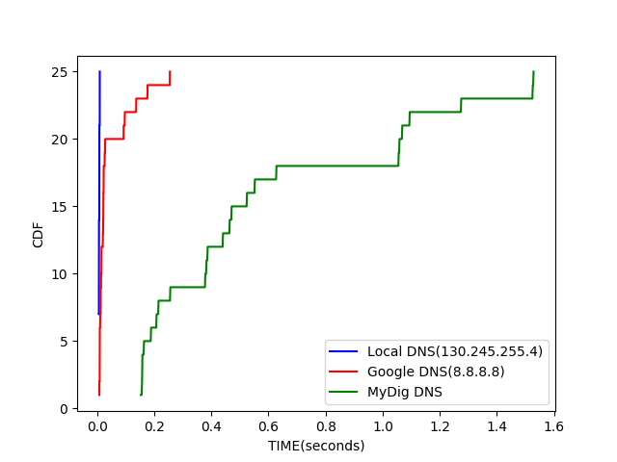

The graph shows that mydig resolver takes lot of time resolving dns(0.2 – 1.6 seconds) as compared to local dns resolver or google dns resolver(less than 0.2 seconds).