Data preprocessing:

* There were a lot of discrepancies in the data like the scores which should have been between 0-1 were greater than 1 and given as percentage. So, these were preprocessed by bringing them within 0-1.
* It was observed that the missing values were created during 2013-105 and the data was complete for 2016-17
* Some important features like qualscore was imputed :
  + It was observed that qualscore was missing only for some performance years of some ACO and were highly similar for a ACO
  + Hence, it the data was sorted by the ACO_name and the qualscore was imputed by backfilling by the last observed data.

The values where per_capita_expenditure was missing, those were dropped

Correlation and plot_importance study:-

To understand the importance of features for per_capita_expenditure, two kinds of study was done:

Pearson Correlation: The ‘correlation.csv’ is the file having correlation values between target feature with other features

Plot_importance : ‘DART’ (Dropout boosting tree) LightGBM was used to study the important features.

**R2_score with crude data was :0.65**

**R2_score after data engineering: 0.69**

It shows that now that newly built features were showing the variance of the data better and hence the features were reliable

Data Engineering:

1. pat_psp_visit_ratio = train['p_em_pcp_vis']/train['p_em_total'] : Ratio of primary healthcare visits
2. pat_sp_visit_ratio = train['p_em_sp_vis']/train['p_em_total']: ratio of specialized heathcare visits
3. pat_nurse_vis_ratio= train['p_nurse_vis']/train['p_em_total']: ratio of visits to clinical nurses
4. pat_pcp_sp_vis_ratio= train['p_em_pcp_vis']/train['p_em_sp_vis']: ratio of visits to primary health care and specailised expert
5. pat_nurse_sp_vis_ratio= train['p_nurse_vis']/train['p_em_sp_vis'] : ratio of visits to nurses and specialed experts
6. n_np_spec= train['n_np']/train['n_spec']: ratio of number of nurses and specilaied nurses
7. n_pcp_spec = train['n_pcp']/train['n_spec']: ratio of primary clinical nurses and specialized nurses
8. n_np_cns = train['n_np']/train['n_cns']: ratio of nurses and clinically trained highly trained nurses
9. 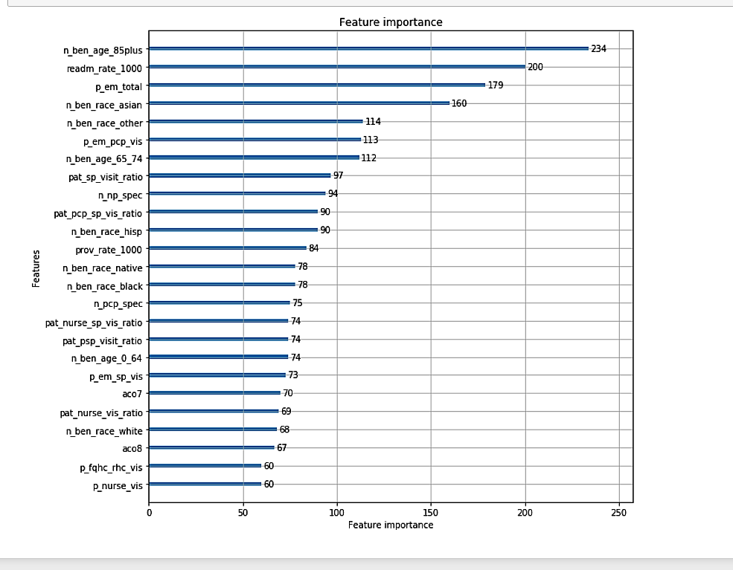

Plot importance showing new features doing quite well than their constituents