**2D Drawing to 3D solid conversion with Image Processing:**

Language used: Python 3.6

Input : image showing Front, Top and Side view of model ( Without hidden edge removal) in First angle projection.

Output: 3D solid model (**. scad**) format.

Libraries used: 1) NumPy (Matrix manipulation)

2)OpenCV (Image processing)

3) openpyscad ( .scad file generation)

Basic steps(For cuboid geometry):

1)Convert image to greyscale image.

2) Convert greyscale image to binary image using thresholding.

3)Partition the binary image in Front, Top and side image.

4) Find contours on each image.

5) Separate 4 vertex simple contours as blocks.

6) Save the vertex information of each block in vertex list.

7) Remove redundant vertices from the block.

8) Find x-difference and y-difference in each vertex block.

9) Find vertices having same x coordinates and vertices having same y coordinates in each block.

10)Check for the cuboid geometry by comparing vertices having same y coordinates in front view and side view and vertices having same x coordinates in front view and top view.

11) Find the length, width and depth of each cuboid found using x difference and y difference of respective blocks.

12) Find position of centroid using coordinates of blocks in different views.

13) Check whether the cuboid is completely inside another cuboid as a hole.

14)Depending on condition 13, decide whether cuboid is to be added or subtracted from the geometry.

15) Make the geometry file using openpyscad library.

Sample Examples:

1. Input: Simple cuboid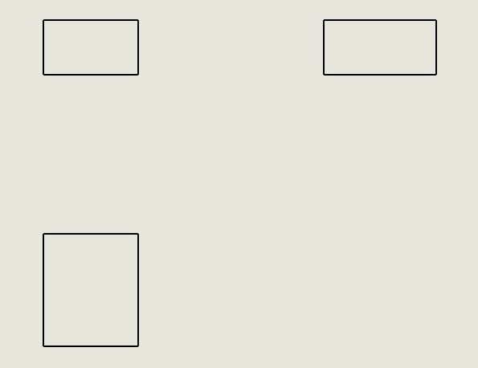

Output:

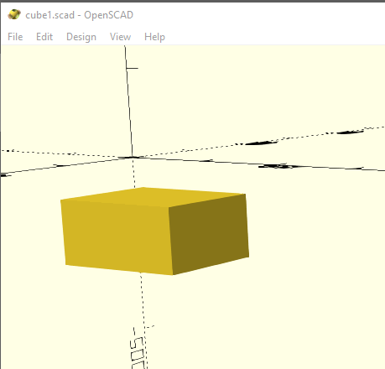

2)Combining cuboids: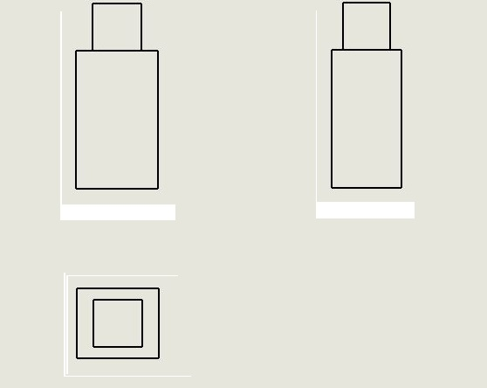

Output:

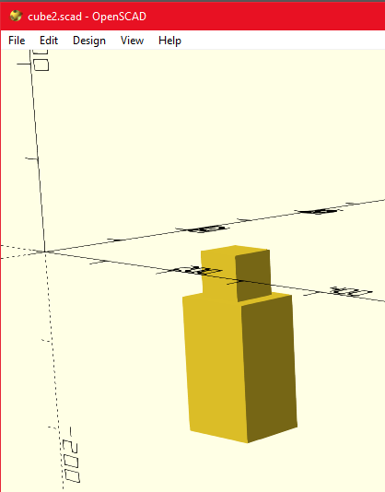

3)Subtracting cuboid: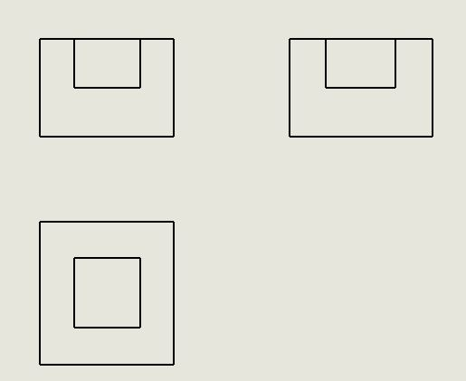

Output:

