Formulation:

The governing equation for strain energy of any structural problem can be given as:



Here, volume integral in the virtual work principle is separated into a deviatoric and

volumetric part.

Where





And



Here the displacement is function of both isoperimetric coordinates. For any general function f of x and y;



And



For strains with respect to x and y:



The Jacobian matrix is given as:



For particular 4 node element element:



To convert derivatives wrt x and y wrt parametrical coordinates:



Now the strain vector can be obtained as





=

  

   

The above three equations can be combined as:



Where: 

The stiffness matrix is given as:



=

This integration can be evaluated using 2x2 gauss quadrature method.

Considering given problem with poissons ratio as 0.4999 like in rubber material, the result obtained is as follows:

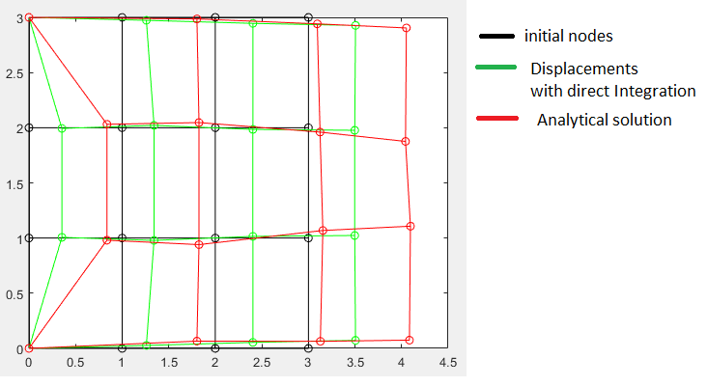

Here, the displacements obtained are very less than actual values because of volumetric locking phenomenon.

**Reduced point integration Method:**

This method is used to reduce effect of volumetric locking by integrating deviatoric part with 4-point integration and volumetric part of strain energy using single point guass quadrature integration.



These are two parts of strain energy of structural element.

In matrix form:



Here D1,N1 are same as basic method and D2 and N2 are as follows:





Solving the given problem using reduced point integration:

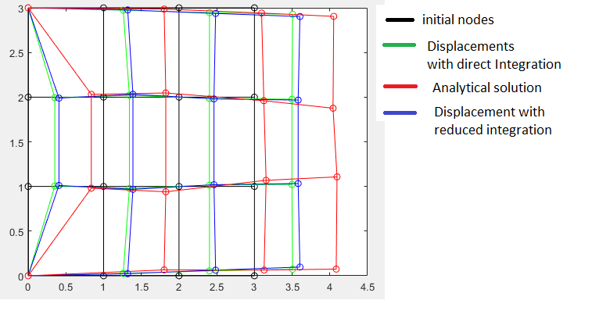

The above result indicates that the displacement error is reduced using reduced point integration method as compared to direct integration.