Parkside International Residential College Area Government 2006-2007
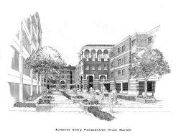
Funding Application: Complete and return to Catherine Chen, Financial Coordinator, by 8pm the Monday before the Tuesday AG meeting, two weeks in advance of the planned event. Contact info:

Catherine Chen
catherkc@usc.edu
Apt. 125

Name & Position: ______________________________________ Date: _______________
Email: __________________________________ Phone Number: ___________________
Program Title: ________________________________________________________________
Projected Location, Date, and Time: ______________________________________________
Have you already been granted use of these facilities? Y N

Program Description: Include details about the program, who it is open to, length of program, projected attendance and attendance limit, etc. Attach copies of any flyers.

**Attach an estimated budget that details how the money will be spent. Please be specific!

Total Cost of the Program: ________________
Will the residents be charged any fees? Y N How much? ____________
Have you received and/or requested funding from other sources?
Please list additional sources and contributing amounts:

Total Amount Requested from Parkside Area Government: _______________

