Abstract
Project Possibility is a nonprofit, community service project committed to creating groundbreaking open source software for the disabled community. Since its inception in the summer of 2007, Project Possibility has been developing a slew of technologies that will help improve the lives of disabled persons, giving them access to experiences previously impossible to achieve. Key areas of work include a mobile currency reader for a blind person to identify bills at a supermarket, AXSJAX scripts to construct accessible websites, binary input games for persons with limited mobility, and a text reader for use by the dyslexic. All projects are fully open source and free for people with disabilities to use.
In addition to its software development, Project Possibility has launched several educational programs at the University of Southern California to get students involved in the open source development process. As an organizer and participant of these programs, I have seen the power of software to make a difference. It is truly amazing what a few lines of code can do to improve the lives of so many people.

Article Text

I first had the privilege of hearing about Project Possibility when founder and USC Master’s student Chris Leung contacted me last summer about rallying student interest for the project. Chris was an incoming Masters student (working part time at Jet Propulsion Lab in Pasadena) and I was an officer in the USC ACM student chapter. He showed me the Lunar Tuner project that Project Possibility had been working on.

Lunar Tuner  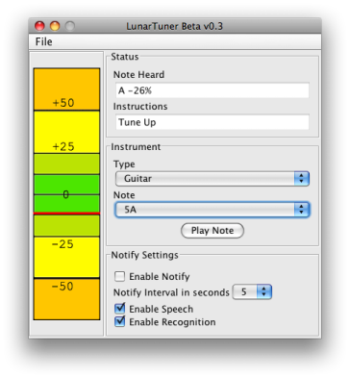 | Features  - Extremely high pitch resolution (0.3 Hz)  - Built in event-driven screenreader  - Built in speech commanding, allowing hands free control  - Periodic spoken tuning instructions (tune up, tune up, tune down, tuned...)  - Real-time display  - Tone generator  - Multiple instrument support  Future Plans  - More instruments  - Better Windows support.  - Mobile device Implementation

The idea behind Lunar Tuner was to create a guitar tuner that a blind or deaf person could use. Lunar Tuner utilizes voice recognition technology Sphinx to detect the current pitch of the instrument and utilizes text-to-speech engine FreeTTS to tell the user whether to tune up or tune down and by how much.
I had a chance to talk to the client for the project and he seemed to be pretty happy with the product. Being a guitar player myself (though amateur), I was intrigued by the tuner design. The reading out of pitch allows one to tune their guitar without having to constantly look at the screen. This was a guitar tuner I would be willing to use, even though I was not disabled. I realized, then, that any advance we make in the realm of assistive technology may bring advances in technology as well.
Seeing the ability of software development to make a difference in the lives of disabled people (and people in general), I was immediately sold on Chris’s idea of having a codeathon to educate students about assistive software development. A semester’s worth of planning culminated in SS.12, a weekend long programming contest that took place on November 17th and 18th, 2007 (see: www.ss12.info). The contest brought together graduate and undergraduate students and industry professionals from such companies as Google, Microsoft, Amgen, MySpace, and JPL to work on some innovative projects. Some of these projects are featured below.

Mobile Currency Reader  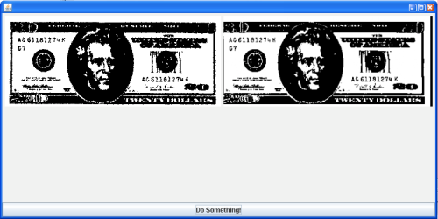 | Disability Addressed: Blindness  Features  - The mobile currency reader will accept an image as an input and attempt to match it against reference images.  Uses  - The software would allow blind persons to use a cell phone camera to take a picture of a bill and know the value of the bill they are holding.

Disability Addressed: Blindness  Features  - The AxsJAX framework helps inject accessibility features into live web pages so that users of adaptive technologies can experience the same level of interactivity that other users have of Web 2.0 applications.  Uses  - A blind person can now have several Web 2.0 applications work with screen readers.  - Currently, we have created scripts for Wikipedia and Web Sudoku. | AxsJAX  [Screenshot needed]

Binary Input Game  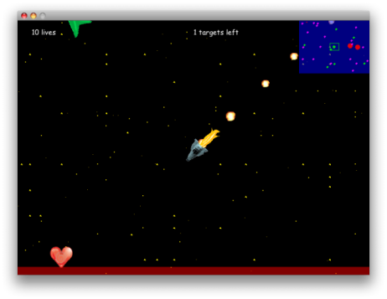 | Disability Addressed: Limited Mobility  Features  - Real-time game playable with a single button.  - Single button allows you to hit the thrusters on your spaceship and then you use the gravitational forces of the space objects to guide your spaceship home.  Uses  - Game would be fully playable by someone who could only move a single body part.  - An eye tracker, foot pedal, vocal command system or any other binary input device could be used to play the game.

During SS.12, I got a chance to work on a binary input game. My team designed a game that would be fully playable by someone with limited mobility. This entailed creating a game that was playable by as few buttons as possible. Because we wanted to design for the most restrictive case, we chose to make a game playable by one button.
To start off, we did some thinking about what types of games could possibly be creatable under the one button scheme. We brainstormed ways that existing real-time multiple button games could be converted to the one button format. We eventually decided to create a rendition of the classic orbit game in which a space ship, guided by gravity, is led to its home planet. The user can use a button to thrust to influence the velocity of the spaceship. Thrusting at the right time allows the spaceship to go in the right direction.
After a grueling weekend of non-stop coding and design, the participants of SS.12 got to unveil what they had been working on. There were some pretty innovative projects (some are described above). It turned out that another team also worked on a binary input game. We learned a bit from their approach. They had also done a real time game but, instead of using some external factor such as gravity to serve as the driving force of their playable object, they used a rotating cursor. Pressing a button would accelerate the playable object in the instantaneous direction of the cursor. My team planned to integrate the more effective approach of navigation into our system.
Immediately after the contest, Project Possibility got emails from companies expressing interest in the developed technologies. Google expressed interest in the AxsJAX project and our binary input game was looked into by an eye tracker firm. The benefits for some did not end with the cash prizes from the contest. I know at least two students who got internships after working with the industry professionals who helped the teams.
And, of course, there was the good cause factor of the event. The fellow students I worked with felt the event was one of the most rewarding computer science experiences they had. Many would do it again. I certainly would.
The lesson to be learned from SS.12 was that innovative software that solves real world problems does not require sorcery. All you need is a couple motivated computer scientists, a hefty amount of pizza and red bull, and a weekend to produce some cutting edge technology.

* * *

The one comment that people had about SS.12 was that it was too short. People were excited by the contest and wanted more time to develop their projects. Thus, the Semester Project programming contest was born. The Semester Project was a semester long programming contest with milestones and the whole design and development process done right.
The Semester Project was a mixture of projects from SS.12 and new ideas that people had. Some featured projects are shown below.

Intelligent Word Prediction System  [need screenshot] | Disability Addressed: Limited Mobility  Features  - Word prediction system that used unigrams, bigrams, and trigrams  - Corpus consisted of articles on Wikipedia  - Learned from user as they typed  - On screen keyboard available for use with eye tracker  - Prediction available as a web service  Uses  - The software would help someone with limited mobility type faster using a keyboard or some other input device.

Disability Addressed: All  Features  - Integrated different sites selling assistive technologies.  - Serves a central portal for disabled people to look for assistive technologies.  Uses  - Helps disabled people find assistive technologies online. | Assistive Technology Search Engine  [Screenshot needed]

YouTube Community Captioning  [need screenshot] | Disability Addressed: Deafness  Features  - Grease Monkey script that allows captions to be displayed on top of videos on You Tube.  - Framework by which individual people could add captions to You Tube videos.  Uses  - The software allows deaf persons to enjoy You Tube videos.

The Semester Project was an equally valuable experience. Since the binary input game was in good hands, I got a chance to work on Word Prediction software for the Semester Project.
Our word prediction system provided innovation in several ways. First it extracted its English word frequency rankings from Wikipedia. Wikipedia is a good baseline because it has text on every subject known to man and thus can predict, to a large extent, the subject matter of what the user is trying to type. Second, the word prediction scheme learns from the user’s choices. So if there are words the user constantly likes to type, the words will influence the recommendations given by word prediction. Thirdly, our word prediction system is offered as a web service making it available to developers in general for use in their own applications. Lastly, we integrated the entire word prediction system with an on screen keyboard for use with an eye tracker. A person with limited mobility would be able to use the eye tracker to type with their eyes. Predictions regarding what they are trying to type would then show up.
One of my team members got to go to a CSUN conference on disability and got feedback on our design. People seemeds generally impressed by the design. [Get quotes from David].
My experiences with Project Possibility have influenced deeply how I view software development and computer science in general. Before, I used to think large software projects that changed the view people did stuff could only really happen with a profit motive. I always thought that organizations like Mozilla and Linux were the exception, not the rule. In my own university backyard, Project Possibility has emerged as the next big revolutionary open source society. And it’s for a good cause. Good code for a good cause.

