Abstract
Project Possibility is a nonprofit, community service project committed to creating groundbreaking open source software for the disabled community. Since its inception in the summer of 2007, Project Possibility has been working on a slew of technologies that will help improve the lives of disabled persons, giving them access to experiences previously unachievable. Key areas of work include a mobile currency reader for blind persons to identify bills at a supermarket, web scripts to construct accessible websites, binary input games for persons with limited mobility, and text readers for use by the dyslexic. All projects are fully open source and free for disabled persons to use.
In addition to its application development efforts, Project Possibility has launched several educational programs at the University of Southern California (USC) to get students involved in the open source community. As an organizer and participant of these programs, I have seen the power of software to make a difference. What a few lines of code can do to improve the lives of so many people is truly amazing.

Article Text

I first had the privilege of hearing about Project Possibility when founder and USC master’s student Chris Leung contacted me last summer about rallying student interest for the project. Leung was an incoming Masters student (working at Jet Propulsion Lab in Pasadena) and I was involved with the USC ACM student chapter. Chris explained to me the mission of the project and showed me the Lunar Tuner project that Project Possibility had been working on.

Lunar Tuner  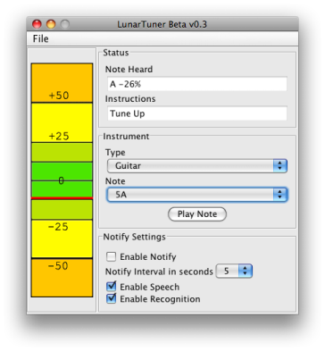 | Features  - Extremely high pitch resolution (0.3 Hz)  - Built in event-driven screenreader  - Built in speech commanding, allowing hands free control  - Periodic spoken tuning instructions (tune up, tune up, tune down, tuned...)  - Real-time display  - Tone generator  - Multiple instrument support  Future Plans  - More instruments  - Better Windows support.  - Mobile device Implementation

Lunar Tuner was designed to be a guitar tuner that a blind or dear person could use. Lunar Tuner utilizes Sphinx, a voice recognition technology, to detect the current pitch of the instrument and text-to-speech engine FreeTTS to verbally tell the user to tune up or tune down.
The feedback from the client for the project was overwhelmingly positive. Seeing the ability of software development to make a difference in the lives of disabled people (and people in general), I was immediately sold on Chris’s idea of having a codeathon to get students involved with assistive software development. A semester’s worth of planning culminated in SS.12, a weekend long programming contest that took place on November 17th and 18th, 2007 (see: www.ss12.info). The contest brought together graduate and undergraduate students and industry professionals from such companies as Google, Microsoft, Amgen, MySpace, and JPL to work on open source assistive technology.

Mobile Currency Reader  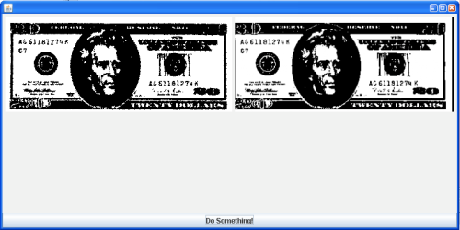 | Disability Addressed: Blindness  Features  - The mobile currency reader will accept an image as an input and attempt to match it against reference images.  Uses  - The software would allow blind persons to use a cell phone camera to take a picture of a bill and know the value of the bill they are holding.

Disability Addressed: Blindness  Features  - The AxsJAX framework helps inject accessibility features into live web pages so that users of adaptive technologies can experience the same level of interactivity that other users have of Web 2.0 applications.  Uses  - A blind person can now have several Web 2.0 applications work with screen readers.  - Currently, we have created scripts for Wikipedia and Web Sudoku. | AxsJAX  [Screenshot needed]

Binary Input Game  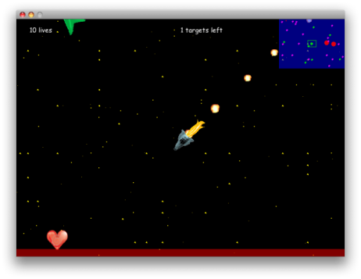 | Disability Addressed: Limited Mobility  Features  - Real-time game playable with a single button.  - Single button allows you to hit the thrusters on your spaceship and then you use the gravitational forces of the space objects to guide your spaceship home.  Uses  - Game would be fully playable by someone who could only move a single body part.  - An eye tracker, foot pedal, vocal command system or any other binary input device could be used to play the game.

During SS.12, I got a chance to work on a binary input game. My team designed a game that would be fully playable by someone with limited mobility. This entailed creating a game that was playable by as few buttons as possible (one button being the most restrictive case).
To start off, we did some thinking about what types of games could possibly be creatable under the one button scheme. We brainstormed ways that existing real-time multiple button games could be converted to the one button format. We eventually decided on creating a rendition of the classic orbit game in which a space ship, guided by gravity, is led to its home planet. The sole input button is used to control the spaceship’s thruster to influence the velocity of the spaceship. Thrusting at the right time allows the spaceship to go in the right direction.
The cool thing about SS.12 was that, though it was a team competitive programming contest, it wasn’t the average cutthroat, secretive codefest. The participants were generally collaborative and open about their approaches to problems. It seemed like we all knew we were working on some greater goal that was larger than the contest itself.
There was actually another team working on a binary input game at the contest. They were happy to share their progress with us. Instead of using some external factor such as gravity to serve as the driving force of their playable object, they used a rotating cursor. Pressing a button would accelerate the playable object in the instantaneous direction of the cursor. We collectively benefited by sharing our approaches of navigation using one button.
Participant and USC Sophomore James Myoung liked the team environment at SS.12. “It was really nice because any time anyone had a problem, someone was right there helping him/her. The fact that my team was cool was also a real plus.” He adds that “everyone got along really well and we each brought something unique to the table.”
Immediately after the contest, Project Possibility got emails from companies expressing interest in the developed technologies. Google expressed interest in the AxsJAX project and our binary input game was looked into by an eye tracker firm. The benefits for some did not end with the cash prizes from the contest. I know at least two students who got internships after working with the industry professionals who helped the teams.
And, of course, there was the good cause factor of the event. The fellow students I worked with felt the event was one of the most rewarding computer science experiences they had. Many would do it again. I certainly would.
The lesson to be learned from SS.12 was that innovative software that solves real world problems does not require sorcery. All you need is a couple motivated computer scientists, a hefty amount of cheese pizza and red bull, and a weekend to produce some cutting edge technology.

* * *
The one comment that people had about SS.12 was that it was too short. The contest succeeded in exciting people about accessible technology. However, many participants wanted more time to develop their projects. Thus, the Semester Project programming contest was born. The Semester Project was a semester long programming contest with milestones, projects plans, and the whole design and development process done right. The Semester Project was a mix of projects from SS.12 and new ideas that people had.

Intelligent Word Prediction System  [need screenshot] | Disability Addressed: Limited Mobility  Features  - Word prediction system that used unigrams, bigrams, and trigrams  - Corpus consisted of articles on Wikipedia  - Learned from user as they typed  - On screen keyboard available for use with eye tracker  - Prediction available as a web service  Uses  - The software would help someone with limited mobility type faster using a keyboard or some other input device.

Disability Addressed: All  Features  - Integrated different sites selling assistive technologies.  - Serves a central portal for disabled people to look for assistive technologies.  Uses  - Helps disabled people find assistive technologies online. | Assistive Technology Search Engine  [Screenshot needed]

YouTube Community Captioning  [need screenshot] | Disability Addressed: Deafness  Features  - Grease Monkey script that allows captions to be displayed on top of videos on You Tube.  - Framework by which individual people could add captions to You Tube videos.  Uses  - The software allows deaf persons to enjoy You Tube videos.

The Semester Project was an equally valuable experience. Since the binary input game was in good hands, I got a chance to work on Word Prediction software for the Semester Project.
Word Prediction is a broad field with a multitude of applications, even outside of assistive technology. Basically any time you need to understand imperfect linguistic output from a user, word prediction comes in handy. The cool thing is that any strides made in word prediction for disabled persons (much like strides many types of assistive technologies) may bring benefits to technologies in the mainstream. Improvements in word prediction algorithms for disabled persons could be ported to cell phones to enable better prediction for text messaging. For the purpose of the semester project, the particular challenge we addressed was developing word prediction techniques to help persons with limited mobility type faster on a keyboard.
Our word prediction system provided innovation in several ways. First it extracted its English word frequency rankings from Wikipedia. Wikipedia is a good baseline because it has text on every subject known to man and thus can predict, to a large extent, the subject matter of what the user is trying to type. Second, the word prediction scheme learns from the user’s choices. So if there are words the user constantly likes to type, the words will influence the recommendations given by word prediction. Thirdly, our word prediction system is offered as a web service making it available to developers in general for use in their own applications. Lastly, we integrated the entire word prediction system with an on screen keyboard for use with an eye tracker. A person with limited mobility would be able to use the eye tracker to type with their eyes. Predictions regarding what they are trying to type would then show up.
One of my team members and USC Junior David Luke Richardson had the opportunity to attend the annual disabilities convention at CSUN to get feedback on our word prediction system design. Richardson states that “People seemed generally impressed by the design. There were industry professionals who came up and said they were impressed by the functionality that we provided, even compared to their own industry level products.”
The Semester project had it triumphs. Yet, to say that the Semester Project went smoothly without and without management pitfalls would be a gross understatement. The fact that the contest was a semester long meant people were dropping in and out of the contest. As key student lead of the Community Captioning project and Masters Student Raed Shomali found, “the Semester Project was a difficult learning experience working with languages and tools people hadn’t worked with before.” His team suffered setbacks when half of the original team dropped due to the normal semester hustle and bustle.
Shomali describes that the people who stayed on seemed to have a “passion for developing software and a determination to never give up. These people enjoyed the opportunity and had fun because they were not only doing it for themselves but because they believed the project was useful and had great potential.” The team’s passion was evident as, despite their hardships, the Community Captioning team still came out as one of the top teams in the competition.
Like many others in the contest, my experiences with Project Possibility have influenced deeply how I view software development and computer science in general. Before, I used to think large software projects that changed the view people did things could only really happen with a profit motive. I always thought that organizations like Mozilla and Linux were the exception. Yet, in my own university backyard, Project Possibility has flourished, looking to emerge as the next revolutionary open source society. And it’s for a great cause. Project Possibility aims to change the way accessible technology is developed, making it more accessible to more people than ever before. A few lines of code can really make a difference.
Leung puts it best when he states, “The existence of Project Possibility sends a profound message to all software developers that they can make a significant difference with their skill. Disabilities is just the context we work in, but really we hope that people realize that they have the power to make a difference. We hope people take time out of their for-profit ventures and give back to the community.”

FOOTNOTE

The programming competitions held by Project Possibility inspired USC ACM’s hackathon to develop software for the One Laptop per Child platform this semester (http://www.codeforacause.net/). They continue to motivate many like competitions. If you would like tips on how to hold a code for a cause event at your university or for your organization, feel free to contact christopher.leung@projectpossibility.org.

