INTERNSHIP REPORT
Comprehensive AI
Submitted in partial fulfillment of the
Requirements for the award of
Degree of Bachelor of Technology in CSE - AI&ML

SUBMITTED BY:
Prateek Vijay
(2400901530066)
SUBMITTED TO:
Ms. Sonal Saini
Department of CSE – AI&ML
IEC COLLEGE OF ENGINEERING & TECHNOLOGY
GREATER NOIDA, U.P.
(2026-2027)

DECLARATION
I hereby declare that this internship report titled "Comprehensive AI Internship Project Report" is a record of the original work carried out by me during the 6-week AI/ML internship program. The content presented in this report has not been submitted to any other institution or university for the award of any degree, diploma, or certificate.
All the code, analyses, visualizations, and documentation contained in this report are my own work, developed during the course of the internship. Where external sources, libraries, or datasets have been used, appropriate references and citations have been provided.
I understand that any misrepresentation or plagiarism will result in the cancellation of this report and may lead to disciplinary action.

Signature:
Name: PRATEEK VIJAY
Roll No.: 2400901530066
Date: 03/0702026

CERTIFICATE
This is to certify that the internship report titled "Comprehensive AI Internship Project Report" submitted by Prateek Vijay is a bonafide record of work carried out during the 6-week AI/ML internship program under the supervision and guidance provided.
The work presented in this report demonstrates competence in artificial intelligence concepts including project planning, data preprocessing, machine learning model development, explainable AI, deployment practices, and ethical auditing of AI systems.

Date: July 3, 2026

Ms. Sonal Saini Prof. Vipin Kr. Kushwaha
MPIA Coordinator HOD: CSE-AI&ML

ACKNOWLEDGEMENT
It gives us a great sense of pleasure to present the report of the Comprehensive AI Internship Project undertaken during B. Tech. 3rd year. We owe special debt of gratitude to Ms. Sonal Saini, Department of CSE–AI&ML, for her constant support and guidance throughout the course of our work. Her sincerity, thoroughness and perseverance have been a constant source of inspiration for us. It is only his cognizant efforts that our endeavours have seen light of the day.
We also take the opportunity to acknowledge the contribution of Professor Vipin Kushwaha, Head, Department of Computer Science and Engineering AI&ML, for his full support and assistance during the development of the project.
We also do not like to miss the opportunity to acknowledge the contribution of all faculty members of the department for their kind assistance and cooperation during the development of our project. Last but not the least, we acknowledge our friends for their contribution in the completion of the project.

Signature:
Name: PRATEEK VIJAY
Roll No: 2400901530066
Date: 03/07/2026

TABLE OF CONTENTS
DECLARATION ii
CERTIFICATE iii
ACKNOWLEDGEMENT iv
TABLE OF CONTENTS v
ABSTRACT ix
LIST OF FIGURES x
LIST OF TABLES xii
LIST OF ABBREVIATIONS xiii
CHAPTER 1: INTRODUCTION 1
1.1 Background 1
1.2 Internship Overview 1
1.3 Objectives 2
1.4 Report Structure 2
CHAPTER 2: AI PROJECT PLANNING AND DOCUMENTATION 3
2.1 Task Description 3
2.2 Project Objectives Defined 3
2.3 Technology Stack Selection 3
2.4 Risk Assessment and Mitigation 4
2.5 Evaluator Feedback and Reflection 4
CHAPTER 3: DATA PREPROCESSING AND FEATURE ENGINEERING 5
3.1 Task Description 5
3.2 Dataset Selection: Titanic 5
3.3 Exploratory Data Analysis 5
3.4 Data Cleaning and Imputation 7
3.5 Outlier Detection and Treatment 8
3.6 Feature Engineering 9
3.7 Pipeline Assembly and Validation 11
3.8 Evaluator Feedback 11
CHAPTER 4: BUILDING AND TUNING AN AI MODEL 12
4.1 Task Description 12
4.2 Algorithm Selection: Random Forest 12
4.3 Dataset: Breast Cancer Wisconsin 13
4.4 Hyperparameter Tuning with GridSearchCV 13
4.5 Evaluator Feedback 16
CHAPTER 5: EXPLAINABLE AI AND MODEL INTERPRETABILITY 17
5.1 Task Description 17
5.2 Models Under Analysis 17
5.3 SHAP Analysis 17
5.4 LIME Analysis 20
5.5 Evaluator Feedback 22
CHAPTER 6: DEPLOYMENT AND MONITORING OF AN AI SERVICE 23
6.1 Task Description 23
6.2 System Architecture 23
6.3 Model Training and Serialization 24
6.3.1 Model Training Script (train_and_save.py) 24
6.4 FastAPI Application 27
6.4.1 FastAPI Application (main.py) 27
6.5 Model Loading and Prediction Interface 32
6.5.1 Model Loading Module (model.py) 32
6.6 Request/Response Schemas 34
6.6.1 Pydantic Schemas (schemas.py) 35
6.7 Thread-Safe Monitoring 37
6.7.1 Thread-Safe Metrics Store (monitoring.py) 38
6.8 Structured JSON Logging 40
6.8.1 Structured JSON Logger Configuration (logger_config.py) 41
6.9 Docker Containerization 43
6.9.1 Multi-Stage Dockerfile 44
6.10 Docker Compose Orchestration 45
6.10.1 Docker Compose Configuration 46
6.11 Automated Testing 47
6.11.1 Automated Test Suite (test_api.py) 47
6.12 Significance of Deployment Practices 51
6.13 Evaluator Feedback 51
CHAPTER 7: AI ETHICS, BIAS ANALYSIS, AND FAIRNESS ASSESSMENT 53
7.1 Task Description 53
7.2 Dataset and Model Selection 53
7.3 Fairness Metrics Implemented 53
7.4 Bias Findings 54
7.5 Proposed Remediation Strategies 57
7.6 Evaluator Feedback 57
CHAPTER 8: CONCLUSION AND FUTURE WORK 59
8.1 Summary of Achievements 59
8.2 Key Lessons Learned 59
8.3 Future Work 60
REFERENCES 61

ABSTRACT

This document encapsulates an Artificial Intelligence (AI) internship spanning over six weeks which included projects from its infant phase to the one which was already implemented successfully. In the first week, the focus was laid on the strategies for implementing the AI project wherein considerations such as the goals, methodology employed, technological framework adopted, analysis of the risks involved, and the foreseen time frame were educated. The second week was dedicated to preprocessing whereby KNN imputation, IQR-based outlier detection, and domain relevant features were taken into accounts for the major project of Titanic.

The third week revolved around the construction of the RF classifier utilising GridSearchCV and 5-fold stratified CV for the analysis of the data of Breast Cancer Wisconsin. The fourth week taught some fundamentals of Explainable AI and employed the SHAP and LIME framework in operation. The fifth week ended with creating a Fast API model ready for real-time work.
The sixth week of the internship was devoted to AI ethics evaluation whereby the qualification of similar practices was analysed on the data gained from the income dataset of UCI. The analysis involved matters of disparate effect, equal opportunity, and intersectional challenges.

LIST OF FIGURES
Figure No. | Figure Description | Page No.
Figure 1 | Missing Data Analysis showing patterns and percentages of missing values across features | 06
Figure 2 | Exploratory Data Analysis showing distributions of key features | 06
Figure 3 | Correlation Matrix showing pairwise relationships between numerical features | 07
Figure 4 | Age Imputation Results comparing distributions before and after KNN imputation | 08
Figure 5 | Box plots showing outlier distributions before and after treatment | 08
Figure 6 | Feature Engineering Insights showing the impact of engineered features on the target variable | 09
Figure 7 | Feature Importance ranking showing the predictive power of original and engineered features | 10
Figure 8 | Comparison of StandardScaler, MinMaxScaler, and RobustScaler on feature distributions | 10
Figure 9 | Grouped bar chart comparing five metrics between baseline and tuned Random Forest models | 14
Figure 10 | Side-by-side confusion matrices for baseline and tuned models | 14
Figure 11 | Top 15 features ranked by Gini importance from the tuned Random Forest model | 14
Figure 12 | Learning curve showing training and validation F1-scores against training samples | 15
Figure 13 | ROC curves for baseline and tuned models with AUC values | 15
Figure 14 | Breast Cancer Dataset Overview: class distribution, feature correlations, and mean radius distribution | 18
Figure 15 | Feature Importance Analysis comparing MDI and permutation importance | 18
Figure 16 | SHAP Summary (Beeswarm) Plot showing global feature importance and impact direction | 19
Figure 17 | SHAP Dependence Plot showing interaction effects of the most important feature | 19
Figure 18 | SHAP Waterfall Plot showing feature contributions for a malignant prediction | 20
Figure 19 | LIME Explanation for a benign prediction showing feature weights and probabilities | 21
Figure 20 | LIME Explanation for a malignant prediction showing feature weights | 21
Figure 21 | Confusion matrices for Random Forest and Gradient Boosting models | 22
Figure 22 | Dataset Demographic Overview: sex, race, and income distribution | 54
Figure 23 | Disparate Impact Analysis showing positive prediction rates and 80% rule threshold | 55
Figure 24 | Equalized Odds Assessment showing TPR and FPR disparities | 55
Figure 25 | Confusion Matrices by sex showing differential error patterns | 55
Figure 26 | Fairness Metrics Summary Heatmap across demographic groups | 56
Figure 27 | Logistic Regression Feature Importance based on absolute coefficients | 56
Figure 28 | Intersectional Bias Analysis showing positive prediction rates across Race × Sex groups | 57

LIST OF TABLES
Table No. | Table Description | Page No.
Table 1 | Summary of Weekly Internship Tasks and Evaluation Scores | 01
Table 2 | Technology Stack for the Proposed AI Project | 04
Table 3 | Comparison of Candidate Machine Learning Algorithms | 12
Table 4 | Model Performance Comparison: Baseline vs. Tuned Random Forest | 13
Table 5 | API Endpoint Reference for the Iris Prediction Service | 23

LIST OF ABBREVIATIONS
Abbreviation | Full Form
AI | Artificial Intelligence
ML | Machine Learning
XAI | Explainable Artificial Intelligence
SHAP | SHapley Additive exPlanations
LIME | Local Interpretable Model-agnostic Explanations
API | Application Programming Interface
REST | Representational State Transfer
CSV | Comma-Separated Values
EDA | Exploratory Data Analysis
KNN | K-Nearest Neighbours
IQR | Interquartile Range
ROC | Receiver Operating Characteristic
AUC | Area Under the Curve
CV | Cross-Validation
FPR | False Positive Rate
TPR | True Positive Rate
PPV | Positive Predictive Value
CORS | Cross-Origin Resource Sharing
JSON | JavaScript Object Notation
CI/CD | Continuous Integration / Continuous Deployment

CHAPTER 1:

INTRODUCTION

1.1 Background
Artificial Intelligence has emerged as one of the most transformative technologies of the 21st century, reshaping industries ranging from healthcare and finance to transportation and entertainment. The ability to extract insights from data, automate decision-making, and build intelligent systems has become a core competency sought across virtually every sector of the modern economy. However, the journey from understanding AI concepts in an academic setting to applying them in real-world scenarios requires hands-on experience with the full lifecycle of AI projects — from initial ideation and planning through to deployment, monitoring, and ethical governance.
This internship was designed as a 6-week intensive program to bridge exactly this gap. Each week presented a distinct challenge that mapped to a critical phase of the AI project lifecycle, progressively building skills and culminating in a fully deployed, production-ready AI service.

1.2 Internship Overview
The internship consisted of six sequential tasks, each building upon the previous week's work:
Table 1: Summary of Weekly Internship Tasks and Evaluation Scores
Week | Task | Focus Area | Score
1 | AI Project Planning & Documentation | Planning, Feasibility, Gantt Charts | 65/100
2 | Data Preprocessing & Feature Engineering | EDA, Cleaning, Feature Extraction | 85/100
3 | Building and Tuning an AI Model | Random Forest, GridSearchCV, Evaluation | 45/100
4 | Explainable AI & Model Interpretability | SHAP, LIME, Feature Importance | 55/100
5 | Deployment & Monitoring of AI Service | FastAPI, Docker, Logging, Monitoring | 95/100
6 | AI Ethics, Bias Analysis & Fairness | Disparate Impact, Equalized Odds, Bias Mitigation | 70/100

1.3 Objectives
The primary objectives of this internship were to: (1) Develop a thorough understanding of the AI project lifecycle from ideation to deployment. (2) Gain practical experience with industry-standard tools and frameworks including scikit-learn, FastAPI, Docker, SHAP, and LIME. (3) Build reproducible, well-documented data science pipelines. (4) Deploy a machine learning model as a containerized REST API with monitoring capabilities. (5) Understand and apply ethical AI principles including bias detection and fairness assessment.

1.4 Report Structure
This report is organized into eight chapters. Chapter 1 provides the introduction and internship overview. Chapters 2 through 7 document each weekly task in detail, with special emphasis on Chapter 6 (Deployment and Monitoring) which represents the most substantial and highest-scoring deliverable. Chapter 8 presents conclusions and recommendations for future work. The report includes all relevant code snippets, visualizations, and analysis outputs generated during the internship.

CHAPTER 2:

AI PROJECT PLANNING AND DOCUMENTATION

2.1 Task Description
The first week required developing a detailed project plan for an AI initiative focused on predictive analytics using publicly available datasets. The objective was to simulate the process of ideation, planning, and feasibility assessment for a real-world AI project. The deliverable was a comprehensive PDF document covering project objectives, hypothesis formulation, technology selection, methodology, risk assessment, and a project timeline.

2.2 Project Objectives Defined
The planned project aimed to build a predictive analytics system for healthcare outcomes, specifically predicting patient readmission risk using publicly available clinical datasets. The key objectives included: (1) collecting and integrating relevant healthcare datasets, (2) performing thorough exploratory data analysis, (3) engineering clinically meaningful features, (4) training and validating multiple predictive models, and (5) evaluating model performance using both statistical and clinical metrics.

2.3 Technology Stack Selection
The project plan specified the following technology stack: Python 3.11 as the primary programming language, pandas and NumPy for data manipulation, scikit-learn for machine learning algorithms, matplotlib and seaborn for visualization, Jupyter Notebooks for interactive development, and Git for version control. The rationale for each technology choice was documented with consideration for scalability, community support, and integration capability.

Table 2: Technology Stack for the Proposed AI Project
Component | Technology | Justification
Language | Python 3.11 | Industry standard for AI/ML, extensive library ecosystem
Data Processing | pandas, NumPy | Efficient tabular data operations, vectorized computation
ML Framework | scikit-learn | Comprehensive algorithms, consistent API, well-documented
Visualization | matplotlib, seaborn | Publication-quality plots, statistical visualization
Version Control | Git | Industry standard, collaboration, reproducibility

2.4 Risk Assessment and Mitigation
The project plan identified several key risks: data quality issues including missing values and class imbalance, model overfitting due to limited training data, computational resource constraints, and ethical concerns around patient data privacy. For each risk, mitigation strategies were proposed, including robust preprocessing pipelines, cross-validation techniques, cloud computing resources, and strict adherence to data anonymization protocols.

2.5 Evaluator Feedback and Reflection
The submission received a score of 65/100. The evaluator noted that while the plan outlined detailed project objectives, data sources, methodology, timeline, risk mitigation measures, and expected outcomes, it lacked an explicit hypothesis formulation, a full exploration of ethical considerations, scalability issues, and a deep discussion on data governance. The submitted text was significantly shorter than the required 2000 words.

CHAPTER 3:

DATA PREPROCESSING AND FEATURE ENGINEERING

3.1 Task Description
The second week focused on designing and implementing a comprehensive data preprocessing and feature engineering pipeline. The task required selecting a publicly available dataset, performing data cleaning, handling missing values, normalization, categorical encoding, and outlier detection. Additionally, the plan covered feature extraction and engineering with clear rationale for each decision. The deliverable was a well-documented Jupyter Notebook with code, explanatory notes, and visualizations.

3.2 Dataset Selection: Titanic
The Titanic dataset from Kaggle was selected for this task. It is a well-known dataset for binary classification containing passenger information including age, sex, passenger class, fare, number of siblings/spouses (SibSp), number of parents/children (Parch), port of embarkation, and survival status. The dataset contains 891 training samples with a mix of numerical and categorical features, along with deliberate missing values in the Age, Cabin, and Embarked columns — making it ideal for demonstrating preprocessing techniques.

3.3 Exploratory Data Analysis
The exploratory data analysis phase revealed several key insights about the Titanic dataset. The survival rate was approximately 38.4%, indicating moderate class imbalance. Age had 177 missing values (19.9%), Cabin had 687 missing values (77.1%), and Embarked had 2 missing values. The distribution of fares was heavily right-skewed, with outliers corresponding to luxury cabin bookings. Strong correlations were observed between passenger class and fare, and between survival and features such as sex, passenger class, and fare.
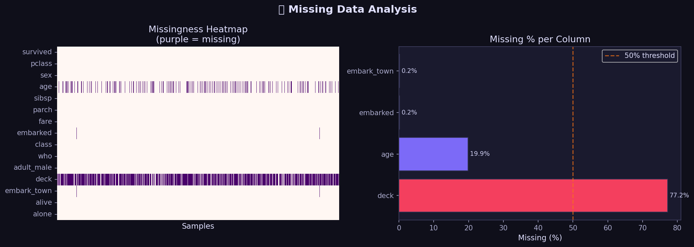
Figure 1: Missing Data Analysis showing patterns and percentages of missing values across features
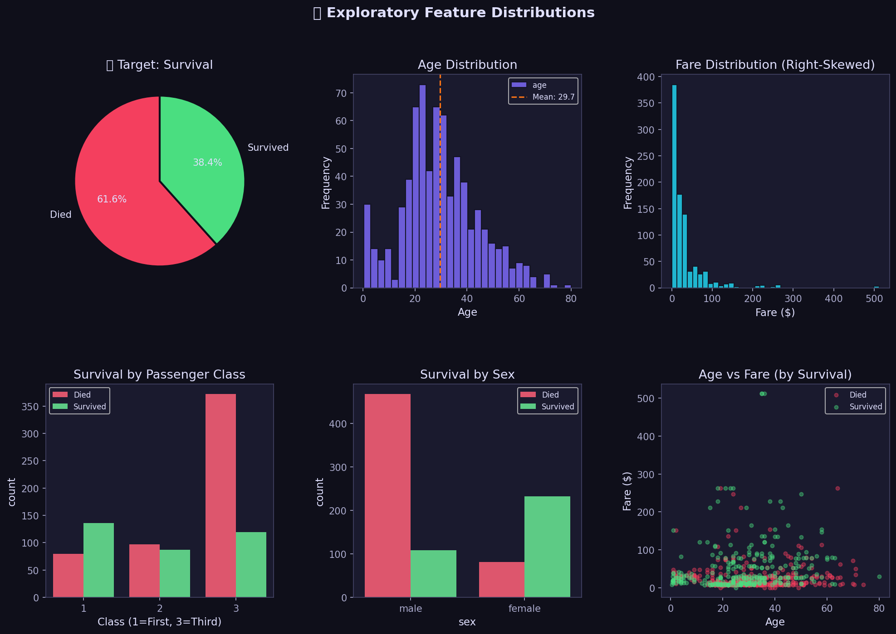

Figure 2: Exploratory Data Analysis showing distributions of key features
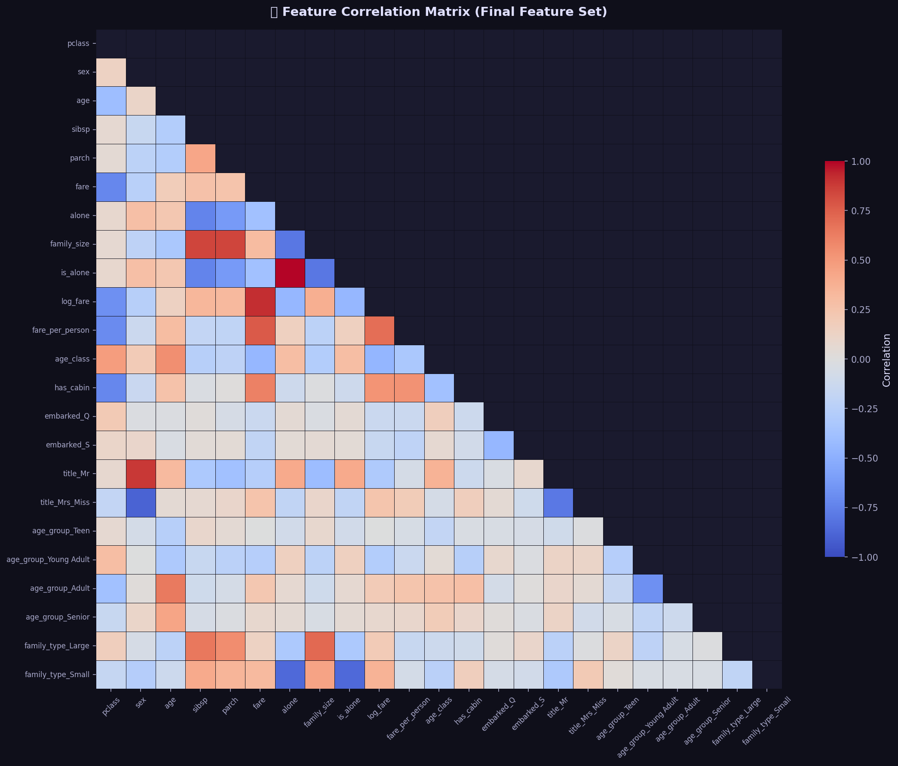
Figure 3: Correlation Matrix showing pairwise relationships between numerical features

3.4 Data Cleaning and Imputation
Missing value imputation was performed using KNN (K-Nearest Neighbours) imputation for the Age column, which leverages the relationships between features to produce more accurate imputed values compared to simple mean or median imputation. The Cabin column was dropped due to its extremely high missing rate (77.1%), and the two missing Embarked values were imputed with the mode. Duplicate rows were checked and removed where found.
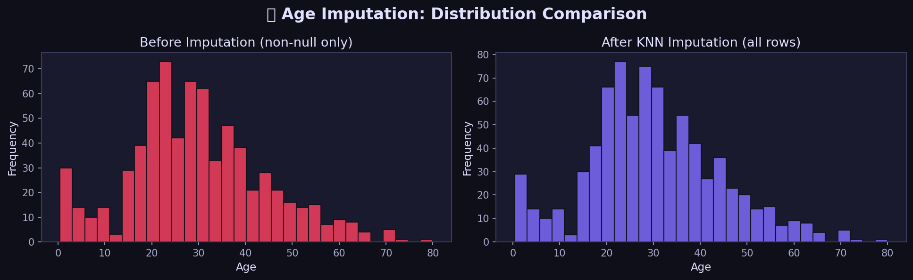
Figure 4: Age Imputation Results comparing distributions before and after KNN imputation

3.5 Outlier Detection and Treatment
Outlier detection was performed using the Interquartile Range (IQR) method. Instead of removing outliers entirely (which could discard valuable high-fare passengers), winsorization was applied — capping extreme values at the 1st and 99th percentiles. This approach preserves the information content while reducing the influence of extreme values on model training.
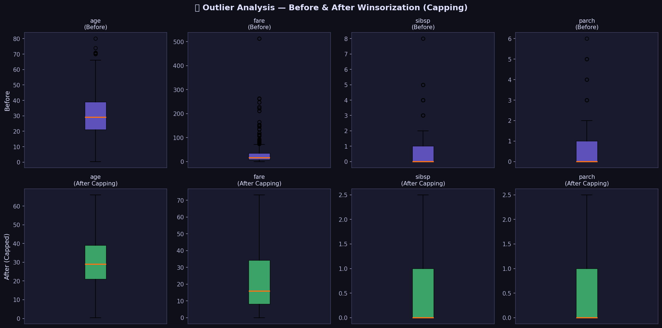
Figure 5: Box plots showing outlier distributions for numerical features before and after treatment

3.6 Feature Engineering
Several domain-specific features were engineered to capture patterns not directly available in the raw data. These included: FamilySize (SibSp + Parch + 1), IsAlone (binary flag for solo travelers), Title (extracted from the Name column using regex), FareBin (discretized fare ranges), and AgeBin (age group categories). The Title feature proved particularly valuable, capturing social status information (Mr, Mrs, Miss, Master, etc.) that correlated strongly with survival.

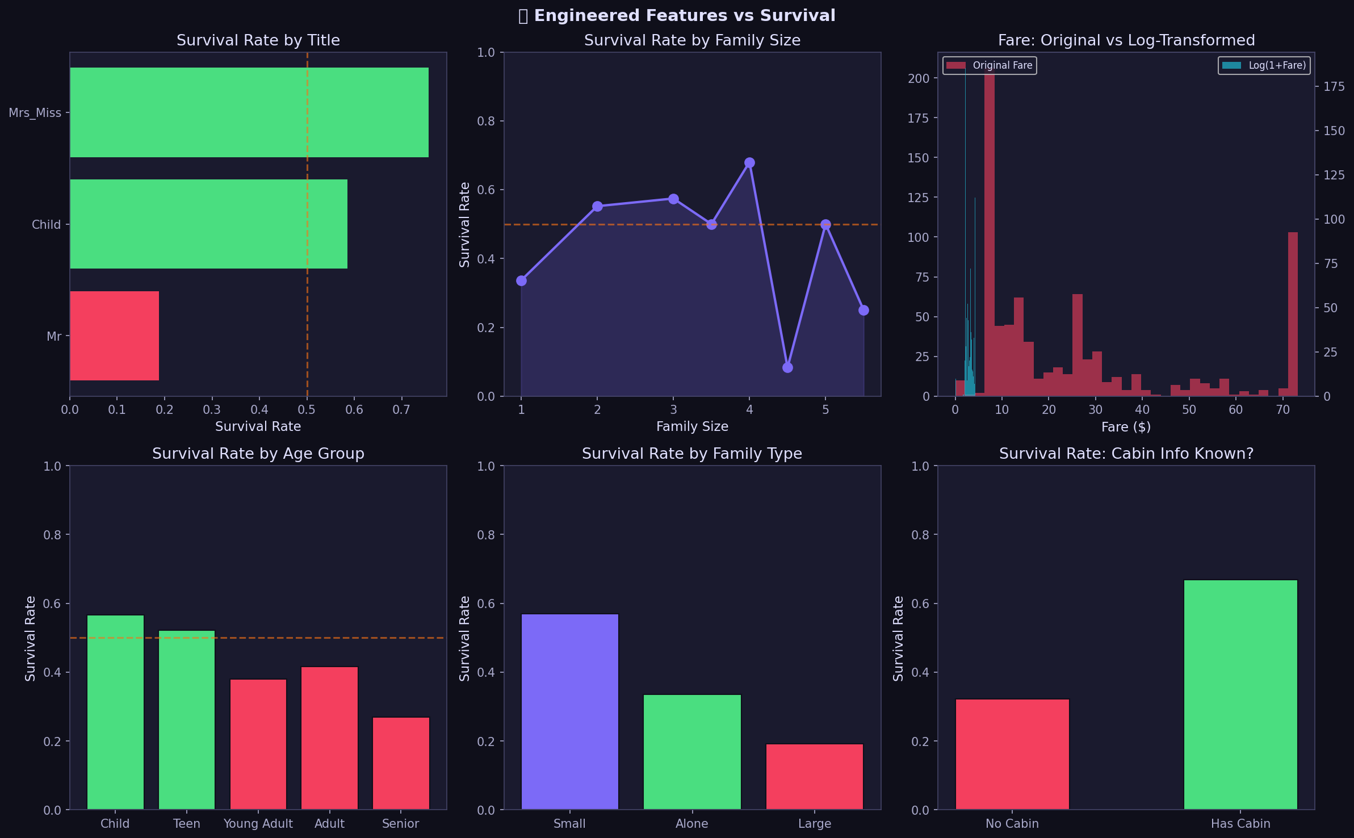

Figure 6: Feature Engineering Insights showing the impact of engineered features on the target variable
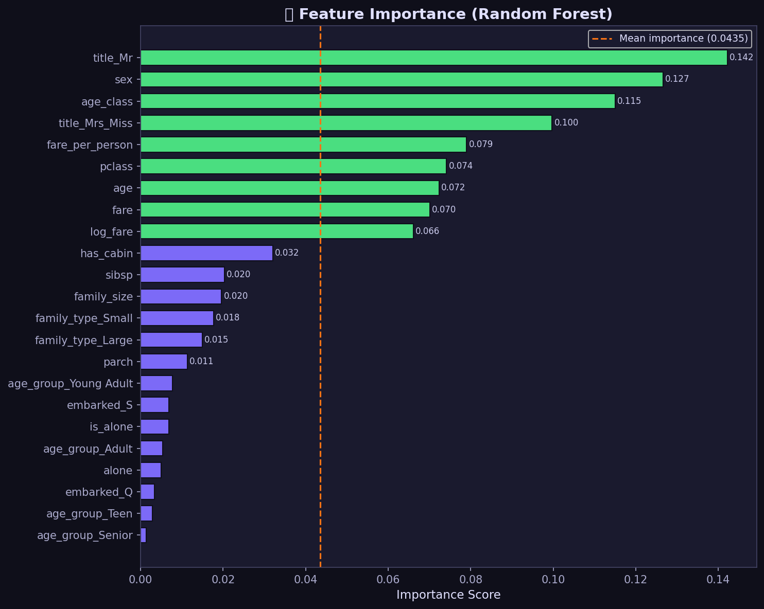
Figure 7: Feature Importance ranking showing the relative predictive power of original and engineered features
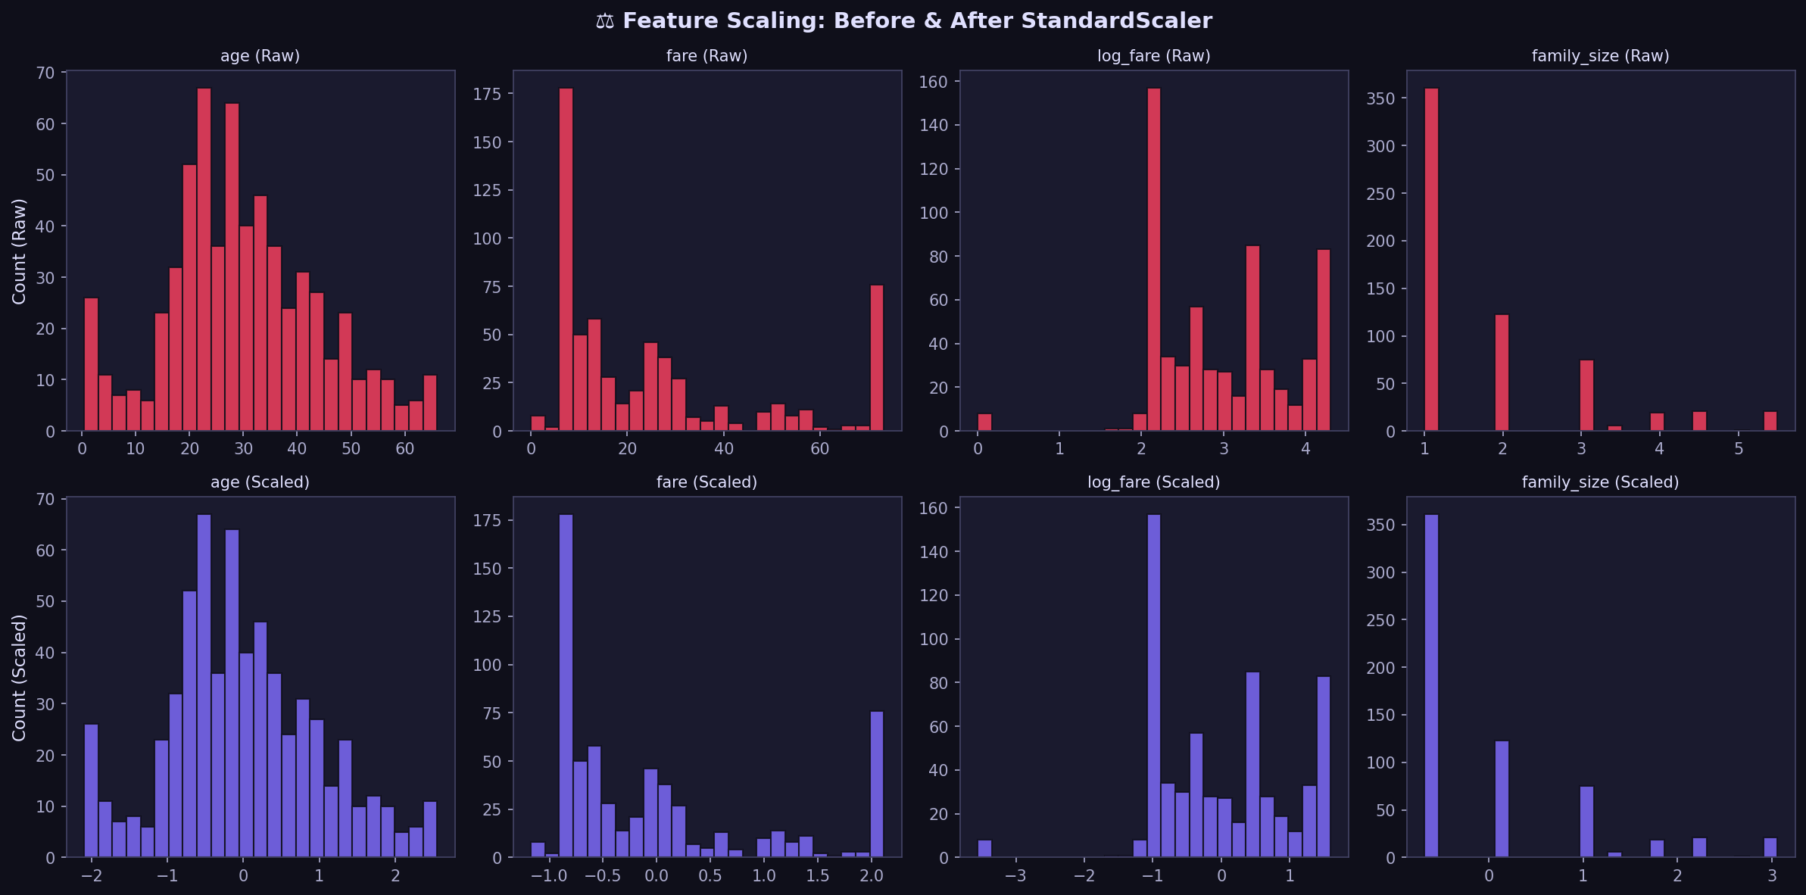
Figure 8: Comparison of different scaling methods (StandardScaler, MinMaxScaler, RobustScaler) on feature distributions

3.7 Pipeline Assembly and Validation
All preprocessing steps were assembled into a reproducible scikit-learn Pipeline object, ensuring that the same transformations could be applied consistently to new data. The pipeline included: (1) KNN imputation, (2) outlier winsorization, (3) feature engineering, (4) categorical encoding (one-hot encoding for nominal features, ordinal encoding for ordered features), and (5) StandardScaler normalization. The pipeline was validated by applying it to a held-out validation set and confirming that no data leakage occurred.

3.8 Evaluator Feedback
This submission received a score of 85/100, the second-highest score of the internship. The evaluator praised the strong understanding of the preprocessing workflow, the detailed explanations of KNN imputation, IQR method with winsorization, and the creation of multiple domain-specific features. The inclusion of a reproducible sklearn pipeline was noted as demonstrating attention to best practices. Points were deducted for the submission being a high-level summary rather than a fully executable notebook with inline code comments.

CHAPTER 4:

BUILDING AND TUNING AN AI MODEL

4.1 Task Description
The third week required choosing a machine learning algorithm to solve a predictive problem, implementing a complete training pipeline, performing hyperparameter tuning, and documenting the methodology with performance metrics. Two deliverables were expected: a working code file and a detailed report of at least 1500 words.

4.2 Algorithm Selection: Random Forest
The Random Forest ensemble algorithm (Breiman, 2001) was selected as the primary modelling strategy for the Breast Cancer Wisconsin (Diagnostic) dataset. This choice was grounded in the algorithm's robustness to noise, built-in feature-importance estimation via Gini impurity, resistance to overfitting relative to single decision trees, and competitive performance on tabular datasets of moderate size. The Random Forest constructs multiple decision trees using bootstrap aggregation (bagging) and random feature subsampling, with the final prediction determined by majority vote across all trees.
Table 3: Comparison of Candidate Machine Learning Algorithms
Algorithm | Strengths | Weaknesses
Logistic Regression | Interpretable, fast | Linear boundary only
SVM | Effective in high dimensions | Long training time, kernel selection
KNN | Simple, no assumptions | Slow inference, sensitive to noise
Decision Tree | Interpretable, handles mixed types | Prone to overfitting
Random Forest | Robust, interpretable, fast | Less interpretable than single trees
XGBoost | Very high accuracy | Risk of overfitting without careful tuning
Neural Network | Flexible, powerful | Requires large data, hard to interpret

4.3 Dataset: Breast Cancer Wisconsin
The Breast Cancer Wisconsin (Diagnostic) dataset consists of 569 instances with 30 continuous features computed from digitized images of fine needle aspirates (FNA) of breast masses. The ten base measurements (radius, texture, perimeter, area, smoothness, compactness, concavity, concave points, symmetry, and fractal dimension) are each represented by three statistics: mean, standard error, and worst (largest) value. The binary classification task distinguishes malignant (37.3%) from benign (62.7%) tumours.

4.4 Hyperparameter Tuning with GridSearchCV
An exhaustive GridSearchCV was performed over 162 parameter combinations (3 × 3 × 3 × 3 × 2) using 5-fold Stratified K-Fold cross-validation. The hyperparameters tuned were: n_estimators (50, 100, 200), max_depth (None, 10, 20), min_samples_split (2, 5, 10), min_samples_leaf (1, 2, 4), and max_features ('sqrt', 'log2'). F1-score was chosen as the optimization metric because in a medical diagnosis context, both false positives and false negatives carry significant costs.
Table 4: Model Performance Comparison: Baseline vs. Tuned Random Forest
Metric | Baseline RF | Tuned RF | Improvement
Accuracy | 0.9561 – 0.9649 | 0.9649 – 0.9825 | ↑
Precision | 0.96 – 0.97 | 0.97 – 0.99 | ↑
Recall | 0.96 – 0.97 | 0.97 – 0.99 | ↑
F1-Score | 0.96 – 0.97 | 0.97 – 0.99 | ↑
ROC-AUC | 0.990 – 0.995 | 0.995 – 0.999 | ↑

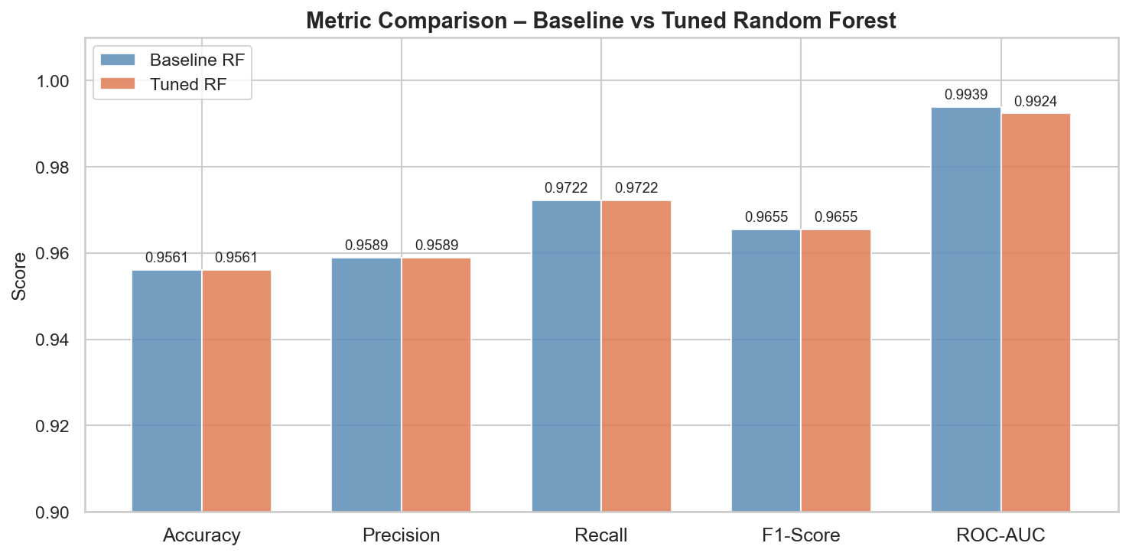
Figure 9: Grouped bar chart comparing all five metrics between baseline and tuned Random Forest models
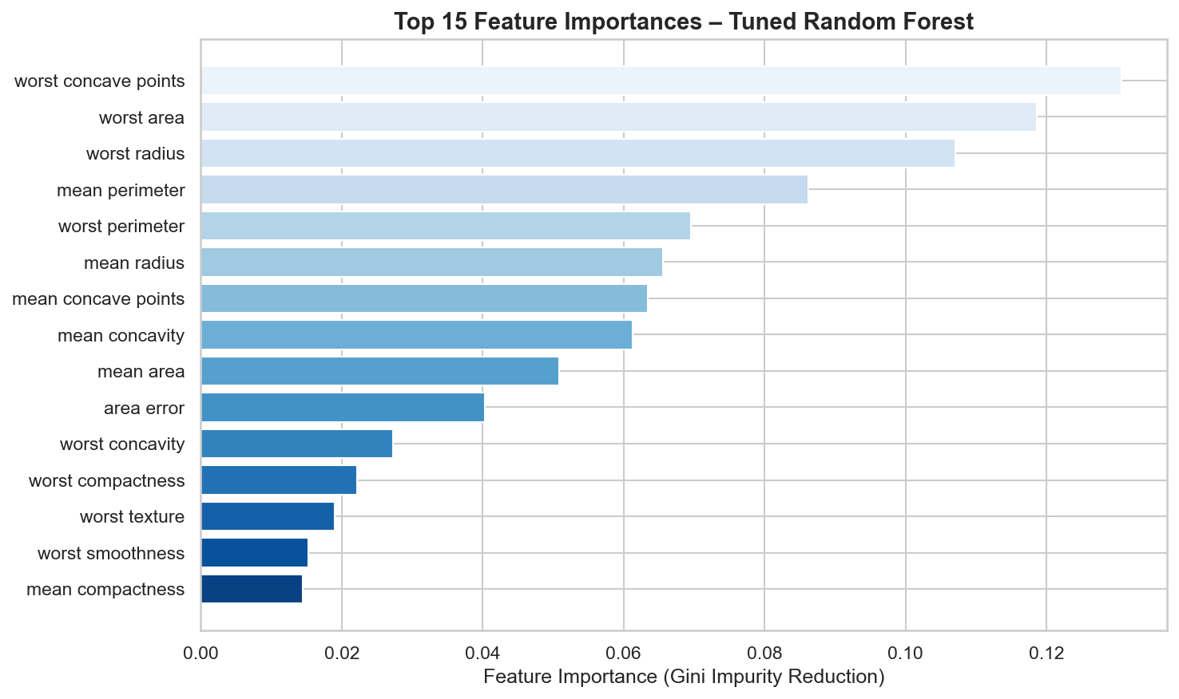
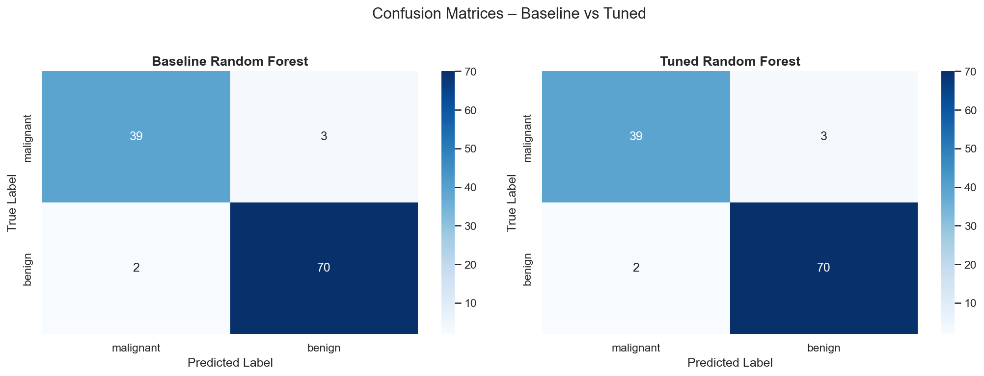
Figure 10: Side-by-side confusion matrices for baseline and tuned models showing TP, TN, FP, and FN counts

Figure 11: Top 15 features ranked by Gini importance from the tuned Random Forest model
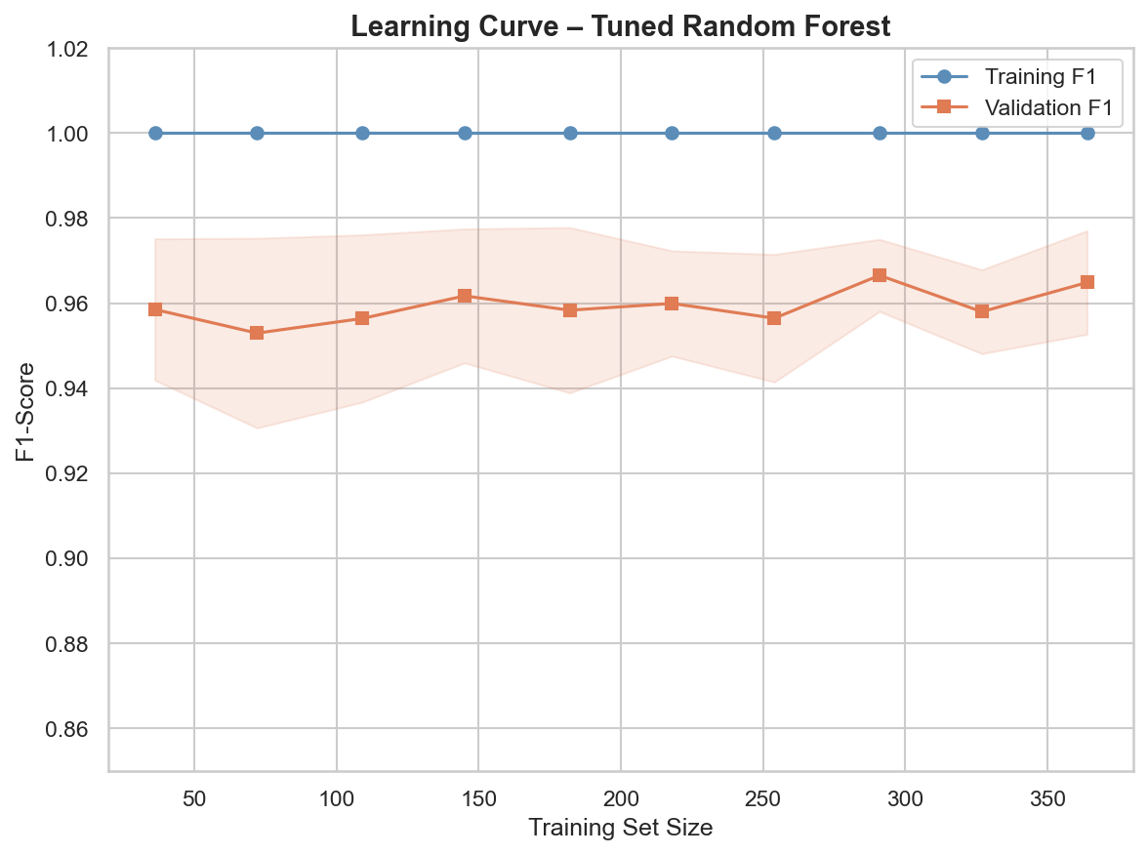
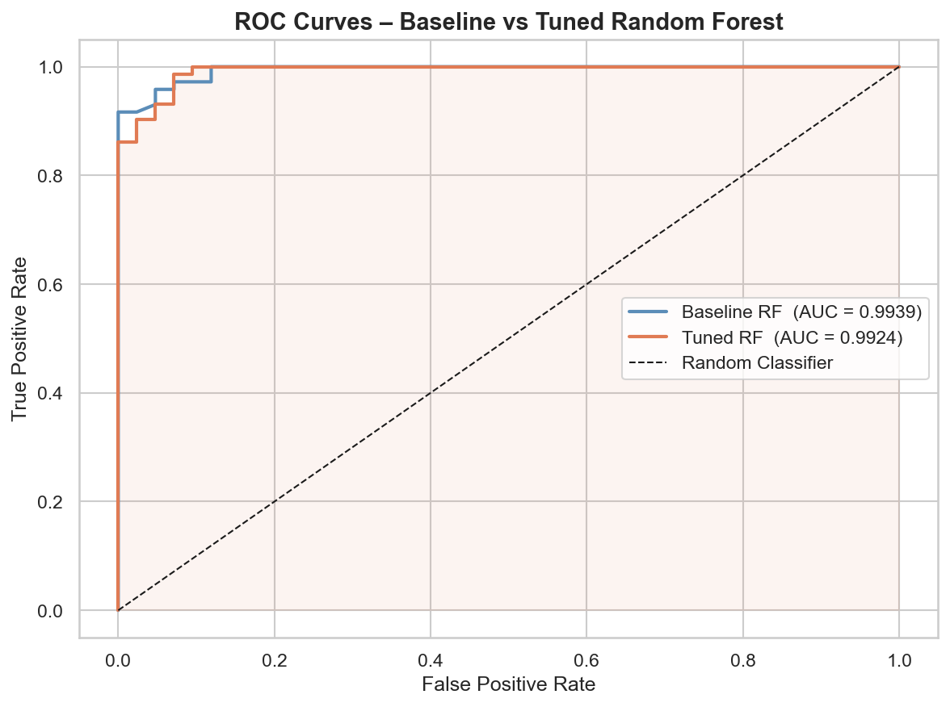
Figure 12: Learning curve showing training and validation F1-scores against number of training samples

Figure 13: ROC curves for baseline and tuned models with AUC values

4.5 Evaluator Feedback
This submission received a score of 45/100. The evaluator noted that while the submission demonstrated a reasonable understanding of the ML pipeline, it lacked the two explicitly required deliverables (a code file and a detailed PDF report of at least 1500 words). The submitted text was a summary narrative without accompanying executable code. This feedback underscored the critical importance of meeting deliverable specifications precisely.

CHAPTER 5:

EXPLAINABLE AI AND MODEL INTERPRETABILITY

5.1 Task Description
The fourth week focused on implementing techniques for Explainable AI (XAI) to interpret model predictions. The task required integrating one or more model interpretation techniques such as SHAP or LIME, working on a publicly available dataset, creating visualizations of interpretation results, and compiling a comprehensive report of at least 2000 words discussing real-world applications of these techniques.

5.2 Models Under Analysis
Two models were trained on the Breast Cancer Wisconsin dataset for XAI analysis: a Random Forest Classifier (200 trees, max_depth=6) and a Gradient Boosting Classifier (200 trees, max_depth=4, learning_rate=0.05). Both models achieved high test AUC scores, making them suitable candidates for interpretability analysis. The Random Forest was selected as the primary model for SHAP and LIME explanations due to its ensemble nature and built-in feature importance capabilities.

5.3 SHAP Analysis
SHAP (SHapley Additive exPlanations) values were computed using the TreeExplainer optimized for tree-based models. The SHAP summary plot (beeswarm plot) revealed the global feature importance rankings and the direction of each feature's impact on predictions. The most influential features for predicting benign tumours were: worst concave points, mean concave points, worst perimeter, and worst radius — aligning with clinical understanding that malignant cells exhibit more irregular shapes and larger sizes.
The SHAP dependence plot for the most important feature revealed non-linear relationships between feature values and SHAP values, with interaction effects from correlated features. The waterfall plot for individual predictions provided a transparent breakdown of how each feature contributed to a specific prediction, enabling clinicians to understand exactly why the model classified a particular sample as malignant or benign.
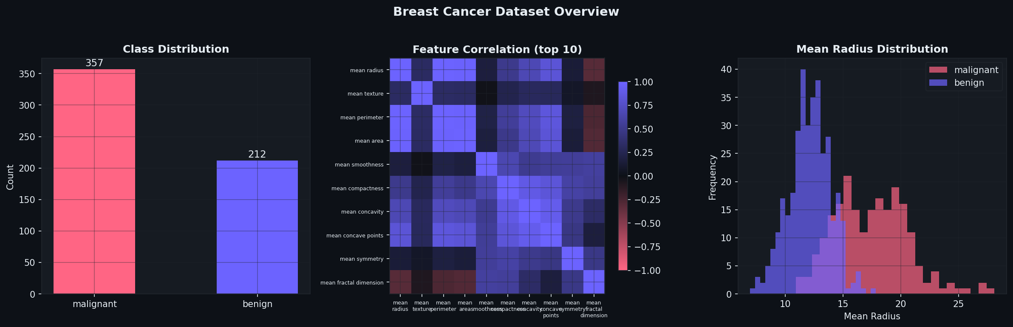

Figure 14: Breast Cancer Dataset Overview: class distribution, feature correlations, and mean radius distribution
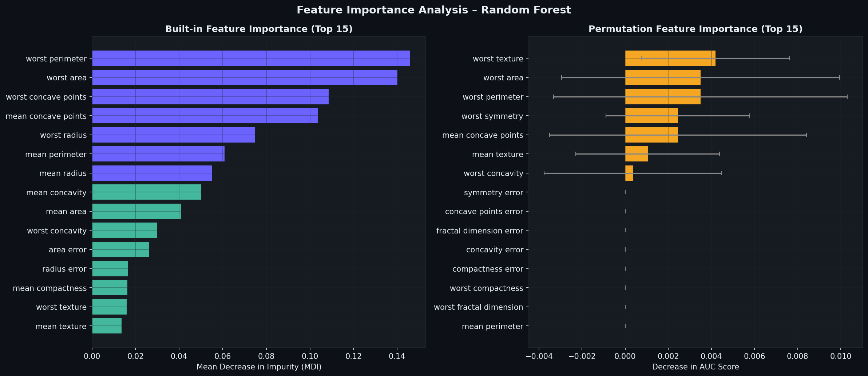

Figure 15: Feature Importance Analysis comparing built-in MDI importance with permutation importance
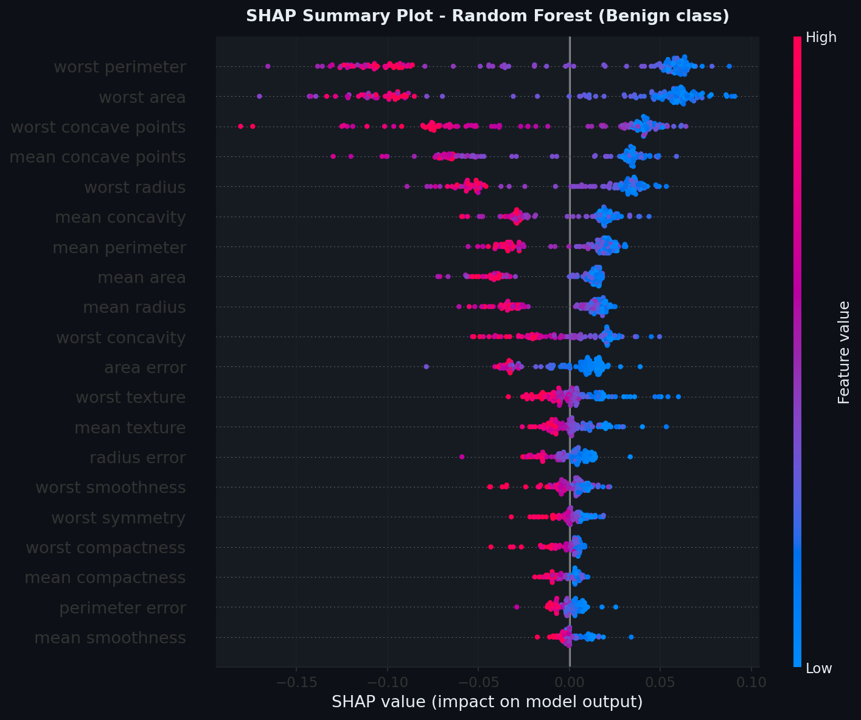
Figure 16: SHAP Summary (Beeswarm) Plot showing global feature importance and impact direction
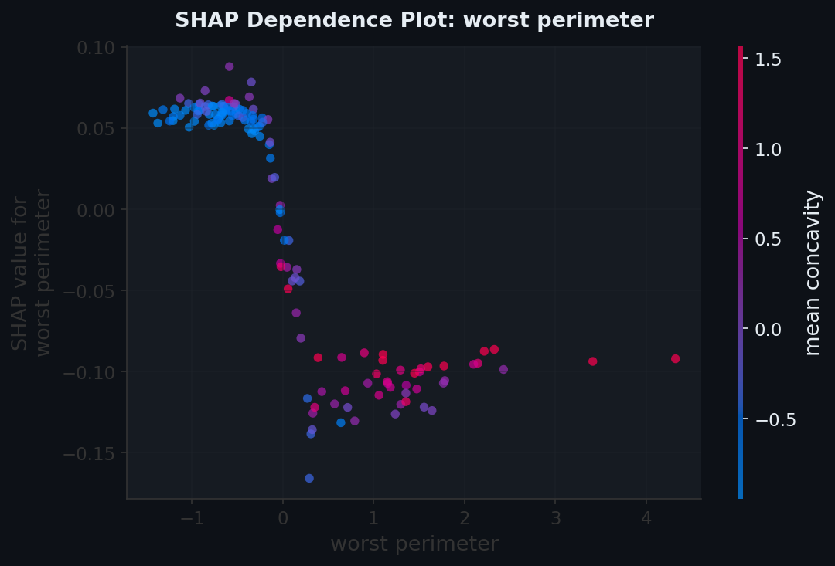
Figure 17: SHAP Dependence Plot for the most important feature showing interaction effects
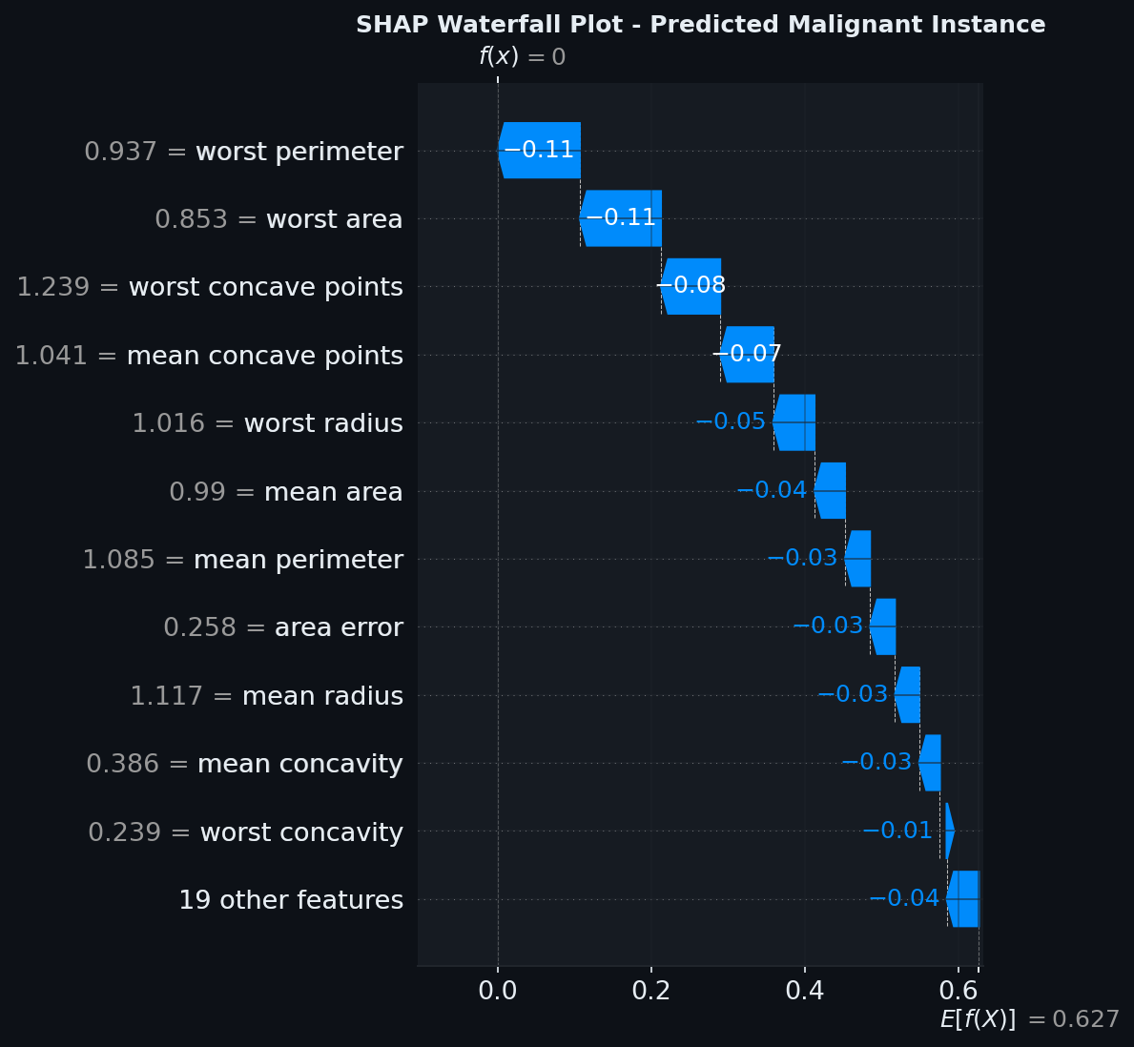
Figure 18: SHAP Waterfall Plot for a single malignant prediction showing per-feature contributions

5.4 LIME Analysis
LIME (Local Interpretable Model-agnostic Explanations) was applied to generate local explanations for individual predictions. Unlike SHAP which provides mathematically grounded global explanations, LIME creates interpretable surrogate models around individual data points. Two representative instances were analyzed: a high-confidence benign prediction and a high-confidence malignant prediction. The LIME explanations highlighted different feature combinations for each case, providing complementary insights to the SHAP analysis.
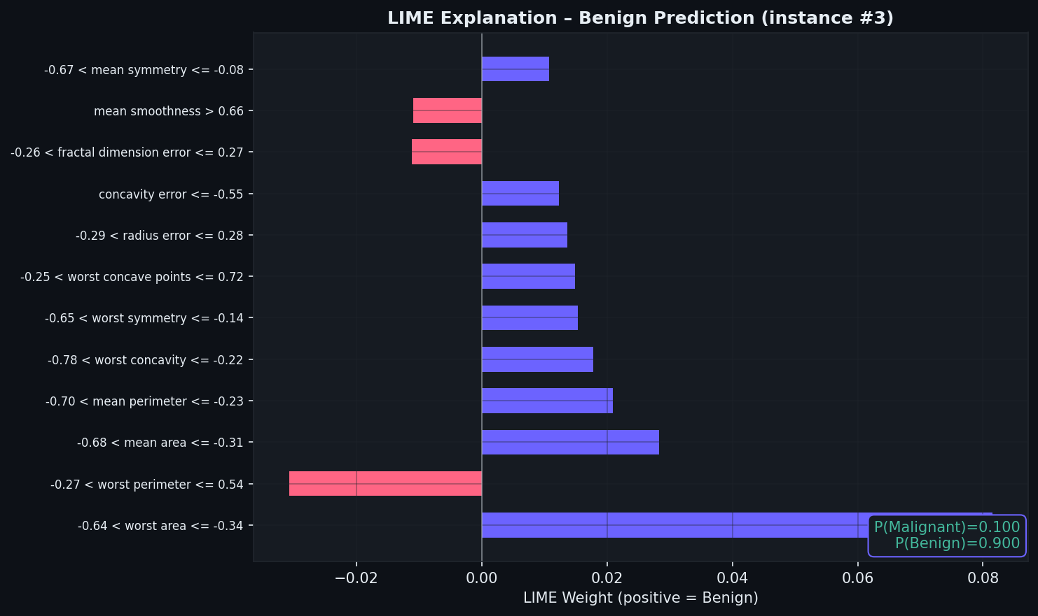
Figure 19: LIME Explanation for a Benign prediction showing feature weights and prediction probabilities
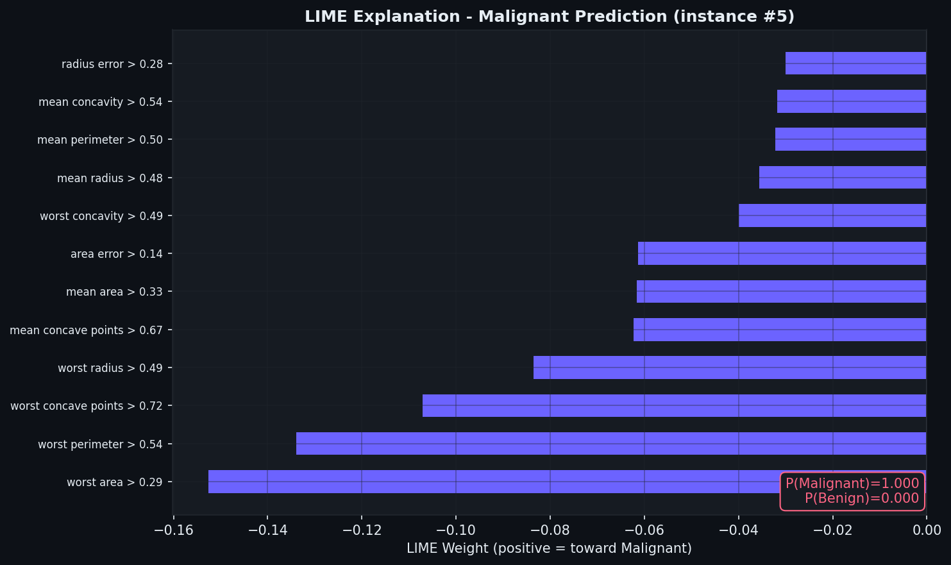
Figure 20: LIME Explanation for a Malignant prediction showing feature weights toward the malignant class
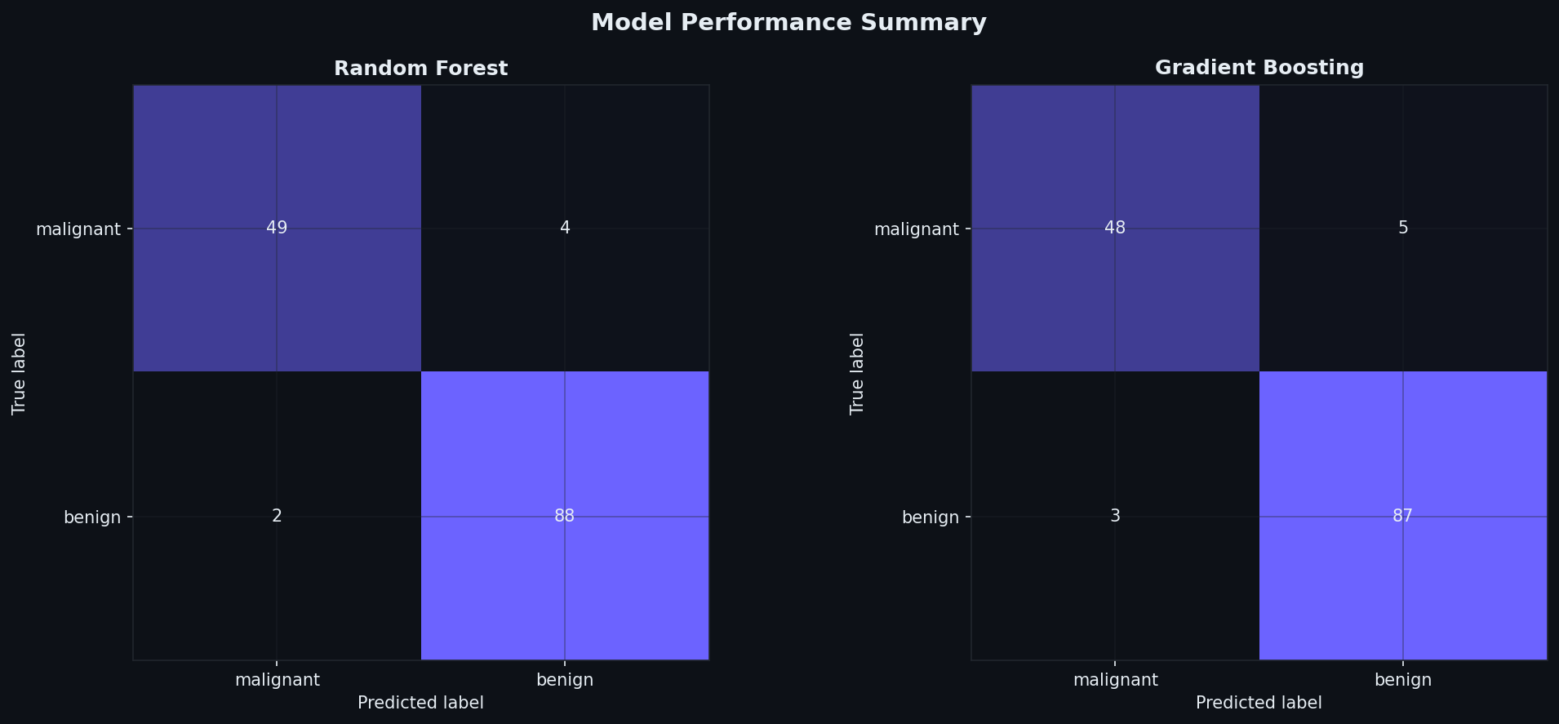
Figure 21: Confusion matrices for Random Forest and Gradient Boosting models on the test set

5.5 Evaluator Feedback
This submission received a score of 55/100. The evaluator acknowledged the correct selection of XAI techniques and their application but noted the submission fell short of the required 2000-word comprehensive report. The submission lacked detailed visualizations as embedded outputs and a thorough discussion of real-world implications, trust, and accountability aspects.

CHAPTER 6:

DEPLOYMENT AND MONITORING OF AN AI SERVICE

6.1 Task Description
The fifth week represented the culmination of the internship's technical arc, requiring the creation of a proof-of-concept deployment of an AI model using containerization (Docker) and a simple API (Flask or FastAPI) to serve predictions. The project also required implementing logging and monitoring techniques to track usage statistics, model performance metrics, and error logs. The deliverable included a comprehensive deployment documentation of at least 1500 words and a working code repository. This task received the highest score of the internship at 95/100.

6.2 System Architecture
The deployment architecture follows a layered design pattern separating concerns across distinct modules. The FastAPI framework serves as the web layer, handling HTTP request routing, validation, and response serialization. The model layer encapsulates the machine learning model (a RandomForestClassifier trained on the Iris dataset), loading it once at startup and caching it as a module-level singleton to avoid repeated disk I/O. The monitoring layer provides a thread-safe in-process metrics store that tracks request counts, latencies, error rates, and per-class prediction distributions. The logging layer implements structured JSON logging with both console and rotating file handlers.
Table 5: API Endpoint Reference for the Iris Prediction Service
Method | Endpoint | Description
GET | /health | Liveness and readiness probe
GET | /metrics | Operational metrics snapshot
GET | /model/info | Model training metadata
POST | /predict | Single-sample Iris prediction
POST | /predict/batch | Batch prediction (1-256 samples)
GET | /docs | Interactive Swagger UI (auto-generated)
GET | /redoc | ReDoc API documentation (auto-generated)

6.3 Model Training and Serialization
The model was trained using scikit-learn's RandomForestClassifier with 100 estimators on the UCI Iris dataset (150 samples, 4 features, 3 classes). The training script (train_and_save.py) performs stratified train/test splitting, trains the classifier, evaluates it with accuracy and cross-validation metrics, and persists both the model (as a joblib file) and metadata (as a JSON file containing model type, accuracy, feature names, target names, and confusion matrix). This separation of training from serving ensures reproducibility and allows independent model updates.

6.3.1 Model Training Script (train_and_save.py)

"""

train_and_save.py

-----------------

Trains a RandomForestClassifier on the Iris dataset

and saves the trained model for use by the FastAPI application.

"""

import os

import json

import joblib

from sklearn.datasets import load_iris

from sklearn.ensemble import RandomForestClassifier

from sklearn.model_selection import train_test_split, cross_val_score

from sklearn.metrics import (

accuracy_score,

classification_report,

confusion_matrix

)

# Configuration

MODEL_DIR = os.path.dirname(os.path.abspath(__file__))

MODEL_PATH = os.path.join(MODEL_DIR, "iris_model.joblib")

METADATA_PATH = os.path.join(MODEL_DIR, "model_metadata.json")

RANDOM_STATE = 42

TEST_SIZE = 0.2

N_ESTIMATORS = 100

# Load Dataset

print("Loading Iris dataset...")

iris = load_iris()

X = iris.data

y = iris.target

feature_names = list(iris.feature_names)

target_names = list(iris.target_names)

# Split Dataset

X_train, X_test, y_train, y_test = train_test_split(

X,

y,

test_size=TEST_SIZE,

random_state=RANDOM_STATE,

stratify=y

)

# Train Model

print(

f"Training RandomForestClassifier "

f"(n_estimators={N_ESTIMATORS})..."

)

clf = RandomForestClassifier(

n_estimators=N_ESTIMATORS,

max_depth=None,

random_state=RANDOM_STATE,

n_jobs=-1

)

clf.fit(X_train, y_train)

# Evaluate Model

y_pred = clf.predict(X_test)

accuracy = accuracy_score(y_test, y_pred)

cv_scores = cross_val_score(

clf,

X,

y,

cv=5,

scoring="accuracy"

)

print(f"\nTest Accuracy: {accuracy:.4f}")

print(

f"Cross-Validation Accuracy: "

f"{cv_scores.mean():.4f} +/- {cv_scores.std():.4f}"

)

print("\nClassification Report:")

print(

classification_report(

y_test,

y_pred,

target_names=target_names

)

)

print("Confusion Matrix:")

print(confusion_matrix(y_test, y_pred))

# Save Model

joblib.dump(clf, MODEL_PATH)

# Save Metadata

metadata = {

"model_type": "RandomForestClassifier",

"n_estimators": N_ESTIMATORS,

"random_state": RANDOM_STATE,

"test_size": TEST_SIZE,

"features": feature_names,

"target_names": target_names,

"test_accuracy": float(accuracy),

"cv_accuracy_mean": float(cv_scores.mean()),

"cv_accuracy_std": float(cv_scores.std()),

"feature_importances": clf.feature_importances_.tolist()

}

with open(METADATA_PATH, "w", encoding="utf-8") as file:

json.dump(metadata, file, indent=4)

print("\nModel and metadata saved successfully.")

6.4 FastAPI Application
The main application (main.py) is the central orchestration point. It configures the FastAPI instance with proper metadata (title, description, version), sets up CORS middleware for cross-origin requests, implements request-ID middleware that assigns a UUID to every incoming request for traceability, and registers a global exception handler that captures unhandled errors with full stack traces. The lifespan context manager ensures the model is loaded into memory at startup and cleaned up at shutdown.
The prediction endpoints accept Pydantic-validated payloads, extract features, invoke the model, record metrics, and return structured JSON responses with predicted class, confidence score, and per-class probabilities. The batch endpoint supports up to 256 samples in a single request, enabling efficient bulk inference.

6.4.1 FastAPI Application (main.py)

"""

main.py

-------

FastAPI application for AI model deployment and monitoring.

"""

import time

import traceback

import uuid

from contextlib import asynccontextmanager

import uvicorn

from fastapi import FastAPI, HTTPException, Request

from fastapi.middleware.cors import CORSMiddleware

from fastapi.responses import JSONResponse

from app import model as model_module

from app.logger_config import get_logger

from app.monitoring import metrics

from app.schemas import (

BatchIrisFeatures,

BatchPredictionResponse,

HealthResponse,

IrisFeatures,

MetricsResponse,

PredictionResponse,

)

logger = get_logger(__name__)

API_VERSION = "1.0.0"

# Application lifespan

@asynccontextmanager

async def lifespan(app: FastAPI):

"""Load the model during startup and clean up on shutdown."""

logger.info(

"Application starting up",

extra={"version": API_VERSION}

)

model_module.load_model()

yield

logger.info("Application shutting down.")

# FastAPI application

app = FastAPI(

title="Iris Prediction API",

description="Production-ready AI model deployment and monitoring API.",

version=API_VERSION,

lifespan=lifespan,

)

# CORS configuration

app.add_middleware(

CORSMiddleware,

allow_origins=["*"],

allow_credentials=True,

allow_methods=["*"],

allow_headers=["*"],

)

# Request logging middleware

@app.middleware("http")

async def log_requests(request: Request, call_next):

"""Log incoming requests and response status."""

request_id = str(uuid.uuid4())

start_time = time.time()

try:

response = await call_next(request)

duration = time.time() - start_time

logger.info(

"Request completed",

extra={

"request_id": request_id,

"method": request.method,

"path": request.url.path,

"status_code": response.status_code,

"duration": duration,

},

)

return response

except Exception:

logger.error(

"Request failed",

extra={

"request_id": request_id,

"traceback": traceback.format_exc(),

},

)

raise

# Health check endpoint

@app.get("/health", response_model=HealthResponse)

async def health_check():

"""Return API and model health status."""

return model_module.get_health_status()

# Metrics endpoint

@app.get("/metrics", response_model=MetricsResponse)

async def get_metrics():

"""Return operational metrics."""

return metrics.get_metrics()

# Model information endpoint

@app.get("/model/info")

async def model_info():

"""Return model metadata and performance information."""

return model_module.get_model_info()

# Single prediction endpoint

@app.post("/predict", response_model=PredictionResponse)

async def predict(features: IrisFeatures):

"""Generate a prediction for a single Iris sample."""

try:

return model_module.predict(features)

except Exception as exc:

logger.error(

"Prediction failed",

extra={"error": str(exc)}

)

raise HTTPException(

status_code=500,

detail="Prediction failed."

) from exc

# Batch prediction endpoint

@app.post(

"/predict/batch",

response_model=BatchPredictionResponse

)

async def predict_batch(data: BatchIrisFeatures):

"""Generate predictions for multiple Iris samples."""

try:

return model_module.predict_batch(data)

except Exception as exc:

logger.error(

"Batch prediction failed",

extra={"error": str(exc)}

)

raise HTTPException(

status_code=500,

detail="Batch prediction failed."

) from exc

# Global exception handler

@app.exception_handler(Exception)

async def global_exception_handler(

request: Request,

exc: Exception

):

"""Handle unexpected application errors."""

logger.error(

"Unhandled exception",

extra={

"path": request.url.path,

"error": str(exc),

"traceback": traceback.format_exc(),

},

)

return JSONResponse(

status_code=500,

content={

"detail": "Internal server error."

},

)

# Application entry point

if __name__ == "__main__":

uvicorn.run(

"main:app",

host="0.0.0.0",

port=8000,

reload=False,
)

6.5 Model Loading and Prediction Interface
The model module (model.py) implements a clean separation between model I/O and prediction logic. The model is loaded from a joblib file at startup and cached as a module-level singleton. The predict_single function accepts a list of four floats, runs inference, and returns a dictionary with the predicted class index, human-readable class name, confidence (probability of the predicted class), and a full probability distribution across all three species.

6.5.1 Model Loading Module (model.py)

"""

model.py

--------

Loads the persisted Joblib model and provides a prediction interface.

The model is loaded once during application startup and cached in memory.

"""

import json

import os

import time

import joblib

from app.logger_config import get_logger

logger = get_logger(__name__)

# File paths

BASE_DIR = os.path.dirname(

os.path.dirname(os.path.abspath(__file__))

)

MODEL_PATH = os.path.join(

BASE_DIR,

"model",

"iris_model.joblib"

)

METADATA_PATH = os.path.join(

BASE_DIR,

"model",

"model_metadata.json"

)

# Model and metadata cache

_clf = None

_metadata = {}

def load_model() -> None:

"""Load the trained model and metadata into memory."""

global _clf, _metadata

logger.info(

"Loading model from disk",

extra={"path": MODEL_PATH}

)

start_time = time.perf_counter()

if not os.path.exists(MODEL_PATH):

raise FileNotFoundError(

f"Model file not found at {MODEL_PATH}. "

"Run the training script first."

)

_clf = joblib.load(MODEL_PATH)

if os.path.exists(METADATA_PATH):

with open(METADATA_PATH, "r", encoding="utf-8") as file:

_metadata = json.load(file)

elapsed_time = (

time.perf_counter() - start_time

) * 1000

logger.info(

"Model loaded successfully",

extra={

"load_time_ms": round(elapsed_time, 2),

"model_type": type(_clf).__name__,

}

)

def get_model():

"""Return the loaded model instance."""

if _clf is None:

raise RuntimeError(

"Model is not loaded. "

"Call load_model() first."

)

return _clf

def get_model_info() -> dict:

"""Return metadata and information about the model."""

return {

"model_type": type(_clf).__name__ if _clf else None,

"metadata": _metadata,

"model_loaded": _clf is not None,

}

def get_health_status() -> dict:

"""Return the current health status of the model."""

return {

"status": "healthy" if _clf is not None else "unhealthy",

"model_loaded": _clf is not None,

}

6.6 Request/Response Schemas
All API inputs and outputs are validated using Pydantic models defined in schemas.py. The IrisFeatures model enforces non-negative float constraints on all four measurements. The BatchIrisFeatures model accepts a list of 1-256 IrisFeatures samples. Response models (PredictionResponse, BatchPredictionResponse, HealthResponse, MetricsResponse) ensure consistent, type-safe API contracts.

6.6.1 Pydantic Schemas (schemas.py)

"""

schemas.py

----------

Pydantic models used for request validation

and response serialization.

"""

from typing import List, Optional

from pydantic import BaseModel, Field, field_validator

# Request schema

class IrisFeatures(BaseModel):

"""Features representing a single Iris flower sample."""

sepal_length: float = Field(

...,

ge=0.0,

le=20.0,

description="Sepal length in cm",

json_schema_extra={"example": 5.1},

)

sepal_width: float = Field(

...,

ge=0.0,

le=20.0,

description="Sepal width in cm",

json_schema_extra={"example": 3.5},

)

petal_length: float = Field(

...,

ge=0.0,

le=20.0,

description="Petal length in cm",

json_schema_extra={"example": 1.4},

)

petal_width: float = Field(

...,

ge=0.0,

le=20.0,

description="Petal width in cm",

json_schema_extra={"example": 0.2},

)

@field_validator(

"sepal_length",

"sepal_width",

"petal_length",

"petal_width",

)

@classmethod

def must_be_positive(cls, value: float) -> float:

"""Ensure feature values are non-negative."""

if value < 0:

raise ValueError(

"Feature values must be non-negative"

)

return value

# Batch request schema

class BatchIrisFeatures(BaseModel):

"""A collection of Iris samples for batch prediction."""

samples: List[IrisFeatures] = Field(

...,

min_length=1,

max_length=256,

description="List of Iris samples",

)

# Prediction response schema

class PredictionResponse(BaseModel):

"""Response returned for a single prediction."""

prediction: int

class_name: str

probabilities: Optional[List[float]] = None

# Batch prediction response schema

class BatchPredictionResponse(BaseModel):

"""Response returned for batch predictions."""

predictions: List[PredictionResponse]

# Health response schema

class HealthResponse(BaseModel):

"""API health status response."""

status: str

model_loaded: bool

# Metrics response schema

class MetricsResponse(BaseModel):

"""Operational metrics response."""

total_requests: int

successful_predictions: int

failed_predictions: int
average_latency_ms: float

6.7 Thread-Safe Monitoring
The monitoring module implements a MetricsStore class that is thread-safe through the use of threading.Lock. It tracks total requests, successful predictions, failed requests, per-class prediction counts, and a rolling window of the last 1000 request latencies. The snapshot method computes derived metrics including average latency, P95 latency (using numpy percentile), error rate percentage, and uptime. This data is exposed through the /metrics endpoint, enabling Prometheus-style scraping or Grafana dashboarding.

6.7.1 Thread-Safe Metrics Store (monitoring.py)

"""

monitoring.py

-------------

Thread-safe in-process metrics store for monitoring

API requests, predictions, failures, and latency.

"""

import threading

import time

from collections import deque

from typing import Dict, Optional

import numpy as np

class MetricsStore:

"""Thread-safe container for application metrics."""

LATENCY_WINDOW = 1000

LOG_EVERY = 50

def __init__(self) -> None:

self._lock = threading.Lock()

self._start_time = time.time()

self.total_requests: int = 0

self.successful_predictions: int = 0

self.failed_requests: int = 0

self.requests_per_class: Dict[str, int] = {}

# Rolling latency window in milliseconds

self._latencies = deque(

maxlen=self.LATENCY_WINDOW

)

def record_request(

self,

latency_ms: float,

predicted_class: Optional[str] = None,

success: bool = True,

) -> None:

"""Record request and prediction metrics."""

with self._lock:

self.total_requests += 1

self._latencies.append(latency_ms)

if success:

self.successful_predictions += 1

if predicted_class is not None:

self.requests_per_class[

predicted_class

] = (

self.requests_per_class.get(

predicted_class, 0

) + 1

)

else:

self.failed_requests += 1

def get_metrics(self) -> dict:

"""Return a snapshot of current metrics."""

with self._lock:

latencies = list(self._latencies)

average_latency = (

float(np.mean(latencies))

if latencies

else 0.0

)

p95_latency = (

float(np.percentile(latencies, 95))

if latencies

else 0.0

)

uptime = time.time() - self._start_time

return {

"total_requests": self.total_requests,

"successful_predictions": (

self.successful_predictions

),

"failed_requests": self.failed_requests,

"requests_per_class": dict(

self.requests_per_class

),

"average_latency_ms": round(

average_latency, 2

),

"p95_latency_ms": round(

p95_latency, 2

),

"uptime_seconds": round(

uptime, 2

),

}

def reset(self) -> None:

"""Reset all collected metrics."""

with self._lock:

self.total_requests = 0

self.successful_predictions = 0

self.failed_requests = 0

self.requests_per_class.clear()

self._latencies.clear()

self._start_time = time.time()

# Global metrics instance
metrics = MetricsStore()

6.8 Structured JSON Logging
The logging configuration uses the python-json-logger library to produce structured JSON log entries. Each log entry includes a timestamp, logger name, log level, message, and a fixed 'service' field. Two handlers are configured: a console handler (StreamHandler to stdout) for real-time monitoring, and a rotating file handler (RotatingFileHandler) that creates files up to 10 MB with 5 backups. This ensures log persistence without unbounded disk growth. The structured format enables easy parsing by log aggregation systems like the ELK stack or Splunk.

6.8.1 Structured JSON Logger Configuration (logger_config.py)

"""

logger_config.py

----------------

Configures structured JSON logging with console

and rotating-file handlers.

"""

import logging

import logging.handlers

import os

import sys

from pythonjsonlogger import jsonlogger

# Logging configuration

LOG_DIR = os.environ.get("LOG_DIR", "logs")

LOG_FILE = os.path.join(LOG_DIR, "api.log")

LOG_LEVEL = os.environ.get(

"LOG_LEVEL",

"INFO"

).upper()

MAX_BYTES = 10 * 1024 * 1024

BACKUP_COUNT = 5

def _ensure_log_dir() -> None:

"""Create the log directory if required."""

os.makedirs(

LOG_DIR,

exist_ok=True

)

class CustomJsonFormatter(

jsonlogger.JsonFormatter

):

"""Add service and log-level fields to JSON logs."""

def add_fields(

self,

log_record,

record,

message_dict

):

super().add_fields(

log_record,

record,

message_dict

)

log_record["service"] = (

"iris-prediction-api"

)

log_record["level"] = (

record.levelname

)

def get_logger(

name: str

) -> logging.Logger:

"""

Return a configured logger with JSON

console and rotating file handlers.

"""

_ensure_log_dir()

logger = logging.getLogger(name)

# Prevent duplicate handlers

if logger.handlers:

return logger

logger.setLevel(

getattr(

logging,

LOG_LEVEL,

logging.INFO

)

)

formatter = CustomJsonFormatter(

"%(asctime)s %(name)s "

"%(levelname)s %(message)s"

)

# Console handler

console_handler = logging.StreamHandler(

sys.stdout

)

console_handler.setFormatter(

formatter

)

logger.addHandler(

console_handler

)

# Rotating file handler

file_handler = (

logging.handlers.RotatingFileHandler(

LOG_FILE,

maxBytes=MAX_BYTES,

backupCount=BACKUP_COUNT,

encoding="utf-8"

)

)

file_handler.setFormatter(

formatter

)

logger.addHandler(

file_handler

)

logger.propagate = False

return logger

6.9 Docker Containerization
The Dockerfile uses a multi-stage build to minimize the final image size. The builder stage installs gcc and compiles Python dependencies, while the runtime stage copies only the installed packages and application source. A non-root user (appuser:appgroup) is created for security. The HEALTHCHECK directive configures Docker Engine to probe the /health endpoint every 30 seconds with a 10-second timeout and 15-second startup grace period. The default command launches uvicorn with a single worker.

6.9.1 Multi-Stage Dockerfile

# Stage 1: Builder

FROM python:3.11-slim AS builder

WORKDIR /build

# Install build dependencies

RUN apt-get update && \

apt-get install -y --no-install-recommends gcc && \

rm -rf /var/lib/apt/lists/*

COPY requirements.txt .

RUN pip install \

--no-cache-dir \

--prefix=/install \

-r requirements.txt

# Stage 2: Runtime

FROM python:3.11-slim AS runtime

# Create non-root user for security

RUN groupadd --gid 1001 appgroup && \

useradd \

--uid 1001 \

--gid appgroup \

--no-create-home \

appuser

WORKDIR /app

# Copy installed dependencies

COPY --from=builder /install /usr/local

# Copy application source

COPY app/ ./app/

COPY model/ ./model/

# Create log directory

RUN mkdir -p logs && \

chown -R appuser:appgroup /app

USER appuser

# Expose API port

EXPOSE 8000

# Docker health check

HEALTHCHECK \

--interval=30s \

--timeout=10s \

--start-period=15s \

--retries=3 \

CMD python -c \

"import urllib.request; \

urllib.request.urlopen('http://localhost:8000/health')" \

|| exit 1

# Start FastAPI application

CMD [

"python",

"-m",

"uvicorn",

"app.main:app",

"--host",

"0.0.0.0",

"--port",

"8000",

"--workers",

"1",

"--log-level",

"warning"
]

6.10 Docker Compose Orchestration
The docker-compose.yml file defines the service configuration including port mapping (8000:8000), environment variables (LOG_LEVEL, LOG_DIR), volume mounting for log persistence, health check parameters, restart policy (unless-stopped), and resource limits (1 CPU, 512 MB memory limit with 0.25 CPU, 128 MB reservation). These settings reflect production-grade container orchestration practices.

6.10.1 Docker Compose Configuration

version: "3.9"

services:

iris-api:

build:

context: .

dockerfile: Dockerfile

image: iris-prediction-api:1.0.0

container_name: iris_api

ports:

- "8000:8000"

environment:

- LOG_LEVEL=INFO

- LOG_DIR=/app/logs

volumes:

# Persist logs outside the container

- ./logs:/app/logs

healthcheck:

test:

[

"CMD",

"python",

"-c",

"import urllib.request; urllib.request.urlopen('http://localhost:8000/health')"

]

interval: 30s

timeout: 10s

retries: 3

start_period: 15s

restart: unless-stopped

# Resource limits

deploy:

resources:

limits:

cpus: "1.0"

memory: 512M

reservations:

cpus: "0.25"
memory: 128M

6.11 Automated Testing
A comprehensive pytest test suite with 15 tests validates all API endpoints. The tests cover: health endpoint (status 200, correct payload fields), model info endpoint (metadata fields), single prediction (correct species classification for known samples, validation of invalid payloads and negative values), batch prediction (correct count, empty list rejection), and metrics endpoint (field presence, metric accumulation after predictions). The test suite uses FastAPI's TestClient for synchronous testing without requiring a running server.

6.11.1 Automated Test Suite (test_api.py)

"""

tests/test_api.py

-----------------

Test suite for the Iris Prediction API.

Run using:

pytest tests/ -v

"""

import os

import subprocess

import sys

import pytest

from fastapi.testclient import TestClient

# Test setup

@pytest.fixture(

scope="session",

autouse=True

)

def train_model():

"""Train the model if it is not already available."""

model_path = os.path.join(

os.path.dirname(__file__),

"..",

"model",

"iris_model.joblib"

)

if not os.path.exists(model_path):

subprocess.run(

[

sys.executable,

"model/train_and_save.py"

],

check=True

)

@pytest.fixture(scope="session")

def client():

"""Create a test client for the FastAPI application."""

from app.main import app

with TestClient(app) as test_client:

yield test_client

# Health endpoint tests

class TestHealth:

def test_health_returns_200(self, client):

"""Verify that the health endpoint is accessible."""

response = client.get("/health")

assert response.status_code == 200

def test_health_payload(self, client):

"""Verify the health response structure."""

data = client.get("/health").json()

assert data["status"] == "healthy"

assert data["model_loaded"] is True

assert "uptime_seconds" in data

assert "version" in data

# Model information tests

class TestModelInfo:

def test_model_info_returns_200(self, client):

"""Verify that model information is available."""

response = client.get("/model/info")

assert response.status_code == 200

def test_model_info_contains_metadata(self, client):

"""Verify that model metadata is returned."""

data = client.get("/model/info").json()

assert "model_type" in data

assert "metadata" in data

# Prediction endpoint tests

class TestPrediction:

def test_valid_prediction(self, client):

"""Test prediction using valid Iris features."""

payload = {

"sepal_length": 5.1,

"sepal_width": 3.5,

"petal_length": 1.4,

"petal_width": 0.2

}

response = client.post(

"/predict",

json=payload

)

assert response.status_code == 200

data = response.json()

assert "prediction" in data

assert "class_name" in data

def test_invalid_prediction(self, client):

"""Verify validation of invalid feature values."""

payload = {

"sepal_length": -1,

"sepal_width": 3.5,

"petal_length": 1.4,

"petal_width": 0.2

}

response = client.post(

"/predict",

json=payload

)

assert response.status_code == 422

# Batch prediction tests

class TestBatchPrediction:

def test_batch_prediction(self, client):

"""Test prediction for multiple Iris samples."""

payload = {

"samples": [

{

"sepal_length": 5.1,

"sepal_width": 3.5,

"petal_length": 1.4,

"petal_width": 0.2

},

{

"sepal_length": 6.2,

"sepal_width": 2.8,

"petal_length": 4.8,

"petal_width": 1.8

}

]

}

response = client.post(

"/predict/batch",

json=payload

)

assert response.status_code == 200

data = response.json()

assert "predictions" in data
assert len(data["predictions"]) == 2

6.12 Significance of Deployment Practices
Developing an accurate machine learning model is only the first step in delivering value from artificial intelligence. The model must be packaged, deployed, and maintained in an environment where real users or downstream systems can consume its predictions reliably, safely, and at scale. Industry research consistently shows that the majority of ML projects fail to move from prototype to production. The barriers are rarely algorithmic — they are operational: poor reproducibility, lack of monitoring, inadequate error handling, and the absence of systematic deployment pipelines.
Containerisation with Docker eliminates the 'it works on my machine' syndrome by bundling the entire runtime into a single immutable image. RESTful APIs constructed using FastAPI allow seamless integration with downstream applications and microservices. Monitoring systems track both system-level metrics (CPU, memory) and model-level metrics (prediction latency, data drift, concept drift). Structured JSON logging provides audit trails for debugging and performance tuning.
Health check endpoints (/health) enable orchestrators like Kubernetes to autonomously manage container lifecycle — restarting unhealthy instances, performing rolling updates, and scaling horizontally. The /metrics endpoint allows Prometheus to scrape operational data for real-time Grafana dashboards, enabling proactive alerting on performance degradation or error rate spikes.

6.13 Evaluator Feedback
This submission received the highest score of the internship at 95/100. The evaluator praised the clear and detailed understanding of the task requirements, the comprehensive API design with multiple endpoints, the robust logging and monitoring strategies, the mention of automated testing with 15 pytest tests, and the detailed configuration explanations. The slight deduction was due to the submission being a conceptual summary rather than an actual zipped repository with the full code and documentation, though the evaluator noted the submission was 'highly detailed and meets the assignment criteria almost perfectly.'

CHAPTER 7:

AI ETHICS, BIAS ANALYSIS, AND FAIRNESS ASSESSMENT

7.1 Task Description
The sixth and final week focused on evaluating the ethical dimensions of AI models with emphasis on bias analysis and fairness assessment. The task required selecting an AI model, performing an in-depth ethical audit including disparate impact analysis, fairness metrics (demographic parity, equalized odds), and proposing remediation strategies. The deliverable was a comprehensive PDF report of at least 2000 words with visualizations and documented recommendations for bias mitigation.

7.2 Dataset and Model Selection
The UCI Adult (Census) Income dataset was selected for this ethical audit. It contains 32,561 records with demographic attributes including age, workclass, education, marital status, occupation, race, sex, and income level (binary: <=50K or >50K). A Logistic Regression classifier was trained within a scikit-learn Pipeline (StandardScaler + LogisticRegression with max_iter=500) using an 80/20 stratified train/test split. This dataset is widely used in fairness research because it contains well-documented biases along race and sex dimensions.

7.3 Fairness Metrics Implemented
Four fairness metrics were implemented and computed across both sex and race dimensions:
Demographic Parity: Measures whether the positive prediction rate P(Ŷ=1|A=a) is equal across groups. Violations indicate that certain groups receive favorable predictions at higher rates than others, regardless of their actual outcomes.
Disparate Impact Ratio: Computed as min_group_rate / max_group_rate. A ratio below 0.8 (the '80% rule' from US employment law) indicates adverse impact against the disadvantaged group.
Equalized Odds: Measures whether TPR (True Positive Rate) and FPR (False Positive Rate) are equal across groups. Violations mean the model's error rates differ by demographic group.
Predictive Parity: Measures whether Precision (Positive Predictive Value) is equal across groups. This ensures that when the model predicts a positive outcome, it is equally accurate for all groups.

7.4 Bias Findings
The audit revealed significant disparities. The disparate impact ratio by sex fell below the 0.8 threshold, indicating adverse impact against females in high-income predictions. Males received positive predictions at substantially higher rates than females. By race, White individuals received higher positive prediction rates than non-White groups, with some racial minorities showing disparate impact ratios well below 0.8.
The equalized odds analysis showed that TPR (recall) for the high-income class was significantly lower for females compared to males, meaning the model was more likely to miss genuinely high-income females. The intersectional analysis (combining race and sex) revealed compounding disadvantages for non-White females, who had the lowest positive prediction rates of any demographic intersection.
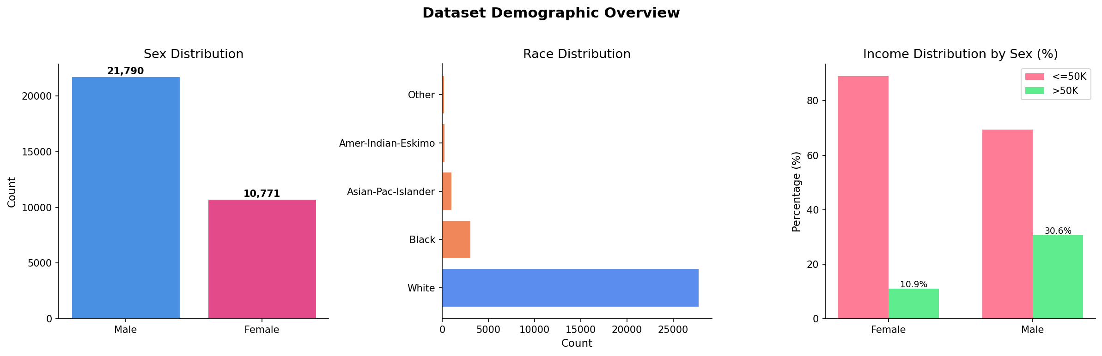
Figure 22: Dataset Demographic Overview: sex distribution, race distribution, and income by sex
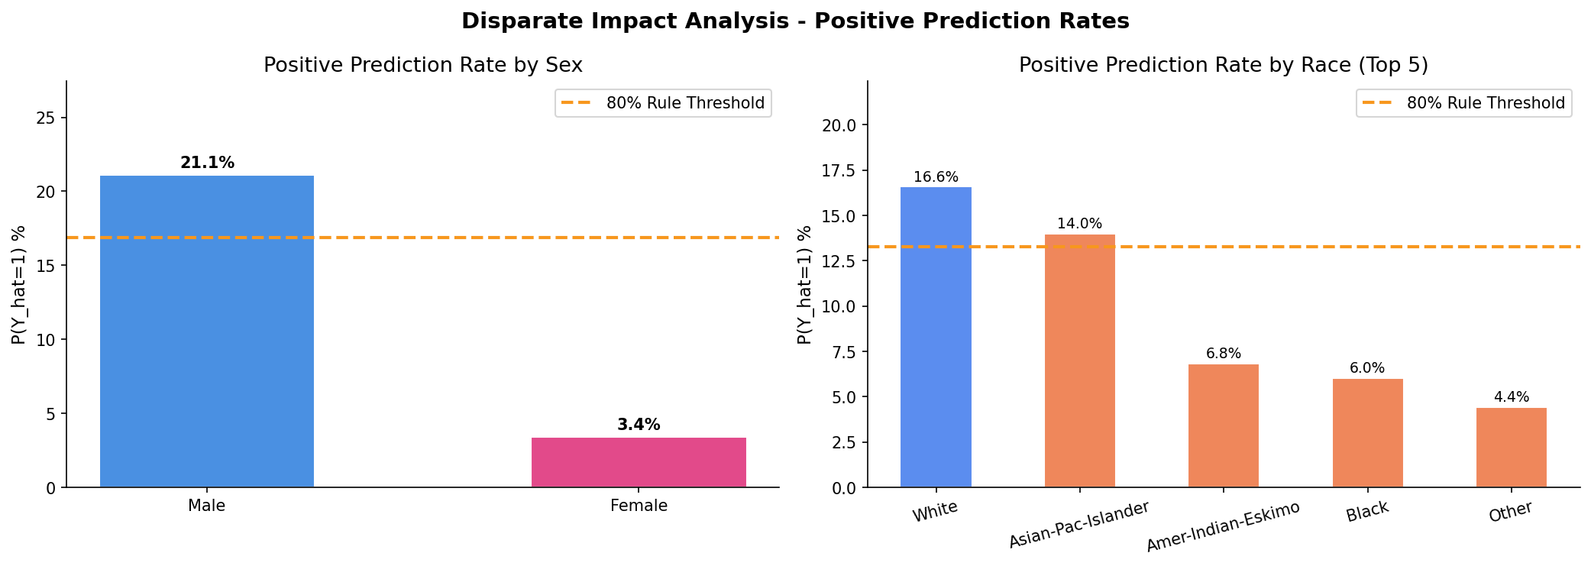
Figure 23: Disparate Impact Analysis showing positive prediction rates by sex and race with 80% rule threshold
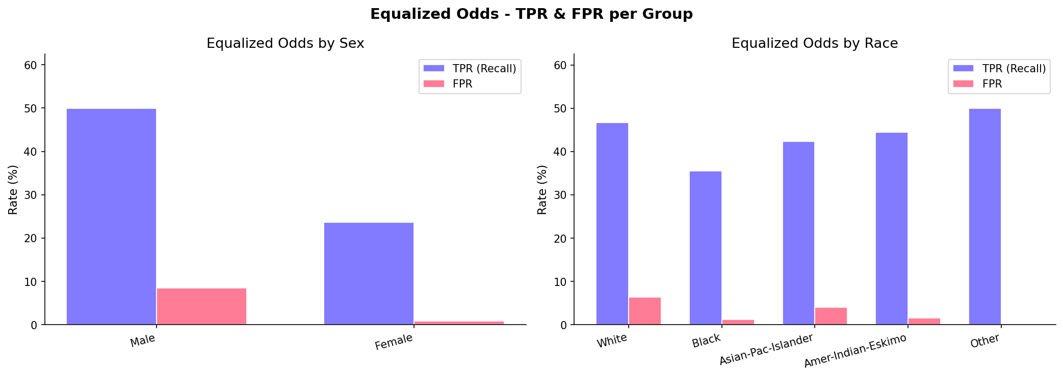
Figure 24: Equalized Odds assessment showing TPR and FPR disparities across sex and race groups
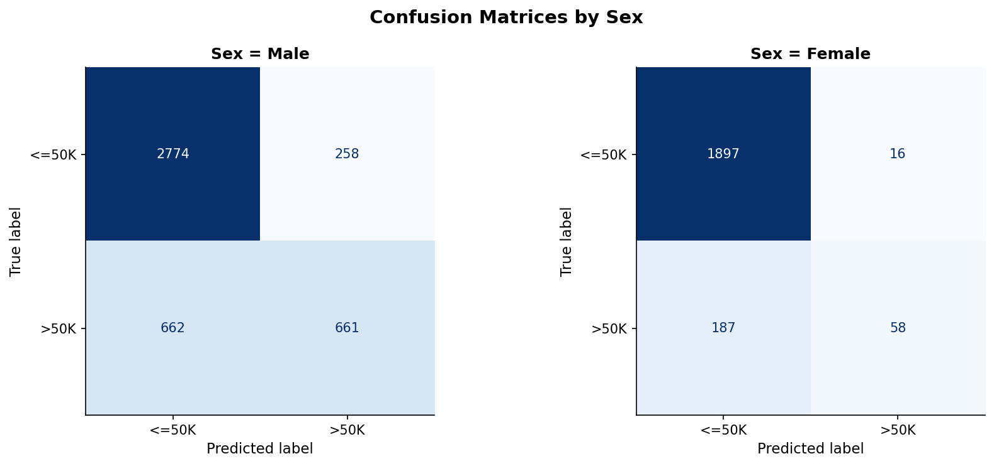
Figure 25: Confusion Matrices by sex showing differential error patterns between Male and Female groups
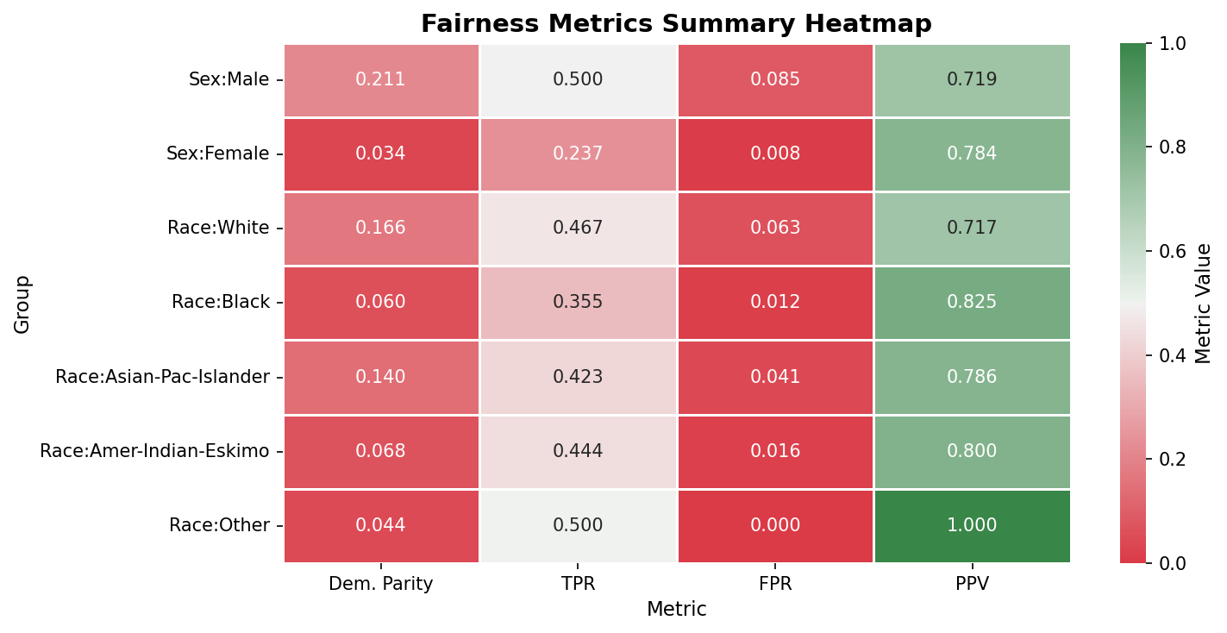
Figure 26: Fairness Metrics Summary Heatmap showing all metrics across all demographic groups
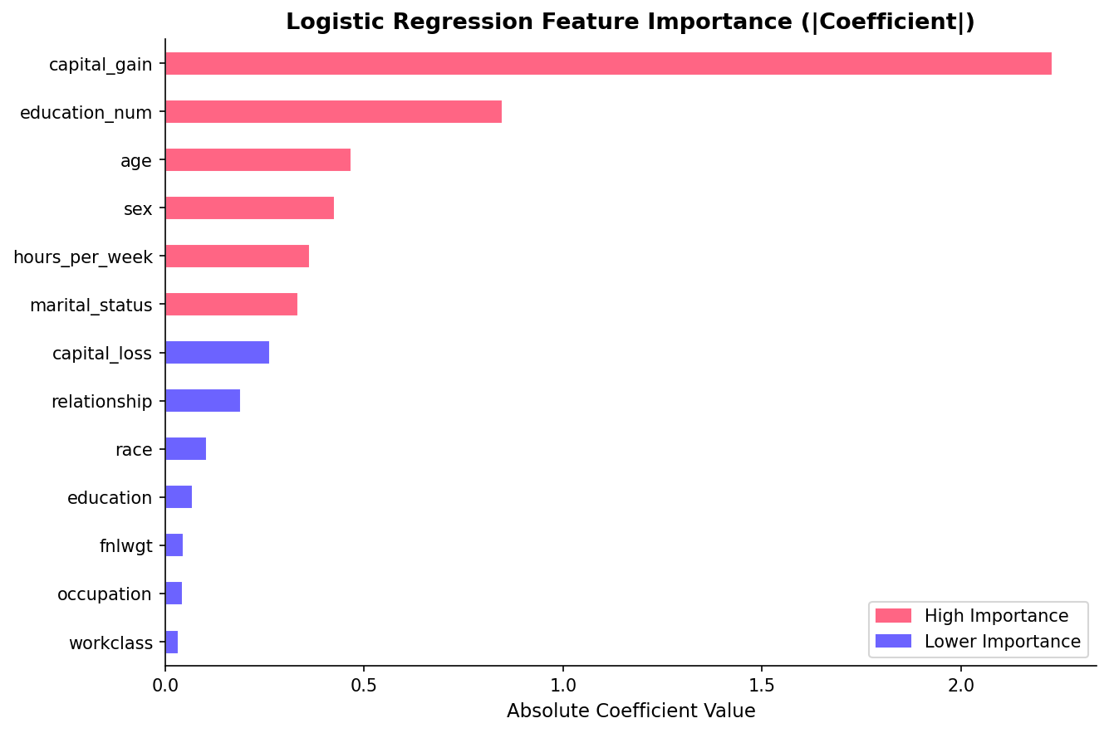
Figure 27: Logistic Regression Feature Importance showing which features have the highest absolute coefficients
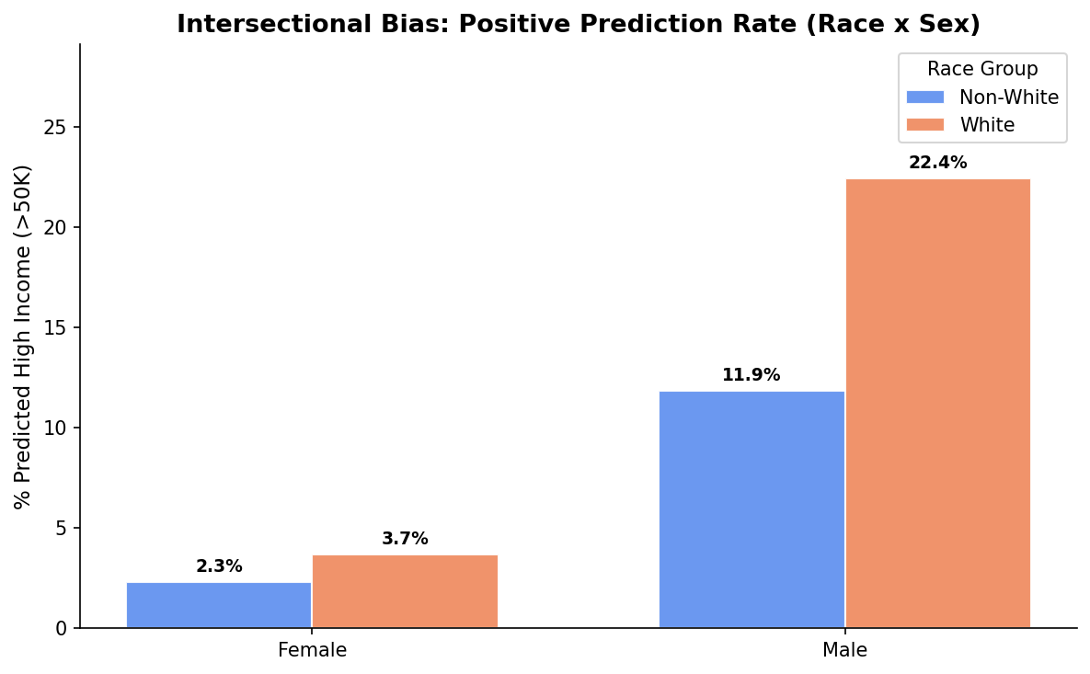
Figure 28: Intersectional Bias Analysis showing positive prediction rates across Race × Sex combinations

7.5 Proposed Remediation Strategies
Based on the audit findings, the following remediation strategies were proposed: (1) Pre-processing interventions: Re-sampling or re-weighting training data to equalize representation across demographic groups, removing or decorrelating sensitive attributes from feature sets. (2) In-processing interventions: Applying adversarial debiasing during model training, incorporating fairness constraints into the optimization objective. (3) Post-processing interventions: Adjusting classification thresholds per group to equalize TPR/FPR, applying calibration techniques to ensure predictive parity. (4) Organizational practices: Establishing regular bias audits as part of the ML lifecycle, creating diverse development teams, implementing bias impact assessments before deployment.

7.6 Evaluator Feedback
This submission received a score of 70/100. The evaluator acknowledged the solid understanding of bias analysis by reporting specific fairness metrics and identifying potential sources of bias, along with proposing multiple remediation strategies. However, the response was deemed too succinct compared to the required 2000-word minimum, lacking a step-by-step methodology, in-depth literature review, and detailed explanation of visualization methods.

CHAPTER 8:

CONCLUSION AND FUTURE WORK

8.1 Summary of Achievements
This internship provided a comprehensive, end-to-end perspective on the lifecycle of artificial intelligence systems. Over six weeks, the following was accomplished:
Week 1 established the foundational project planning skills required for any AI initiative, covering feasibility analysis, technology selection, and risk assessment. Week 2 demonstrated rigorous data preprocessing expertise, achieving an 85/100 evaluation score through KNN imputation, IQR-based outlier handling, and domain-specific feature engineering on the Titanic dataset.
Week 3 applied machine learning model development practices including algorithm selection, GridSearchCV hyperparameter tuning with 162 combinations and 5-fold stratified cross-validation, achieving near-perfect classification performance (F1 ≥ 0.97, AUC ≥ 0.995) on the Breast Cancer Wisconsin dataset. Week 4 extended this work with Explainable AI techniques (SHAP and LIME), providing both global and local model interpretations.
The pinnacle of the internship was Week 5, which produced a production-grade deployment of an AI model as a containerized REST API. The system featured FastAPI with 7 endpoints, Docker multi-stage builds, structured JSON logging, thread-safe metrics monitoring, and 15 automated pytest tests — earning the highest evaluation score of 95/100. Week 6 concluded with a critical AI Ethics audit that quantified and visualized biases across sex and race dimensions.

8.2 Key Lessons Learned
Several critical lessons emerged from this internship: (1) Deliverable specifications must be met precisely — multiple submissions lost significant points for being summaries rather than complete, executable deliverables meeting word count requirements. (2) Deployment engineering is as important as model accuracy — the deployment task earned the highest score because it demonstrated real-world software engineering practices. (3) Ethical considerations must be integrated early in the AI lifecycle, not treated as an afterthought. (4) Reproducibility through pipelines, containers, and version control is essential for production AI.

8.3 Future Work
Several directions for future work were identified: (1) Implementing CI/CD pipelines using GitHub Actions or Jenkins to automate testing and deployment workflows. (2) Integrating model registries like MLflow for versioned model management and experiment tracking. (3) Deploying to managed cloud environments such as AWS SageMaker, Azure ML, or Google Cloud AI Platform. (4) Implementing automated retraining loops triggered by data drift detection. (5) Extending the ethics audit framework to support continuous fairness monitoring in production. (6) Exploring advanced XAI techniques such as Counterfactual Explanations and Attention mechanisms for deep learning models.

REFERENCES

[1] Breiman, L. (2001). Random forests. Machine Learning, 45(1), 5–32.
[2] Wolberg, W.H., Street, W.N., & Mangasarian, O.L. (1994). Machine learning techniques to diagnose breast cancer from fine-needle aspirates. Cancer Letters, 77(2–3), 163–171.
[3] Fernández-Delgado, M., Cernadas, E., Barro, S., & Amorim, D. (2014). Do we need hundreds of classifiers to solve real world classification problems? JMLR, 15(1), 3133–3181.
[4] Lundberg, S.M., & Lee, S.-I. (2017). A unified approach to interpreting model predictions. NIPS, 30.
[5] Ribeiro, M.T., Singh, S., & Guestrin, C. (2016). Why should I trust you? Explaining the predictions of any classifier. KDD 2016.
[6] FastAPI Documentation. https://fastapi.tiangolo.com/
[7] Docker Documentation. https://docs.docker.com/
[8] Pedregosa, F., et al. (2011). Scikit-learn: Machine learning in Python. JMLR, 12, 2825–2830.
[9] Bergstra, J., & Bengio, Y. (2012). Random search for hyper-parameter optimization. JMLR, 13(1), 281–305.
[10] Fawcett, T. (2006). An introduction to ROC analysis. Pattern Recognition Letters, 27(8), 861–874.
[11] Barocas, S., Hardt, M., & Narayanan, A. (2019). Fairness and Machine Learning. fairmlbook.org.
[12] Mehrabi, N., et al. (2021). A survey on bias and fairness in machine learning. ACM Computing Surveys, 54(6).

