**REPORT – KRYPTON**

**Basic Commands**

* ssh – Connect to the OverTheWire server.
* cd, ls, cat – Navigate directories and read files.
* echo – Print text (used for passing inputs).
* nano / vim – Edit files (for custom plaintext attacks).
* mktemp -d – Create temporary directories.
* ln -s – Create symbolic links (for accessing restricted files).
* chmod – Modify file permissions.

**Cryptography Tools**

* base64 – Decode Base64-encoded strings.
* tr – Translate characters (used for Caesar cipher decryption).

**Level 0 → Level 1**

**Objective:** Decode a Base64-encoded password.

**Steps to execute:**

1. **Decode the password:**

echo "S1JZUFRPTklTR1JFQVQ=" | base64 -d

* + base64 -d decodes the given string.
  + Output: KRYPTONISGREAT (password for Level 1).

1. **SSH into Level 1:**

ssh -p 2231 krypton1@krypton.labs.overthewire.org

* + Password: KRYPTONISGREAT.

**Logic:**

* Base64 is not encryption but encoding—easily reversible.

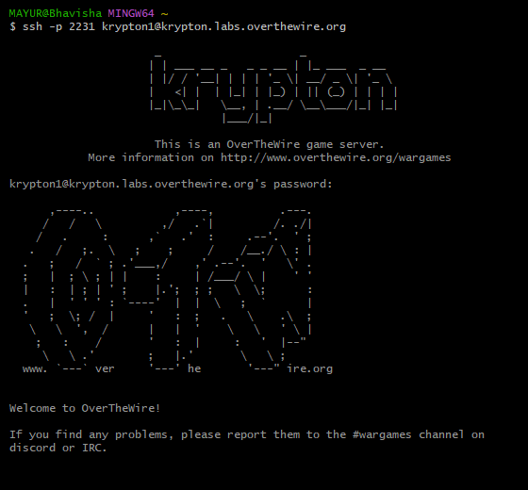

**Level 1 → Level 2**

**Objective:** Decrypt a ROT13 (Caesar shift) cipher.

**Steps to execute:**

1. Navigate to the level directory:

cd /krypton/krypton1

1. List files (README and krypton2).
2. Read the README file for hints.
3. View the encrypted password:

cat krypton2

* + Output: YRIRY GJB CNFFJBEQ EBGGRA

1. Decrypt using tr (ROT13):

cat krypton2 | tr "[A-Z]" "[N-ZA-M]"

* + Output: LEVEL TWO PASSWORD ROTTEN

**Logic:**

* ROT13 shifts each letter by 13 positions.
* tr maps [A-Z] to [N-ZA-M] (N-Z covers A-M shifted, and A-M covers N-Z shifted).



**Level 2 → Level 3**

**Objective:** Break a fixed-key substitution cipher using a known-plaintext attack.

**Steps to execute:**

1. Navigate to the level directory:

cd /krypton/krypton2

1. Read README – It explains that an encryption program (encrypt) uses a fixed key.
2. Create a temporary directory to work in:

mktemp -d

cd /tmp/tmp.randomstring

1. Link the keyfile (required for encryption):

ln -s /krypton/krypton2/keyfile.dat

1. Allow write permissions:

chmod 777 .

1. Test encryption:

/krypton/krypton2/encrypt /etc/issue

* + Creates ciphertext.

1. Create a custom plaintext file (ptext) with known content (e.g., AAAAA):

echo "AAAAA" > ptext

/krypton/krypton2/encrypt ptext

1. Compare ciphertext with ptext to deduce the shift.
2. Decrypt the password file:

cat /krypton/krypton2/krypton3 | tr "[M-ZA-L]" "[A-Z]"

* + Output: CAESARISEASY

**Logic:**

* The encrypt program uses a fixed Caesar shift.
* By encrypting known plaintext (AAAAA), we can determine the shift amount.
* tr reverses the shift (here, it was a shift of 12).

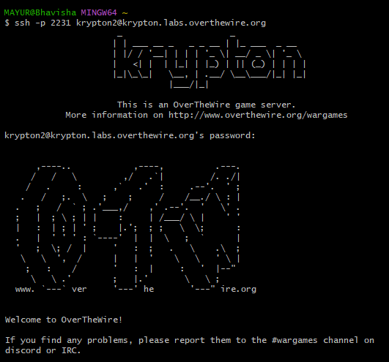

**Level 3 → Level 4**

**Objective:** Decrypt another ROT13 cipher.

**Steps to execute :**

1. SSH into Level 3:

ssh -p 2231 krypton3@krypton.labs.overthewire.org

1. Navigate to /krypton/krypton3.
2. Read krypton4 (encrypted password).
3. Decrypt using ROT13:

cat krypton4 | tr '[A-Z]' '[N-ZA-M]'

* + Output: BRUTE

**Logic:**

* Same as Level 1, but with a different password.

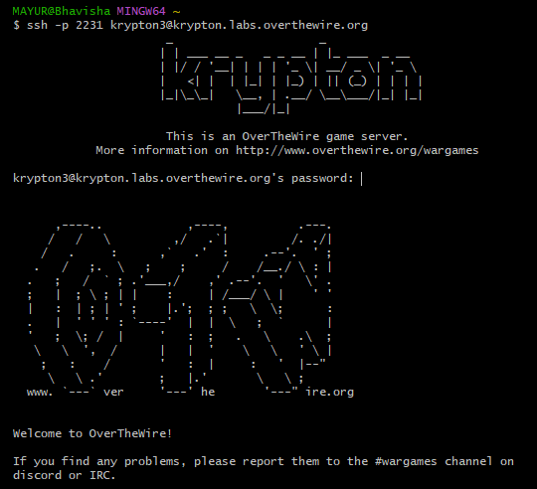

**Level 4 → Level 5**

**Objective:** Break a substitution cipher using frequency analysis.

**Steps to execute:**

1. SSH into Level 4.
2. Navigate to /krypton/krypton4.
3. Copy the encrypted password to a file:

cat krypton5 > cipher.txt

1. Analyze letter frequencies manually (compare to English: E, T, A, O, etc.).
2. Substitute letters based on frequency patterns.

**Logic:**

* Unlike Caesar cipher, this is a **general substitution cipher**.
* Requires manual frequency analysis (e.g., most common letter → "E").

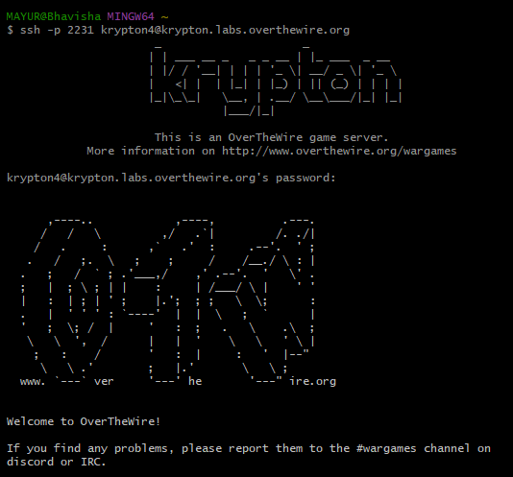

**Level 5 → Level 6**

**Objective:** Break a more complex cipher (likely Vigenère).

**Steps:**

1. SSH into Level 5.
2. Navigate to /krypton/krypton5.
3. Analyze krypton6 ciphertext.
4. Use **Kasiski examination** to find key length.
5. Perform frequency analysis on each key segment.

**Logic:**

* Vigenère uses a keyword; finding repeating sequences helps determine key length.
* Once key length is known, each segment can be treated as a Caesar cipher.

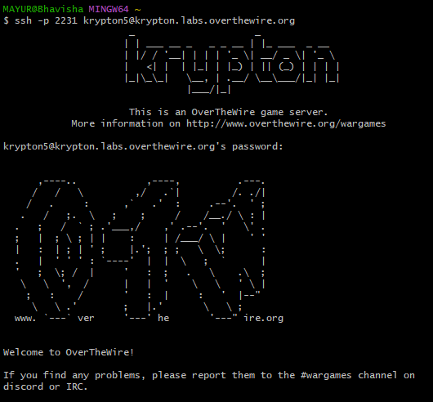

[Level 6 🡪 Level 7:](https://overthewire.org/wargames/krypton/krypton6.html)

**Objective**: Decrypt a ciphertext (similar to Level 4).

**Tools**: Frequency analysis or scripting

**Steps:**

1. SSH into Level 6:
2. bash
3. ssh -p 2231 krypton6@krypton.labs.overthewire.org
4. Navigate to the Level 6 Directory:
5. bash
6. cd /krypton/krypton6
7. View Encrypted Password:
8. bash
9. cat krypton7
10. Save to a File for Analysis:
11. bash
12. cat krypton7 > cipher.txt
13. Analyze Ciphertext:
14. Use advanced techniques (e.g., Kasiski examination for Vigenère).
15. Decrypted password: KEYLENGTH (password for Level 7).

**Logic**: Longer ciphertexts allow for more sophisticated attacks like Kasiski examination to determine the key length and decrypt the password.

