Retail & Warehouse Sales Intelligence
AI-Assisted Product, Supplier & Operational Analytics

1. Executive Summary
This project develops an interactive analytics dashboard for retail and warehouse sales activity. The analysis focuses on retail sales, warehouse sales, retail transfers, item types, products and suppliers. An Isolation Forest model is included as an AI-assisted anomaly detection layer to identify unusual operational records for further investigation.

2. Dataset
The project uses the supplied Retail and wherehouse Sale.csv file. The file contains 30,000 records and 9 columns. The data covers 2020 and the months January, March, July and September. The source dataset is available on Kaggle.
Metric | Value | Observation
Records | 30,000 | No duplicate rows found
Columns | 9 | Operational sales dataset
Suppliers | 290 | 33 missing supplier values handled as Unknown
Products | 15,732 descriptions | High product variety
Item types | 8 | Wine is the largest record group
Months | 1, 3, 7, 9 | Not a complete annual time series

3. Data Preparation
The dataset was checked for missing values, duplicate rows, data types and categorical cardinality. There were 33 missing supplier values and 1 missing retail-sales value. Supplier values were filled with 'Unknown Supplier', while the missing numeric retail-sales value was treated as zero for the dashboard calculations. No duplicate rows were detected.

4. Key Business Findings
Across the supplied records, warehouse sales are much larger than retail sales, while retail transfers are also substantial. Beer has the largest combined activity because of its warehouse volume. Wine dominates the number of records and is the largest item type by record count. A relatively small group of products and suppliers accounts for a large share of total activity, making concentration analysis useful for inventory and supplier planning.
Total retail sales: 208,186.94. Total retail transfers: 197,821.74. Total warehouse sales: 822,930.93.
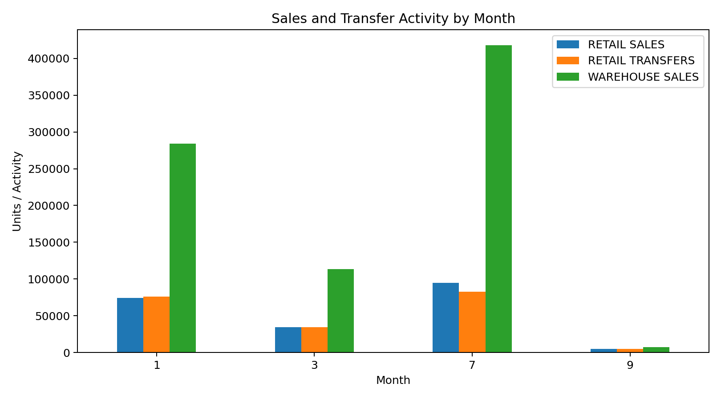
Figure 1. Monthly retail, transfer and warehouse activity.
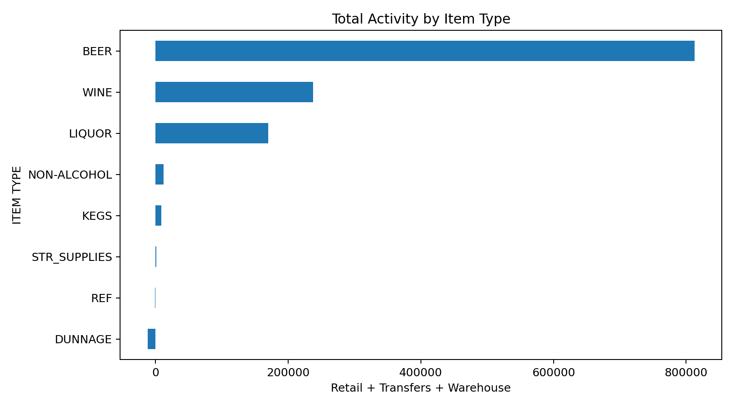
Figure 2. Total activity by item type.

5. Product & Supplier Analysis
Product-level aggregation highlights the products that contribute most to combined retail, transfer and warehouse activity. Supplier aggregation provides a second view of concentration and helps identify suppliers whose operational activity deserves closer monitoring.
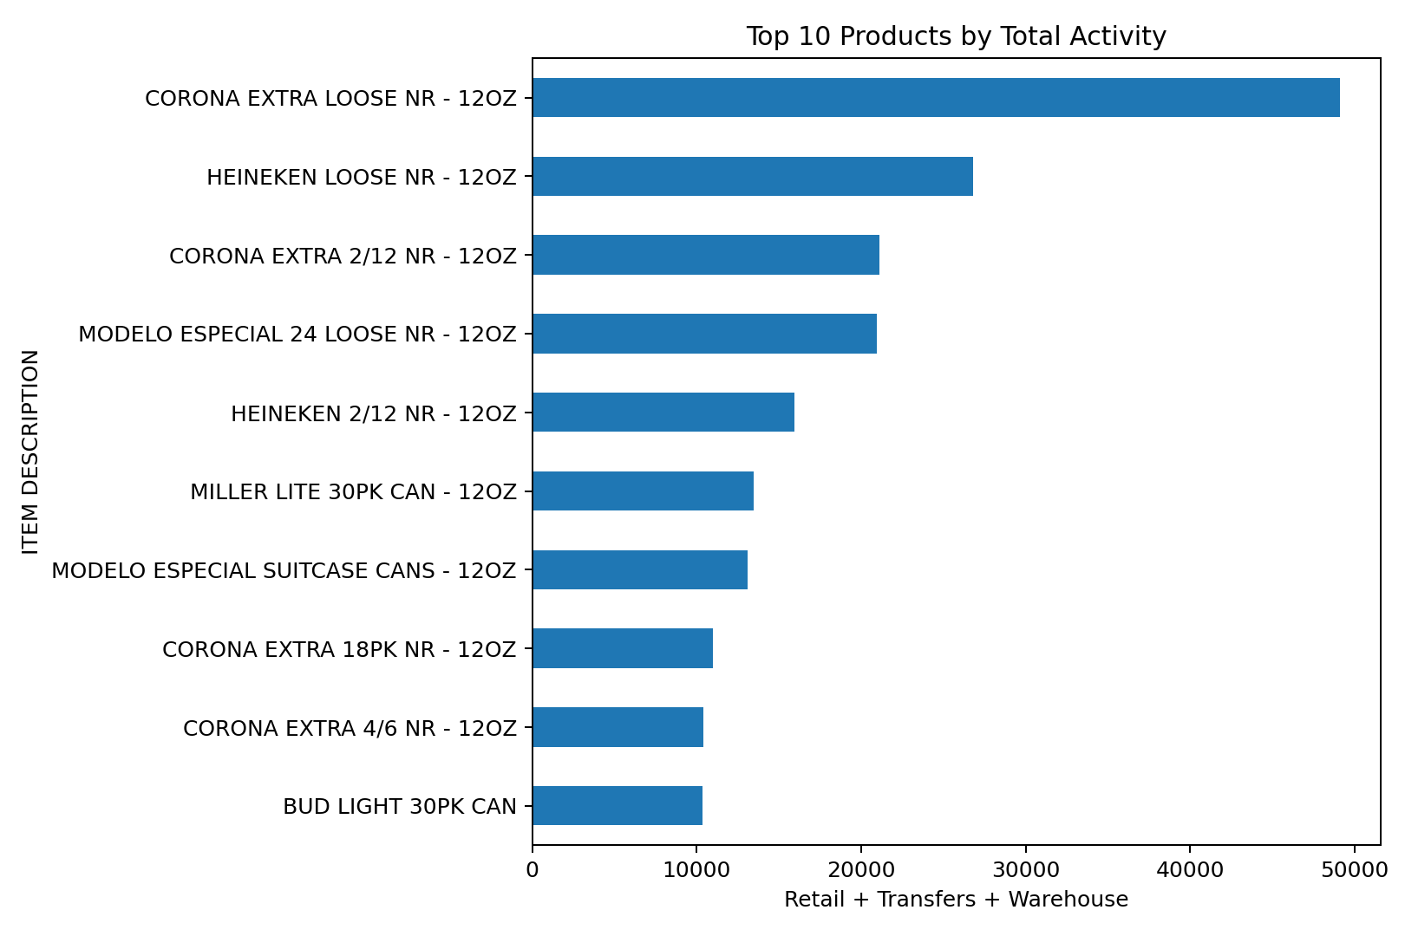
Figure 3. Top products by total activity.
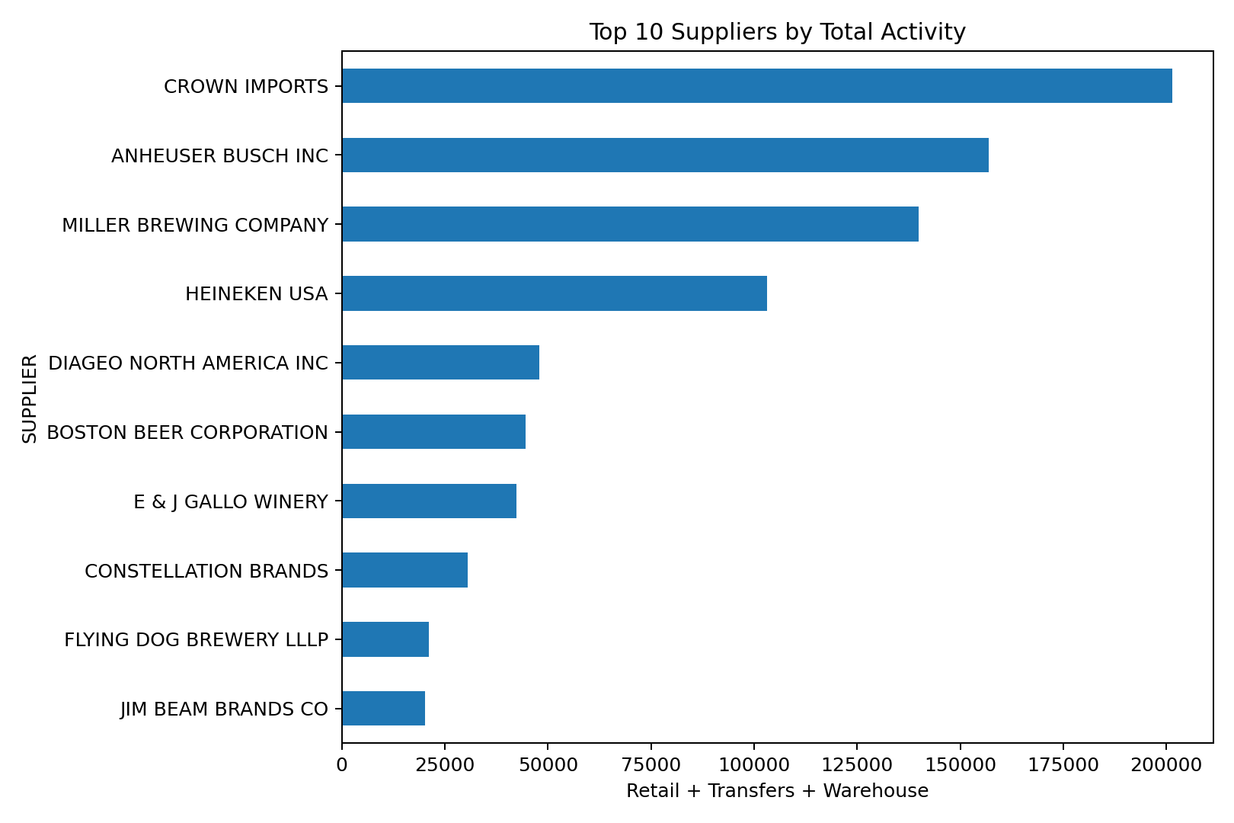
Figure 4. Top suppliers by total activity.

6. AI / Machine Learning Component
The project uses Isolation Forest, an unsupervised machine-learning algorithm, to identify records that behave differently from the majority of the dataset. Features include retail sales, retail transfers, warehouse sales and total activity. The purpose is operational screening: a flagged record may be a legitimate high-volume item, a data-quality issue, or another unusual business event. It is not treated as proof of an error or misconduct.

7. Business Recommendations
- Prioritize inventory review for products with high warehouse activity and unusual transfer patterns.
- Use item-type and supplier concentration to focus procurement and operational monitoring on the most important contributors.
- Investigate AI-flagged records manually before making inventory or supplier decisions.
- Monitor retail-to-warehouse relationships rather than evaluating retail sales alone.
- For future work, obtain a longer and more complete time series before making formal seasonal or forecasting claims.

8. Dashboard & Technology
The interactive dashboard is implemented in Streamlit. Pandas and NumPy handle data preparation, Plotly provides interactive visualizations, and scikit-learn provides the anomaly detection model.

9. Limitations
The dataset does not contain unit prices, revenue, profit, customer IDs or store locations. Therefore, the project does not claim monetary revenue/profit analysis or customer-level analytics. The available months are incomplete, so a conventional seasonality or long-term forecasting model is intentionally excluded.

10. Conclusion
The project demonstrates how raw retail and warehouse activity data can be transformed into decision-support information. The dashboard combines descriptive analytics with an unsupervised AI component and converts the resulting patterns into practical inventory, supplier and operational recommendations.

