Analyzing Business Performance Gains from Cloud Adoption Using Data-Driven Approach

Pratham Bajaj
Department of Computer Science and Engineering
Chitkara University institute of engineering and technology
Rajpura, India
pratham2072.be22@chitkara.edu.in
Nayaja
Department of Computer Science and Engineering
Chitkara University institute of engineering and technology
Rajpura, India
nayaja1968.be22@chitkara.edu.in

Abstract— Cloud computing has profoundly changed the information technology landscape and how organizations run their business operations. Many organizations have reported improved financial and operational performance after shifting their information technology infrastructure from traditional computing to cloud computing. This study aims to examine the impact of the adoption of cloud computing on business operational performance in terms of cost reduction, collaboration efficiency, and system reliability. Comparative analysis was done on the organization’s operational performance before and after the adoption of cloud computing.
Keywords— Cloud Technology Implementation, Cloud Service Models (SaaS, PaaS, IaaS), Experimental Study, Business Transformation, Operational Efficiency.

INTRODUCTION
The way businesses conduct their day-to-day activities has been shaped by the constant improvements that have been witnessed in information technology. This study uses logistic regression in a novel way to measure efficiency gains following cloud adoption. When it comes to communication, information storage, as well as decision-making through analysis, modern-day businesses rely on technology. A huge financial investment is required to fund hardware resources, system updates, as well as technical expertise, to support traditional IT infrastructure. A modern technology approach that allows businesses to access resources as well as make payments according to their needs is cloud computing. Users are offered on-demand services that include resources such as processing, storage, networking, as well as software. This means that businesses do not have to make their own servers to access resources; they can use cloud computing to access resources as needed.

The idea of shared computing environments is what led to the development of cloud computing. In [1], this idea was proposed by John McCarthy, a computer scientist, in the 1960s. He argued that resources would be offered remotely based on demand. The development of the internet in the 1990s created opportunities for the development of software that could be delivered through internet platforms. The development of a web-based customer management system by Salesforce in 1999 was a huge improvement.

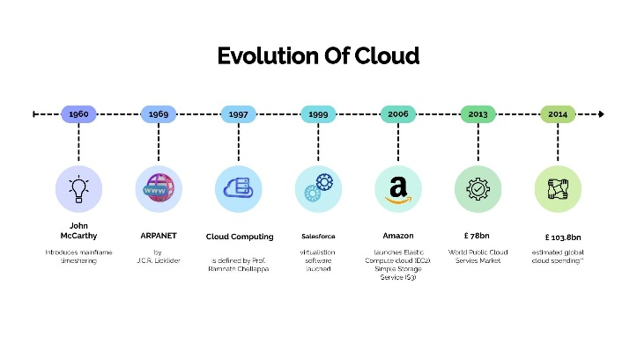
Fig (i) Evolution of cloud
Cloud computing started to gain momentum in the mid-2000s when Amazon started offering Amazon Web Services in 2006, which enabled businesses to access computer infrastructure and storage via the internet. This was followed by other major technology organizations launching cloud platforms like Microsoft Azure from Microsoft and Google Cloud Platform from Google, which further propelled the use of cloud computing in different sectors. Today, cloud computing is considered an integral part of digital transformation strategies because it helps businesses deliver applications quickly, facilitates better collaboration in remote working conditions, and helps manage large amounts of data in a more efficient manner [2].

LITERATURE REVIEW
Cloud computing is one of the major topics in academic research because of its growing importance in the modern business world. Many researchers have studied the effects of cloud computing on the way businesses operate and their efficiency. The studies have shown both the positive and negative sides of using cloud computing in businesses.
Previous studies have shown that cloud computing allows businesses to use computing resources over the internet without having to own a lot of physical computing devices.
Many studies have shown that using cloud computing allows businesses to save on costs. According to Mell and Grance (2011), cloud computing is an on-demand service paradigm that increases cost-effectiveness and scalability.
They can also focus on more important business activities rather than focusing on the physical devices they own.

Cloud computing allows users to access their applications anywhere. This allows businesses to operate more efficiently. Studies like [3] (2009) highlights better resource utilization using cloud. This is because it allows people to communicate anywhere.
However, the majority of current research lacks quantitative modelling of efficiency gains and instead concentrates on qualitative advantages. Cloud computing helps organizations to effectively handle large volumes of data, hence enabling better planning. When other technologies are integrated into cloud computing, it becomes easier to integrate all sections of an organization to work effectively together. This enhances the smooth flow of tasks within an organization.
Some people are worried about using cloud computing, though. These concerns range from the security of the data stored, the issue of protecting the privacy of the data, and the use of third-party services. It is necessary to have good security measures in place in order to run cloud computing safely and effectively.
Although a lot of study has been done on the advantages of cloud computing, not much has been done to measure improvements in operational efficiency using predictive models like logistic regression. The purpose of this study is to close this gap.

RESEARCH OBJECTIVES
1. Investigate the reduction in operational costs after migrating to the cloud.
2. Investigate the impact of cloud computing on remote collaborations.
3. Evaluate the improvement in operational effectiveness.
4. Identify the next technological opportunities in cloud computing.

RESEARCH METHODOLOGY
The study employs a quantitative experimental research design to investigate the impact of cloud computing on business operations. Organizations that have adopted cloud computing technology are used as a sample for the study. Data are collected from before the adoption of cloud computing technology and compared with data collected after the adoption of cloud computing technology.

DATA COLLECTION
Collected data is analyzed to determine the change in performance using statistical techniques. Data is collected on general bases such as how they were spending their money before using the cloud and how much reduction in cost and efficiency is achieved by using the cloud. This analysis helps to identify patterns that show the efficiency of cloud computing.

DATA ANALYSIS
The data collected is analyzed using descriptive and comparative statistical tools. The performance indicators are compared before and after the adoption of cloud computing to find the extent of improvement in business process performance.

RESULT AND ANALYSIS

Impact on Operational Cost
In traditional information technology systems, companies have to invest heavily in hardware such as servers, information networks, and data centers. Such information technology systems also involve recurring expenses in maintaining these systems, updating these systems, and powering these systems. In [4], it states that cloud computing is different in that it follows a pay-as-you-go system. This way, companies only end up paying for the computing services they use.
One of the advantages of cloud computing is that it reduces the cost associated with maintaining information technology. This is because companies can use virtual computing services at remote data centers. Due to these advantages, companies have been able to migrate to cloud computing. It has been reported that 42% of companies use cloud computing services to reduce information technology costs.
In [5], it mentions that SaaS market is growing continuously worldwide. The growth of the SaaS market is estimated at 9 percent every year. The market is expected to reach $60.36 billion between 2019 and 2023. Some trusted organizations were even able to save up to $1.5 million every year using SaaS solutions. In the case of traditional IT environments, many organizations face problems with software updates and versions. However, these problems are being solved using cloud platforms. With the help of these platforms, organizations are getting a hassle-free environment.
The market for cloud management and security services provided in public clouds is growing at a rapid rate. This market is expected to reach $17.6 billion by 2022. With the help of these services, organizations are able to build applications from anywhere. Additionally, they are getting security benefits without having to install cybersecurity solutions [6].

Table 1. Upfront cost estimation for server setup
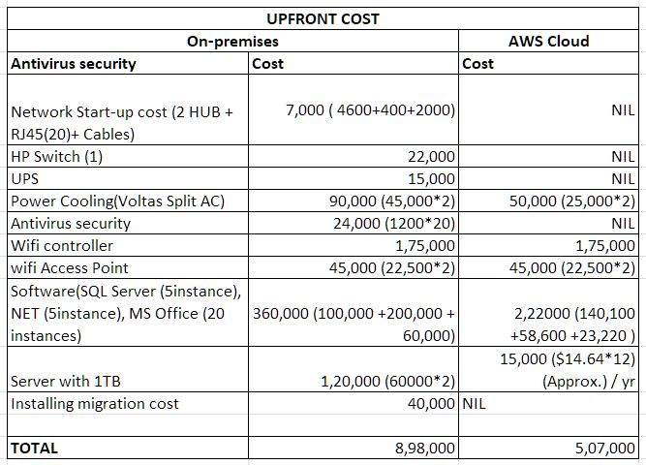

Table 2. Recurring cost estimation for server
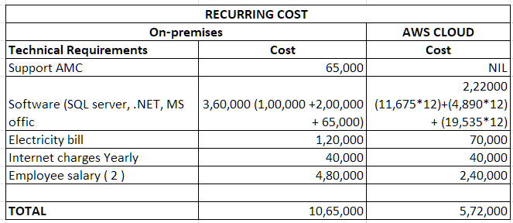

Table 3. Overall cost saving by cloud adoption
Cost Savings Table
On-premises (Before Cloud) | Cloud (After Cloud)
=8,98,000 + 10,65,000 = 19,63,000 | = 5,07,000 + 5,72,000 = 10,79,000
Total Saving for 12 months of using Cloud = 8,84,000 INR.

Big organizations that are using cloud solutions have reported that they were able to save 30-40 percent of their expenses related to IT infrastructure. They were even able to achieve faster growth in revenues of up to 35 percent. Cloud computing is helpful for organizations to reduce their expenses and improve their business environment.

Impact on Operational Efficiency
In the last few years, there has been a rise in the concept of digital transformation, which has influenced various organizations to change their approach to designing their IT infrastructure. Organizations have started to adopt a cloud-first strategy, which means that whenever they are planning to adopt any technology, they will first consider using a cloud solution. According to industry reports, currently, 43% of IT and business decision-makers are adopting this strategy. This change is directly linked to the change in the nature of workplaces, especially because of the rise of remote work.

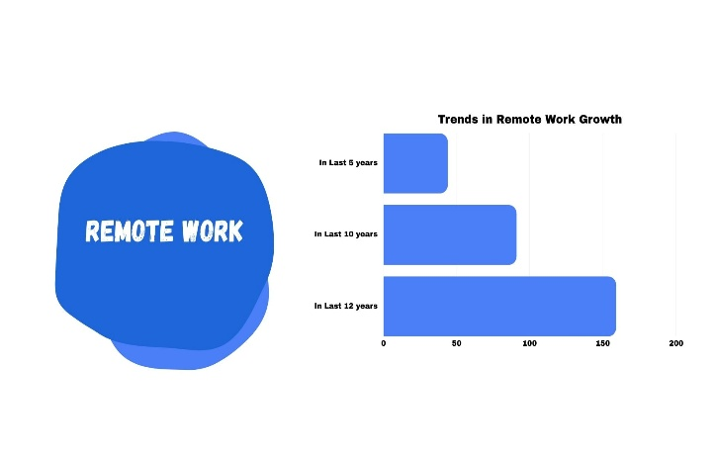
Fig (ii) Trends in Remote Work Growth

In [7] and Fig (ii), tells that the concept of remote work has increased by nearly 159% over the last twelve years. This change has been huge for organizations, as 66% have started to allow flexible work arrangements for their employees. This change has been possible because of cloud computing, as this technology allows employees to access any system or application from anywhere.
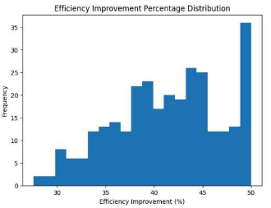
Fig (iii) Efficiency Improvement Percentage Distribution

It has been observed by various organizations after the implementation of cloud technology in their business processes that there has been a marked improvement in their performances. In Fig (iii), Our analysis has shown improvements in operational efficiency up to 30%. Therefore, flexible working models with cloud computing have become an important aspect in enhancing the working performances of organizations.

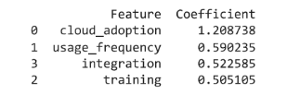
Fig (iv) Logistic Regression Feature Coefficient

Using logistic regression we have verified that adoption of cloud lead to increase in operation efficiency and in some cases it can grow up to even 2.5x than the previous work efficiency through proper integration and training.

Improved Disaster management
Today's businesses rely on running their systems without any breaks. In case there is any interruption in the business process, it will not only reduce the productivity of the company but will also harm the company's reputation, as the users are directly affected. Cloud-based disaster recovery solutions will help businesses overcome this issue because they will be able to recover their systems. With the help of the cloud, businesses will be able to shift their systems to another server setup, which will help them prevent system crashes during disasters or any other natural events. A disaster recovery plan involves proper thinking and consideration of various key issues [8].
The Recovery Point Objective indicates the amount of data that can be lost. It is usually expressed as time. This will help businesses decide on the frequency of backup. The frequency will depend on the nature of business activities.
The Recovery Time Objective indicates the maximum time a business needs to recover. This is applicable to businesses that need to perform transactions, such as financial businesses or trading businesses. These businesses need to recover very fast because any delay will result in huge losses. So, RPO and RTO need to be decided on the basis of how important the data is to the company.

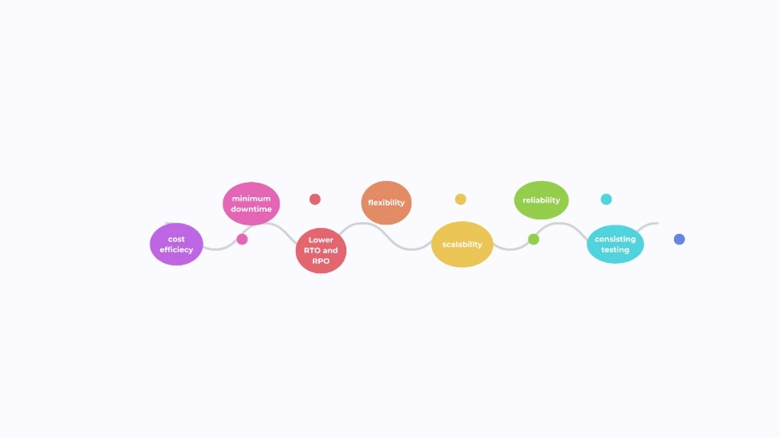
Fig (v) Benefits of Cloud on Disaster Recovery

In addition, cloud-based disaster recovery solutions strengthen an organization’s ability to recover from cyberattacks and data breaches. These systems ensure that essential applications and information remain accessible even after security incidents. Considering that the average financial impact of recovering from a data breach can exceed USD 4.88 million, implementing reliable disaster recovery mechanisms has become a critical component of modern business continuity strategies.

CHALLENGES IN CLOUD ADOPTION

Political Issues Due to Global Boundaries
C Cloud computing is operational in many countries, which means that the data is not stored in just one place. The existence of political boundaries, however, is likely to affect the use of cloud computing since each country has its own set of privacy regulations. The country may be worried about the security of the data when it is stored outside the country. The country may be worried about outsiders accessing the data. The solution to this problem is the existence of regional data centers, which may be expensive compared to cloud servers [9].

Privacy and Security
There are some business enterprises that are concerned about their privacy and security while using cloud technology. This is because they feel that they will not be safe if they store their data on a cloud server, which might be located at a distant place or even a different country [10].
Another important factor that has to be considered is the compliance of the law regarding the issue of privacy. There are certain laws regarding the protection of private information, but there are still some ambiguities regarding the cloud environment. This has made some business enterprises feel that they might violate data protection and privacy laws if they use cloud technology.

FUTURE TRENDS IN CLOUD COMPUTING
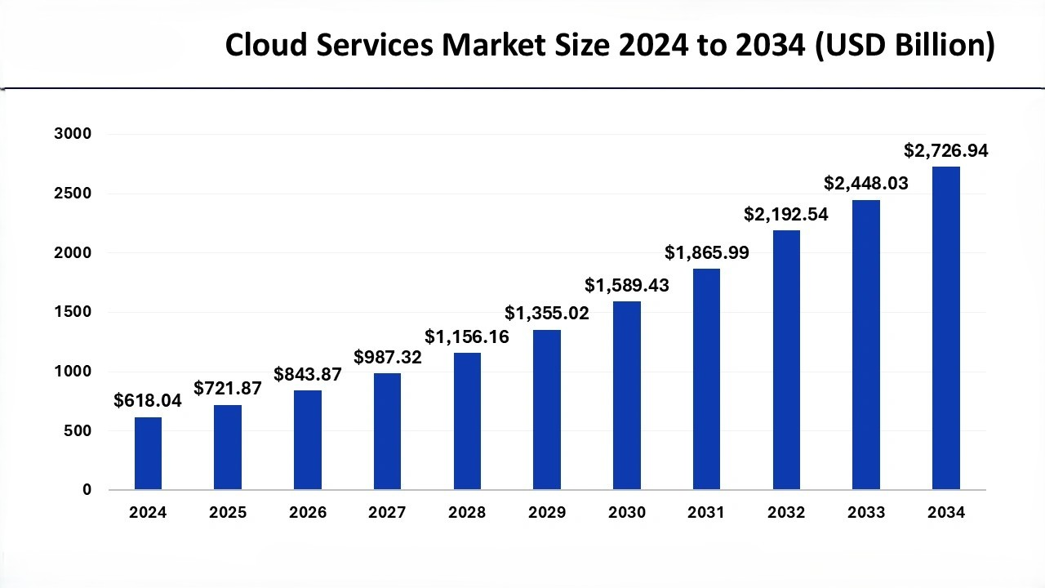
Fig (vi) Cloud Servies Market Size

Fig (vi), shows that the future of cloud computing is full of opportunities for growth in business operations. Market projections indicate that the global cloud services market is growing at a rapid rate. The market is increasing from USD 618.04 billion in 2024 to nearly USD 2,726.94 billion in 2034. This steady growth is because organisations have gained immense trust in using cloud technology and want to move more in this direction in the coming future.
One of the most exciting trends in the future of cloud computing is the integration of Artificial Intelligence (AI). With the evolution of Artificial Intelligence technology, cloud technology is also developing technologies to provide infrastructural support for Artificial Intelligence. The coming future is looking forward to a Cloud-Based Artificial Intelligence platform for big data and machine learning technologies.

CONCLUSION
Through the comparison of the organisational performance before and after the implementation of cloud technology, this study employed an experimental method to investigate the impact of cloud computing on business operations. The result and conclusion show that the operational performance is greatly enhanced by the application of cloud computing in business operations. The business organisations that employed cloud computing have greatly benefited in terms of financial gains, productivity, reliability of the system, and accessibility to technology resources. Therefore, in conclusion, the experimental research has proved that cloud computing is a technically viable solution to improve operational performance and business efficiency. In [11], says that the future prospect of cloud computing is quite bright, considering the continuous evolution of cloud technology and the increase in the digital revolution of different sectors. It is now expected that business organisations would employ cloud technology to access newer products and technologies.

ACKNOWLEDGEMENT
The authors would like to thank Chitkara University for providing the resources and academic support required to complete this study. The supportive academic environment and access to relevant research materials greatly contributed to the development of this work. The authors also express their gratitude to the faculty members for their valuable guidance. Their insights, encouragement, and constructive suggestions helped shape the direction of the study and improved the overall quality of the research.

REFERENCES

- Wikipedia: Cloud Computing [Internet]. Wikimedia Foundation. Available at: https://en.m.wikipedia.org/wiki/Cloud_computing (2022). Accessed 2026
- CXO Content: Evolution and the Future of Cloud Computing [Internet]. Available at: https://cxocontent.com/future-of-cloud-computing-inception-to-edge-computing/ (2021). Accessed 2026
- Buyya, R., Yeo, C.S., Venugopal, S.: Market-Oriented Cloud Computing: Vision, Hype, and Reality for Delivering IT Services as Computing Utilities. Future Generation Computer Systems (2009)
- Armbrust, M., Fox, A., Griffith, R., et al.: A View of Cloud Computing. Communications of the ACM 53(4), 50–58 (2010)
- Mell, P., Grance, T.: The NIST Definition of Cloud Computing. National Institute of Standards and Technology (NIST), U.S. Department of Commerce (2011)
- Verity IT: Can Cloud Computing Reduce Your IT Costs? ? [Internet]. Available at: https://www.linkedin.com/pulse/can-cloud-computing-reduce-your-costs-verity-it-2gxve Accessed 2026
- Rapyder: What is Disaster Recovery & Its Importance for Business [Internet].Available at: https://www.rapyder.com/blog/disaster-recovery-in-cloud-computing/ Accessed 2026
- Rapyder: What is Disaster Recovery & Its Importance for Business [Internet].Available at: https://www.rapyder.com/blog/disaster-recovery-in-cloud-computing/ Accessed 2026
- Verity IT: Can Cloud Computing Reduce Your IT Costs? [Internet]. Available at: https://www.linkedin.com/pulse/can-cloud-computing-reduce-your-costs-verity-it-2gxve Accessed 2026
- Zhang, Q., Chen, M., Li, L.: Cloud Computing: State-of-the-Art and Research Challenges. Journal of Internet Services and Applications 1(1), 7–18 (2010)
- Tutorials Point: Cloud Computing Challenges [Internet]. Available at: https://www.tutorialspoint.com/cloud_computing/cloud_computing_challenges.htm (2022). Accessed 2026

