**Q1. What is a directory?**

Ans. A folder in linux Operating system is called directory.



**Q2. What is a path or pathname in context to directories or file system?**

Ans. A filename that includes information about the directory in which the file is stored.  
  
**Q3.**

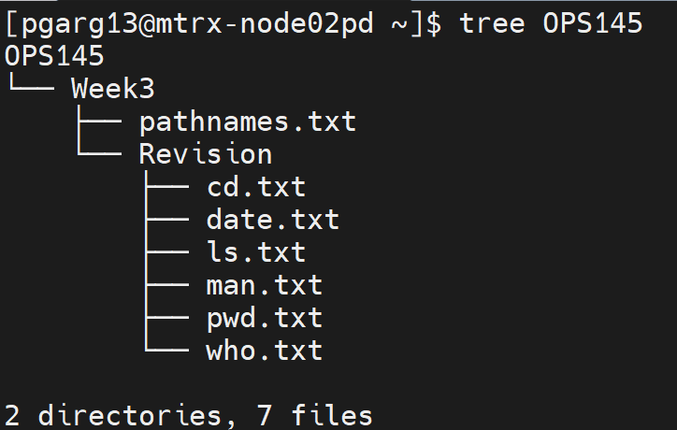

**Write the path from your current directory to who.txt.**

Ans. OPS145/Week3/Revision/who.txt

**Q4. Write the command to create SLG directory.**

Ans. mkdir SLG

**Q5. Write the command to go inside SLG directory.**

**Ans.** cd SLG

**Q6. Write the command to create OPS145 directory.**

Ans. mkdir OPS145

**Q7. Write a single command to create Revision directory and Week3 directory together and Revision directory is inside Week3 directory**

Ans. mkdir -p OPS145/Week3/Revision

**-p** -> this option allows us to create nested folders. If the parent folder doest not exits it will create it then create the child.

**Q8.**



**Go inside Revision directory with single command and write a single command to create all these text files.**

Ans.

1. cd /OPS145/Week3/Revision

(If you see I was in SLG directory in previous question. Now I want to go directly to Revision. I can do that by specifying the whole path to that folder from my current directory)

1. touch cd.txt date.txt exit.txt ls.txt man.txt pwd.txt who.txt

**Q9.**

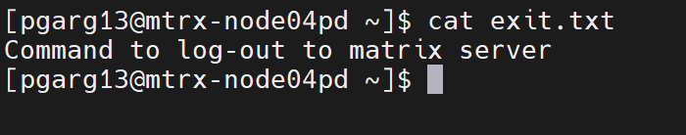

**Using vi text editor put the following text shown by my cat comand in exit.txt file.**

Ans.

You can execute cat command as above but you will see nothing as there is nothing inside it.

1. vi exit.txt
2. type ‘i' to go insert mode
3. type the text
4. click ESC to go in command mode -> type ":wq" OR shift + z + z.

vi is a text editor like your notes or notepad that you have on your computer but for linux environments.

cat is more like a visualizer, which lets you see the text without opening the file.

If you execute cat command now you will see the text

**Q10. Now write a single command to copy the content of exit.txt to a new file logout.txt (new file means we don’t have it yet, so we have to basically create file with the text same as exit.txt).**

Ans. cp exit.txt logout.txt

So, cp command not just copy the file but if the file does not exist it can create it and copy the content.

**Q11. Create Week2 directory in OPS145 directory.**

Ans.

mkdir ~/OPS145/Week2

**OR**

mkdir /home/(your username)/OPS145/Week2

**OR**

../../Week2

(why I did that because I am in Revision directory right now to create folder in OPS145 I have to specify the path to it and the folder name Week2).

**Q12. Now write a single command to create a new directory “command” which has all the files of Revision directory as shown below.**

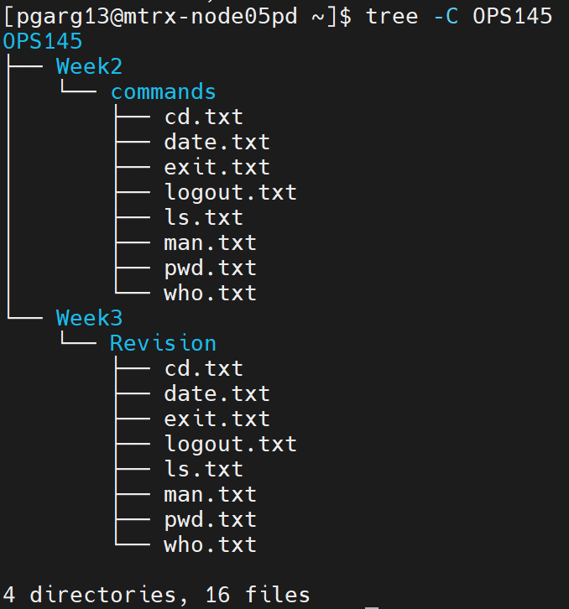

Ans. cp -r . ~/OPS145/Week2/commands

( As I mentioned before cp command can act as creating something if that thing doest not exist and then copy)

-r -> this option is same as we saw -p for mkdir. Same idea copy file/folder resursively.

If you look closely cp command takes two arguments first is dot ‘.’ Which is source

Second is ~/OPS145/Week2/commands which is destination

So, with the above command I am saying that copy my current folder and everything inside it to commands folder literaly

As commands folder does not exit first it will create it.

**Q13. Go into Week3 directory and write a single command to remove the Revision folder.**

**Ans.**

1. cd ..

(I am in revision directory to go in parent directory which is Week3 I say ..)

1. rm -r Revision

-r -> this option is same as we saw -p for mkdir and -r for cp. Same idea delete or remove files/folders recursively.

**Q14.**

**What is the meaning of the first character on the left of the output of ls -l command.**

Ans. First character represent File type

d : directory

'-' : regular file

b or c : device file