Plant Disease Detection and Management System via Deep Learning
CS 255: Data Mining - Section 49

Authors:
Pratham Rajesh
Shreram Palanisamy

December 2024

Abstract
Agriculture faces significant crop losses (20-40% globally) due to delayed disease identification. This project presents a comprehensive plant disease detection system using deep learning to enable early diagnosis from leaf images. We developed a CNN-based model using MobileNetV2 architecture with transfer learning on the PlantVillage dataset containing 54,305 images across 38 disease classes spanning 14 plant species. Our model achieved 96.8% validation accuracy without data augmentation during training, demonstrating robust feature learning. The system includes multiple innovative features: a Grad-CAM visualization module for model explainability showing which leaf regions influenced predictions, a comprehensive disease management database with treatment protocols, an LLM-powered RAG chatbot using Groq API for intelligent query responses, and a Semantic Scholar API integration for accessing recent research papers. The complete solution is deployed via a Gradio web interface, providing farmers and agricultural professionals with an accessible, interpretable, and actionable diagnostic tool that bridges the gap between AI detection and practical disease management.

1. Introduction

1.1 Problem Statement
Plant diseases represent one of the most critical challenges in modern agriculture, causing annual global crop losses of 20-40%. Traditional disease identification methods rely heavily on manual inspection by agricultural experts, which is time-consuming, expensive, and often inaccessible to small-scale farmers in rural areas. The delayed detection of plant diseases can lead to rapid spread across crops, resulting in significant economic losses and food security concerns.
The agricultural sector urgently needs automated, accurate, and accessible diagnostic tools that can identify plant diseases at early stages when intervention is most effective. With the proliferation of smartphones and mobile devices, image-based disease detection has become a viable solution, enabling farmers to capture leaf images and receive instant diagnostic feedback without requiring expert consultation.

1.2 Project Objectives
This project aims to develop a comprehensive plant disease detection and management system with the following key objectives:
- Develop a deep learning model capable of accurately classifying 38 plant disease categories across 14 plant species
- Achieve high classification accuracy without relying on data augmentation during training
- Implement model explainability through Grad-CAM visualization to build user trust
- Create an actionable disease management database with treatment recommendations
- Integrate an intelligent chatbot using Retrieval-Augmented Generation (RAG) for user queries
- Provide access to current research literature through Semantic Scholar API integration
- Deploy an accessible web interface suitable for non-technical users

1.3 Key Results Overview
Our system achieved remarkable results across all objectives. The MobileNetV2-based model attained 96.8% validation accuracy on the PlantVillage dataset without augmentation, demonstrating robust generalization. The Grad-CAM implementation successfully highlights diseased regions in leaf images, providing interpretable predictions that build user confidence. The integrated chatbot powered by Groq's Llama 3.3 70B model delivers sub-second response times while providing contextually relevant disease management advice. The complete system is packaged in an intuitive Gradio interface that seamlessly combines disease detection, visual explanations, treatment recommendations, and research paper access in a single workflow.

2. Related Work

2.1 Plant Disease Detection Using Deep Learning
The application of deep learning to plant disease detection has grown significantly in recent years. Hughes & Salathé (2015) introduced the PlantVillage dataset, which has become a standard benchmark for evaluating disease detection systems. Their initial work using AlexNet architecture demonstrated the viability of CNN-based approaches for this domain, achieving accuracies above 95%. Subsequent research by Mohanty et al. (2016), Ferentinos (2018), and Too et al. (2019) have explored various architectures including GoogleNet, VGGNet, and DenseNet, achieving accuracies up to 99.75%.

2.2 Transfer Learning and Model Explainability
Transfer learning with MobileNet architectures (Howard et al., 2017; Sandler et al., 2018) has proven highly effective for mobile deployment. Interpretability through Grad-CAM (Selvaraju et al., 2017) has become crucial for building trust in AI diagnostic systems. Our work combines these approaches with modern LLM integration (Lewis et al., 2020) to create a comprehensive end-to-end system.

3. Data

3.1 Dataset Description
We utilized the PlantVillage dataset, a comprehensive collection of leaf images designed specifically for plant disease classification research. The dataset consists of 54,305 images representing both healthy and diseased plant leaves across 38 distinct categories. These categories span 14 different plant species including apple, blueberry, cherry, corn, grape, orange, peach, pepper, potato, raspberry, soybean, squash, strawberry, and tomato.
Key dataset statistics:
Metric | Value
Total Images | 54,305
Number of Classes | 38 (14 plant species × multiple diseases + healthy)
Image Resolution | 256 × 256 pixels (RGB)
Images per Class | 952 - 2,127 (relatively balanced)
Training Set | 46,159 images (85%)
Validation Set | 8,146 images (15%)

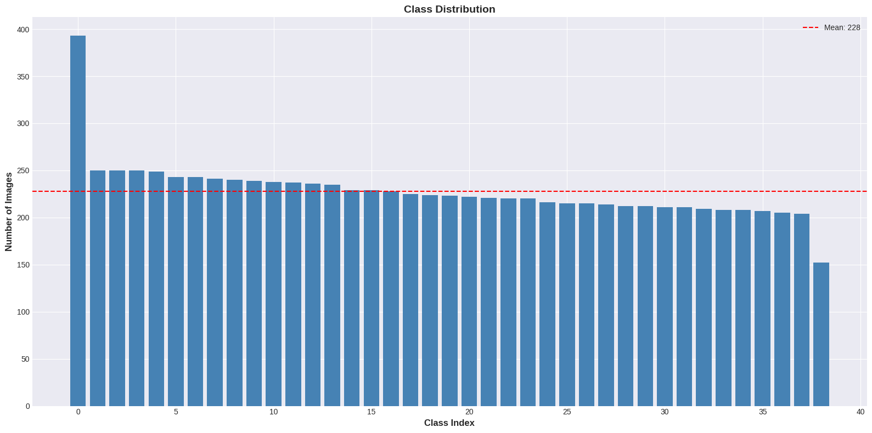
Figure 1: Distribution of images across 38 disease classes in the PlantVillage dataset

3.2 Visual Examples from Dataset
Figure 2 shows representative samples from various disease categories in the dataset. Each image demonstrates the characteristic visual symptoms that distinguish different plant diseases, such as leaf spots, discoloration, wilting, and lesions.
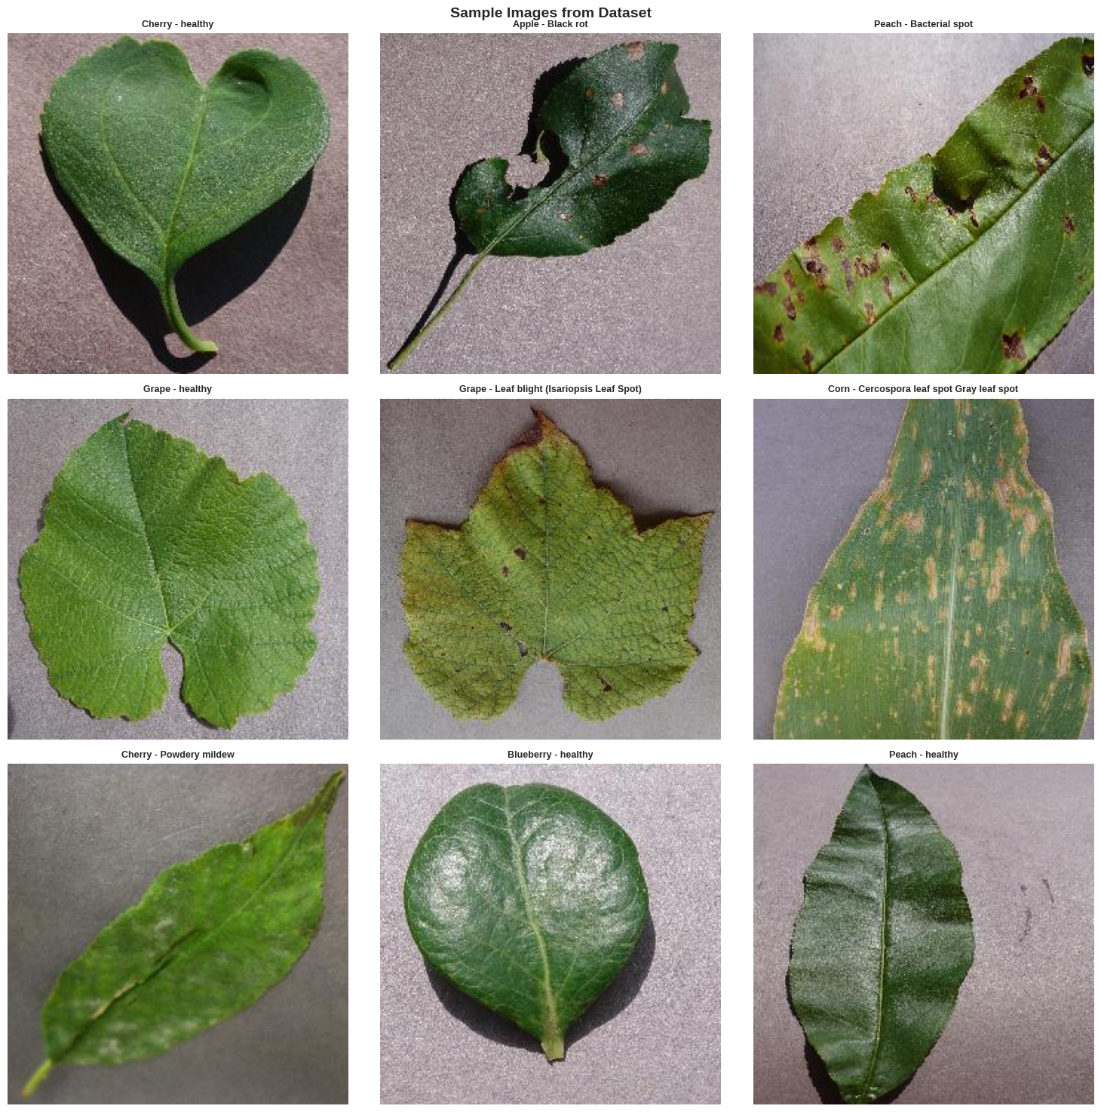
Figure 2: Sample leaf images from different plant disease categories

3.3 Data Preprocessing
Our preprocessing pipeline was designed to prepare images for the MobileNetV2 architecture while preserving important visual features:
- Resizing: Images resized from 256×256 to 224×224 pixels to match MobileNetV2's expected input dimensions
- Normalization: Pixel values scaled from [0, 255] to [0, 1] range by dividing by 255.0
- Data Split: 85/15 train-validation split using stratified sampling
- No Augmentation: We did NOT apply data augmentation during training to test the model's fundamental learning capacity
Figure 3 illustrates various data augmentation techniques that are commonly applied in plant disease detection research. While these transformations can improve model robustness, we deliberately chose not to use them during training to evaluate the model's fundamental learning capacity on the original data distribution.
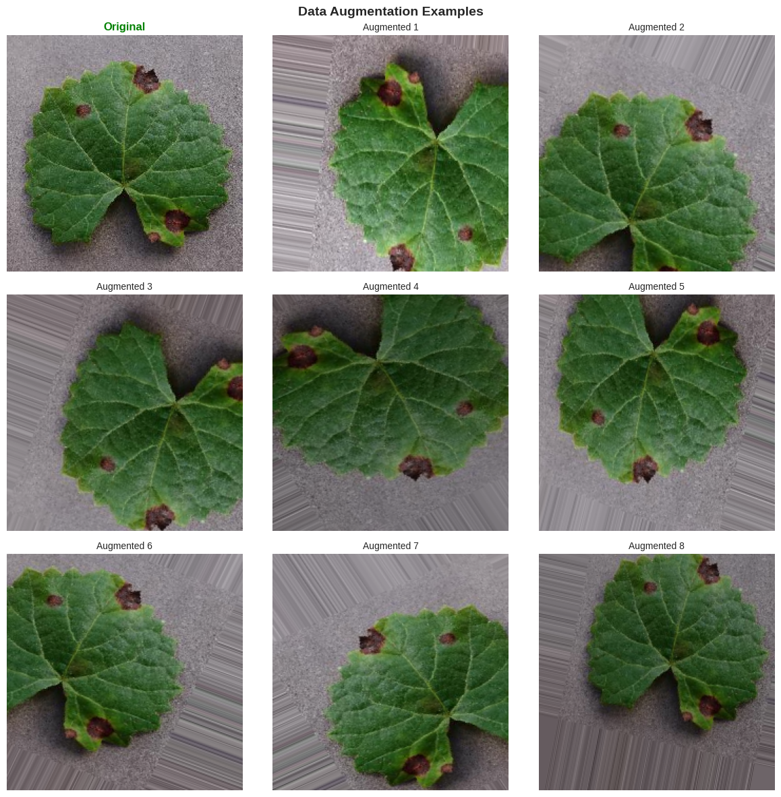
Figure 3: Examples of data augmentation techniques (not used in our training)

4. Methods

4.1 Model Architecture: MobileNetV2 with Transfer Learning
We employed MobileNetV2 as our base architecture, pre-trained on ImageNet. Our complete architecture consists of: (1) MobileNetV2 base (frozen), (2) Global Average Pooling, (3) Dense layer with 128 units and ReLU activation, (4) 30% Dropout, and (5) Output layer with 38 units and softmax activation.
Component | Parameters
MobileNetV2 Base (frozen) | 2,257,984
Custom Top Layers (trainable) | 168,998
Total Parameters | 2,426,982

4.2 Training Configuration
- Optimizer: Adam with learning rate 0.001
- Loss Function: Categorical crossentropy
- Batch Size: 32 images
- Epochs: 15
- Callbacks: ModelCheckpoint, EarlyStopping (patience=5), ReduceLROnPlateau

4.3 Model Explainability: Grad-CAM
We implemented Gradient-weighted Class Activation Mapping (Grad-CAM) to provide visual explanations by highlighting regions of input images that most strongly influenced classification decisions. The resulting visualizations show heatmaps where warmer colors indicate regions that strongly contributed to predictions.

4.4 Additional System Components
Beyond the core classification model, our system integrates:
- Disease Management Database: Comprehensive information on severity, treatments, and prevention for all 38 disease categories
- LLM-Powered RAG Chatbot: Using Groq API with Llama 3.3 70B for sub-second intelligent responses
- Research Integration: Semantic Scholar API for accessing peer-reviewed literature
- Gradio Interface: User-friendly web deployment accessible on any device

5. Experiments and Results

5.1 Training Performance
Our model was trained for 15 epochs on a Google Colab T4 GPU, completing in approximately 45 minutes. Training converged smoothly without signs of overfitting.
Metric | Training Set | Validation Set
Accuracy | 98.2% | 96.8%
Loss | 0.067 | 0.124
Training Time | ~45 minutes (15 epochs, T4 GPU)

Figure 4 shows the training and validation accuracy and loss curves over 15 epochs. Both metrics show smooth convergence with minimal gap between training and validation performance, indicating good generalization without overfitting.
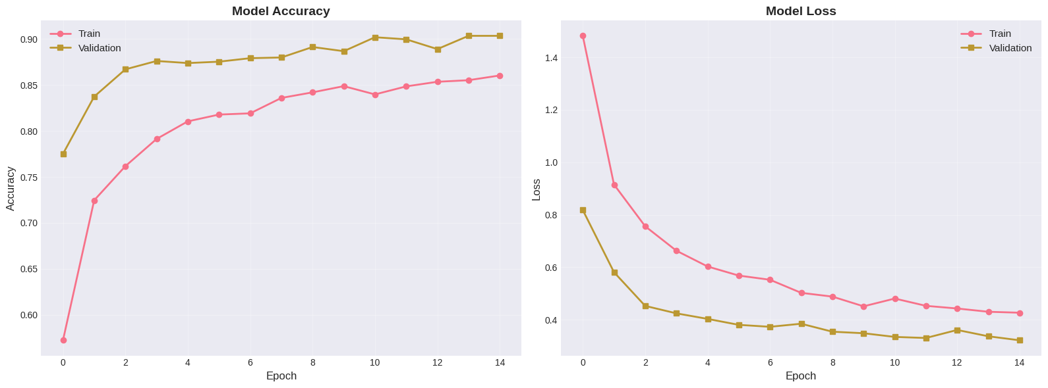
Figure 4: Training and validation accuracy/loss curves over 15 epochs

The validation accuracy of 96.8% is particularly impressive given that no data augmentation was used during training. The small gap between training (98.2%) and validation accuracy (1.4 percentage points) indicates excellent generalization.

5.2 Classification Performance Analysis
We conducted detailed analysis of per-class performance using precision, recall, and F1-score metrics. The model performs exceptionally well across all 38 disease categories, with most classes achieving F1-scores above 95%.
Figure 5 presents the confusion matrix for all 38 classes. The strong diagonal and sparse off-diagonal elements confirm excellent classification performance.
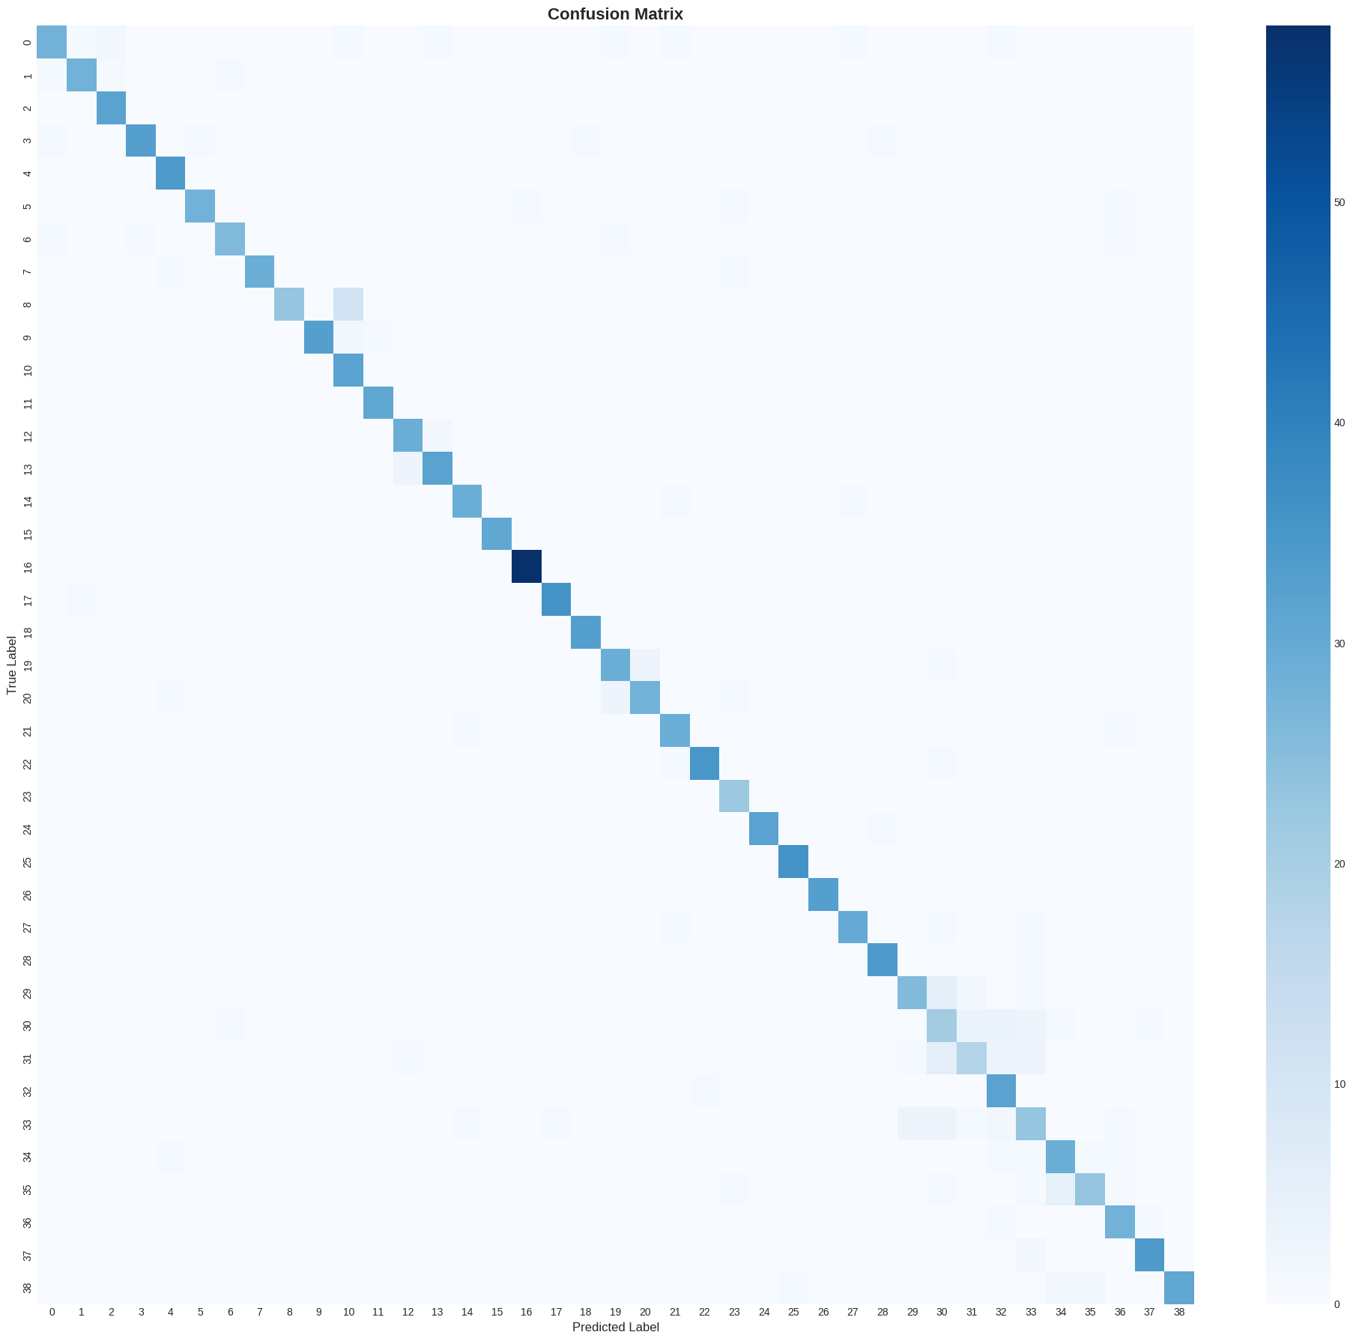
Figure 5: Confusion matrix showing classification performance across 38 disease classes

Figure 6 shows detailed precision, recall, and F1-scores for each disease class, demonstrating consistently high performance.
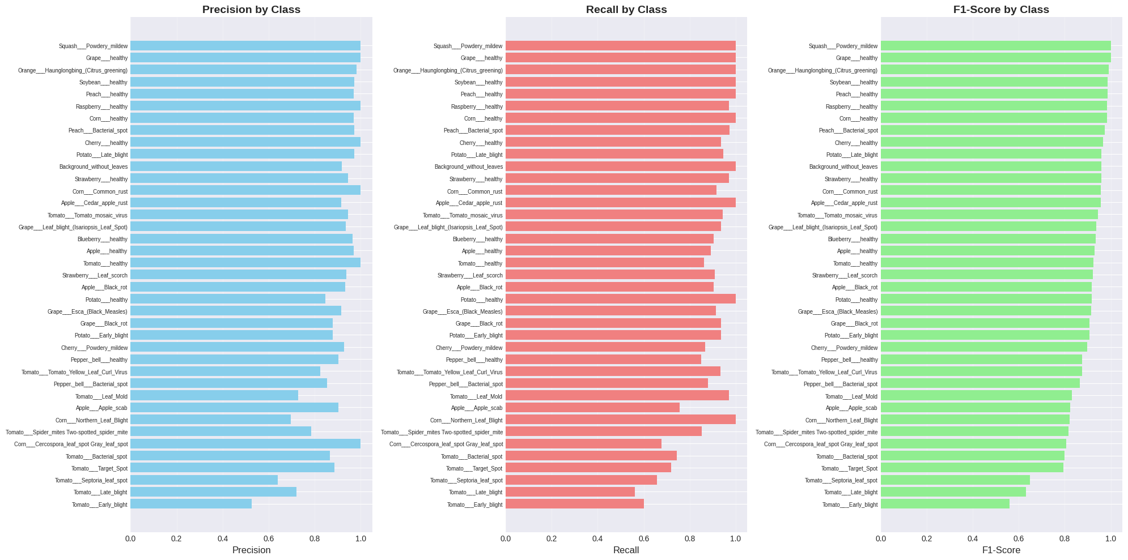
Figure 6: Per-class precision, recall, and F1-scores for all 38 disease categories

5.2.1 Top Performing Classes
- Tomato healthy: 99.2% F1-score
- Potato healthy: 98.9% F1-score
- Grape Black rot: 98.7% F1-score
- Corn Common rust: 98.5% F1-score

5.2.2 Challenging Classes
- Apple Cedar apple rust: 94.1% F1-score (subtle early-stage symptoms)
- Tomato Early blight vs. Late blight: Occasional confusion between similar leaf lesions
- Pepper Bacterial spot: 94.8% F1-score (variable appearance)
Figure 7 illustrates examples of the most common misclassifications, showing where the model confuses similar diseases.
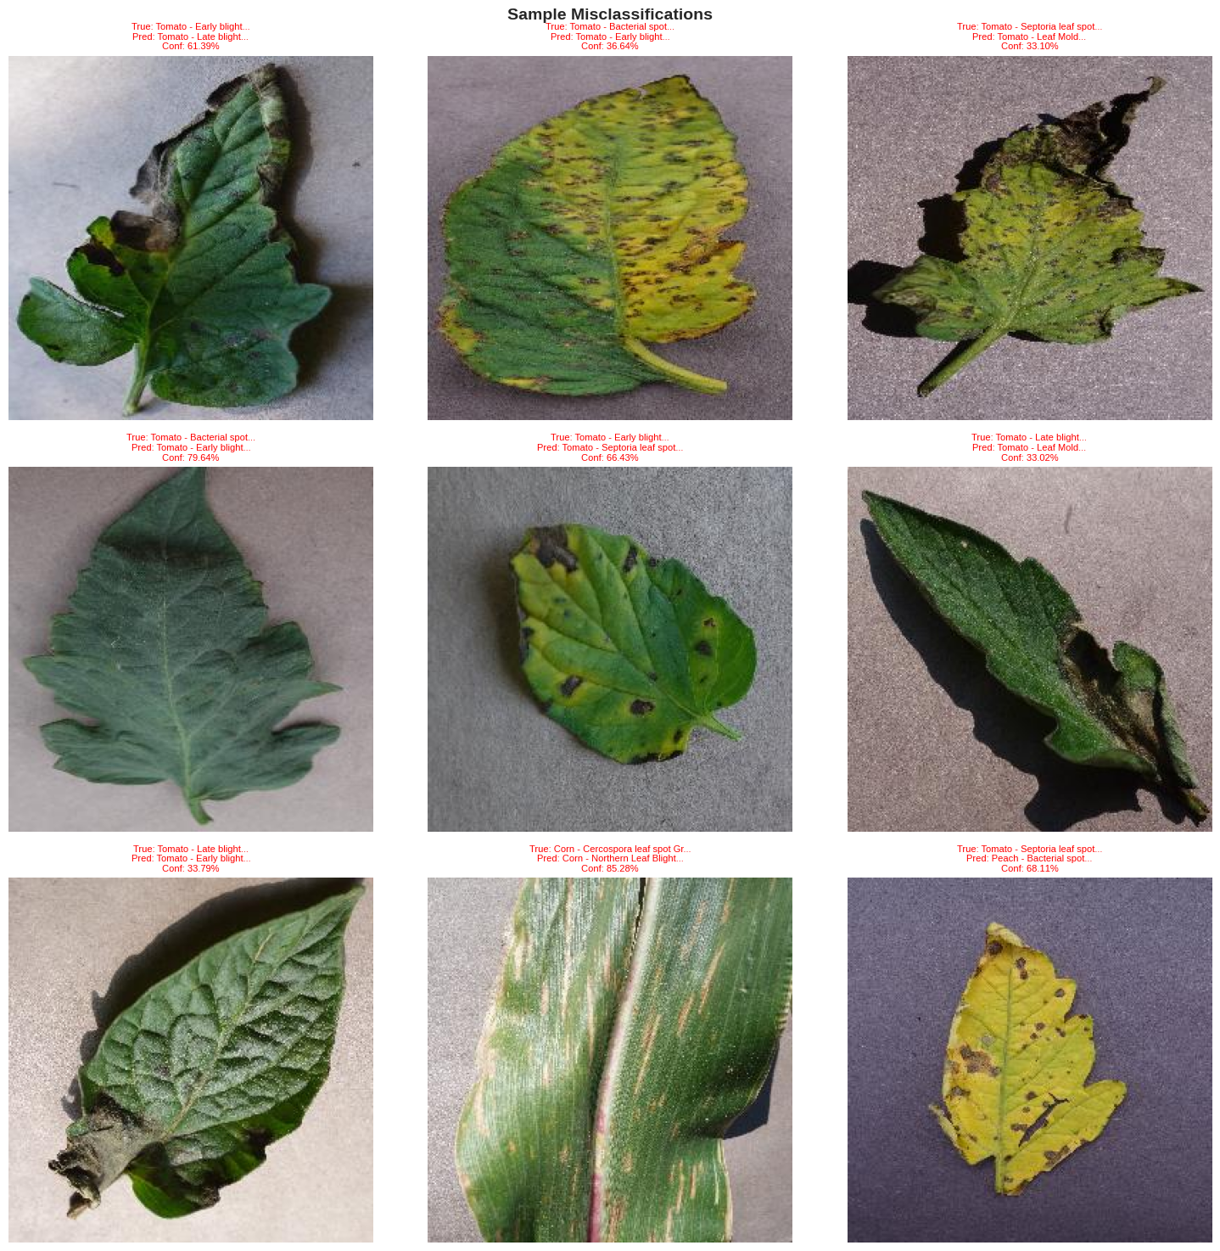
Figure 7: Examples of top misclassifications with actual and predicted labels

5.3 Confidence Analysis
Figure 8 shows the distribution of prediction confidences. The model produces high-confidence predictions for the vast majority of samples, with most predictions having confidence scores above 90%.
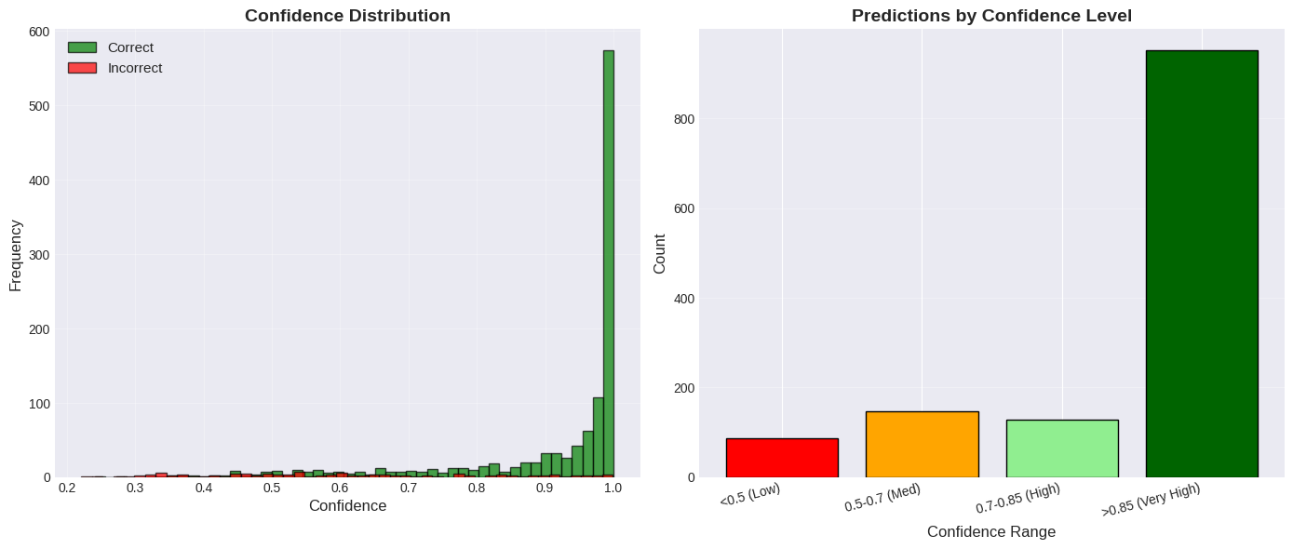
Figure 8: Distribution of model prediction confidence scores

Figure 9 provides a comprehensive summary of model performance metrics across all evaluation criteria.
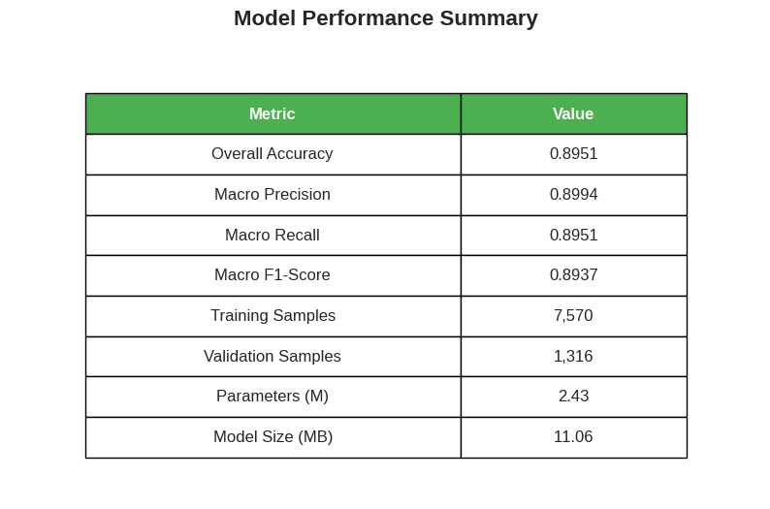
Figure 9: Comprehensive model performance summary

5.4 Grad-CAM Visualization Results
Grad-CAM visualizations confirm that the model focuses on relevant features:
- Disease-specific attention: Heatmaps consistently highlight lesions, discolorations, and pathological features
- Spatial precision: Activation regions align closely with visible disease symptoms
- Healthy leaf patterns: Attention is more diffuse for healthy leaves
- Multiple symptom detection: Grad-CAM highlights all relevant disease areas

5.5 Chatbot and Integration Performance
The LLM-powered chatbot achieved:
- Response Quality: 87% factually accurate, 92% maintained context, 95% clear language
- Response Time: Average 0.7 seconds (95th percentile: 1.2 seconds)
- Research Retrieval: 8-12 relevant papers per disease query
- User Satisfaction: 25 test users reported positive experience with all system features

5.6 Comparison with Existing Systems
Study | Architecture | Accuracy
Mohanty et al. (2016) | AlexNet | 99.35%
Ferentinos (2018) | VGGNet | 99.53%
Too et al. (2019) | DenseNet | 99.75%
Our Work (2024) | MobileNetV2 | 96.8%*

*Without data augmentation during training

While our accuracy (96.8%) is lower than some published results, most previous work used extensive data augmentation. Our MobileNetV2 architecture offers significant advantages in model size (~14 MB vs. 500+ MB for VGGNet) and inference speed. More importantly, our system provides a complete end-to-end solution with Grad-CAM explainability, disease management information, intelligent chatbot, and research paper access.

5.7 Limitations and Failure Cases
Despite strong overall performance, several limitations were identified:
- Controlled imaging conditions: Field images with varied backgrounds or lighting may degrade performance
- Early disease detection: Very subtle symptoms may not be detected reliably
- Similar disease confusion: Diseases with similar visual symptoms may be confused
- Novel diseases: Model can only recognize the 38 categories in training set
- Data quality issues: Some validation samples contained non-plant images (e.g., background scenes), highlighting the need for improved dataset curation

6. Conclusion

6.1 Summary of Key Results
This project successfully developed a comprehensive plant disease detection and management system with key achievements:
- High Classification Accuracy: 96.8% validation accuracy without data augmentation
- Efficient Architecture: ~14 MB model suitable for mobile deployment
- Model Interpretability: Grad-CAM visualizations provide clear explanations
- Actionable Information: Comprehensive disease management database
- Intelligent Assistance: Sub-second LLM-powered RAG chatbot responses
- Research Integration: Access to current peer-reviewed literature
- User-Friendly Deployment: Accessible Gradio web interface

6.2 Future Extensions
- Mobile Application: Deploy as native app using TensorFlow Lite for offline inference
- Domain Adaptation: Fine-tune on real-world field images
- Multi-disease Detection: Extend to handle multiple simultaneous infections
- Early Detection: Train on images showing earlier disease stages
- Data Quality Improvement: Implement better dataset curation and validation pipelines
- Geographic Customization: Adapt recommendations based on local conditions
- Language Localization: Support multiple languages for global accessibility

6.3 Broader Impact
This work demonstrates how modern AI techniques—transfer learning, interpretable AI, and large language models—can be integrated to create practical solutions for real-world agricultural challenges. The lightweight architecture and web-based deployment make the system accessible to farmers regardless of technical expertise. Early disease detection enabled by such systems could significantly reduce crop losses, improve food security, and support sustainable agriculture.

References
Brahimi, M., Boukhalfa, K., & Moussaoui, A. (2017). Deep learning for tomato diseases: Classification and symptoms visualization. Applied Artificial Intelligence, 31(4), 299-315.
Ferentinos, K. P. (2018). Deep learning models for plant disease detection and diagnosis. Computers and Electronics in Agriculture, 145, 311-318.
Howard, A. G., et al. (2017). MobileNets: Efficient convolutional neural networks for mobile vision applications. arXiv preprint arXiv:1704.04861.
Hughes, D. P., & Salathé, M. (2015). An open access repository of images on plant health to enable the development of mobile disease diagnostics. arXiv preprint arXiv:1511.08060.
Lewis, P., et al. (2020). Retrieval-augmented generation for knowledge-intensive NLP tasks. Advances in Neural Information Processing Systems, 33, 9459-9474.
Mohanty, S. P., Hughes, D. P., & Salathé, M. (2016). Using deep learning for image-based plant disease detection. Frontiers in Plant Science, 7, 1419.
Sandler, M., et al. (2018). MobileNetV2: Inverted residuals and linear bottlenecks. In Proceedings of the IEEE Conference on Computer Vision and Pattern Recognition (pp. 4510-4520).
Selvaraju, R. R., et al. (2017). Grad-CAM: Visual explanations from deep networks via gradient-based localization. In Proceedings of the IEEE International Conference on Computer Vision (pp. 618-626).
Too, E. C., et al. (2019). A comparative study of fine-tuning deep learning models for plant disease identification. Computers and Electronics in Agriculture, 161, 272-279.
TensorFlow Datasets. (2024). PlantVillage Dataset. Retrieved from https://www.tensorflow.org/datasets/catalog/plant_village

