ALIA — Project Overview
Sep 30, 2026 · @Prat

Summary
Alia Access Guardrail is a live accessibility (WCAG / ADA) auditor for Alia's Shopify popups. It answers one question for a merchant: is this popup accessible to every shopper? It renders a real popup on a simulated storefront, audits the live page, and returns a 0 to 100 score, a screen-reader transcript, a keyboard walkthrough, and a draft accessibility statement.
In the demo, one click takes the same popup from 13 / 100 (Non-conformant) to 100 / 100 (Conformant). It runs entirely in the browser: no backend, no database, no customer data.

Problem statement
Alia's popup runs on every merchant's storefront, but merchants have no way to tell whether it works for shoppers who use a keyboard or a screen reader. When a popup fails, it blocks the whole page: the shopper can't reach the store, and the merchant is legally exposed.
- Legal risk is concentrated in ecommerce. 77% of 2024 U.S. digital-accessibility lawsuits targeted ecommerce sites (UsableNet year-end report). The European Accessibility Act took effect June 28, 2025.
- Popups are a common failure point. Typical bugs: no dialog role, keyboard focus escaping behind the overlay, no Escape key, unlabeled email fields, low-contrast text.
- Competitors already cover this. Wisepops, Justuno, and Klaviyo all publish popup accessibility documentation. When I built this, Alia's help center had none.

Why I built it
I wanted to show how I'd add value at Alia, not just talk about it. I looked for a gap that matters to the business and that nobody else was covering. Popup accessibility fit: it carries real legal risk for merchants, Alia's competitors already address it, and Alia controls the shared code that could fix it for every store at once.
I also treated it as a product exercise, not just a coding one. It's scoped to a 60-second demo that makes the case in one click, and it's honest about its limits. The generated statement is labeled as a self-assessment, not a certified audit.
- ☐ Open question: add your own story here (for example, what made you notice this gap or why accessibility matters to you).

How it works and tech stack
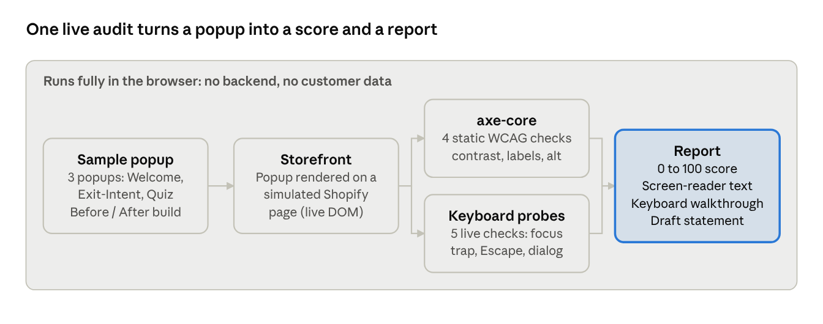
ALIA audit pipeline · popup to report
The popup is rendered on a mock storefront. Two audit engines run against the live page: axe-core for static rules, and my own probes that press real keys and move real focus. The results roll up into one score and report.
Layer | Technology | Why I chose it
UI framework | React 18 | Component model fits the popup, scorecard, and panels
Language | TypeScript 5 | Typed audit results and check definitions catch mistakes early
Build tool | Vite 5 | Fast dev server and simple production build
Styling | Tailwind CSS 3 driven by CSS variables | One token block controls the whole brand theme
Static audit | axe-core 4.10 (Deque) | Industry-standard WCAG rule engine
Behavioral audit | Custom TypeScript DOM probes | Checks focus trapping, Escape, and focus return, which axe-core can't
Font | Self-hosted Inter (Fontsource) | No external CDN, so the app works fully offline
Hosting | Static, client-side only | No backend, database, or API keys needed
The app is about 2,300 lines of TypeScript, TSX, and CSS across 24 source files.

Why it helps
One fix in Alia's shared popup code protects every merchant using it. This tool shows exactly what to fix and proves when it's fixed.
Who | What they get
Merchants | A plain-language score and pass/fail list for each popup, plus a draft accessibility statement to start from
Shoppers with disabilities | Popups they can read, navigate, and close with a keyboard or screen reader
Alia | Lower legal risk for customers, parity with Wisepops, Justuno, and Klaviyo, and accessibility as a selling point
Alia engineers | Each failing check linked to its exact WCAG rule, with evidence (for example, the measured contrast ratio)
The scoring is deliberately simple and open: each check counts equally (pass = 1, warn = 0.5, fail = 0). A real failure always shows as FAIL, never softened.

What I learned and next steps
- Static scanners miss the hard failures. axe-core catches contrast and missing labels. It can't tell whether focus escapes a dialog or whether Escape closes it. I wrote custom probes for that.
- The tool has to pass its own test. The auditor is fully keyboard-operable, has visible focus rings, and respects reduced-motion settings.
- Design for change. All brand colors live in one CSS token block that mirrors Alia's editor slots, so re-theming takes four lines.
Next steps if this went into production:
- Run the audit against merchants' real popup configurations instead of the three sample popups.
- Add the score to the popup editor so merchants see it before they publish.
- Add a mobile and screen-magnifier pass, and check it against real assistive technology.

