Momentum MCP — Project Overview
Sep 30, 2026 · @Prat

Summary
Momentum MCP: your AI remembers where you left off. It is a local-first Model Context Protocol (MCP) server that gives AI assistants memory of your unfinished work: open commitments, project context, people, and decisions. Any MCP-compatible assistant (Claude, ChatGPT, Cursor, VS Code, and others) can pick up where you left off instead of starting from zero.
It is a working v0.1.1 with 10 MCP tools, a command-line tool, automated tests, and CI. All data stays on your own machine.

Problem statement
Knowledge workers lose momentum when unfinished work and relationship context are spread across tools. An AI assistant reasons well inside one conversation, but without lasting memory it has to rebuild your situation every time.
Creating a task is easy. The real cost is reconstructing everything around it: what happened, what's unresolved, who owes what, and why a decision was made. A to-do item like "Follow up with Alex" doesn't say who Alex is, what was discussed, which project it belongs to, or what depends on the reply.
Task managers store tasks, notes apps store notes, and chatbots store conversations. Real work happens across all of them, so nothing holds the full picture.

Why I built it
I didn't set out to build an MCP server. I started with a problem I kept hitting in my own work: across job search, networking, projects, and community work, I lost time rebuilding context. A follow-up lived in one note, a decision in another chat, and the reason for a choice somewhere else. After a few days away, I had to piece it all back together before I could make progress.
That's when I realized the problem wasn't creating tasks. It was continuity. I wanted my AI assistant to know where I'd left off, without relying on one chat history or putting my personal work data in another cloud service.
I chose MCP because it separates the thinking from the memory. Momentum owns the data, and whichever AI I use does the reasoning. So my data isn't locked into one chatbot or one model.

How it works and tech stack
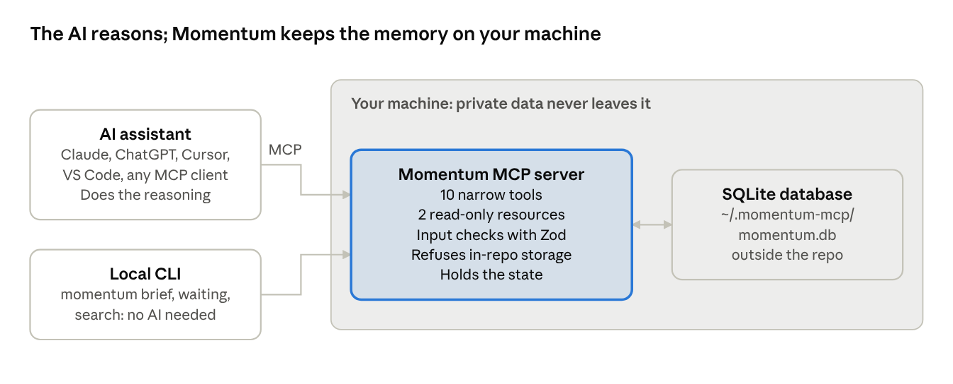
Momentum architecture · AI client or CLI to local database
There are two ways in. An AI assistant connects over MCP (local stdio, so no network port is opened), or you use the command-line tool directly. Both read and write the same local database. Momentum stores five kinds of records: projects, people, context notes, open loops, and decisions.
Layer | Technology | Why I chose it
Language | TypeScript | One typed language for the server, CLI, tests, and scripts
Runtime | Node.js 24 | Built-in SQLite (node:sqlite) and TypeScript support, so few dependencies
AI protocol | Model Context Protocol (MCP) SDK | One integration works with many AI clients
Transport | stdio | Stays local, with no network service or login to secure
Storage | SQLite | Easy to install, query, back up, and move
Validation | Zod | Checks every tool input before it reaches the database
Quality | Node test runner, GitHub Actions CI, custom privacy scanner | Build, tests, and privacy checks run on every push
The codebase has two runtime dependencies (the MCP SDK and Zod) and about 960 lines of TypeScript source. It is MIT-licensed.

Why it helps
Momentum lets you ask your AI questions it normally can't answer across conversations, and get answers based on your real data.
You ask | Momentum tool the AI calls | What you get
"What should I focus on today?" | get_daily_brief | Priorities, overdue items, stale projects, people to reconnect with
"What am I waiting on?" | get_waiting_on | Everything that depends on someone else, kept separate from normal tasks
"Where did I leave the Atlas launch?" | get_context | Recent updates, open items, and decisions for that project only
"What did we decide, and why?" | get_recent_decisions | Decisions with their reasoning, not just the outcome
"Jordan will send the review Friday, track it" | capture_context, create_open_loop | A saved note plus a tracked follow-up
Privacy is built in, not promised. Data stays in a local SQLite file outside the code repository. There's no telemetry, no cloud account, and no AI API key. The tool also refuses to store private data inside a Git repository, and a privacy scanner checks for leaked secrets before anything is published.

What I learned and next steps
- Technical choices shape the product story. What context an AI needs, what it may access, and where data lives aren't just engineering questions. They drive trust, adoption, and positioning.
- Less is more in data modeling. I narrowed all productivity concepts down to five building blocks: projects, people, context, open loops, and decisions.
- Narrow tools are safer and smarter. Each tool answers one clear question and returns only what's needed. That's better for privacy and gives the AI cleaner context.
- Prove the core before adding integrations. I held back Gmail and calendar connections on purpose, because each one changes the privacy model.
Next steps:
- Better relevance ranking and duplicate detection for people and projects
- Optional calendar and email connections with clear permissions
- Encrypted backup and export
- A simple visual interface for people who don't use the terminal
Success measures I'd track: share of open loops resolved, time from an expected reply to follow-up, and how useful users rate the daily brief. None of these require collecting private content.

