Pollak Immigration Operations Hub — Project Overview
Sep 30, 2026 · @Prat

Summary
One connected workspace for an immigration law firm. The Pollak Immigration Operations Hub is a practice-management prototype built for Pollak PLLC, an immigration firm in Dallas and Fort Lauderdale. It puts cases, forms, documents, USCIS notices, and deadlines in one place, so that nothing important slips between tools.
The standout feature is the USCIS Notice Inbox. It reads a notice, matches it to the right client and case, and suggests deadlines. It shows how confident it is in each extracted field, and nothing is filed until an attorney approves it. The prototype has 13 screens, runs in any browser with no install, and uses only fictional sample data.

Problem statement
Immigration firms run on hard deadlines, but the information behind those deadlines is spread across inboxes, folders, spreadsheets, and calendars. One missed USCIS notice or deadline can hurt a client's status.
A single USCIS notice kicks off a chain of manual work. Someone has to read it, find the client and case, copy the key fields, file it, update the case status, add deadlines to the calendar, and assign a reviewer. Each hand-off is a chance for error, and there's often no clear record of who did what.
At the same time, AI tools that promise to automate this raise a fair concern for lawyers: they can't let software file or calendar anything they haven't checked.

Why I built it
I wanted to show what a focused operations tool could look like for a real firm, built around how an immigration practice actually works. Pollak PLLC handles high-stakes, deadline-driven cases, including H-1B, green card, naturalization, O-1, and E-2 matters. That makes it a good test of whether software can reduce manual work without taking control away from attorneys.
I set three rules for myself:
- Show the whole connected workflow, not a loose set of features.
- Keep attorneys in control. No AI decision is final without human sign-off.
- Use plain, specific language. No "seamless integration" or "revolutionary AI". Every feature says exactly what it does.
- ☐ Open question: add your own story here (for example, how you found Pollak or what gap you noticed).

How it works and tech stack
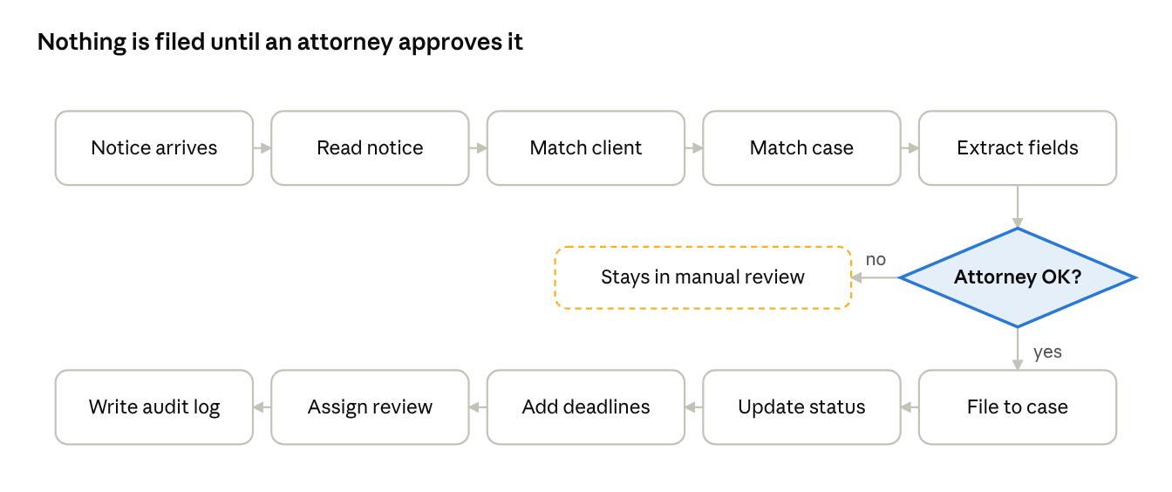
USCIS notice workflow · 10 steps, 1 attorney approval
The Notice Inbox shows this whole flow live. The original notice sits on the left, and the extracted fields with their confidence scores sit on the right. Once an attorney approves, one click updates the case, creates the deadlines, and writes the audit log. The same data also drives 12 other screens, including the dashboard, cases, clients, forms, documents, calendar, tasks, reports, integrations, admin, and a client portal preview.
Layer | Technology | Why I chose it
Front end | Plain HTML, CSS, and JavaScript | No build step or dependencies: open index.html and it runs
Navigation | Hash-based single-page routing | Every screen has its own link, with no server needed
Data | Fictional in-memory dataset (data.js) | Realistic clients, cases, notices, and deadlines for a believable demo
Design system | Pollak brand colors, Inter typeface | Matches the firm's look, with accessible contrast and responsive layout down to tablet
Usability | Keyboard shortcuts (/ to search, g + letter to navigate) | Fast for power users such as paralegals
Hosting | GitHub Pages via GitHub Actions | Deploys automatically at /pollak on every push
The prototype is about 2,500 lines of HTML, CSS, and JavaScript.

Why it helps
It turns a scattered, error-prone process into one tracked flow, with a person approving every key step.
Who | What they get
Attorneys | A priority dashboard, review checkpoints on forms, and the final say on every filing and deadline
Paralegals and assistants | Notices matched to cases automatically, reuse of form data with its source shown, and tasks with dependencies and "waiting on" states
Firm administrators | Role-based access, security settings, team workload, and reports on prep time and notice processing
Clients | A plain-language portal showing their case status, with internal notes never exposed
Safety features built into the design:
- Every extracted field shows a confidence score, and low-confidence matches can't be approved.
- Every auto-created deadline shows its source document, confidence, approver, and reminder schedule.
- A tamper-resistant activity log records who did what on each case.
- Auto-filing is off by default, and the app never claims to e-file directly with USCIS.

What I learned and next steps
- In regulated work, trust beats automation. The most important design choice was deciding what the software should not do on its own.
- Showing confidence builds trust. Displaying a confidence score on each field lets staff focus their review where it matters.
- Realistic data makes a prototype believable. I built a detailed fictional dataset (10 clients, attorneys and paralegals, real visa types, a fixed "today" of July 15, 2026) so every screen tells a coherent story.
- Honest copy is a feature. Integration cards show what each connection imports and exports, plus error and reconnect states, instead of promising everything.
Next steps if this went into production:
- Connect real notice extraction (OCR plus a language model) behind the same approval flow
- Add a real backend with authentication, encryption, and audit storage
- Integrate with the firm's existing email, calendar, and document systems
- Test with paralegals to measure time saved per notice

