EMBEDDED SYSTEM

JOURNAL

NAME : Pratham Kamble

ROLL NO. : 20272

CLASS : TYBsc

SUBJECT : Computer Science

PAPER : Embedded System

PAPER CODE : CSD104

INDEX

|  |  |  |  |
| --- | --- | --- | --- |
| **SR**  **NO.** | **TITLE** | **DATE** | **PG**  **NO.** |
| 1. | Blinking LED | 29-08-2022 | 1 |
| 2. | Simulating Traffic Signal Lights | 12-09-2022 | 3 |
| 3. | Switching LED ON/OFF using a push button | 19-09-2022 | 5 |
| 4. | Turing LED ON/OFF using LDR | 26-09-2022 | 7 |
| 5. | Calculating distance from obstacle using Ultrasonic Sensor | 17-10-2022 | 9 |
| 6. | Buzzer | 17-10-2022 | 11 |
| 7. | 7 - Segment display | 24-10-2022 | 13 |

**PRACTICAL 1**

**DATE:** 29-08-2022

**Aim:** To study the Blinking of LED using Arduino.

**Apparatus:** Arduino uno, Arduino USB 2.0 data Cable, Breadboard, LED, Jumper Wires, resistor 220 ohm.

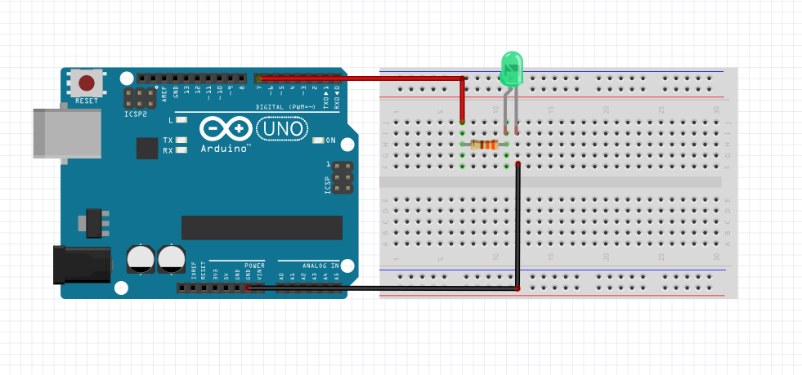**Circuit Diagram:**

**Code:**

int led1=7;

void setup()

{

  // put your setup code here, to run once:

// pinMode(pin,Mode);

pinMode(7,OUTPUT);

}

void loop()

{

  // put your main code here, to run repeatedly:

digitalWrite(led1,HIGH);

delay(1000);

digitalWrite(led1,LOW);

delay(1000);

}

**Conclusion:**

The Blinking of LED using Arduino was studied successfully.

**PRACTICAL 2**

**DATE:** 12-09-2022

**Aim:** To study the Simulating Traffic Signal Lights using Arduino.

**Apparatus**: Arduino uno, Arduino USB 2.0 data Cable, Breadboard, LED (Green, Red and Yellow), Jumper Wires, resistor 110 ohm.

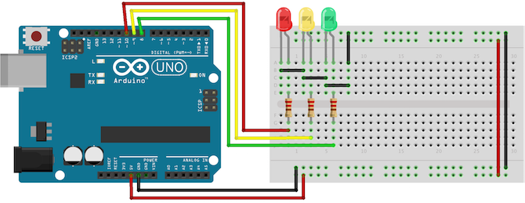**Circuit Diagram:**

**Code:**

int ledred = 10;

int ledyellow = 9;

int ledgreen = 8;

void setup() {

  // put your setup code here, to run once:

  pinMode(10, OUTPUT);   //red LED output

  pinMode(9, OUTPUT);   //yellow LED output

  pinMode(8, OUTPUT);  //green LED output

}

void loop() {

  // put your main code here, to run repeatedly:

  digitalWrite(ledred, HIGH);  //blink red for 4 sec

  delay(4000);

  digitalWrite(ledyellow, HIGH);  //blink yellow for 1.5 sec

  delay(1500);

//red and yellow off

digitalWrite(ledred, LOW);

digitalWrite(ledyellow, LOW);

//green on for 5 sec

digitalWrite(ledgreen, HIGH);

delay(5000);

digitalWrite(ledgreen, LOW);

delay(500);

//green blink 0.5 sec and delay for 0.5 sec

digitalWrite(ledgreen, HIGH);

delay(500);

digitalWrite(ledgreen, LOW);

delay(500);

digitalWrite(ledgreen, HIGH);

delay(500);

digitalWrite(ledgreen, LOW);

delay(500);

digitalWrite(ledgreen, HIGH);

delay(500);

digitalWrite(ledgreen, LOW);

delay(500);

}

**Conclusion:**

The Simulating Traffic Signal Lights using Arduino was studied successfully.

**PRACTICAL 3**

**DATE:** 19-09-2022

**Aim**: To study the Switching LED ON/OFF using a push button using Arduino.

**Apparatus:** Arduino uno, Arduino USB 2.0 data Cable, Breadboard, LED, Push Button, Jumper Wires, resistor (10K and 100 ohm).

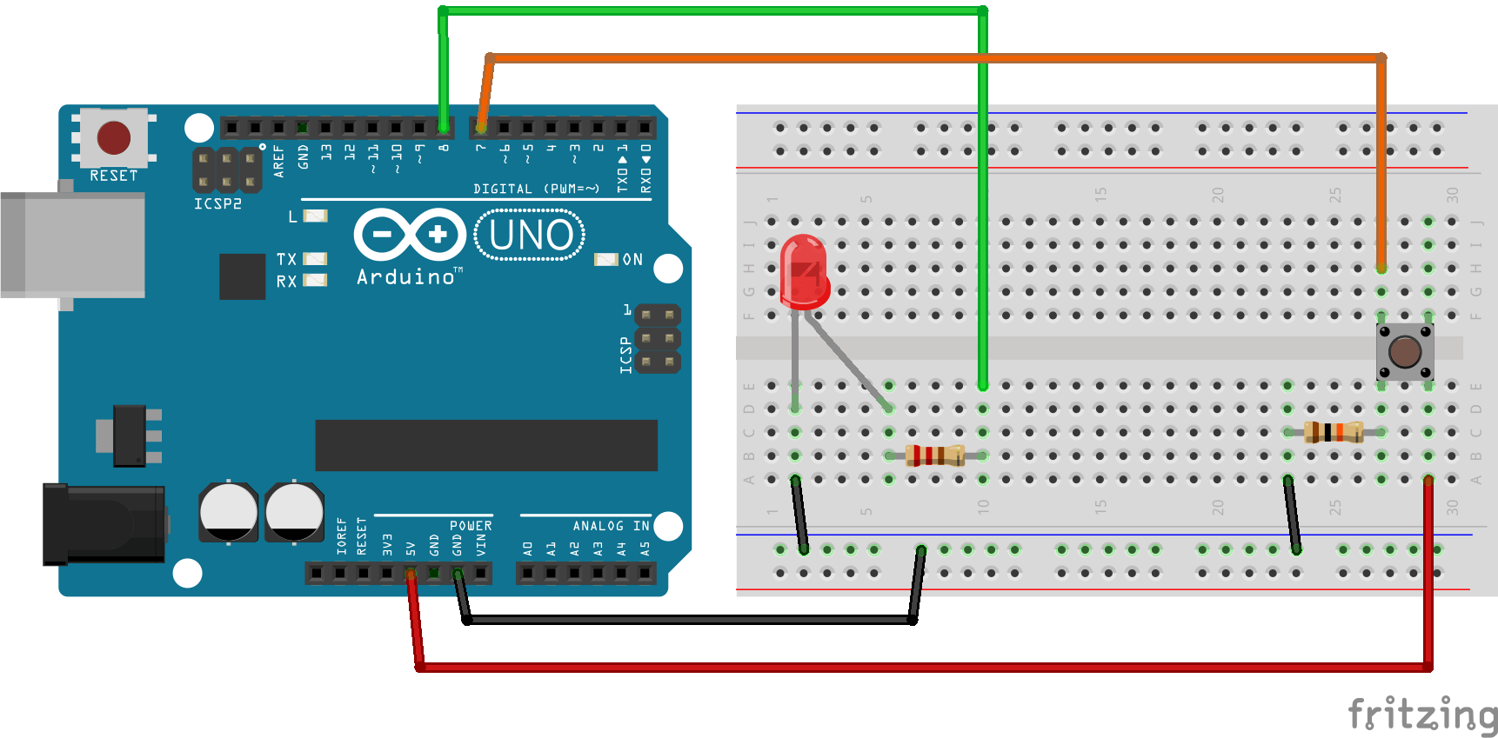**Circuit Diagram:**

**Code:**

int b = 7;

int x;

int led = 8;

void setup() {

  // put your setup code here, to run once:

  Serial.begin(9600);

  pinMode(7, INPUT);

  pinMode(8, OUTPUT);

}

void loop() {

  // put your main code here, to run repeatedly:

  x = digitalRead(b);

  Serial.println(x);

  if (x == 0) {

    digitalWrite(8, LOW);

  } else {

    digitalWrite(8, HIGH);

  }

}

**Conclusion:**

The Switching LED ON/OFF using a push button using Arduino was studied successfully.

**PRACTICAL 4**

**DATE:** 26-09-2022

**Aim:** To study the Turning LED ON/OFF using LDR using Arduino.

**Apparatus:** Arduino uno, Arduino USB 2.0 data Cable, Breadboard, LED, Jumper Wires, resistor (10K and 220 ohms), photo resistor (LRD).

**Circuit Diagram:**

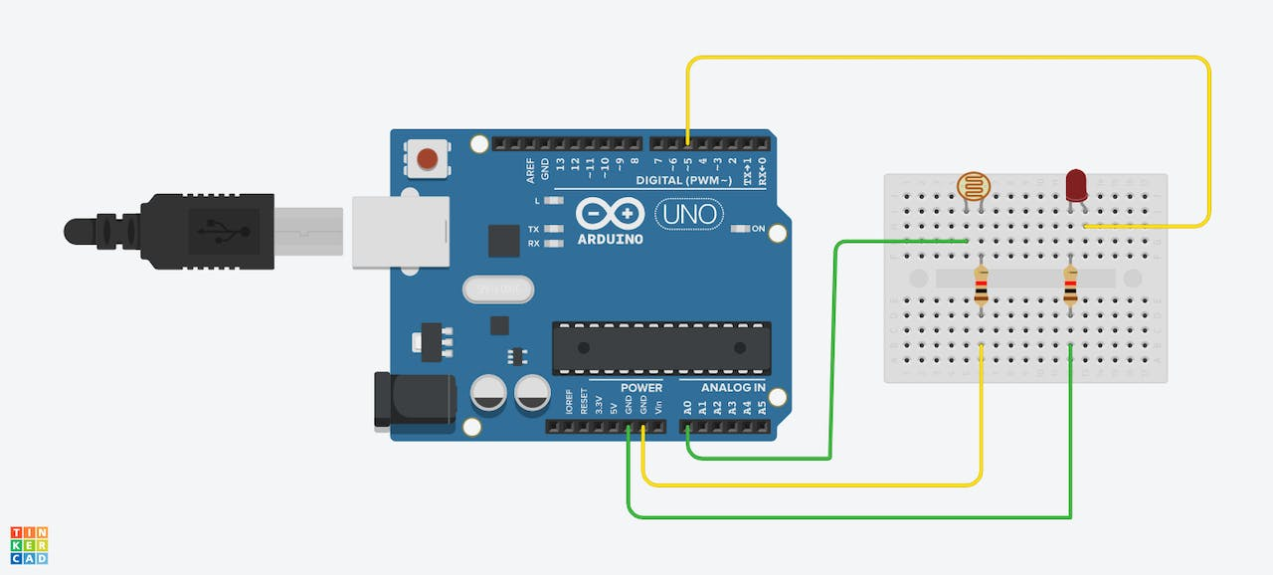

**Code:**

int ldr = A0;  //Set A0(Analog Input) for LDR

int value = 0;

void setup() {

  // put your setup code here, to run once:

  Serial.begin(9600);

  pinMode(5,OUTPUT);

}

void loop() {

  // put your main code here, to run repeatedly:

  value = analogRead(ldr);  //Read the value of LDR(light)

  Serial.println("LDR value is : ");  //Prints the value of LDR to Serial Monitor

  Serial.println(value);

  if(value < 200)

  {

    digitalWrite(5,HIGH);  //makes the LED glow in Dark

  }

  else

  {

    digitalWrite(5,LOW);  //Turns the LED OFF in Light

  }

}

**Conclusion:**

The Turning LED ON/OFF using LDR using Arduino was studied successfully.

**PRACTICAL 5**

**DATE:** 10-10-2022

**Aim:** To study the Calculating of distance from obstacle using Ultrasonic sensor.

**Apparatus:** Arduino uno, Arduino USB 2.0 data Cable, Breadboard, Jumper Wires, Ultrasonic Sensor.

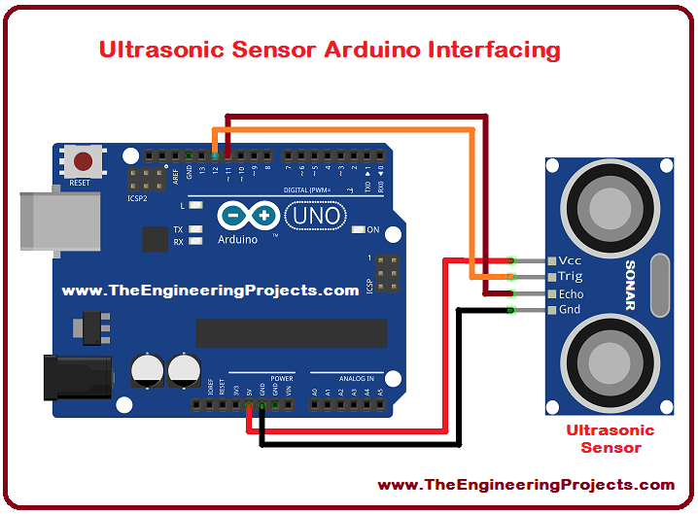**Circuit Diagram:**

**Code:**

const int trigPin = 12;

const int echoPin = 11;

long duration;

long distance;

void setup() {

  // put your setup code here, to run once:

  pinMode(triPin,OUTPUT);

  pinMode(echoPin,INPUT);

  Serial.begin(9600);

}

void loop() {

  // put your main code here, to run repeatedly:

  digitalWrite(trigPin,LOW);

  delayMicroseconds(2);

  digitalWrite(trigPin,HIGH);

  delayMicroseconds(10);

  digitalWrite(trigPin,LOW);

  duration = pulseIn(echoPin,HIGH);

  distance = (duration * 0.034/2);

  Serial.println(distance);

}

**Conclusion:**

The Calculating of distance from obstacle using Ultrasonic sensor was studied successfully.

**PRACTICAL 6**

**DATE:** 17-10-2022

**Aim:** To study the Buzzer using Arduino.

**Apparatus:** Arduino uno, Arduino USB 2.0 data Cable, Breadboard, Buzzer, Jumper Wires.

**Circuit Diagram:**

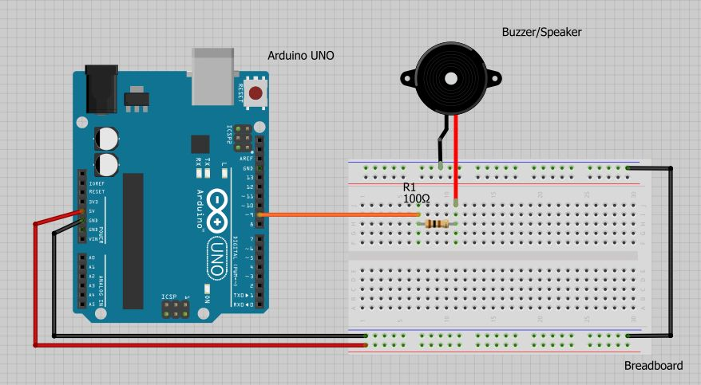

**Code:**

int Buzzer = 9;

void setup() {

  pinMode(Buzzer,OUTPUT);

}

void loop() {

  digitalWrite(Buzzer,HIGH);

  delay(1000);

  digitalWrite(Buzzer,LOW);

  delay(1000);

}

**Conclusion:**

The Buzzer using Arduino was studied successfully.

**PRACTICAL 7**

**DATE:** 24-10-2022

**Aim:** To study the 7-segment display using Arduino.

**Apparatus:** Arduino uno, Arduino USB 2.0 data Cable, Breadboard, Jumper Wires, resistor 220 ohm, 7-segment display.

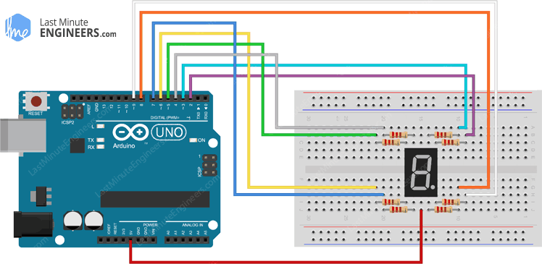**Circuit Diagram:**

**Code:**

int num,pin;

int num_arr[10][7] ={

  {0,0,0,0,0,0,1},  //0

  {1,0,0,1,1,1,1},  //1

  {0,0,1,0,0,1,0},  //2

  {0,0,0,0,1,1,0},  //3

  {1,0,0,1,1,0,0},  //4

  {0,1,0,0,1,0,0},  //5

  {0,1,0,0,0,0,0},  //6

  {0,0,0,1,1,1,1},  //7

  {0,0,0,0,0,0,0},  //8

  {0,0,0,0,1,0,0}   //9

};

void setup() {

  // put your setup code here, to run once:

  //define PinModes

  pinMode(2,OUTPUT);

  pinMode(3,OUTPUT);

  pinMode(4,OUTPUT);

  pinMode(5,OUTPUT);

  pinMode(6,OUTPUT);

  pinMode(7,OUTPUT);

  pinMode(8,OUTPUT);

}

void loop() {

  // put your main code here, to run repeatedly:

  for(num=0;num<10;num++)

  {

    for(pin=2;pin<=8;pin++)

    {

      digitalWrite(pin,num_arr[num][pin-2]);

    }

    delay(1000);

  }

}

**Conclusion:**

The study of 7-segment display using Arduino was done successfully.