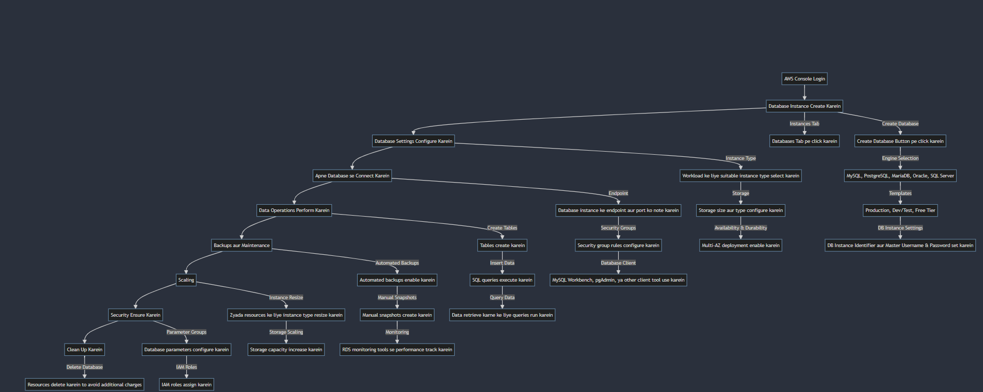

AWS RDS HANDS ON LAB