# 1. SDLC OVERVIEW

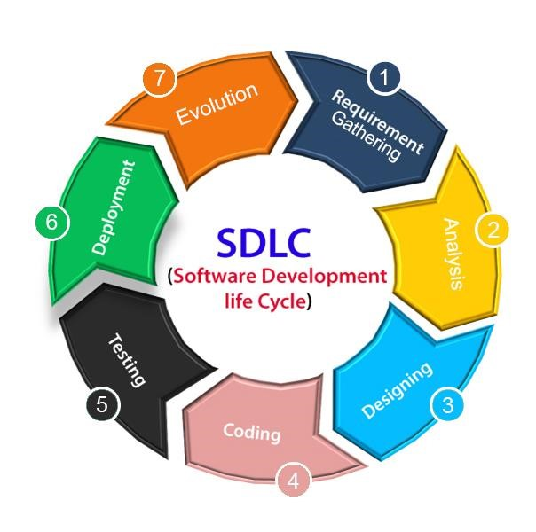

SDLC OVERVIEW

The System Development Life Cycle (SDLC) is a step-by-step process used to create software, ensuring it is well-designed and meets user needs. The first step is Requirements Analysis, where the team gathers information on what the software should do. For a Car Rental Management System, this includes understanding how customers will register, search for vehicles, and book them.

Next is Designing, where the team plans how the software will look and work. They decide how the different parts, like the customer booking page and the vehicle database, will interact. This planning helps make sure the system will be easy to use and function smoothly.

After the design is done, the Coding phase begins. Here, developers write the actual code to build the system based on the design. For the Car Rental System, this includes creating the features for customer registration, vehicle booking, and payments.

Once coding is finished, the system enters the Testing phase. This is where the software is checked to make sure everything works properly. The team tests all the features, like searching for vehicles, making a booking, and securing customer data.

After successful testing, the system is moved to the Deployment phase, where it goes live for users. For the Car Rental System, this means making the website or app available online so customers can start booking cars.

The last step is Evolution, where the system is maintained and improved over time. As new customer needs arise or updates are needed, the system will be adjusted. This keeps the software up-to-date, secure, and working well for users in the long term.

# 2. REQUIREMENT GATHERING AND ANALYSIS

**2.1 Organization Details**

## 1. Name of the Organization: -

Name of college with stream

- Navrachana University, BCA

## 2. Brief details of the Organization: -

Introduction of college

Navrachana University College in Vadodara, Gujarat, offers various courses for both undergraduate and postgraduate students in fields like Engineering, Management, Sciences, Humanities, and Education. The college focuses on providing well-rounded education, mixing classroom learning with hands-on experience and research. With modern facilities and connections to industries, it helps students gain the skills they need to succeed in today’s world.

**2.2 Meetings**

## 1. Meetings with Principal: - Name of Head

**2. Principal Requirement in their words: -** What they suggest 1 or 2 lines in your words

We meet our faculty and refer and visited some of the websites for the project**.**

### 2.3 Data which will be Input into the system

1. Text Format
2. Image Format
3. Number Format

### 2.4 Data which will be Output from the system

1. Text Format
2. Image Format
3. Number Format

### 2.5 Types of Project

- Online

### 2.6 Method of collecting Data

(use fact finding techniques)

➢ Research and Site visit.

➢ Observation of the work environment

# 3. SYSTEM REQUIREMENT SPECIFICATIONS

## 3.1 Introduction

### Purpose: -

* The purpose of this Car Rental Management System is to streamline the car rental process for customers, allowing them to book vehicles easily from anywhere in the world by providing an integrated online platform. The system aims to minimize human effort, simplify the process of filling in rental details, and offer the best possible deals by matching customer preferences with available vehicles

**3.1.2 Intended Audience and Reading Suggestions: -**

* The Intended Audience for whom you are developing

**3.1.3 System Scope: -**

* This project is based

## 3.2 Overall Description

### 3.2.1 System Function: -

**(1) Different Modules which are used in your project for example:**

## (2) Customer

## Register

* Login

**3.2.2 User classes and characteristics: -**

1. **User Classes** • F

•

1. **User Characteristics**

**a)**

.

## b)

.

**3.2.3 Operating Environment: -**

➢

### 3.2.4 Design and Implementation: -

➢

➢

➢

**3.2.5 Assumptions and dependencies: -**

➢

➢

➢

### 3.3 External Interface Requirement

**3.3.1 User Interface: -**

➢ Booking.

* Confirmation page.
* Login/Sign up page.
* Dashboard for Registered user.

#### 3.3.2 Software Interface: -

* Operating System - Window 10.
* Front End – HTML, CSS, JAVASCRIPT.
* Back End – PHP, MYSQL.
* Other tools –MSVISO, WORD.

### 3.4 System Features

➢ Quick booking.

➢ Cost saving.

➢ Vehicle maintenance.

### 3.5 Other non-functional Requirements

#### 3.5.1 Performance requirement: -

➢ Response Time.

➢ Scalability.

➢ Data Load.

**3.5.2 Security requirement: -**

* User Authentication.
* Data Encryption.
* Session Management.
* Audit Logging.

* + 1. **Safety requirement: -**

* + Audit Logging.
  + System Recovery.
  + Error Handling.

**4. SYSTEM ANALYSIS AND MODELING**

# Use case

**4.2 E-R Diagram**

## 4.3 Data Dictionary: -

TABLE 1 – Attendance list of tables which are used in your database with table name and constraints

Table – Name of Table

|  |  |  |  |  |
| --- | --- | --- | --- | --- |
| Sr-no | Column name | Data Type | Null | Constraints |
|  |  |  |  |  |
|  |  |  |  |  |
|  |  |  |  |  |
|  |  |  |  |  |

|  |  |  |  |  |
| --- | --- | --- | --- | --- |
|  |  |  |  |  |

TABLE 2 – name of your table as per database

|  |  |  |  |  |
| --- | --- | --- | --- | --- |
|  |  |  |  |  |
|  |  |  |  |  |
|  |  |  |  |  |
|  |  |  |  |  |
|  |  |  |  |  |
|  |  |  |  |  |

## 4.4 FUNCTIONAL AND BEHAVIORAL MODELING

### 4.4.1 Context Diagram (0-Level Diagram): -

**4.4.2 First Level Diagram (1-Level Diagram): -**

### 4.4.3 second level it required

**4.5 Gantt Chart** according to our time line

|  |  |  |
| --- | --- | --- |
| Enrollment no 1  Enrollment no2  Group members enroenrollment  numbers  **5. TESTCASE** |  | Name of your Project |
| Name of University |  | Page **13** of **17 (page numbers)** |

Name of University

Page

**14**

of

**17**

**page numbers**

**(**

**)**

Enrollment no 1

Enrollment no2

Group members enroenrollment

numbers

Name of your Project

**1.**

**SCREENSHOTS**

**H**

**ome Page**

**:**

**-**

Screen shots with filled data and after screen shot notes

of that particular screen shot

Name of University

Page

**15**

of

**17**

**(**

**)**

**page numbers**

Enrollment no 1

Enrollment no2

Group members enroenrollment

numbers

Name of your Project

**.**

**7**

**LIMITATIONS AND FUTURE ENHAN**

**CEM**

**ENTS**

**7.1**

**Limitations:**

**-**

➢

Limitations of your system

➢

**7.2**

**Future Enhancements**

**:**

**-**

In future how you improve your

project.

|  |  |
| --- | --- |
| Enrollment no 1  Enrollment no2  Group members enroenrollment  numbers      **8. CONCLUSION** | Name of your Project |
| Name of University | Page **16** of **17 (page numbers)** |

Name of University

Page

**17**

of

**17**

**)**

**page numbers**

**(**

Enrollment no 1

Enrollment no2

Group members enroenrollment

numbers

Name of your Project

**9**

**.**

**REFERENCES AND BIBLOGRAPHY**

All the references listed below were used to

develop and

design th

is web

application and were a

lso used for

documentation. We are

thankful to eac

h and every person

who helped us

and supported for this project completion

.

References:

-

[www.stackoverfl](http://www.stackoverflow.com/)

[o](http://www.stackoverflow.com/)

[w.co](http://www.stackoverflow.com/)

[m](http://www.stackoverflow.com/)

Bibliography:

-

[m](http://www.materializescss.com/)

[www.materializescss.co](http://www.materializescss.com/)