**Ingestion -2**

Ingesting all the tables at once.

Crate a new pipeline and name it ‘Copy_all_tables’

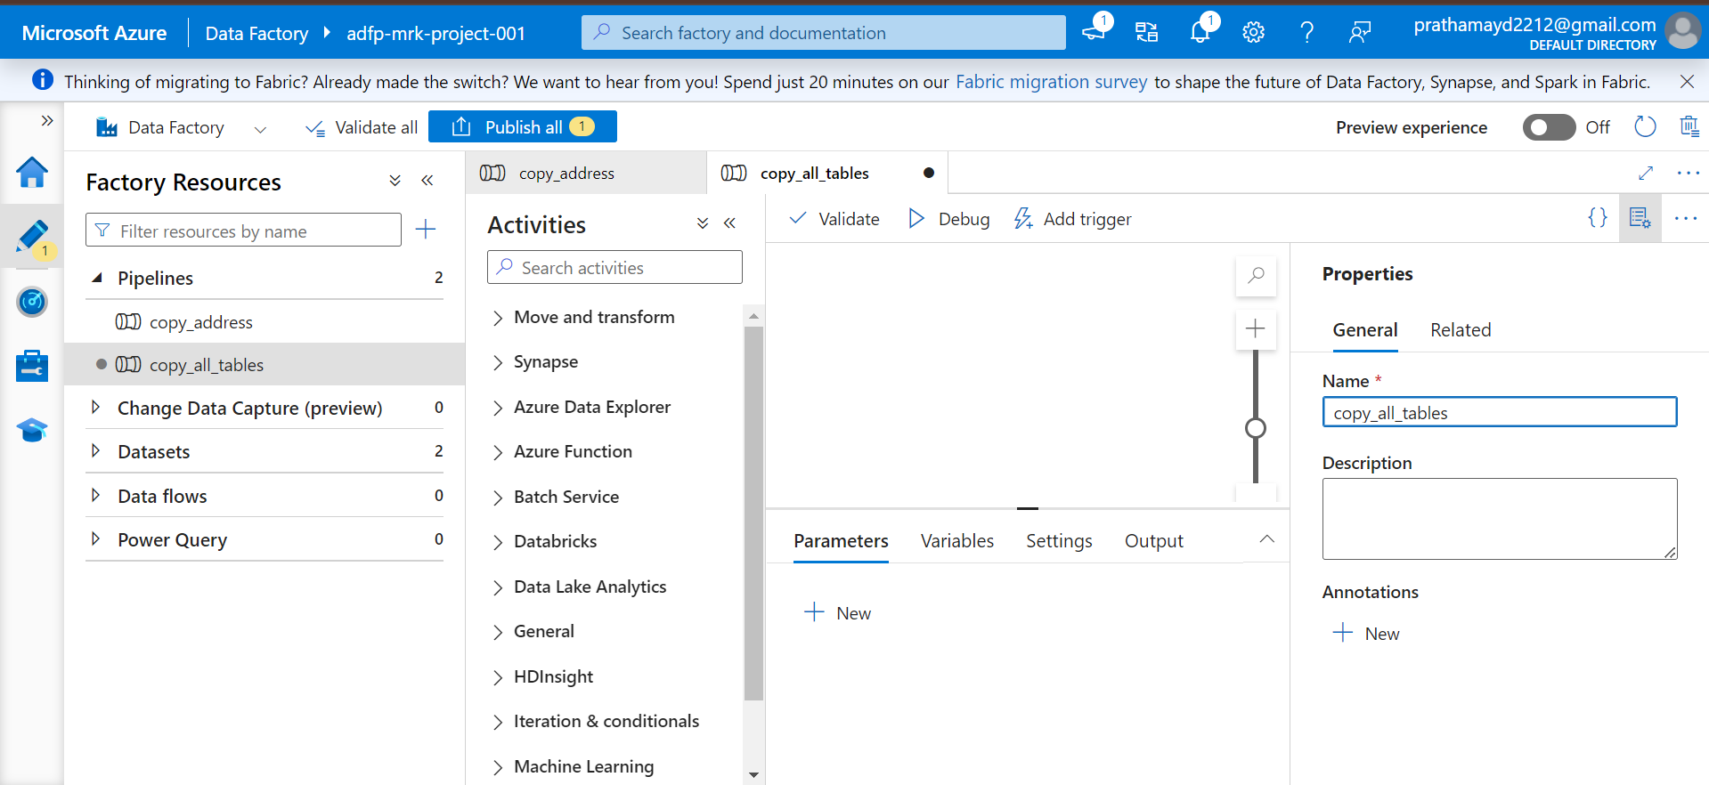

Next we will create a query in sql server that will extract all the table and schema details

Select

s.name as SchemaName,

t.name as TableName

from sys.tables as t

INNER JOIN sys.schemas as s

on t.schema_id = s.schema_id

Where s.name = 'SalesLT'

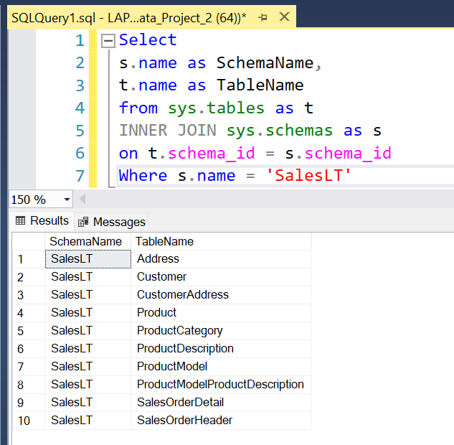

ADF🡪 Lookup 🡪 Drag n drop 🡪 Rename

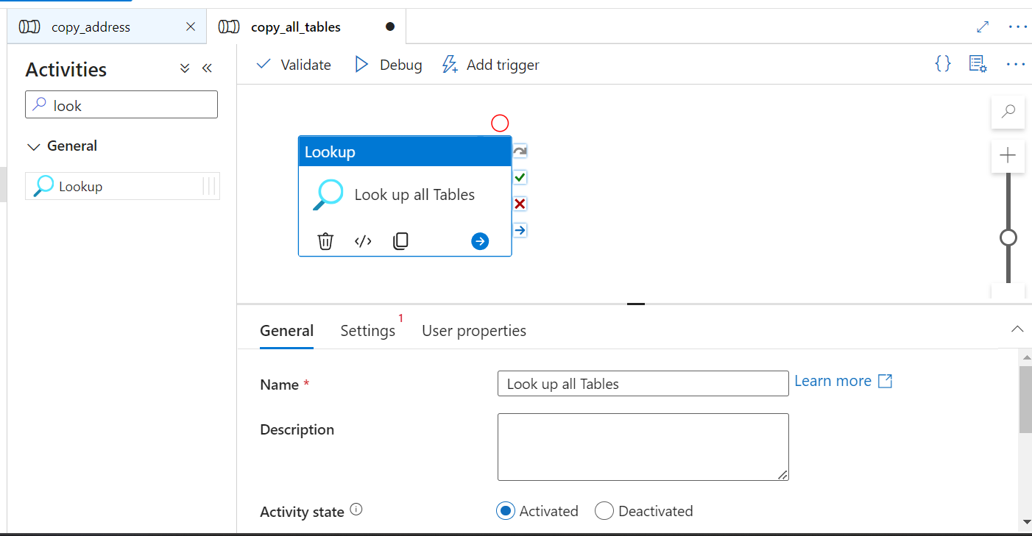

Move to Settings 🡪 Create a new source data 🡪 + NEW

Enter all the details, select your linked services.

Do not select any table and just create the source data.

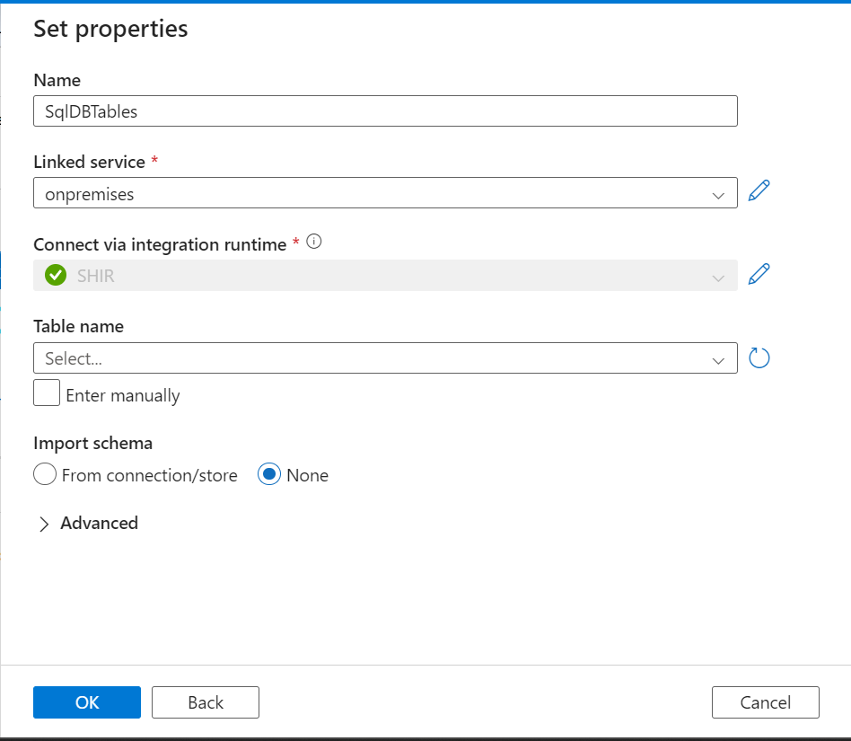

Come back to the lookup option and select the query option and copy paste the query that we created earlier.

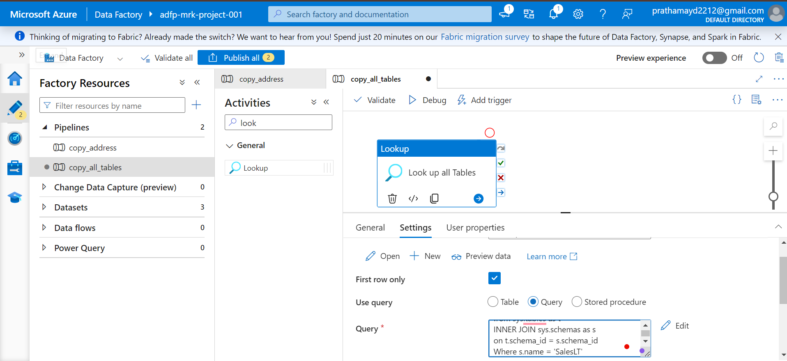

🡪Uncheck the First row only and click on preview data and you will be able to view the data.

🡪Click Debug and run the lookup object

OUTPUT will have Input and output option here:

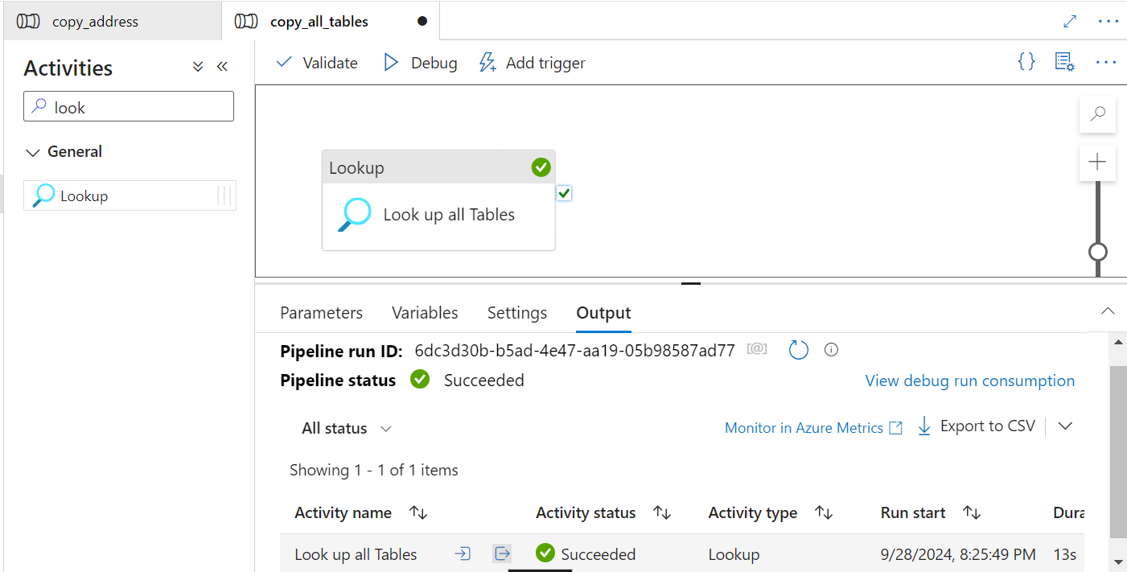

We will be using the output code in our net step which will be a json code and that will have the list of table names that we want to import.

Drag and drop the foreach activity for the next step and rename it to ‘ForEachSchemaTable’

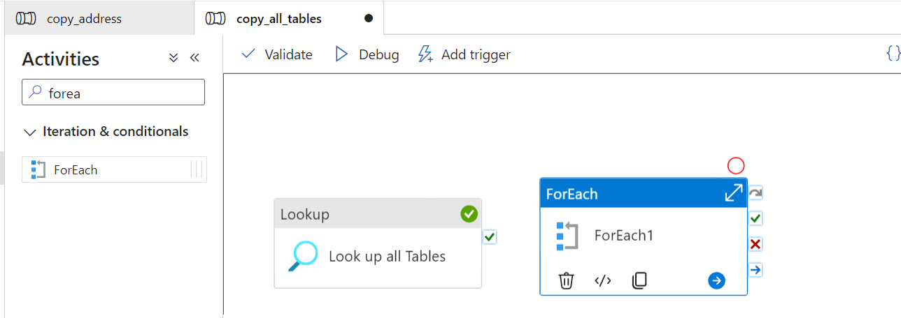

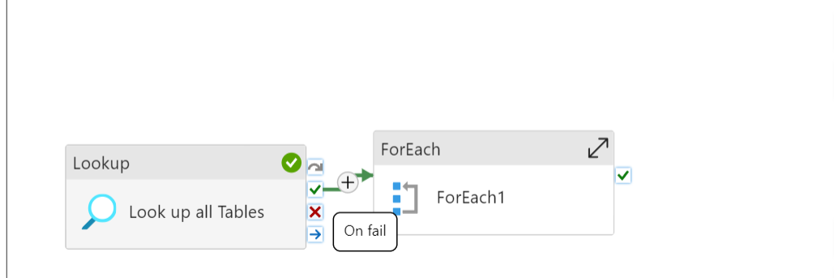

🡪Click on the tick ✔️ mark and drag it to the foreach loop which will create a dependency.

🡪Foreach loop 🡪 setting 🡪Items 🡪Add Dynamic Content 🡪Look Up All Tables and change the code as shown in the second screenshot.

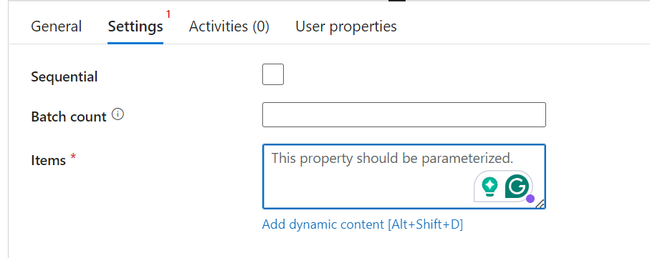

In the below line “Value” is being added separately by us because above in the output option we have the table data stored under value in json format. So adding value over here will read all the table and schema details of the dataset that we want to import.

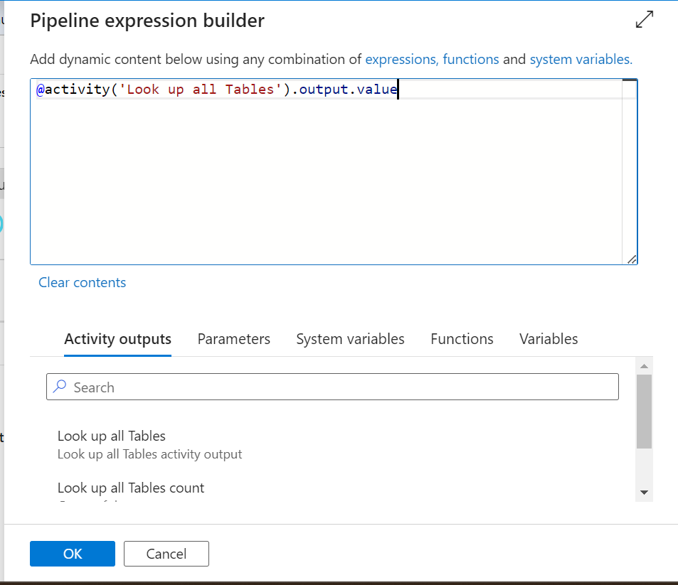

**Click OK**

ForEach Schema Table🡪Activity🡪Edit

You will enter inside the foreach loop.

Inside the foreach loop, add activity (copy data) drag and drop in the dashboard.

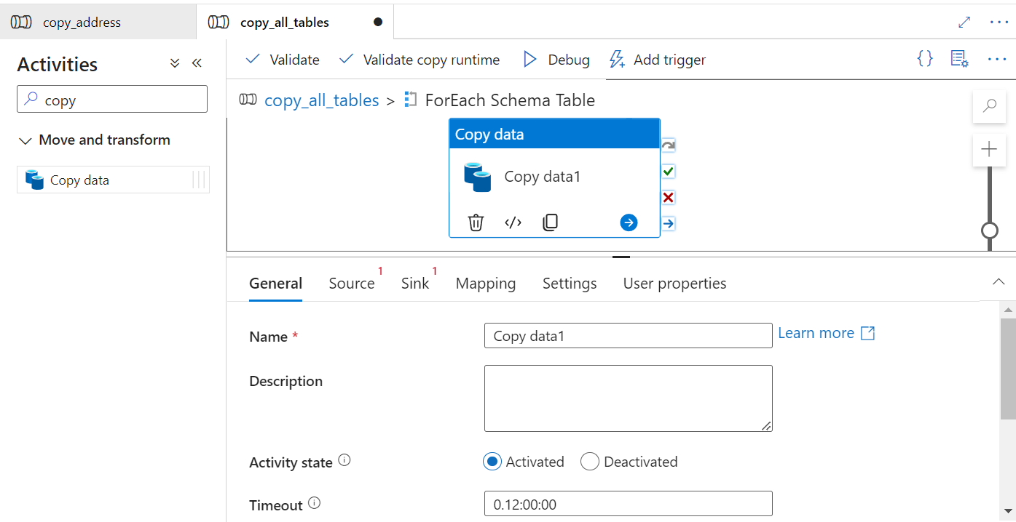

Rename the activity and configure the Source option.

+New source and create a new linked service to import the data.

Since earlier we have used the dynamic option we do not have to choose any table and just click on create.

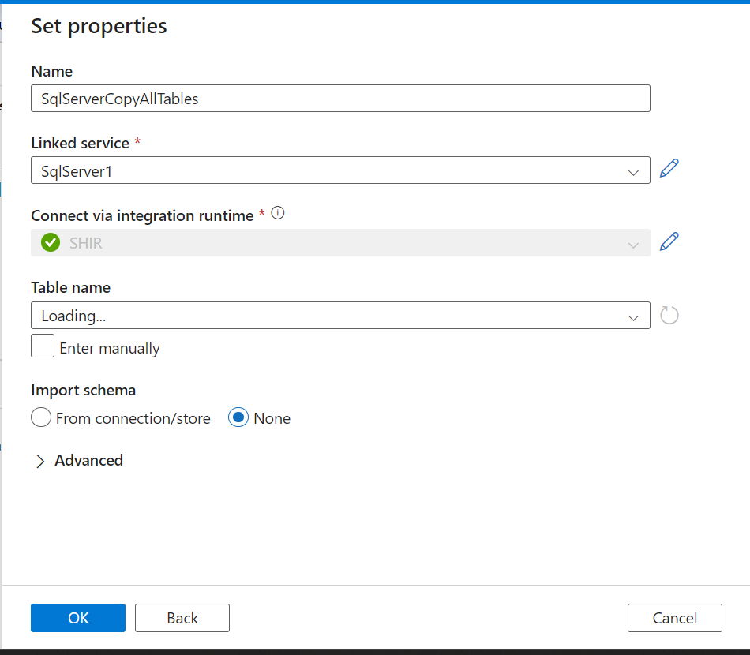

Once done, click on the query option and then select on add dynamic content.

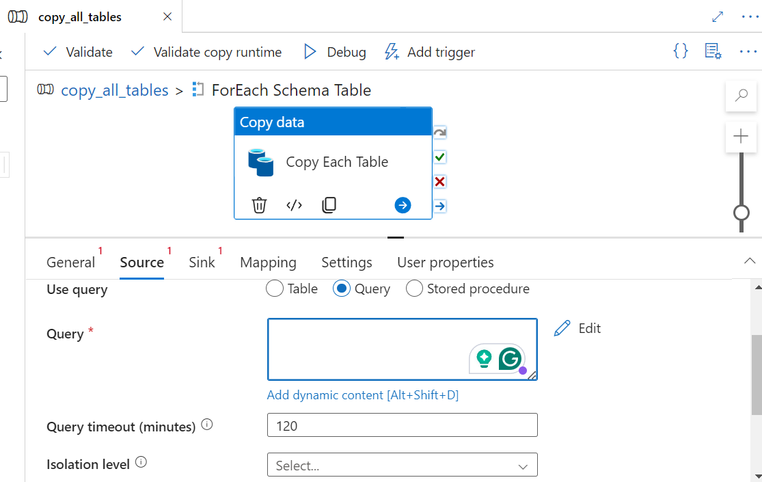

**Type the below code in the box**

**@{concat('SELECT * FROM',item().SchemaName,'.', item().TableName)}**

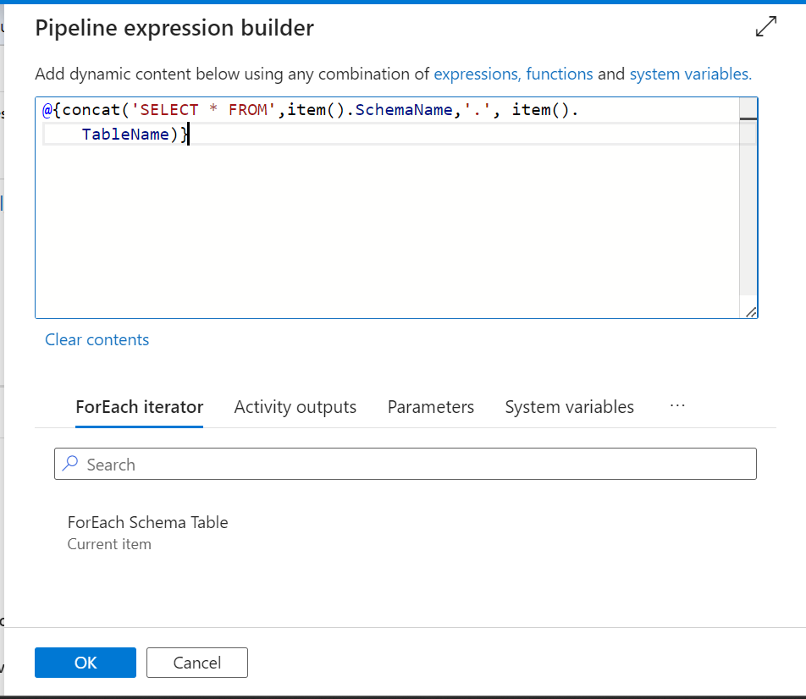

**Now create a new sink data set option for azure blob storage to transfer the tables .**

**New sink🡪azure Blob Storage 🡪Parquet 🡪Select the already created linked service 🡪Choose the bronze container🡪 click ok**

**Open the sink dataset and add parameters to it.**

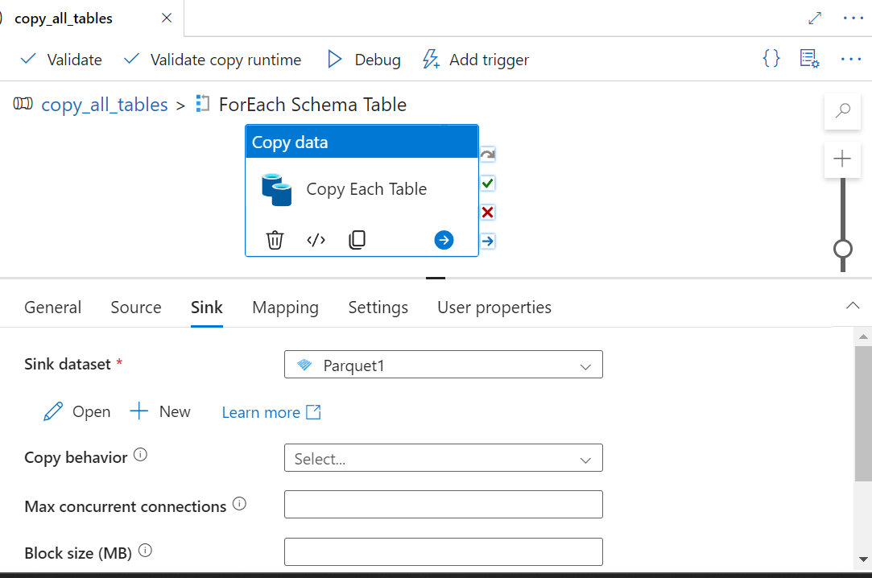

**🡪**

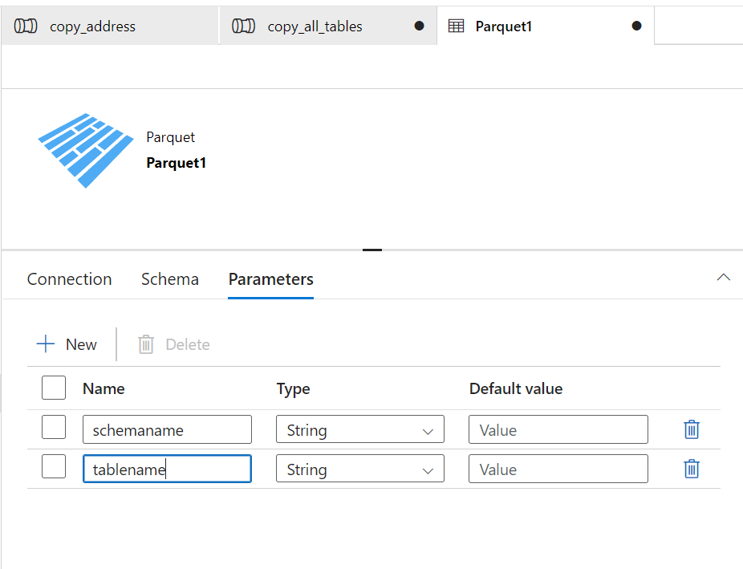

**Go back to copy all tables🡪Add dynamic parameters and type it manually**

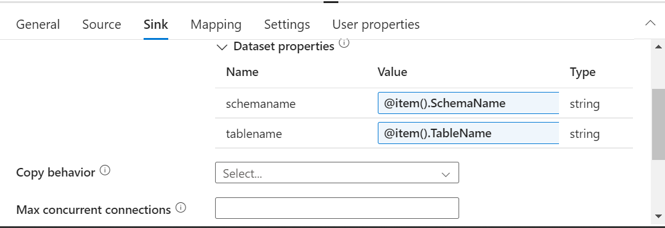

**Again open the Sink Data set 🡪Connection**

**And click on the directory and add the given code to create a hierarchy of the folder structure.**

[We have Directory/File Name] First we will add dyamic content for directory and then for file name

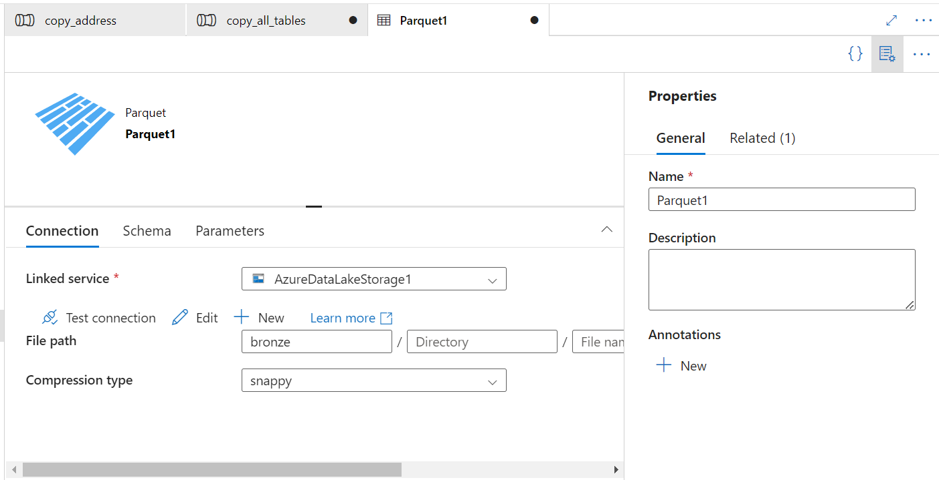

**@{concat(dataset().schemaname, '/', dataset().tableName)}**

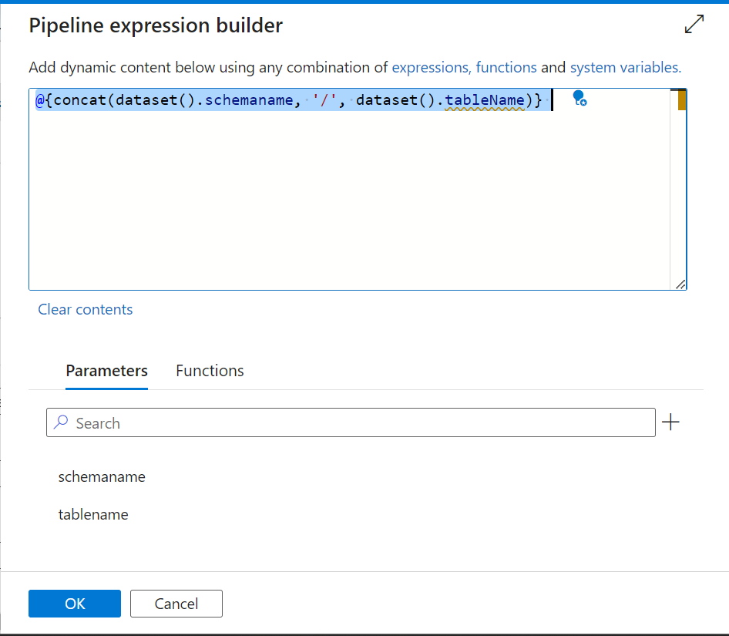

**And we will do the same for filename as well**

**@{concat(dataset().tablename,'.parquet')}**

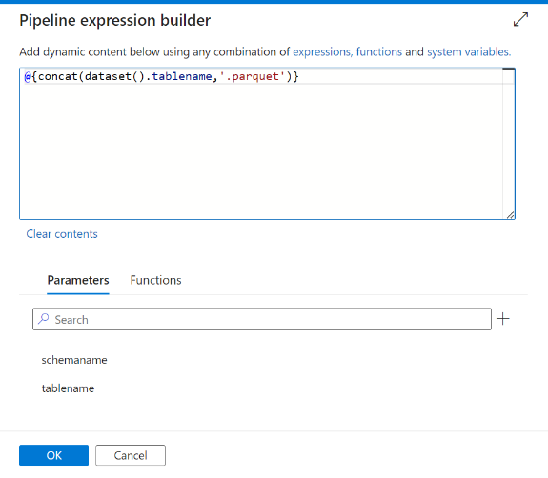

**Now we will come to the outer pipeline and first publish all the changes and then use the trigger 🡪 Trigger now option to run this pipeline now**

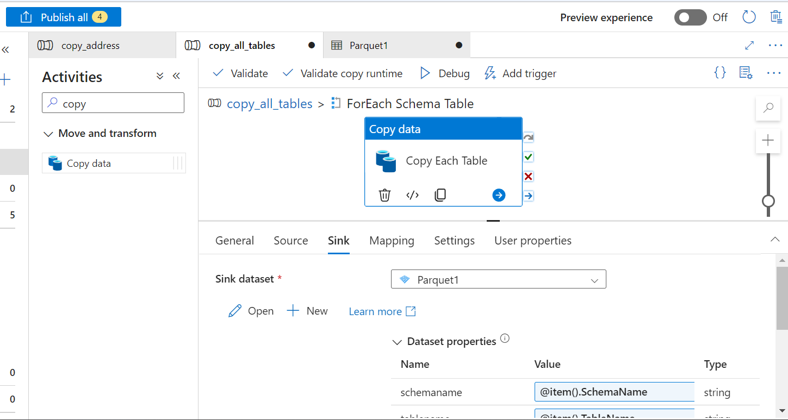

**Go to the monitor option and see the pipeline running.  
Once completed successfully you will see the Ui as shown below:**

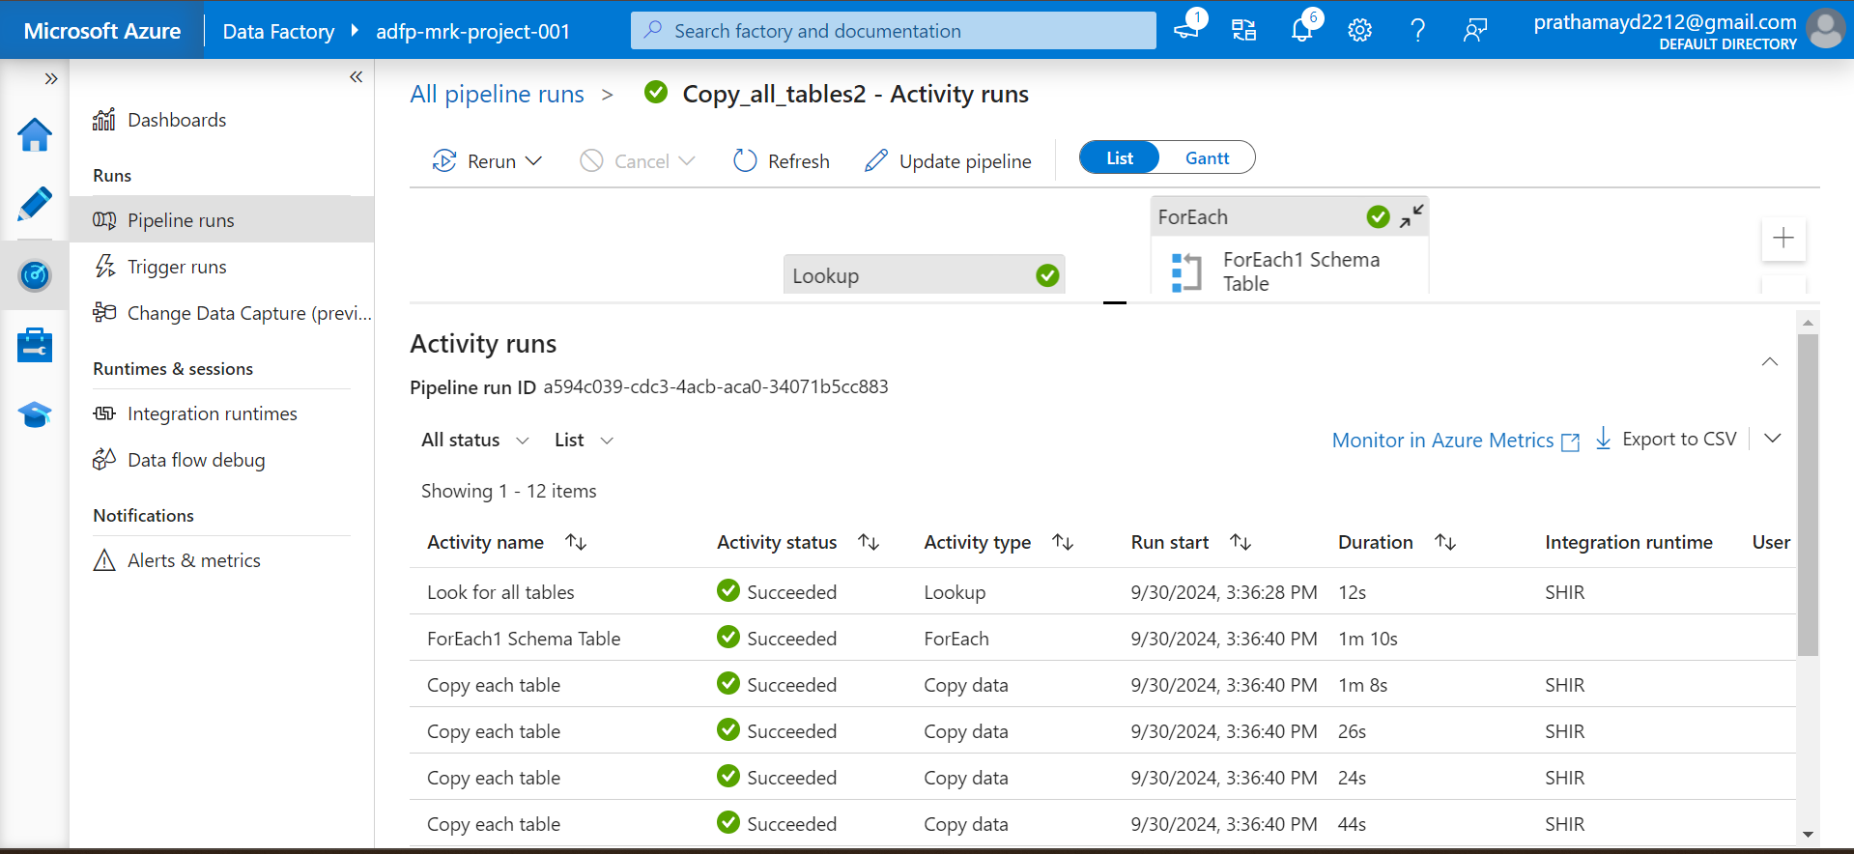

**If you check the blob storage you can also see the files.**

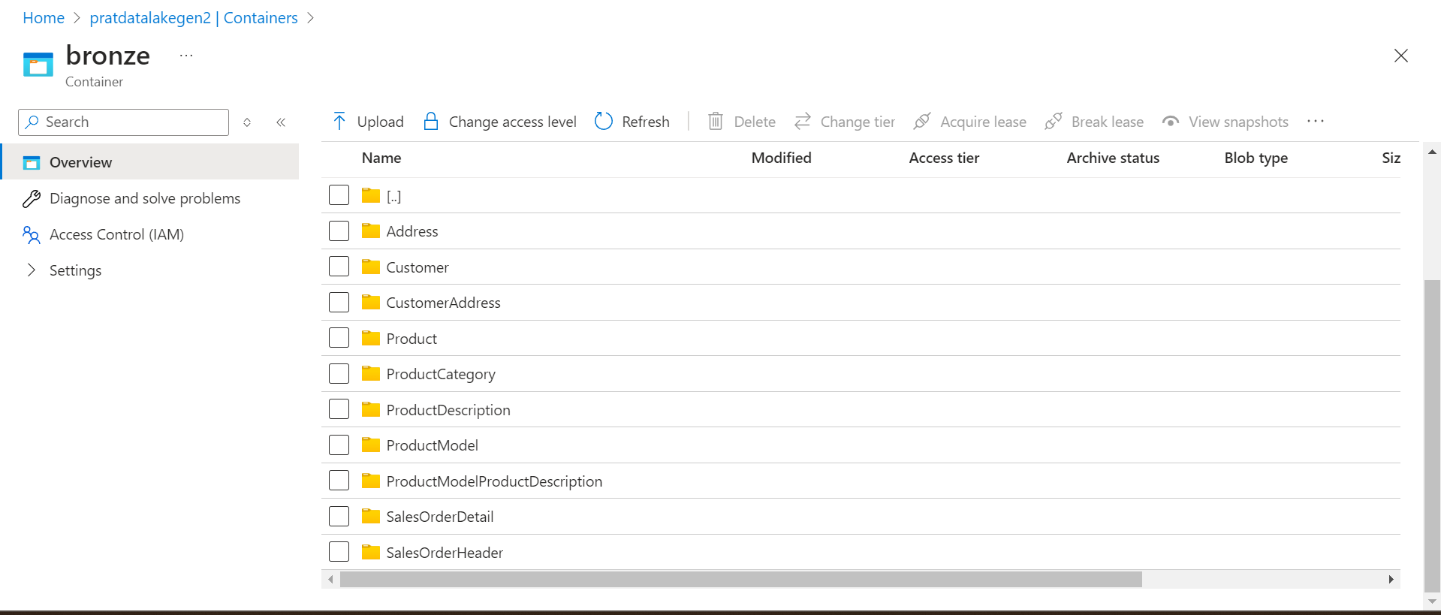

**Officially Data Ingestion is completed:**

