## Project: Code Reviewer Wireframe

### 1. Project Overview

* Goal: Create a web application that leverages the Llama 3 LLM to provide insightful code reviews and suggestions to developers.
* Target Users: Software developers looking for automated code quality assistance.
* Key Features:
  + Code file upload (Python, Java, JavaScript initially)
  + Natural language input for user questions/context
  + LLM-powered code analysis and feedback
* Technical Stack:
  + Streamlit (UI)
  + LangChain (LLM interaction & chaining)
  + Llama 3 (70B-8192 context window) via Groq
  + AI21Embeddings
  + FAISS (Vector Store)

### 2. Wireframe: Main Review Page

Screenshot/Mockup: (Insert visual here if possible)

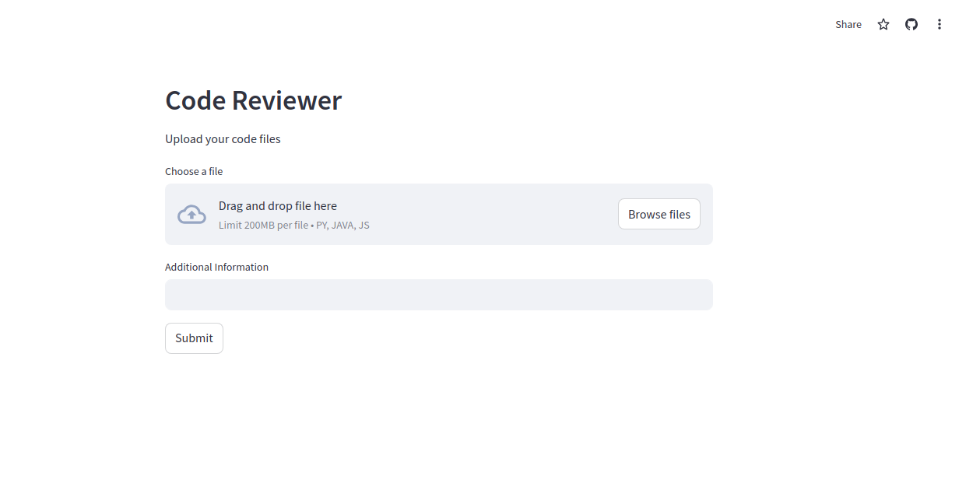

Description:

* Header: "Code Reviewer" (consider logo placement)
* File Upload Section:
  + Clear call to action: "Upload your code files"
  + File input control (stylized for modern look)
  + Allowed file types displayed prominently (".py, .java, .js")
* Additional Information Section:
  + Text input area labeled: "Provide context or ask a specific question (optional)"
  + Placeholder text: e.g., "Are there any potential security risks in this code?"
* Submit Button:
  + Large, visually distinct button labeled "Submit"
  + Consider adding a loading indicator for visual feedback
* Review Output Section:
  + Dynamically populated after submission
  + Heading: "Review Summary:"
  + LLM Response: Display the LLM-generated code review in an easy-to-read format.
    - Use Markdown support for formatting (bullet points, code blocks, etc.)
    - Consider line-highlighting or annotations if feasible in the future.

### 3. Additional Considerations

* Error Handling: Design clear error messages for invalid file types, LLM request failures, etc.
* User Feedback: Implement a mechanism to collect user feedback on review accuracy.
* Future Enhancements:
  + Support for more programming languages.
  + Integration with code repositories (GitHub, GitLab, etc.).
  + More advanced code visualizations.
* Style Guide: Adhere to a consistent style guide for UI elements, colors, and fonts.