Industrial Internship Report on
”Banking Information System”
Prepared by
Pratham Devanand Tekulwar

Executive Summary
This report provides details of the Industrial Internship provided by upskill Campus and The IoT Academy in collaboration with Industrial Partner UniConverge Technologies Pvt Ltd (UCT).
This internship was focused on a project/problem statement provided by UCT. We had to finish the project including the report in 6 weeks’ time.
My project was (Banking Information System)
This internship gave me a very good opportunity to get exposure to Industrial problems and design/implement solution for that. It was an overall great experience to have this internship.

TABLE OF CONTENTS
1 Preface 3
2 Introduction 4
2.1 About UniConverge Technologies Pvt Ltd 4
2.2 About upskill Campus 8
2.3 Objective 9
2.4 Reference 9
2.5 Glossary 10
3 Problem Statement 11
4 Existing and Proposed solution 12
5 Proposed Design/ Model 13
5.1 High Level Diagram (if applicable) 13
5.2 Low Level Diagram (if applicable) 13
5.3 Interfaces (if applicable) 13
6 Performance Test 14
6.1 Test Plan/ Test Cases 14
6.2 Test Procedure 14
6.3 Performance Outcome 14
7 My learnings 15
8 Future work scope 16

Preface

- Final Summary of Internship
- Summary of the 6 Weeks’ Work
During the four-week internship program, I worked on developing a Banking Information System using Core Java. The project was completed in a structured manner, starting from basic concepts and gradually progressing toward a fully functional system.
- Week 1: Designed system structure and implemented basic functionalities like user registration and login.
- Week 2: Developed core banking operations such as deposit, withdrawal, and fund transfer.
- Week 3: Implemented file handling for data persistence, allowing storage and retrieval of user data.
- Week 4: Completed system integration, testing, and performance improvements.Focused on report preparation, system documentation, and understanding real-world applicability of the project.
The final system successfully demonstrates a complete banking workflow with user interaction, transaction handling, and data storage.

- Need of Relevant Internship in Career Development
Internships play a crucial role in bridging the gap between academic knowledge and industry requirements. Through this internship, I gained practical exposure to real-world problem-solving, system design, and application development.
It helped me:
- Understand how theoretical concepts are applied in real projects
- Improve technical and problem-solving skills
- Gain confidence in building complete software systems
- Prepare for future career opportunities in software development

- Brief About Project / Problem Statement
The project aims to develop a Banking Information System prototype that simulates essential banking operations such as account creation, authentication, transaction processing, and data management.
The system addresses the need for an efficient, simple, and reliable way to manage banking operations digitally while demonstrating core software engineering principles.

- Opportunity Provided by USC/UCT
The internship program provided by USC/UCT offered an excellent platform to:
- Work on a real-world project
- Gain hands-on experience in Java development
- Learn industry-relevant skills
- Enhance technical knowledge through guided learning
This opportunity helped in building confidence and understanding of professional work environments.

- Program Planning and Execution
The program was well-structured and planned in a step-by-step manner:
- Initial phase focused on understanding concepts
- Intermediate phase involved implementation of features
- Final phase emphasized testing, optimization, and documentation
This structured approach ensured smooth learning and effective project completion.

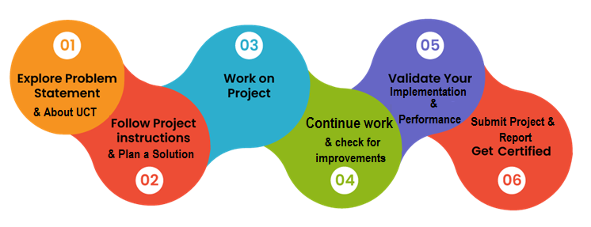
- My Learnings and Overall Experience
Throughout the internship, I gained valuable knowledge and experience in:
- Core Java programming
- Object-Oriented Programming (OOP) concepts
- File handling and data persistence
- System design and modular development
- Debugging and problem-solving
Overall, the experience was highly beneficial and helped in improving both technical and analytical skills.

- Acknowledgement
I would like to express my sincere gratitude to:
- Mentors and Guides at USC/UCT for their continuous support and guidance
- Faculty members for their encouragement and valuable suggestions
- Peers and fellow interns for their collaboration and knowledge sharing
- My family and friends for their constant support and motivation
Their contributions played a significant role in the successful completion of this internship.

- Message to Juniors and Peers
I would like to advise my juniors and peers to:
- Focus on understanding concepts rather than just completing tasks
- Practice coding regularly and work on real-world projects
- Take internships seriously as they provide valuable practical experience
- Stay consistent, be curious, and never hesitate to learn new technologies
This internship experience has been a great learning journey, and I encourage others to make the most out of such opportunities.

Introduction

About UniConverge Technologies Pvt Ltd
A company established in 2013 and working in Digital Transformation domain and providing Industrial solutions with prime focus on sustainability and RoI.
For developing its products and solutions it is leveraging various Cutting Edge Technologies e.g. Internet of Things (IoT), Cyber Security, Cloud computing (AWS, Azure), Machine Learning, Communication Technologies (4G/5G/LoRaWAN), Java Full Stack, Python, Front end etc.

- UCT IoT Platform ()
UCT Insight is an IOT platform designed for quick deployment of IOT applications on the same time providing valuable “insight” for your process/business. It has been built in Java for backend and ReactJS for Front end. It has support for MySQL and various NoSql Databases.
- It enables device connectivity via industry standard IoT protocols - MQTT, CoAP, HTTP, Modbus TCP, OPC UA
- It supports both cloud and on-premises deployments.
It has features to
• Build Your own dashboard
• Analytics and Reporting
• Alert and Notification
• Integration with third party application(Power BI, SAP, ERP)
• Rule Engine

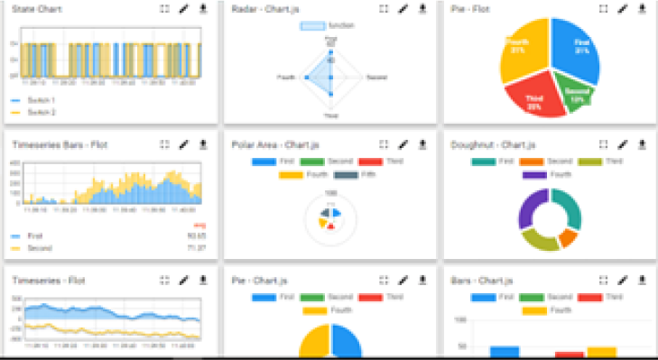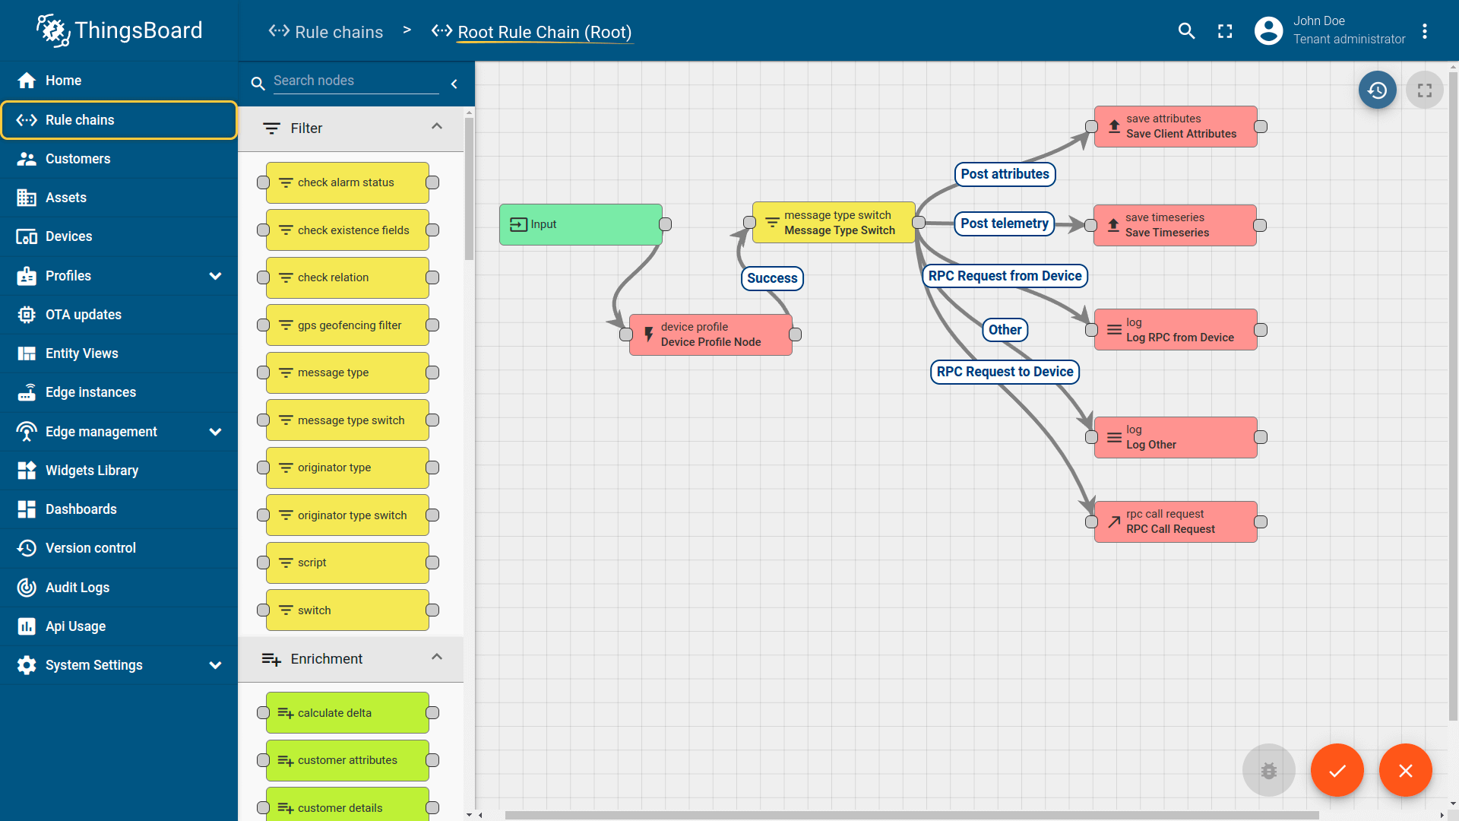

- Smart Factory Platform ()
Factory watch is a platform for smart factory needs.
It provides Users/ Factory
- with a scalable solution for their Production and asset monitoring
- OEE and predictive maintenance solution scaling up to digital twin for your assets.
- to unleased the true potential of the data that their machines are generating and helps to identify the KPIs and also improve them.
- A modular architecture that allows users to choose the service that they what to start and then can scale to more complex solutions as per their demands.
Its unique SaaS model helps users to save time, cost and money.
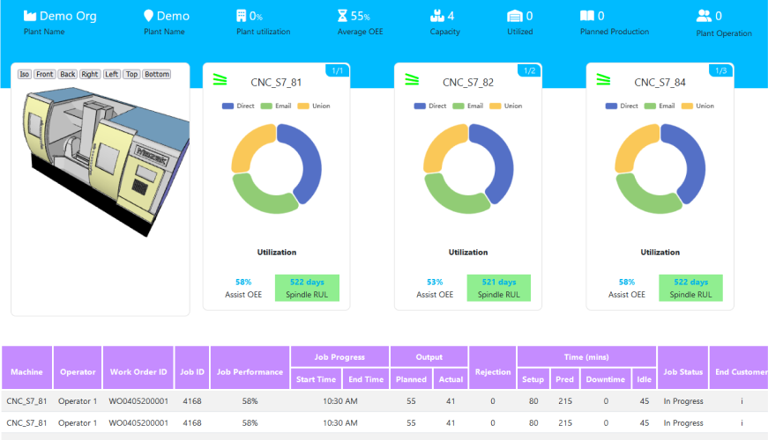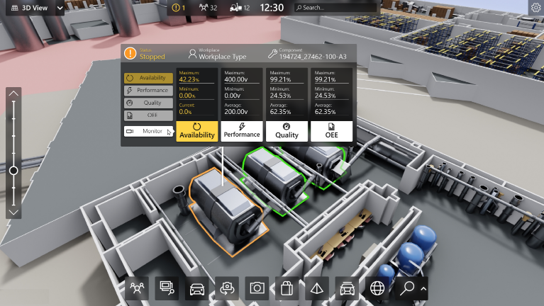

-  based Solution
UCT is one of the early adopters of LoRAWAN teschnology and providing solution in Agritech, Smart cities, Industrial Monitoring, Smart Street Light, Smart Water/ Gas/ Electricity metering solutions etc.
- Predictive Maintenance
UCT is providing Industrial Machine health monitoring and Predictive maintenance solution leveraging Embedded system, Industrial IoT and Machine Learning Technologies by finding Remaining useful life time of various Machines used in production process.
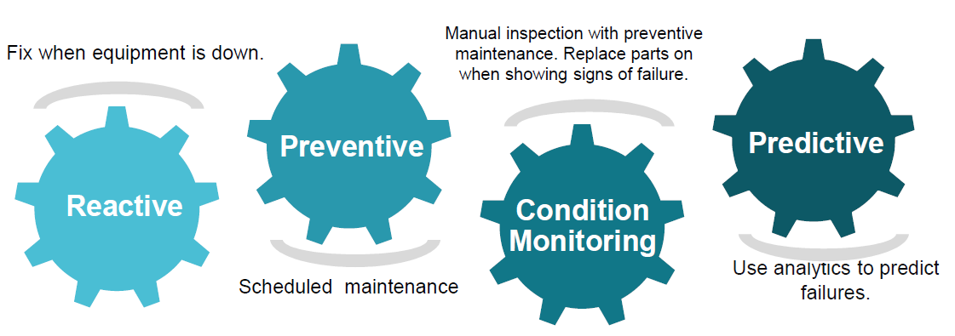

About upskill Campus (USC)
upskill Campus along with The IoT Academy and in association with Uniconverge technologies has facilitated the smooth execution of the complete internship process.
USC is a career development platform that delivers personalized executive coaching in a more affordable, scalable and measurable way.




Seeing need of upskilling in self paced manner along-with additional support services e.g. Internship, projects, interaction with Industry experts, Career growth Services
https://www.upskillcampus.com/
upSkill Campus aiming to upskill 1 million learners in next 5 year

The IoT Academy
The IoT academy is EdTech Division of UCT that is running long executive certification programs in collaboration with EICT Academy, IITK, IITR and IITG in multiple domains.

Objectives of this Internship program
The objective for this internship program was to
☛ get practical experience of working in the industry.
☛ to solve real world problems.
☛ to have improved job prospects.
☛ to have Improved understanding of our field and its applications.
☛ to have Personal growth like better communication and problem solving.

Reference
[1] Official Website of UniConverge Technologies Pvt Ltd – https://www.uniconverge.com
[2] Java Documentation (Oracle) – https://docs.oracle.com/javase/8/docs/
[3] Introduction to IoT and Industry 4.0 – https://www.iotforall.com
[4] Upskill Campus Official Website – https://www.upskillcampus.com
[5] The IoT Academy Official Website – https://www.theiotacademy.co

Glossary
Terms | Acronym
Internet of Things | IOT
Machine Learning | ML
Return on Investment | ROI
Hyper Text Transfer Protocol | HTTP
Software as a Service | SaaS

Problem Statement

The objective of this project is to design and develop a Banking Information System using Core Java that simulates the basic operations of a real-world banking environment. The system aims to provide a functional prototype that demonstrates essential banking services such as user registration, account management, transactions, and data handling.
In many traditional systems, managing customer accounts and transactions manually can be inefficient, error-prone, and time-consuming. Therefore, this project focuses on creating a digital solution that automates these processes, ensuring accuracy, efficiency, and ease of use.
The system allows users to create accounts by providing basic details, securely log in using authentication mechanisms, and perform financial operations such as deposits, withdrawals, and fund transfers. Additionally, it provides account statements to track transaction history and current balance.
To enhance reliability, the system incorporates error handling mechanisms to manage invalid operations such as insufficient balance or incorrect login credentials. Furthermore, it includes data persistence using file handling, enabling storage and retrieval of user data even after the program is restarted.
Overall, the project serves as a simplified model of a banking system that demonstrates core functionalities, usability, and system design principles using Java programming.

Existing and Proposed solution

- Existing Solutions and Their Limitations
Existing banking systems, especially traditional or basic digital systems, provide functionalities such as account management, transaction processing, and record maintenance. Many large-scale banking applications use advanced technologies like databases, cloud infrastructure, and secure authentication mechanisms.
However, these systems have certain limitations when considered from a learning or prototype perspective:
- Complexity: Real-world banking systems are highly complex and difficult for beginners to understand and implement.
- High Resource Requirement: They require databases, servers, and networking infrastructure, which may not be feasible for small-scale or academic projects.
- Lack of Simplicity for Learning: Existing systems are not designed for educational purposes, making it hard to grasp core concepts.
- Limited Accessibility: Proprietary banking systems are not openly accessible for experimentation or modification.
- Overhead of Advanced Technologies: Integration of APIs, security layers, and distributed systems adds unnecessary complexity for a prototype-level implementation.

- Proposed Solution
The proposed solution is to develop a Banking Information System using Core Java that provides a simplified yet functional prototype of real-world banking operations.
This system focuses on implementing key features such as:
- User Registration and Authentication
- Account Management
- Deposit and Withdrawal Operations
- Fund Transfer between users
- Account Statement with transaction history
- Basic Error Handling
- Data Persistence using File Handling
The solution is designed to be lightweight, easy to understand, and modular, allowing users to interact with the system through a console-based interface. It demonstrates the complete flow of banking operations while maintaining simplicity.
Overall, the project adds value by combining simplicity with practical functionality, making it suitable for both learning and demonstration purposes.

Code submission (Github link)
Link : https://github.com/pratham468/upskillCampus.git

Report submission (Github link) : first make placeholder, copy the link.

Report link :- https://github.com/pratham468/upskillCampus/blob/main/Sample_InternshipReport_USC_UCT.docx

Proposed Design/ Model

High Level Diagram (if applicable)

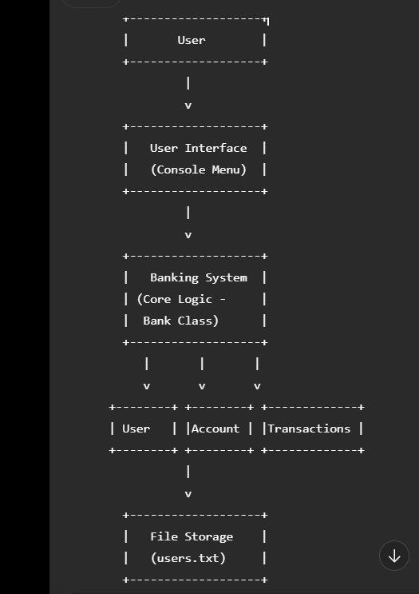
Figure 1: HIGH LEVEL DIAGRAM OF THE SYSTEM

Low Level Diagram (if applicable)
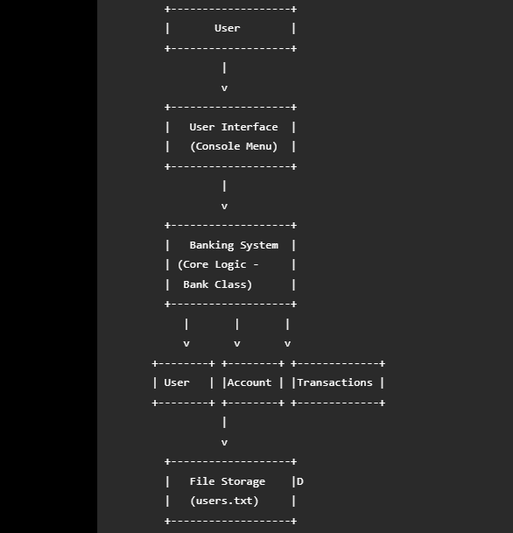

Interfaces (if applicable)
Update with Block Diagrams, Data flow, protocols, FLOW Charts, State Machines, Memory Buffer
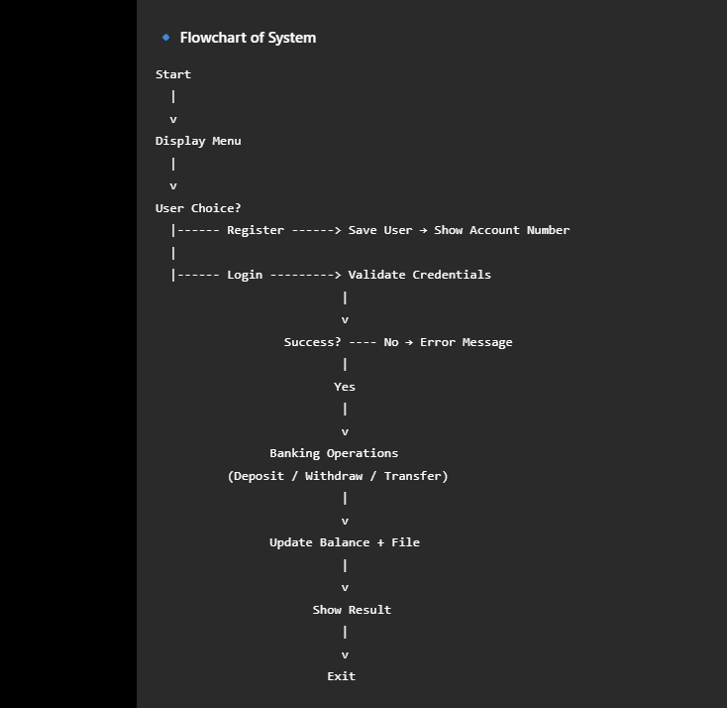

Performance Test

The performance testing of the Banking Information System focuses on evaluating how efficiently the system operates under defined constraints such as memory usage, execution speed, and data handling capability.

- Identified Constraints:
- Memory Constraint:
  - The system uses in-memory data structures (HashMap) to store user data during execution.
  - Large number of users may increase memory usage.
- Speed / Execution Time:
  - Operations such as login, deposit, withdrawal, and transfer must execute quickly.
  - File handling operations may introduce slight delays.
- Data Persistence Limitation:
  - Uses text file (users.txt) instead of database.
  - File-based storage may become slower with increasing data size.
- Scalability:
  - Designed for small to medium-scale usage.
  - Not optimized for high concurrent users.

- Handling of Constraints in Design:
- Efficient Data Structures:
  - Used HashMap for fast data retrieval (O(1) lookup time).
- Optimized File Handling:
  - BufferedReader and BufferedWriter used to improve I/O performance.
- Modular Design:
  - Separation of classes (User, Account, Bank) improves maintainability and scalability.
- Error Handling:
  - Prevents system crashes due to invalid inputs or operations.

- 6.1 Test Plan / Test Cases
Test Case ID | Description | Input | Expected Output
TC01 | User Registration | Valid user details | Account created successfully
TC02 | Login | Correct credentials | Login successful
TC03 | Login Failure | Invalid password | Error message
TC04 | Deposit | Valid amount | Balance updated
TC05 | Withdraw (Valid) | Amount ≤ balance | Balance reduced
TC06 | Withdraw (Invalid) | Amount > balance | Insufficient balance message
TC07 | Fund Transfer | Valid account + amount | Transfer successful
TC08 | Data Persistence | Restart system | Data retained

- 6.2 Test Procedure
- Compile and run the Java program using:
- javac *.java
- java Main
- Perform the following steps:
  - Register a new user
  - Login using credentials
  - Perform deposit and withdrawal operations
  - Transfer funds to another account
  - Exit and restart the program
  - Login again to verify data persistence
- Record system response time and correctness of output.

- 6.3 Performance Outcome
- Memory Usage:
  - Efficient for small datasets (up to hundreds of users)
  - No memory overflow observed during testing
- Execution Speed:
  - Fast response for all operations (instant execution)
  - Slight delay observed during file read/write operations
- Accuracy:
  - All transactions processed correctly
  - No data inconsistency observed
- Reliability:
  - System handled invalid inputs gracefully
  - No crashes during testing

- Recommendations for Improvement:
- Replace file storage with database (MySQL) for better scalability
- Optimize file handling for large datasets

My learnings

During the development of the Banking Information System project, I gained valuable technical and practical knowledge that enhanced my understanding of software development.
- Object-Oriented Programming (OOP):
Developed a strong understanding of core OOP concepts such as classes, objects, encapsulation, and modular design by implementing separate classes like User, Account, and Bank.
- Java Programming Skills:
Improved proficiency in Core Java, including the use of data structures such as HashMap and ArrayList, as well as methods, constructors, and control flow.
- File Handling (Data Persistence):
Learned how to implement file-based storage using BufferedReader and BufferedWriter to save and retrieve user data, making the system more realistic.
- System Design & Architecture:
Understood how to design a complete application flow from user input to processing and output, including high-level and low-level system design.
- Error Handling & Debugging:
Gained experience in identifying and fixing errors such as invalid inputs, insufficient balance, and file-related issues, improving debugging skills.
Overall, this project helped bridge the gap between theoretical knowledge and practical implementation, preparing me for real-world software development challenges.

Future work scope

The current Banking Information System is a functional prototype developed using Core Java. However, it can be further enhanced and extended to meet real-world industry standards. The following improvements are proposed for future development:
- Database Integration:
Replace file-based storage with a robust database system such as MySQL or PostgreSQL to handle large-scale data efficiently and ensure better data management.
- Graphical User Interface (GUI):
Upgrade the console-based interface to a user-friendly GUI using Java Swing or JavaFX to improve usability and user experience.
- Security Enhancements:
Implement advanced security features such as:
  - Password encryption (hashing techniques)
  - OTP-based authentication
  - Role-based access control
- Multi-User and Concurrency Handling:
Introduce multi-threading to allow multiple users to access the system simultaneously, similar to real banking environments.
- Transaction Management System:
Store transaction history permanently with timestamps and provide features like filtering, searching, and exporting statements.
- Web-Based Application:
Convert the system into a web application using technologies like Spring Boot, HTML, CSS, and JavaScript for wider accessibility.

