Task Manager Module
Implementation of a Mini Software Module (CRUD + Task Suggestion)
Submitted by: Pratham
Project Report

1. Objective
The goal of this assignment is to take part in the actual coding process by implementing a mini software module from a defined set of requirements. This task simulates the execution phase of software development, where code quality, efficiency and adherence to best practices matter most.
I implemented a Task Manager module in Python with SQLite storage. It supports CRUD (Create, Read, Update, Delete) operations and includes a rule-based task suggestion feature that recommends which task to work on next.

2. Feature Definition
- Create a task with a title, description, priority (low, medium, high) and due date.
- Read: list all tasks, view one task, and filter by status or priority.
- Update: edit task details or mark a task as completed.
- Delete a task permanently.
- Suggest: recommend the most important pending task using a transparent scoring formula (Section 6).
- Validate every input and return a clear error message when data is invalid.

3. System Architecture
The module uses a layered design. Each layer has one responsibility, which makes the code easier to read, test and extend. Figure 1 shows how the components interact.
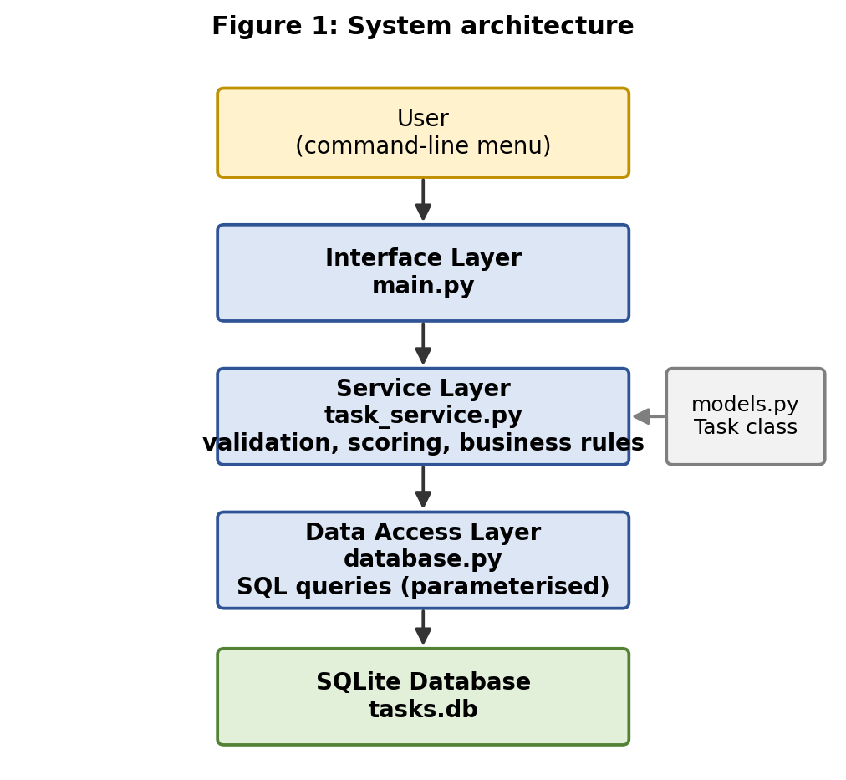
Figure 1: System architecture
Layer | File | Responsibility
Interface | main.py | Command-line menu; reads input and prints results.
Service | task_service.py | Validation, business rules and the suggestion scoring.
Data access | database.py | SQLite connection and parameterised SQL queries.
Model | models.py | Task class describing one task.
Tests | tests/test_tasks.py | Unit tests for service and data layers.

4. Database Design
All tasks are stored in a single SQLite table. Figure 2 shows its columns and data types.
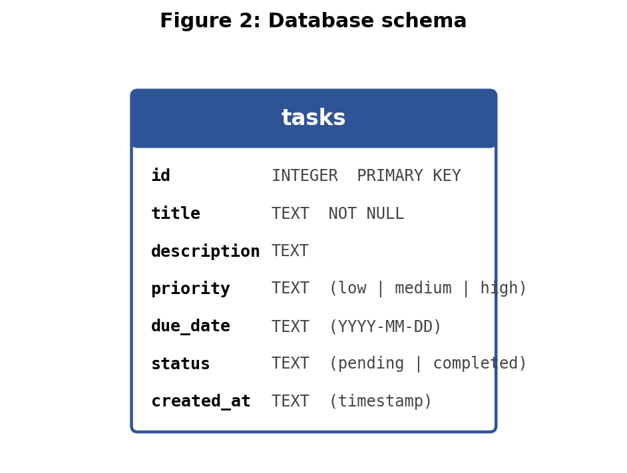
Figure 2: Database schema
Example rows stored in the table (sample data used throughout this report):
id | title | priority | due_date | status
1 | Finish internship report | high | 2026-10-01 | pending
2 | Buy groceries | low | 2026-09-29 | pending
3 | Prepare presentation | medium | 2026-10-05 | pending
4 | Submit fee form | high | 2026-09-27 | pending
5 | Read book | low | 2026-11-01 | pending

5. How a Request Flows Through the System
Every operation follows the same path: interface, then service, then database. Figure 3 uses "Add task" as an example.
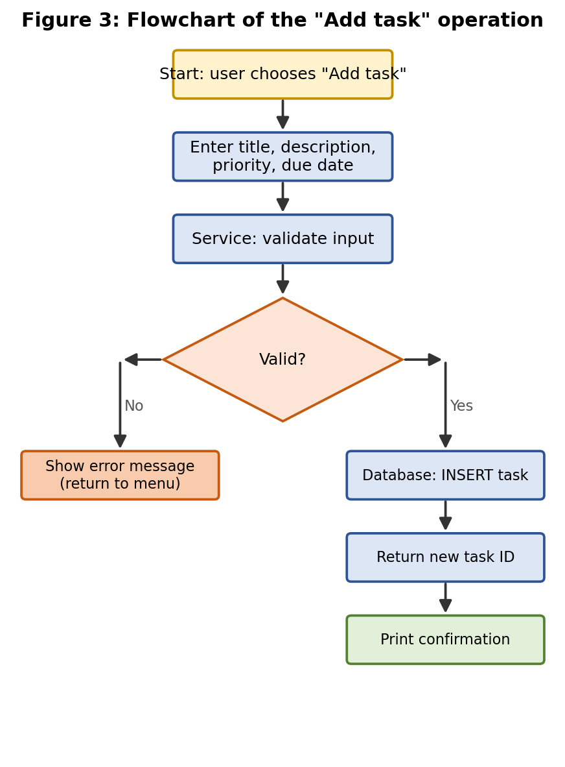
Figure 3: Flowchart of the "Add task" operation
Step by step:
- The user picks option 1 and enters the title, description, priority and due date.
- The service layer checks the data. The title must not be empty, the priority must be low, medium or high, and the date must match YYYY-MM-DD.
- If any check fails, an error is shown (for example "Error: priority must be low, medium or high") and nothing is saved.
- If all checks pass, the data layer runs a parameterised INSERT and returns the new task ID.
- The interface prints a confirmation such as "Task added with ID 6".

6. Task Suggestion Process (Recommendation Logic)
The suggestion feature answers the question "What should I work on next?". It is rule-based, not machine learning. This is a deliberate decision: the rules are easy to explain, need no training data, and always give the same result for the same input, which makes the feature simple to test.
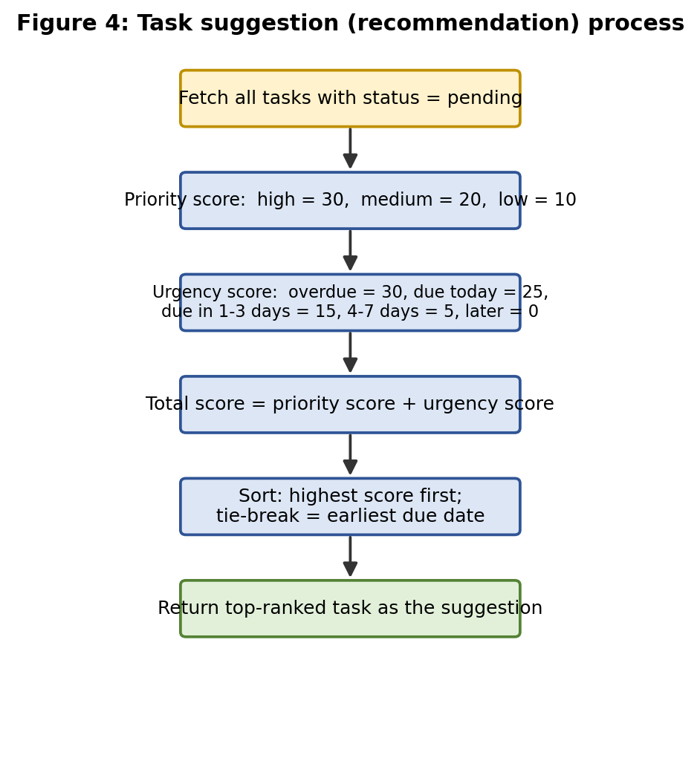
Figure 4: Task suggestion process

6.1 Scoring rules
Each pending task receives a total score made of two parts:
Part | Condition | Points
Priority | high | 30
Priority | medium | 20
Priority | low | 10
Urgency | overdue | 30
Urgency | due today | 25
Urgency | due in 1 to 3 days | 15
Urgency | due in 4 to 7 days | 5
Urgency | due in more than 7 days | 0

6.2 Worked example
Assume today is 2026-09-29 and the five sample tasks from Section 4 are pending.
ID | Task | Priority pts | Urgency pts | Total
4 | Submit fee form (overdue by 2 days) | 30 | 30 | 60
1 | Finish internship report (due in 2 days) | 30 | 15 | 45
2 | Buy groceries (due today) | 10 | 25 | 35
3 | Prepare presentation (due in 6 days) | 20 | 5 | 25
5 | Read book (due in 33 days) | 10 | 0 | 10

Result: task 4, "Submit fee form", is suggested first because it has the highest score (60). If two tasks tie, the one with the earlier due date wins. Note how "Buy groceries" (low priority) outranks "Prepare presentation" (medium priority) because it is due today. This shows why urgency is scored separately from priority.

6.3 Core code
def suggest_next_task(tasks, today):
"""Return the pending task with the highest score."""
pending = [t for t in tasks if t.status == "pending"]
if not pending:
return None
# Sort by score (descending), then by due date (ascending)
return sorted(pending,
key=lambda t: (-score(t, today), t.due_date))[0]

7. Development Decisions
Decision | Reason
Layered architecture | Interface can be swapped (e.g. for a web UI) without touching service or database code.
SQLite | No server or setup needed; ships with Python, so anyone can run the project immediately.
Parameterised queries | Prevents SQL injection; user text is never joined into SQL strings.
Validation in service layer | One place for all checks, so rules are not duplicated.
Rule-based suggestions | Transparent, explainable and testable; no training data required.
In-memory DB for tests | Tests never touch real data and run in milliseconds.

8. Sample Run
Example console session (input in bold text in the actual program prompts; output shown as printed):
=== Task Manager ===
1. Add task 2. View tasks 3. Update task
4. Complete 5. Delete 6. Suggest next 7. Exit
Choose an option: 1
Title: Finish internship report
Priority (low/medium/high): high
Due date (YYYY-MM-DD): 2026-10-01
Task added with ID 1

Choose an option: 1
Title: Buy groceries
Priority (low/medium/high): urgent
Error: priority must be low, medium or high

Choose an option: 6
Suggested next task: [4] Submit fee form (score 60)

9. Testing
Unit tests cover normal behaviour and invalid input. Each test states its input and the expected result:
Test case | Input | Expected result
Create valid task | title "Read", priority "low" | Task saved; ID returned
Empty title | title "" | Error: title cannot be empty
Invalid priority | priority "urgent" | Error: priority must be low, medium or high
Invalid date | due_date "31-12-2026" | Error: date must be YYYY-MM-DD
Update task | change priority to "high" | Stored priority becomes high
Complete task | task ID 1 | Status changes to completed
Delete task | task ID 1 | Task no longer in list
Delete missing task | task ID 999 | Error: task not found
Suggestion order | five sample tasks, today 2026-09-29 | Task 4 returned first
Suggestion tie | equal scores, different dates | Earlier due date returned
Suggestion empty | no pending tasks | None returned

10. Installation and Usage
git clone https://github.com/<username>/task-manager.git
cd task-manager
python -m venv venv
venv\Scripts\activate # Windows
source venv/bin/activate # macOS / Linux
python main.py

The project uses only the Python standard library, so no extra packages are required. To run the tests:
python -m unittest discover tests

11. Conclusion
This assignment gave me hands-on experience of taking requirements through design, implementation, documentation and testing. The final module is functional, modular and documented. Possible future improvements include user authentication, task categories, and replacing the rule-based suggestion with a learned model once enough usage data exists.
Source code and README: https://github.com/<username>/task-manager

